SUPPLEMENTARY INFORMATION
Self-Adaptive Infrared Vision via Neural-Controlled Gain Compression in a Single Photodetector
Yuxin Song^{1,2#}, Xin Li^{1,2#}, Junzhe Gu^{1,2}, Jin Chen¹, Feilong Yu¹, Juntong Liu^{1,2}, Jiaji Yang^{1,2,3}, Guanhai Li^{1,2,4,5*}, Xiaoshuang Chen^{1,2,3,4,5}, Wei Lu^{1,2,3,4,5}
¹State Key Laboratory of Infrared Physics, Shanghai Institute of Technical Physics, Chinese Academy of Sciences, 500 Yu-Tian Road, 200083 Shanghai, China
²University of Chinese Academy of Sciences, No. 19A Yuquan Road, 100049 Beijing, China
³School of Physical Science and Technology, ShanghaiTech University, 201210 Shanghai, China
⁴Hangzhou Institute for Advanced Study, University of Chinese Academy of Sciences, No.1 Sub-Lane Xiangshan, 310024 Hangzhou, China
⁵Shanghai Research Center for Quantum Sciences, 99 Xiupu Road, 201315 Shanghai, China
*ghli0120@mail.sitp.ac.cn; xschen@mail.sitp.ac.cn; luwei@mail.sitp.ac.cn

Table of contents
Figure S1. Output characteristics (I_{ds}–V_{ds}) of the device under various gate voltages (V_{g} = −40 V to 40 V) in the dark.
Figure S2. Transfer characteristics (I_{ds}–V_{g}) under different source–drain biases (V_{ds} = ±0.1 V) in the dark.
Figure S3. Energy band profiles of Au, BP and PdSe₂ after contact in lighting.
Figure S4. Photoswitching response of the Au/BP/PdSe₂ vdWH device at V_{ds} = 0 V and V_{g} = -40 V under 1550 nm laser illumination with different power densities.
Figure S5. Time-resolved photoresponse of the Au/BP/PdSe₂ vdWH device at V_{ds} = 0 V and V_{g} = 40 V.
Figure S6. Time-resolved photoresponse of the Au/BP/PdSe₂ vdWH device at V_{ds} = 0 V and V_{g} = -40 V.
Figure S7. Output I_{ds}–V_{ds} characteristics under dark and illuminated conditions (λ = 1550 nm).
Figure S8. Transfer curves of the Au/BP/PdSe₂ vdWH device at different source–drain voltages varying from −2 V to 2 V under 1550 nm laser illumination.
Figure S9. Output electrical power as a function of source–drain biases.
Figure S10. The source–drain current as a function of the source–drain and gat biases under dark condition and the different light power density from the 1550 nm laser irradiation.
Figure S11. Power dependent specific detectivity under the gate voltage V_{g} = -40 V, 0 V and 40 V.
Figure S12. Photocurrent (I_{ds}) versus optical power density at fixed gate voltages (V_{g}= −40 V, 0 V, and 40 V).
Figure S13. Gate voltage dependent Exponential factor.
Figure S14. Full-Stokes detection and imaging.
Figure S15. Real shot of the Full-Stokes imaging test.
Figure S16. Detailed signal processing flow diagram of optoelectronic compensation system.

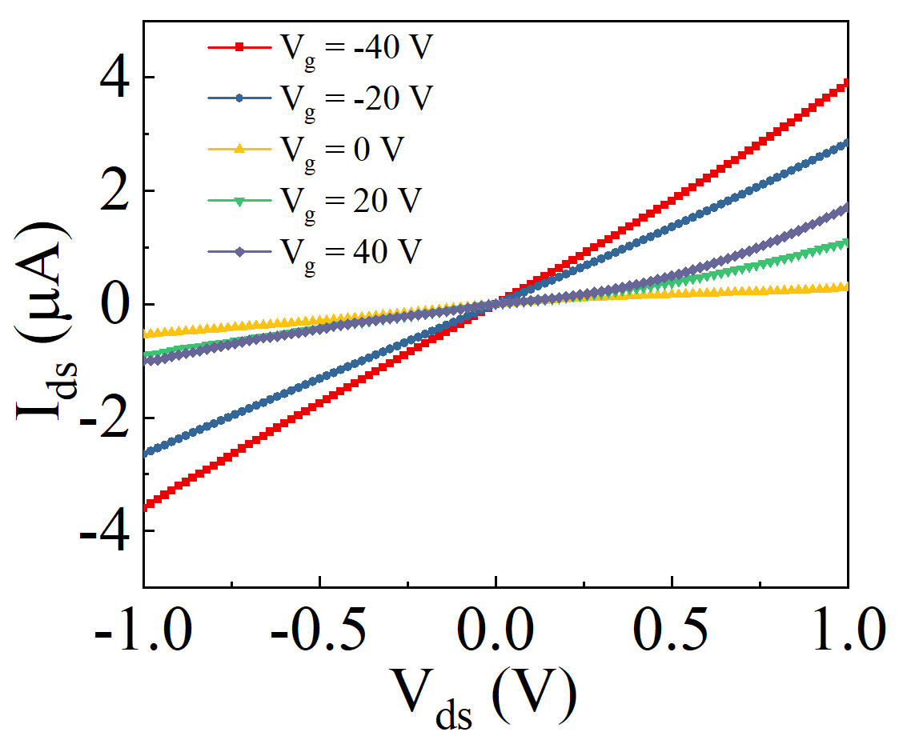
Figure S1. Output characteristics (I_{ds}–V_{ds}) of the device under various gate voltages (V_{g} = −40 V to 40 V) in the dark.
To probe the electrical tunability of the heterostructure, we measured the output characteristics (I_{ds}–V_{ds}) under various back-gate voltages in the absence of illumination. At zero bias, the Au/BP interface acts as the dominant transport bottleneck due to its Schottky barrier, suppressing dark current. Upon applying negative gate voltages, the Fermi level in BP is pulled downward, leading to (i) increased hole carrier density and (ii) reduced band bending at the junction. These effects synergistically lower the barrier and enhance current flow. In contrast, positive gate voltages induce electron carriers in BP, enabling ambipolar conduction but simultaneously increasing the depletion width and Schottky barrier height, which weakens the net current modulation.

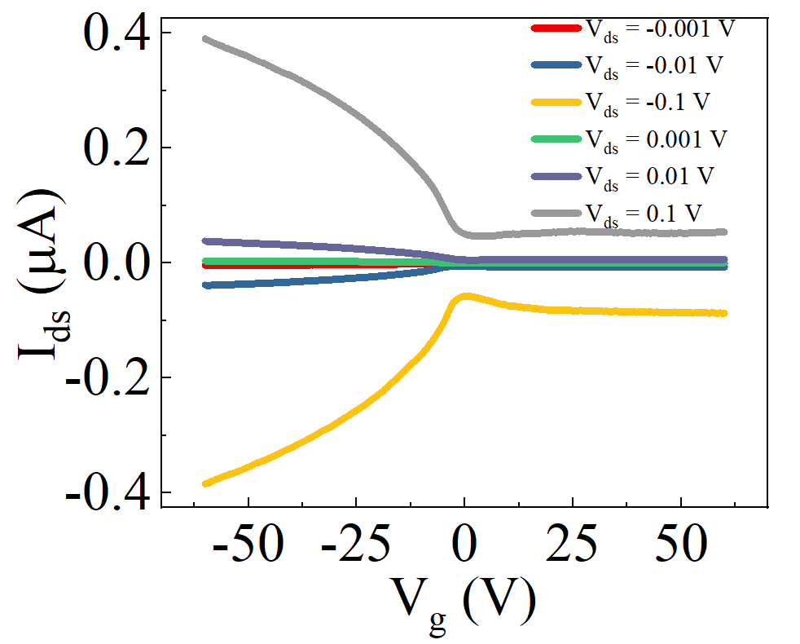
Figure S2. Transfer characteristics (I_{ds}–V_{g}) under different source–drain biases (V_{ds} = ±0.1 V) in the dark.
This gate-dependent behavior is further corroborated by the transfer curves. Symmetric characteristics are observed with respect to V_{g}, although stronger current enhancement appears under negative gating, consistent with the hole-dominant transport mechanism.

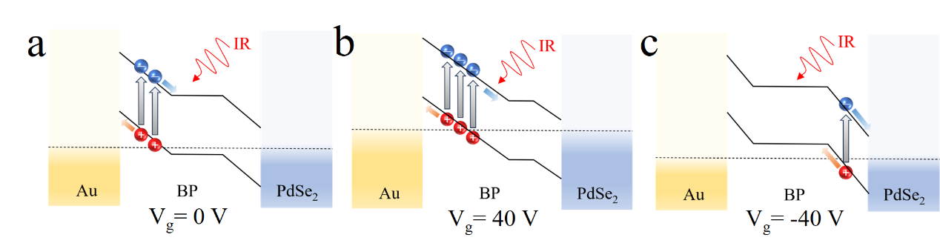
Figure S3. Energy band profiles of Au, BP and PdSe₂ after contact in lighting. (a) (b) (c) correspond to a gate voltage of 0 V, 40 V, and -40 V. The optical absorption region and responsivity change with the gate voltage.
Due to the use of the bottom electrode in the device, the surface state introduced by the electrode deposition process can effectively damage, so the device Fermi level can be significantly regulated by the gate voltage. The Schottky barrier height for the metal-semiconductor contact equals the difference in the Fermi levels of the metal and the semiconductor. Additionally, because of the thin-layer structure of the 2D material, the gate voltage can effectively modulate the Fermi level of the 2D material¹. Furthermore, the built-in electric field strength is influenced by the doping concentration of the material; the higher the concentration, the stronger the field strength. Electrostatic doping can be understood as defect doping here.
Applying a gate voltage re-balance the band alignment across the two serial heterointerfaces. A negative gate voltage enlarges the BP/ PdSe₂ barrier and narrows the depletion area, resulting in weak photocarrier injection and small photovoltaic gain. Conversely, a positive gate voltage elevates the barrier at the Au side and widens the depletion region, resulting in efficient photocarrier injection and large photovoltaic gain. Because the same electrostatic knob controls both the response area and responsivity, the current–power transfer function can be reshaped at will, providing the non-linear compressive response required for wide LDR detection.
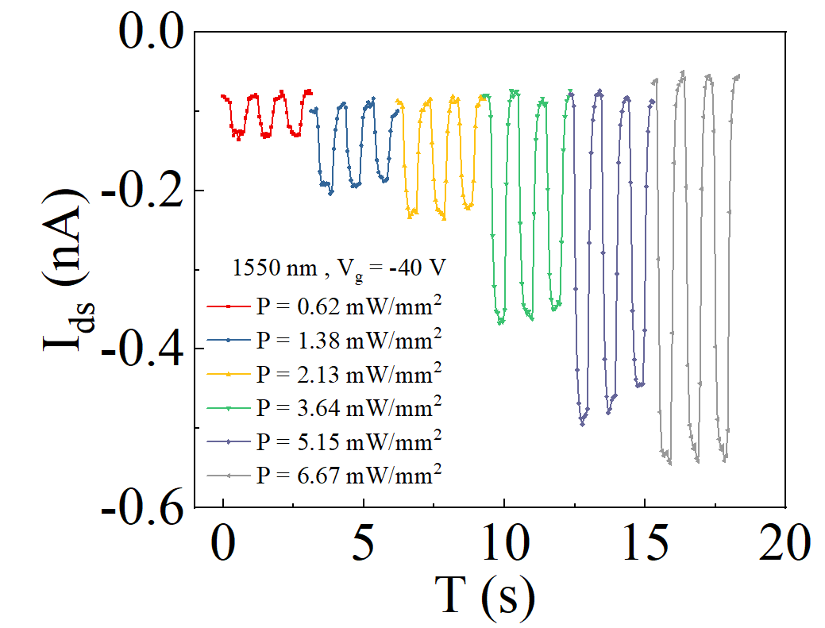
Figure S4. Photoswitching response of the Au/BP/PdSe₂ vdWH device at V_{ds} = 0 V and V_{g} = -40 V under 1550 nm laser illumination with different power densities.

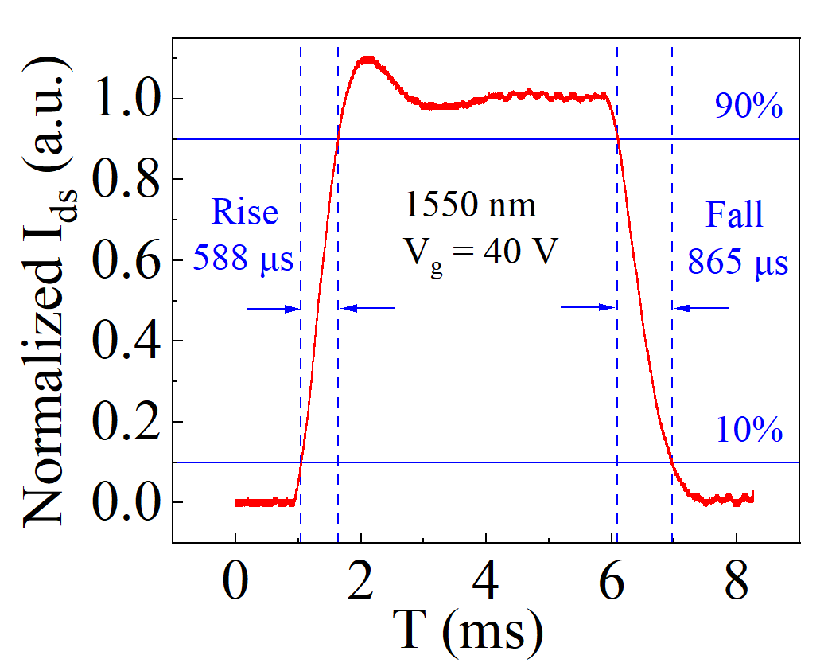
Figure S5. Time-resolved photoresponse of the Au/BP/PdSe₂ vdWH device at V_{ds} = 0 V and V_{g} = 40 V.

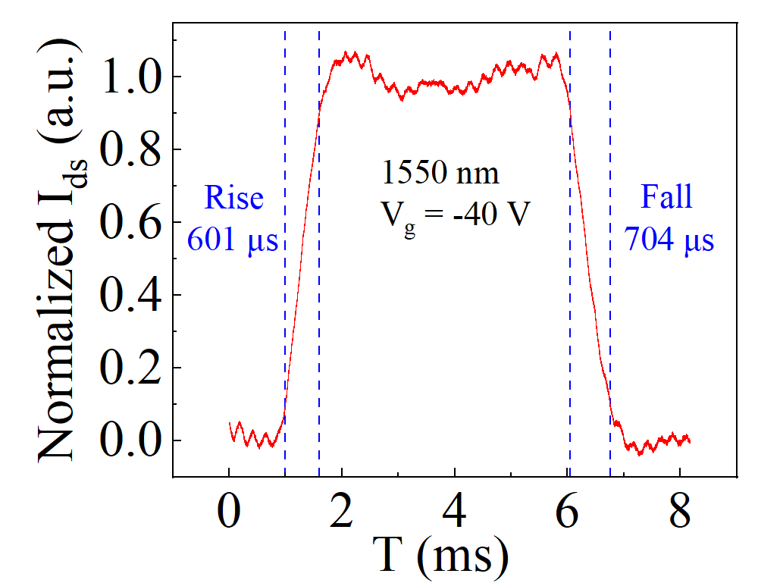
Figure S6. Time-resolved photoresponse of the Au/BP/PdSe₂ vdWH device at V_{ds} = 0 V and V_{g} = -40 V.

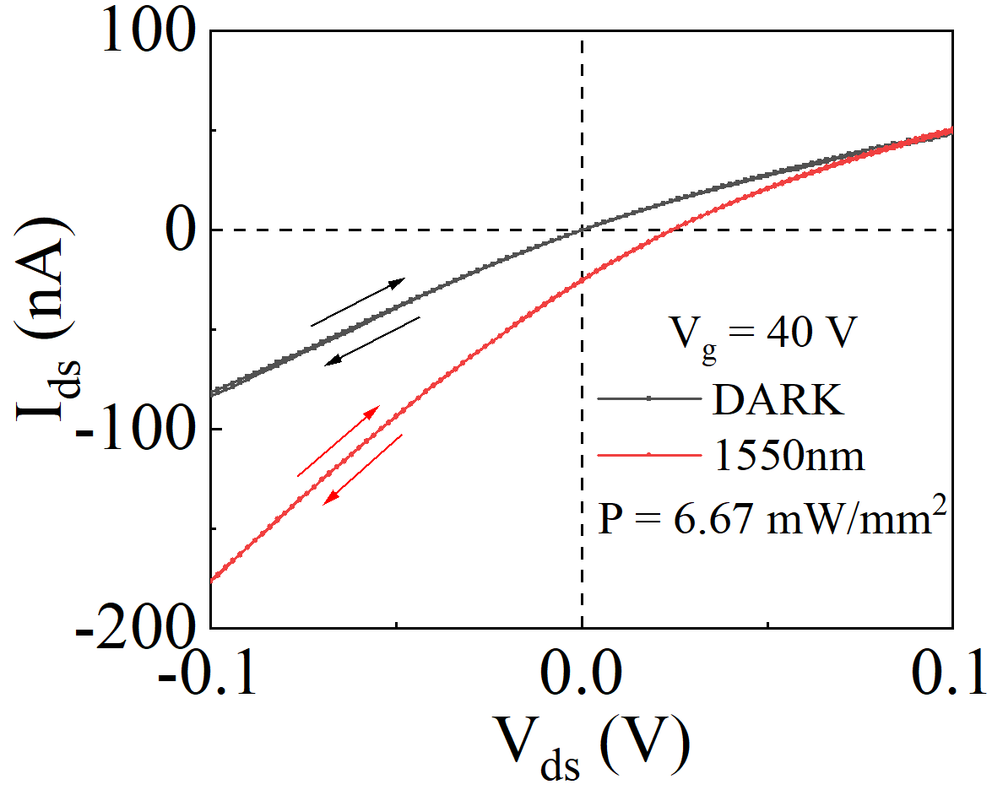
Figure S7. Output I_{ds}–V_{ds} characteristics under dark and illuminated conditions (λ = 1550 nm).
The output characteristics under dark and illuminated conditions. The absence of noticeable hysteresis or shift during source-drain voltage sweeping indicates good device stability and negligible parasitic capacitance, even under photoexcitation.

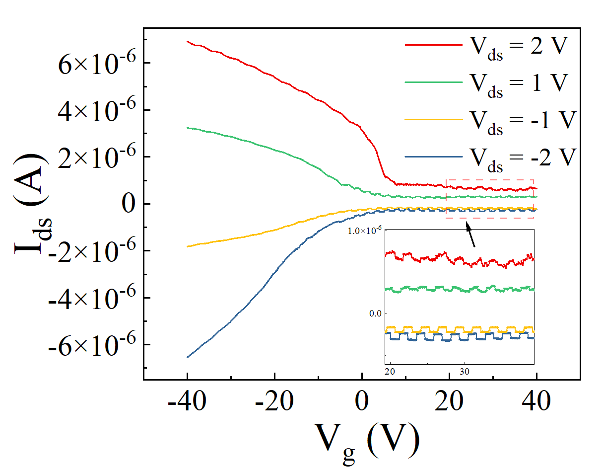
Figure S8. Transfer curves of the Au/BP/PdSe₂ vdWH device at different source–drain voltages varying from −2 V to 2 V under 1550 nm laser illumination.
In the case of different source-drain voltages, the signal-to-noise is always the largest under the condition of positive gate voltage.

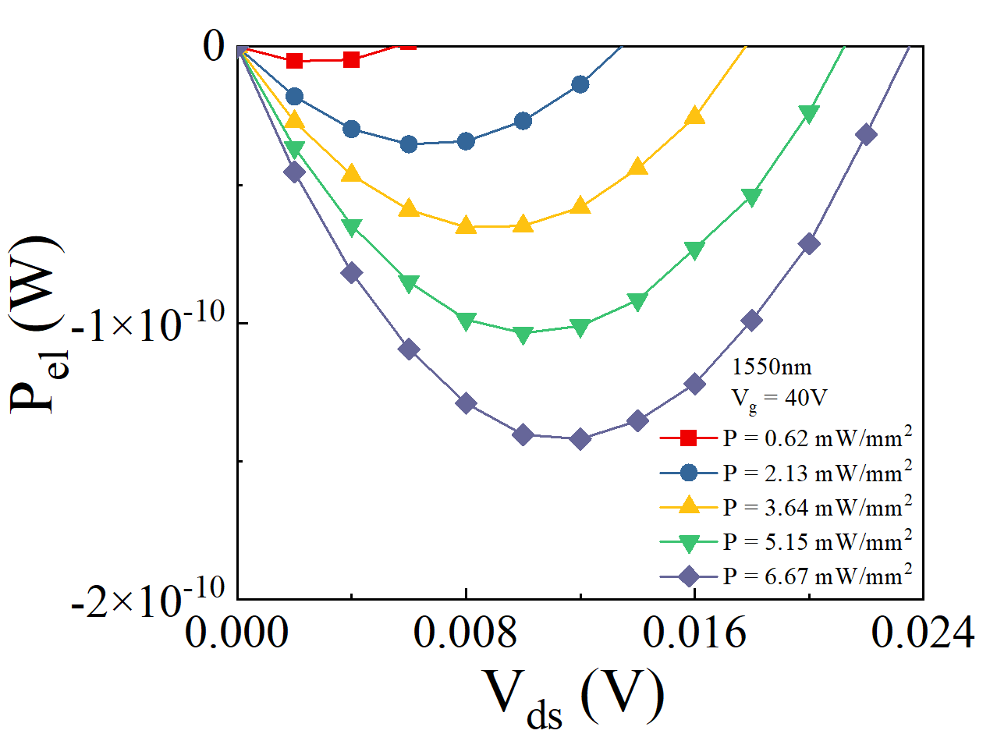
Figure S9. Output electrical power as a function of source–drain biases.
The output electrical power (P_{el}), which describes the electricity generation capability of a photovoltaic detector or solar cell, is defined as P_{el} = I_{ds}·V_{ds}.
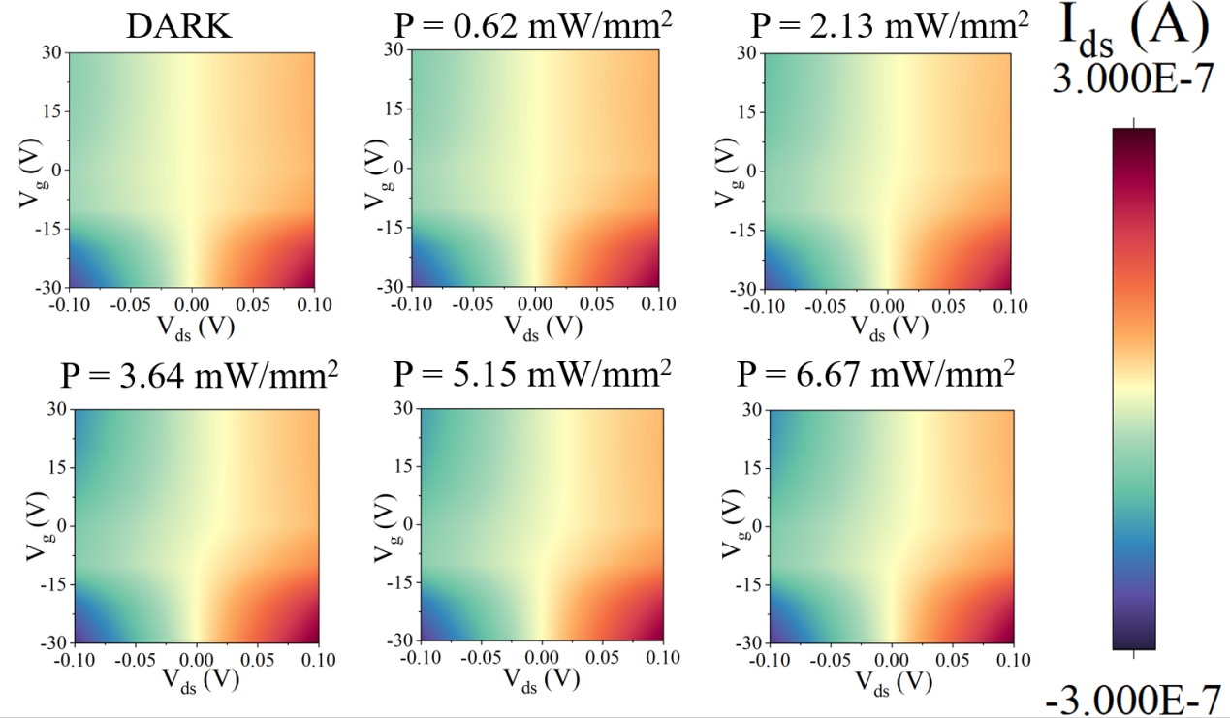
Figure S10. The source–drain current as a function of the source–drain and gat biases under dark condition and the different light power density from the 1550 nm laser irradiation.
The incident light intensity dynamically regulates the zero-reference line of the source-drain current. The position of the zero-current contour shifts with input power, verifying that incident light intensity effectively reconfigures the optimal working point-a necessary condition for closed-loop exposure adaptation in the full photodetection system.
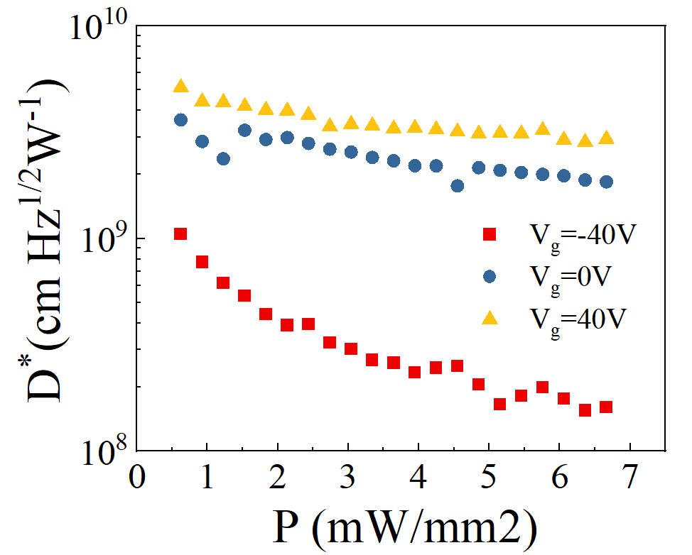
Figure S11. Power dependent specific detectivity under the gate voltage V_{g} =-40V, 0V and 40V.
The detectivity is calculated by D* = RA^{1/2}/(2eI_{dark})^{1/2}, where A is the effective channel area, R is photo-responsivity, e is the elementary charge, and I_{dark} is the back-ground current in the dark state.

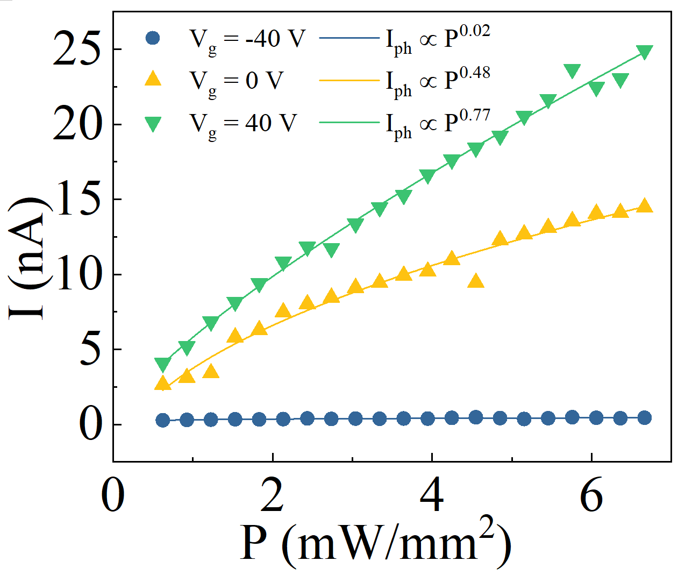
Figure S12. Photocurrent (I_{ds}) versus optical power density at fixed gate voltages. It shows power-law scaling with gate-dependent nonlinear exponents α.

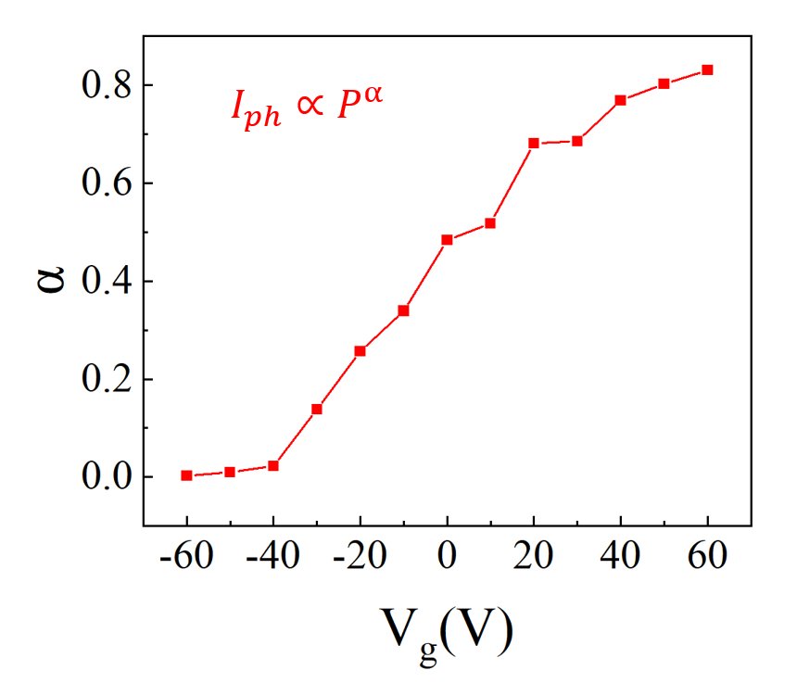
Figure S13. Gate voltage dependent Exponential factor. The Exponential factor increases with the increase of gate voltage until saturation.

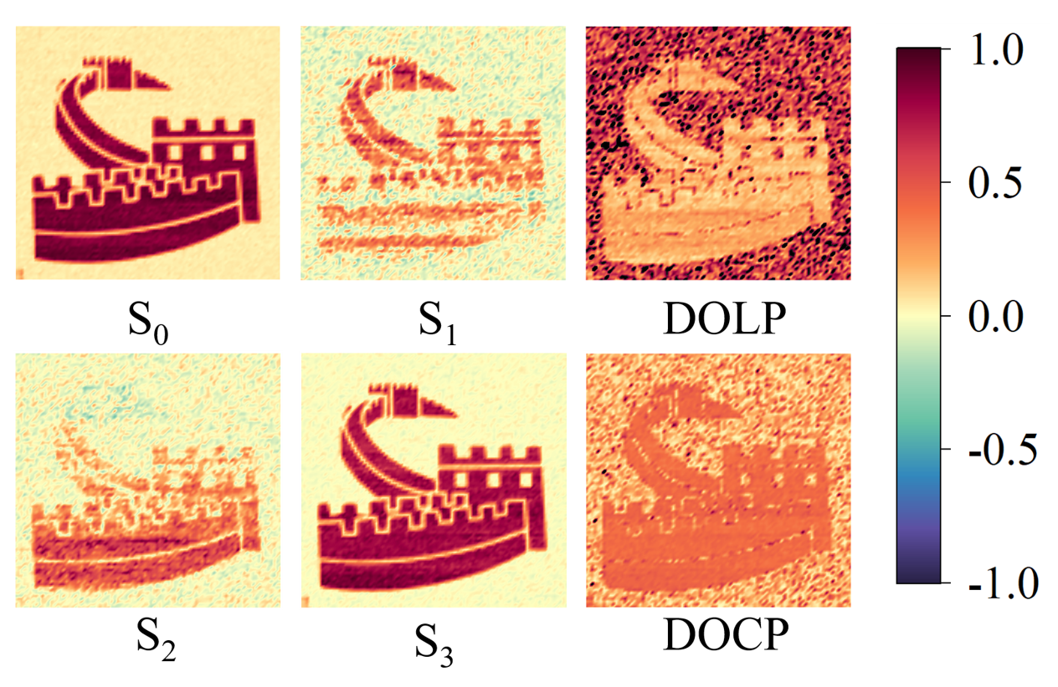Figure S14. Full-Stokes detection and imaging.
Full-Stokes imaging for S₀-S₃ parameters, degree of linear polarization (DOLP) and degree of circular polarization (DOCP) values. The circular and linear polarization degrees are calculated according to equation: DOLP = (S₁² + S₂²)^{0.5}/S₀, DOCP = |S₃|/S₀. Using an optical power meter and a polarizer replacement Au/BP/PdSe₂ vdWH device, the result is S = (1, 0.23, -0.18, 0.95), DOLP = 0.29, DOCP = 0.95. The experimental error may be due to the fact that the polarization ratio of the Au/BP/PdSe₂ vdWH device (8) is much smaller than that of commercial polarizer (1000) and the inhomogeneity of the imaging target material and the laser.

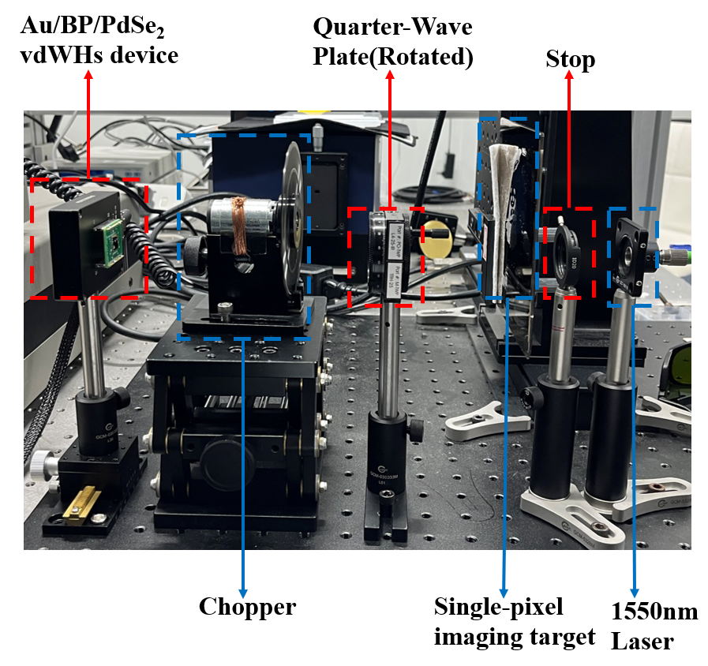Figure S15. Real shot of the Full-Stokes imaging test.
The test process is to rotate the 1/4 waveplate and record the photocurrent value with the angle of the waveplate.² Eight equally spaced angles from 0° to 180° are selected to measure the photocurrent value. There is a general expression for the measured photocurrent values at different angles, and the four coefficients of ABCD can be obtained by Fourier analysis, from which the Stokes parameter is calculated.
$$\begin{aligned}A=\frac{1}{4}\sum_{n=1}^{8}{I_{n}\left(θ_{n}\right)}\#\left(1\right)\end{aligned}$$
$$\begin{aligned}B=\frac{1}{2}\sum_{n=1}^{8}{I_{n}\left(θ_{n}\right)}\sin{2θ_{n}}\#\left(2\right)\end{aligned}$$
$$\begin{aligned}C=\frac{1}{2}\sum_{n=1}^{8}{I_{n}\left(θ_{n}\right)}\cos{4θ_{n}}\#\left(3\right)\end{aligned}$$
$$\begin{aligned}D=\frac{1}{2}\sum_{n=1}^{8}{I_{n}\left(θ_{n}\right)}\sin{4θ_{n}}\#\left(4\right)\end{aligned}$$
$$\begin{aligned}S_{0}=A−C\#\left(5\right)\end{aligned}$$
$$\begin{aligned}S_{1}=2C\#\left(6\right)\end{aligned}$$
$$\begin{aligned}S_{2}=2D\#\left(7\right)\end{aligned}$$
$$\begin{aligned}S_{3}=B\#\left(8\right)\end{aligned}$$
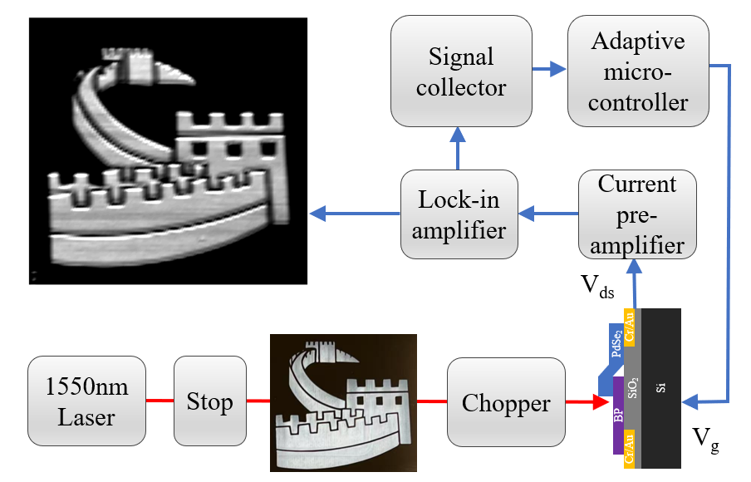
Figure S16. Detailed signal processing flow diagram of optoelectronic compensation system.
A 1550 nm laser beam was collimated through a stop to reduce its cross-sectional dimensions and then transmitted through a photomask controlled by a motorized translation stage as the target image. The scanning step size was set to 0.4 mm with a scanning range of 44 mm in both length and width. The incident light was modulated by a chopper to generate frequency-specific signals, which were subsequently processed through a low-noise current preamplifier and a 100 kHz DSP lock-in amplifier to suppress background noise and enhance the signal-to-noise ratio. The optical signals were detected by an Au/BP/PdSe₂ vdWH device, and the final image was reconstructed using the output from the 100 kHz DSP lock-in amplifier, completing the imaging pipeline.³

References
1. Wang, X.; Wang, P.; Wang, J.; Hu, W.; Zhou, X.; Guo, N.; Huang, H.; Sun, S.; Shen, H.; Lin, T.; Tang, M.; Liao, L.; Jiang, A.; Sun, J.; Meng, X.; Chen, X.; Lu, W.; Chu, J., Ultrasensitive and Broadband MoS2 Photodetector Driven by Ferroelectrics. Advanced Materials 2015, 27 (42), 6575-6581.
2. Ma, X.; Wang, Z.; Qin, Q.; Chen, J.; Liu, X.; Zou, F.; Xu, Z.; Chen, W.; Li, G.; Li, Y.; Zhai, T.; Li, L., Simultaneous AoLP and DoLP Detection in a Bias-Switchable PdSe2/MoS2/PdSe2 Heterojunction for Polarization Discrimination. Advanced Materials 2025, 37 (16), 2500572.
3. Chen, J.; Yu, F.; Liu, X.; Bao, Y.; Chen, R.; Zhao, Z.; Wang, J.; Wang, X.; Liu, W.; Shi, Y.; Qiu, C.-W.; Chen, X.; Lu, W.; Li, G., Polychromatic full-polarization control in mid-infrared light. Light: Science & Applications 2023, 12 (1), 105.

