Supplementary Material
Table S1: Participant HCWs vaccination and prior infection characteristics at the start of each Omicron sub-lineage predominant circulation period, multi-centre VEBIS HCW COVID-19 vaccine effectiveness study, 16 Dec 2021–21 May 2024
 | Omicron BA.1/2 | Omicron BA.4/5/BQ.1 | Omicron BA.2/XBB | Omicron XBB.1.5/BA.2.86
Number of doses of the last COVID-19 vaccine | N = 1 220 | N = 441 | N = 382 | N = 139
Primary course | 69 (6%) | 25 (6%) | 3 (1%) | 0 (0%)
First booster dose | 1,149 (94%) | 346 (78%) | 45 (12%) | 6 (4%)
Second booster dose | 2 (0%) | 70 (16%) | 334 (87%) | 46 (33%)
Third booster dose | 0 (0%) | 0 (0%) | 0 (0%) | 87 (63%)
Brand of the last COVID-19 vaccine | N = 1 220 | N = 441 | N = 382 | N = 139
Comirnaty monovalent original (Pfizer/BioNTech) | 924 (76%) | 212 (48%) | 177 (46%) | 4 (3%)
Spikevax monovalent original (Moderna) | 285 (23%) | 208 (47%) | 54 (14%) | 0 (0%)
Vaxzevria (AstraZeneca) | 3 (0%) | 0 (0%) | 1 (0%) | 0 (0%)
Jcovden (Janssen) | 1 (0%) | 0 (0%) | 0 (0%) | 0 (0%)
Comirnaty bivalent original & Omicron BA.1 (Pfizer/BioNTech) | 4 (0%) | 6 (1%) | 50 (13%) | 5 (4%)
Comirnaty bivalent original & Omicron BA.4/5 (Pfizer/BioNTech) | 0 (0%) | 8 (2%) | 82 (21%) | 8 (6%)
Comirnaty Omicron XBB1.5 adapted monovalent (Pfizer/BioNTech) | 0 (0%) | 0 (0%) | 0 (0%) | 116 (83%)
Spikevax Omicron XBB1.5 adapted monovalent (Moderna) | 0 (0%) | 0 (0%) | 0 (0%) | 3 (2%)
Other | 0 (0%) | 2 (0%) | 10 (3%) | 2 (1%)
Missing | 3 (0%) | 5 (1%) | 8 (2%) | 1 (1%)
Severity of last SARS-CoV-2 prior infection | N = 457 | N = 880 | N = 826 | N = 950
Hospitalisation | 11 (2%) | 14 (2%) | 26 (3%) | 36 (4%)
Symptomatic | 302 (66%) | 499 (57%) | 470 (57%) | 583 (61%)
Asymptomatic | 17 (4%) | 25 (3%) | 10 (1%) | 144 (15%)
Missing | 127 (28%) | 342 (39%) | 320 (39%) | 187 (20%)
Number of prior SARS-CoV-2 infections | N = 457 | N = 880 | N = 826 | N = 950
One | 403 (88%) | 749 (85%) | 576 (70%) | 555 (58%)
Two | 53 (12%) | 125 (14%) | 220 (27%) | 281 (30%)
Three or more | 1 (0%) | 6 (1%) | 30 (4%) | 114 (12%)
Evidence of the last SARS-CoV-2 prior infection | N = 457 | N = 880 | N = 826 | N = 950
Self-diagnosed | 32 (7%) | 84 (9%) | 96 (11%) | 183 (19%)
Confirmed by CT scan | 4 (1%) | 7 (1%) | 4 (0%) | 4 (0%)
Laboratory confirmed | 390 (85%) | 553 (63%) | 505 (61%) | 763 (80%)
Not documented | 31 (7%) | 236 (27%) | 221 (27%) | 0 (0%)
COVID-19: coronavirus disease 2019, CT: Computerised Tomography, HCWs: Healthcare workers, SARS-CoV-2: Severe Acute Respiratory Syndrome Coronavirus 2, VEBIS: Vaccine Effectiveness Burden and Impact Studies

Table S2: Hybrid, prior SARS-CoV-2 infection and COVID-19 vaccination protection against PCR-confirmed SARS-CoV-2 infection during the Omicron sub-lineage predominant circulation, multi-centre VEBIS HCW COVID-19 vaccine effectiveness study, 16 Dec 2021–21 May 2024
 | N | Person-days | Events | HR | HR (95% CI) | aHR | aHR (95% CI)
Omicron BA.1/2
(-/-) No prior infection and waned vaccination | 466 | 11 848 | 42 | Ref | Ref | Ref | Ref
(+/+) Hybrid immunity | 413 | 24 137 | 38 | 0.38 | 0.22–0.65 | 0.37 | 0.21–0.63
(+/-) Infection-induced immunity | 366 | 12 145 | 10 | 0.27 | 0.13–0.55 | 0.26 | 0.12–0.53
(-/+) Vaccination-induced immunity | 1 022 | 76 135 | 225 | 0.73 | 0.50–1.08 | 0.72 | 0.49–1.06
Omicron BA.4/5/BQ.1
(-/-) No prior infection and waned vaccination | 586 | 32 913 | 120 | Ref | Ref | Ref | Ref
(+/+) Hybrid immunity | 390 | 16 758 | 25 | 0.36 | 0.22–0.59 | 0.36 | 0.22–0.58
(+/-) Infection-induced immunity | 907 | 73 957 | 131 | 0.46 | 0.35–0.60 | 0.45 | 0.34–0.59
(-/+) Vaccination-induced immunity | 265 | 8 741 | 29 | 0.78 | 0.50–1.22 | 0.77 | 0.50–1.19
Omicron BA.2/XBB
(-/-) No prior infection and waned vaccination | 147 | 7 670 | 19 | Ref | Ref | Ref | Ref
(+/+) Hybrid immunity | 313 | 21 895 | 31 | 0.96 | 0.50–1.86 | 0.91 | 0.45–1.85
(+/-) Infection-induced immunity | 640 | 39 738 | 54 | 0.69 | 0.39–1.24 | 0.66 | 0.36–1.22
(-/+) Vaccination-induced immunity | 90 | 6 522 | 18 | 1.96 | 0.91–4.23 | 2.05 | 0.96–4.40
Omicron XBB.1.5/BA.2.86
(-/-) No prior infection and waned vaccination | 169 | 13 564 | 40 | Ref | Ref | Ref | Ref
(+/+) Hybrid immunity | 214 | 23 474 | 25 | 0.51 | 0.30–0.87 | 0.51 | 0.30–0.87
(+/-) Infection-induced immunity | 46 | 4 545 | 9 | 1.12 | 0.49–2.55 | 1.11 | 0.49–2.53
(-/+) Vaccination-induced immunity | 917 | 92 006 | 143 | 0.54 | 0.38–0.76 | 0.53 | 0.37–0.74
aHR: adjusted Hazard Ratios, CI: Confidence Interval, HCWs: Healthcare workers, HR: hazard ratios, PCR: polymerase chain reaction, Ref: reference group, SARS-CoV-2: Severe Acute Respiratory Syndrome Coronavirus 2, VEBIS: Vaccine Effectiveness Burden and Impact Studies

Figure S1: Participation of the hospitals by calendar month follow-up period, multi–centre VEBIS HCW COVID-19 vaccine effectiveness study, 16 Dec 2021–21 May 2024
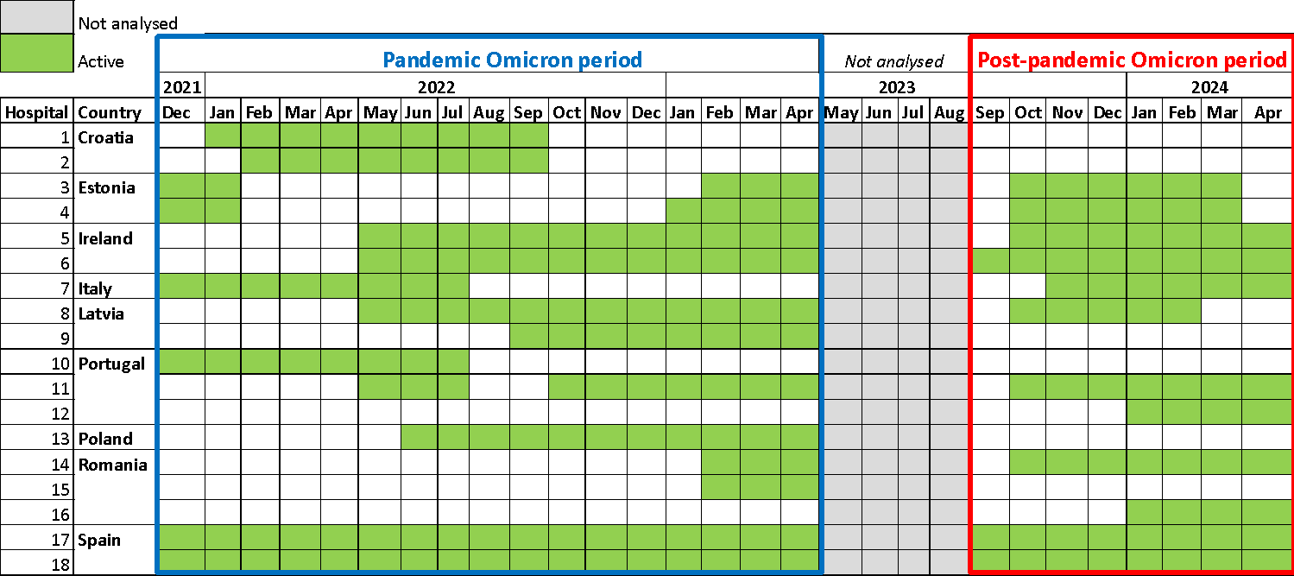
Green indicates periods of active follow-up in participating hospitals; light grey represents periods without follow-up. HCW: Healthcare workers, VEBIS: Vaccine Effectiveness Burden and Impact Studies.

Figure S2: Data inclusion flow chart for analysis pandemic Omicron period and post-pandemic Omicron period, multi–centre VEBIS HCW COVID-19 vaccine effectiveness study, 16 Dec 2021–21 May 2024
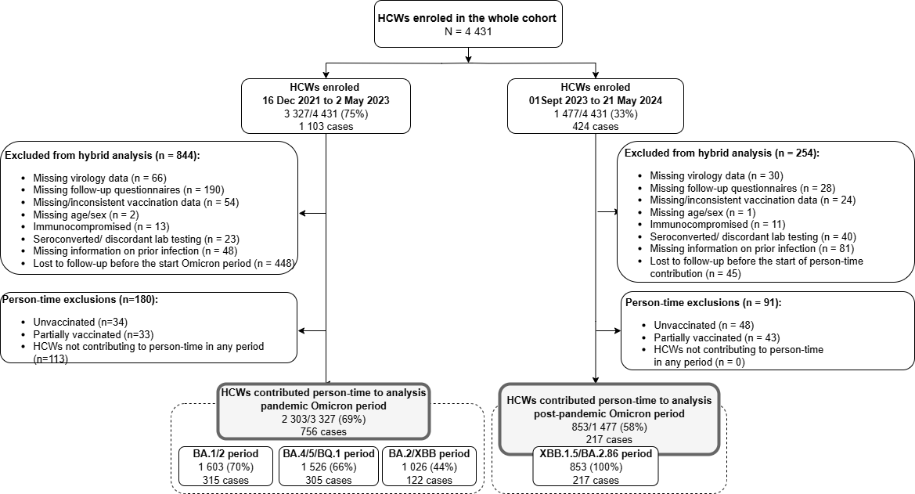As HCWs can be enrolled in one or more Omicron sub-lineage predominant circulation periods, numbers may not directly add up. HCW: Healthcare workers, VEBIS: Vaccine Effectiveness Burden and Impact Studies.
Figure S3: Proportions of SARS-CoV-2 Omicron sub-lineage in sequenced samples over time and by country in the multi-centre VEBIS HCW vaccine effectiveness study: Analysis of ERVIS data, Dec 2021-May 2024

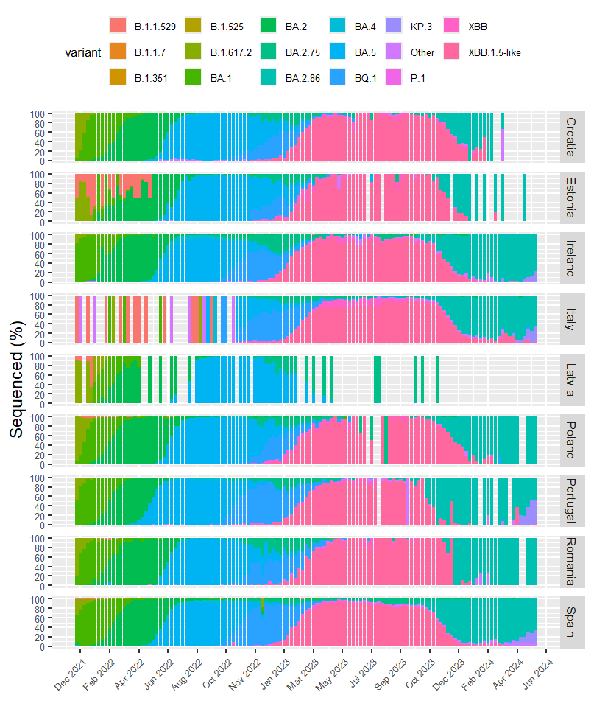
ERVISS: European Respiratory Virus Surveillance Summary, HCW: Healthcare workers, VEBIS: Vaccine Effectiveness Burden and Impact Studies

