Common variant-based genome editing to address the heterogeneity of pathogenic variants in dominant disorders

Yifan Fu^{1, 2, †}, Yangyang Duan^{1, 2, †}, Han Cao^{1, 2}, Hayley W.S. Tsang^{1, 2}, Lok-Yin Wong¹, Sunny Yik-Man Ngai^{1, 2}, Wing-Yu Fu^{1, 2}, Amy K.Y. Fu^{1–3}, and Nancy Y. Ip^{1–3, *}

¹ Division of Life Science, State Key Laboratory of Nervous System Disorders, Daniel and Mayce Yu Molecular Neuroscience Center, The Hong Kong University of Science and Technology, Hong Kong Special Administrative Region, China
² InnoHK Hong Kong Center for Neurodegenerative Diseases, Hong Kong Special Administrative Region, China
³ SIAT–HKUST Joint Laboratory for Brain Science, Shenzhen, Guangdong, China

† These authors contributed equally to this work.
* Correspondence should be addressed to:
Prof. Nancy Y. Ip
Division of Life Science, State Key Laboratory of Nervous System Disorders, Daniel and Mayce Yu Molecular Neuroscience Center, The Hong Kong University of Science and Technology, Hong Kong Special Administrative Region, China
Phone: +852-2358-6161
Fax: +852-2358-1552
E-mail: boip@ust.hk
Table of Contents
Supplementary Methods 2
Targeted long-read sequencing and allele-specific analysis 2
Supplementary Tables 3
Supplementary Table 1. Population coverage comparison of COVER across five major ancestral groups 3
Supplementary Table 2. Combined heterozygous frequency of 2–3 common variants of APP 4
Supplementary Table 3. sgRNAs tested in the surrogate EGFP reporter assay 5
Supplementary Table 4. List of patient-derived induced pluripotent stem cells used in this study 6
Supplementary Table 5. Genotypes of common variant pairs in familial Alzheimer’s disease patient-derived induced pluripotent stem cells 7
Supplementary Table 6. Summary of TELL-seq sequencing quality and haplotype phasing quality 8
Supplementary Table 7. Potential off-target sites identified by CRISPOR 9
Supplementary Table 8. Primers for detecting potential off-target editing sites in induced pluripotent stem cells 10
Supplementary Table 9. Primers for genotyping, targeted deep sequencing, RT-qPCR, and targeted long-read sequencing 11
Supplementary Table 10. PASEF m/z window and mobility range for mass spectrometry 12
Supplementary Figures 13
Supplementary Figure 1. Pathogenic variants number and their minor allele frequency in causal genes of autosomal dominant disorders 13
Supplementary Figure 2. Distribution of quantitative metrics for haplosufficiency screening across causal genes of autosomal dominant disorders 14
Supplementary Figure 3. Filtering of frameshift-mediated COVER targets 15
Supplementary Figure 4. Population coverage of COVER across major ancestral groups 16
Supplementary Figure 5. Validation of COVER population coverage estimates using the UK Biobank 17
Supplementary Figure 6. Haplotype phasing in the HVRDi002-A-1 line 19
Supplementary Figure 7. Allele-specific genome editing by haplotype 1-targeting sgRNAs in APP-V717I iPSCs 20
Supplementary Figure 8. Genome editing profiles in the genome-edited APP-V717I line 21
Supplementary Figure 9. APP processing and expression of APP-processing related genes 23
Supplementary Figure 10. Transcriptome analysis of APP-V717I-Con and NDC-Con neurons 24
Supplementary Figure 11. Proteome analysis of APP-V717I-Con and NDC-Con neurons 26
Supplementary Figure 12. Specificity and efficiency analysis of GFAP-targeting constructs 28
Supplementary Figure 13. Haplotype phasing in the GFAP-R416W line 29
Supplementary Figure 14. Off-target evaluation in the genome-edited GFAP-R416W line 30
Supplementary Figure 15. GFAP protein expression analysis upon inactivation of the mutant GFAP allele 31
Supplementary References 32

Supplementary Methods

Targeted long-read sequencing and allele-specific analysis
We adapted the PCR enrichment strategy from a previously described long-range PCR/SMRT-seq workflow with modifications¹. Briefly, we amplified the target region from 500 ng gnomic DNA using 2×KAPA HiFi polymerase (Roche) and the primers listed in Supplementary Table 9. We performed extension for 3 min and purified PCR products with 0.8× SPRI beads (Beckman Coulter) and 70% ethanol washes. We then submitted barcoded amplicons to Azenta for PacBio Revio HiFi sequencing. After sequencing, we demultiplexed HiFi BAM files using lima (v26.2.1) and converted BAM files to FASTQ format using pbtk (v3.5.0/bam2fastq).
We analyzed editing outcomes were analyzed using CRISPRLungo² with the following parameters: CRISPRlungo \ "ATATTCATGGATGGGGAGGC" \ --additional_target "TAATATCAGTCACCCATCAC" \ --minimap2_opt "-r 500,1800" \ --largeins_cutlen 500 \ --largedel_cutlen 500. To determine allele-specific editing outcomes, we assigned each read to Hap1 mutant (Mut), Hap2 wild-type, or ambiguous category based on three SNPs (i.e., rs2830026, rs2070655, and rs6516719). We defined the Mut haplotype by the presence of rs2830026-G, rs2070655-G, or rs6516719-C, and the wild-type haplotype by rs2830026-A, rs2070655-A, or rs6516719-A. We first assigned haplotypes using rs2070655. When deletions disrupted rs2070655, we inferred haplotypes from the flanking SNPs rs2830026 and rs6516719. We classified reads lacking all three SNPs or containing conflicting Mut and WT haplotype markers as ambiguous.
Next, we grouped reads into large-deletion and non-large-deletion subsets based on CRISPRLungo classifications. We analyzed reads assigned to the LargeDel category separately as large-deletion events. We defined the non-large-deletion subset as reads classified as wild-type (WT), insertion (Ins), deletion (Del), inversion (Inv), substitution (Sub), or Complex. Within each subset, we calculated the proportions of mutant, wild-type, and ambiguous reads relative to the total number of reads in that subset.

Supplementary Tables

Supplementary Table 1. Population coverage comparison of COVER across five major ancestral groups
Group1 | Group2 | N1 | N2 | Median1 (%) | Median2 (%) | P | Adjusted P | Wilcoxon_r
EUR | AMR | 902 | 904 | 0.463 | 0.441 | 5.91E-07 | 5.32E-06 | 1.18E-01
EUR | SAS | 902 | 898 | 0.463 | 0.448 | 8.95E-04 | 6.26E-03 | 7.83E-02
EUR | EAS | 902 | 893 | 0.463 | 0.448 | 2.27E-04 | 1.81E-03 | 8.70E-02
EUR | AFR | 902 | 907 | 0.463 | 0.437 | 3.90E-07 | 3.90E-06 | 1.19E-01
AMR | SAS | 904 | 898 | 0.441 | 0.448 | 5.20E-02 | 2.60E-01 | 4.58E-02
AMR | EAS | 904 | 893 | 0.441 | 0.448 | 2.54E-01 | 9.21E-01 | 2.69E-02
AMR | AFR | 904 | 907 | 0.441 | 0.437 | 8.13E-01 | 1.00E+00 | 5.55E-03
SAS | EAS | 898 | 893 | 0.448 | 0.448 | 5.23E-01 | 1.00E+00 | 1.51E-02
SAS | AFR | 898 | 907 | 0.448 | 0.437 | 3.68E-02 | 2.21E-01 | 4.91E-02
EAS | AFR | 893 | 907 | 0.448 | 0.437 | 2.30E-01 | 9.21E-01 | 2.83E-02
EUR, European; AMR, Admixed American; SAS, South Asian; EAS, East Asian; AFR, African; N1/N2, number of analyzed genes in Group 1 and Group 2, respectively. Pairwise comparisons were performed using two-sided pairwise Wilcoxon rank-sum tests. Adjusted P values were corrected for multiple testing using Holm's method.

Supplementary Table 2. Combined heterozygous frequency of 2–3 common variants of APP
Common variant pairs |  | Heterozygous frequency | Combined heterozygous frequency
Common variant 1 | Common variant 2 | Heterozygous frequency | 2 pairs | 3 pairs
rs6516719  chr21:26053007:C:T | rs2830026  chr21:26050815:C:T | 0.48 | 0.68 | 0.76
rs2248682  chr21:26089013:A:T | rs8130594  chr21:26090461:C:G | 0.38 | 0.68 | 0.76
rs2070654  chr21:26090411:A:C | rs2830046  chr21:26086390:G:A | 0.40 |  | 0.76

Supplementary Table 3. sgRNAs tested in the surrogate EGFP reporter assay
Gene | sgRNA | Sequence | PAM
Scramble | Con | GGAGACCACGGCAGGTCTCA
APP | APP_H1a_sg1 | ATATTCATGGATGGGGAGGC | TGcG
APP | APP_H1a_sg2 | GTACCCCCTGTCCCCACACA | TGCg
APP | APP_H2a_sg1 | CCCGTGTACCCCCTGTCCCCAC | ACATGCaC
APP | APP_H2a_sg2 | ATGGGGAGGCTGtGCATGTG | TGG
APP | APP_H2a_sg3 | TGGGGAGGCTGtGCATGTGT | GGG
APP | APP_H2a_sg4 | GGGGAGGCTGtGCATGTGTG | GGG
APP | APP_H2a_sg5 | GGATGGGGAGGCTGtGCATG | TGT
APP | APP_H1b_sg1 | TTAACTCTGTGATGGGTGAc | TGA
APP | APP_H1b_sg2 | TGTGATGGGTGAcTGATATT | ATTAAT
APP | APP_H1b_sg3 | ATAATATCAgTCACCCATCA | CAGAGT
APP | APP_H1b_sg4 | TAATATCAgTCACCCATCAC | AGA
APP | APP_H2b_sg1 | TTAACTCTGTGATGGGTGAt | TGA
APP | APP_H2b_sg2 | TTAAAATTAACTCTGTGATG | GGTGAt
APP | APP_H2b_sg3 | TGTGATGGGTGAtTGATATT | ATTAAT
APP | APP_H2b_sg4 | ATAATATCAaTCACCCATCA | CAGAGT
APP | APP_H2b_sg5 | TAATATCAaTCACCCATCAC | AGA
GFAP | GFAP_H1a_sg1 | AGAGAGGGTCCTCTTGcTTC | AGCGGT
GFAP | GFAP_H1a_sg2 | GCCCTGACCGCTGAAgCAAG | AGG
GFAP | GFAP_H1a_sg3 | AGAGGGTCCTCTTGcTTCAG | CGG
GFAP | GFAP_H2a_sg1 | AGAGAGGGTCCTCTTGaTTC | AGCGGT
GFAP | GFAP_H2a_sg2 | CTTCCTAGAGAGAGGGTCCT | CTTGaT
GFAP | GFAP_H2a_sg3 | AGAGGGTCCTCTTGaTTCAG | CGG
GFAP | GFAP_H2a_sg4 | GCCCTGACCGCTGAAtCAAG | AGG
GFAP | GFAP_H1b_sg1 | GAAGGGCCAGGGaCGAGGAC | CTGGGT
GFAP | GFAP_H1b_sg2 | GGGAGAAGGGCCAGGGaCGA | GGA
GFAP | GFAP_H1b_sg3 | TGCCAGGGGAGAAGGGCCAG | GGa
GFAP | GFAP_H1b_sg4 | TCGACCCAGGTCCTCGtCCC | TGG
GFAP | GFAP_H1b_sg5 | GGGGAGAAGGGCCAGGGaCG | AGG
GFAP | GFAP_H2b_sg1 | GAAGGGCCAGGGgCGAGGAC | CTGGGT
GFAP | GFAP_H2b_sg2 | GGGAGAAGGGCCAGGGgCGA | GGA
GFAP | GFAP_H2b_sg3 | TCGACCCAGGTCCTCGcCCC | TGG
GFAP | GFAP_H2b_sg4 | GCCAGGGGAGAAGGGCCAGG | GgCG
Shaded candidate sgRNAs selected with high allelic specificity. Lowercase letters indicate the common variant site on the spacer or PAM. PAM, protospacer adjacent motif.

Supplementary Table 4. List of patient-derived induced pluripotent stem cells used in this study
hPSCreg name | Sex | Age at tissue collection (years) | Provider | Genetic alteration | Disease
HVRDi001-A-1 | Male | 57 | WiCell | APP-V717I | FAD
HVRDi002-A-1 | Female | 33 | WiCell | APP-V717I | FAD
STBCi015-C | Male | 55–59 | EBiSC | APP-V717I | FAD
WISCi016-A | Male | 8 | WiCell | GFAP-R416W | Alexander disease
WISCi016-A-1 | Male | 8 | WiCell | GFAP-R416W corrected | Alexander disease
FAD, familial Alzheimer’s disease.

Supplementary Table 5. Genotypes of common variant pairs in familial Alzheimer’s disease patient-derived induced pluripotent stem cells
hPSCreg name | Common variant pair 1 |  | Common variant pair 2 |  | Common variant pair 3
hPSCreg name | rs6516719 | rs2830026 | rs2248682 | rs8130594 | rs2070654 | rs2830046
HVRDi001-A-1 | Hetero | Hetero | Homo | Homo | Homo | Homo
HVRDi002-A-1 | Hetero | Hetero | Hetero | Hetero | Homo | Homo
STBCi015-C | Hetero | Hetero | Homo | Homo | Hetero | Hetero
Hetero, heterozygous; homo, homozygous.

Supplementary Table 6. Summary of TELL-seq sequencing quality and haplotype phasing quality
hPSCreg name | DNA molecule > 20 kb | DNA molecule > 100 kb | Mean  depth | Mapping rate | % phased count | N50 | Number of reads
HVRDi002-A-1 | 88.3% | 6.8% | 44.3× | 98.28% | 98.8% | 2,638,211 | 1,090,998,994

Supplementary Table 7. Potential off-target sites identified by CRISPOR
sgRNA | # | Type | Gene | Locus | CFD score
APP_H1b_sg4 | 1 | Intergenic | AVL9|MIR550A2 | chr7_32608465 | 0.07
APP_H1b_sg4 | 2 | Exon | COL8A1 | chr3_99799046 | 0.02
GFAP_H1b_sg4 | 1 | Intron | GAD1 | chr2_170821450 | 0.31
GFAP_H1b_sg4 | 2 | Intron | CASZ1 | chr1_10782521 | 0.29
GFAP_H1b_sg4 | 3 | Intron | CYHR1 | chr8_144455627 | 0.24
GFAP_H1b_sg4 | 4 | Intergenic | ZNF236|RP11-862L9.3 | chr18_76973753 | 0.17
GFAP_H1b_sg4 | 5 | Intergenic | MAT2B|RNU6-168P | chr5_163771312 | 0.15
GFAP_H1a_sg3 | 1 | Exon | PON1 | chr7_95302203 | 0.74
GFAP_H1a_sg3 | 2 | Intergenic | SPDEF|C6orf106 | chr6_34561682 | 0.4
GFAP_H1a_sg3 | 3 | Exon | TOE1/MUTYH | chr1_45340379 | 0.37
GFAP_H1a_sg3 | 4 | Intron | RASGRF1 | chr15_79015510 | 0.35
GFAP_H1a_sg3 | 5 | Intergenic | MEGF9|FBXW2 | chr9_120736066 | 0.35
CFD, cutting frequency determination.

Supplementary Table 8. Primers for detecting potential off-target editing sites in induced pluripotent stem cells
sgRNA | # | Primer | Sequence
APP_H1b_sg4 | 1 | 1b-4_OT1F | AAAACTCACAAATCTGCCCC
APP_H1b_sg4 | 1 | 1b-4_OT1R | GCACTACGAGAAAGAAGGGG
APP_H1b_sg4 | 2 | 1b-4_OT2F | GAATCATGAAGAAGTAGAAAACCTGAGCAGAT
APP_H1b_sg4 | 2 | 1b-4_OT2R | GGTATGGCTATCAGGGTAATGCTGGACT
GFAP_H1a_sg3 | 1 | 1c-3_OT1F | CAGTAGCTGGGAATAAAGTCACT
GFAP_H1a_sg3 | 1 | 1c-3_OT1R | TGAGACAGGAGACCTTTGGG
GFAP_H1a_sg3 | 2 | 1c-3_OT2F | AGCATCTTACTCTGTGCTGC
GFAP_H1a_sg3 | 2 | 1c-3_OT2R | GTAAGCCCACAGATGGCTAC
GFAP_H1a_sg3 | 3 | 1c-3_OT3F | GAGGTAGCCTTCAAAGCCTC
GFAP_H1a_sg3 | 3 | 1c-3_OT3R | TGTAGTCTCCTCGTGGCTAG
GFAP_H1a_sg3 | 4 | 1c-3_OT4F | GAATCAGAGAGAGGACCCCA
GFAP_H1a_sg3 | 4 | 1c-3_OT4R | TTCCGGCCAAAGTCTAAAGG
GFAP_H1a_sg3 | 5 | 1c-3_OT5F | AGCAAGGACAGCTTTGTGAA
GFAP_H1a_sg3 | 5 | 1c-3_OT5R | GGAGAGGTTGTTCATGGTCC
GFAP_H1b_sg4 | 1 | 1d-4_OT1F | ACCCAAGATGTCAGAGGGAA
GFAP_H1b_sg4 | 1 | 1d-4_OT1R | AAACTGGCATGAAATGGGGT
GFAP_H1b_sg4 | 2 | 1d-4_OT2F | CTAAGAGCAGGTTGGACACG
GFAP_H1b_sg4 | 2 | 1d-4_OT2R | CGATTGGAGACTGTCTGTCC
GFAP_H1b_sg4 | 3 | 1d-4_OT3F | CAGCTCTAAACACCTCCTGG
GFAP_H1b_sg4 | 3 | 1d-4_OT3R | GCTGTTTTGCCTGTGCTAAG
GFAP_H1b_sg4 | 4 | 1d-4_OT4F | GTGCTGTGCGCTCTCAAT
GFAP_H1b_sg4 | 4 | 1d-4_OT4R | CCATGTGGTCGGTTAACTGA
GFAP_H1b_sg4 | 5 | 1d-4_OT5F | TCTGCAGAAACTCCAGAACC
GFAP_H1b_sg4 | 5 | 1d-4_OT5R | TGAGTTGTTTGGAGGGCTTT

Supplementary Table 9. Primers for genotyping, targeted deep sequencing, RT-qPCR, and targeted long-read sequencing
Primer name | Sequence | Notes
APP_DEL-F | GTCGCCAAAGAGGTACCAGC | APP-V717I deletion genotyping and  targeted long-read sequencing
APP_DEL-R | GCTCCCTAAGAAAAAGAGGCG | APP-V717I deletion genotyping and  targeted long-read sequencing
GFAP_DEL-F | CAGGGCCAGCTTGACATTGA | GFAP-R416W deletion genotyping
GFAP_DEL-R | ACCTTGCAGGCACTTACAGC | GFAP-R416W deletion genotyping
GFAP_cDNA-F | CGAGGAGAACCGGATCACCA | GFAP cDNA targeted deep sequencing
GFAP_cDNA-R | TCACATCACATCCTTGTGCTCCT | GFAP cDNA targeted deep sequencing
APP_b_GT-F | ACGGGACTAAGCTCCCTAAGA | Common variant genotyping in APP
APP_b_GT-R | CGGAGGAGGATGACTCGGAT | Common variant genotyping in APP
APP_a_GT-F | ACCAAGTGCTCGGTCAGACT | Common variant genotyping in APP
APP_a_GT-R | GTCGCCAAAGAGGTACCAGC | Common variant genotyping in APP
GFAP_a_GT-F | CTCCTTGAAGCCAGCATTGAG | Common variant genotyping in GFAP
GFAP_a_GT-R | ACAAAGGGCTGGTGTCCAAT | Common variant genotyping in GFAP
GFAP_b_GT-F | AGCACGAAGCCAACGACTAC | Common variant genotyping in GFAP
GFAP_b_GT-R | CAGGGCCAGCTTGACATTGA | Common variant genotyping in GFAP
GAPDH-F | GCACCGTCAAGGCTGAGAAC | qPCR validation primer
GAPDH-R | AGGGATCTCGCTCCTGGAA | qPCR validation primer
HDAC6-F | GCCTCAATCACTGAGACCATCC | qPCR validation primer
HDAC6-R | GGTGCCTTCTTGGTGACCAACT | qPCR validation primer

Supplementary Table 10. PASEF m/z window and mobility range for mass spectrometry
#MS Type | Cycle ID | Start IM [1/K0] | End IM [1/K0] | Start mass [m/z] | End mass [m/z] | CE [eV]
MS1 | 0 | - | - | - | - | -
PASEF | 1 | 1.0465 | 1.1981 | 875 | 900 | -
PASEF | 1 | 0.893 | 1.0446 | 675 | 700 | -
PASEF | 1 | 0.85 | 0.8911 | 475 | 500 | -
PASEF | 2 | 1.0657 | 1.2173 | 900 | 925 | -
PASEF | 2 | 0.9122 | 1.0638 | 700 | 725 | -
PASEF | 2 | 0.85 | 0.9103 | 500 | 525 | -
PASEF | 3 | 1.0849 | 1.2365 | 925 | 950 | -
PASEF | 3 | 0.9314 | 1.083 | 725 | 750 | -
PASEF | 3 | 0.85 | 0.9295 | 525 | 550 | -
PASEF | 4 | 1.1041 | 1.2557 | 950 | 975 | -
PASEF | 4 | 0.9506 | 1.1022 | 750 | 775 | -
PASEF | 4 | 0.85 | 0.9487 | 550 | 575 | -
PASEF | 5 | 1.1233 | 1.2749 | 975 | 1,000 | -
PASEF | 5 | 0.9698 | 1.1214 | 775 | 800 | -
PASEF | 5 | 0.85 | 0.9679 | 575 | 600 | -
PASEF | 6 | 0.989 | 1.1406 | 800 | 825 | -
PASEF | 6 | 0.85 | 0.9871 | 600 | 625 | -
PASEF | 7 | 1.0082 | 1.1598 | 825 | 850 | -
PASEF | 7 | 0.8547 | 1.0063 | 625 | 650 | -
PASEF | 8 | 1.0273 | 1.179 | 850 | 875 | -
PASEF | 8 | 0.8738 | 1.0255 | 650 | 675 | -
CE, collision energy; IM, ion mobility

Supplementary Figures
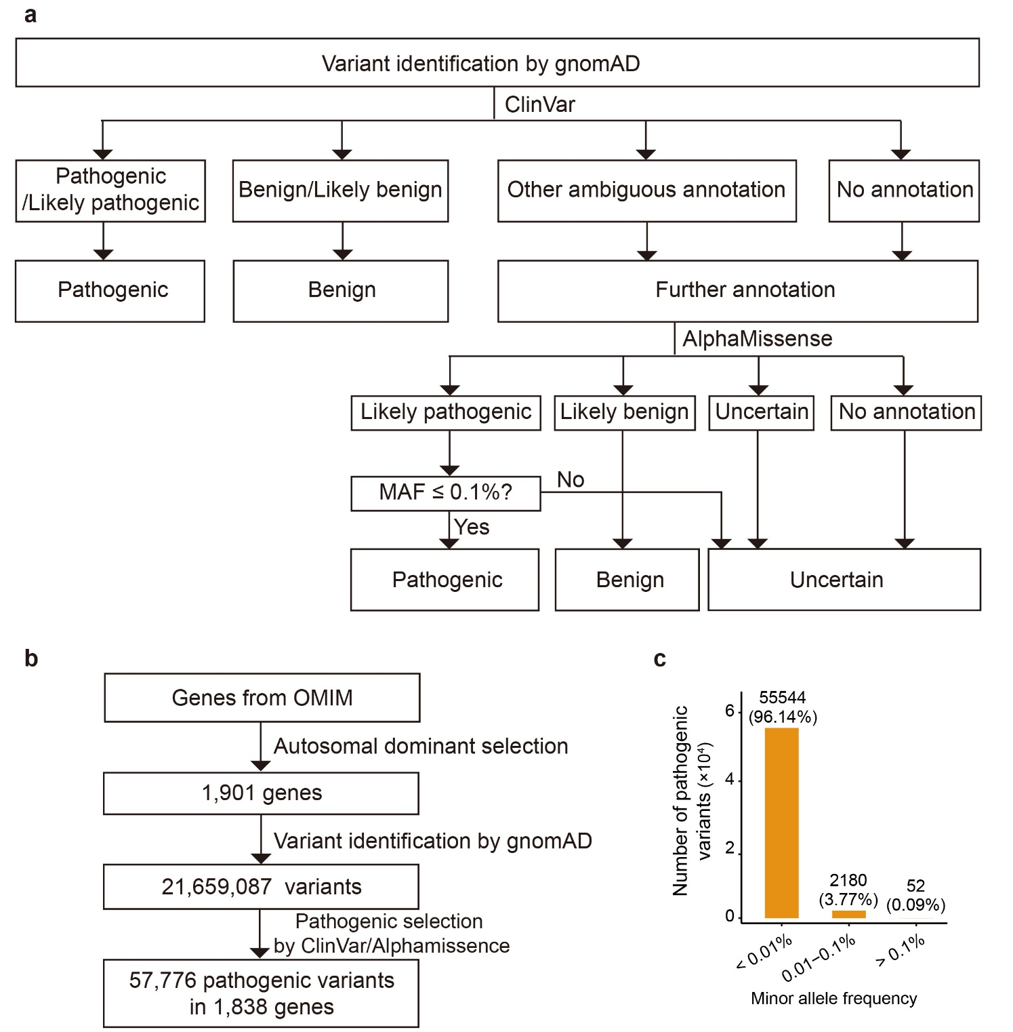

Supplementary Figure 1. Pathogenic variants number and their minor allele frequency in causal genes of autosomal dominant disorders
(a) Workflow for classifying gnomAD variants within autosomal dominant disorder genes using ClinVar and AlphaMissense annotations. (b) Summary of gene and variant selection. Genes annotated in OMIM as causal for autosomal dominant disorders were used to define genomic search intervals, from which gnomAD variants were retrieved and classified. (c) Minor allele frequencies of the pathogenic variants within the 1,838 causal genes of autosomal dominant disorders.
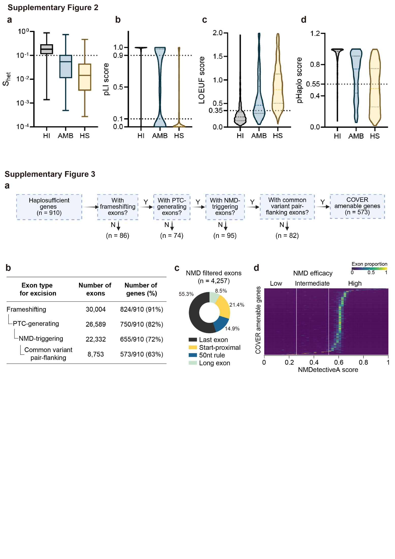

Supplementary Figure 2. Distribution of quantitative metrics for haplosufficiency screening across causal genes of autosomal dominant disorders
(a–d) Distribution of four gene constraint or predictive metrics among genes classified as haploinsufficient (HI), ambiguous (AMB), and haplosufficient (HS). Dashed lines indicate the respective thresholds utilized for filtering candidate genes suitable for the COVER strategy. The gene constraint or predictive metrics include: (a) S_{het} scores (selection coefficient for heterozygous loss-of-function variants), (b) pLI (probability of loss-of-function intolerance) scores, (c) LOEUF (loss-of-function observed by expected upper bound fraction) scores, and (d) pHaplo (probability of haploinsufficiency) scores.

Supplementary Figure 3. Filtering of frameshift-mediated COVER targets
(a) Sequential filtering workflow for identifying frameshift-mediated COVER-amenable genes from the haplosufficient gene set. (b) Number of exons and genes retained after each filtering step. (c) Exon targets removed by the NMD filter, stratified by the corresponding exclusion criterion, including last exons, start-proximal exons, premature termination codons located within 50 bp of the final exon–exon junction and long-exon contexts. (d) Distribution of NMDetectiveA scores for retained common-variant-pair-flanked exon targets across 573 COVER-amenable genes. Predicted NMD efficacy is classified into low (< 0.25), intermediate (0.25 – 0.55), and high (> 0.55).

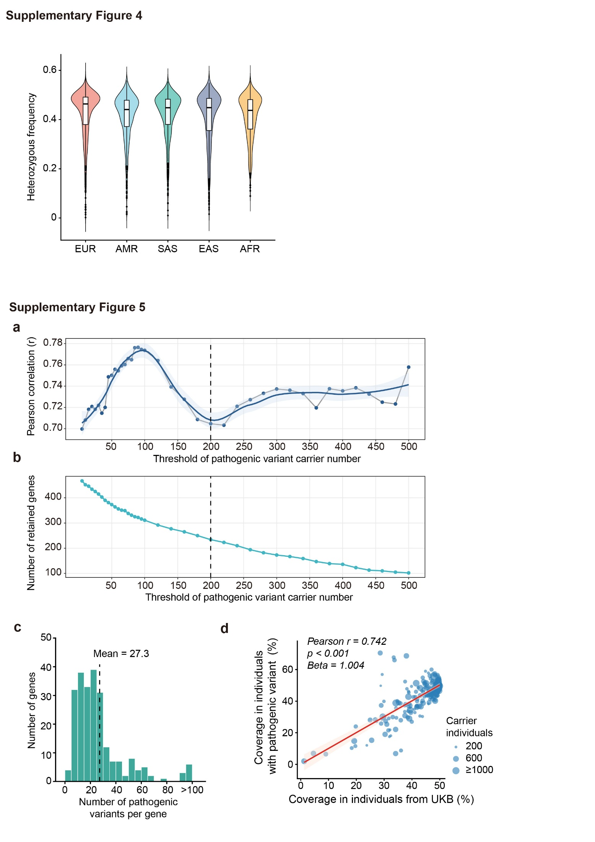

Supplementary Figure 4. Population coverage of COVER across major ancestral groups
Violin plots show the distribution of gene-level coverage estimates for the COVER strategy across five major ancestral populations represented in the 1000 Genomes Project: European (EUR), Admixed American (AMR), South Asian (SAS), East Asian (EAS), and African (AFR). Center lines indicate medians, and box boundaries denote the interquartile range. Statistical significance was assessed using two-sided pairwise Wilcoxon rank-sum tests with Holm’s method for multiple-testing adjustment. Effect sizes (r) and adjusted P values are provided in Supplementary Table 1.

Supplementary Figure 5. Validation of COVER population coverage estimates using the UK Biobank
(a, b) Selection of the minimum pathogenic variant carrier threshold used for gene selection from the UK Biobank cohort. (a) Pearson correlation coefficients between COVER coverage estimates derived from UK Biobank pathogenic variant carriers and coverage estimates from the 1000 Genomes Project European population were calculated across a range of carrier-number thresholds. The dashed line indicates the selected threshold of 200 carriers. (b) Number of genes retained for coverage analysis at different pathogenic variant carrier-number thresholds in the UK Biobank cohort. Increasing the minimum carrier threshold reduced the number of genes eligible for downstream analysis. The dashed line indicates the selected threshold of 200 carriers. (c) Distribution of pathogenic-variant counts per gene across 234 autosomal dominant disease genes represented in UK Biobank pathogenic-variant carriers. The dashed line indicates the mean number of pathogenic variants per gene. (d) Correlation between COVER coverage estimated in the overall UK Biobank population and COVER coverage estimated among UK Biobank individuals carrying candidate pathogenic variants (n = 234, Beta = 1.004, Pearson r = 0.742, p < 0.0001; simple linear regression).
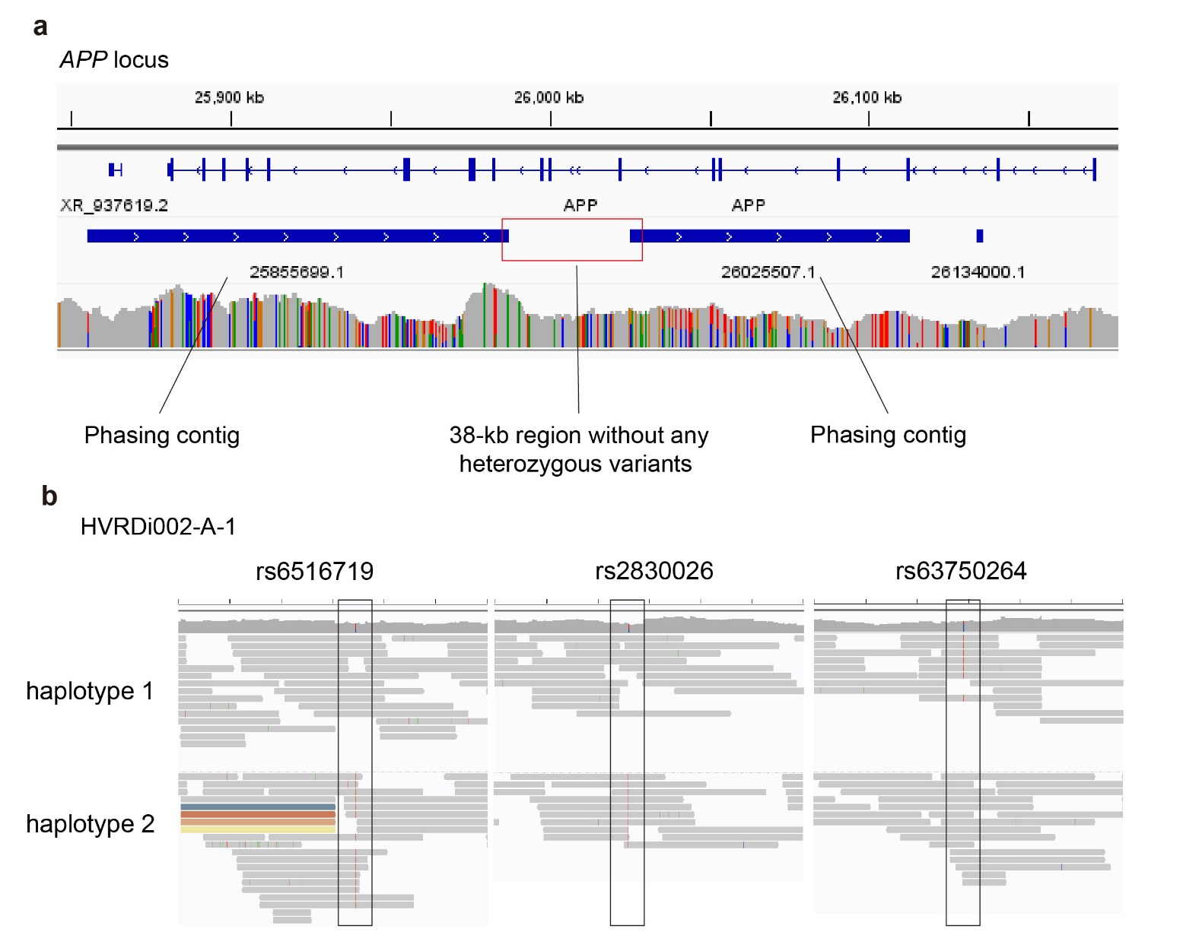

Supplementary Figure 6. Haplotype phasing in the HVRDi002-A-1 line
(a) IGV (Integrative Genomics Viewer) view of haplotype phasing results by PacBio HiFi showing a 38-kb region without any heterozygous variants or breaking phasing contigs. (b) IGV view of haplotype phasing results by TELL-seq for rs6516719, rs2830026, and the APP-V717I mutation in the HVRDi002-A-1 line.
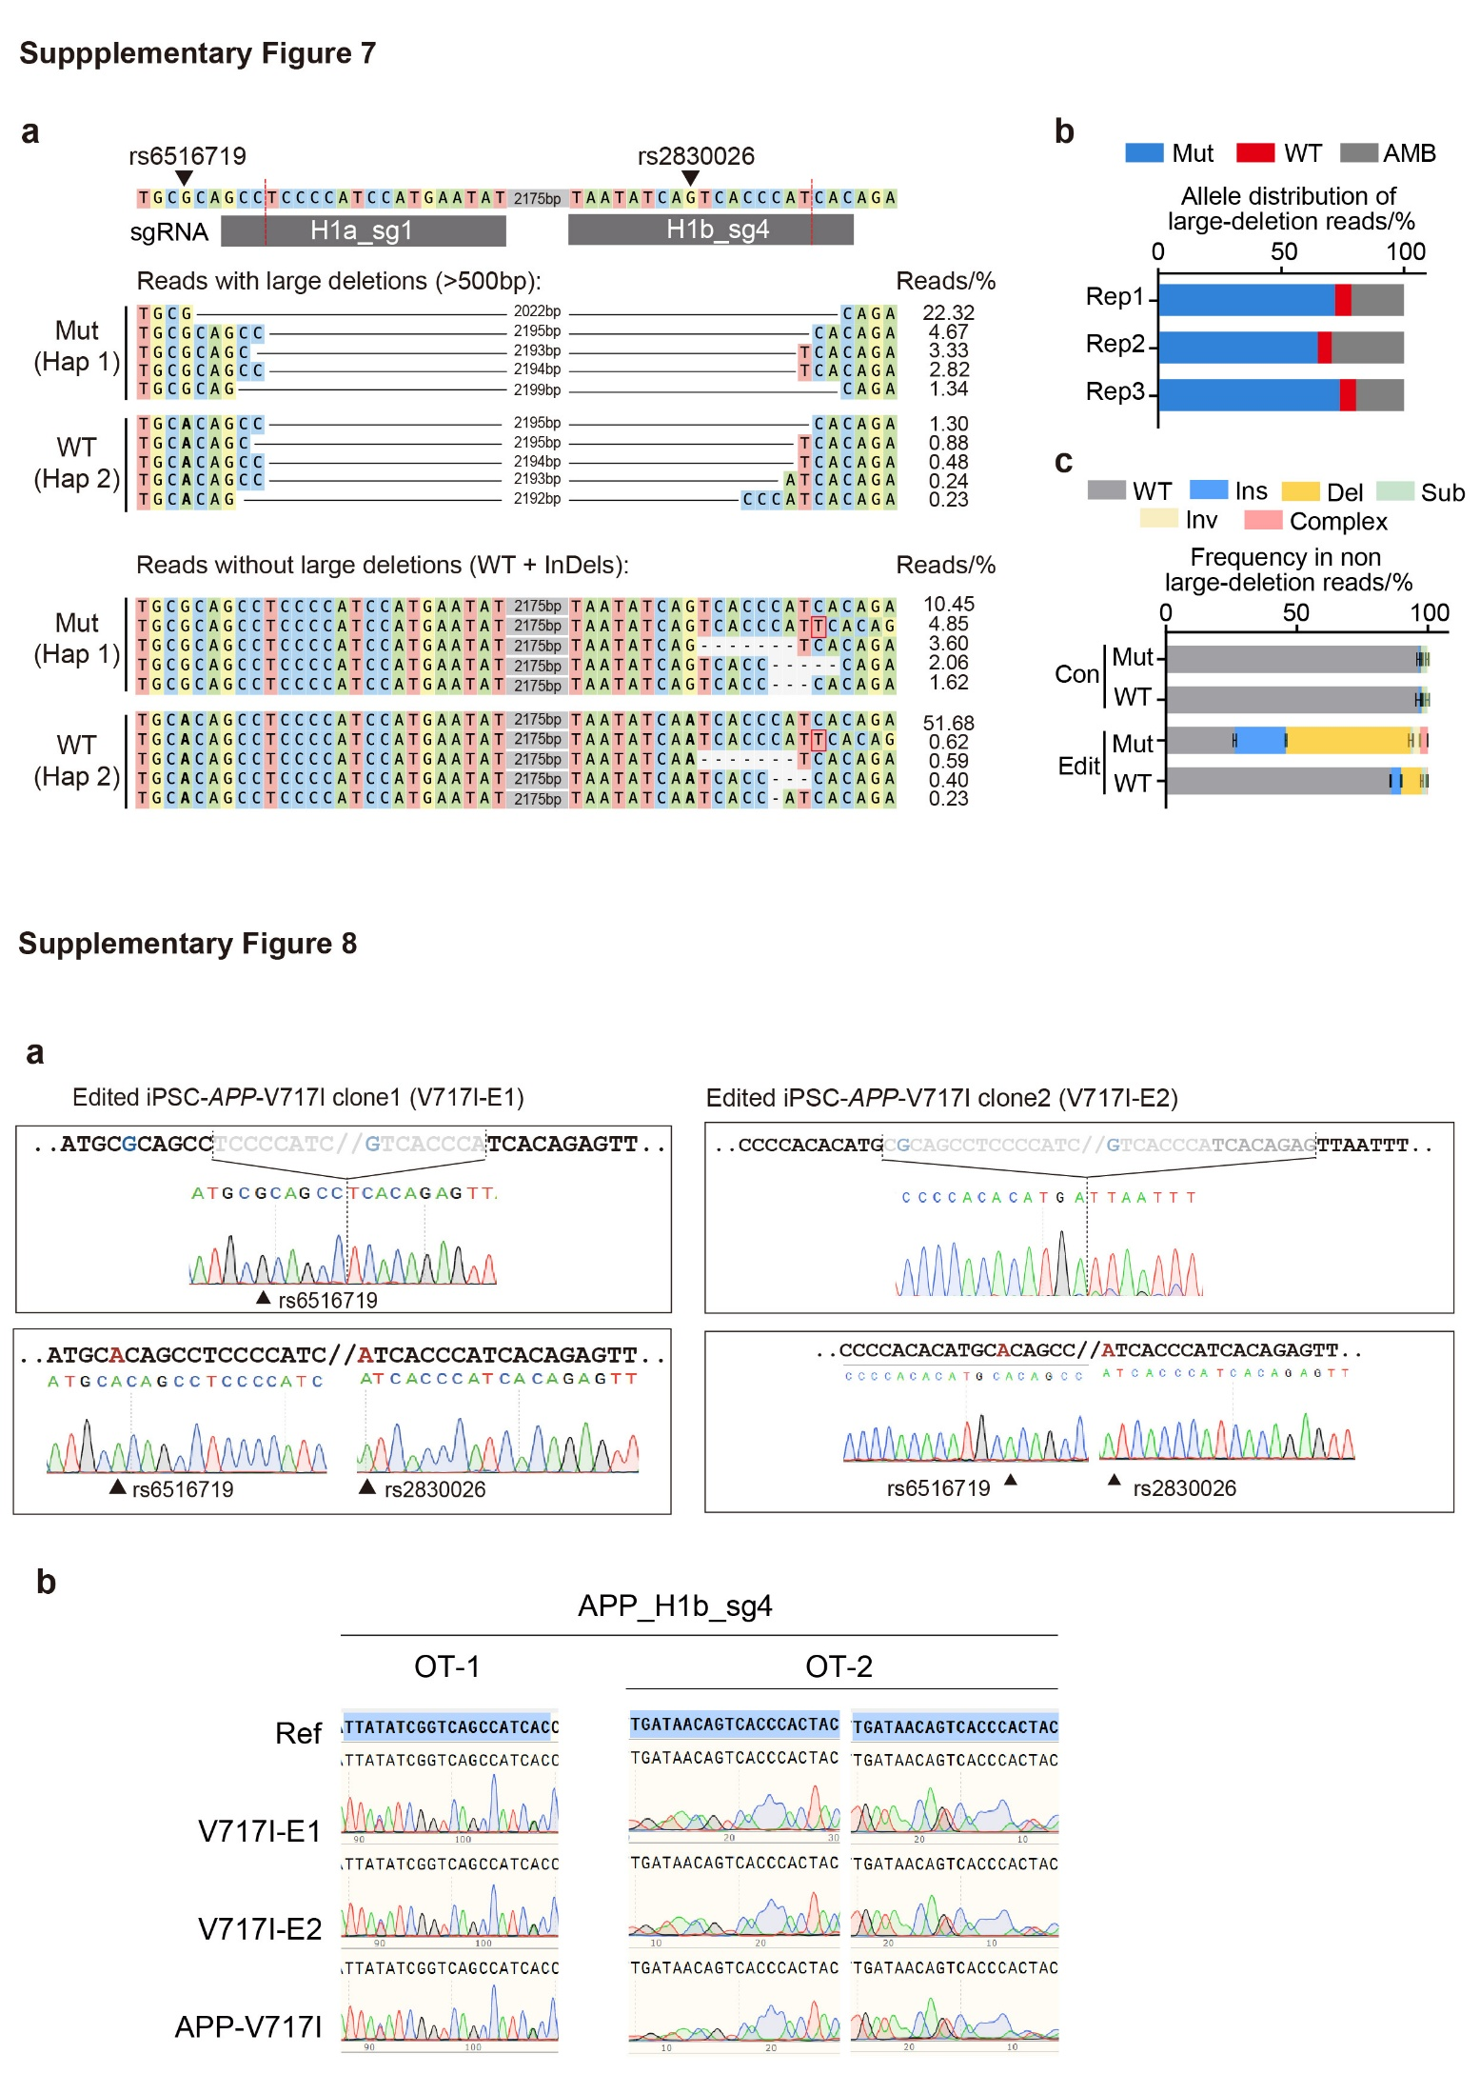

Supplementary Figure 7. Allele-specific genome editing by haplotype 1-targeting sgRNAs in APP-V717I iPSCs
(a) Representative targeted long-read sequencing alignments of the edited APP locus in genome-edited iPSCs. Reads carrying large deletions (>500 bp) and reads without large deletions are shown separately. Mut, mutant Hap1 allele; WT, wild-type Hap2 allele; AMB, ambiguously assigned reads. (b) Allelic distribution of large-deletion reads (>500 bp) identified by targeted long-read sequencing across three biological replicates. (c) Distribution of editing outcomes among reads without large deletions in control and edited iPSC populations. Editing outcomes were classified as insertions (Ins), deletions (Del), substitutions (Sub), inversions (Inv), complex editing events (Complex), or unmodified reads (WT).

Supplementary Figure 8. Genome editing profiles in the genome-edited APP-V717I line
(a) Sanger sequencing results of the allelic genome editing profile of the genome-edited APP-V717I clones (V717I-E1 and V717I-E2). (b) Sanger sequencing results of the predicted off-target sites in 2 genome-edited APP-V717I lines (i.e., V717I-E1 and V717I-E2) and the unedited APP-V717I line.
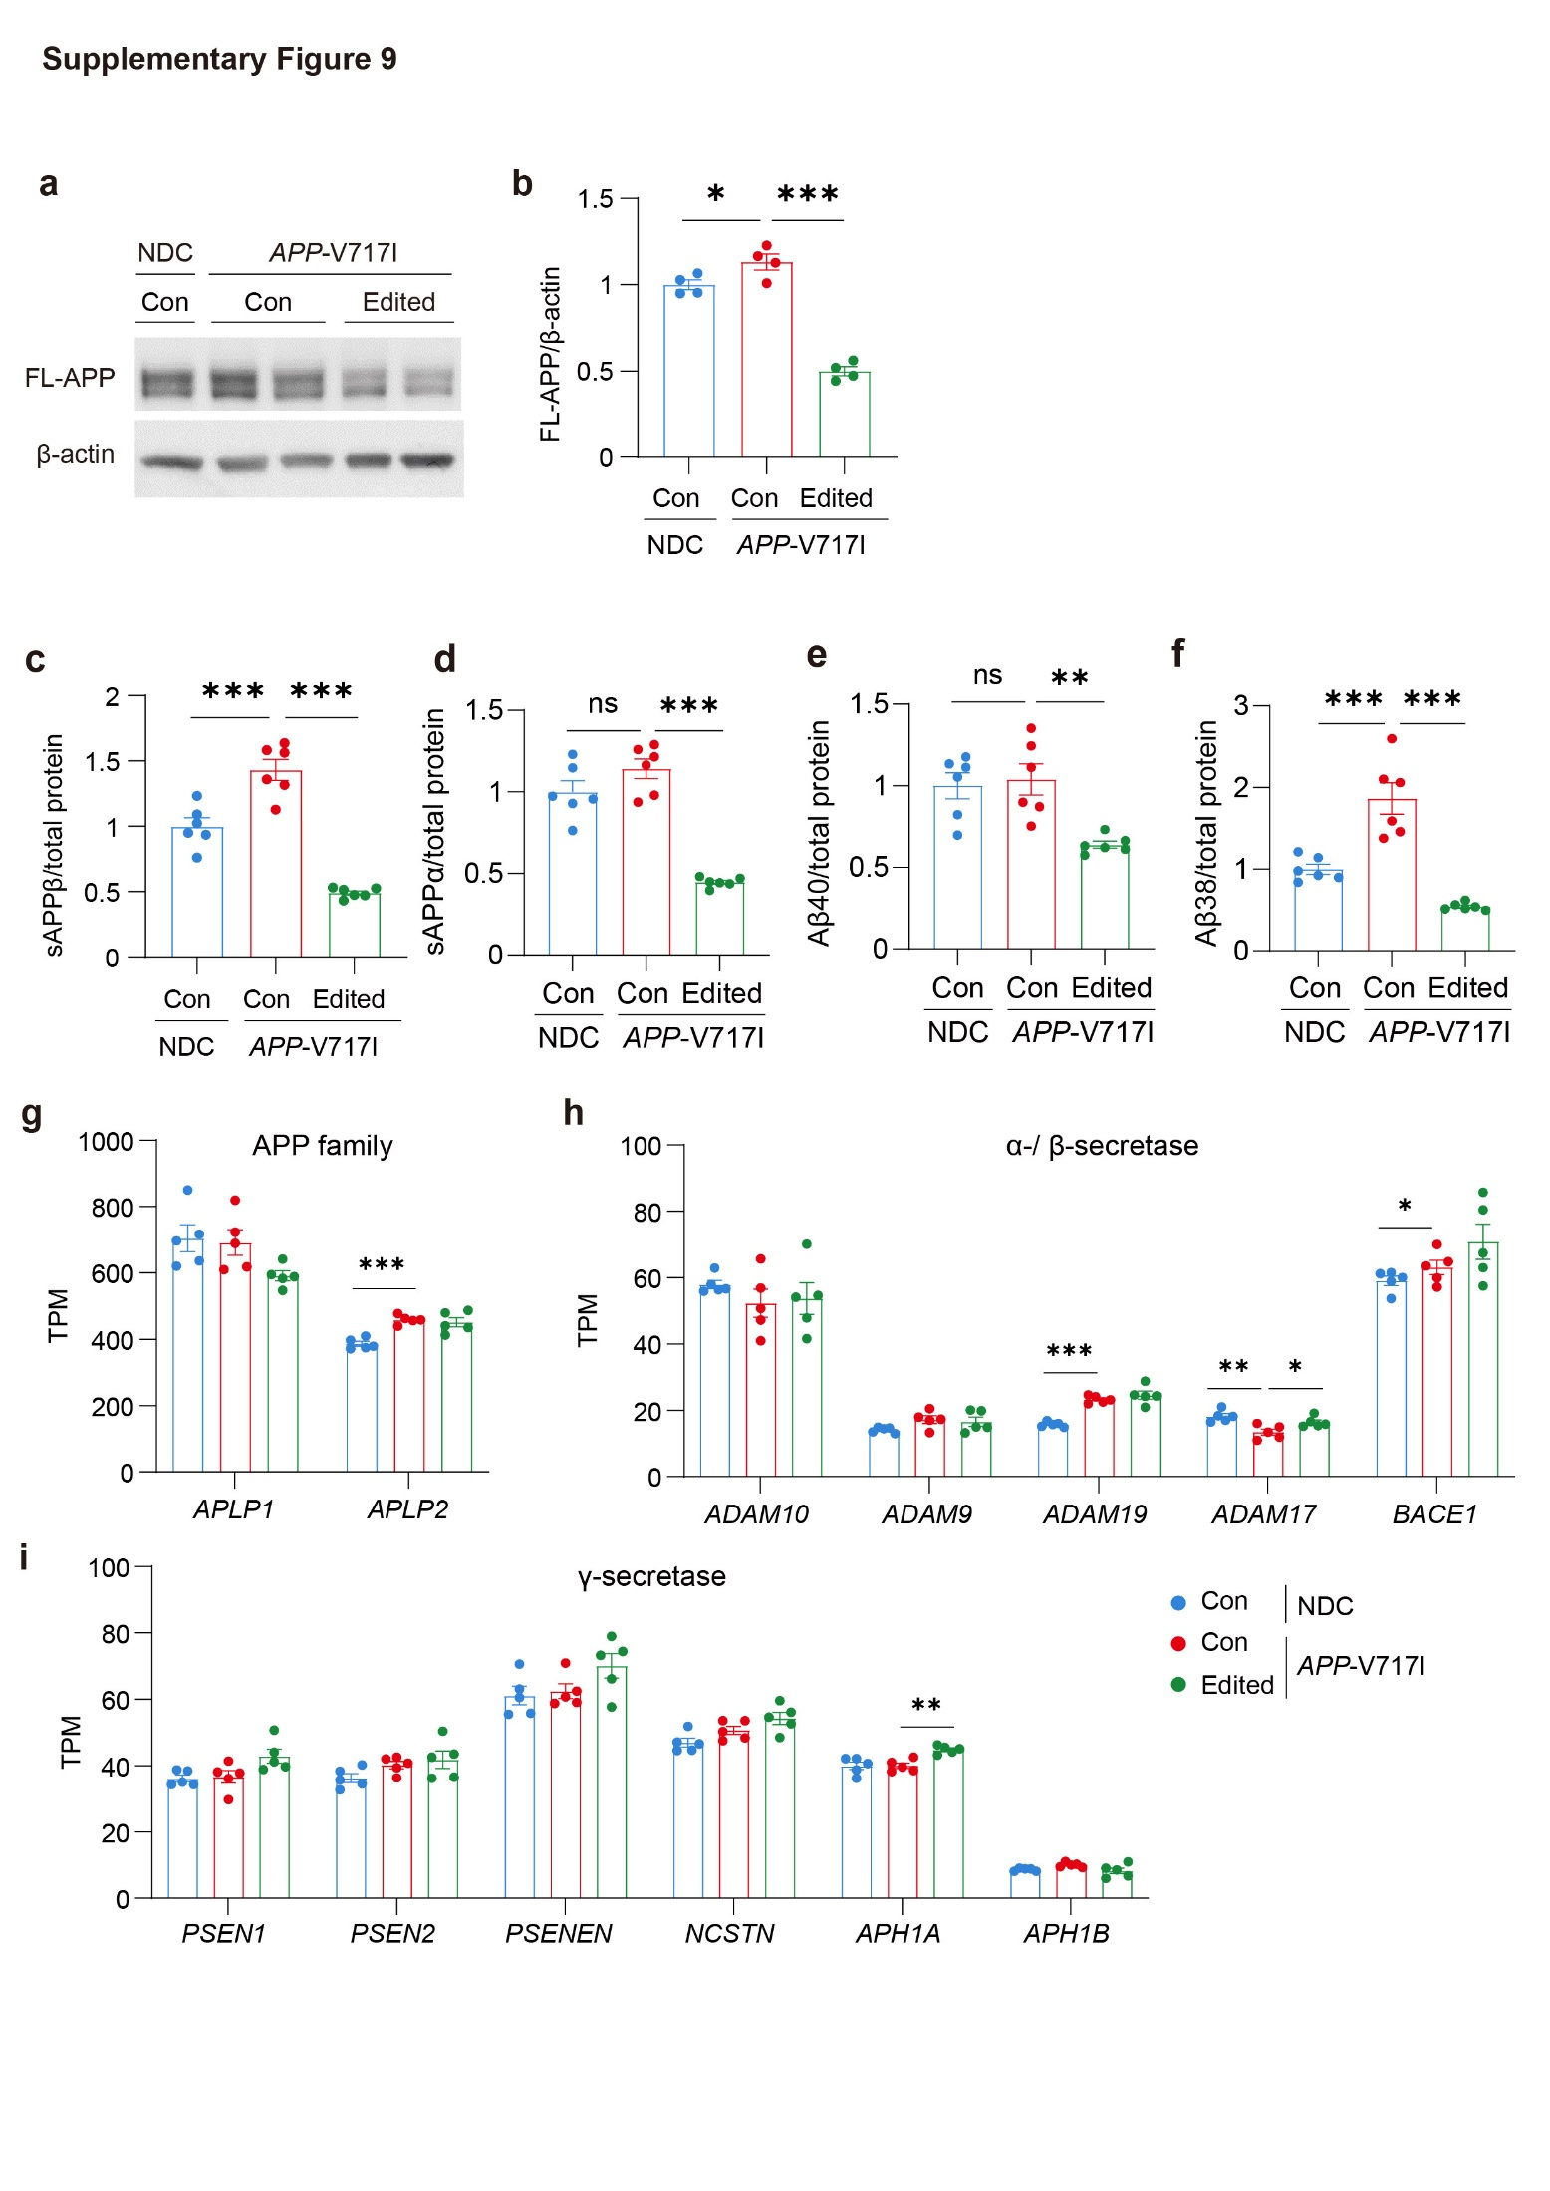

Supplementary Figure 9. APP processing and expression of APP-processing related genes
(a, b) Western blot analysis (a) and corresponding quantification (b) of full-length APP (FL-APP) protein expression level normalized to β-actin. Values are mean ± SEM (n = 4 independent biological replicates per condition; ***p < 0.001 vs. APP-V717I-Con neurons, one-way ANOVA followed by Dunnett’s multiple comparisons test). (c, d) Extracellular secretion levels of sAPPβ (c) and sAPPα (d) in conditioned media normalized to total protein content. Values are mean ± SEM (n = 6 independent biological replicates per condition; *p < 0.05, **p < 0.01, and ***p < 0.001 vs. APP-V717I-Con neurons, one-way ANOVA followed by Dunnett’s multiple comparisons test). (e, f) amyloid-beta 40 (Aβ40) and Aβ38 ratio in conditioned media normalized to total protein. Values are mean ± SEM (n = 6 independent biological replicates per condition; *p < 0.05, **p < 0.01, and ***p < 0.001 vs. APP-V717I-Con neurons, one-way ANOVA followed by Dunnett’s multiple comparisons test). (g–i) Transcriptional profiling (transcripts per million, TPM) determined by RNA-seq for genes belonging to the APP family (i.e., APLP1 and APLP2) (g), α- and β-secretases (i.e., ADAM10, ADAM9, ADAM19, ADAM17, and BACE1) (h), and components of the γ-secretase complex (PSEN1, PSEN2, PSENEN, NCSTN, APH1A, and APH1B) (i). Values are mean ± SEM (n = 5 independent biological replicates per condition; *p < 0.05, **p < 0.01, and ***p < 0.001 vs. APP-V717I-Con neurons, one-way ANOVA followed by Dunnett’s multiple comparisons test).

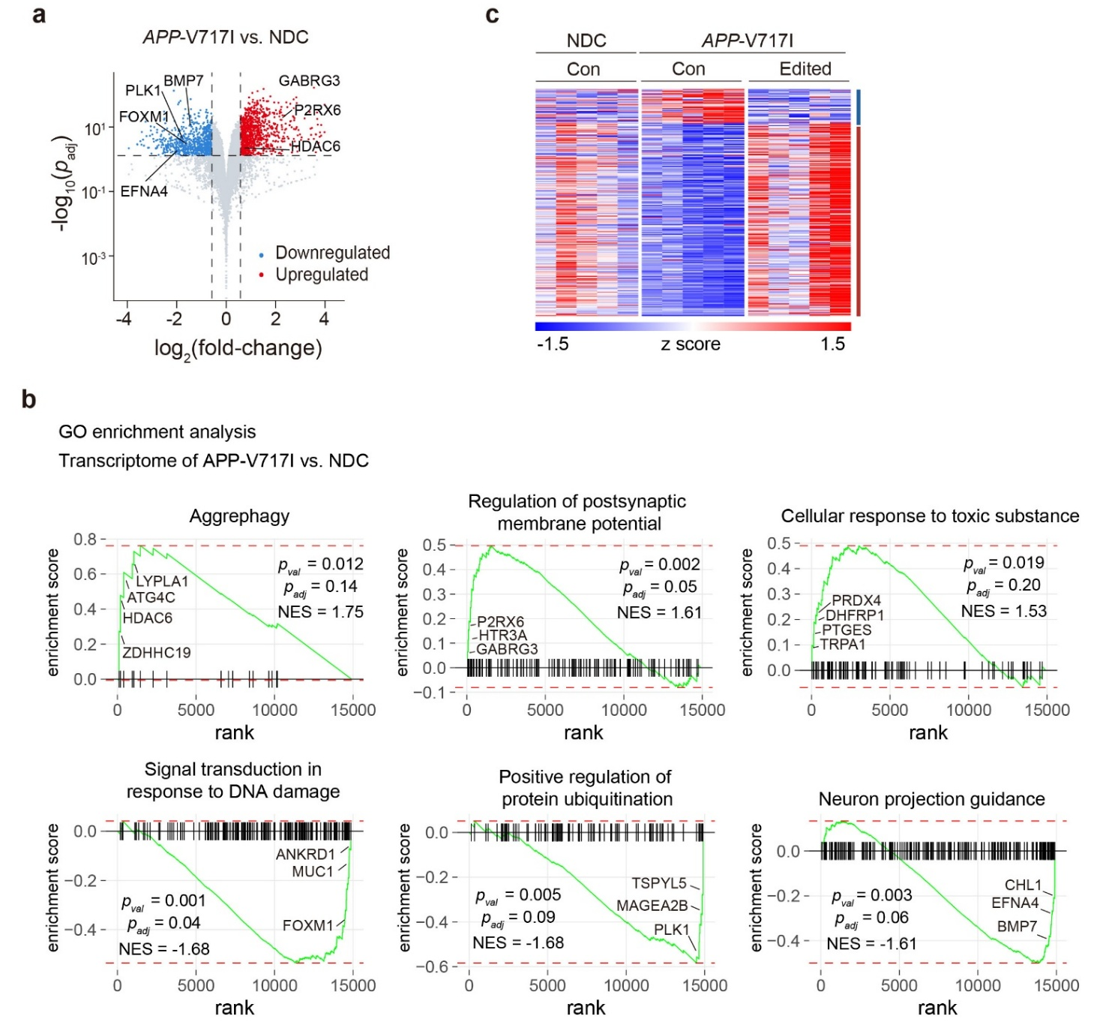

Supplementary Figure 10. Transcriptome analysis of APP-V717I-Con and NDC-Con neurons
(a) Volcano plot showing the differentially expressed genes in APP-V717I-Con neurons versus NDC-Con neurons (953 upregulated genes, 817 downregulated genes; n = 5 independent biological replicates per condition; Benjamini–Hochberg adjusted p < 0.05; fold-change >1.5 or <−1.5). NDC, nondemented control. (b) Representative Gene Ontology (GO) terms enriched by gene set enrichment analysis (GSEA) of transcriptomic profiles in the APP-V717I-Con versus NDC-Con neurons. (c) Expression profiles of the 723 differentially expressed genes in NDC-Con, APP-V717I-Con, and APP-V717I-Edited and neurons (n = 5 independent biological replicates per condition). These genes were selected based on differential expression gene analysis comparing APP-V717I-Edited versus APP-V717I-Con neurons.

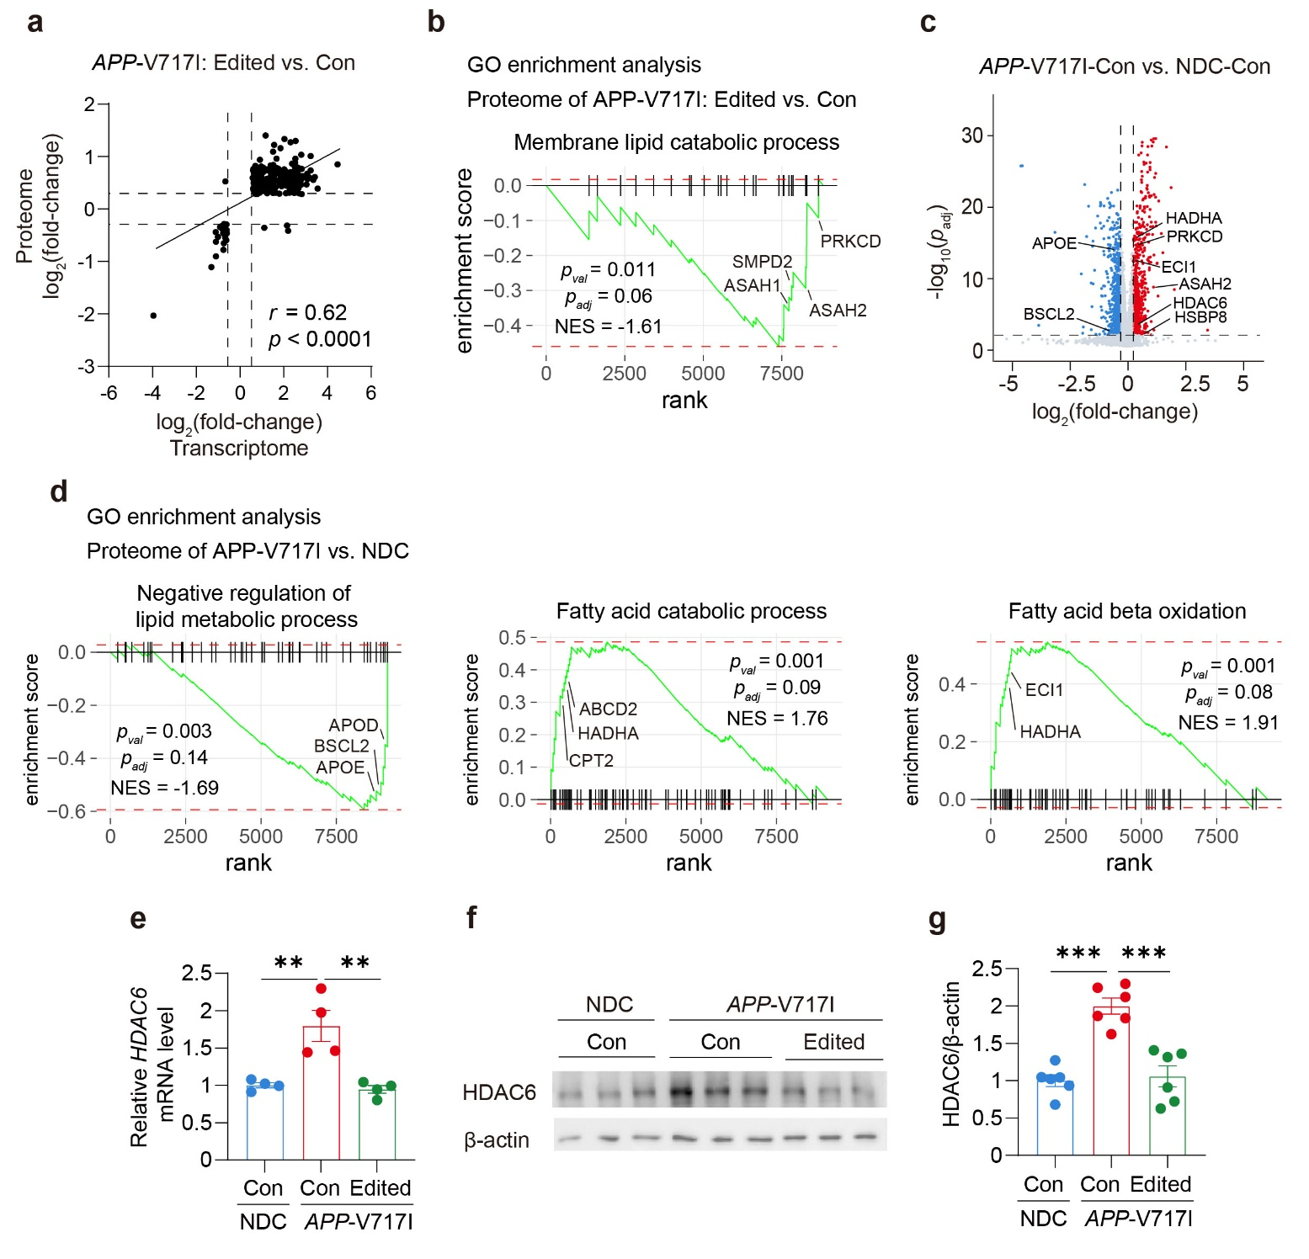

Supplementary Figure 11. Proteome analysis of APP-V717I-Con and NDC-Con neurons
(a) Correlation of the differentially expressed genes (DEGs) and differentially expressed proteins (DEPs) in the APP-V717I-Edited versus APP-V717I-Con neurons (r = 0.62, p < 0.0001; simple linear regression analysis). (b) GSEA of proteomic profiles identified lipid-related pathway in APP-V717I-Edited versus APP-V717I-Con neurons. (c) Volcano plot showing the differentially expressed proteins (DEPs) in APP-V717I-Con neurons versus NDC-Con neurons (602 upregulated proteins, 761 downregulated proteins; n = 12 independent biological replicates per condition; adjusted p < 0.05; fold-change >1.2 or <−1.2). NDC, nondemented control. (d) GSEA of proteomic profiles identified lipid-related pathway in APP-V717I-Con versus NDC-Con neurons. (e) RT-qPCR validation of the differentially expressed genes observed in RNA-seq (n = 4 independent biological replicates per condition; *p < 0.05, **p < 0.01, one-way ANOVA followed by Dunnett’s multiple comparisons test). (f, g) Western blot analysis and quantification of the cellular oxidative stress-associated protein, HDAC6 (n = 6 independent biological replicates per condition; ***p < 0.001, one-way ANOVA followed by Dunnett’s multiple comparisons test).

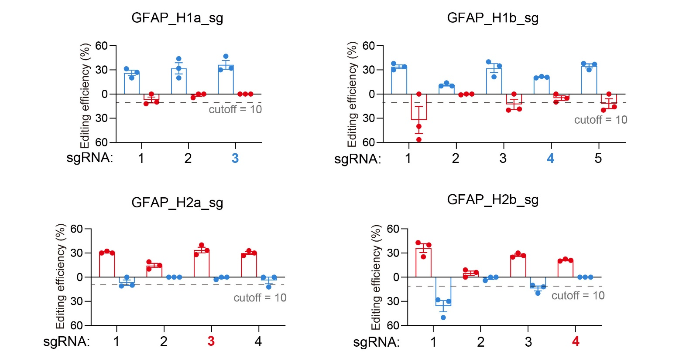

Supplementary Figure 12. Specificity and efficiency analysis of GFAP-targeting constructs
Specificity and efficiency analysis of GFAP-targeting constructs by EGFP reporter assay. The sgRNAs for each site are annotated according to their 5′ protospacer adjacent motif location. Each sgRNA was tested with Hap1 and Hap2 target DNA sequences. Editing efficiencies are quantified as the percentage of EGFP-positive cells. Values are mean ± SEM (n = 3 independent biological replicates).

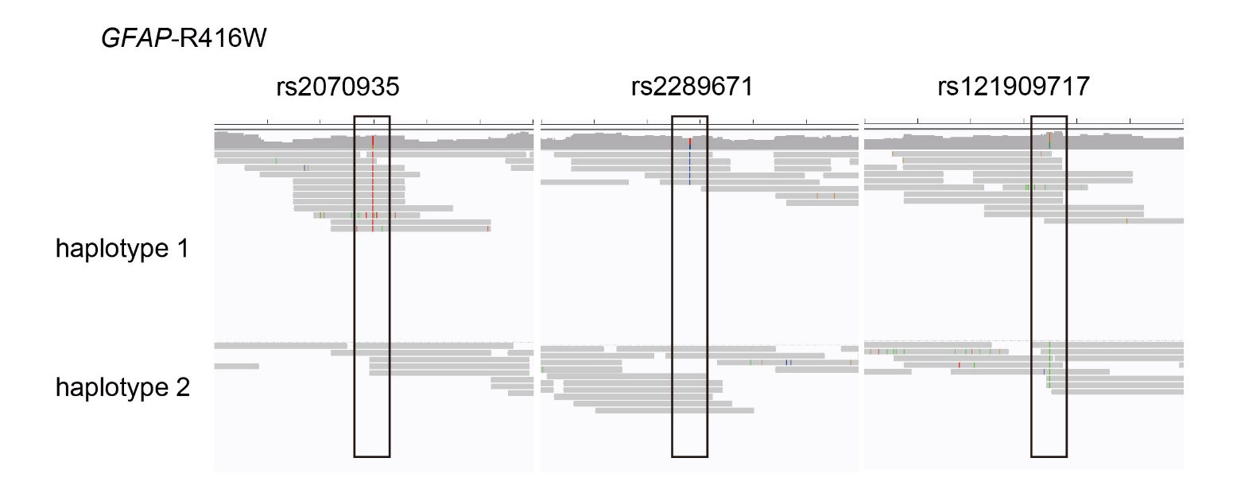

Supplementary Figure 13. Haplotype phasing in the GFAP-R416W line
IGV (Integrative Genomics Viewer) view of haplotype phasing results by PacBio HiFi long-read sequencing for the GFAP-R416W line.

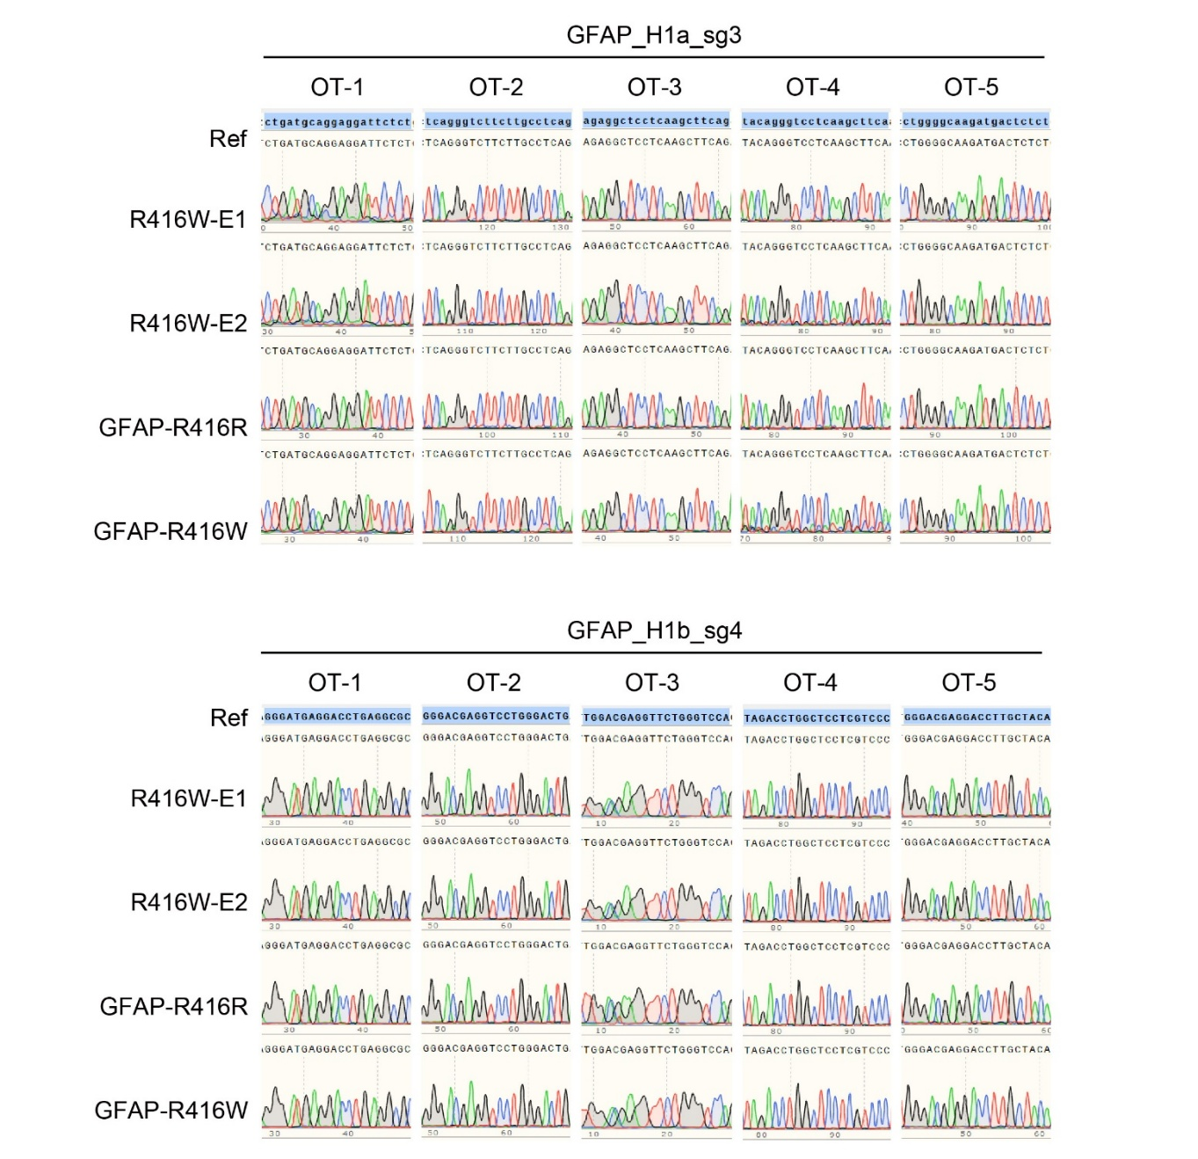

Supplementary Figure 14. Off-target evaluation in the genome-edited GFAP-R416W line
Sanger sequencing results of the predicted off-target sites in two genome-edited GFAP-R416W lines, the GFAP-R416W line, and the GFAP-R416R line.

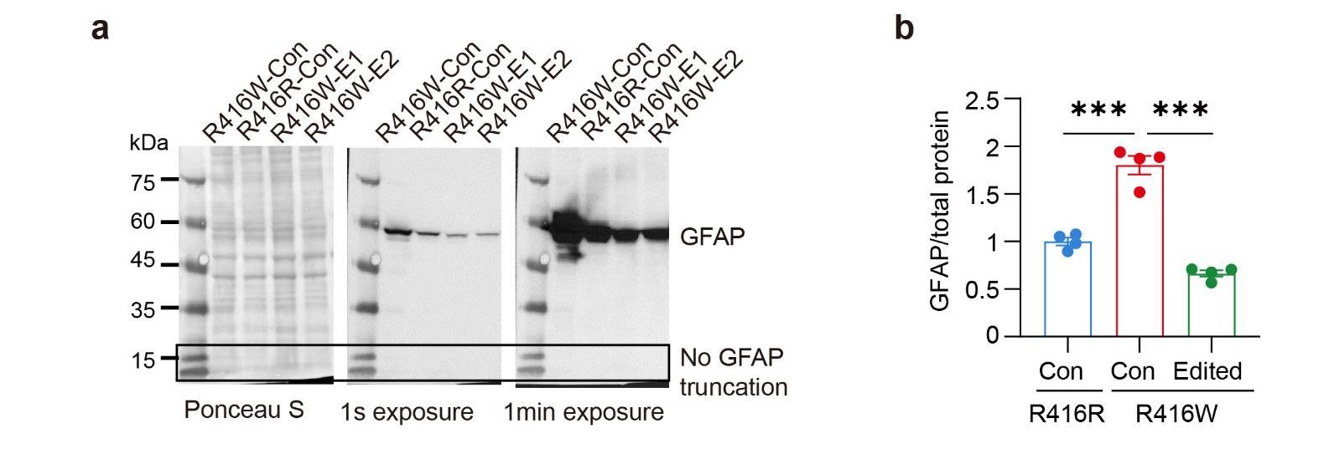

Supplementary Figure 15. GFAP protein expression analysis upon inactivation of the mutant GFAP allele
(a, b) Western blot analysis and quantification of GFAP protein expression upon inactivation of the mutant GFAP allele. The predicted truncated GFAP protein (~15 kDa) is indicated by the dashed rectangle at the bottom. Values are mean ± SEM (n = 4 independent biological replicates per condition; ***p < 0.001 vs. GFAP-R416R-Con neurons, one-way ANOVA followed by Dunnett’s multiple comparisons test).

Supplementary References
1. Park, S. H. et al. Comprehensive analysis and accurate quantification of unintended large gene modifications induced by CRISPR-Cas9 gene editing. Science Advances 8, eabo7676 (2022).
2. Hwang, G.-H. et al. Analyzing long-read CRISPR experiments with CRISPRLungo. 2025.10.21.683786 Preprint at https://doi.org/10.1101/2025.10.21.683786 (2025).

