Supplementary Information

Supplemental Table 1. Band description of S2
Band no. | Band name | wavelength (nm )
1 | Coastal aerosol | 443 nm
2 | Blue | 490 nm
3 | Green | 560 nm
4 | Red | 665 nm
5 | Vegetation red edge | 705 nm
6 | Vegetation red edge | 740 nm
7 | Vegetation red edge | 783 nm
8 | NIR | 842 nm
8a | Narrow NIR | 865 nm
9 | Water vapour | 940 nm
10 | SWIR – Cirrus | 1375 nm
11 | SWIR 1 | 1610 nm
12 | SWIR 2 | 2190 nm
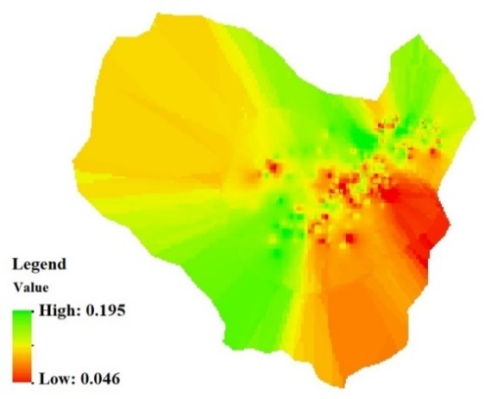 | 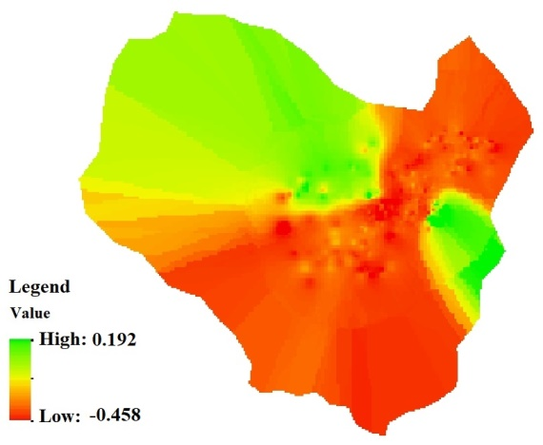 | 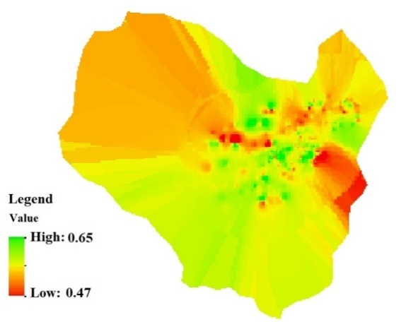
(a) | (b) | (c)
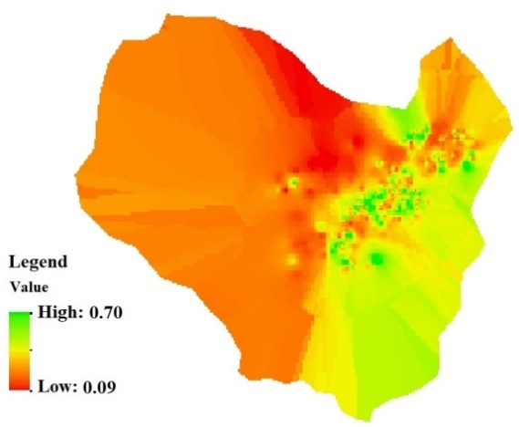 | 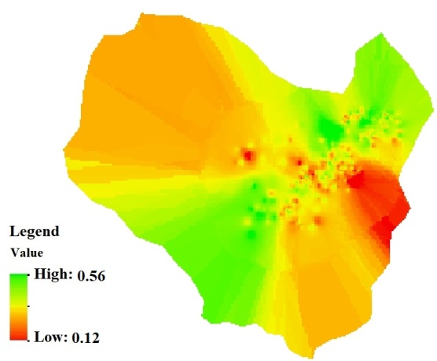 | 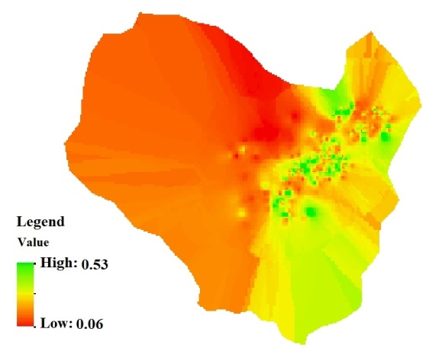
(d) | (e) | (f)
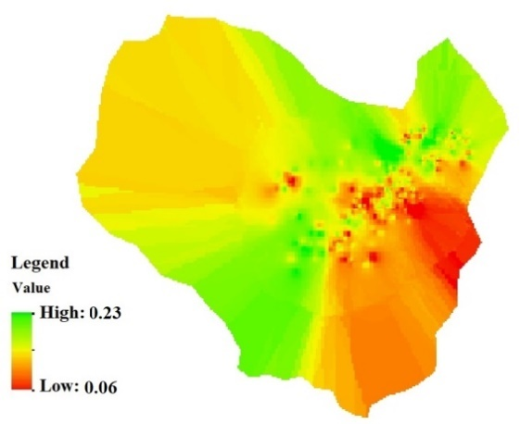 | 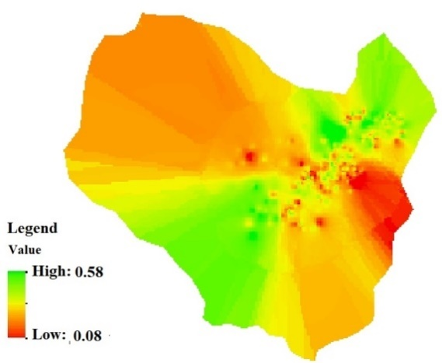 | 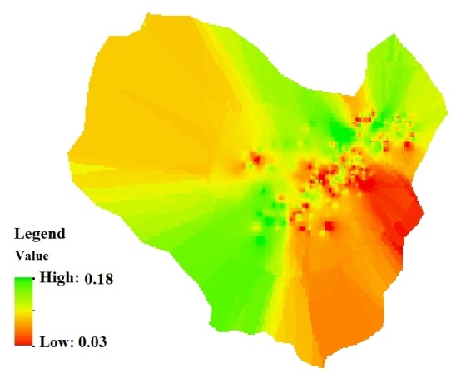
(g) | (h) | (i)
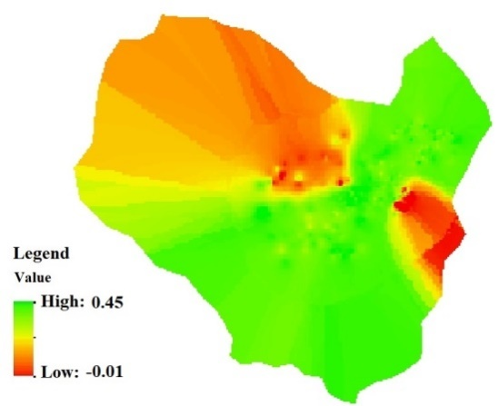 | 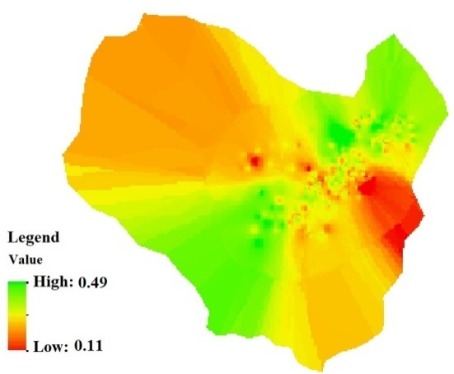 | 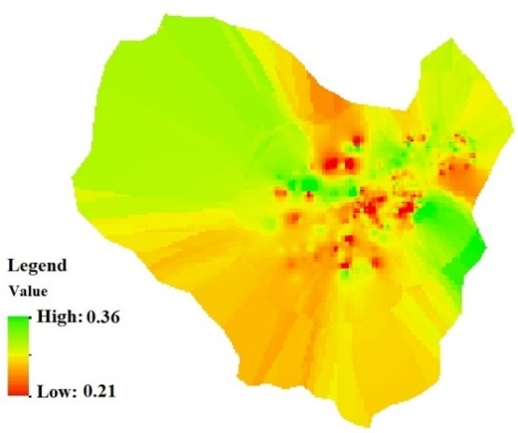
(j) | (k) | (l)
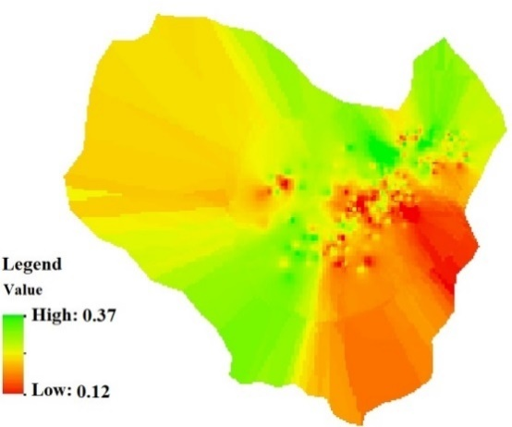 | 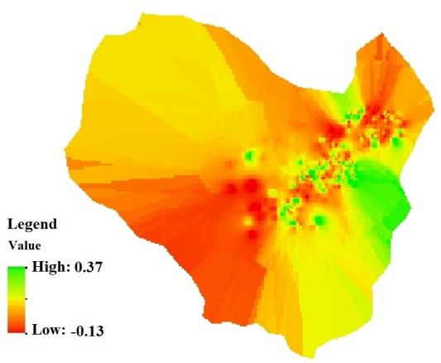
(m) | (n)
Supplemental Figure 1.Remote Sensing Indices for Soil Potassium Modeling. a - Bulk density, b - Calcium Carbonate Equivalent, c - Channel network base level, d- Clay mean, e- EVI, f – Geology, g- Greeness Index, h- Landuse, i- Mean annual temperature, j- NDVI, k- NDWI, l- Soil map, m- Texture, n- Wind effect.

