Supplymentary Material
Table S1. Missing Data Handling and Imputation Strategies for Training and Validation Datasets
 | Training Datasets (SICdb database) |  |  |  | Training Datasets (eICU database)
Variable | Imputation Method | Imputation Value | Missing Percentage  (%) |  | Imputation Method | Imputation Value | Missing Percentage (%)
Hb | Median | 8.9 | 0.9 |  | Median | 9.3 | 0.96
WBC | Median | 12.81 | 0.9 |  | Median | 14.6 | 1.26
MCV | Median | 87.6 | 0.9 |  | Median | 89 | 12.37
MCHC | Median | 33.5 | 0.9 |  | Median | 32.8 | 4.8
MCH | Median | 30 | 0.9 |  | Median | 29.7 | 4.8
Lactate | Median | 2.56 | 0.02 |  | Median | 2.4 | 61.27
Creatinine | Median | 1 | 1.39 |  | Median | 1.13 | 0.98
PLT | Median | 147 | 0.93 |  | Median | 142 | 1.2
SOFA | Median | 5 | 0.04 |  | / | / | 0
HCT | Median | 36 | 0.13 |  | Median | 36.5 | 0.86
BE | Median | -3.8 | 0.11 |  | Median | -3.8 | 38.85
Mg | Median | 0.8 | 2.88 |  | Median | 1.8 | 22.34
Sodium | Median | 138 | 16.82 |  | Median | 137 | 1.75
pH | Median | 7.325 | 0.1 |  | Median | 7.31 | 26.95
SpO2 | Median | 92.4 | 0.01 |  | Median | 90 | 8.79
RR | Median | 17 | 20.34 |  | Median | 10 | 2.15
T | Median | 37.8 | 2.09 |  | Median | 37.6 | 1.37
Height | / | / | 0 |  | Median | 82.6 | 0.49
Weight | / | / | 0 |  | Median | 170.2 | 2.44
BE: Base Excess; eICU: eICU Collaborative Research Database; Hb: Hemoglobin; HCT: Hematocrit; MCH: Mean Corpuscular Hemoglobin; MCHC: Mean Corpuscular Hemoglobin Concentration; MCV: Mean Corpuscular Volume; Mg: Magnesium; PLT: Platelet Count; RR: Respiratory Rate; SICdb: Salzburg Intensive Care database; SOFA: Sequential Organ Failure Assessment; SpO2: Oxygen Saturation; T: Temperature; WBC: White Blood Cell Count.

Table S2. Performance of different time point HEDI in predicting ICU mortality

HEDI | Cut-off | AUC (95% CI) | Sensitivity  (95% CI) | Specificity  (95% CI) | PLR (95% CI) | NLR (95% CI) | PPV (95% CI) | NPV (95% CI)
24h | 0.49 | 0.587 (0.567 - 0.608) | 41.82 (32.5 - 57.4) | 74.68 (59.7 - 83.3) | 1.65 (1.40 - 2.08) | 0.78 (0.70 - 0.82) | 11.7 (9.9 - 14.5) | 94.1 (93.7 - 94.8)
30h | 0.73 | 0.608 (0.587 - 0.627) | 39.16 (37.1 - 54.9) | 81.28 (64.7 - 81.8) | 2.09 (1.58 - 2.24) | 0.75 (0.67 - 0.77) | 14.4 (11.0 - 15.4) | 94.3 (94.0 - 95.0)
36h | 0.56 | 0.629 (0.610 - 0.650) | 49.80 (40.5 - 62.2) | 72.73 (60.6 - 82.0) | 1.83 (1.57 - 2.32) | 0.69 (0.62 - 0.74) | 12.8 (11.1 - 15.9) | 94.8 (94.3 - 95.3)
42h | 0.59 | 0.645 (0.623 - 0.665) | 52.97 (43.0 - 64.3) | 72.77 (59.5 - 82.9) | 1.95 (1.64 - 2.48) | 0.65 (0.58 - 0.70) | 13.5 (11.6 - 16.6) | 95.1 (94.6 - 95.6)
48h | 0.64 | 0.656 (0.634 - 0.675) | 54.19 (49.0 - 62.7) | 73.67 (65.1 - 77.8) | 2.06 (1.76 - 2.35) | 0.62 (0.56 - 0.66) | 14.2 (12.5 - 16.0) | 95.3 (94.8 - 95.7)
54h | 0.64 | 0.665 (0.644 - 0.685) | 55.73 (48.5 - 64.2) | 73.15 (65.6 - 79.5) | 2.08 (1.81 - 2.45) | 0.61 (0.54 - 0.65) | 14.3 (12.4 - 16.5) | 95.4 (94.9 - 96.0)
60h | 0.64 | 0.672 (0.653 - 0.692) | 57.16 (48.1 - 64.2) | 72.79 (66.4 - 81.2) | 2.10 (1.87 - 2.62) | 0.59 (0.53 - 0.64) | 14.4 (12.9 - 17.5) | 95.5 (95.0 - 96.0)
66h | 0.64 | 0.676 (0.657 - 0.696) | 58.18 (48.9 - 63.6) | 72.52 (69.0 - 81.1) | 2.12 (1.93 - 2.66) | 0.58 (0.52 - 0.64) | 14.5 (13.3 - 17.7) | 95.6 (95.1 - 96.1)
72h | 0.64 | 0.681 (0.661 - 0.701) | 59.00 (51.3 - 63.5) | 72.42 (69.3 - 80.4) | 2.14 (2.01 - 2.63) | 0.57 (0.52 - 0.62) | 14.6 (13.5 - 17.8) | 95.7 (95.1 - 96.1)
PPV: Positive predictive value; PLR: Positive likelihood ratio; NPV: Negative predictive value; NLR: Negative likelihood ratio.
Table S3. Performance metrics comparison of nine machine learning algorithms on training and internal testing datasets.
 |  | Accuracy | Sensitivity | Specificity | PPV | NPV | F1 score | Kappa score | ROC AUC
Tain Dataset | ANN | 0.808 (0.809, 0.809) | 0.674 (0.673, 0.673) | 0.960 (0.960, 0.960) | 0.950 (0.949, 0.949) | 0.674 (0.673, 0.673) | 0.788 (0.788, 0.788) | 0.621 (0.623, 0.623) | 0.817 (0.817, 0.817)
Tain Dataset | Decision Tree | 0.951 (0.953, 0.953) | 0.958 (0.958, 0.958) | 0.943 (0.947, 0.947) | 0.950 (0.953, 0.953) | 0.958 (0.958, 0.958) | 0.954 (0.955, 0.955) | 0.902 (0.905, 0.905) | 0.951 (0.953, 0.953)
Tain Dataset | Extra Trees | 1.000 (1.000, 1.000) | 1.000 (1.000, 1.000) | 1.000 (1.000, 1.000) | 1.000 (1.000, 1.000) | 1.000 (1.000, 1.000) | 1.000 (1.000, 1.000) | 1.000 (1.000, 1.000) | 1.000 (1.000, 1.000)
Tain Dataset | Gradient Boosting | 1.000 (1.000, 1.000) | 1.000 (1.000, 1.000) | 1.000 (1.000, 1.000) | 1.000 (1.000, 1.000) | 1.000 (1.000, 1.000) | 1.000 (1.000, 1.000) | 1.000 (1.000, 1.000) | 1.000 (1.000, 1.000)
Tain Dataset | KNN | 1.000 (1.000, 1.000) | 1.000 (1.000, 1.000) | 1.000 (1.000, 1.000) | 1.000 (1.000, 1.000) | 1.000 (1.000, 1.000) | 1.000 (1.000, 1.000) | 1.000 (1.000, 1.000) | 1.000 (1.000, 1.000)
Tain Dataset | LightGBM | 1.000 (1.000, 1.000) | 1.000 (1.000, 1.000) | 1.000 (1.000, 1.000) | 1.000 (1.000, 1.000) | 1.000 (1.000, 1.000) | 1.000 (1.000, 1.000) | 1.000 (1.000, 1.000) | 1.000 (1.000, 1.000)
Tain Dataset | Random Forest | 1.000 (1.000, 1.000) | 1.000 (1.000, 1.000) | 1.000 (1.000, 1.000) | 1.000 (1.000, 1.000) | 1.000 (1.000, 1.000) | 1.000 (1.000, 1.000) | 1.000 (1.000, 1.000) | 1.000 (1.000, 1.000)
Tain Dataset | SVM | 0.767 (0.777, 0.777) | 0.671 (0.677, 0.677) | 0.875 (0.887, 0.887) | 0.860 (0.870, 0.870) | 0.671 (0.677, 0.677) | 0.754 (0.762, 0.762) | 0.539 (0.558, 0.558) | 0.773 (0.782, 0.782)
Tain Dataset | XGBoost | 1.000 (1.000, 1.000) | 1.000 (1.000, 1.000) | 1.000 (1.000, 1.000) | 1.000 (1.000, 1.000) | 1.000 (1.000, 1.000) | 1.000 (1.000, 1.000) | 1.000 (1.000, 1.000) | 1.000 (1.000, 1.000)
Test  Dataset | ANN | 0.804 (0.791, 0.816) | 0.667 (0.646, 0.687) | 0.959 (0.949, 0.967) | 0.948 (0.937, 0.959) | 0.667 (0.648, 0.687) | 0.783 (0.769, 0.798) | 0.613 (0.590, 0.636) | 0.813 (0.801, 0.823)
Test  Dataset | Decision Tree | 0.904 (0.895, 0.913) | 0.925 (0.913, 0.935) | 0.880 (0.865, 0.894) | 0.898 (0.885, 0.910) | 0.925 (0.914, 0.936) | 0.911 (0.902, 0.919) | 0.806 (0.788, 0.825) | 0.902 (0.893, 0.912)
Test  Dataset | Extra Trees | 0.972 (0.968, 0.977) | 0.986 (0.981, 0.990) | 0.957 (0.947, 0.966) | 0.963 (0.954, 0.971) | 0.986 (0.981, 0.991) | 0.974 (0.970, 0.979) | 0.944 (0.934, 0.954) | 0.971 (0.966, 0.977)
Test  Dataset | Gradient Boosting | 0.973 (0.968, 0.978) | 0.977 (0.971, 0.983) | 0.968 (0.960, 0.976) | 0.972 (0.965, 0.979) | 0.977 (0.971, 0.984) | 0.975 (0.970, 0.980) | 0.946 (0.936, 0.955) | 0.973 (0.968, 0.978)
Test  Dataset | KNN | 0.969 (0.963, 0.974) | 0.994 (0.991, 0.997) | 0.940 (0.928, 0.951) | 0.950 (0.940, 0.959) | 0.994 (0.991, 0.997) | 0.972 (0.967, 0.976) | 0.938 (0.926, 0.948) | 0.967 (0.962, 0.973)
Test  Dataset | LightGBM | 0.977 (0.972, 0.982) | 0.985 (0.979, 0.990) | 0.969 (0.961, 0.976) | 0.973 (0.965, 0.980) | 0.985 (0.980, 0.990) | 0.979 (0.974, 0.983) | 0.954 (0.945, 0.964) | 0.977 (0.972, 0.981)
Test  Dataset | Random Forest | 0.965 (0.959, 0.970) | 0.980 (0.974, 0.986) | 0.948 (0.937, 0.958) | 0.955 (0.946, 0.964) | 0.980 (0.974, 0.986) | 0.968 (0.962, 0.973) | 0.930 (0.917, 0.941) | 0.964 (0.958, 0.970)
Test  Dataset | SVM | 0.775 (0.762, 0.788) | 0.684 (0.666, 0.703) | 0.878 (0.863, 0.893) | 0.864 (0.847, 0.880) | 0.684 (0.665, 0.704) | 0.764 (0.749, 0.779) | 0.554 (0.526, 0.579) | 0.781 (0.768, 0.794)
Test  Dataset | XGBoost | 0.973 (0.968, 0.978) | 0.979 (0.973, 0.985) | 0.966 (0.958, 0.974) | 0.970 (0.963, 0.978) | 0.979 (0.973, 0.985) | 0.975 (0.970, 0.979) | 0.946 (0.935, 0.956) | 0.973 (0.967, 0.978)
ANN: Artificial Neural Network; KNN: K-Nearest Neighbors; LightGBM: Light Gradient Boosting Machine; NPV: Negative predictive value; PPV: Positive predictive value; ROC AUC: Receiver Operating Characteristic Area Under the Curve; SVM: Support Vector Machine; XGBoost: Extreme Gradient Boosting
Table S4. Performance metrics comparison of nine machine learning algorithms on training and internal testing datasets.
 | Survivors  (n = 12202) | Non-survivors  (n = 978) | P-value
Age, (years) | 66 [56, 75] | 67.5 [56, 77] | 0.022
Gender, (male) | 12202 (100.0%) | 978 (100.0%) | 1
Height, (cm) | 170.2 [162.6, 177.8] | 170.2 [162.6, 177.8] | 0.394
Weight, (kg) | 82.6 [69.9, 97.8] | 81.6 [67.9, 100.0] | 0.134
BMI, (kg/m2) | 28.2 [24.4, 33.1] | 27.8 [23.7, 33.4] | 0.138
Renal Dysfunction, n (%) | 1238 (10.1%) | 147 (15.0%) | < 0.001
Diabetes, n (%) | 3496 (28.7%) | 295 (30.2%) | 0.333
Hypertension, n (%) | 6624 (54.3%) | 515 (52.7%) | 0.342
Lung Disease, n (%) | 1528 (12.5%) | 174 (17.8%) | < 0.001
Fluid Input, (ml) | 5266.0 [0.00, 17315.1] | 5318.0 [0.00, 22735.0] | < 0.001
Urine Output, (ml) | 6502.0 [3392.0, 12194.0] | 4285.0 [1397.5, 10601.5] | < 0.001
Fluid Balance, (ml) | -930.73 [-4475.00, 5544.21] | 0.00 [-2858.00, 11746.25] | < 0.001
Blood Product Input, (ml) | 630.5 [630.5, 630.5] | 630.5 [630.5, 630.5] | < 0.001
Minimum_BE | -3.0 [-4.0, -1.9] | -6.0 [-14.0, -3.0] | < 0.001
Minimum_pH | 7.31 [7.29, 7.34] | 7.21 [7.10, 7.31] | < 0.001
Minimum_Mg (mmol/L) | 1.80 [1.70, 2.00] | 1.80 [1.50, 1.90] | < 0.001
Minimum_MCH, (g/L) | 29.70 [28.60, 30.70] | 29.70 [28.23, 30.80] | 0.054
Minimum_MCHC | 32.80 [32.00, 33.50] | 32.30 [31.30, 33.10] | < 0.001
Minimum_MCV | 89.00 [86.00, 92.60] | 89.00 [85.00, 93.00] | 0.989
Minimum_Sodium, (mmol/L) | 137 [134, 139] | 137 [134, 141] | < 0.001
Maximum_Lactate, (mmol/L) | 2.40 [2.40, 2.40] | 4.30 [2.40, 10.17] | < 0.001
Maximum_Cr, (mg/dL) | 1.10 [0.85, 1.55] | 2.13 [1.36, 3.34] | < 0.001
Maximum_WBC, (x109/L) | 14.5 [11.0, 18.7] | 18.3 [13.4, 24.8] | < 0.001
Maximum_HCT, (%) | 36.4 [32.2, 40.8] | 36.4 [32.0, 42.0] | 0.203
Minimum_Hb, (g/L) | 9.3 [7.9, 10.8] | 9.0 [7.5, 10.7] | < 0.001
Minimum_PLT, (x109/L) | 142 [104, 193] | 119 [61, 175] | < 0.001
Minimum_SpO2, (%) | 90 [88, 93] | 85 [69, 90] | < 0.001
Minimum_RR, (bpm) | 10.00 [8.00, 12.00] | 10.00 [7.00, 14.00] | 0.762
Maximum_T, (℃) | 37.6 [37.2, 38.1] | 37.7 [37.2, 38.5] | < 0.001
Maximum_SOFA | 7 [5, 10] | 13 [10, 15] | < 0.001
Vasopressor Used, n (%) | 3427 (28.1%) | 594 (60.7%) | < 0.001
Positive Balance, n (%) | 5223 (42.8%) | 476 (48.7%) | < 0.001
Negative Balance, n (%) | 6780 (55.6%) | 460 (47.0%) | < 0.001
Blood Product Transfusion, n (%) | 1711 (14.0%) | 180 (18.4%) | < 0.001
Hyperkalemia, n (%) | 580 (4.8%) | 198 (20.2%) | < 0.001
Hyperthermia, n (%) | 1251 (10.3%) | 243 (24.8%) | < 0.001
Fever, n (%) | 8862 (72.6%) | 684 (69.9%) | 0.076
Mean_MAP, (mmHg) | 79 [73, 87] | 75 [68, 83] | < 0.001
Minimum_MAP, (mmHg) | 60 [54, 68] | 49 [49, 58] | < 0.001
Maximum_MAP, (mmHg) | 105 [94, 121] | 107 [93, 126] | 0.032
TWMAP, (mmHg) | 79 [73, 87] | 75 [68, 83] | < 0.001
HEDI | 0.18 [-0.07, 0.71] | 0.90 [0.17, 2.19] | < 0.001
BE: Base Excess; BMI: body mass index; bpm: breath per minute; Cr: Creatinine; Hb: Hemoglobin; HCT: Hematocrit; HEDI: Hypotension Exposure Duration Index; MAP: Mean Artery Pressure; MCH: Mean Corpuscular Hemoglobin; MCHC: Mean Corpuscular Hemoglobin Concentration; MCV: Mean Corpuscular Volume; Mg: Magnesium; PLT: Platelet Count; RDW: RR: Respiratory Rate; SOFA: Sequential Organ Failure Assessment; SpO2: Oxygen Saturation; T: Temperature; TWMAP: Time Weighted Mean Artery Pressure; WBC: White Blood Cell Count.
Table S5. Performance metrics of the Extra Trees model in the external validation cohort and stratified by vasoactive medication use.
 | Total validation cohort  (n = 13,180) | Receiving Vasoactive  (n = 3,976) | Non Receiving Vasoactive  (n = 9,204)
Accuracy | 0.871 (0.865, 0.876) | 0.802 (0.788, 0.814) | 0.901 (0.895, 0.907)
Sensitivity | 0.544 (0.518, 0.567) | 0.645 (0.611, 0.679) | 0.425 (0.384, 0.463)
Specificity | 0.911 (0.906, 0.916) | 0.839 (0.827, 0.851) | 0.938 (0.933, 0.944)
PPV | 0.429 (0.407, 0.451) | 0.491 (0.461, 0.521) | 0.351 (0.319, 0.384)
NPV | 0.544 (0.517, 0.569) | 0.645 (0.611, 0.678) | 0.425 (0.390, 0.463)
F1 score | 0.480 (0.457, 0.499) | 0.558 (0.530, 0.584) | 0.384 (0.353, 0.416)
Kappa score | 0.407 (0.383, 0.430) | 0.433 (0.400, 0.467) | 0.331 (0.297, 0.363)
ROC AUC | 0.727 (0.715, 0.740) | 0.742 (0.725, 0.759) | 0.682 (0.663, 0.700)
NPV: Negative predictive value; PPV: Positive predictive value; ROC AUC: area under the receiver operating characteristic curve.

Figure S1. Patient Selection Flowchart for the Training Cohort.
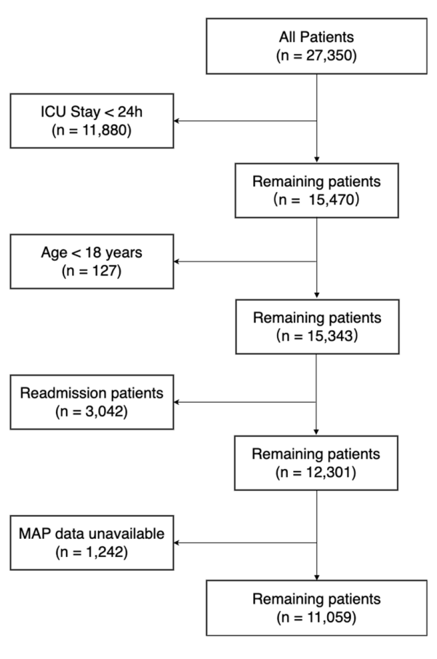
ICU: intensive care unit; MAP: mean artery pressure.
Figure S2.Feature Selection Analysis for ICU Mortality Prediction Model.
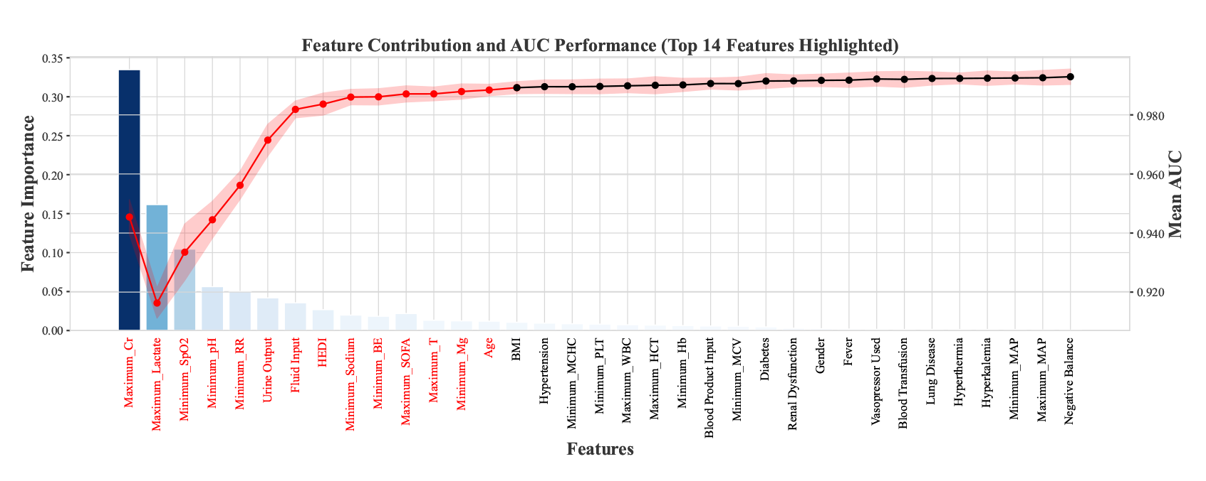
The primary y-axis (bars) represents individual feature contribution to the model, while the secondary y-axis (red curve) shows cumulative AUC performance as features are progressively added. The optimal 14 contributing features are highlighted, with maximum Cr demonstrating the highest predictive value, followed by minimum SpO2, urine output, and maximum Lactate. The 48h HEDI metric ranks as an important predictor (8th position), confirming its independent contribution to mortality prediction.This feature selection approach optimizes model performance while maintaining clinical interpretability.
Figure S3. Patient Selection Flowchart for the Training Cohort.
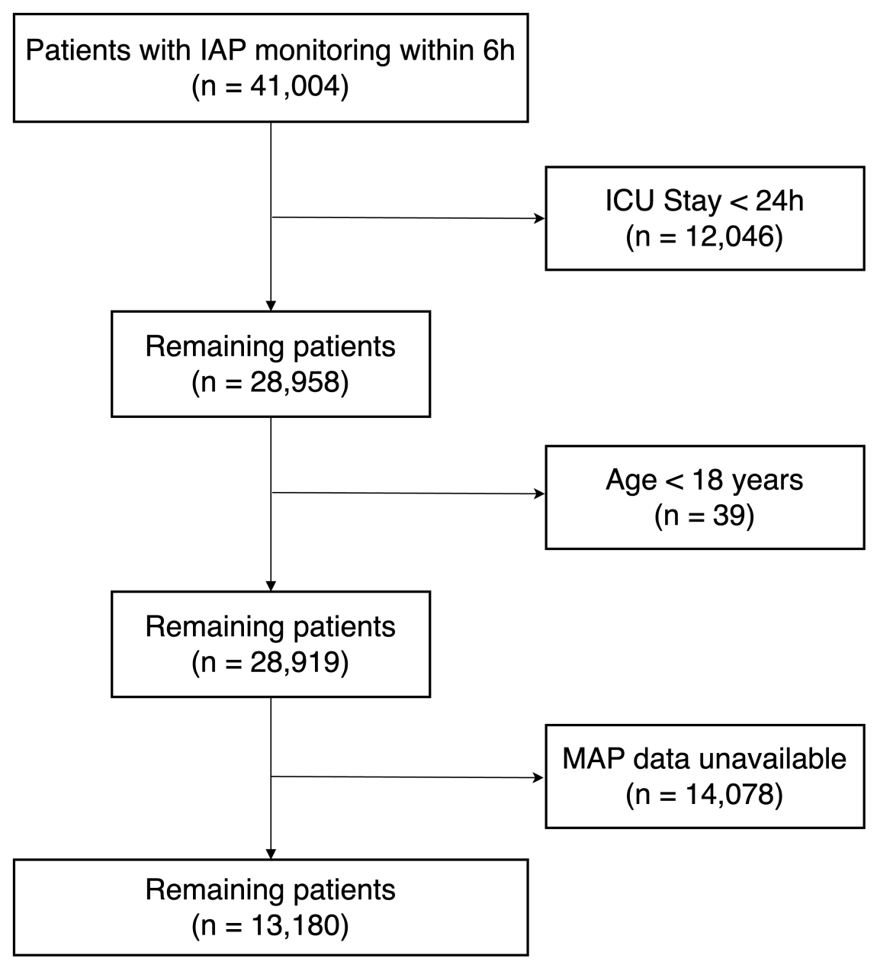
IAP: Invasive Artery Pressure; ICU: intensive care unit; MAP: mean artery pressure.
Figure S4. Feature Selection Analysis for ICU Mortality Prediction Model based on 48-hour HEDI.
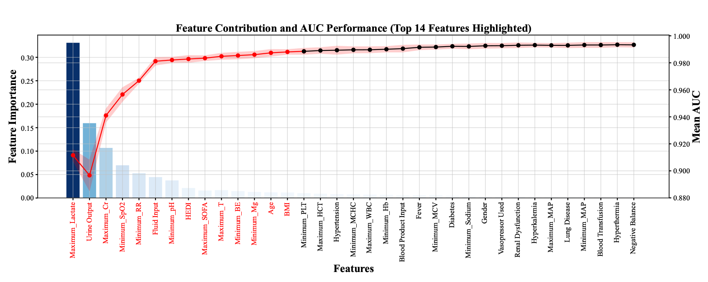
The primary y-axis (bars) represents individual feature contribution to the model, while the secondary y-axis (red curve) shows cumulative AUC performance as features are progressively added. The optimal 14 contributing features are highlighted, with maximum Lactate demonstrating the highest predictive value, followed by urine output, and maximum Cr. The 48h HEDI metric ranks as an important predictor (8th position), confirming its independent contribution to mortality prediction.
Figure S5.Performance Comparison of Machine Learning Models for ICU Mortality Prediction Based on 48-hour HEDI.

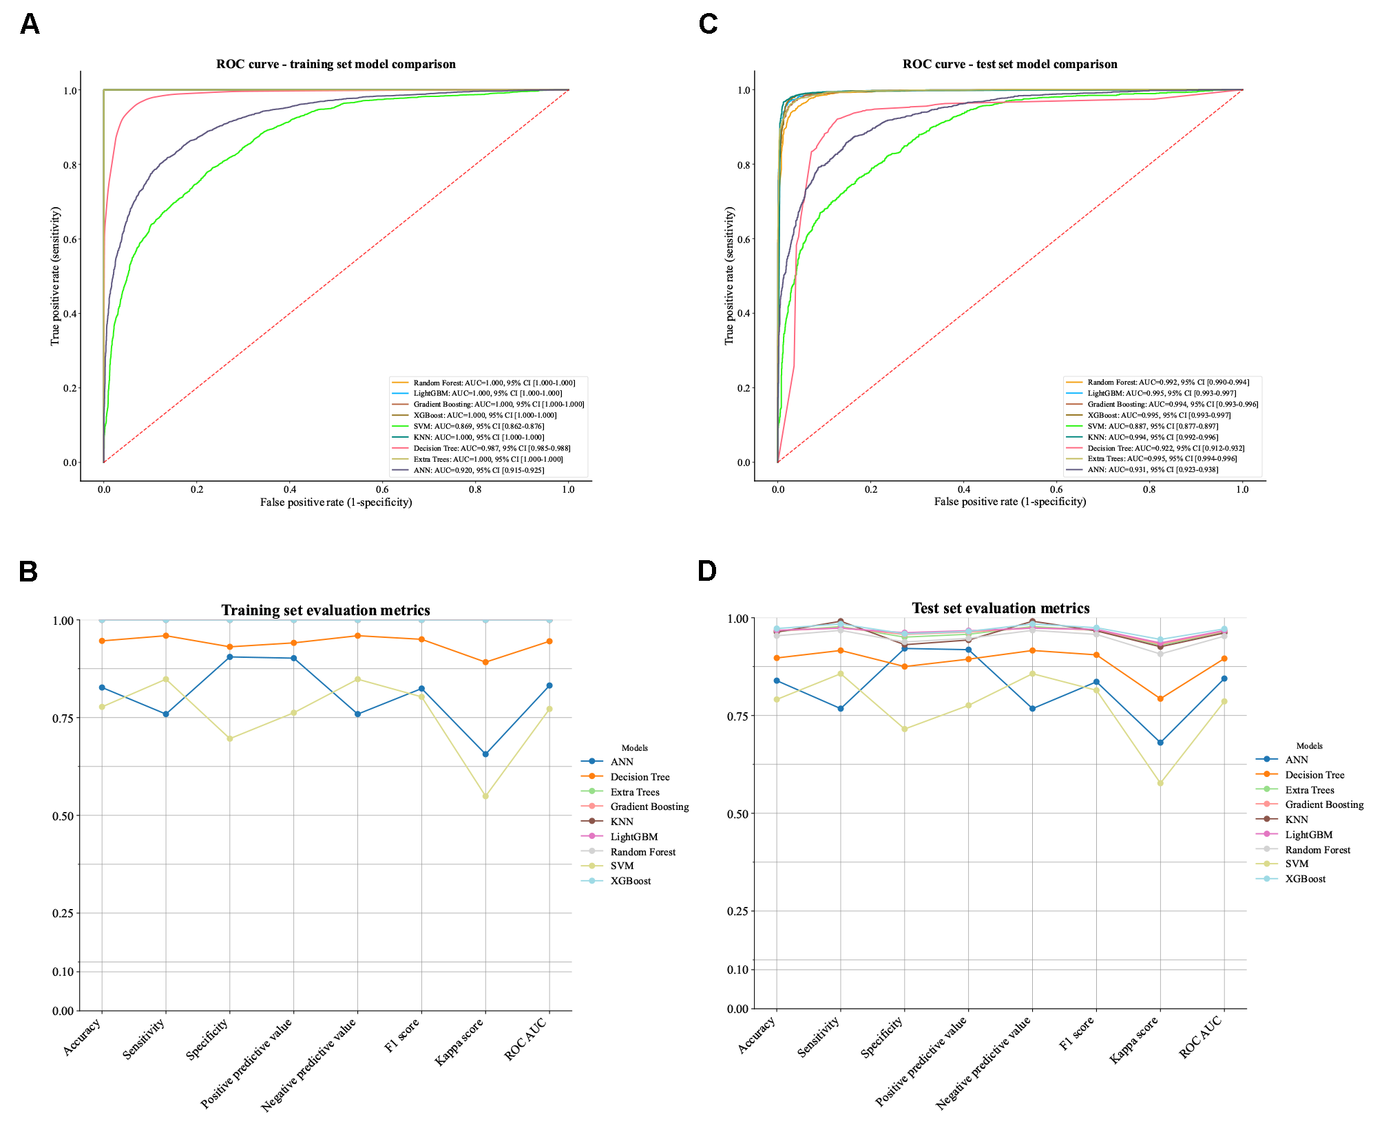
Panel A: ROC curves for nine different machine learning models on the training set, all demonstrating excellent discriminative ability with AUC values exceeding 0.86. Panel B: Comprehensive evaluation metrics for all models on the training set, including accuracy, sensitivity, specificity, positive and negative predictive values, F1 score, Kappa score, and ROC AUC. Panel C: ROC curves for the same models applied to the internal test set, maintaining robust performance. Panel D: Evaluation metrics for the internal test set, showing consistent performance across all assessment criteria.
Figure S6. Feature Importance Analysis of Machine Learning Models with 48-hour HEDI for ICU Mortality Prediction.
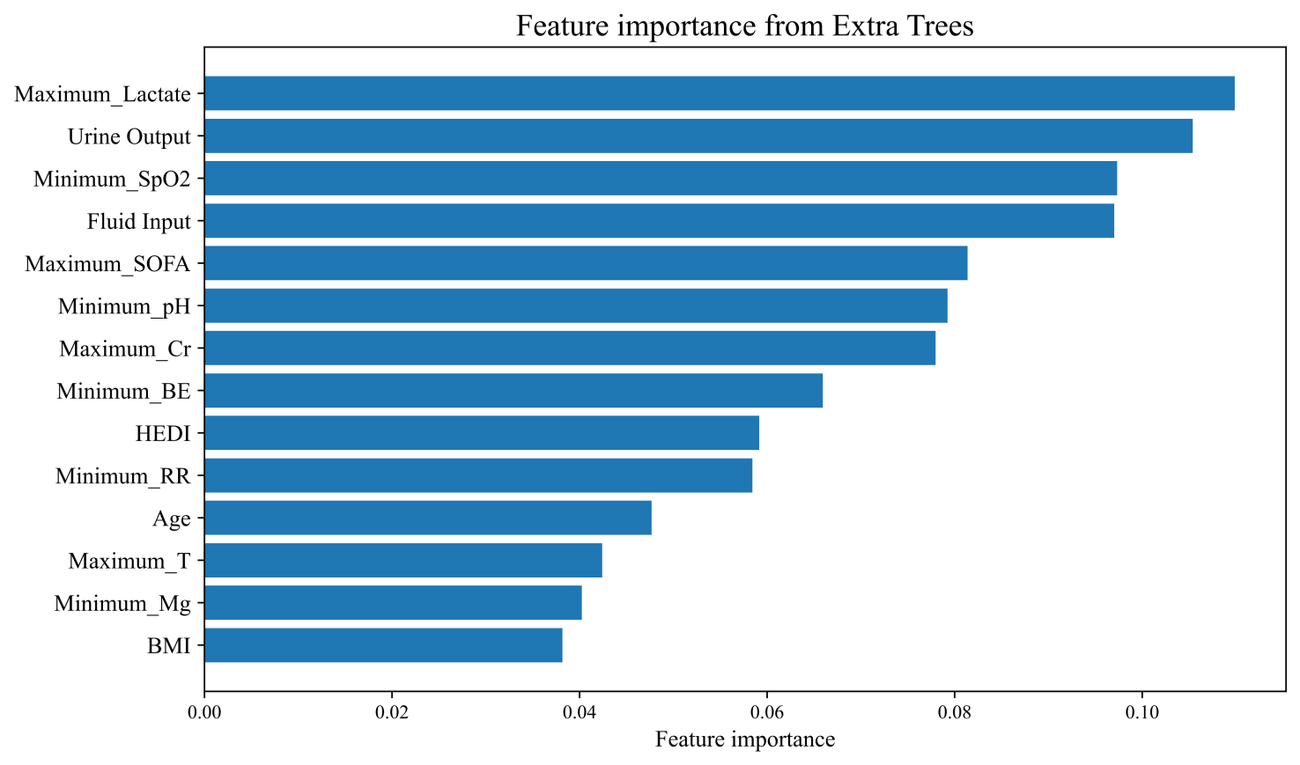
Relative feature importance rankings from the best-performing models: Extra Trees. Traditional clinical parameters such maximum lactate level and urine output demonstrate the highest predictive value. HEDI consistently appears as an important predictor across all models, ranking 9th in Extra Trees.
Figure S7. SHAP Analysis of Feature Contributions to ICU Mortality Prediction.

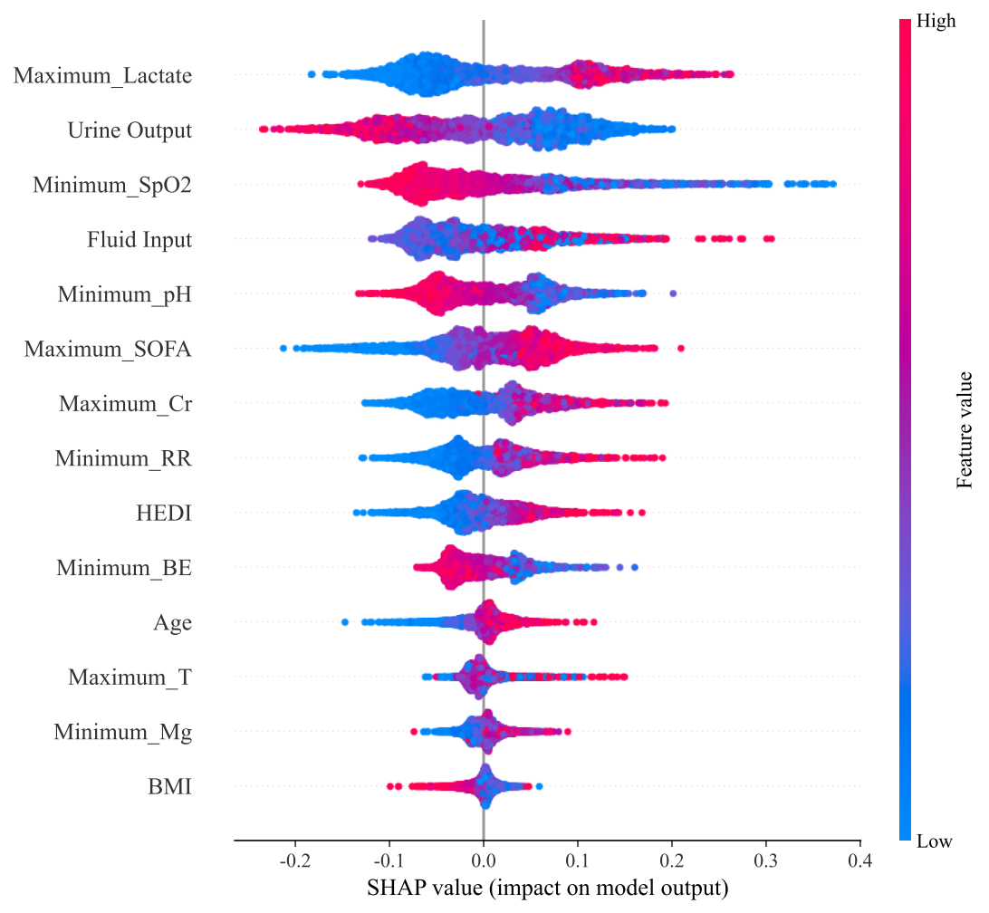
Maximum lactate level demonstrates the strongest positive impact on mortality prediction. 48-hour HEDI appears as an important contributor in Extra Trees, confirming its independent predictive value for ICU mortality.
Figure S8. Extra Trees Model Performance in External Validation.
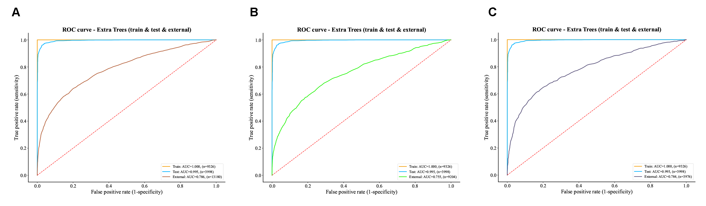
ROC curves demonstrating model performance in training (yellow), test (blue), and external validation cohorts (A: overall eICU population, n = 13,180; B: patients receiving vasopressors, n = 4,021; C: patients without vasopressors, n = 9,159).

