Supporting Information

Quantum Coherent Beating in Polar Disubphthalocyanine-Fullerene Cocrystals for Ultrafast Photothermal Conversion
Yong Chen^{1,7}, Yu Zhang^{2,7}, Haozhe Dong³, Nian-Ling Li¹, Fei Huang¹, Wei Lu¹, Hong Yi³, Zihao Xu⁴, Juan Casado⁵, Feng Liu⁶, Xian-Kai Wan*^{,1}, Chuang Zhang*^{,2}, Jingsong You*^{,1}, Cheng Zhang*^{,1}
¹Key Laboratory of Green Chemistry and Technology of Ministry of Education, College of Chemistry, Sichuan University, 29 Wangjiang Road, Chengdu 610064, P. R. China.
²Key Laboratory of Photochemistry, Beijing National Laboratory for Molecular Sciences, Institute of Chemistry, Chinese Academy of Sciences, Beijing 100190, P. R. China.
³The Institute for Advanced Studies (IAS), Wuhan University, Wuhan 430072, P. R. China.
⁴Huairou Research Center, Beijing National Laboratory for Molecular Sciences, Institute of Chemistry, Chinese Academy of Sciences, Beijing 100190, P. R. China.
⁵Department of Physical Chemistry, University of Malaga, Campus de Teatinos s/n, Málaga, 29071, Spain.
⁶Future Organic Optoelectronics Research Center, Global Institute of Future Technology, Shanghai Jiao Tong University, Shanghai 200240, P. R. China.
⁷These authors contributed equally to this work.
Table of Contents
I. General information 2
II. Synthesis and thermal stability of DiSubPcs 3
III. Electrochemical and photophysical properties of SubPcs 5
IV. Crystal packings 9
V. Theoretical calculations 11
VI. Photophysical properties 11
VII. Photothermal conversion 12
VIII. References 13
IX. ¹H and ¹³C NMR spectra 14

General information
All commercially available reagents were used without further purification unless otherwise noted. All the reactions dealing with air- or moisture-sensitive compounds were carried out in a dry reaction vessel under a positive pressure of nitrogen.
NMR spectra were recorded on an Agilent 400-MR DD2 spectrometer. The ¹H NMR (400 MHz) chemical shifts were measured relative to CDCl₃ (CDCl₃: δ = 7.26 ppm). The ¹³C NMR (100 MHz) chemical shifts were given using CDCl₃ as the internal standard (CDCl₃: δ = 77.16 ppm). Matrix-assisted laser desorption/ionization time of flight mass spectra (MALDI-TOF-MS) were collected with a Shimadzu AXIMA Performance. UV-vis-NIR absorption spectra were recorded by SHIMADZU UV-3600. Emission spectra were obtained using an Edinburgh Instruments FLS920 Fluorimeter. PL lifetimes were acquired using the Fluorimeter pulsed xenon flash-lamp, Xe900, of 0.4 W and Picoquant PLS-λ nanosecond LED diodes. X-ray single-crystal diffraction data were collected on an Agilent Technologies Gemini single-crystal diffractometer. Thermogravimetric analysis (TGA) was carried out using METTLER TOLEDO TGA/DSC2 at a rate of 10 °C/min under nitrogen atmosphere. Cyclic voltammogram (CV) was performed on LK2005A with a solution of tetrabutylammonium hexafluorophosphate (Bu₄NPF₆, 0.1 M) in CH₂Cl₂ as electrolyte and ferrocene/ferrocenium (Fc/Fc⁺) as standard. Three-electrode system (Ag/Ag+, platinum wire and glassy carbon electrode as reference, counter, and work electrode, respectively) was used in the CV measurement. All potentials were corrected against Fc/Fc⁺. CV was measured with a scan rate of 100 mV/s. Theoretical calculations were carried out using Gaussian 09 software. The FMO distributions were visualized using Gaussview 5.0 software. The ground state structures were optimized by density functional theory (DFT) at B3LYP/6-31G* level. To evaluate the photothermal conversion performance, the light source we used is a laser of 550 nm (0.5 W cm⁻²) and the system temperature was monitored and recorded by FLIR E6-XT Infrared Camera.

Synthesis and thermal stability of DiSubPcs
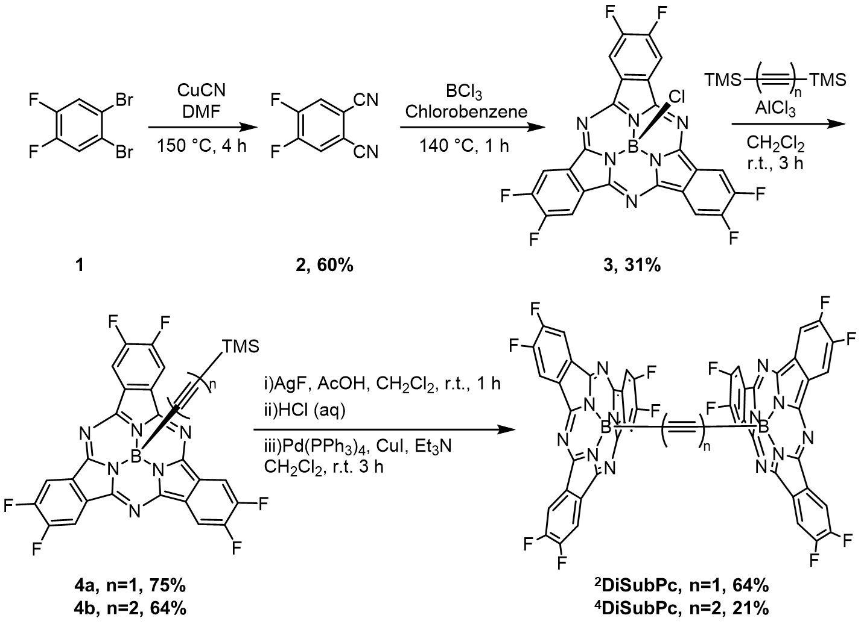
Scheme S1. Synthesis routes of DiSubPcs.
Preparation of the 4a and 4b
1,2-Dibromo-4,5-difluorobenzene 1 were obtained from commercial suppliers and used without further purification, 2-4 were prepared according to the literature¹. The ¹H NMR and ¹³C NMR data were in accordance with the reported data.
Preparation of the DiSubPcs
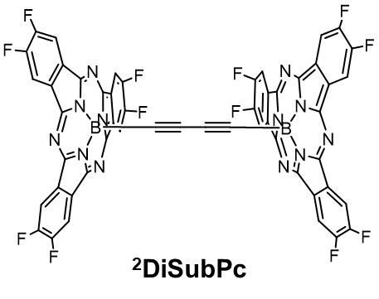
4a (600 mg, 1 mmol) was dissolved in a solution of CH₂Cl₂ (50 mL) and AcOH (5 mL, 0.7 M in CH₂Cl₂), and then AgF (1.3 g, 10 mmol) was added. The mixture was allowed to stir for 60 min, and then aqueous HCl (100 mL, 0.1 M) was added. The reaction mixture was vigorously stirred and extracted with CH₂Cl₂, and the combined organic phases was dried over Na₂SO₄ and filtered. The volume was concentrated to 50 mL, then Pd(PPh₃)₂Cl₂ (72 mg, 0.1 mmol) and CuI (38 mg, 0.2 mmol) was added, and Et₃N (5 mL) was injected to the system. The mixture was stirred for 4 h, filtered through a celite pad and washed with CH₂Cl₂, and concentrated under vacuum. The residue was chromatographed on silica gel with PE/CH₂Cl₂ = 1/1 (v/v) to provide the corresponding product ²DiSubPc as red solid (64% yield). ¹H NMR (400 MHz, CDCl₃): δ = 8.42 (t, J = 8.0 Hz, 2H), ¹³C NMR (100 MHz, CDCl₃): δ = 153.98, 153.81, 151.42, 151.26, 149.40, 127.01, 110.40, 29.85. MS (MALDI-TOF): calcd for C₅₂H₁₂B₂F₁₂N₁₂: 1054.1302, found: 1054.1840.
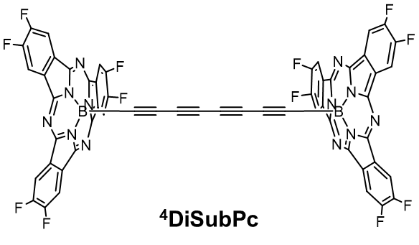
⁴DiSubPc was synthesized according the same route with the yield of 21%. ¹H NMR (400 MHz, CDCl₃): δ = 8.53 (t, J = 8.0 Hz, 2H), ¹³C NMR (100 MHz, CDCl₃): δ = 154.10, 153.94, 151.54, 151.38, 149.63, 127.11, 110.56, 61.10, 60.82, MS (MALDI-TOF): calcd for C₅₆H₁₃B₂F₁₂N₁₂⁺: [M+H]⁺, 1103.1375, found: 1103.0451.
Thermal stability
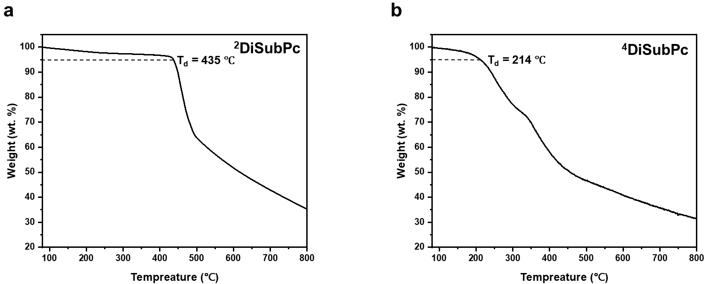
Figure S1. Thermal gravimetric analysis (TGA) curves of compounds a) ²DiSubPc, b) ⁴DiSubPc.

Electrochemical and photophysical properties of SubPcs
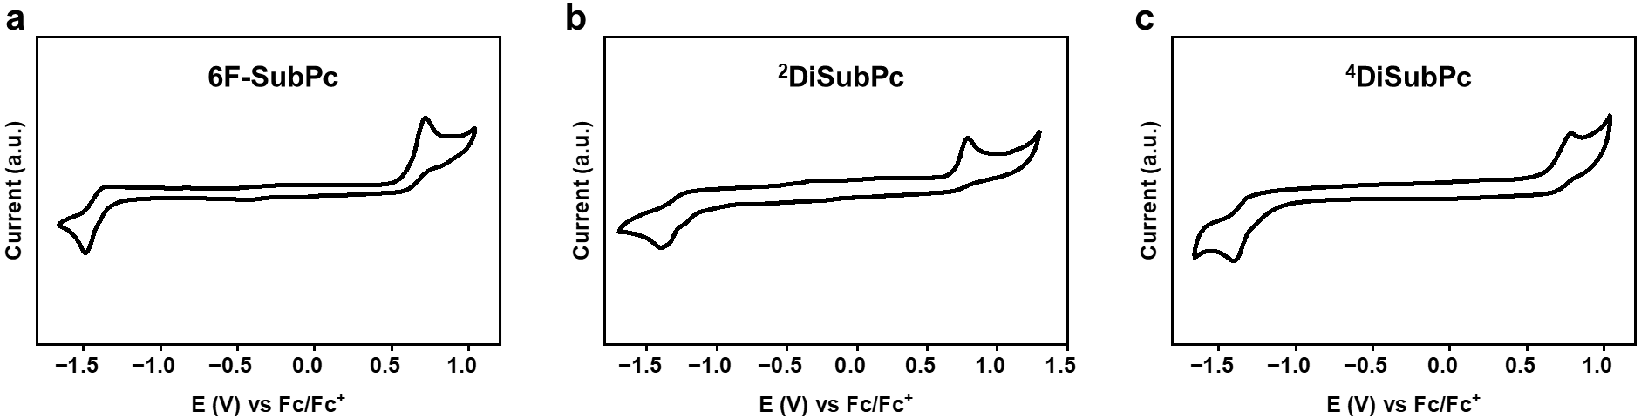
Figure S2. CV of a) 6F-SubPc, b) ²DiSubPc and c) ⁴DiSubPc in dry CH₂Cl₂ (1.0×10⁻³ M) containing 0.1 M Bu₄NPF₆.
Table S1. Photophysical and electrochemical properties of SubPcs through UV/Vis/NIR absorption spectra in toluene and CVs.
Compounds | λ_{max}^{[a]}  [nm] | E_{g}^{abs [b]}  [eV] | HOMO^{[c]}  [eV] | LUMO^{[c]}  [eV] | E_{g}^{CV[d]}  [eV]
6F-SubPc | 563 | 2.25 | -5.70 | -2.93 | 2.77
²DiSubPc | 569 | 2.25 | -5.65 | -2.93 | 2.67
⁴DiSubPc | 574 | 2.25 | -5.70 | -2.98 | 2.72
[a] Absorption maxima in toluene (10 μM). [b] Optical bandgaps were calculated according to E_{g} = 1240/λ_{onset}, where λ_{onset} is the onset value of the absorption spectrum in the long wavelength region. [c] From CVs measured in CH₂Cl₂ (1.0×10⁻³ M). The HOMO and LUMO energy levels are adjusted according to the redox half potential of Fc/Fc⁺ and estimated according to the formula: E_{HOMO} (eV) = - (4.8 + E^{ox} – E_{(Fc/Fc}⁺₎^{1/2}), E_{LUMO} (eV) = - (4.8 + E^{red} - E_{(Fc/Fc}⁺₎^{1/2}). [d] Estimated according to the formula: E_{g} (eV) = E_{LUMO} - E_{HOMO}.

Absorption titrations
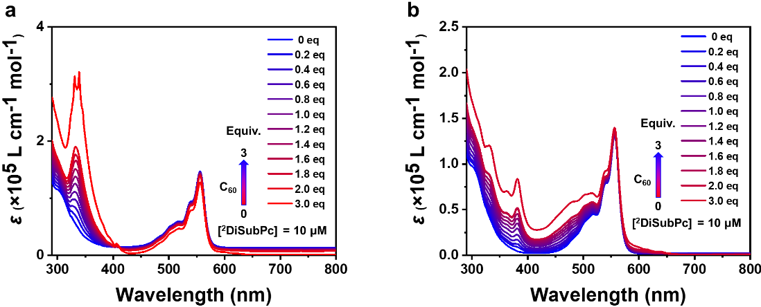
Figure S3. The changes of the UV-Vis-NIR spectra of ²DiSubPc (10 μM in toluene) with the addition of a) C₆₀ and b) C₇₀ from 0 to 3.0 equiv.
Binding constant based on fluorescence titrations between DiSubPcs and both C₆₀ and C₇₀
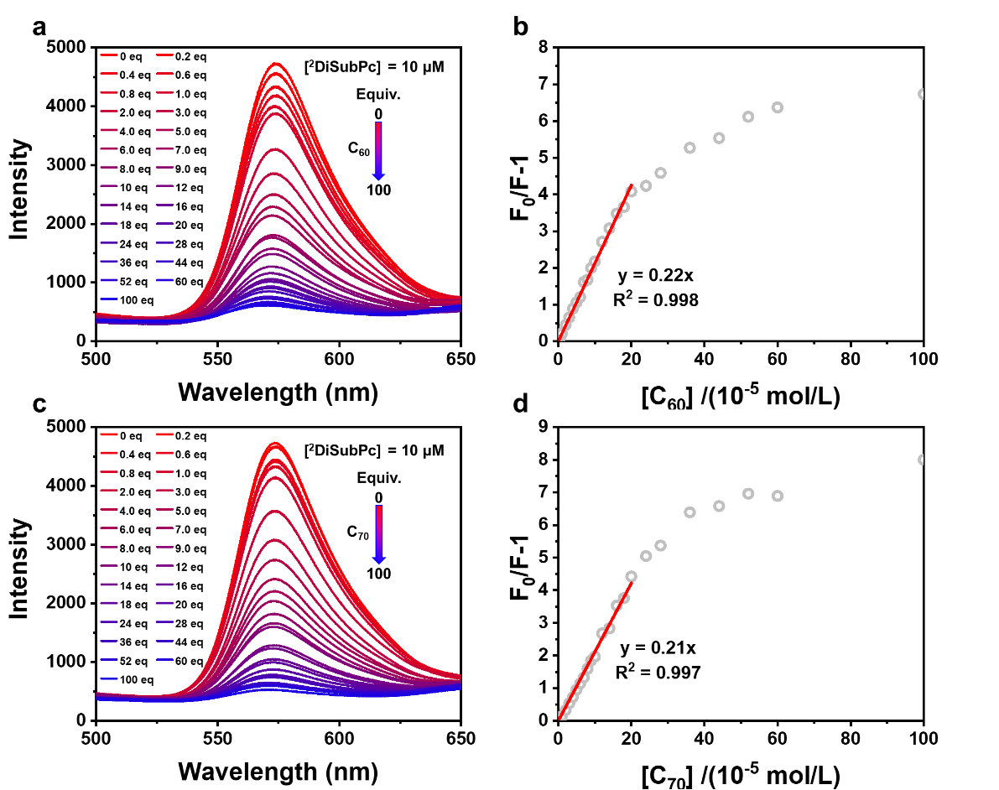
Figure S4. Changes in the PL intensity of ²DiSubPc (10 μM in toluene) upon the addition of a) C₆₀ and c) C₇₀ from 0 to 100 equiv. b, d) The corresponding intensity changes of PL at 573 nm (black dots) employed for linear fitting, with the fitting curve displayed in red (0-20 equiv.).
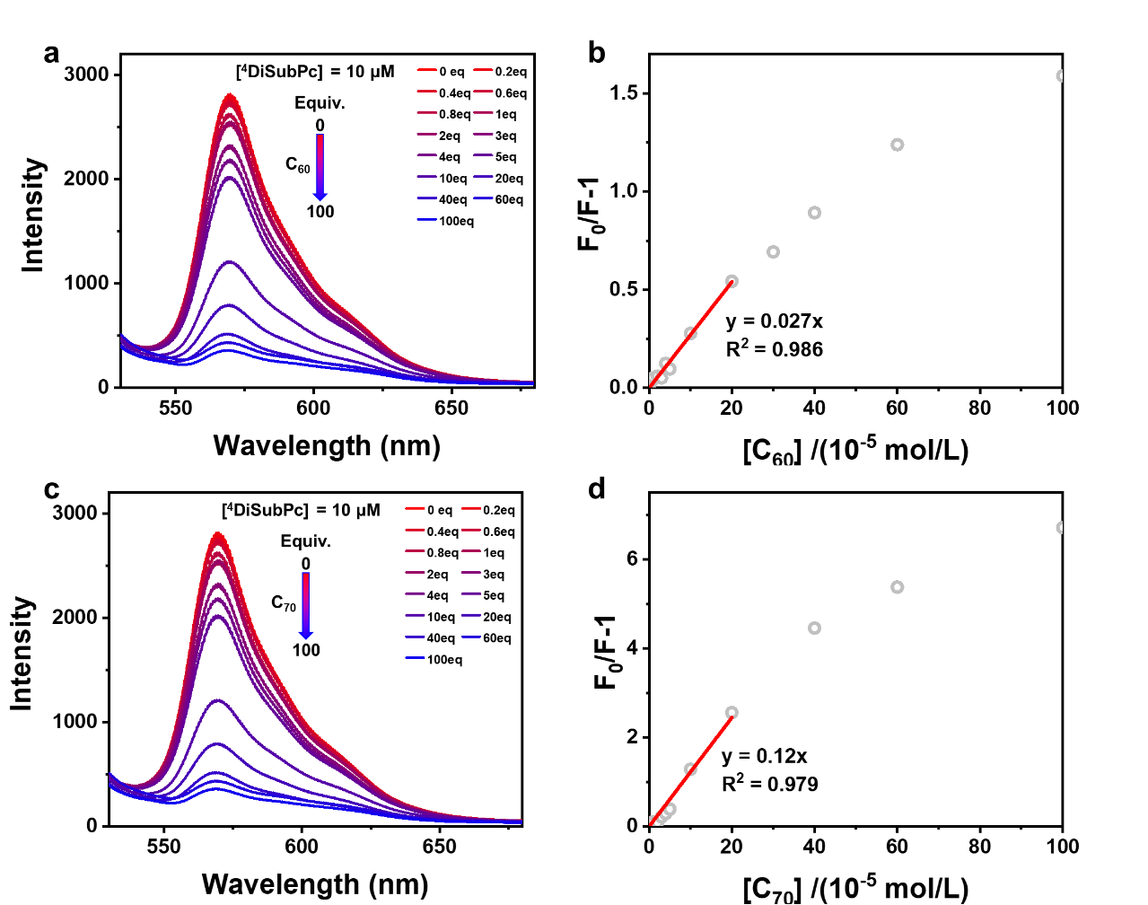
Figure S5. Changes in the PL intensity of ⁴DiSubPc (10 μM in toluene) upon the addition of a) C₆₀ and c) C₇₀ from 0 to 100 equiv. b, d) The corresponding intensity changes of PL at 573 nm (black dots) employed for linear fitting, with the fitting curve displayed in red (0-20 equiv.).

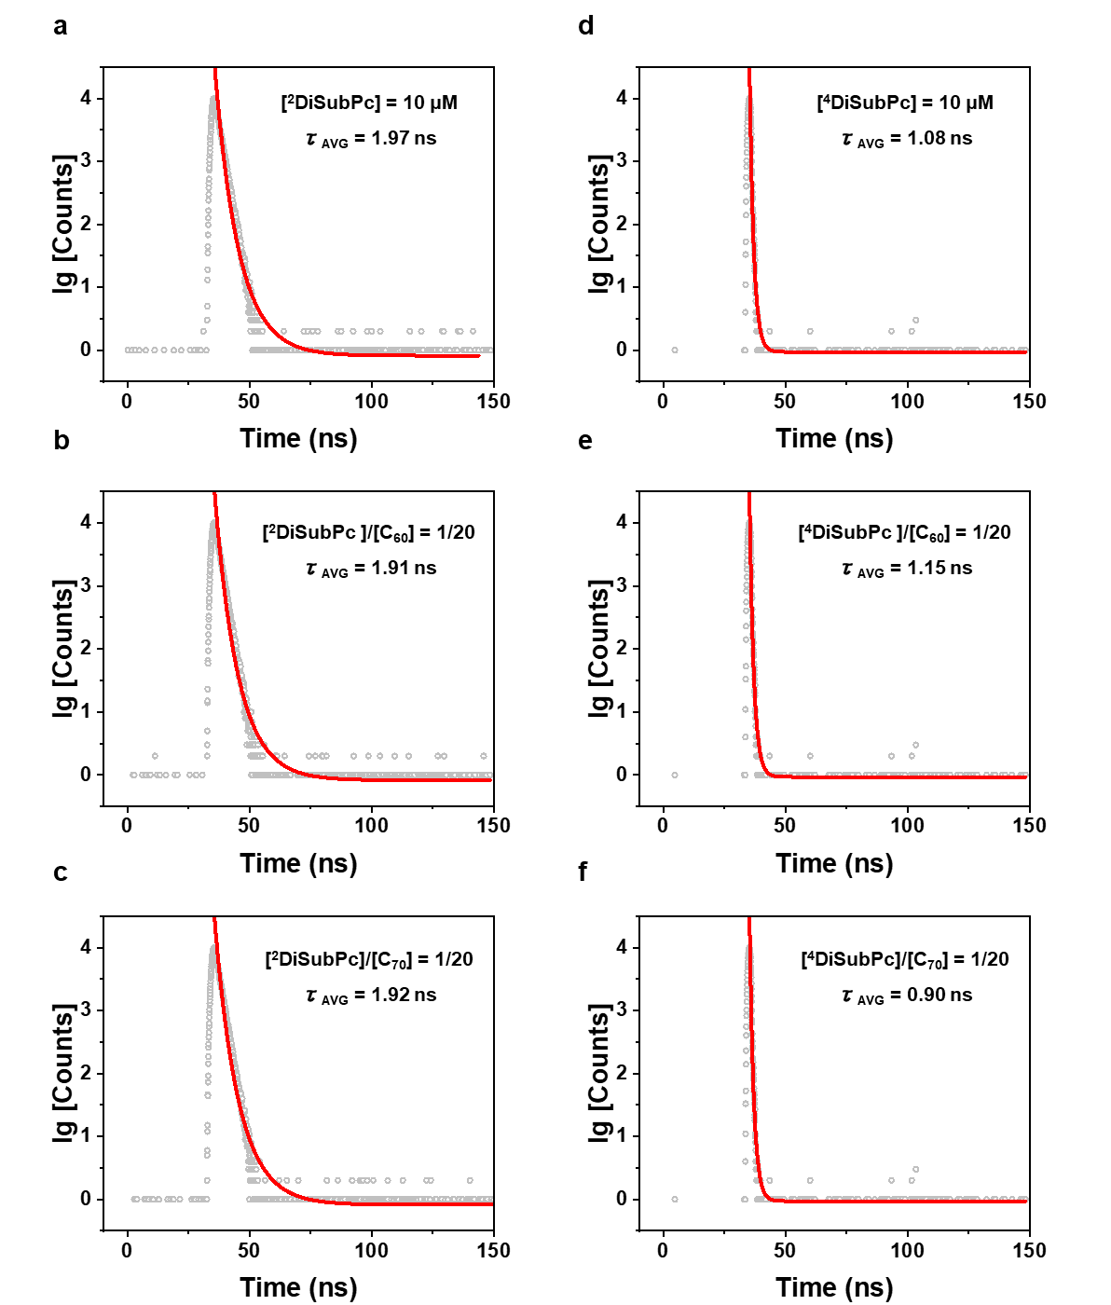
Figure S6. a–c) The fluorescence lifetime of ²DiSubPc (10.0 µM in Toluene) was measured a) without and with the addition of 20 equivalents of either b) C₆₀ or c) C₇₀. d–f) The fluorescence lifetime of ⁴DiSubPc (10.0 µM in Toluene) was measured d) without and with the addition of 20 equivalents of either e) C₆₀ or f) C₇₀. The fitted results are shown in red curves.
As showing in figure S4, the addition of fullerenes leads to a gradual quenching of the PL. In general terms, dynamic quenching (quenching agents and fluorophores collide) and static quenching (quenching agents and fluorophores form the non-fluorescent complex) are the two main causes of fluorescence quenching. The combination quenching effect can be described follows Stern-Volmer equation:
F₀/F = (1+K_{D}[Q]) (1+K_{B}[Q]) = 1+ (K_{D}+K_{B}) [Q]+K_{D}K_{B}[Q]²
where F₀ and F are the fluorescent intensity of the fluorophores DiSubPcs without and with quenching agent fullerene, K_{D} is the dynamic quenching constant, [Q] is the concentration of fullerene, K_{B} is the bimolecular binding constant. Considering the low concentration of [Q], [Q]² is small enough to be ignored. Since dynamic quenching always leads to changes in fluorescence lifetime, we tested the fluorescence lifetime of DiSubPcs solution in toluene before and after adding fullerene. Based on the almost identical fluorescence lifetimes, we judged that not dynamic quenching but static quenching leads to the fluorescence quenching, so the above equation could be estimated as:
F₀/F ≈ 1+K_{B}[Q]
Therefore, the slope of the above equation, gives the value of the binding constant between ²DiSubPc and C₆₀ (C₇₀).

Crystal packings
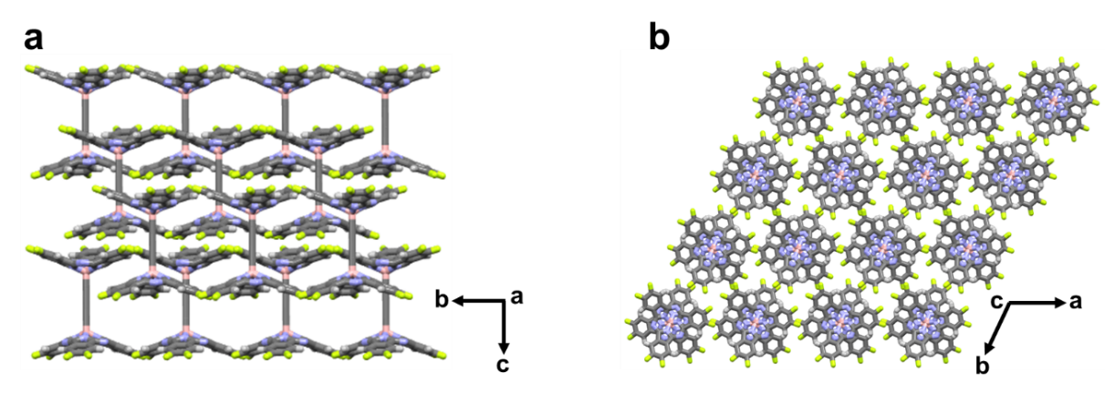
Figure S7. The view from a) a-axis and b) c-axis of ²DiSubPc single crystal.
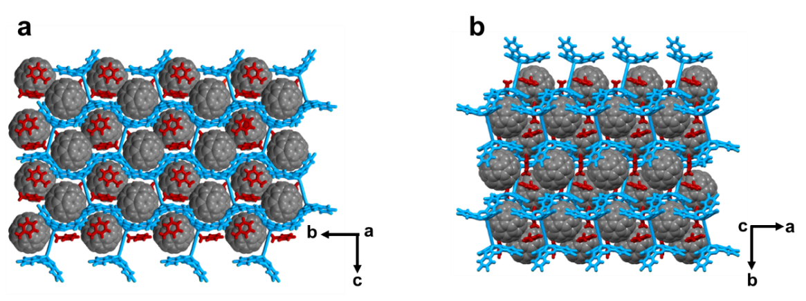
Figure S8. The view from a) a-axis and b) c-axis of ²DiSubPc-C₆₀ crystal.
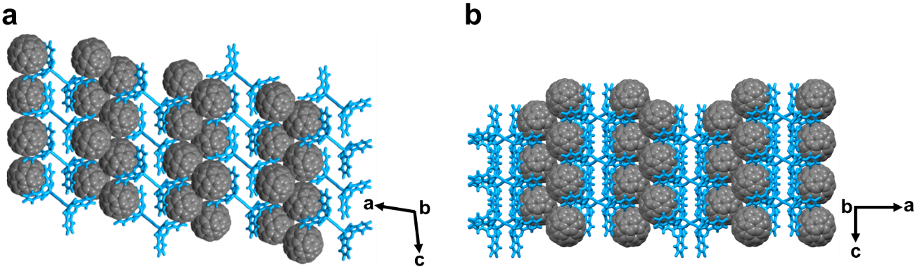
Figure S9. The view from a) a-axis and b) b-axis of ²DiSubPc-C₇₀ crystal.
Table S2. Crystallographic data of ²DiSubPc, ²DiSubPc-C₆₀ and ²DiSubPc-C₇₀
Crystals | ²DiSubPc | ²DiSubPc-C₆₀ | ²DiSubPc-C₇₀
Crystal System | Trigonal | Monoclinic | Monoclinic
Crystal Symmetry | D_{3d} | C_{2h} | C_{s}
Space Group | R$\overline{3}$c | P2₁/n | Cc
a [Å] | 13.3772(11) | 13.238(2) | 49.716(8)
b [Å] | 13.3772(11) | 25.513(3) | 11.0347(16)
c [Å] | 41.769(6) | 17.776(2) | 21.540(4)
α [ °] | 90 | 90 | 90
β [ °] | 90 | 92.285(5) | 103.506(8)
γ [ °] | 120 | 90 | 90
V [Å³] | 6473.14 | 5998.91 | 11490.1
R [%] | 9.59 | 13.35 | 23.67
Rw [%] | 6.18 | 21.71 | 25.31
B-B Distance [Å] | 6.96 | 6.95 | 6.90
Fullerene-SubPc Distance [Å] | - | 3.15 3.20 3.37  3.15 3.20 3.37 | 3.03 3.14 3.31  3.13 3.18 3.26

Theoretical calculations
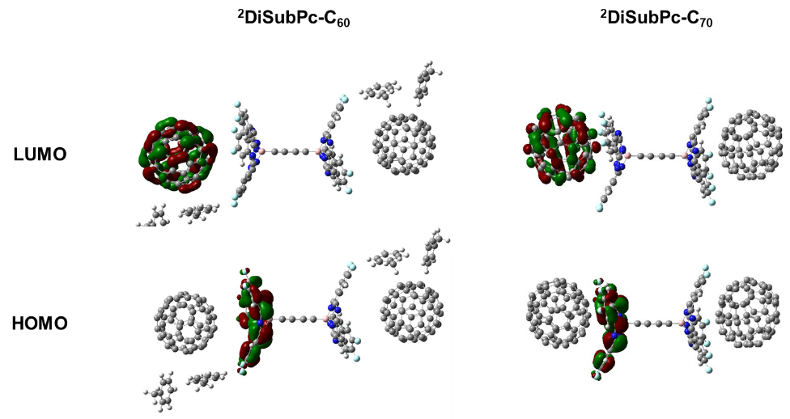
Figure S10. Calculated FMO distributions of ²DiSubPc-C₆₀ and ²DiSubPc-C₇₀.

Photophysical properties
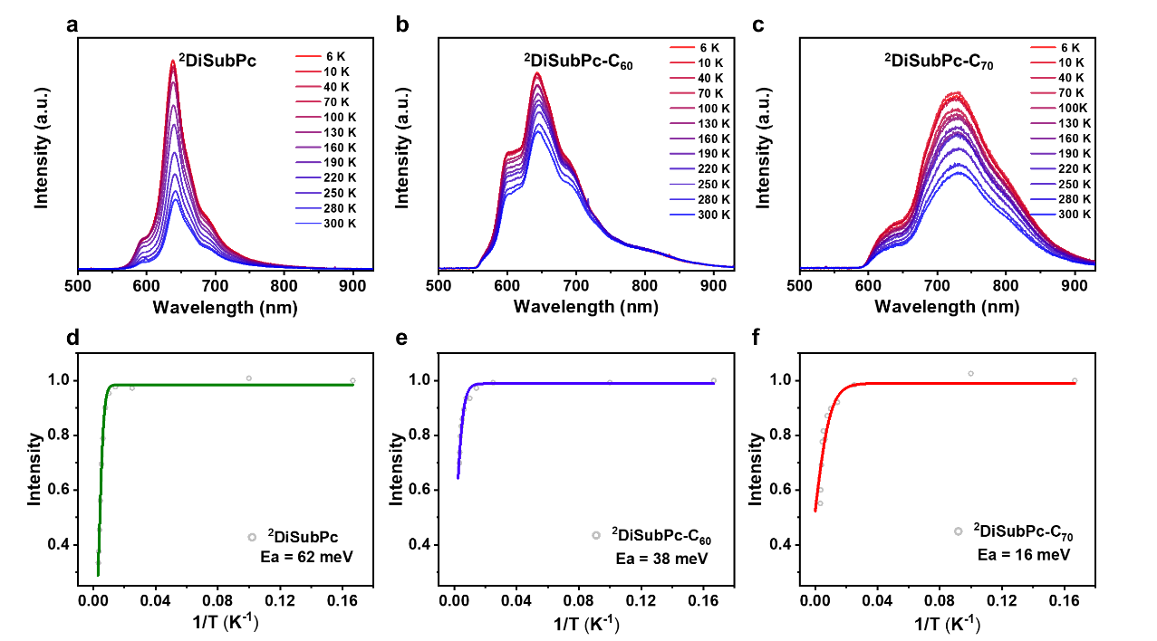
Figure S11. a-c) The temperature-dependent PL spectra from 6 K to 300 K, d-f) The corresponding integral of fluorescence intensity (black dots) employed for linear fitting, with the fitting curve and obtained activation energy displayed.
($I\left(T\right)=\frac{I\text{0}}{1+A·e^{-E_{a}/\left(k_{B}T\right)}}$)
In the equation, I(T) and I₀ refer to photoluminescence intensity of ²DiSubPc-C₇₀ in specific temperature and low temperature, A is the ratio factor, E_{a} is the activation energy of nonradiative process, k_{B} is the Boltzmann constant and T is the specific temperature.
Table S3. The PL lifetime of ²DiSubPcs, ²DiSubPcs-C₆₀ and ²DiSubPcs-C₇₀ in 300 K.
Samples | ²DiSubPc | ²DiSubPc-C₆₀ | ²DiSubPc-C₇₀
A₁ | 100% | 100% | 15.5%
τ₁ (ns) | 1.12 | 0.89 | 0.73
A₂ | - | - | 84.5%
τ₂ (ns) | - | - | 4.96

Photothermal conversion
Table S4. The photothermal properties of ²DiSubPcs-C₇₀ compared with previous organic solids in the literature.
Samples | Increased temperature (℃)/light intensity  (W cm⁻²) | Normalized increased temperature (℃) in 0.5 Wcm^{-2 [a]} | References
²DiSubPc-C₇₀ | 213/0.5 | 213 | This work
TCNQ-Tp-Py | 130/0.9 | 72 | Angew. Chem. Int. Ed. 2025, 64, e202413805
CF cocrystals | 60/0.276 | 109 | ACS. Nano. 2022, 16, 15000
TAHC | 60/0.5 | 60 | Angew. Chem. Int. Ed. 2022, 134, e202202571
TPP-2IND | 160/0.9 | 89 | Aggregate 2024, 5, e535
DDPA-PDN | 114/0.8 | 71 | Adv. Funct. Mater. 2021, 31, 2106247
FCDTDPP | 100/0.5 | 100 | Angew. Chem. Int. Ed. 2025, 64, e202418047
GDPA-QCN | 30/0.1 | 150 | Angew. Chem. Int. Ed. 2022, 61, e202117087
COF-Azu-TP | 200/1 | 100 | Small 2024, 20, 2307635
P(DPP)₄ | 115/0.8 | 72 | Dyes and Pigments 2021, 192, 109460
PPBBT | 48/0.8 | 30 | Nat. Commun. 2019, 10, 1192
CR-TPE-T | 100/0.8 | 63 | Adv. Mater. 2022, 34, 2108048
CR-DPA-T | 110/0.8 | 69 | Adv. Mater. 2020, 32, 1908537
[a] Assuming a linear correlation between the added temperature and light intensity, we give the value of the normalized temperature raise for these materials irradiated with the light of 0.5 W cm⁻².

References
(1).(a) Afraj, S. N., Jiang, B. H., Su, Y. W., Yang, C. H., Shih, H. S., Velusamy, A., Ni, J. S., Ezhumalai, Y., Su, T. Y., Liu, C. L., Yau, S., Chen, C. P., Chen, M. C., Dicyclopentadithienothiophene-based non-fullerene acceptors for ternary blend organic photovoltaics. J. Mater. Chem. C. 2024, 12, 2247-2257; (b) Bukuroshi, E., Vestfrid, J., Gross, Z., Bender, T. P., Fluorinated boron subphthalocyanines: Lewis acid based templating chemistry facilitates random halide exchange, and fluoride versus chloride affects the basic photophysical properties and the solid-state arrangement. New. J. Chem. 2019, 43, 16730-16737; (c) Bukuroshi, E., Petersen, A. U., Brolos, L., Bender, T. P., Nielsen, M. B., Exploring the synthesis and electronic properties of axially substituted boron subphthalocyanines with carbon-based functional groups. Eur. J. Inorg. Chem. 2020, 2020, 3481-3495.

¹H and ¹³C NMR spectra

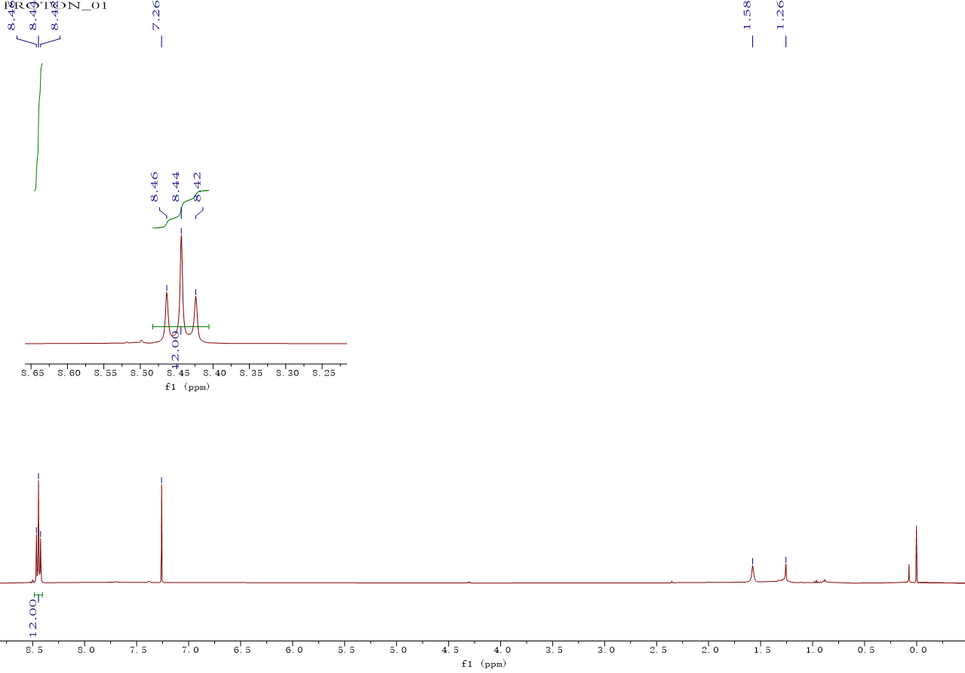
Figure S12. ¹H-NMR and ¹³C-NMR spectra of ²DiSubPc
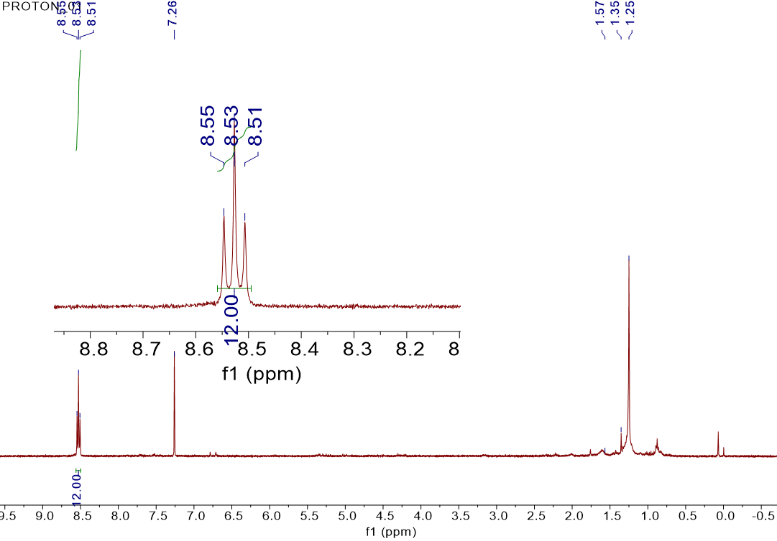

Figure S13. ¹H-NMR and ¹³C-NMR spectra of ⁴DiSubPc

