SUPPLEMENTARY MATERIAL

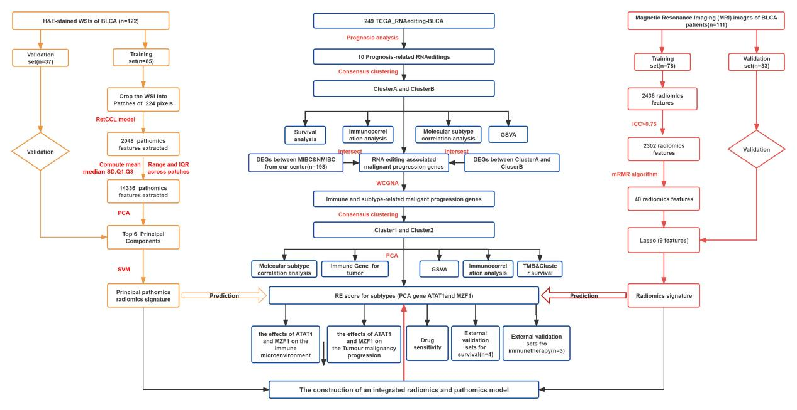
Supplementary Figure 1. The flow chart of this study.
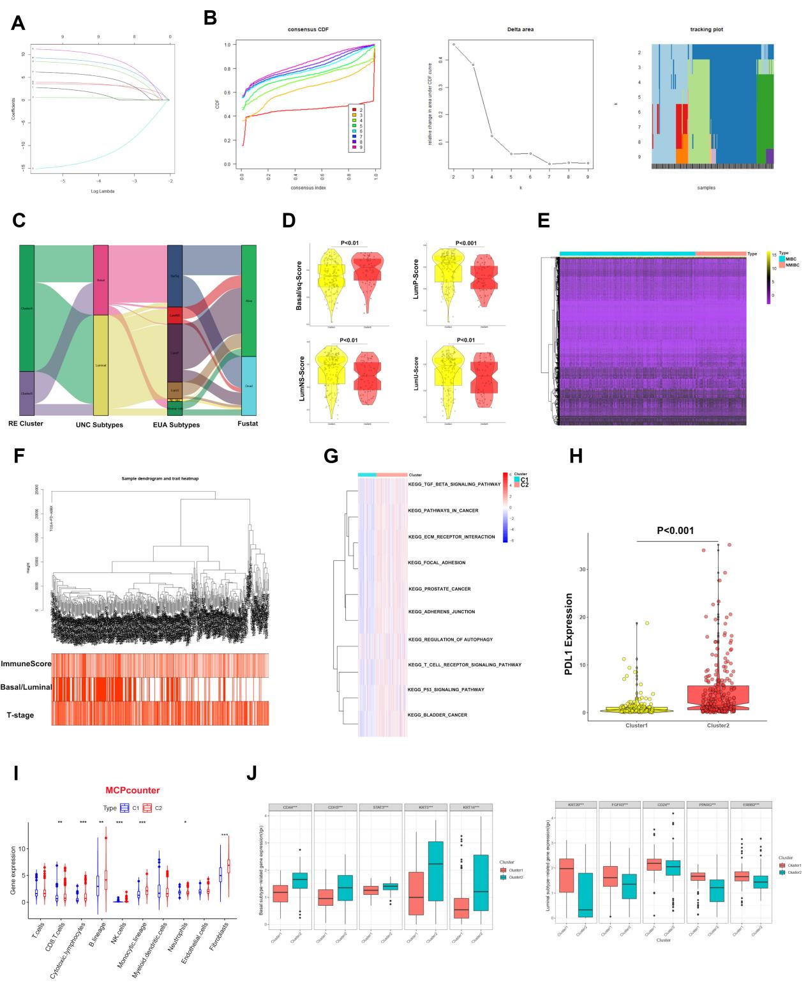
Supplementary Figure 2. Exploring the molecular characterization of RE-related subtype in BCa. (A) The result of LASSO analysis. (B) The result of consensus clustering, and Bca patients were divided into Cluster A and Cluster B. (C) Correlations between RE clusters and classical molecular subtype classifications. (D) Correlation analysis in RE-related subtypes and EUA subtype scores, p value calculated using the Wilcoxon-test. (E) Heat map showing expression clustering of differential genes between tumor and normal samples. (F) Clustering dendrogram of TCGA-BCa samples. (G) The GSVA indicates the KEGG pathway involved in cluster1 and cluster2. (H) The expression level of PD-L1 in difference clusters. (I) The infiltration levels of TIICs between RE clusters in the MCPcounter algorithms.The asterisks indicate a statistically significant p value calculated using the t-test or Mann-Whitney U (J) The expression of marker genes of subtypes Basal and Luminal. (*P < 0.05; **P < 0.01; ***P < 0.001; ****P < 0.0001).

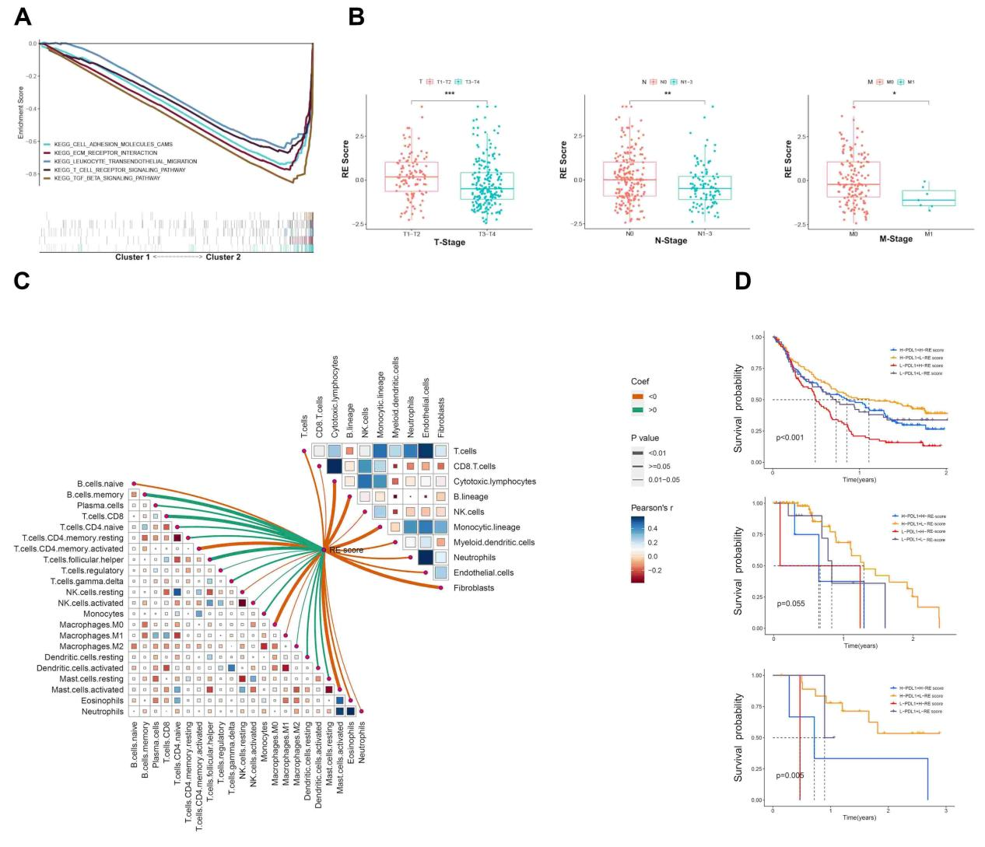
Supplementary Figure 3. Exploring the clinical characterization of RE-related subtypes in BCa. (A) Results of KEGG analysis of principal component genes in the Low RE group. (B) Correlation analysis between RE score and clinical characteristics. (C) The lower left part indicates the correlation between RE scores and TIICs in the ssGSEA algorithm; the upper right part indicates the correlation between RE scores and TIICs in the MCPcounter algorithm in STPH cohort. (D) The survival analysis in patient (including IMvigor210C, GSE78220, GSE176307) with different RE score and PD-L1 expression.
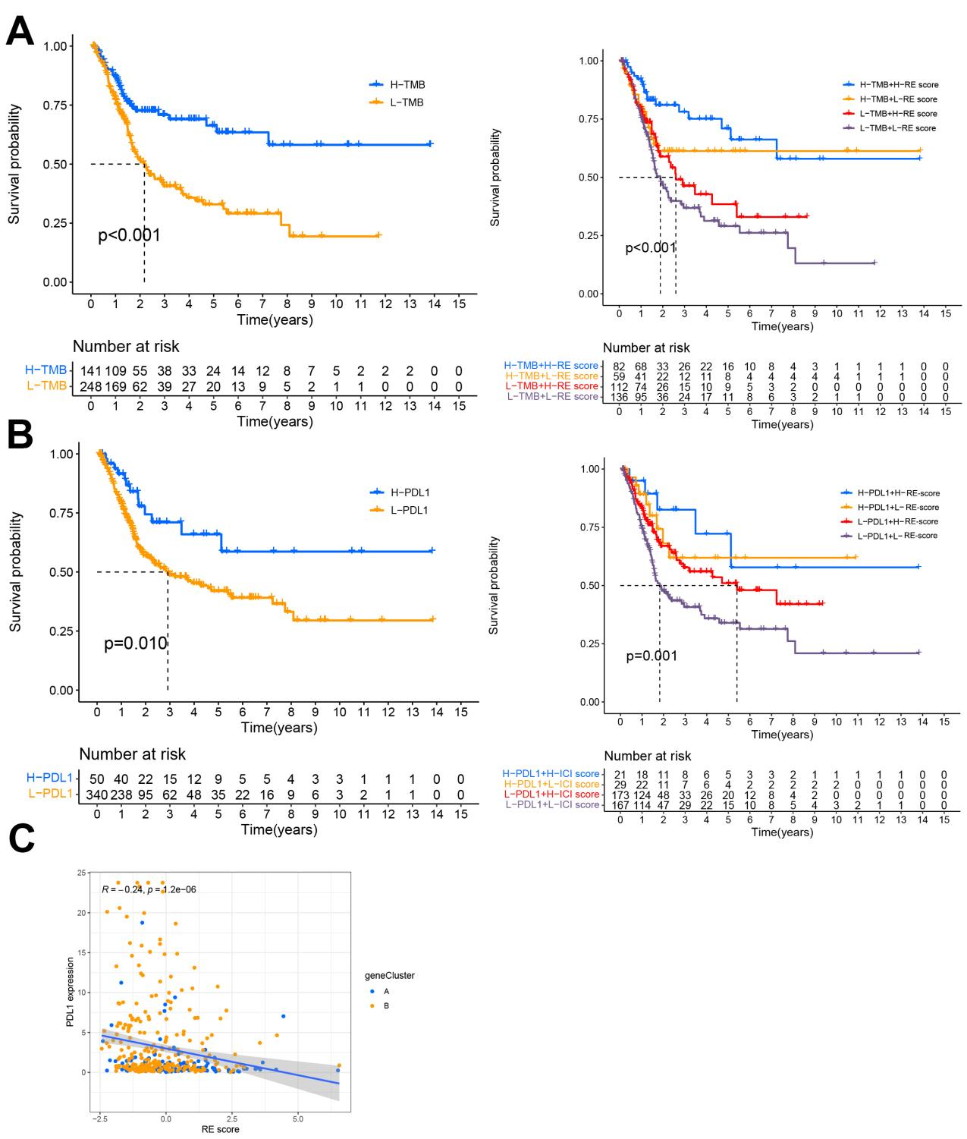
Supplementary Figure 4. Combined prognostic analysis of PD-L1, TMB and RE score. (A) The prognostic analysis of TMB in TCGA-BCa cohort. (B) The combined prognostic analysis of TMB and RE score. (C) The prognostic analysis of PD-L1 in TCGA-BCa cohort. (D) The combined prognostic analysis of PD-L1 and RE score. (E) The correlation analysis of PD-L1 and RE score.

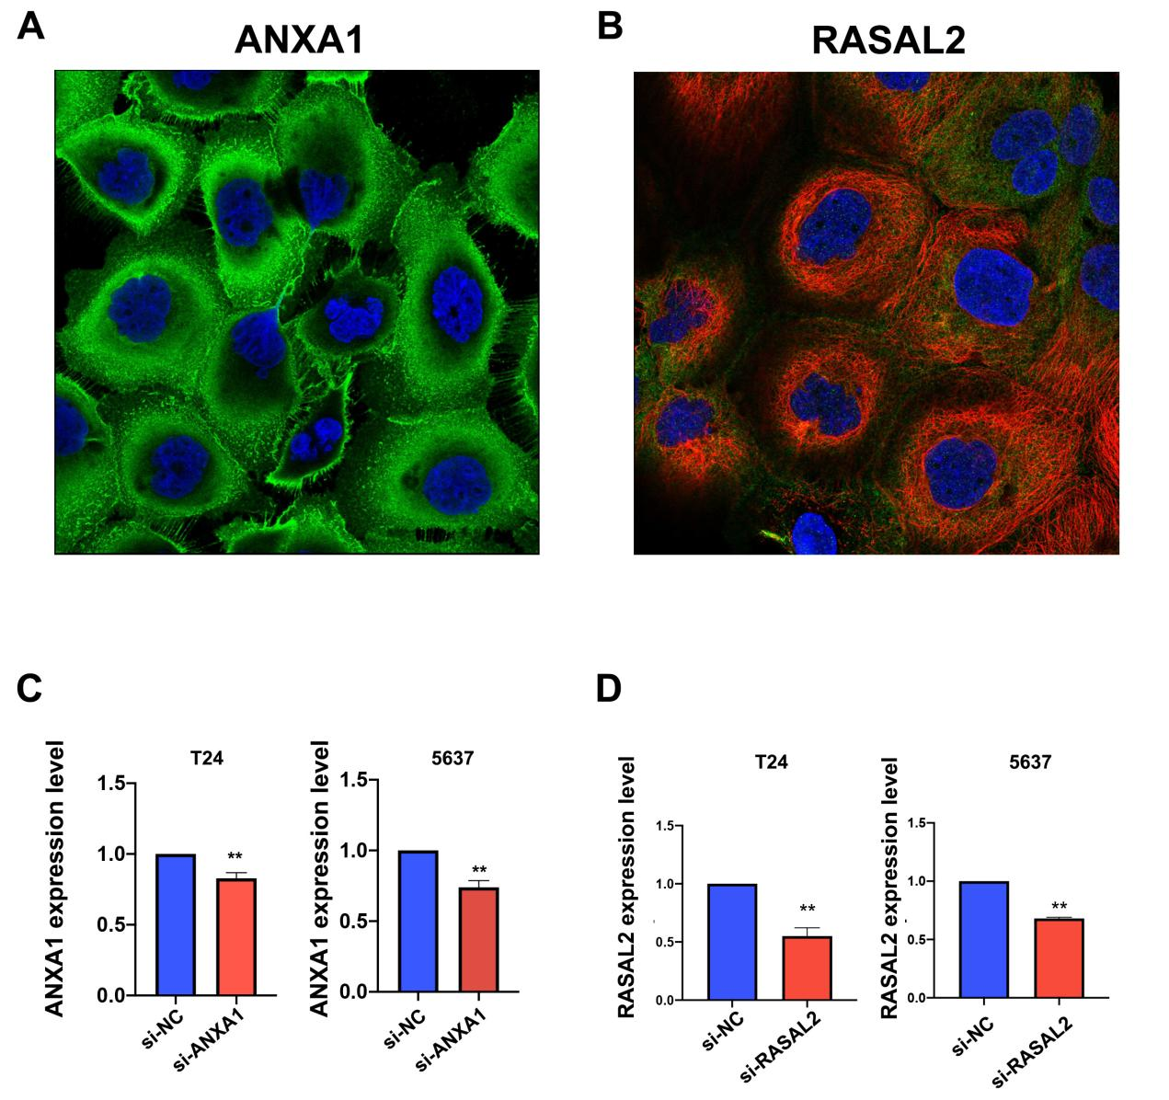
Supplementary Figure 5. Validation of knockdown efficiency of si-RASAL2 and si-ANXA1. (A-B) Immunofluorescence results demonstrating the location of RASAL2 and ANXA1 expression in cells. (C-D) RT-Qpcr validation of knockdown efficiency of si-RASAL2 and si-ANXA1.

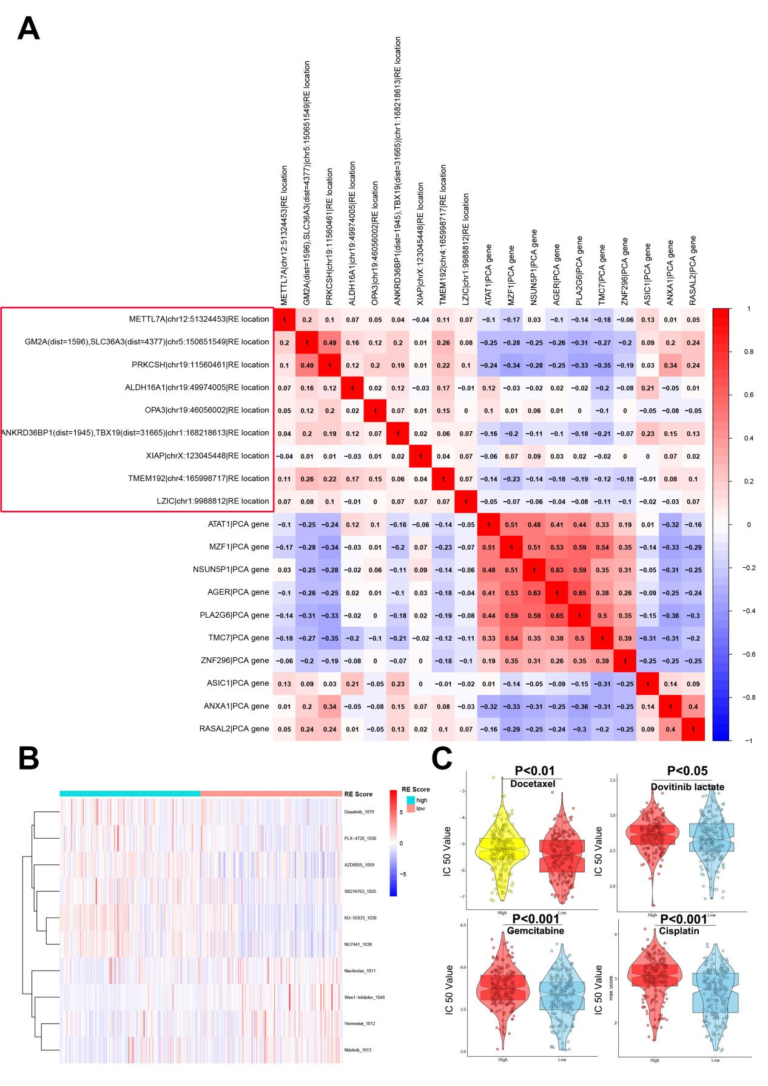
Supplementary Figure 6. Drug sensitivity analysis based on RE scores. (A) The correlation analysis of prognosis related AIRE sites with PCA genes. (B) High RE score samples were more sensitive to Dasatinib, PLX-4720, and AZD8005, while low RE score samples were more sensitive to Navitoclax, Wee1-inhibitor, and Vorinostat.(C) Low RE score samples also showed greater sensitivity to gemcitabine, cisplatin, docetaxel, and paclitaxel.
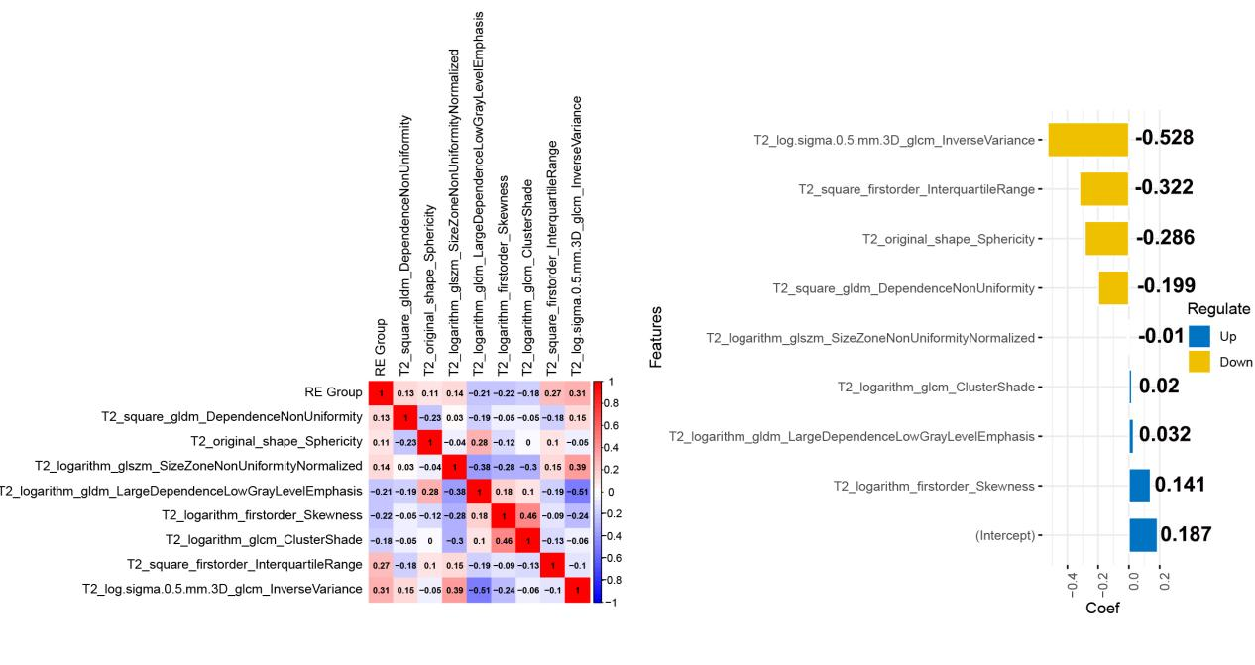
Supplementary Figure 7. Correlation analysis of radiomic features and RE score. (A) Correlation analysis of radiomic features and RE score. (B) The coef of different radiomic features in LASSO signature.
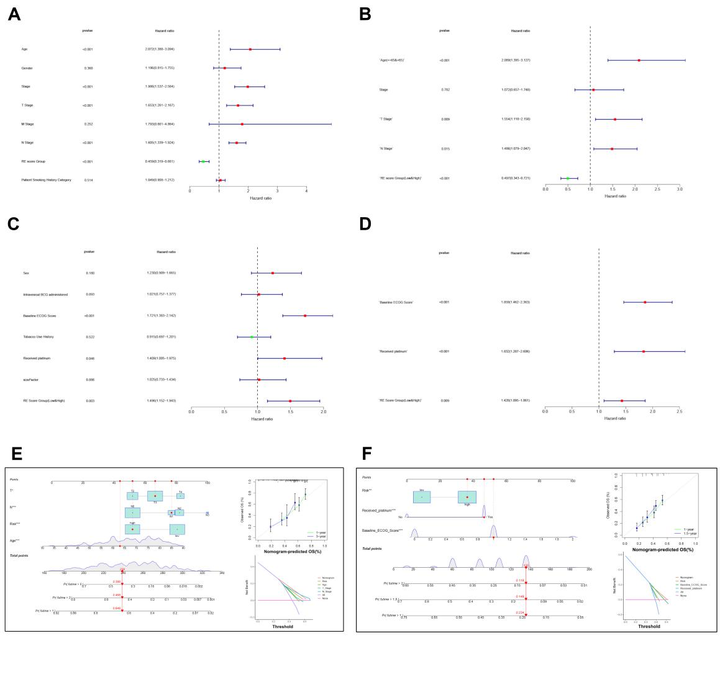
Supplementary Figure 8. Constructing a Nomogram to Predict Prognosis of ICI Treatment for Bladder Cancer. (A-B) Unicox and multicox analysis of patient clinical characteristics in TCGA-BCa cohort.(C-D) Unicox and multicox analysis of patient clinical characteristics in IMvigor210C cohort. (E) Constructing a Nomogram to Predict Prognosis in BCa Patients in the TCGA Cohort. (F) Constructing a Nomogram to Predict Prognosis in BCa Patients in the IMvigor210C Cohort.

Gene | Primer sequences
RASAL2-F | ACAGACACAGCAGGTTCAGT
RASAL2-R | AGCAAGCGGCGTTCATATTC
ANXA1-F | GCGGTGAGCCCCTATCCTA
ANXA1-R | TGATGGTTGCTTCATCCACAC
ASIC1-F | CGAAGCAGGCATCAAAGTGC
ASIC1-R | TTTGGATGATAGGGAGCCACG
AGER-F | TACCGAGTCCGTGTCTACCAGATTC
AGER-R | CCATCCAAGTGCCAGCTAAGAGTC
CXCL8-F | ACTGAGAGTGATTGAGAGTGGAC
CXCL8-R | AACCCTCTGCACCCAGTTTTC
CXCL2-F | TTGTCTCAACCCCGCATCG
CXCL2-R | CAGTTGGATTTGCCATTTTTCAG
CXCL11-F | GACGCTGTCTTTGCATAGGC
CXCL11-R | GGATTTAGGCATCGTTGTCCTTT
GAPDH-F | GAGCGAGATCCCTCCAAAAT
GAPDH-R | GGCTGTTGTCATACTTCTCATGG

Table S1. The list of primer sequences .

Name | Brand | Number
GAPDH | Abcam | ab8245
p65 | HUABIO | # ET1603-12
p50 | HUABIO | # ET1603-18
H3 | HUABIO | # ET1701-64
Table S2: The detail of antibody

SUPPLEMENTARY METHODS

Data processing software
The Flow chart shown in the Supplementary Figure 1. R version 4.2.0 (Action of the Toes) with Strawberry Perl version-5.30.0 (64-bit) (URL: https://www.perl.org/) was used in this study. All R packages were sourced from public websites and downloaded from Bioconductor (URL: http://www.bioconductor.org/). All statistical and data processing software is open source and can be downloaded at the URL provided above.
Identification of mRNAs with differential expression
EDGER R package (http://bioconductor.org/package/EDGER/) wasapplied to screen the differential expressed genes (DEGs) between normal and tumor samples in the TCGA-BCa as well as between MIBC and NMIBC samples from our center. After normalization of the raw data, the differences of genes expression between two types of samples were analyzed with false discovery rate (FDR) < 0.01 and log2 |fold change| > 1. Prognosis-related genes were selected according to tumor invasiveness (NMIBC vs. MIBC) and RE-related genes via Venn diagram.
Weighted gene co-expression network approach (WGCNA)
Based on the "WGCNA" R package v1.67, gene co-expression networks were constructed based on the Basal/Luminal grouping, Immune score, and T-stage. First, To calculate Pearson correlation coefficients, all paired genes with similar co-expression were compared on the basis of their co-expression importance. The appropriate β value(0.9) was chosen to establish the scale-free network. After this, a topological overlap matrix (TOM) was generated, which measures how well networks are connected. An estimated gene dendrogram was created, similar modules with with correlations >0.7 were ombined. As a last step, the TOM's difference measure was performed to group genes that have similar expression profiles into modules. Module eigengenes (ME) constitute the expression pattern of all genes. The module with the highest association with three indicators (P<0.05) was selected for further analysis.
Enrichment Analysis
Biological pathways between clusters were explored by gene set variation analysis (GSVA). GO (Gene Ontology) describes biological processes(BP), molecular functions(MF), and cellular components(CC) of genes The Kyoto Encyclopedia of Genes and Genomes (KEGG) were used to annotate involved pathways. Furthermore, the FDR threshold (0.05) was applied to c5.cp.kegg.v5.2.symbols.gmt, which is the reference gene set.
Construction of Nomogram
To predict BCa patients’ prognoses based on RE score and other clinical factors, univariate and multivariate Cox regression analyses were performed. Calibration plots and consistency index (C-index) were used to validate the nomogram.
Transwell assay
Polyester membrane cell embedding dishes with 24-well plates (Insert: 8.0um; diameter: 6.5mm, JET, China) were used to test cells' invasion and migration ability. 6 × 10⁴ cells were inoculated into the upper chamber covered with 200 mg/mL Matrigel (1:8, Yepsen, China) and resuspended using a serum-free DMEM medium. Basolateral chambers were then filled with DMEM medium containing 10% FBS. Matrigel-invaded cells were fixed with 90% ethanol for 10 minutes for 15 minutes and stained with 0.5% crystal violet after 16 hours of incubation.. Then five randomly selected fields of view were selected and counted, and this experiment was repeated three times.
Real time quantitative PCR (RT-qPCR)
In accordance with the manufacturer's instructions, total RNA of cells was extracted with TRIzol® reagent (Thermo Fisher Scientific, Inc, USA).. RT-qPCR was conducted using SYBR®Green PCR Master Mix Reagents (Applied Thermo Scientific) in the 7900HT Fast Real-Time PCR System following the recommended protocols . GAPDH was applied as a control for calculating the normalization of relative mRNA expressions. The 2-ΔΔCt method was used to analyze the results. The list of prime was shown in Table S1
Western Blot Analysis
Total protein was extracted using SDS lysis buffer (Beyotime, Nantong, China), and protein concentration was quantified using the BCA Protein Assay Kit (Beyotime, Nantong, China). Equal amounts of protein (40 μg per lane) were separated on 12% SDS-PAGE gels and transferred onto polyvinylidene fluoride (PVDF) membranes (Millipore, Burlington, MA, USA). Membranes were blocked in 5% non-fat milk at room temperature to reduce non-specific binding. Subsequently, membranes were incubated with primary antibodies overnight at 4°C. The following day, membranes were washed three times with PBST (10 minutes per wash) and then incubated with corresponding HRP-conjugated secondary antibodies for 1 hour at room temperature. After a second round of washing (three times, 10 minutes each), protein bands were visualized using a silver stain detection system (Beyotime, Nantong, China). Details of the antibodies used for this assay are provided in Supplementary Table S2.

