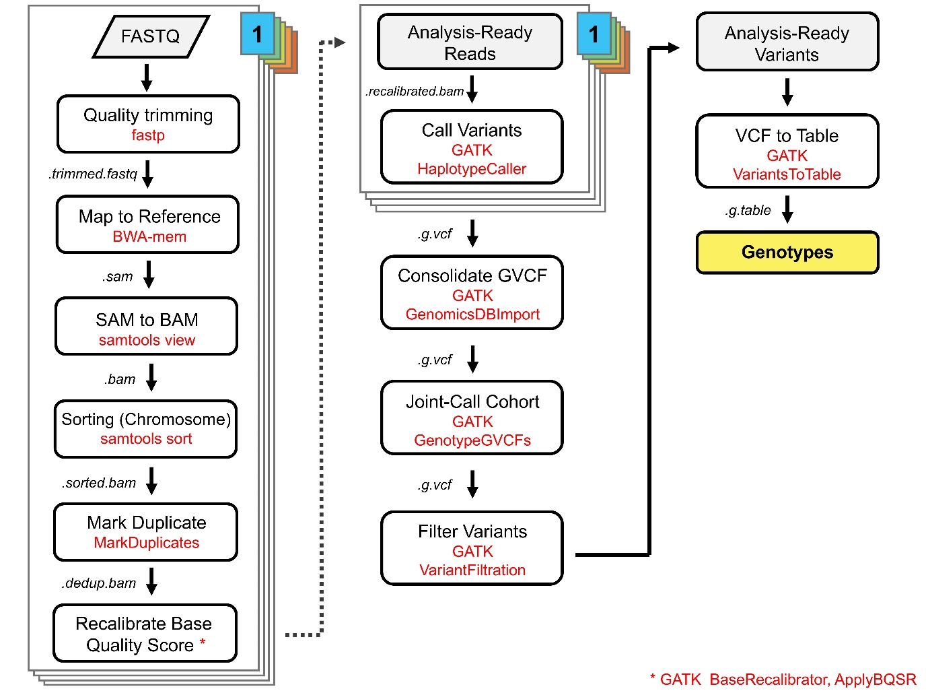
Supplementary Fig. S1. Diagram of NGS data analysis pipeline for SNP genotyping. The analysis followed the GATK best practices. The names of the tools used are shown in red letters.

Supplementary Fig. S2. Genotype recovery rates for X, Y SNPs of g DNA and PTA DNA across different input amounts. Left and right panels show results for gDNA and PTA DNA, respectively. The box plot shows medians, interquartile ranges (IQRs), and individual data points. At the same input, PTA DNA consistently showed higher genotype recovery rates and lower variability than gDNA.

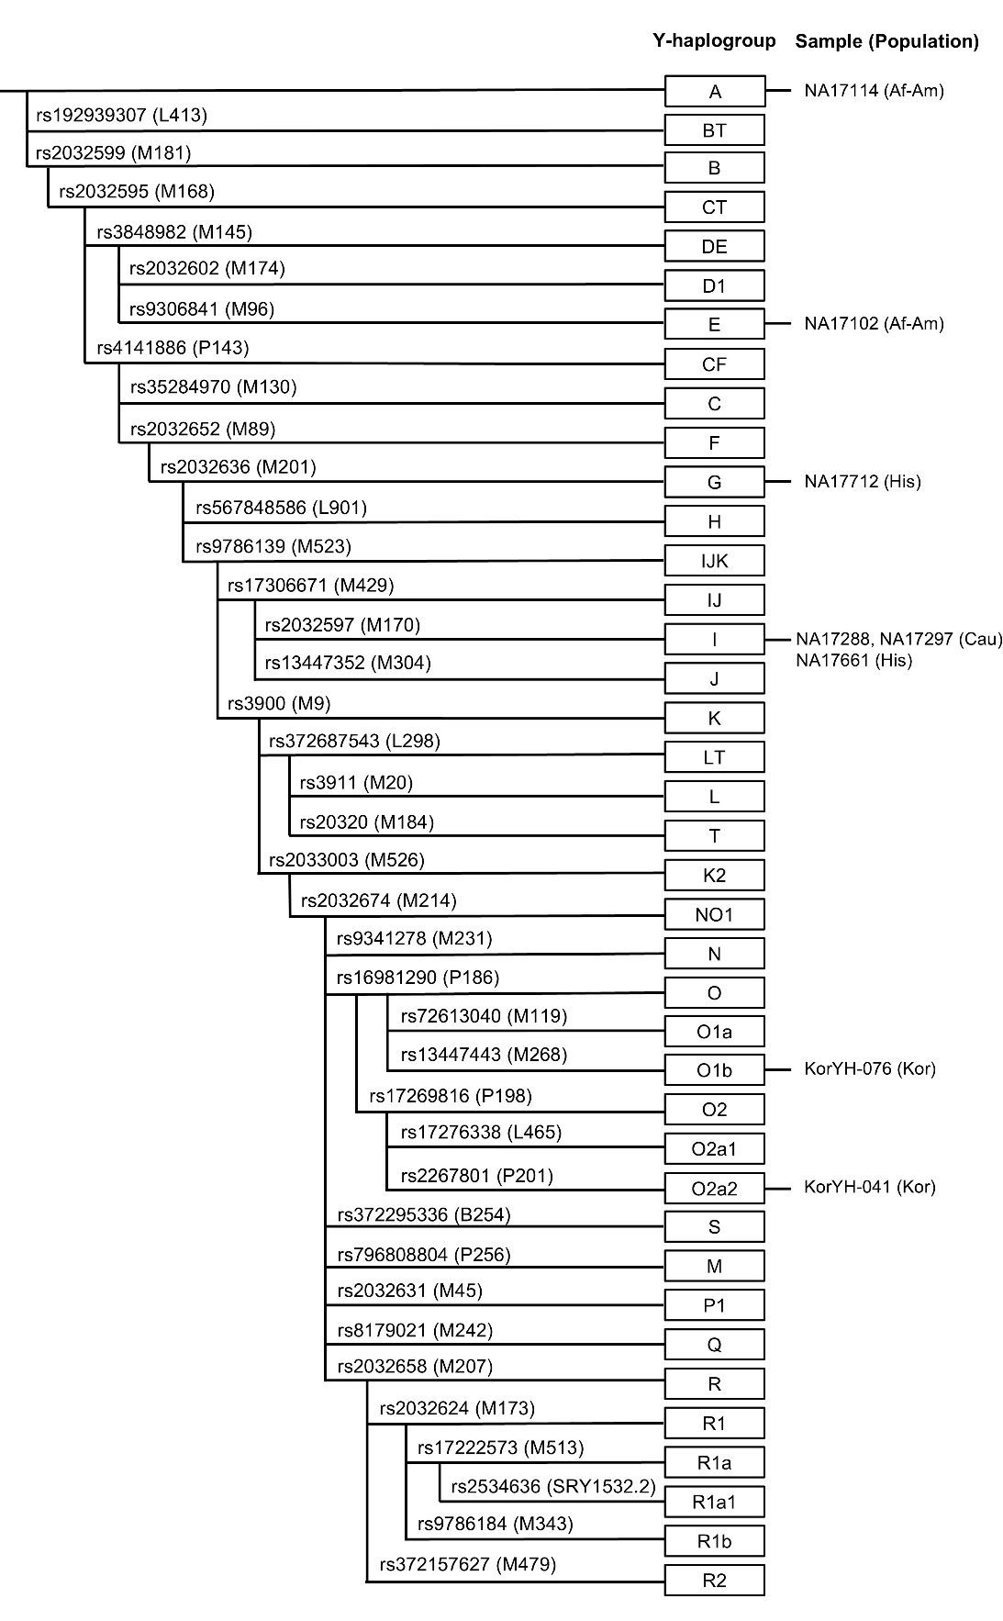
Supplementary Fig. S3. Y-haplogroup tree and haplogroup assignment based on 38 Y SNPs. Each branch represents a Y SNP (rs number), and haplogroup designations follow their respective mutations. The right column displays the samples used in this study and the populations of each sample. Abbreviations for populations are Af-Am, African-American; Cau, Caucasian; His-Hispanic; Kor, Korean.

