Supplementary Materials

Sensitivity analysis using interrupted time series analysis
Interrupted time series analysis was applied to assess volume changes of cancer surgeries in the rates per month over the baseline period (January 2019 to January 2024) and the period of strike (February 2024 to July 2024). To account for monthly patterns in the data (e.g., seasonality), we included a categorical fixed effect for each calendar month in the model.
Accordingly, the model to estimate the volume changes of cancer surgery was as follows:
$$Y_{t}= β_{0}+ β_{1}× time before intervention + β_{2}× intervention \left(i\right) +{ β}_{3}× time after intervention + β_{4}× month+ ε_{t}$$
where, $Y_{t}$ represents the monthly rates of cancer surgeries for each cancer, where t indicates time in months, and intervention is a binary variable coded as 0 (pre-strike) or 1 (post-strike). $β_{0}$ indicates the baseline level of the surgery, $β_{1}$ indicates the pre-strike trend, $β_{2}$ indicate the level changes in cancer surgeries following the strike, $β_{3}$ indicates the slope change in post-strike, and $β_{4}$ is for adjusts for monthly seasonal pattern. $ε_{t}$ is the error term. Statistical significance was considered at a p-value less than 0.05.

Supplementary Table 1. Cancer surgery and consultation based on the International Classification of Diseases, Tenth Revision
Type of cancer | Diagnosis for consultation | Surgery
Thyroid cancer | C73; Thyroid cancer  D0930; Carcinoma in situ, thyroid cancer | P4551; Total hemithyroidectomy, left or right  P4552; Total thyroidectomy, left and right (bilateral)  P4553; Subtotal hemithyroidectomy, left or right  P4554; Subtotal hemithyroidectomy, left and right (bilateral)  P4561; Radical operation of malignant thyroid neoplasm  P4543; Parathyroidectomy, malignant
Gastric cancer | C16; Stomach cancer  D002; Carcinoma in situ, stomach | QA536, Q2533, Q2534, Q2536, Q2537; Total gastrectomy with and without LN dissection  Q2550, Q2551, Q2552; Vagotomy  Q2561, Q2562; Pyloroplasty  Q2571; Gastroduodenostomy  Q2572; Gastrojejunostomy  Q2573; Roux-en-Y operation  Q0259, Q2594, Q0251, Q0252, Q0253, Q0254, Q0255, Q0256, Q0257, Q0258, Q2598; Subtotal gastrectomy with and without lymph node (LN) dissection
Lung cancer | C34; Malignant neoplasm of lung and bronchus  D022; Carcinoma in situ of lung and bronchus | Q1401; Wedge resection of lung, single  Q1403; Wedge resection of lung, 2–3  Q1404; Wedge resection of lung, 4–5  Q1405; Wedge resection of lung, ≥ 6  Q1410; Segmentectomy of lung  Q1421; Lobectomy of lung, single  Q1422; Bilobectomy of lung  Q1423; Lobectomy and segmentectomy  Q1424; Sleeve lobectomy  Q1431; Pneumonectomy  Q1432; Sleeve pneumonectomy  Q1450; Lung decortication  Q1471; Cryosurgical ablation of lung cancer
Colorectal cancer | C18; Malignant neoplasm of colon  C19; Malignant neoplasm of recto-sigmoid junction  C20; Malignant neoplasm of rectum  D010; Carcinoma in situ, rectum  D011; Carcinoma in situ, recto-sigmoid junction | QA671 & Q2671; Hemicolectomy with and without LN dissection, left or right  QA672 & Q2672; Total colectomy with and without LN dissection  QA673 & Q2673; Partial colectomy with and without LN dissection  QA679 & Q2679; Colectomy with colostomy [Hartman operation] with and without LN dissection  Q1261 & Q1262; Partial colectomy, left and right or left and sigmoid colon  Q2890, Q2891, Q2892, Q2893; Proctectomy  QA921 & Q2921; Anterior resection with and without LN dissection  QA922 & Q2922; Lower anterior resection with and without LN dissection  QA923 & Q2923; Abdominoperineal resection with and without LN dissection  Q0292 & QA928 & Q2928; Ultra-lower anterior resection with and without LN dissection  QA925 & QA926; Total proctocolectomy with and without LN dissection

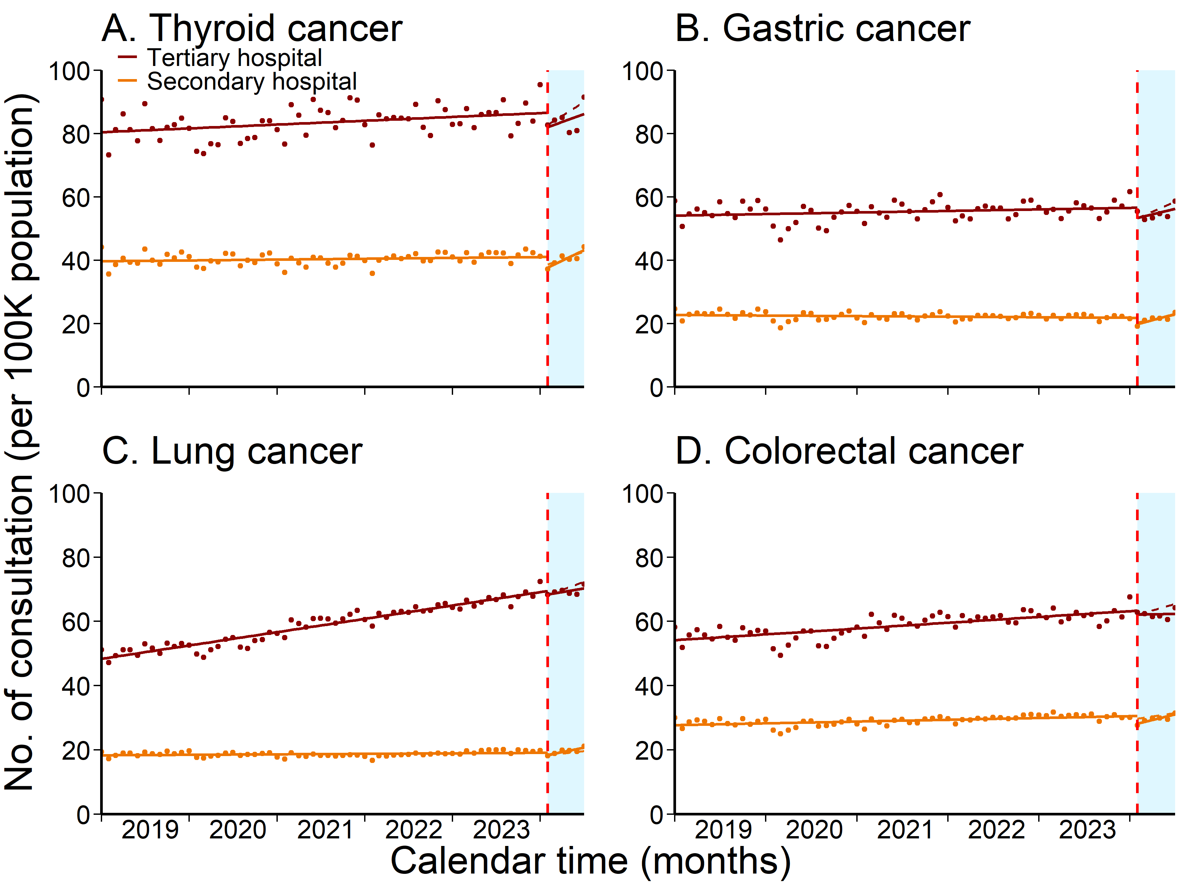Supplementary Figure 1. Monthly number of consultations per 100,000 population in South Korea, during January 2019 – July 2024 for thyroid (A), gastric (B), lung (C), and colorectal cancer (D). The vertical dashed lines indicate February 2024 (i.e., the resident physicians' strike started), and the blue shaded region indicates the period during the strike.

