Content of Supplementary

Tables in Supplementary
Table S1. PRISMA 2020 Checklist.
Table S2. Search strategies for each database.
Table S3. Characteristics of the included 70 RCTs.
Table S4. Meta-regression of DCR.
Table S5. Meta-regression of ORR.
Table S6. Meta-regression of QoL.
Table S7. Meta-regression of SAEs.

Figures in Supplementary
Figure S1. Risk of bias for each included RCT.
Figure S2. Forest plot on ORR.
Figure S3. Forest plot on QoL.
Figure S4. Forest plot on 0.5-year survival rates.
Figure S5. Forest plot on 1-year survival rates.
Figure S6. Forest plot on 2-year survival rates.
Figure S7. Forest plot on changes in CD3⁺ T cells.
Figure S8. Forest plot on changes in CD4⁺ T cells.
Figure S9. Forest plot on changes in CD8⁺ T cells.
Figure S10. Forest plot on changes in CD4⁺/CD8⁺ ratio.
Figure S11. Forest plot on SAEs.
Figure S12. Forest plot on leukopenia.
Figure S13. The funnel plot of the DCR with the trim-and-fill method.
Figure S14. The funnel plot of the ORR with the trim-and-fill method.
Figure S15. The funnel plot of the QoL with the trim-and-fill method.
Figure S16. The funnel plot of the SAEs with the trim-and-fill method.

Table S1. PRISMA 2020 Checklist.

Topic | No. | Item | Location where item is reported
TITLE
Title | 1 | Identify the report as a systematic review. | 1
ABSTRACT
Abstract | 2 | See the PRISMA 2020 for Abstracts checklist | 5
INTRODUCTION
Rationale | 3 | Describe the rationale for the review in the context of existing knowledge. | 6 - 7
Objectives | 4 | Provide an explicit statement of the objective(s) or question(s) the review addresses. | 6 - 7
METHODS
Eligibility criteria | 5 | Specify the inclusion and exclusion criteria for the review and how studies were grouped for the syntheses. | 8 - 9
Information sources | 6 | Specify all databases, registers, websites, organisations, reference lists and other sources searched or consulted to identify studies. Specify the date when each source was last searched or consulted. | 8
Search strategy | 7 | Present the full search strategies for all databases, registers and websites, including any filters and limits used. | 8
Selection process | 8 | Specify the methods used to decide whether a study met the inclusion criteria of the review, including how many reviewers screened each record and each report retrieved, whether they worked independently, and if applicable, details of automation tools used in the process. | 8 - 11
Data collection process | 9 | Specify the methods used to collect data from reports, including how many reviewers collected data from each report, whether they worked independently, any processes for obtaining or confirming data from study investigators, and if applicable, details of automation tools used in the process. | 8 - 11
Data items | 10a | List and define all outcomes for which data were sought. Specify whether all results that were compatible with each outcome domain in each study were sought (e.g. for all measures, time points, analyses), and if not, the methods used to decide which results to collect. | 10 - 11
 | 10b | List and define all other variables for which data were sought (e.g. participant and intervention characteristics, funding sources). Describe any assumptions made about any missing or unclear information. | 8 - 11
Study risk of bias assessment | 11 | Specify the methods used to assess risk of bias in the included studies, including details of the tool(s) used, how many reviewers assessed each study and whether they worked independently, and if applicable, details of automation tools used in the process. | 10
Effect measures | 12 | Specify for each outcome the effect measure(s) (e.g. risk ratio, mean difference) used in the synthesis or presentation of results. | 10 - 11
Synthesis methods | 13a | Describe the processes used to decide which studies were eligible for each synthesis (e.g. tabulating the study intervention characteristics and comparing against the planned groups for each synthesis (item 5)). | 8 - 9
 | 13b | Describe any methods required to prepare the data for presentation or synthesis, such as handling of missing summary statistics, or data conversions. | 10 - 11
 | 13c | Describe any methods used to tabulate or visually display results of individual studies and syntheses. | 10 - 11
 | 13d | Describe any methods used to synthesize results and provide a rationale for the choice(s). If meta - analysis was performed, describe the model(s), method(s) to identify the presence and extent of statistical heterogeneity, and software package(s) used. | 10 - 11
 | 13e | Describe any methods used to explore possible causes of heterogeneity among study results (e.g. subgroup analysis, meta - regression). | 10 - 11
 | 13f | Describe any sensitivity analyses conducted to assess robustness of the synthesized results. | 10 - 11
Reporting bias assessment | 14 | Describe any methods used to assess risk of bias due to missing results in a synthesis (arising from reporting biases). | 10 - 11
Certainty assessment | 15 | Describe any methods used to assess certainty (or confidence) in the body of evidence for an outcome. | 10 - 11
RESULTS
Study selection | 16a | Describe the results of the search and selection process, from the number of records identified in the search to the number of studies included in the review, ideally using a flow diagram. | 11 - 12
 | 16b | Cite studies that might appear to meet the inclusion criteria, but which were excluded, and explain why they were excluded. | 11 - 12
Study characteristics | 17 | Cite each included study and present its characteristics. | 11 - 12
Risk of bias in studies | 18 | Present assessments of risk of bias for each included study. | 12
Results of individual studies | 19 | For all outcomes, present, for each study: (a) summary statistics for each group (where appropriate) and (b) an effect estimate and its precision (e.g. confidence/credible interval), ideally using structured tables or plots. | 12 - 15
Results of syntheses | 20a | For each synthesis, briefly summarise the characteristics and risk of bias among contributing studies. | 12 - 15
 | 20b | Present results of all statistical syntheses conducted. If meta - analysis was done, present for each the summary estimate and its precision (e.g. confidence/credible interval) and measures of statistical heterogeneity. If comparing groups, describe the direction of the effect. | 12 - 15
 | 20c | Present results of all investigations of possible causes of heterogeneity among study results. | 14 - 15
 | 20d | Present results of all sensitivity analyses conducted to assess the robustness of the synthesized results. | 14 - 15
Reporting biases | 21 | Present assessments of risk of bias due to missing results (arising from reporting biases) for each synthesis assessed. | 15 - 16
Certainty of evidence | 22 | Present assessments of certainty (or confidence) in the body of evidence for each outcome assessed. | 16
DISCUSSION
Discussion | 23a | Provide a general interpretation of the results in the context of other evidence. | 16 - 17
 | 23b | Discuss any limitations of the evidence included in the review. | 18
 | 23c | Discuss any limitations of the review processes used. | 18
 | 23d | Discuss implications of the results for practice, policy, and future research. | 18
OTHER INFORMATION
Registration and protocol | 24a | Provide registration information for the review, including register name and registration number, or state that the review was not registered. | 8
 | 24b | Indicate where the review protocol can be accessed, or state that a protocol was not prepared. | 8
 | 24c | Describe and explain any amendments to information provided at registration or in the protocol. | NA
Support | 25 | Describe sources of financial or non - financial support for the review, and the role of the funders or sponsors in the review. | 20
Competing interests | 26 | Declare any competing interests of review authors. | 20
Availability of data, code and other materials | 27 | Report which of the following are publicly available and where they can be found: template data collection forms; data extracted from included studies; data used for all analyses; analytic code; any other materials used in the review. | 20

From: Page MJ, McKenzie JE, Bossuyt PM, Boutron I, Hoffmann TC, Mulrow CD, et al. The PRISMA 2020 statement: an updated guideline for reporting systematic reviews. MetaArXiv. 2020, September 14. DOI: 10.31222/osf.io/v7gm2. For more information, visit: www.prisma - statement.org
Table S2. Search strategies for each database.

Search strategy of PubMed.
#1 Liver Neoplasms [MeSH Terms]
#2 Hepatic Neoplasms [Title/Abstract]
#3 Hepatic Neoplasm [Title/Abstract]
#4 Neoplasm, Hepatic [Title/Abstract]
#5 Neoplasms, Hepatic [Title/Abstract]
#6 Neoplasms, Liver [Title/Abstract]
#7 Liver Neoplasm [Title/Abstract]
#8 Neoplasm, Liver [Title/Abstract]
#9 Cancer of Liver [Title/Abstract]
#10 Liver Cancer [Title/Abstract]
#11 #1 OR #2 OR #3 OR #4 OR #5 OR #6OR#7OR#8 OR #9 OR #10
#12 ADI Injection [Title/Abstract]
#13 ADI ZhuSheYe [Title/Abstract]
#14 #12 OR #13 OR
#15 randomized controlled trial [Publication Type]
#16 #11 AND #14 AND #15

Search strategy of “Web of Science”.
ADI injection (All Fields) and Primary liver cancer (All Fields) and Randomized controlled trial (All Fields)

Search strategy of “Cochrane library”.
ADI injection in All Text and Primary liver cancer in All Text and Randomized controlled trial in All Text

Search strategy of China National Knowledge Infrastructure Library (CNKI).
1. “yuanfaxingganai”
2. “ADI zhusheye” [means ADI injection]
3. “suijiduizhaoshiyan” [Randomized controlled trial]
4. 1 AND 2 AND 3

Search strategy of Wanfang Data.
1. “yuanfaxingganai”
2. “ADI zhusheye” [means ADI injection]
3. “suijiduizhaoshiyan” [Randomized controlled trial]
4. 1 AND 2 AND 3

Table S3. Characteristics of the included 70 RCTs.

RCTs | Sex (M/F) | Average ages (E/C) | Patients (E/C) | TNM stages | KPS score | Interventions | Controls | Follow - up (days) | Outcomes
Zhang DW 2016 | 62/33 | 52.4/52.7 | 50/45 | Ⅱ - Ⅲ | ≥ 60 | ADI 50ml + FP = 84days | FP = 84days | 730 | ②④⑤
Wang TC 2018 | 43/20 | 53.4/53.4 | 30/33 | Ⅱ - Ⅳ | ≥ 60 | ADI 60ml + TACE = 30days | TACE = 30days | NR | ①⑧
Yuan HS 2010 | 36/6 | 48/48 | 21/21 | NR | ≥ 60 | ADI 50ml - 100ml + TACE = 10days | TACE = 10days | NR | ①②④⑤
Yuan SA 2003 | NR | NR | 86/48 | NR | NR | ADI 50ml + TAE = 90days | TAE = 90days | 730 | ①③④⑤
Long JA 2006 | 76/52 | 52/49 | 68/60 | Ⅱ - Ⅲ | ≥ 60 | ADI 60ml + TAE = 15days | TAE = 15days | NR | ①②
Dai WH 2010 | 95/5 | NR | 50/50 | NR | NR | ADI 100ml + FP = 10days | FP = 10days | 365 | ①④⑧
Qin P 2017 | 47/39 | 57.7/58.7 | 43/43 | NR | NR | ADI 90ml + TACE = 21days | TACE = 21days | 180 | ①
Zhang GS 2012 | 68/26 | 57.1/56.7 | 47/47 | Ⅱ - Ⅳ | ≥ 60 | ADI100ml + TACE = 8days | TACE = 8days | 730 | ①②③④⑤⑦
Yang XL 2006 | 38/12 | 51.5/49.5 | 28/22 | Ⅱ - Ⅳ | NR | ADI 50ml + DDP = 15days | DDP = 15days | NR | ①⑦⑨
Hu ZC 2011 | 45/18 | NR | 33/30 | NR | ≥ 60 | ADI 50ml + CT = 28days | CT = 28days | NR | ①②⑨
Wu X 2011 | 47/29 | NR | 46/30 | NR | NR | ADI 40 - 90ml + PLARE = 27days | PLARE = 27days | NR | ⑨
Li HF 2011 | 38/30 | NR | 36/32 | NR | ≥ 60 | ADI 50 - 100ml + TACE = 10days | TACE = 10days | NR | ①②
Zhang JX 2011 | 85/28 | NR | 75/38 | NR | NR | ADI 50 - 100ml + TACE = 30days | TACE = 30days | 730 | ②④⑤⑨
Yin JW 2020 | 43/17 | 52.3/54.5 | 30/30 | NR | NR | ADI 50ml + TACE = 28days | TACE = 28days | NR | ①
Zhang H 2005 | 46/4 | 52.6/52.4 | 23/27 | NR | NR | ADI 100ml + TACE = 14days | TACE = 14days | NR | ⑧
Wen XM 2010 | 20/17 | NR | 19/18 | NR | ≥ 60 | ADI 50ml + AAASCI = 14days | AAASCI = 14days | NR | ②⑧⑨
Wang T 2004 | 57/12 | 65.8/66.7 | 35/34 | NR | ≥ 60 | ADI 50ml + TACE = 15days | TACE = 15days | NR | ①②
Li YM 2003 | 38/22 | NR | 30/30 | NR | ≥ 60 | ADI 50 - 80ml + WM = 20days | WM = 20days | NR | ①②⑧
Guo ZJ 2006 | 52/9 | 51.3/49.1 | 31/30 | NR | ≥ 60 | ADI 80ml + PMCT = 21days | PMCT = 21days | 730 | ①②③④⑤⑦⑧⑨
Zhou YH 2009 | 54/4 | NR | 29/29 | NR | ≥ 60 | ADI 70ml + GK = 18 - 21days | GK = 18 - 21days | NR | ①②
Yuan HX 2005 | 58/15 | NR | 35/38 | NR | ≥ 60 | ADI 50 + TACE = 10 - 15days | TACE = 10 - 15days | NR | ①②⑧
Dong HT 2007 | 52/13 | 56.3/56.7 | 33/32 | Ⅱ - Ⅳ | ≥ 60 | ADI 80 - 100ml + TACE = 20days | TACE = 20days | NR | ①②
Liu RC 2005 | 26/9 | NR | 16/19 | Ⅱ - Ⅲ | ≥ 60 | ADI 50ml + TACE = 10 - 20days | TACE = 10 - 20days | NR | ①②
Qin P 2015 | 43/35 | 64.2/65.4 | 43/35 | Ⅱ - Ⅳ | NR | ADI 90ml + TACE = 21days | TACE = 21days | 730 | ①⑤
Ma T 2005 | 60/5 | NR | 36/29 | Ⅱ - Ⅳ | ≥ 60 | ADI 50ml + TACE = 10 - 20days | TACE = 10 - 20days | NR | ①②⑧
Li RJ 2005 | 48/14 | NR | 32/30 | NR | ≥ 60 | ADI 50ml + TACE = 21days | TACE = 21days | NR | ②
Liu JH 2006 | 51/19 | 49.3/51.8 | 35/35 | NR | ≥ 60 | ADI 50ml + TACE = 30days | TACE = 30days | 1825 | ③
Zhang KQ 2004 | 55/10 | NR | 35/30 | NR | NR | ADI 50ml + TACE = 10days | TACE = 10days | 365 | ①④
Zhang CZ 2007 | 30/12 | NR | 24/18 | NR | ≥ 60 | ADI 60 - 100ml + TACE = 1 - 15days | TACE = 1 - 15days | NR | ①②⑥⑦
Tan XY 2005 | 45/18 | NR | 33/30 | NR | ≥ 60 | ADI 50ml + TACE = 20days | TACE = 20days | NR | ②
Meng SX 2008 | 97/51 | 55.2/56.8 | 75/73 | Ⅱ - Ⅳ | ≥ 60 | ADI 50ml + TACE = 14days | TACE = 14days | 730 | ①②③④⑤
Gou AL 2008 | 44/10 | NR | 27/27 | NR | ≥ 60 | ADI 80ml + TACE = 30 - 90days | TACE = 30 - 90days | NR | ①②
Zhan GQ 2010 | 46/12 | NR | 32/26 | Ⅱ - Ⅳ | ≥ 60 | ADI 50ml + TACE = 20days | TACE = 20days | 730 | ①②⑥⑦
Guo MA 2016 | 47/24 | NR | 36/35 | NR | NR | ADI 60ml + TACE = 28days | TACE = 28days | 1095 | ①
Dong HT 2008 | 68/24 | 56/55.7 | 46/46 | Ⅱ - Ⅳ | ≥ 60 | ADI 60ml + TACE = 21days | TACE = 21days | 730 | ①②③④⑤⑦
Huang W 2015 | 67/49 | 58.1/55.4 | 58/58 | Ⅱ - Ⅳ | NR | ADI 50 - 100ml + TACE = 10days | TACE = 10days | NR | ⑧
Chen SC 2007 | 41/19 | NR | 32/28 | NR | ≥ 60 | ADI 60 ml + TACE = 21days | TACE = 21days | NR | ①②⑧⑨
Yang CY 2010 | 40/26 | NR | 40/26 | Ⅱ - Ⅳ | NR | ADI 50 + TACE = 15days | TACE = 15days | NR | ①
Ayi XMGL2010 | 80/28 | 56.3/55.7 | 54/54 | Ⅱ - Ⅳ | ≥ 60 | ADI 60 ml + TACE = 21days | TACE = 21days | 730 | ①②③④⑤⑦
Ma X 2020 | 61/31 | 50.3/49.7 | 46/46 | Ⅱ - Ⅳ | NR | ADI 50 - 100ml + TACE = 10days | TACE = 10days | NR | ①⑧
Sun ZJ 2012 | 72/8 | NR | 40/40 | NR | ≥ 60 | ADI 80ml + TACE = 14days | TACE = 14days | NR | ②
Liu D 2019 | 69/47 | 59.2/60.4 | 58/58 | NR | NR | ADI 100ml + TACE = 21days | TACE = 21days | NR | ⑧
Tao HY 2017 | 77/51 | 59.1/60.8 | 64/64 | Ⅱ - Ⅲ | NR | ADI 60 ml + TACE = 28days | TACE = 28days | 90 - 1050 | ①⑧⑨
Huang JS 2020 | 31/31 | 51.7/52.3 | 32/30 | NR | NR | ADI 50 ml + TACE = 7days | TACE = 7days | 180 | ①
Zhu JB 2012 | 98/52 | NR | 50/100 | NR | ≥ 60 | ADI 70 ml + TACE = 28days | TACE = 28days | NR | ②
Liu DY 2018 | 49/27 | NR | 36/40 | NR | ≥ 60 | ADI 50 ml + TACE + RFA = 42days | TACE + RFA = 42days | 730 | ①②⑧
Yi AF 2022 | 83/77 | 55.6/55.5 | 80/80 | Ⅱ - Ⅳ | NR | ADI 50 ml + 5 - FU = 30days | 5 - FU = 30days | NR | ①⑧
Tang XY 2021 | 59/23 | 59.1/58.7 | 41/41 | NR | NR | ADI 50 ml + RFA = 14days | RFA = 14days | NR | ①⑧
Han Y 2020 | 41/33 | 59.2/58.7 | 37/37 | NR | ≥ 60 | ADI 50 ml + XELOX = 18days | XELOX = 18days | NR | ①②
Zhang Q 2018 | 39/30 | 58.6/58.2 | 35/34 | Ⅱ - Ⅳ | NR | ADI 60 ml + XELOX = 28days | XELOX = 28days | NR | ①
Wei HB 2018 | 63/21 | 47/48 | 42/42 | NR | NR | ADI 70 ml + TACE = 30days | TACE = 30days | 730 | ①⑧
He HJ 2018 | 45/29 | 45.5/45.5 | 37/37 | NR | NR | ADI 50 ml + FOLFOX4 = 28days | FOLFOX4 = 28days | NR | ①
Fu ZY 2018 | 53/33 | 53.6/55.2 | 43/43 | NR | NR | ADI 50 ml + CAFI = 56days | CAFI = 56days | NR | ①⑧
Hou YL 2018 | 57/37 | 54.6/56.2 | 47/47 | NR | ≥ 60 | ADI 50 ml + CAFI = 84days | CAFI = 84days | NR | ①②
Zhang MM 2018 | 33/37 | 54.9/55.2 | 35/35 | NR | ≥ 60 | ADI 50 ml + XELOX = 30days | XELOX = 30days | NR | ①②
Hou CW 2017 | 45/41 | 55.7/58.2 | 43/43 | Ⅱ - Ⅳ | ≥ 60 | ADI 50 ml + 5 - FU = 30days | 5 - FU = 30days | NR | ①②⑧
Qin L 2017 | 39/23 | 44/45.5 | 32/30 | Ⅱ - Ⅳ | NR | ADI 50 ml + TACE = 30days | TACE = 30days | 365 | ①③④⑧
Wang CZ 2016 | 47/21 | NR | 34/34 | NR | NR | ADI 50 ml + CAFI = 28days | CAFI = 28days | NR | ⑧
Zhou XK 2016 | 37/7 | 50.1/54.6 | 23/21 | Ⅱ - Ⅳ | NR | ADI 100 ml + WM = 15days | WM = 15days | NR | ⑨
Liu R 2015 | 21/15 | NR | 18/18 | NR | ≥ 60 | ADI 100 ml + WM = 28days | WM = 28days | NR | ①②
Huang ZC 2015 | 28/17 | NR | 30/15 | NR | NR | ADI 100 ml + LO = 29days | LO = 29days | 730 | ①④⑤⑦
Yu B 2013 | 29/31 | NR | 30/30 | NR | NR | ADI 50 ml + TACE = 60days | TACE = 60days | NR | ①⑨
Chen HW 2012 | 48/24 | 52/54 | 36/36 | Ⅱ - Ⅳ | ≥ 60 | ADI 60 ml + FOLFOX4 = 60days | FOLFOX4 = 60days | 240 | ①②⑥⑦
Liu GY 2011 | 40/18 | 48/46 | 30/28 | Ⅱ - Ⅳ | ≥ 60 | ADI 60 ml + TACE = 15days | TACE = 15days | NR | ①②
Xie XP 2010 | 53/14 | NR | 36/31 | NR | NR | ADI 50 ml + RFA = 30days | RFA = 30days | 730 | ⑧⑨
Feng XM 2010 | 44/26 | 52.6/53.2 | 32/38 | Ⅱ - Ⅳ | ≥ 60 | ADI 50 ml + 5 - FU = 84days | 5 - FU = 84days | NR | ①②
Huang ZF 2009 | 53/7 | 49.8/49 | 30/30 | NR | ≥ 60 | ADI 50 - 100ml + TACE = 30days | TACE = 30days | 880 | ②⑧⑨
Huang J 2009 | 51/9 | 45.2/45 | 30/30 | NR | ≥ 60 | ADI 80ml + TACE = 30days | TACE = 30days | NR | ①②
Li XD 2009 | 29/9 | NR | 21/17 | NR | NR | ADI 100ml + 3D - CRT = 21days | 3D - CRT = 21days | NR | ①⑥
Yang JM 2006 | 50/12 | NR | 31/31 | NR | ≥ 60 | ADI 50ml + TACE = 15days | TACE = 15days | NR | - ②
① The clinical effectiveness rate; ② Quality of life; ③ half - year survival rate; ④ one - year survival rate; ⑤ two - year survival rate; ⑥ gastrointestinal reactions; ⑦ leucopenia; ⑧ Immune cell change; ⑨ Liver function change; M: male; F: female; E: experimental group; C: control group; NR: not reported; ADI: Aidi injection; FP:5 fluorouracil + cisplatin; TACE: transcatheter arterial chemoembolization; TAE: transcatheter arterial embolization; DDP: cisplatin; CT: Conventional treatment; PLARE: Protect liver and reduce enzymes; AAASCI: Arsenious Acid and Sodium Chloride Injection; WM: Western medicine; PMCT: guided microwave coagulation therapy; GK: Gamma Knife; 5 - FU:5 fluorouracil; RFA: Radiofrequency ablation; XEOLX: capecitabine plus oxaliplatin; FOLFOX4:5fluorouracil + Calcium Folinate + Oxaliplatin; CAFI:fluorouracil + cisplatin + interferon; LO:Iodizedoil; 3D - CRT:3 - dimensional conformal radiation therapy.

References of 70 included RCTs.

1. Zhang D, He J, Wu H, et al. Clinical study of FP + ADI injection combined with 1251 particle implantation in the treatment of advanced primary liver cancer. Hainan Medical Journal 2016;27(23):3844 - 3847.
张大为,何津,吴会静,等.FP + 艾迪注射液联合1251粒子植入治疗中晚期原发性肝癌的临床研究.海南医学2016;27(23):3844 - 3847.
2. Wang T, Jiang M, Cui F. Therapeutic effect of Addy hepatic artery perfusion combined with TACE in the treatment of advanced liver cancer. Shandong Medical Journal 2009;49(20):103 - 104.
王天昌,蒋明,崔菲.艾迪肝动脉灌注联合TACE术治疗中晚期肝癌疗效观察.山东医药2009;49(20):103 - 104.
3. Yuan H, Xiao X, Huang H. Clinical observation of Addy combined with TACE in the treatment of advanced liver cancer. Jiangxi Medical Journal 2010;45(06):560 - 561.
袁华墅,肖晓洪,黄海.艾迪联合TACE治疗中晚期肝癌的临床观察.江西医药2010;45(06):560 - 561.
4. Yuan S, Li M, Huang K, et al. Observation of therapeutic effect of Addy sequential therapy on advanced liver cancer. Chinese Journal of Cancer Prevention and Treatment 2003(10):1118. doi: 10.16073/j.cnki.cjcpt.2003.10.044
袁胜安,李明东,黄坤明,石磊,于峰,李淑芳.艾迪序贯治疗中晚期肝癌疗效观察.肿瘤防治杂志2003;(10):1118. doi: 10.16073/j.cnki.cjcpt.2003.10.044
5. Long J, Li Y. Observation of 68 patients with stage II and III primary liver cancer treated by Addy combined with interventional chemotherapy. Hebei Medicine 2006(03):251 - 252.
龙建安,李叶枚.艾迪与介入化疗联合应用治疗Ⅱ、Ⅲ期原发性肝癌68例观察.河北医学2006;(03):251 - 252.
6. Dai W, Liu X, Gong Y, et al. Clinical observation of ADI injection combined with TACE in the treatment of primary liver cancer. China Medical Herald 2010;7(22):105 - 106.
戴伟华,刘小平,龚毅,等.艾迪注射液联合TACE术治疗原发性肝癌的临床观察.中国医药导报2010;7(22):105 - 106.
7. Qin P, Zhang X, Tang L. Clinical observation of ADI injection combined with hepatic artery intervention in the treatment of primary liver cancer. Electronic Journal of Clinical Medical Literature 2017;4(48):9362. doi: 10.16281/j.cnki.jocml.2017.48.040
秦鹏,张学强,唐利. 艾迪注射液联合肝动脉介入治疗原发性肝癌的临床效果观察.临床医药文献电子杂志 2017;4(48):9362. doi: 10.16281/j.cnki.jocml.2017.48.040.
8. Zhang G, Zhang W, Ma L, et al. Clinical study of ADI injection combined with hepatic artery intervention in the treatment of primary liver cancer. Modern Preventive Medicine 2012;39(05):1253 - 1255.
张国顺,张文缓,马利转,等.艾迪注射液联合肝动脉介入治疗原发性肝癌的临床研究.现代预防医学2012;39(05):1253 - 1255.
9. Yang X. ADI injection combined interventional therapy for 28 cases of advanced liver cancer. Traditional Chinese Medicinal Research 2006(07):30 - 32.
杨晓丽.艾迪注射液联合介入治疗中晚期肝癌28例.中医研究2006;(07):30 - 32.
10. Hu Z, Chen S, Lu G, Li Y. Analysis of short - term efficacy of ADI injection in the treatment of advanced primary liver cancer. Chinese Youjiang Medical Journal 2011;39(04):424 - 425.
胡正操,陈素梅,卢冠铭,等.艾迪注射液治疗晚期原发性肝癌的近期疗效分析.右江医学2011;39(04):424 - 425.
11. Wu X, Li H. Therapeutic effect of different doses of ADI injection on advanced primary liver cancer. Modern Journal of Integrated Traditional Chinese and Western Medicine 2011;20(36):4665 - 4566.
吴霞,李慧.不同剂量艾迪注射液治疗原发性肝癌晚期的疗效观察.现代中西医结合杂志2011;20(36):4665 - 4666.
12. Li H, Li B. Clinical effect of hepatic artery perfusion embolization chemotherapy combined with Addy interventional therapy on patients with advanced liver cancer. Chinese Journal of Practical Medicine 2011;39(19):39 - 40. doi: 10.3760/cma.j.issn.1674 - 4756.2011.19.016
李洪福,李炳华. 肝动脉灌注栓塞化疗联合艾迪介入治疗中晚期肝癌患者的临床疗效.中国实用医刊2011;39(19):39 - 40. DOI:10.3760/cma.j.issn.1674 - 4756.2011.19.016.
13. Zhang J. Therapeutic effect of hepatic arterial chemoembolization combined with Addy on 113 cases of primary liver cancer. Chinese Journal of Clinical Rational Drug Use 2011;4(25):43 - 44. doi: 10.15887/j.cnki.13 - 1389/r.2011.25.072
张建新.肝动脉化疗栓塞联合艾迪治疗原发性肝癌113例疗效观察.临床合理用药杂志2011;4(25):43 - 44.DOI:10.15887/j.cnki.13 - 1389/r.2011.25.072.
14. Yin J, Yang S. Effect of hepatic arterial chemoembolization combined with ADI injection in the treatment of primary liver cancer and its effect on serum basic fibroblast growth factor level. Henan Medical Research 2020;29(34):6457 - 6459.
尹军伟,杨珊珊.肝动脉化疗栓塞术联合艾迪注射液治疗原发性肝癌的效果及对血清碱性成纤维细胞生长因子水平的影响.河南医学研究2020;29(34):6457 - 6459.
15. Zhang H, Yu J, Jia C. Effect of transcatheter arterial chemoembolization combined with ADDY on cellular immune function and quality of life in patients with advanced liver cancer. Clinical Focus 2005;20(18):1050 - 1051.doi: 10.3969/j.issn.1004 - 583X.2005.18.016
张昊,于静,贾长河.经肝动脉介入化疗栓塞联合艾迪对晚期肝癌患者细胞免疫功能及生存质量的影响.临床荟萃2005;(18):1050 - 1051.
16. Wen X, Cheng H, Zhao W. Clinical analysis of addy arsenite in treatment of advanced liver cancer. Hainan Medical Journal 2010;21(15):15 - 17.
温小明,程惠安,招卫乾.应用亚砷酸艾迪治疗晚期肝癌临床分析.海南医学2010;21(15):15 - 17.
17. Wang T. Observation of curative effect of addy combined with interventional liver chemotherapy on senile hepatocellular carcinoma. Journal of Gansu University of Chinese Medicine 2004;(03):19 - 20.
王彤.中药艾迪联合肝介入化疗治疗老年肝癌疗效观察.甘肃中医学院学报2004;(03):19 - 20.
18. Li Y. Therapeutic effect of ADI injection on 30 cases of advanced liver cancer. Forum on Traditional Chinese Medicine 2003;(05):36 - 37.
李益民.艾迪注射液治疗晚期肝癌30例疗效观察.国医论坛2003;(05):36 - 37.
19. Guo Z, Lin J, Jin C, Zhong Y. Clinical observation of Addy combined with ultrasound - guided microwave coagulation in the treatment of primary liver cancer. Traditional Chinese Medicine Journal 2006;(06):51 - 54.
郭争捷,林建军,金昌男,等.艾迪联合超声引导微波凝固治疗原发性肝癌临床观察.中医药通报2006;(06):51 - 54.
20. Zhou Y, Xu Z, Rong Q, et al. Clinical observation of ADI injection combined with super gamma knife in the treatment of massive liver cancer. Shandong Medical Journa 2009;49(21):93 - 94.
周燕华,徐子海,容谦,等.艾迪注射液联合超级伽玛刀治疗巨块型肝癌临床观察.山东医药2009;49(21):93 - 94.
21. Yuan H, Yu Z. ADI injection combined with hepatic artery intervention for primary liver cancer. Chinese Clinical Oncology 2005;10(1):64 - 66. doi: 10.3969/j.issn.1009 - 0460.2005.01.021
袁洪新,于志坚.艾迪注射液联合肝动脉介入治疗原发性肝癌.临床肿瘤学杂志2005;(01):64 - 66.
22. Dong H, He Y, Lu W, Zhao W. Clinical observation of 33 cases of primary liver cancer treated by ADI injection combined with hepatic artery intervention. Chinese Journal of Information on Traditional Chinese Medicine 2007;(12):62 - 63.
董海涛,贺用和,卢雯平,等.艾迪注射液联合肝动脉介入治疗原发性肝癌33例临床观察.中国中医药信息杂志2007;(12):62 - 63.
23. Liu R. Clinical observation of ADI injection combined with hepatic artery intervention in the treatment of primary liver cancer. Fujian Journal of Traditional Chinese Medicine 2005; (06):7 - 8.
刘荣成.艾迪注射液联合肝动脉介入治疗原发性肝癌的临床观察.福建中医药2005;(06):7 - 8.
24. Qin P, Wang L, song X. Clinical effect of ADI injection combined with hepatic artery interventional therapy on 78 cases of hepatocellular carcinoma. For all Health 2015;9(10):40 - 41.
秦鹏,王亮亮,宋香全.中药艾迪注射液联合肝动脉介入治疗法治疗肝癌78例临床疗效观察.大家健康(学术版)2015;9(10):40-41.
25. Ma T, Wang N. Clinical study of ADI injection combined with hepatic artery intervention in the treatment of primary liver cancer. Chinese Journal of Cancer Prevention and Treatment 2005;(07):538 - 540. doi: 10.16073/j.cnki.cjcpt.2005.07.019
马涛,王宁菊.艾迪注射液联合肝动脉介入治疗原发性肝癌的临床研究.肿瘤防治杂志2005;(07):538-540.doi:10.16073/j.cnki.cjcpt.2005.07.019
26. Li R. Curative effect of ADI injection combined with hepatic artery intervention in the treatment of primary liver cancer. Chinese Journal of Practical Medicine 2005 ;(24):69.
李瑞君.艾迪注射液联合肝动脉介入治疗原发性肝癌疗效观察.中原医刊2005;(24):69.
27. Liu J. ADI injection combined with chemotherapy in treatment of 35 cases of advanced primary liver cancer. Fujian Journal of Traditional Chinese Medicine 2006 ;(02):37 - 38.
刘建辉.艾迪注射液联合化疗治疗晚期原发性肝癌35例.福建中医药2006;(02):37 - 38.
28. Zhang K. Clinical observation of ADI injection combined with interventional embolization chemotherapy in the treatment of advanced liver cancer 2004;163 - 165.
张坤强. 艾迪注射液联合介入栓塞化疗治疗中晚期肝癌临床观察.循证医学与临床实践肿瘤治疗新进展论坛专题讲座及论文汇编2004;163 - 165.
29. Zhang C, Wang J. Observation of curative effect of ADI injection combined with low dose chemotherapy on hepatocellular carcinoma. Journal of Basic and Clinical Oncology 2007(02):143 - 144.
张春珍,王俊生.艾迪注射液联合小剂量化疗治疗肝癌的疗效观察.肿瘤基础与临床2007;(02):143 - 144.
30. Tan X, Gong H. Clinical efficacy of ADI injection combined with hepatic arterial chemotherapy and embolization in the treatment of primary liver cancer. Cancer Research on Prevention and Treatment 2005;32(5):313 - 314. doi: 10.3971/j.issn.1000 - 8578.2005.05.022
谭晓云,龚红卫.艾迪注射液配合肝动脉化疗及栓塞治疗原发性肝癌临床疗效观察.肿瘤防治研究2005;(05):313 - 314.
31. Meng S. Clinical observation of ADI injection combined with hepatic artery intervention in the treatment of primary liver cancer. Journal of Emergency in Traditional Chinese Medicine 2008(11):1523 - 1524.
孟胜喜.艾迪注射液并肝动脉介入治疗原发性肝癌临床观察.中国中医急症2008;(11):1523 - 1524.
32. Gou A, Wu Y. ADI injection combined with interventional embolization in the treatment of 27 cases of hepatocellular carcinoma. Jiangxi Journal of Traditional Chinese Medicine 2008;39(12):24.
勾安伦,吴英宝.艾迪注射液配合介入栓塞治疗肝癌27例.江西中医药2008;39(12):24.
33. Zhan G, Zheng S, Zhu L, et al. ADI injection combined with hepatic arterial chemoembolization in the treatment of primary intermediate and advanced liver cancer. Cancer Research on Prevention and Treatment 2010;37(03):364 - 365.
占国清,郑三菊,朱琳,等.艾迪注射液联合肝动脉化疗栓塞治疗原发性中晚期肝癌.肿瘤防治研究2010;37(03):364 - 365.
34. Guo，MA, Xu，MH, Hu Q. Clinical study of Addy combined with TACE interventional therapy for primary liver cancer. China Modern Medicine 2016;23(26):37 - 39.
郭梦安,徐美华,胡奇军. 艾迪联合TACE介入治疗原发性肝癌的临床研究.中国当代医药2016;23(26):37 - 39.
35. Dong H, Guan N, Zhao W, et al. Clinical observation of 92 cases of primary liver cancer treated with ADI injection and hepatic artery intervention. Chinese Journal of New Drugs 2008;(19):1703 - 1706.
董海涛,关念波,赵炜,等.艾迪注射液并肝动脉介入治疗原发性肝癌92例临床观察.中国新药杂志2008;(19):1703 - 1706.
36. Huang W, Zeng R, Zhong H, et al. Effect of ADI Injection on serum inflammatory factors and immune function after TACE operation in patients with liver cancer. The Practical Journal of Cancer 2015;30(05):658 - 661.
黄文,曾茹雪,钟辉,等.艾迪注射液对肝癌患者TACE术后血清炎性因子及免疫功能的影响.实用癌症杂志2015;30(05):658 - 661.
37. Chen S, Ding J. ADI injection combined with hepatic artery chemoembolization in the treatment of 32 cases of advanced primary liver cancer. Rehabilitation Medicine 2007; (05):14 - 16.
陈声池,丁建昆.艾迪注射液合肝动脉化疗栓塞治疗晚期原发性肝癌32例.福建中医学院学报2007;(05):14 - 16.
38. Yang C, Lan Y. Clinical observation of ADI injection combined with TACE in the treatment of primary liver cancer. China Modern Medicine 2010;17(33):52 - 53.
阳春英,兰英. 艾迪注射液联合TACE术治疗原发性肝癌的临床观察.中国当代医药2010;17(33):52 - 53. DOI:10.3969/j.issn.1674 - 4721.2010.33.028.
39. Ayi X, Liu J. Clinical observation of ADI injection combined with hepatic artery perfusion embolization in treating 108 cases of primary liver cancer. Journal of Modern Oncology 2011;19(01):111 - 114.
阿衣夏木古丽,柳江.艾迪注射液联合肝动脉灌注栓塞治疗原发性肝癌108例临床观察.现代肿瘤医学2011;19(01):111 - 114.
40. Ma X, He X, Gao N, Zhang C. Clinical effect of ADI injection combined with hepatic arterial chemoembolization in the treatment of advanced liver cancer. Chronic Pathematology Journal 2020;21(03):447 - 448. doi: 10.16440/j.cnki.1674 - 8166.2020.03.048
马馨,贺新爱,郜娜娜,等.艾迪注射液联合肝动脉化疗栓塞术治疗中晚期肝癌的临床疗效.慢性病学杂志2020;21(03):447 - 448.DOI:10.16440/j.cnki.1674 - 8166.2020.03.048.
41. Sun Z, Liu Z. Clinical efficacy of ADI injection combined with hepatic arterial chemoembolization in the treatment of advanced primary liver cancer. China Practical Medicine 2012;7(33):119. doi: 10.14163/j.cnki.11 - 5547/r.2012.33.213
孙志强,刘正丽.艾迪注射液联合肝动脉化疗栓塞治疗中晚期原发性肝癌临床疗效观察.中国实用医药2012;7(33):119. DOI:10.14163/j.cnki.11 - 5547/r.2012.33.213.
42. Liu D, Zhang G, Shen Z, et al. Effect of ADI injection combined with hepatic arterial chemoembolization on the clinical efficacy, vascular growth factor and cellular immune function of patients with primary liver cancer. Journal of Hainan Medical University 2019;25(23):1770 - 1775. doi: 10.13210/j.cnki.jhmu.20191118.001
刘东,张罡,沈忠培,等.艾迪注射液联合肝动脉化疗栓塞术对原发性肝癌患者的临床疗效、血管生长因子及细胞免疫功能的影响.海南医学院学报2019;25(23):1770 - 1775.DOI:10.13210/j.cnki.jhmu.20191118.001.
43. Tao H, Wan L, Wei G, et al. Clinical study of ADI injection combined with hepatic arterial chemoembolization in the treatment of primary liver cancer. Acta Chinese Medicine 2017;32(07):1157 - 1160. doi: 10.16368/j.issn.1674 - 8999.2017.07.304
陶海云,万里新,魏光敏,等.艾迪注射液联合肝动脉化疗栓塞术治疗原发性肝癌临床研究.中医学报2017;32(7):1157 - 1160. DOI:10.16368/j.issn.1674 - 8999.2017.07.304.
44. Huang J, Zeng L, Cai J. Effect of ADI injection combined with transhepatic arterial chemoembolization in the treatment of advanced liver cancer. China Medicine and Pharmacy 2020;10(04):251 - 253.
黄俊生,曾立,蔡俊义.艾迪注射液联合经肝动脉化疗栓塞术治疗中晚期肝癌效果观察.中国医药科学2020;10(04):251 - 253.
45. Zhu J, Xiao Y, Kong X, et al. Hepatic artery embolization combined with Addy injection and Tibivudine in the treatment of 50 cases of advanced primary liver cancer. Herald of Medicine 2012;31(01):25 - 27.
朱介宾,肖亦明,孔宪和,等.肝动脉栓塞术联合艾迪注射液与替比夫定治疗晚期原发性肝癌50例.医药导报2012;31(01):25 - 27.
46. Liu D, Yang G, Lu Z. Effect of transcatheter arterial chemoembolization combined with radiofrequency ablation and Addy on peripheral blood T lymphocyte subsets in patients with primary liver cancer. Journal of Practical Hepatology 2018;21(02):261 - 264.
刘大勇,杨光华,鲁朝敏.经肝动脉化疗栓塞联合射频消融术和艾迪治疗原发性肝癌患者疗效及其对外周血T淋巴细胞亚群的影响.实用肝脏病杂志2018;21(02):261 - 264.
47. Yi A, Li W, Liu J. Effect of ADI injection combined with 5 - fluorouracil on immune function in patients with hepatitis B - associated liver cancer. Oncology Progress 2022;20(07):691 - 694.
易爱芬,李文,刘静莉.艾迪注射液联合5 - 氟尿嘧啶对乙型肝炎相关性肝癌患者免疫功能的影响.癌症进展2022;20(07):691 - 694.
48. Tang X. ADI injection combined with radiofrequency ablation in the study of vascular growth factor and lymphocyte subsets in patients with primary liver cancer. Medical Journal of Liaoning 2021;35(03):64 - 66.
汤晓燕.艾迪注射液配合射频消融术用于原发性肝癌患者血管生长因子及淋巴细胞亚群研究.辽宁医学杂志2021;35(03):64 - 66.
49. Han Y. Clinical effect of ADI injection combined with XELOX chemotherapy in the treatment of advanced primary liver cancer. Henan Medical Research 2020;29(08):1439 - 1440.
韩瑜.艾迪注射液联合XELOX化疗治疗晚期原发性肝癌的临床效果.河南医学研究2020;29(08):1439 - 1440.
50. Zhang Q. Effect of ADI injection combined with XELOX chemotherapy on serum AFP and CEA levels in patients with primary liver cancer. Modern Diagnosis and Treatment 2018;29(21):3398 - 3340.
张琪.艾迪注射液联合XELOX化疗方案对原发性肝癌患者血清AFP、CEA水平变化的影响.现代诊断与治疗2018;29(21):3398 - 3400.
51. Wei H, Cui Y, Zhen W, et al. Clinical effect of ADI injection assisted hepatic artery embolization chemotherapy in the treatment of primary liver cancer. Anti - tumor Pharmacy 2018;8(05):743 - 747.
魏洪波,崔颖,甄威,等.艾迪注射液辅助肝动脉栓塞化疗治疗原发性肝癌的临床疗效.肿瘤药学2018;8(05):743 - 747.
52. He H, Zeng Z. Evaluation of therapeutic effect of ADI injection + FOLFOX4 chemotherapy on primary liver cancer. Electronic Journal of Clinical Medical Literature 2018;5(72):53. doi: 10.16281/j.cnki.jocml.2018.72.043
何慧晶,曾真.艾迪注射液+FOLFOX4化疗治疗原发性肝癌的疗效评价.临床医药文献电子杂志2018;5(72):53. DOI:10.16281/j.cnki.jocml.2018.72.043.
53. Fu Z. Effect of ADI injection combined with chemotherapy on immune function and tumor disease control rate in patients with primary liver cancer. Heilongjiang Medicine and Pharmacy 2018;41(04):154.
符震宇.艾迪注射液联合化疗方案对原发性肝癌患者免疫功能及肿瘤疾病控制率的影响.黑龙江医药科学2018;41(04):154 .
54. Hou Y. Effect of ADI injection combined with CAFI chemotherapy regimen on KPS score and tumor disease control rate in patients with primary liver cancer. Journal of North Pharmacy 2018;15(07):56 - 57.
侯艳林.艾迪注射液联合CAFI化疗方案对原发性肝癌患者KPS评分及肿瘤疾病控制率的影响.北方药学2018;15(07):56 - 57.
55. Zhang M. Effect of ADI injection combined with XELOX chemotherapy on serum levels of VEGF and ICAM - 1 in patients with primary liver cancer. Henan Medical Research 2018;27(05):819 - 820.
张苗苗.艾迪注射液联合XELOX化疗方案对原发性肝癌患者血清VEGF、ICAM - 1水平的影响.河南医学研究2018;27(05):819 - 820.
56. Hou C, Zheng L, Zhao L, et al. Effect of ADI injection combined with 5 - fluorouracil on T lymphocyte subsets in patients with primary liver cancer. The Practical Journal of Cancer 2017;32(11):1851 - 1854.
侯传伟,郑黎明,赵雷,等.艾迪注射液联合5-氟尿嘧啶对原发性肝癌患者T淋巴细胞亚群的影响.实用癌症杂志2017;32(11):1851 - 1854.
57. Qin L, Zuo L, He F, et al. Clinical observation of TACE combined with Addy injection in the treatment of primary liver cancer. Guiding Journal of Traditional Chinese Medicine and Pharmacy 2017;23(03):54 - 56. doi: 10.13862/j.cnki.cn43 - 1446/r.2017.03.017
覃岭,左罗,何峰,等.TACE联合艾迪注射液治疗原发性肝癌的临床观察.中医药导报2017;23(03):54 - 56.DOI:10.13862/j.cnki.cn43 - 1446/r.2017.03.017.
58. Wang C. Clinical efficacy of ADI injection combined with chemotherapy in the treatment of primary liver cancer. Modern Diagnosis and Treatment 2016;27(24):4634 - 4635.
王承志.艾迪注射液联合化疗治疗原发性肝癌的临床疗效观察.现代诊断与治疗2016;27(24):4634 - 4635.
59. Zhou X, Zhou Y, Xiao L, et al. Clinical observation of ADI injection in the treatment of advanced liver cancer. Pharmacy Today 2016;26(07):499 - 501.
周小康,周勇,肖柳,等.艾迪注射液治疗晚期肝癌的临床观察.今日药学;2016,26(07):499 - 501.
60. Liu R. Study on the treatment of advanced primary liver cancer with ADI injection. Clinical Journal of Chinese Medicine 2015;7(21):119 - 120.
周小康,周勇,肖柳,等.艾迪注射液治疗晚期肝癌的临床观察.今日药学2016;26(07):499 - 501.
61. Huang Z, Mao H, Gan Y, et al. Clinical study on interventional embolization of ADI - iodide emulsion for primary liver cancer. Journal of Southeast University(Medical Science Edition) 2015;34(02):205 - 208.
黄子诚,毛海波,甘雁妃,等.艾迪 - 碘油乳液介入栓塞治疗原发性肝癌的临床研究.东南大学学报(医学版) 2015;34(02):205 - 208.
62. Yu B. Clinical observation of ADI injection combined with hepatic artery embolization chemotherapy in the treatment of primary liver cancer. Chinese Hepatology 2013;18(07):499 - 501. doi: 10.14000/j.cnki.issn.1008 - 1704.2013.07.024.
余波.艾迪注射液联合肝动脉栓塞化疗治疗原发性肝癌临床观察.肝脏2013;18(07):499 - 501.DOI:10.14000/j.cnki.issn.1008 - 1704.2013.07.024.
63. Cheng H, Luo M, Jiang T, et al. Therapeutic effect of ADI injection combined with FOLFOX4 chemotherapy on primary liver cancer. Journal of Modern Oncology 2012;20(04):777 - 779.
程宏文,骆明莲,江涛,等.艾迪注射液联合FOLFOX4化疗治疗原发性肝癌疗效观察.现代肿瘤医学,2012,20(04):777 - 779.
64. Liu G. Clinical study of ADI injection combined with interventional treatment of primary liver cancer. Medical Innovation of China 2011;8(19):12 - 13.
刘广裕.艾迪注射液配合介入治疗原发性肝癌的临床研究.中国医学创新2011;8(19):12 - 13.
65. Xie X, Chen P, Zhu H, et al. Clinical study of ADI injection combined with radiofrequency therapy for primary liver cancer. China Journal of Modern Medicine 2010;20(12):1857 - 59 + 62.
谢勋鹏,陈萍,朱红军,等.艾迪注射液联合射频治疗原发性肝癌的临床研究.中国现代医学杂志,2010,20(12):1857 - 1859 + 1862.
66. Feng X, Fu F, liu J, et al. ADI injection combined with 5 - fluorouracil plus cisplatin chemotherapy regimen for advanced liver cancer. Journal of Xinxiang Medical University 2010;27(03):273 - 275.
冯献明,付方现,刘俊叶,等.艾迪注射液联合5 - 氟尿嘧啶加顺铂化疗方案治疗中晚期肝癌.新乡医学院学报2010;27(03):273 - 275.
67. Huang Z, Yang Z, Li H, et al. Effect of ADI injection combined with hepatic arterial chemoembolization on quality of life and immune function of hepatocellular carcinoma.Proceedings of the 2009 International Conference on Traditional Chinese Medicine Oncology 2009:493 - 496.
黄智芬,杨泽江,黎汉忠,等.艾迪注射液联合肝动脉化疗栓塞治疗肝癌对生活质量及免疫功能的影响. 2009年国际中医药肿瘤大会论文集2009:512 - 516.
68. Huang J. Clinical observation of ADI injection in treatment of 60 cases of advanced liver cancer. Journal of Guizhou University of Traditional Chinese Medicine 2009;31(06):54 - 55. doi: 10.16588/j.cnki.issn1002 - 1108.2009.06.045
黄俭.艾迪注射液治疗晚期肝癌60例的临床观察.贵阳中医学院学报2009;31(06):54 - 55.DOI:10.16588/j.cnki.issn1002 - 1108.2009.06.045.
69. Li X, Wang L, Sun J. Observation on the efficacy of 3D - CRT combined with Addy injection in the treatment of hepatocellular carcinoma complicated with abdominal effusion. Shandong Medical Journal 2009;49(21):54 - 55.
李晓东,王鲁军,孙静.3D - CRT联合艾迪注射液腹腔灌注治疗肝癌合并腹腔积液疗效观察山东医药;2009,49(21):54 - 55.
70. Yang J. ADI injection combined with interventional embolization in the treatment of primary liver cancer. Journal of Medical Forum 2006; 20:26 - 27.
杨家梅.艾迪注射液配合介入栓塞治疗原发性肝癌.医药论坛杂志2006; 20:26 - 27.

Table S4. Meta-regression of DCR.

Characteristics | estimate | se | Z | P | ci.lb | ci.ub
Year of publication | - 0.0013 | 0.0155 | - 0.0849 | 0.932 | - 0.0317 | 0.0291
Number of authors | - 0.0751 | 0.0418 | - 1.7953 | 0.073 | - 0.1571 | 0.0069
TNM | - 0.0031 | 0.0056 | - 0.5603 | 0.585 | - 0.0141 | 0.0078
ADI dosage | - 0.0066 | 0.0057 | - 1.1571 | 0.257 | - 0.0178 | 0.0046
Follow up | - 0.1687 | 0.1894 | - 0.8908 | 0.373 | - 0.5398 | 0.2025
RoB2 | - 0.0837 | 0.0615 | - 1.3596 | 0.174 | - 0.2043 | 0.0370
Estimate: Regression coefficient; Se: Standard error; Z: Z - statistic; P: P - value; ci.lb: Confidence interval lower bound; ci.ub: Confidence interval upper bound.
Table S5. Meta-regression of ORR.

Characteristics | estimate | se | Z | P | ci.lb | ci.ub
Year of publication | 0.0116 | 0.0125 | 0.9280 | 0.353 | - 0.0129 | 0.0362
Number of authors | - 0.0031 | 0.0346 | 0.0900 | 0.928 | - 0.0647 | 0.0709
TNM | - 0.0004 | 0.0042 | 0.0854 | 0.932 | - 0.0078 | 0.0085
ADI dosage | - 0.5726 | 0.3760 | - 1.5230 | 0.128 | - 1.3095 | 0.1643
Follow up | - 0.2273 | 0.5431 | - 0.4185 | 0.676 | - 1.2918 | 0.8371
RoB2 | - 0.0691 | 0.2266 | 0.3051 | 0.760 | - 0.3750 | 0.5132
Estimate: Regression coefficient; Se: Standard error; Z: Z - statistic; P: P - value; ci.lb: Confidence interval lower bound; ci.ub: Confidence interval upper bound.
Table S6. Meta-regression of QoL.

Characteristics | estimate | se | Z | P | ci.lb | ci.ub
Year of publication | - 0.0184 | 0.0334 | - 0.5506 | 0.582 | - 0.0839 | 0.0471
Number of authors | 0.0213 | 0.0555 | 0.3832 | 0.701 | - 0.0876 | 0.1301
TNM | - 0.0109 | 0.0086 | - 1.2709 | 0.204 | - 0.0277 | 0.0059
ADI dosage | - 0.1072 | 0.4573 | - 0.2344 | 0.815 | - 1.0035 | 0.7891
Follow up | 0.2746 | 0.7994 | 0.3435 | 0.731 | - 1.2922 | 1.8413
RoB2 | 0.1122 | 0.0829 | 1.3529 | 0.176 | - 0.0503 | 0.2747
Estimate: Regression coefficient; Se: Standard error; Z: Z - statistic; P: P - value; ci.lb: Confidence interval lower bound; ci.ub: Confidence interval upper boun
Table S7. Meta-regression of SAEs.

Characteristics | estimate | se | Z | P | ci.lb | ci.ub
Year of publication | 0.0295 | 0.1263 | 0.2334 | 0.815 | - 0.2180 | 0.2770
Number of authors | - 0.0442 | 0.1309 | - 0.3380 | 0.735 | - 0.3008 | 0.2123
TNM | - 0.0131 | 0.0164 | - 0.8023 | 0.422 | - 0.0453 | 0.0190
ADI dosage | - 0.0074 | 0.0131 | - 0.5677 | 0.570 | - 0.0331 | 0.0182
Follow up | - 0.0030 | 0.0094 | - 0.3227 | 0.747 | - 0.0214 | 0.0153
RoB2 | 0.3745 | 0.2459 | 1.5230 | 0.128 | - 0.1075 | 0.8565
Estimate: Regression coefficient; Se: Standard error; Z: Z - statistic; P: P - value; ci.lb: Confidence interval lower bound; ci.ub: Confidence interval upper bound.
Figure S1. Risk of bias for each included RCT.

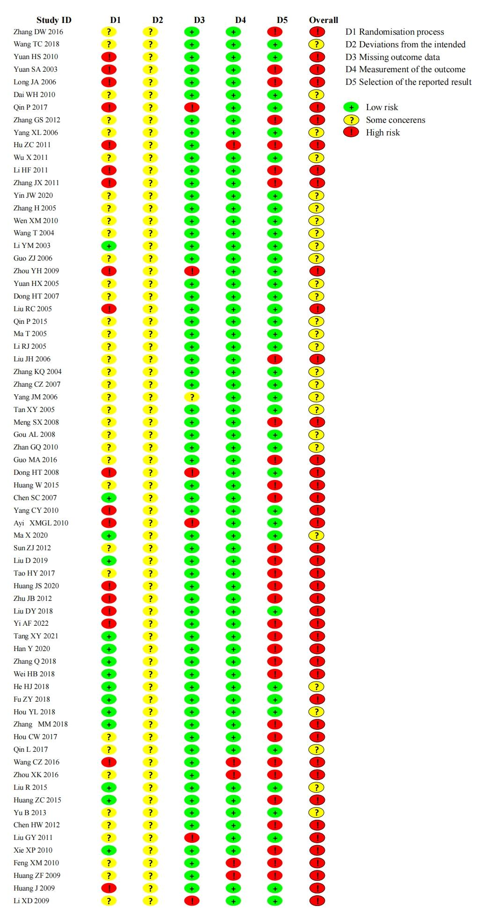

Figure S2. Forest plot on ORR.

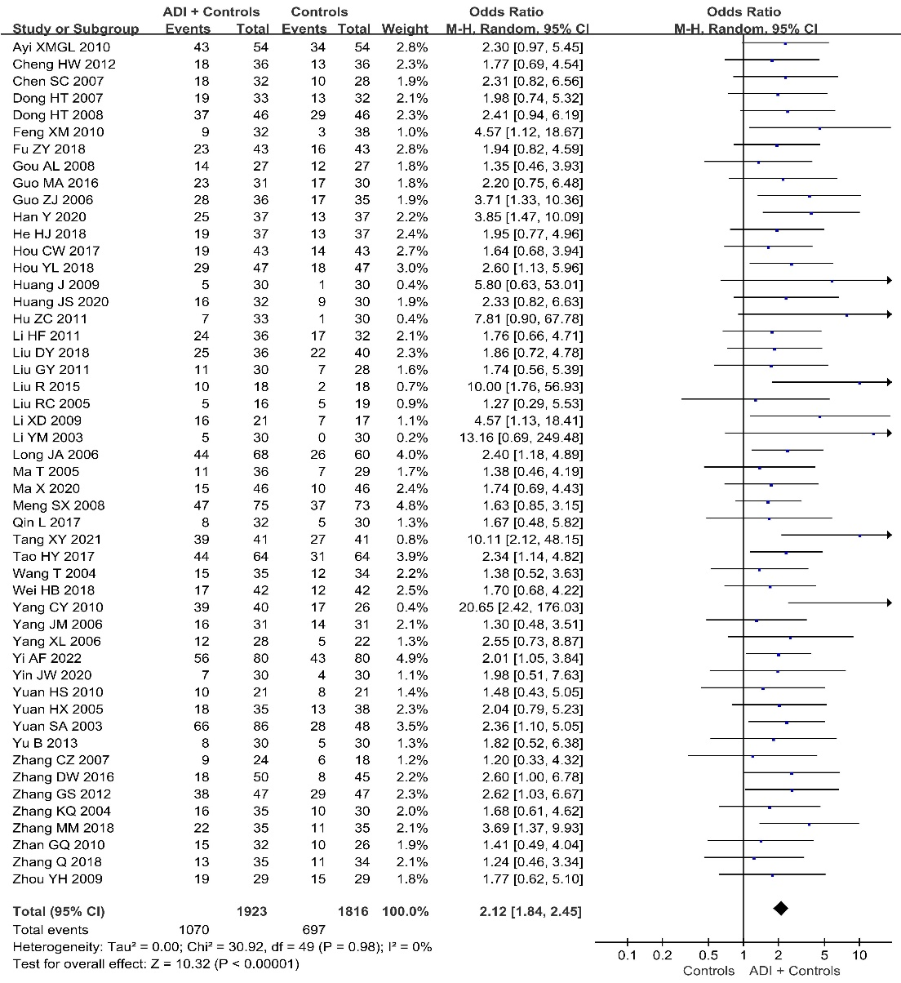
Figure S3. Forest plot on QoL.

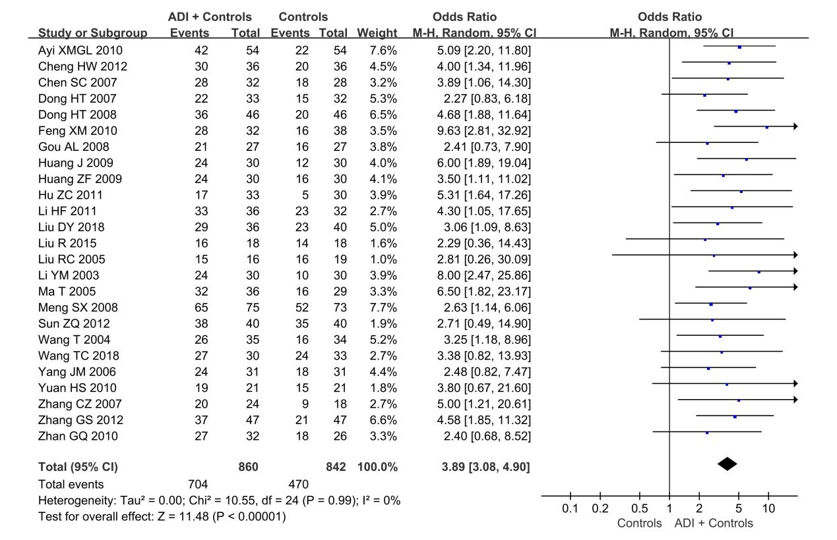

Figure S4. Forest plot on 0.5-year survival rates.

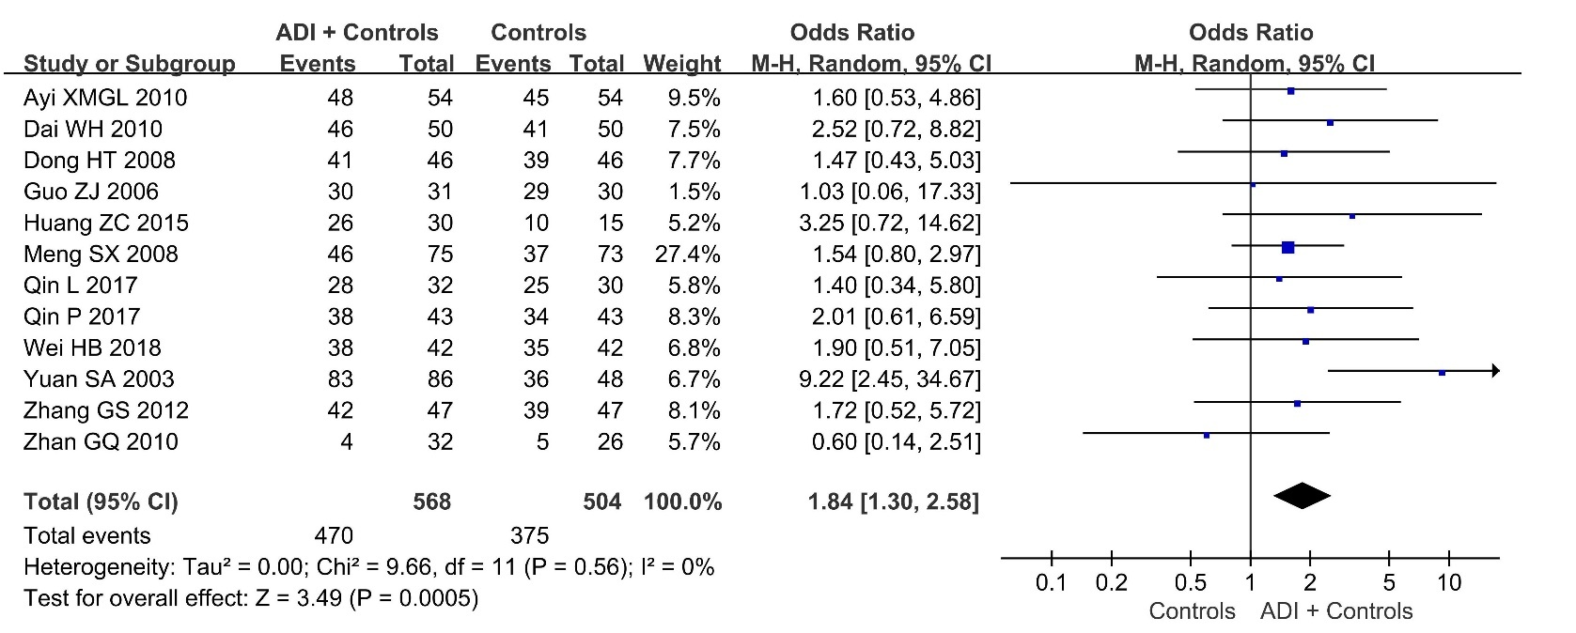

Figure S5. Forest plot on 1-year survival rates.

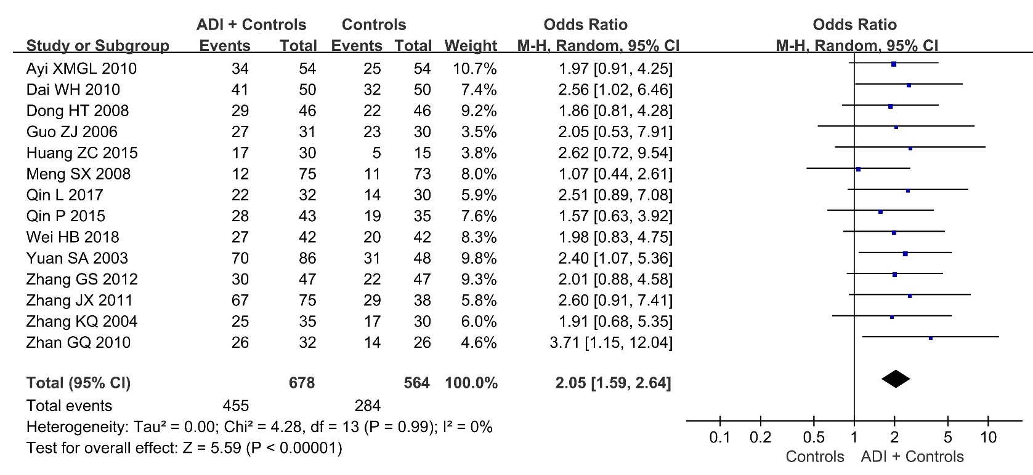

Figure S6. Forest plot on 2-year survival rates.

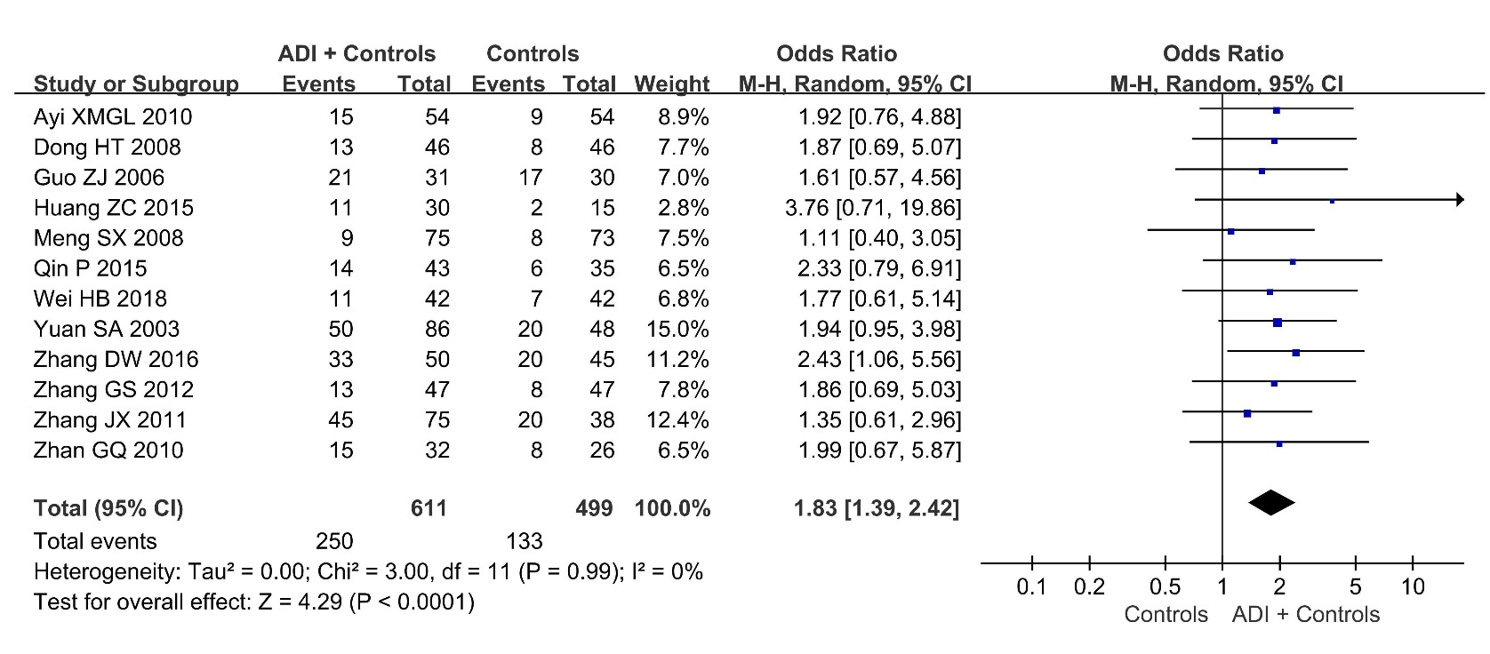

Figure S7. Forest plot on changes in CD3⁺ T cells.

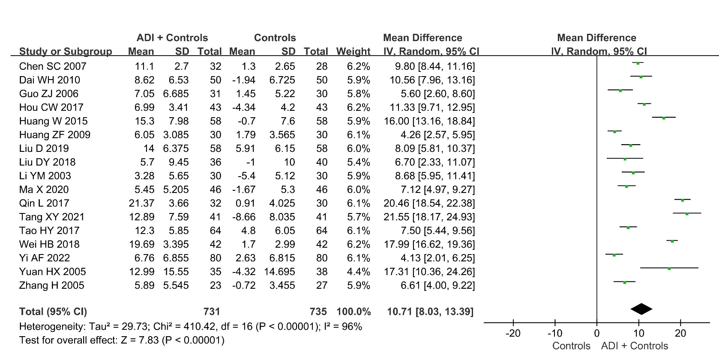

Figure S8. Forest plot on changes in CD4⁺ T cells.

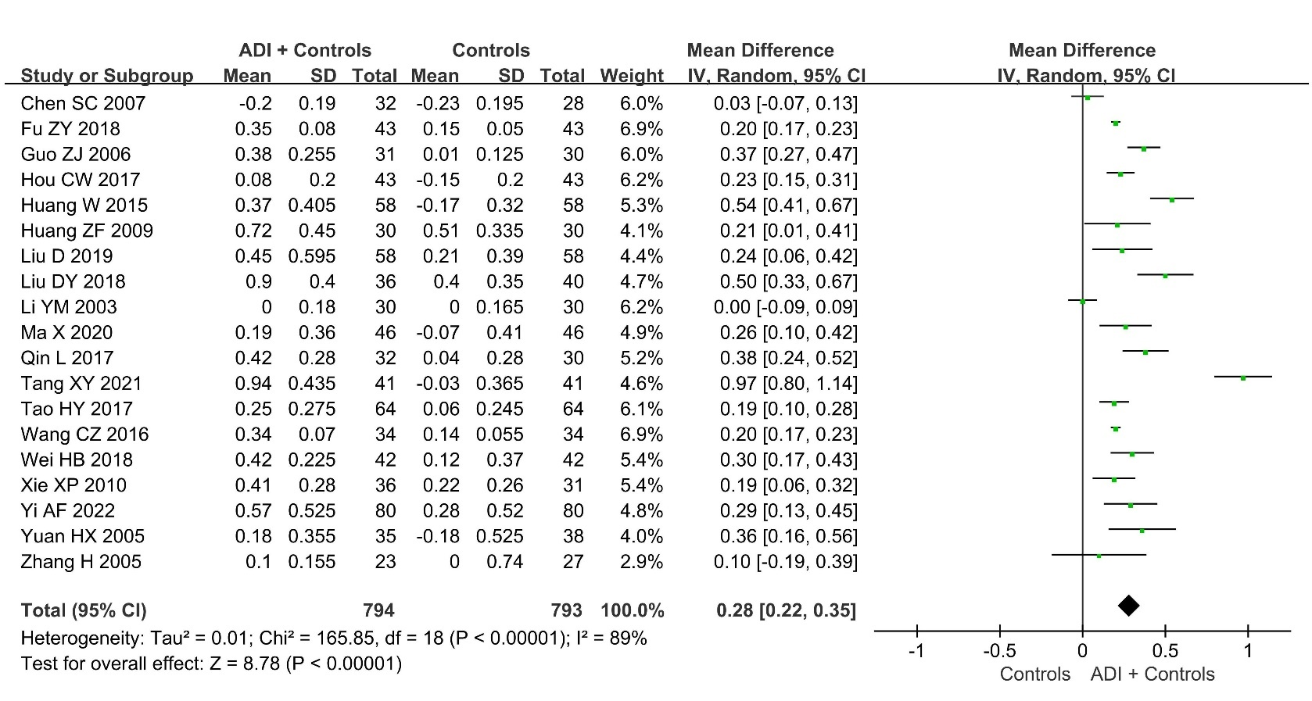

Figure S9. Forest plot on changes in CD8⁺ T cells.

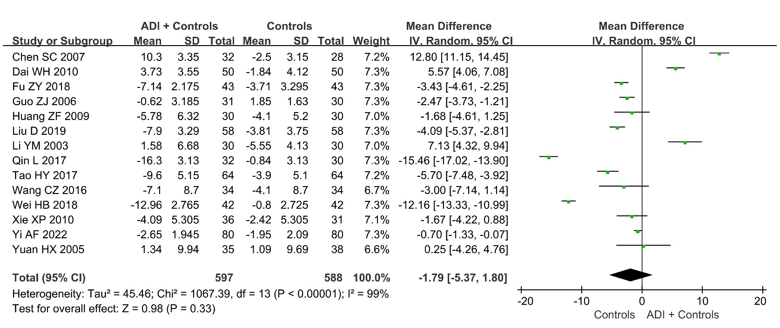

Figure S10. Forest plot on changes in CD4⁺/CD8⁺ ratio.

Figure S11. Forest plot on SAEs.

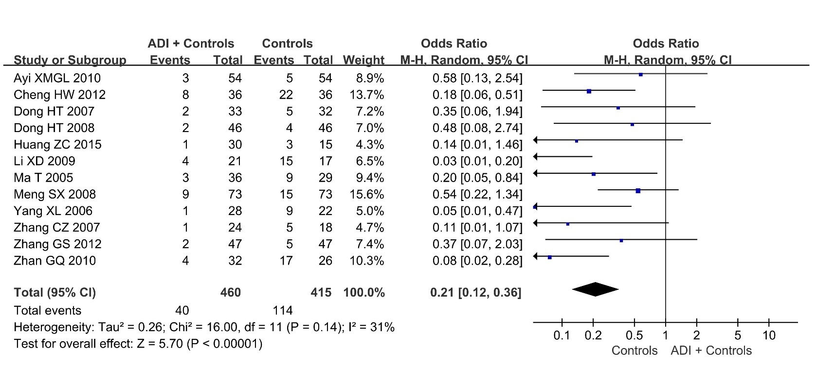

Figure S12. Forest plot on leukopenia.
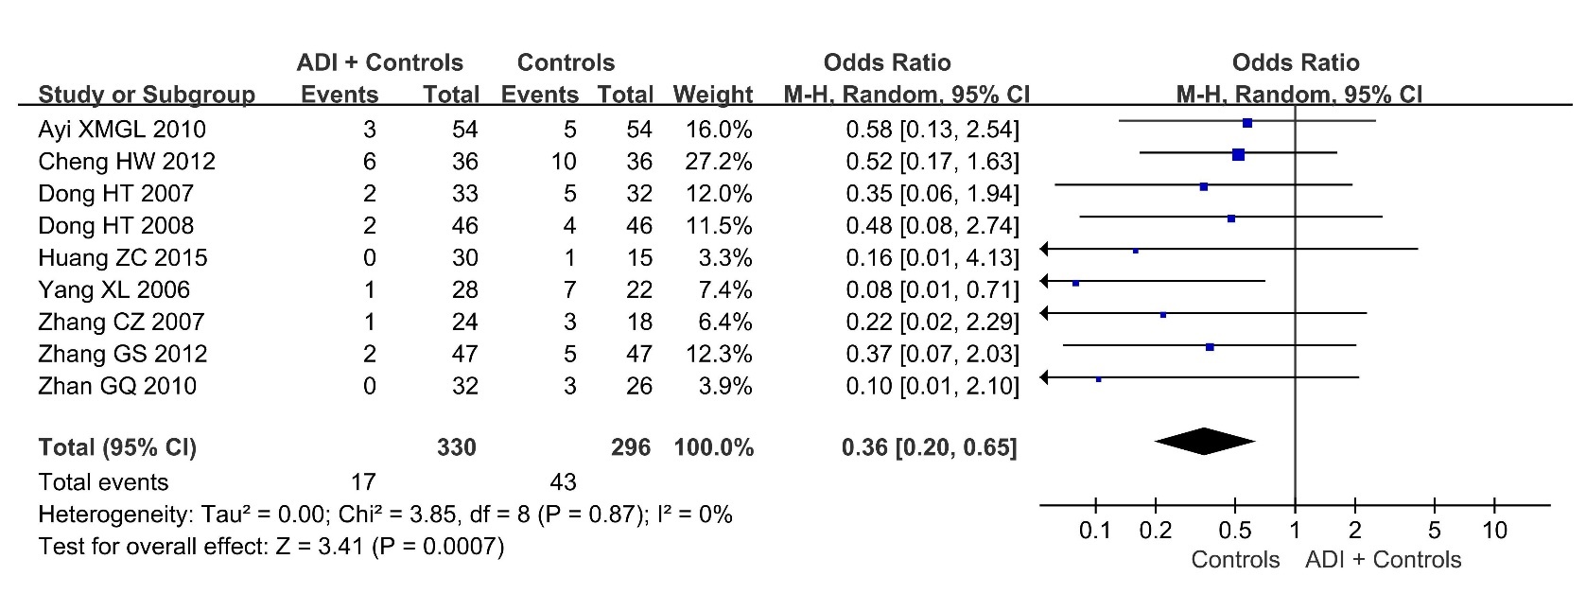
Figure S13. The funnel plot of the DCR with the trim-and-fill method.

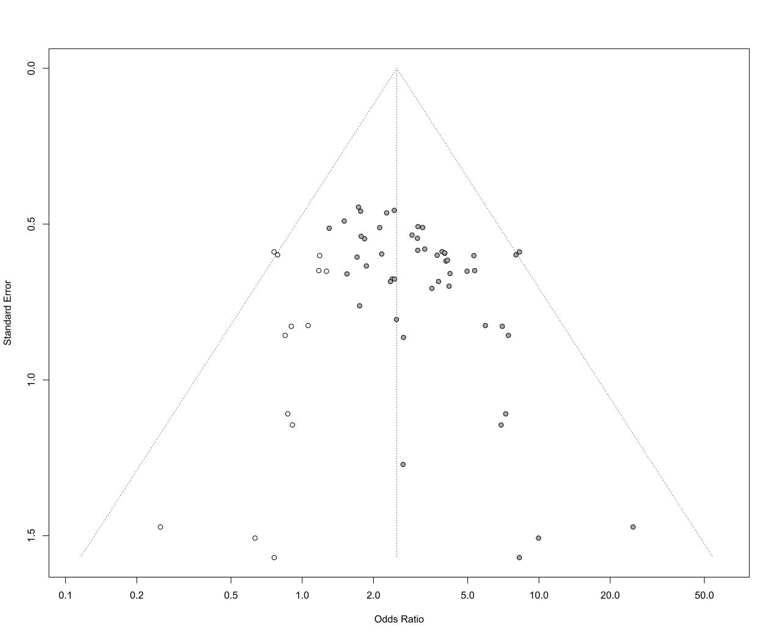
Figure S14. The funnel plot of the ORR with the trim-and-fill method.

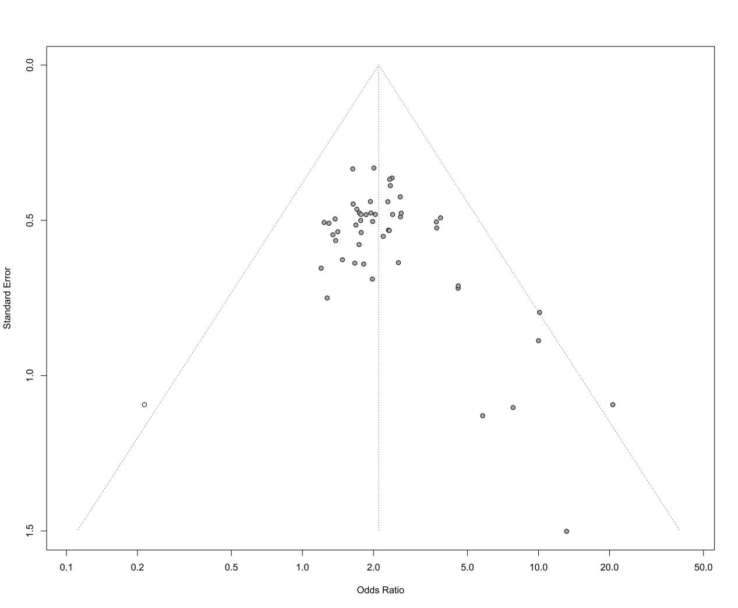

Figure S15. The funnel plot of the QoL with the trim-and-fill method.

Figure S16. The funnel plot of the SAEs with the trim-and-fill method.

