A Genome-Wide Association Study for Fumonisin Contamination Resistance in Tropical Maize. Euphytica. Karla Jorge Silva, Claudia Teixeira Guimarães, Sylvia Morais de Sousa Tinoco, Karine da Costa Bernardino, Roberto dos Santos Trindade, Valéria Aparecida Vieira Queiroz, Renata Regina Pereira da Conceição, José Henrique Soler Guilhen, Natanael Tavares de Oliveira, Cynthia Maria Borges Damasceno, Roberto Willians Noda, Luiz Antônio dos Santos Dias, Lauro José Moreira Guimarães, Janaína de Oliveira Melo, Maria Marta Pastina* *Corresponding author (marta.pastina@embrapa.br) Embrapa Milho e Sorgo, Rodovia MG 424, km 45, Zona Rural, 35701970 - Sete Lagoas, MG - Brazil.

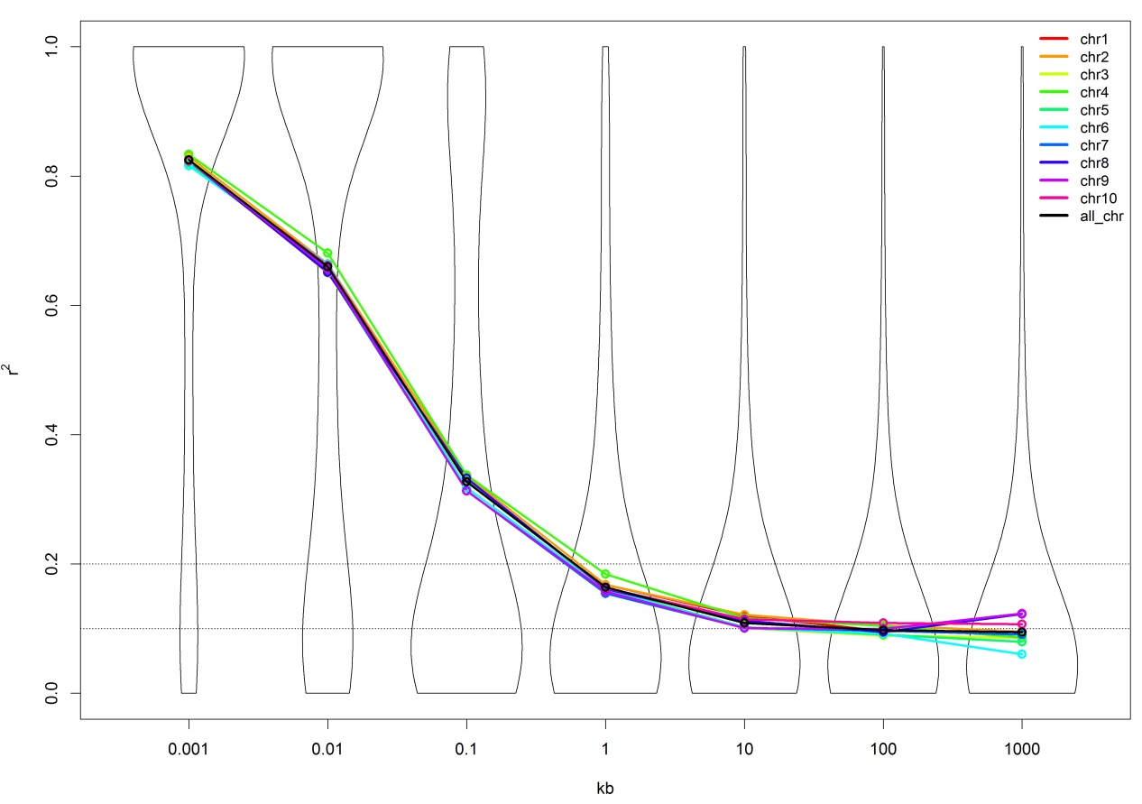

Genome-wide average linkage disequilibrium (LD) decay over genetic distances. Plot of pair-wised single-nucleotide polymorphism (SNP) LD r² values as a function of intermarker map distance (kb). Violin Plot pair distance and mean chromosome (colored lines) and general (black line) imbalances in the maize panel

