Supplementary Material

Title:
Association between Ambient Air Pollutants and Meteorological factors with SARS-CoV-2 transmission and mortality in India: An exploratory study.
Authors:
Sumit Aggarwal^{1#}, Sivaraman Balaji^{1#}, Tanvi Singh¹, Geetha R. Menon², Sandeep Mandal¹, Madhumathi J¹, Nupur Mahajan¹, Jasmine Kaur¹, Harpreet Singh¹, Kiran Rade³, Samiran Panda^{1*}.
Author’s Affiliations:
- Division of Epidemiology and Communicable Diseases, Indian Council of Medical Research-Headquarters, New Delhi – 110029, India
- Indian Council of Medical Research-National Institute of Medical Statistics, New Delhi – 110029, India.
- World Health Organization, New Delhi- 110002 India.
# Authors equally contributed
* Corresponding Author
Dr. Samiran Panda, Scientist G and Head, Division of Epidemiology and Communicable Diseases, Indian Council of Medical Research-Headquarters, New Delhi – 110029, India. Email: pandasamiran@gmail.com, Phone No: +91-11-26588296.

Supplementary Figures
Figure S1. Monthly average Ambient Air Pollutants levels among pre-lockdown (January to March 2020), Phase I (April to June 2020) and Phase II (July to November 2020) in Kolkata (a), Mumbai (b), Hyderabad (C), Delhi (d) and Bengaluru (e).
b
a

d
c
e
Figure S2. Six-year trend of ambient air pollutants in Delhi (a) and Kolkata (b).
a
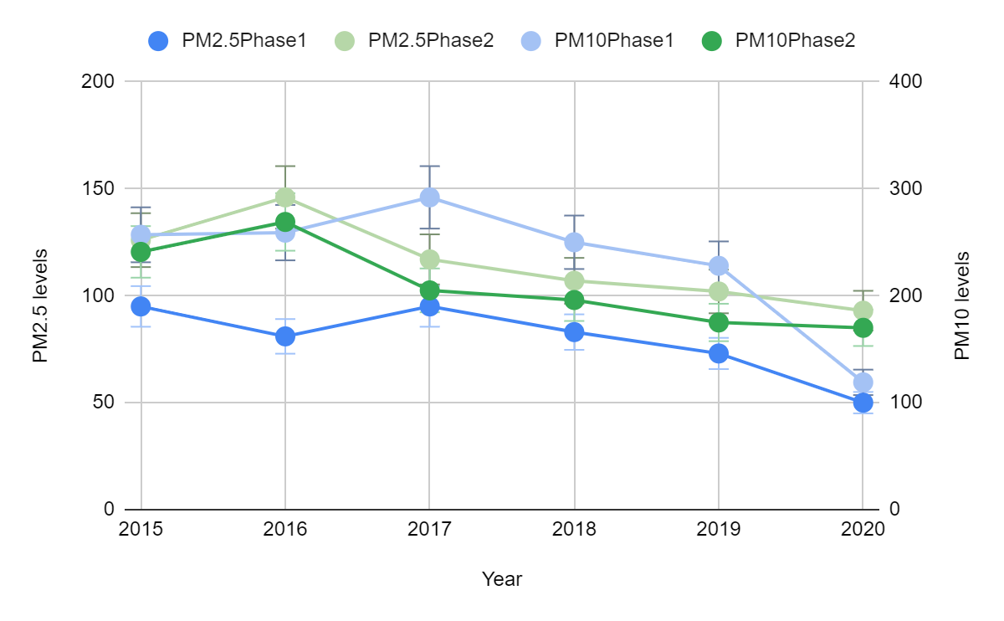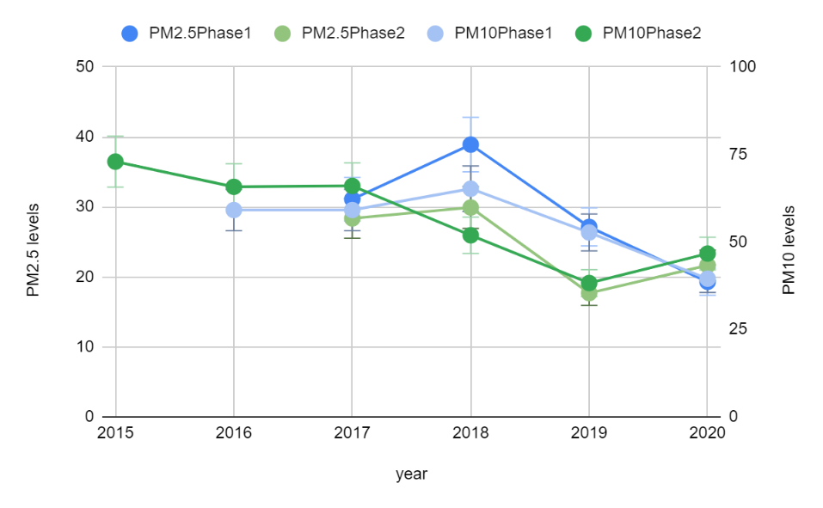
b

Supplementary Tables
Table S1. List of official sources used for data collection in this study.
Data particulars | Sources
Environmental data for PM 2.5, PM 10 and CO emissions | https://cpcb.nic.in/
Meteorological data - Temperature and Relative humidity | https://cpcb.nic.in/
Population data - population density and population | https://censusindia.gov.in/, http://data.un.org/Search.aspx?q=india
COVID data - for test positivity | ICMR - ISRM database
Mortality data –Delhi | http://health.delhigovt.nic.in/wps/wcm/connect/  doit_health/Health/Home/Covid19/Bulletin+Apr+2020
Mortality data- Kolkata | http://health.delhigovt.nic.in/wps/wcm/connect/  doit_health/Health/Home/Covid19/Bulletin+Apr+2020

Table S2. Categories of Ambient Air Pollutants (AAP) as per their safety levels determined by NAAQS, India.
Category | PM 2.5 | PM 10 | NO2 | SO2 | CO | Ozone | Score
Good | 0-30 | 0-50 | 0-40 | 0-40 | 0-1.0 | 0-50 | 1
Satisfactory | 31-60 | 51-100 | 41-80 | 41-80 | 1.1-2.0 | 51-100 | 2
Moderate | 61-90 | 101-250 | 81-180 | 81-380 | 2.1-10 | 101-168 | 3
Poor | 91-120 | 251-350 | 181-280 | 381-800 | 10-17 | 169-208 | 4
Very poor | 121-250 | 351-430 | 281-400 | 801-1600 | 17-34 | 209-748 | 5
Severe | >250 | >430 | >400 | >1600 | >34 | >748 | 6

Table S3. Mann Whitney Wilcoxon Test results of Particulate Matters (PM) levels among group variables (Pre-lockdown and Phase I, Phase I and Phase II) (*p<0.05, **p<0.01, *** p<0.001, # p<0.0001).
Variables | Cities | Asymp.sig
Pre-lockdown and Phase I
PM_{2.5} | Delhi | 0.0001
PM_{2.5} | Bengaluru | 0.0001
PM_{2.5} | Mumbai | 0.001
PM_{2.5} | Hyderabad | 0.0001
PM_{2.5} | Kolkata | 0.0001
PM₁₀ | Delhi | 0.0001
PM₁₀ | Bengaluru | 0.0001
PM₁₀ | Mumbai | 0.0001
PM₁₀ | Hyderabad | 0.0001
PM₁₀ | Kolkata | 0.0001
Phase I and Phase II
PM_{2.5} | Delhi | 0.239
PM_{2.5} | Bengaluru | 0.001
PM_{2.5} | Mumbai | 0.006
PM_{2.5} | Hyderabad | 0.089
PM_{2.5} | Kolkata | 0.351
PM₁₀ | Delhi | 0.003
PM₁₀ | Bengaluru | 0.047
PM₁₀ | Mumbai | 0.0001
PM₁₀ | Hyderabad | 0.007
PM₁₀ | Kolkata | 0.631

Table S4. Daily average of maximum Ambient Temperature (AT) and mean AT.
Duration | AT range | Delhi | Bengaluru | Mumbai | Hyderabad | Kolkata
Phase I | Mean | 31.53 | 26.30 | 29.47 | 26.37 | 28.70
Phase I | Maximum | 35.08 | 26.30 | 30.40 | 29.40 | 28.97
Phase II | Mean | 29.70 | 24.05 | 27.53 | 25.66 | 28.60
Phase II | Maximum | 35.04 | 24.03 | 28.47 | 29.11 | 28.65
Total | Mean | 30.40 | 25.12 | 28.27 | 25.93 | 28.63
Total | Maximum | 35.09 | 24.91 | 29.22 | 29.22 | 28.77

Table S5. Correlation coefficient analysis between COVID-19 ATPR, daily average of mean Particulate Matters (PM) and Ambient Temperature (AT). (‘+’ values are considered as positively significant and ‘-‘ values are positively significant, *p<0.05, **p<0.01).

Study Period | Variables | Lag | Bengaluru |  | Delhi |  | Hyderabad |  | Kolkata |  | Mumbai
Study Period | Variables | Lag | K | S | K | S | K | S | K | S | K | S
Phase I | AT | No lag | -.399** | -.560** | .262** | .389** | .422** | .613** | -0.092 | -0.139 | 0.144* | 0.233*
Phase I | AT | Lag 7 | -.410** | -.583** | .352** | .502** | 0.213* | 0.341* | -0.017 | -0.024 | -0.009 | -0.013
Phase I | AT | Lag 14 | -.325** | -.477** | .260** | .373** | 0.158* | 0.227* | -0.0024 | -0.047 | -0.101 | -0.147
Phase I | PM 2.5 | No lag | -.337** | -.499** | 0.065 | 0.105 | -.117 | -.171 | -0.032 | -0.029 | -.299** | -.403**
Phase I | PM 2.5 | Lag 7 | -.347** | -.475** | -0.011 | -0.021 | -.277** | -.404** | 0.023 | 0.049 | -.161** | -.236**
Phase I | PM 2.5 | Lag 14 | -.194** | -.279** | 0.126 | 0.198 | -.265** | -.389** | -0.025 | -0.041 | -.0.189** | -.215**
Phase I | PM 10 | No lag | -0.068 | -0.119 | 0.064 | 0.090 | -0.014 | -0.020 | 0.014 | 0.021 | -.295** | -.378**
Phase I | PM 10 | Lag 7 | -0.168* | -0.251* | -0.017 | -0.022 | -.195** | -.295** | -0.015 | -0.028 | -.186* | -.287*
Phase I | PM 10 | Lag 14 | -.200** | -.301** | 0.053 | 0.075 | -.230** | -.355** | -0.175 | -0.259 | -.251** | -.343**
Phase II | AT | No lag | 0.086 | 0.121 | -.230** | -.273** | -.133** | -.202** | .151 | 0.213 | -.219** | -.326**
Phase II | AT | Lag 7 | 0.087 | 0.118 | -.0.089 | -0.128 | -.143** | -.209** | 0.050 | 0.079 | -.216** | -.320**
Phase II | AT | Lag 14 | 0.067 | 0.086 | -.0.026 | -0.036 | -.178** | -.257** | 0.007 | 0.030 | -0.119* | -0.201*
Phase II | PM 2.5 | No lag | -.370** | -.489** | .340** | .498** | -.384** | -.556** | -0.074 | -0.114 | -.422** | -.589**
Phase II | PM 2.5 | Lag 7 | -.298** | -.399** | .360** | .470** | -.474** | -.677** | 0.014 | 0.012 | -.404** | -.580**
Phase II | PM 2.5 | Lag 14 | -.248** | -.336** | .283** | .436** | -.389** | -.528** | 0.095 | 0.130 | -.396** | -.570**
Phase II | PM 10 | No lag | -.250** | -.332** | .396** | .569** | -.380** | -.557** | -0.109 | -0.170 | -.360** | -.503**
Phase II | PM 10 | Lag 7 | -.151** | -.201* | .351** | .593** | -.458** | -.662** | -0.048 | -0.070 | -.364** | -.510**
Phase II | PM 10 | Lag 14 | -0.074 | -0.101 | .292** | .439** | -.356** | -.538** | 0.059 | 0.063 | -.368** | -.517**
Total Period | AT | No lag | -.267** | -.398** | -0.011 | -0.038 | -0.194* | -.300* | 0.091 | 0.139 | .162** | .256**
Total Period | AT | Lag 7 | -.290** | -.427** | .124* | .194* | -.185** | -.288** | 0.045 | 0.070 | .090** | .136**
Total Period | AT | Lag 14 | -.247** | -.379** | .193** | .294** | -.182** | -.273** | -0.021 | -0.028 | 0.052 | 0.074
Total Period | PM 2.5 | No lag | -.229** | -.322** | .162** | .251** | -.256** | -.477** | -0.015 | -0.011 | -.367** | -.520**
Total Period | PM 2.5 | Lag 7 | -.135* | -.192* | .098* | .163** | -.363** | -.520** | 0.055 | 0.091 | -.383** | -.550**
Total Period | PM 2.5 | Lag 14 | -0.042 | -0.046 | .095* | .135* | -.340** | -.495** | 0.105 | 0.157 | -.381** | -.545**
Total Period | PM 10 | No lag | -.114* | -.161* | .216** | .323** | -.210** | -.313** | -0.050 | -0.071 | -.299** | -.441**
Total Period | PM 10 | Lag 7 | -0.084 | -0.123 | .144** | .231** | -.312** | -.454** | -0.001 | -0.001 | -.326** | -.480**
Total Period | PM 10 | Lag 14 | -0.044 | -0.068 | .100* | .161** | -.275** | -.417** | 0.032 | 0.045 | -.343** | -.499**

