Response surface optimisation test results
I. Response surface test design and results
The Box-Behnken design was employed to investigate the thermal stability of mayonnaise prepared following compound enzymatic digestion. The data presented in Table. S1 were subjected to regression fitting analysis using Design-Expert 13 software. The thermal stability value of mayonnaise, represented as L/l*, was selected as the response variable. Four factors were considered in the experimental design: A - phospholipase A₂ (PLA₂) addition amount, B - flavoprotein (Fla) addition amount, C - enzymatic digestion temperature, and D - enzymatic digestion time. A total of 29 experimental runs were conducted for these four factors at three levels. Specifically, the factor-level combinations were tested 24 times, and the central point was replicated 5 times. The experiments were executed in accordance with the response surface design protocol, and the corresponding response values were recorded. The results of the response surface experiments are summarized in Table S1. A quadratic regression equation with the thermal stability value L/l* of mayonnaise as the objective function was derived: Y = 25.46 + 0.2617A - 0.0433B - 0.1083C + 0.0283D - 0.3925AB + 0.0975AC - 0.1750AD + 0.0175BC + 0.055BD - 0.08CD - 0.6116A² - 0.4841B² - 0.4941C² - 0.3241D².
II. Analysis of variance of response surface regression equations
Analysis of variance (ANOVA) was performed on the regression equation. The F - value reflects the contribution of the corresponding model component to the response variable. A larger F - value indicates a greater influence of the factor. In statistical analysis, when P < 0.01, the regression model shows highly significant differences; when P < 0.05, it shows statistically significant differences, which implies that the experimental model is statistically significant. As presented in Table S2, the F - value of the model is 51.93 with P < 0.0001, indicating highly significant differences, which validates the reliability of the regression equation. For the lack - of - fit term, the F - value is 4.72 and the P - value is 0.074 > 0.05, suggesting a negligible error. This indicates that the regression equation provides a good fit, and the developed model can be utilized for analyzing and predicting the test results. The coefficient of determination R² is 0.981, and the adjusted coefficient of determination R²_{Adj} is 0.9622. These values imply that 96.22% of the experimental results are associated with the experimental factors, and 98% of the variations in the response values can be accounted for by the model, demonstrating that the experimental results are consistent with the actual situation.
The significance test in ANOVA is used to assess the impact of independent variables on the dependent variable. As presented in Table S2, the effect of factor A on the response variable Y is highly significant (P < 0.0001), the effect of factor C on Y is significant (0.0001 ≤ P < 0.05), while the effects of factors B and D on Y are not significant (P > 0.05). Among the interaction terms in the model, AB has a highly significant effect on Y, the effects of AC and AD on Y are significant, whereas the effects of BC, BD, and CD on Y are not significant. Additionally, the quadratic terms A², B², C², and D² in the model all have a highly significant impact on Y. Based on the P - values, the order of the influence of each factor on the thermal stability of mayonnaise, from greatest to least, is PLA₂ addition amount, enzymatic digestion temperature, Fla addition amount, and enzymatic digestion time.
III. Response surface analysis of factor interactions
The three-dimensional surface and contour plots of the response surface can effectively illustrate the impact of the interaction among the influencing factors on the response variable Y. The interaction between these influencing factors is more prominently manifested in the three-dimensional surface and contour plots. In the 3D surface plot, the steeper the surface gradient and the greater the inclination, the more significant the interaction effect; in the contour plot, the closer the contour line shape is to an ellipse, the more significant the interaction effect.
Maintaining the enzyme digestion temperature and the enzyme digestion time constant, the established regression model was employed to analyze the response surfaces and contours of the addition of PLA₂ and Fla on the thermal stability of mayonnaise. As depicted in Fig. S1, both the increase in the addition of PLA₂ and Fla had an enhancing effect on the L/l* value related to the thermal stability of mayonnaise initially. However, as the amount of addition increased, the L/l* value decreased. When the amount of PLA₂ (A) was 1 U, the L/l* value exhibited a clear pattern of first increasing and then decreasing as the amount of Fla (B) increased. When the amount of PLA₂ (A) was 3 U, the L/l* value decreased with the increase of Fla (B), and the interaction effect was extremely significant[1,2].
The reason for this is mainly that PLA₂ acts on the phospholipids in egg yolks. Phospholipids mainly bind to proteins to form lipoproteins. When PLA₂ acts on the phospholipids, the interaction force between phospholipids and proteins is disrupted, causing damage to the structure of lipoproteins. When Fla is added to the system, Fla acts on protein hydrolysis, generating peptides with a smaller molecular weight that have a faster adsorption speed. When the amount of Fla is further increased, the degree of protein hydrolysis intensifies. The low molecular weight proteins expose more hydrophilic amino acid residues, resulting in a limited ability to adsorb to the oil-water interface, which reduces the thermal stability of mayonnaise.
When the addition of Fla was fixed, the L/l* value showed a trend of first increasing and then decreasing as the amount of PLA₂ addition increased, although the decreasing trend was not very obvious. This is mainly because after PLA₂ digestion, certain proteins buried inside the egg yolk particles were exposed. These exposed proteins reacted with the protease. As the amount of PLA₂ addition increased, more enzyme cleavage sites were exposed, which in turn led to more proteins reacting with the protease.
When the addition of flavoprotein (Fla) was kept constant and the enzyme digestion time was held constant, the addition of PLA₂ exhibited a significant interaction with the enzyme digestion temperature. When the amount of PLA₂ (A) was 1 U, the L/l* value clearly showed a trend of increasing first and then decreasing as the relevant factor (presumably related to the enzyme digestion temperature or another variable represented by B, which should be clarified more precisely) increased.
Enzyme activity can only be maximized at an appropriate reaction temperature. When the temperature is above or below the optimal reaction temperature, the enzyme activity decreases. At the optimal reaction temperature, both the binding rate of PLA₂ to phospholipids and the enzymatic reaction rate are high, and the generated lysophospholipids are beneficial to the stability of mayonnaise.
When the addition of Fla was maintained constant and the enzyme digestion temperature was fixed, there was a significant interaction between the addition of PLA₂ and the enzyme digestion time. An increase in the enzyme digestion time is initially beneficial for the full reaction between the enzyme and the substrate. However, an excessive extension of the enzyme digestion time, on the contrary, leads to a decrease in the L/l* value. This is probably because when the reaction reaches its maximum, the enzymatic substrate is completely consumed, and the reaction products exert a certain inhibitory effect on the enzyme activity. Moreover, an excessive prolongation of the enzymatic time is detrimental to the thermal stability of mayonnaise.
The influence of the interactions between factors BC, BD, and CD on the L/l* values was not significant. Based on the analysis of variance (ANOVA) results and the response surface analysis, it is evident that the addition of PLA₂ has the most substantial impact on the L/l* value during the enzymatic digestion process. Moreover, PLA₂ and Fla exhibit a synergistic effect on enhancing the thermal stability of mayonnaise.

Box-Behnken design with experimental result
 | PLA₂  / U | Fla  / U | temperature  / ℃ | time  / h | L/l*
1 | 2 | 100 | 55 | 2 | 25.42
2 | 1 | 100 | 60 | 2 | 23.79
3 | 2 | 150 | 55 | 2.5 | 24.57
4 | 2 | 100 | 60 | 1.5 | 24.58
5 | 2 | 150 | 60 | 2 | 24.36
6 | 2 | 100 | 55 | 2 | 25.46
7 | 1 | 100 | 55 | 2.5 | 24.46
8 | 2 | 100 | 55 | 2 | 25.49
9 | 2 | 100 | 50 | 2.5 | 24.98
10 | 3 | 100 | 60 | 2 | 24.55
11 | 2 | 100 | 60 | 2.5 | 24.61
12 | 2 | 50 | 55 | 1.5 | 24.79
13 | 3 | 150 | 55 | 2 | 24.3
14 | 2 | 100 | 55 | 2 | 25.42
15 | 2 | 50 | 60 | 2 | 24.44
16 | 2 | 50 | 50 | 2 | 24.6
17 | 2 | 150 | 50 | 2 | 24.45
18 | 1 | 100 | 50 | 2 | 24.3
19 | 3 | 100 | 55 | 1.5 | 24.9
20 | 3 | 50 | 55 | 2 | 25.07
21 | 1 | 100 | 55 | 1.5 | 24.07
22 | 2 | 100 | 50 | 1.5 | 24.63
23 | 3 | 100 | 55 | 2.5 | 24.59
24 | 2 | 100 | 55 | 2 | 25.53
25 | 1 | 50 | 55 | 2 | 23.76
26 | 2 | 150 | 55 | 1.5 | 24.52
27 | 2 | 50 | 55 | 2.5 | 24.62
28 | 1 | 150 | 55 | 2 | 24.56
29 | 3 | 100 | 50 | 2 | 24.67
Table. S1 Box-Behnken design with experimental result.

Analysis of variance in regression model
Source | Sum of Squares | Df | Mean Square | F | P | Significance
Model | 5.93 | 14 | 0.4239 | 51.93 | < 0.0001 | **
A-PLA₂ | 0.8216 | 1 | 0.8216 | 100.66 | < 0.0001 | **
B-Fla | 0.0225 | 1 | 0.0225 | 2.76 | 0.1188
C-temperature | 0.1408 | 1 | 0.1408 | 17.25 | 0.001 | *
D-time | 0.0096 | 1 | 0.0096 | 1.18 | 0.2957
AB | 0.6162 | 1 | 0.6162 | 75.5 | < 0.0001 | **
AC | 0.038 | 1 | 0.038 | 4.66 | 0.0487 | *
AD | 0.1225 | 1 | 0.1225 | 15.01 | 0.0017 | *
BC | 0.0012 | 1 | 0.0012 | 0.1501 | 0.7043
BD | 0.0121 | 1 | 0.0121 | 1.48 | 0.2435
CD | 0.0256 | 1 | 0.0256 | 3.14 | 0.0983
A² | 2.43 | 1 | 2.43 | 297.25 | < 0.0001 | **
B² | 1.52 | 1 | 1.52 | 186.23 | < 0.0001 | **
C² | 1.58 | 1 | 1.58 | 194 | < 0.0001 | ***
D² | 0.6813 | 1 | 0.6813 | 83.47 | < 0.0001 | **
Residual | 0.1143 | 14 | 0.0082
Lack of Fit | 0.1053 | 10 | 0.0105 | 4.72 | 0.074 | not significant
Pure Error | 0.0089 | 4 | 0.0022
Total | 6.05 | 28
R²=0.9811 |  |  | R²_{Adj}=0.9622
Note: ** denotes P < 0.0001 (extremely significant difference); * denotes 0.0001 ≤ P < 0.05 (statistically significant difference).
Table. S2 Analysis of variance in regression model.

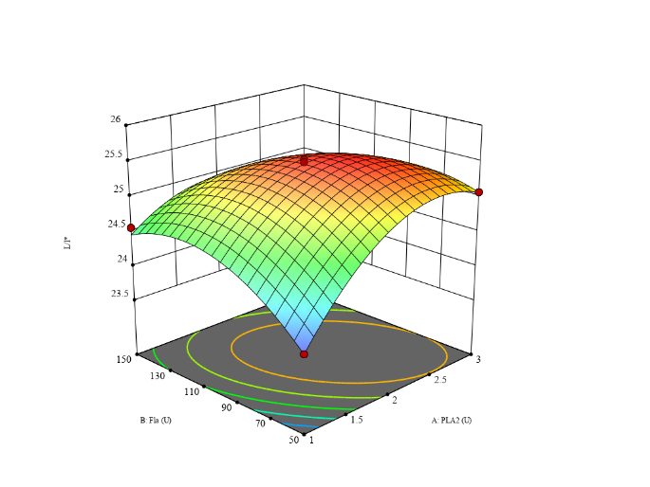
(b)
(a)
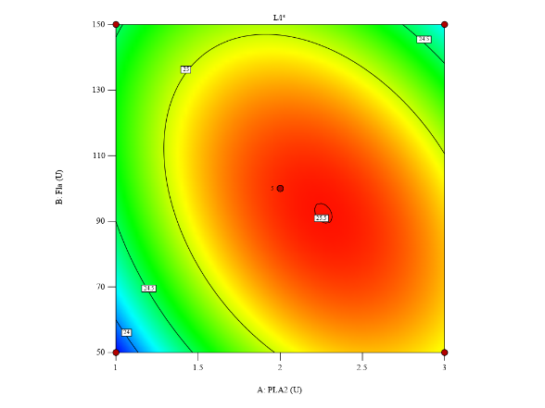

(d)
(c)
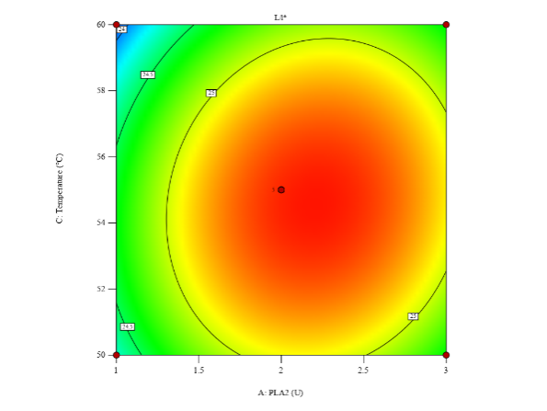
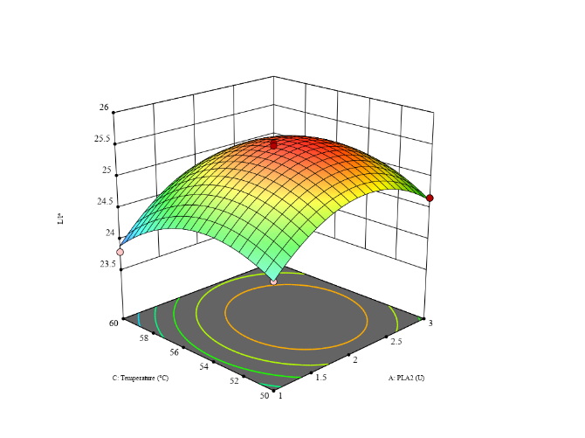

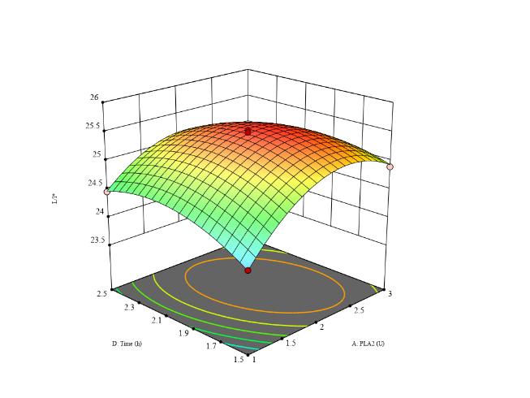
(f)
(e)
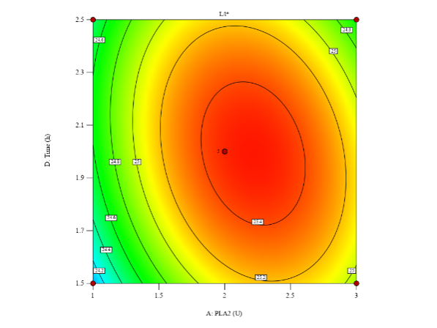

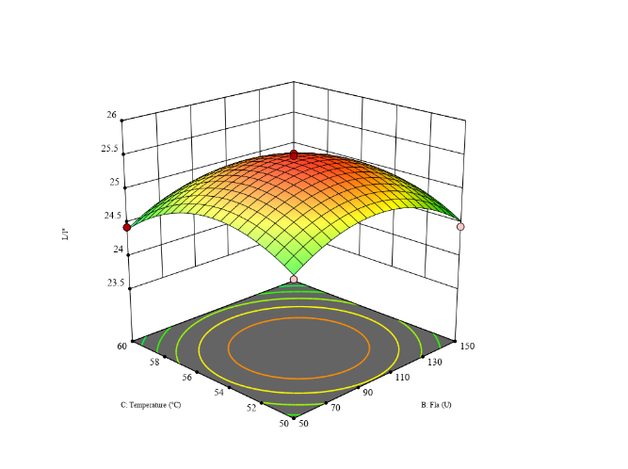
(h)
(g)
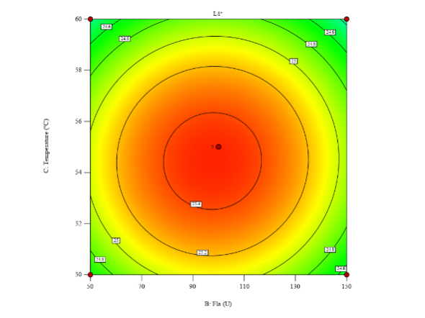

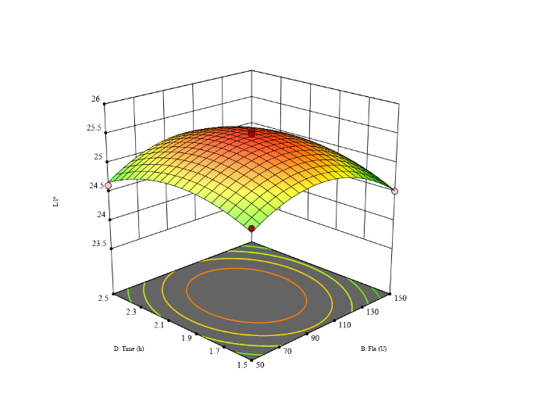
(j)
(i)
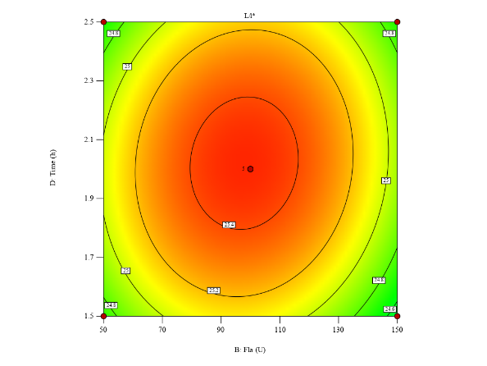

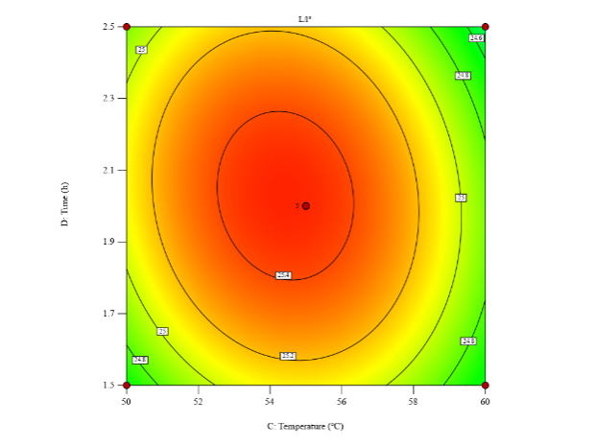
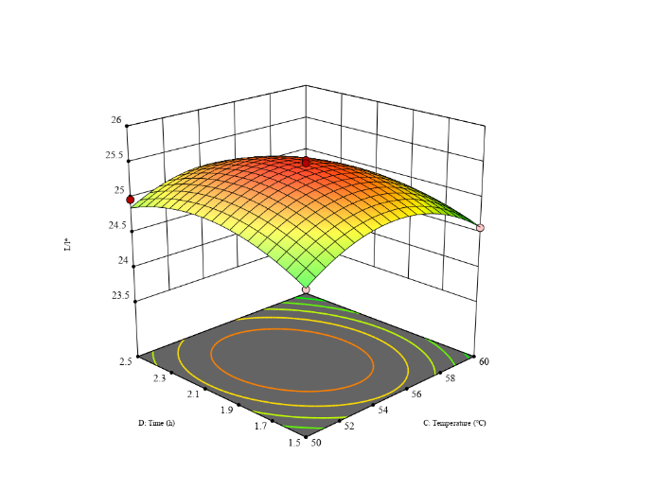
(l)
(k)

Fig. S1 The response surface and contour plots depicting the effects of the interaction among various factors on the thermal stability of mayonnaise.
(a): the response surface graph generated by PLA₂ addition and Fla addition, (c): the response surface graph generated by PLA₂ addition and enzymolysis temperature, (e): the response surface graph generated by PLA₂ addition and enzymolysis temperature, (g): the response surface graph generated by Fla addition and enzymolysis temperature,(i): the response surface graph generated by Fla addition and enzymolysis time, (k): the response surface diagram generated by enzymolysis time and temperature, and (b), (d), (f), (h), (j) and (l) are respectively correlated with (a), (c) and (e).(g), (i), and (k) correspond to contour plots.

REFERENCES
1 Ünsal M, Işık-Gülsaç I, Üresin E, et al. (2019). Optimisation of biomass catalytic depolymerisation conditions by using response surface methodology:. Waste Management & Research, 38(3), 322-331.
2 Yiqi, Jiang, Hong, Wang, Caifang, & Zhao, et al. (2018). Establishment of stable microalgal-bacterial consortium in liquid digestate for nutrient removal and biomass accumulation. Bioresource Technology.

