Sacrum morphology supports taxonomic heterogeneity of Australopithecus africanus at Sterkfontein Member 4

Cinzia Fornai^{1,2}*, Viktoria A. Krenn^{1,2}, Philipp Mitteroecker³, Nicole M. Webb^{1,4}, Martin Haeusler¹

¹Institute of Evolutionary Medicine, University of Zurich.
²Department of Evolutionary Anthropology, University of Vienna.
³Department of Theoretical Biology, University of Vienna.
⁴Senckenberg Research Institute and Natural History Museum Frankfurt.
*Corresponding author: cinzia.fornai@univie.ac.at

Supplementary Information
Supplementary Note 1: Quadratic Discriminant Analysis (QDA)
Since StW 431 seems to plot in an intermediate position between Homo and Pongo in the PC1-PC2 plot for the PCA in shape space, a QDA (see for example, ^{50, section 3.6)} was carried out to assess the likelihood that StW 431 could be morphologically allied with either Homo and Pongo. The analysis was performed in R software package ⁵³ using a script prepared and supplied by Fred L. Bookstein. The models were built considering only the modern human adults and leaving out the StW 431 data. The p ~0.05 threshold for the hypothesis that StW 431 belongs to Homo is 6.83, and that for the hypothesis that StW 431 belongs to Pongo is 0.146. Intermediate values reflect equivocal results. The likelihood ratio (LR) for the hypothesis that StW 431 belongs to Homo is 33.90 for PC1-PC2 and 38.44 for PC2-PC3.

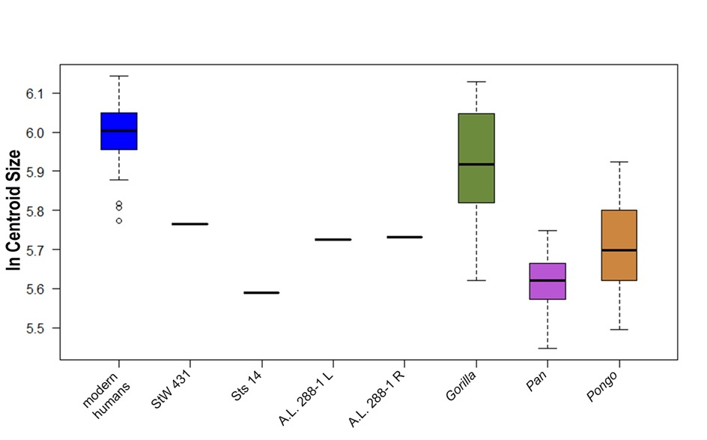
Supplementary Figure 1: Boxplots of the ln centroid sizes. Sts 14 and A.L. 288-1 are smaller than any recent modern humans considered, while StW 431 is at the lower end of the modern human distribution. The ln centroid sizes of the Australopithecus sacra are in the range of Pan and Pongo, and of the smallest Gorilla specimens. Sts 14 is smaller than any modern human specimens including the subadults, and falls in the range of variation of Pan and Pongo, while StW 431 is at the lower end of the distribution of Homo. The regression analysis shows that the influence of size on shape is appreciable for this sample (12.3% of the total variance), while it reduces to 3.3% for the hominin subsample.
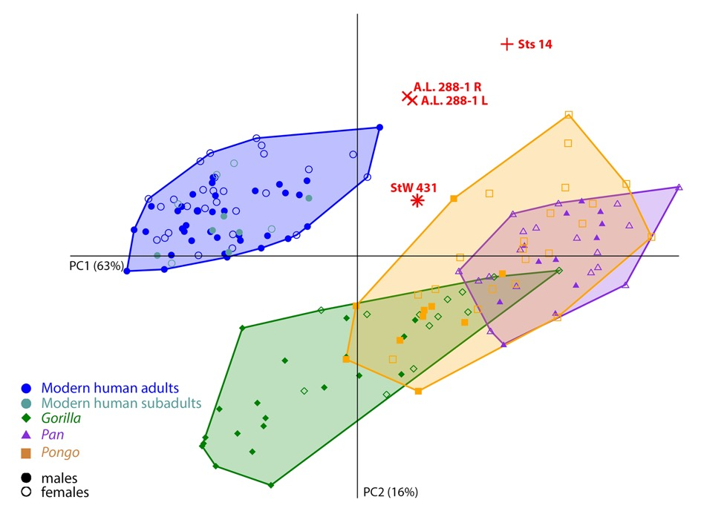
Supplementary Figure 2: PCA plot in form space after full GPA for the complete sample including both modern humans and great apes. In this plot, modern humans separate completely from great apes. In this analysis, the male gorillas and orangutans tend to separate from the rest of the great apes for their large size. There is still a complete overlap of male and female modern humans and Pan, while a dimorphic trend is observed both in Pongo and especially Gorilla. The Australopithecus individuals are distinct from the rest of the sample.
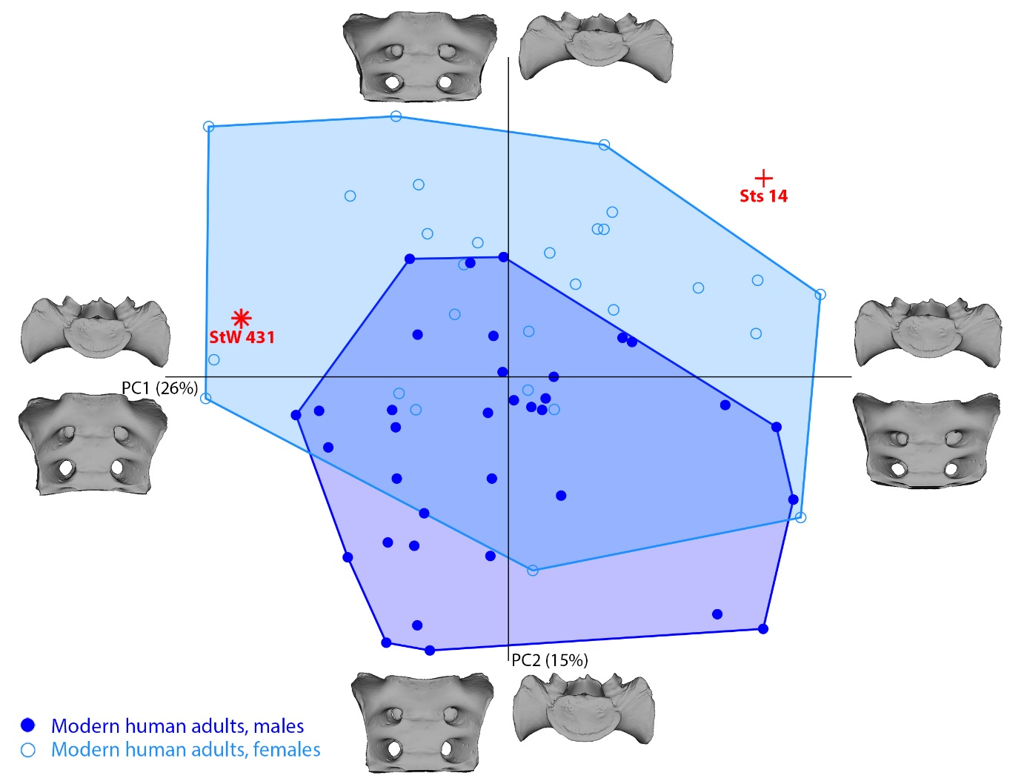
Supplementary Figure 3: PCA plot in shape space after full GPA for the modern human adults, Sts 14 and StW 431. In the PC1-PC2 plot, male and female modern humans form two overlapping groups. Sts 14 and StW 431 diverge largely along PC1, which reflects the different cranio-caudal orientation of the wings. When the Procrustes distances are calculated based on this PC, only 1.0% of the pairwise comparisons between all modern humans and 1.1% between the male-female pairs are higher than the distances between Sts 14 and StW 431. The sexual-related variation, corresponding to the relative width of the wings with respect to the sacral body, occurs in PC2, along which Sts 14 and StW 431 also diverge.
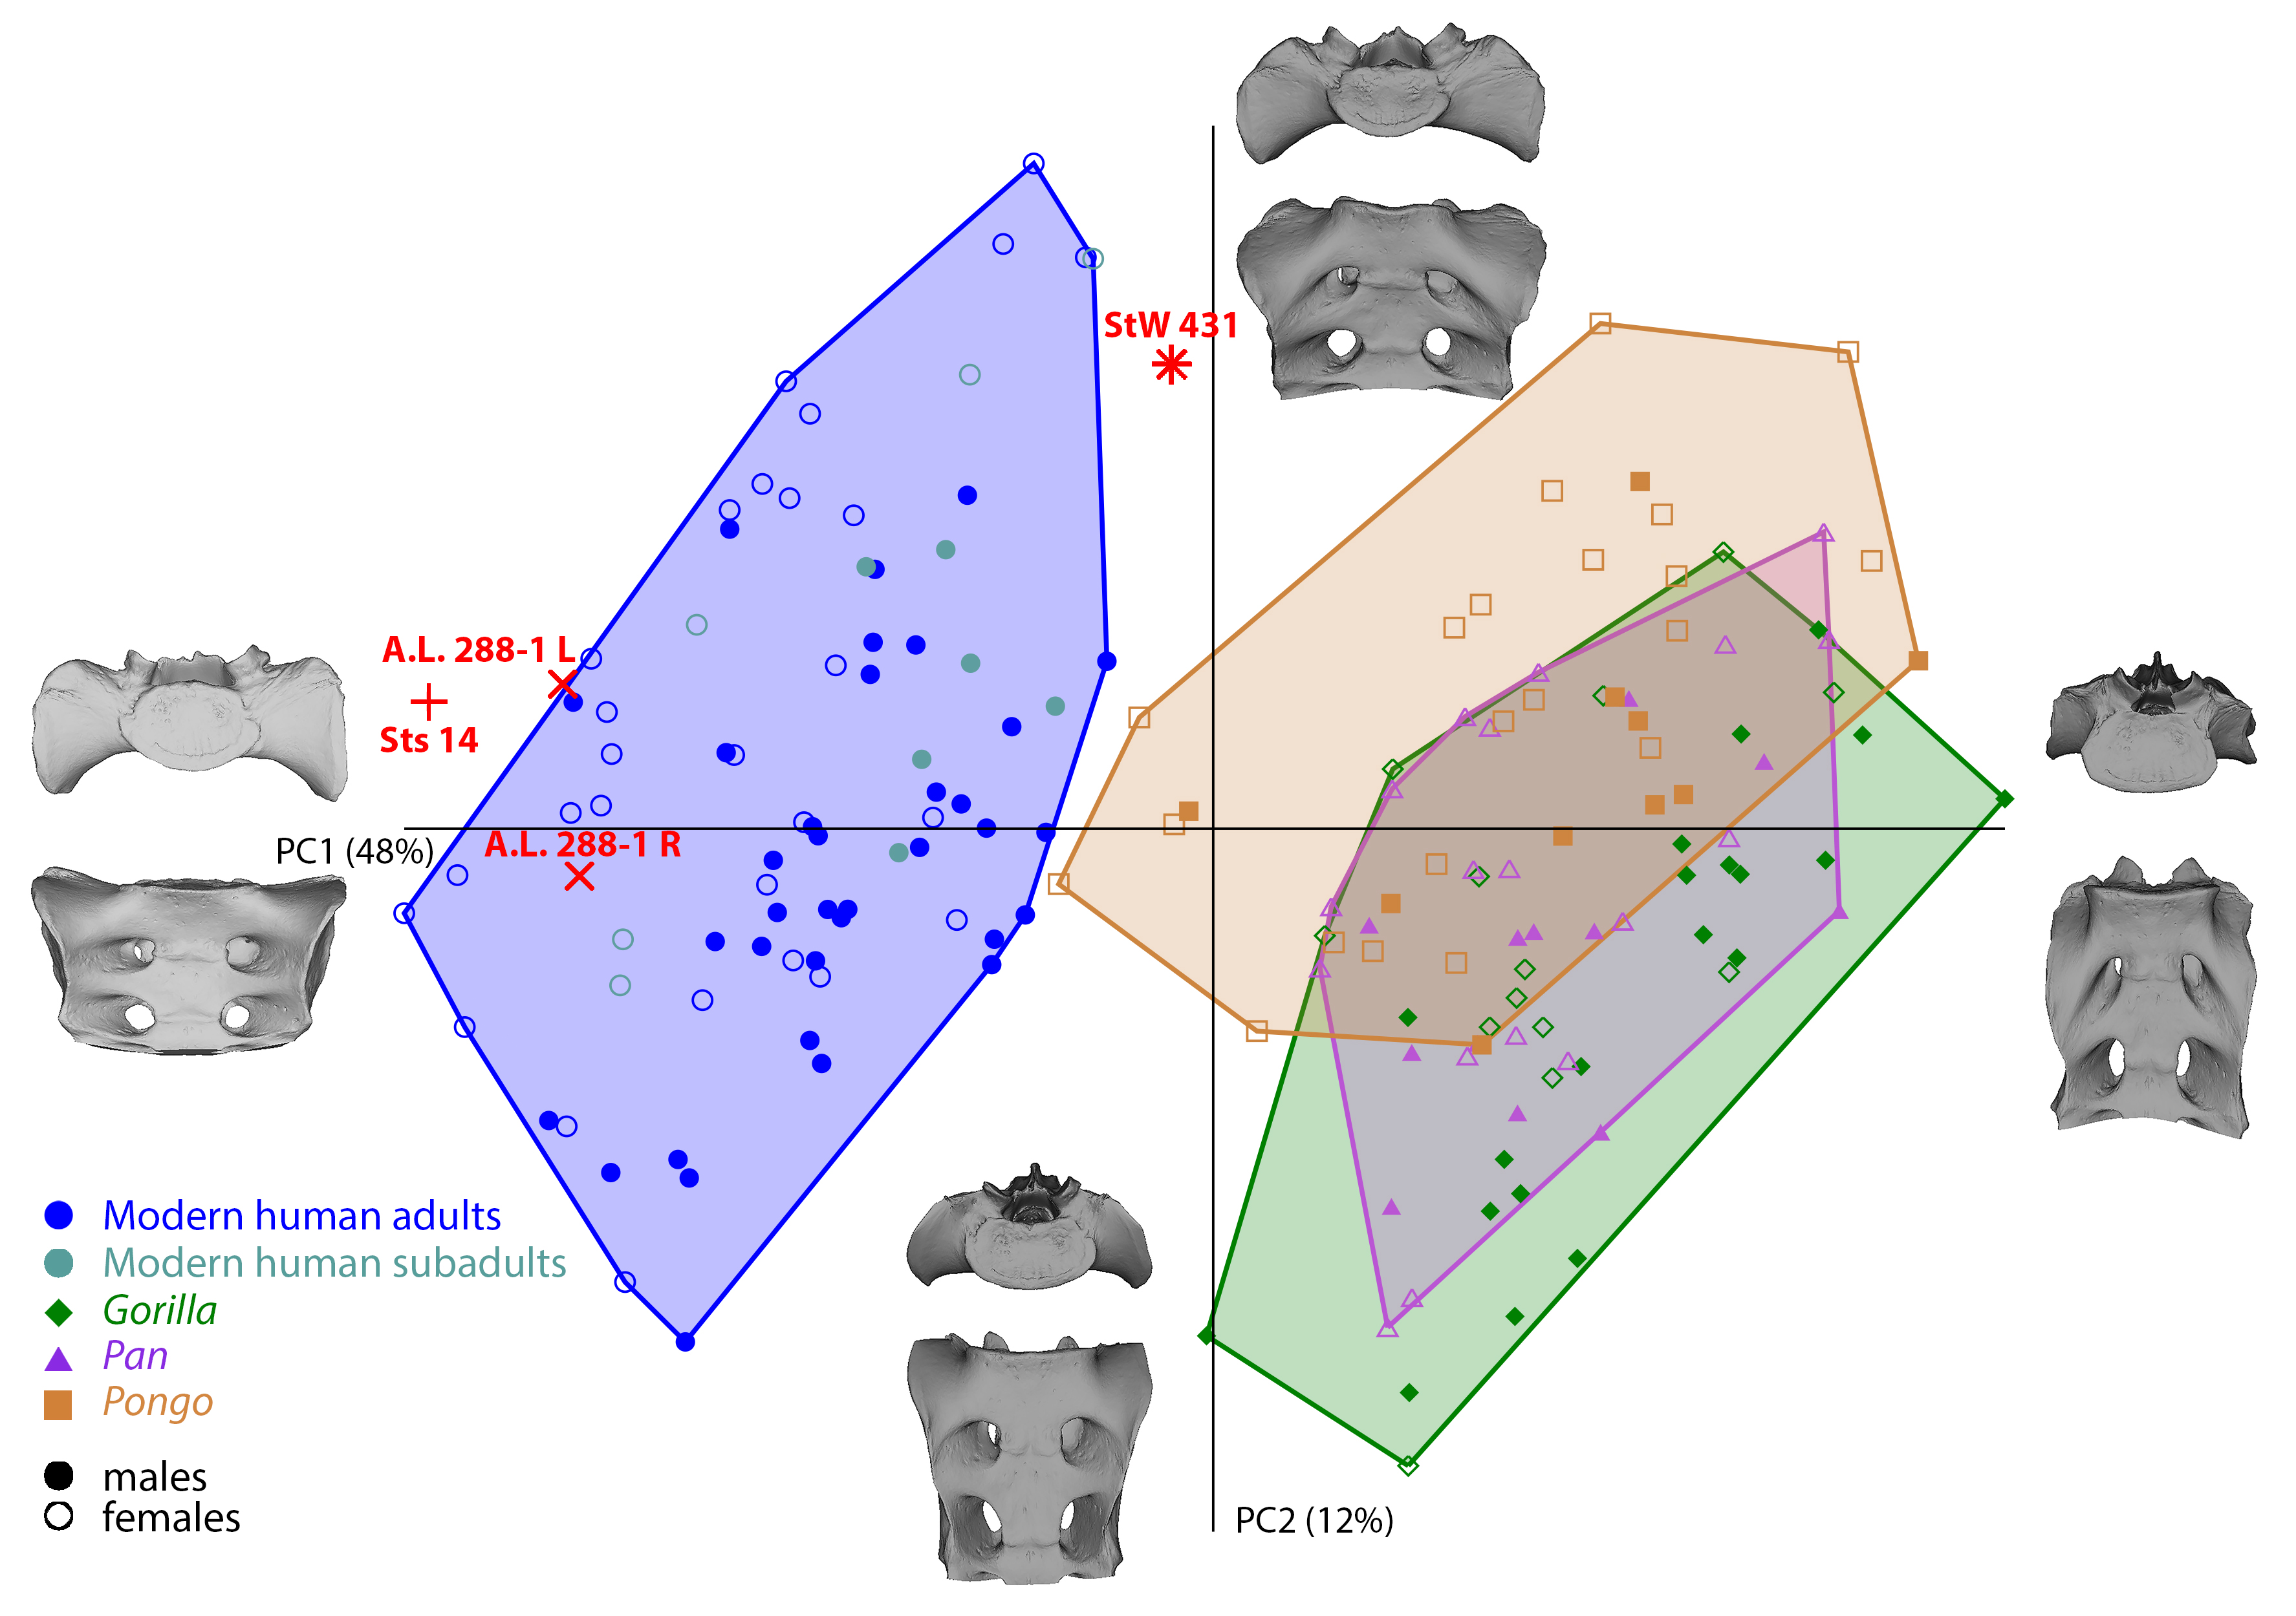
Supplementary Figure 4: PCA plot of the shape coordinates after Procrustes superimposition based on a subset of 13 landmarks on the body of the first sacral vertebra. This analysis emphasizes the relative dimensions of the wings in relation to the sacral body. Sts 14 plots at an extreme of the modern human distribution and StW 431 plots on the other side, between modern humans and great apes. These outcomes highlight the large differences between Sts 14 and StW 431 in terms of width-to-height proportions. Modern humans are distinct from the great apes in the PC1-PC2 plot, while Gorilla, Pan and Pongo overlap extensively.

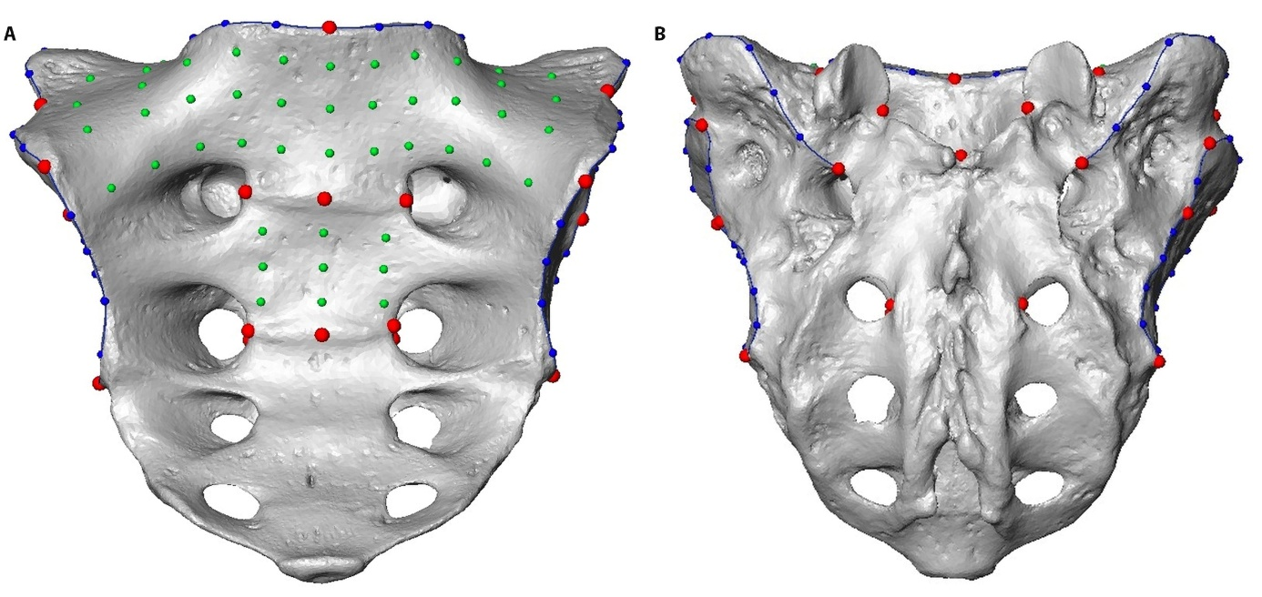
Supplementary Figure 5: The landmark configuration used. (A) Anterior and (B) posterior views of a modern human sacrum. Landmarks: red points; curve semilandmarks: blue points; surface semilandmarks: green points.

