Table 1. Dobutamin Stress Echocardiography Findings
Procedure DSE (November 2024) | Resting echocardiography (October 2024)
DSE with low dose dobutamine (5mcg/BW/minute) and peak dose (20mcg/BW/minute).  GLS (Global Longitudinal Strain)  Normal : -16 to -18  WMSi (Wall Motion Score Index )  Normal : 1.0, mild hypokinesi : 1.5 | Normal dimension cardiac chambers  Normal Global and segmental left ventricular systolic function with EF 73%  Normal right ventricular systolic function  IVS and LVPW normal thickness  Normokinetik wall motion  Aortic, Mitral and tricuspid mild regurgitation
ECG changes | DSE changes
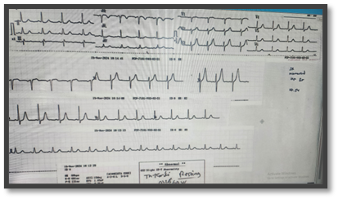 | Resting (0 mcg/BW/minute)  BP 149/118 HR 85 bpm  Kinetic : hypokinetic mid inferolateral  ECG : sinus rhythm, 82 bpm, normoaxis  Ejection fraction (EF) 49%  GLS -15, WMSI: 1.05
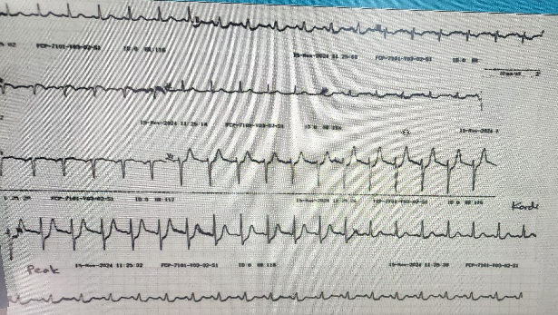 | Peak (25 mcg/BW/minute)  BP 149/78 HR 117 bpm  Kinetic : hypokinetic mid inferolateral  ECG : sinus rhythm, 116 bpm, normoaxis, upsloping ST depression V3-6  Ejection fraction (EF) 60%  GLS -15.4, WMSI : 1.05
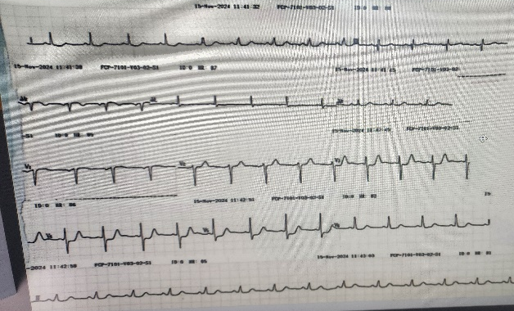 | Recovery (0 mcg/BW/minute)  BP 138/87 HR 85 bpm  Kinetic : hypokinetic mid inferolateral  ECG : sinus rhythm, 88 bpm, normoaxis, horizontal ST depression V3-5  Ejection fraction (EF) 51%  GLS -15.4, WMSI : 1.05
Conclusion DSE | Negative Ischaemic response

Table 2. Exercise Stress Test Result

Procedure
Exercise stress test performed using Modified Bruce Protocol. The main limiting symptoms (angina, chest pain, fatigue) and 85% of the Age-predicted maximal heart rate (APMHR) or beta-blocker user-adjusted (164-(0.7x age)) were selected as the endpoints for the exercise test using the standard modified Bruce protocol on a General Electrical (GE) T2100 treadmill. Maximal Heart Rate using beta-blocker was 124 bpm | Resting Electrocardiography (ECG) : Sinus Rhythm, 83 bpm, normoaxis, T inverted at III  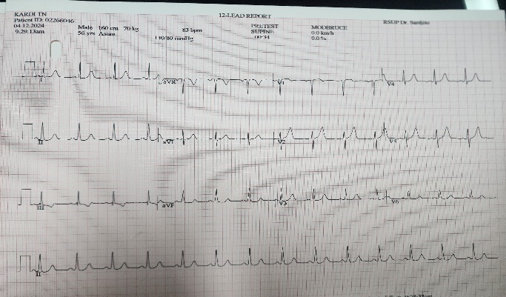

Stage 0 / 02:50
Clinical Changes  BP 140/80 mmHg  Speed 2.6 km/h  Inclination 0%  Non limiting chest pain  ECG Changes  Sinus Rhythm, 126 bpm (101 % MHR on beta-blocker user), Horizontal ST-segment depression (STD) 1 mm on V6 | 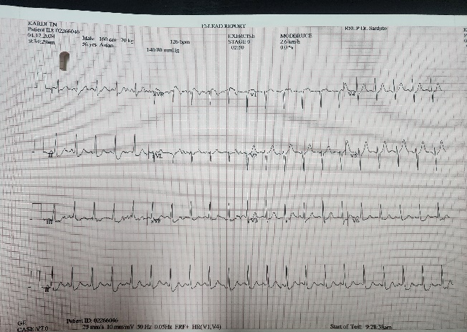

Stage 0.5 / Peak exercise 05:50
Clinical Changes  BP 120/80 mmHg (Hypotension response)  Speed 2.7 km/h  Inclination 5%  Limiting chest pain  ECG Changes  Sinus Rhythm, 129 bpm (104 % MHR on beta-blocker user), Horizontal ST-segment depression (STD) on II, III, AVF, V6 with deepest ST depression 3 mm and persist marked ST-segment elevation (STE) on aVR | 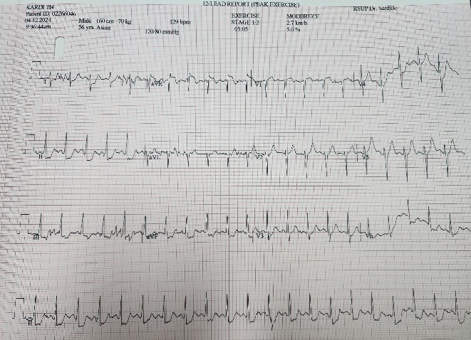

Recovery 00.16 (active)
Clinical Changes  BP 120/80 mmHg  Speed 2.4 km/h  Inclination 0%  Limiting chest pain  ECG Changes  Sinus Rhythm, 126 bpm (101 % MHR on beta-blocker user), Horizontal ST-segment depression (STD) on II, III, AVF with deepest ST depression 3 mm and upsloping STD on V6, persist marked STE on aVR | 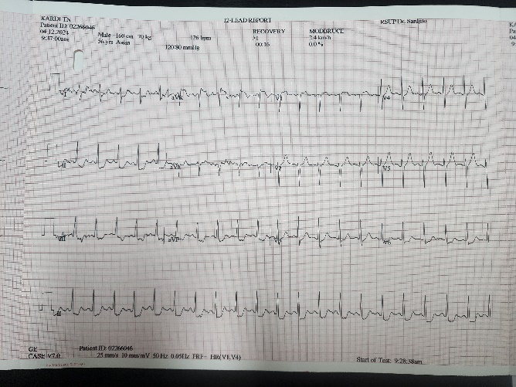

Recovery 02.50 (passive)
Clinical Changes  BP 120/80 mmHg , Speed 0.0 km/h  Inclination 0%  Chest pain subsided  ECG Changes  Sinus Rhythm, 97 bpm, downsloping ST-segment depression (STD) on II, III, AVF, V6 and Horizontal STD on I, AVL, V3,V4 with deepest ST depression 1 mm and persist marked STE on aVR | 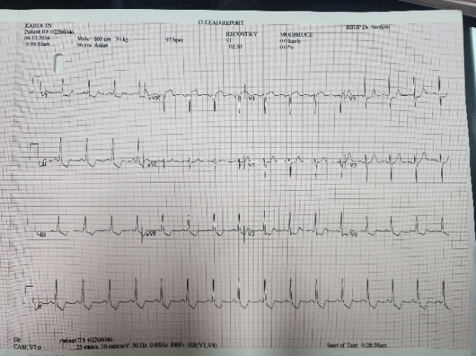

Recovery 05.50
Clinical Changes  BP 120/80 mmHg  Speed 0.0 km/h  Inclination 0%  Chest pain subsided  ECG Changes  Sinus Rhythm, 95 bpm, downsloping ST-segment depression (STD) on I, II, III, AVL, AVF, V3,V4, V6 and decreased STE on aV | 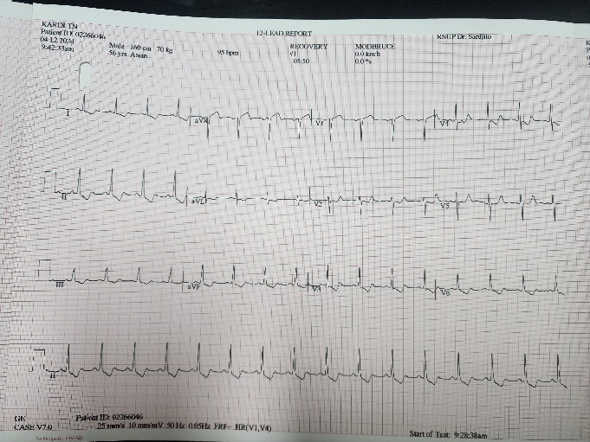

Recovery 08.50
Clinical Changes  BP 120/80 mmHg  Speed 0.0 km/h  Inclination 0%  Chest pain subsided  ECG Changes  Sinus Rhythm, 92 bpm, normoaxis and ST-T changes back to baseline | 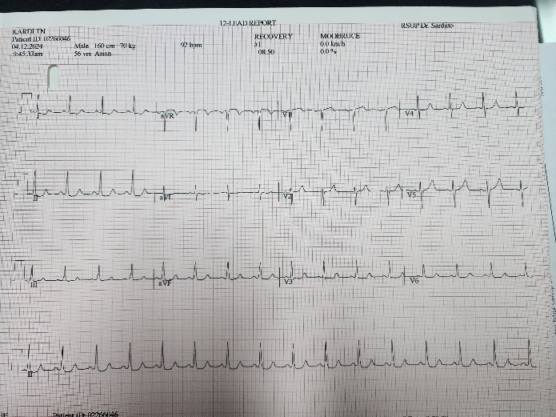
Conclusion | Positive ischemic response with DTS -13 (High Risk)  Respon hypotension on peak exercise  Low Fitness Class (3.44 METs)

