Childhood abuse is linked to poor sleep in adult women

Geraldine O’Bryanª, Sarah M. Tashjian^{a*}
ª University of Melbourne, School of Psychological Sciences, Parkville, Melbourne, Australia, 3010

*Corresponding author Sarah M. Tashjian (sarah.tashjian@unimelb.edu.au), University of Melbourne, School of Psychological Sciences, Parkville, Melbourne, Australia, 3010, Phone: +61 (03) 8344 6377

Supplemental Materials

Three-Class Model from the LCA on the ACE-Q
Figure S1 shows the profile plot for the three-class model. Class 1 (53.71%, n = 188) had a low probability of endorsement across all items (<.30), as such it was labelled ‘low ACEs’. Class 2 (24.29%, n = 85) was primarily characterized by threat-based items. These included emotional and physical abuse, where predicted probabilities for these items exceeded .70. Therefore Class 2 was labelled ‘emotional and physical abuse’. Class 3 (22%, n = 77) was primarily characterized by deprivation-based ACEs. Specifically, household mental illness (.90). However, Class 3 also had endorsement across a range of other items including household substance abuse, parental divorce/separation, emotional abuse and emotional neglect. Therefore Class 3 was labelled ‘household dysfunction and mixed ACEs’.

Figure S1
Profile Plot Showing the Predicted probabilities of Endorsing each ACE-Q item for the Three Latent Classes
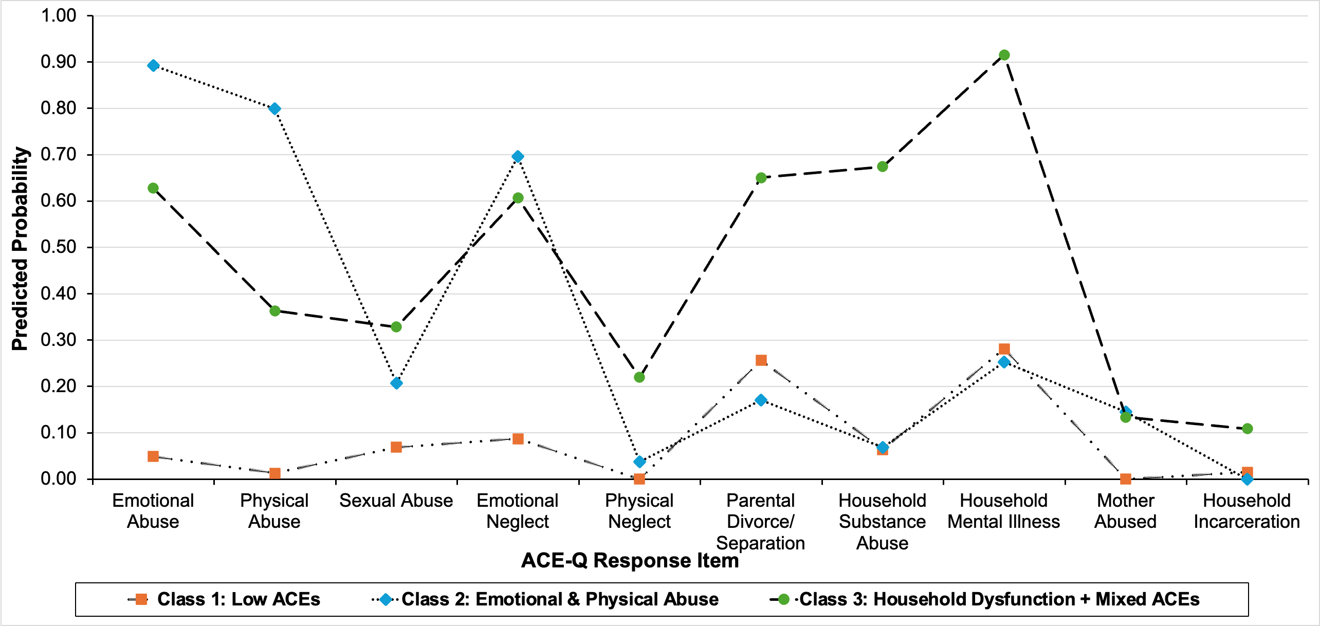
Note. Predicted probabilities of endorsing (selecting ‘yes’) for each ACE-Q item are shown. The legend indicates each of the three latent classes.
Results from the Logistic Regression using the Three-Class Model as Predictors
Results from a binary logistic regression using ACE subgroups from the three-class LCA model are shown in Table S1. Consistent with Hypothesis 4 (where we instead used the predictors from the four-class model), results showed ACE subgroups differentially relate to the odds of reporting sleep issues, $χ²$(2) = 12.97, p = .002. Notably, the household dysfunction group was associated with sleep issues when compared to the low ACEs subgroup. This contrasted with the four-class model used in the main analyses where we did not find a significant differences in sleep for the household dysfunction subgroup compared with the low ACEs subgroup. The reason for the difference is that in the three-class model the ‘high ACEs’ subgroup is collapsed into the larger household dysfunction subgroup, making household dysfunction less distinguishable. Those in the high ACEs subgroup had worse sleep issues than those in the low ACEs subgroup in the four-class model. In other words, the three-class model masks that high ACEs is driving the significant results without a significant finding for household dysfunction when separated out in the four-class model. Thus, the three-class model leads to obscured inferences about the relationship between household dysfunction and sleep. Together, these findings provided additional support for the four-class model.
Table S1
Binary Logistic Regression Predicting the Odds of Having Sleep Issues – ACE Subgroups from the Three-Class LCA Model
 |  |  |  |  |  |  |  |  | 95% CI for OR
Predictor | B |  | SE | z |  |  | p |  | LL |  | OR |  | UL
(Intercept) |  | -0.48 | 0.15 |  | -3.18 | .001 |  | 0.46 |  | 0.62 |  | 0.83
Household dysfunction + Mixed ACEs |  | 0.71 | 0.27 |  | 2.60 | .009 |  | 1.2 |  | 2.03 |  | 3.44
Emotional/Physical Abuse |  | 0.83 | 0.27 |  | 3.13 | .002 |  | 1.36 |  | 2.29 |  | 3.87
Note: Pseudo $R^{2}$= .05 (Nagelkerke), .04 (Cox & Snell), .03 (McFadden); AIC: 477.09
N = 350; Significant p-values are bolded.
Reference Category is ‘Low ACEs’

Summary of Participant Characteristics in each LCA Subgroup
Table S2
Summary of Participant Characteristics for the ACE-Q LCA Subgroups
 | ACE-Q Subgroups
Measure | Low ACEs | High ACEs | Emotional/Physical Abuse | Household Dysfunction
ACE-Q | 0.61 (0.67) | 5.62 (1.35) | 3.31 (1.0) | 3.0 (1.0)
PSQI | 7.51 (3.32) | 9.72 (3.84) | 8.86 (3.84) | 7.94 (3.94)
Age | 26.20 (8.69) | 27.20 (10.50) | 24.40 (6.16) | 24.90 (6.89)
Note. Low ACEs (n = 163); High ACEs (n = 40); Emotional/Physical Abuse (n = 96), Household Dysfunction (n = 51). The mean is reported for each measure. The standard deviation of the mean is indicated in brackets.

Table S3
Summary of Participant Characteristics for PSQI LCA Subgroups
 | PSQI Subgroups
Measure | High Sleep Issues | Low Sleep Issues
ACE-Q | 2.61 (2.07) | 1.97 (1.77)
PSQI | 11.10 (2.86) | 5.61 (2.06)
Age | 26.10 (8.73) | 25.20 (7.47)
Note. High sleep issues (n = 165), Low sleep issues (n = 185); The mean is reported for each measure. The standard deviation of the mean is indicated in brackets.

PSQI Components as Outcome Measures – Exploratory Results
Additional logistic regressions allowed us to determine whether links between sleep issues, as traditionally measured using the PSQI, and ACE exposure, as measured with LCA, could be identified. We used ACE subgroups as predictors and the seven binary-coded PSQI components as outcome variables. The low ACEs subgroup was used as the reference group in all analyses. Compared to women in the ‘low ACEs’ subgroup, women in the ‘high ACEs’ subgroup had higher odds of reporting issues with perceived sleep quality, sleep disturbances, and daytime dysfunction (Table S4). Additionally, women in the ‘emotional and physical abuse’ subgroup had higher odds of reporting issues with daytime dysfunction compared to women in the ‘low ACEs’ subgroup. In contrast, women in the ‘household dysfunction’ subgroup did not report an increase in any sleep related issues when compared to women in the ‘low ACEs’ subgroup. Together, these findings indicate abuse (emotional and/or physical) and ‘high ACEs’ are associated with sleep quality issues rather than issues specific to sleep duration. These findings converge with LCA analyses again pointing to abuse and high ACE exposure, rather than household dysfunction, as relevant for sleep issues.
Table S4
Binary Logistic Regression Analyses: ACE Subgroups Predicting the Odds of Reporting High Sleep Issues for Each PSQI Sleep Component

PSQI Component | Predictor | B |  | p |  | OR |  | 95% CI (Lower, Upper)
Subjective Sleep Quality | Intercept |  | -0.46 |  | .002 |  | 0.61 |  | [0.44, 0.84]
 | High ACEs |  | 0.87 |  | .020 |  | 2.38 |  | [1.18, 3.22]
 | Household Dysfunction |  | 0.27 |  | .410 |  | 1.30 |  | [0.69, 2.43]
 | Emotional / Physical Abuse |  | 0.50 |  | .050 |  | 1.65 |  | [1.00, 2.66]
Sleep Latency | Intercept |  | 0.21 |  | .150 |  | 1.26 |  | [0.79, 2.01]
 | High ACEs |  | 0.41 |  | .260 |  | 1.51 |  | [0.75, 2.99]
 | Household Dysfunction |  | 0.40 |  | .230 |  | 1.49 |  | [0.79, 2.81]
 | Emotional/Physical Abuse |  | 0.30 |  | .250 |  | 1.35 |  | [0.81, 2.25]
Sleep Duration | Intercept |  | -1.19 |  | <.001 |  | 0.30 |  | [0.25, 0.37]
 | High ACEs |  | 0.68 |  | .070 |  | 1.97 |  | [0.93, 4.18]
 | Household Dysfunction |  | 0.12 |  | .750 |  | 1.13 |  | [0.53, 2.43]
 | Emotional/Physical Abuse |  | 0.54 |  | .060 |  | 1.72 |  | [0.99, 2.96]
Sleep Efficiency | Intercept |  | -1.76 |  | <.001 |  | 0.17 |  | [0.11, 0.26]
 | High ACEs |  | 0.66 |  | .123 |  | 1.93 |  | [0.90, 4.41]
 | Household Dysfunction |  | 0.07 |  | .866 |  | 1.08 |  | [0.43, 2.70]
 | Emotional/Physical Abuse |  | 0.42 |  | .208 |  | 1.52 |  | [0.79, 2.94]
Sleep Disturbances | Intercept |  | -0.79 |  | <.001 |  | 0.44 |  | [0.24, 0.83]
 | High ACEs |  | 1.19 |  | .001 |  | 3.29 |  | [1.62, 6.66]
 | Household Dysfunction |  | -0.09 |  | .800 |  | 0.92 |  | [0.45, 1.84]
 | Emotional/Physical Abuse |  | 0.45 |  | .090 |  | 1.57 |  | [0.93, 2.66]
Sleep Medication | Intercept |  | -2.15 |  | <.001 |  | 0.13 |  | [0.07, 0.26]
 | High ACEs |  | 0.42 |  | .420 |  | 1.51 |  | [0.52, 14.5]
 | Household Dysfunction |  | 0.61 |  | .170 |  | 1.84 |  | [0.74, 4.62]
 | Emotional/Physical Abuse |  | 0.54 |  | .150 |  | 1.72 |  | [0.82, 3.59]
Daytime dysfunction | Intercept |  | -0.18 |  | .150 |  | 0.79 |  | [0.26, 2.38]
 | High ACEs |  | 0.80 |  | .030 |  | 2.23 |  | [1.10, 4.51]
 | Household Dysfunction |  | -0.34 |  | .310 |  | 0.71 |  | [0.37, 1.35]
 | Emotional/Physical Abuse |  | 0.70 |  | .010 |  | 2.01 |  | [1.20, 3.35]
Note. Significant p-values are bolded; PSQI Components are binary coded where 0 = low sleep issues, and 1 = high sleep issues; Reference category is ‘Low ACEs’ .

