Supplementary Figure 3e. Median overall survival in stage II cholangiocarcinoma NOS patients based on treatment type they received. 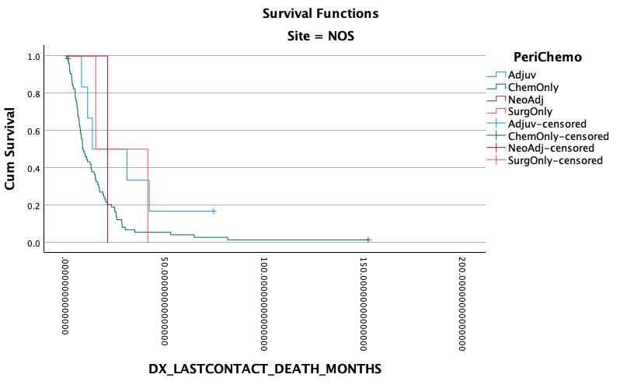
Surgery vs Adjuvant P=896
Surgery vs Neoadjuvant P=0.808
Surgery vs chemo P=0.320
Adjuvant vs Neoadjuvant P=758
Neoadjuvant vs chemo P=0.638
Adjuvant vs chemo P=0.064
0 50 100 150 200

Months since Diagnosis
Site: NOS
Surgery only: 14.9 months
Chemotherapy only: 8.7 months
Adjuvant chemo: 13.2 months
Neoadjuvant chemo: 20.9 months

