Supplementary Figure 2e. Median overall survival in stage I cholangiocarcinoma NOS patients based on treatment type they received. 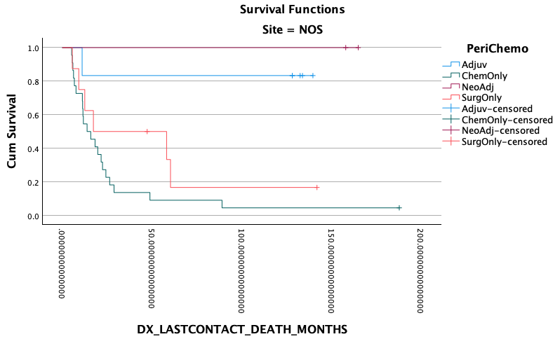
Surgery vs Adjuvant P=0.038
Surgery vs Neoadjuvant P=0.092
Surgery vs chemo P=0.181
Adjuvant vs Neoadjuvant P=0.564
Neoadjuvant vs chemo P=0.023
Adjuvant vs chemo P=0.002

Surgery only: 65.7 months
Chemotherapy only: 17.4 months
Adjuvant chemo: 50.4 months
Neoadjuvant chemo: 79.8 months
Site: NOS
0 50 100 150 200 250

Months since Diagnosis

