Supplementary Figure 4e. Median overall survival in stage III cholangiocarcinoma NOS patients based on treatment type they received. 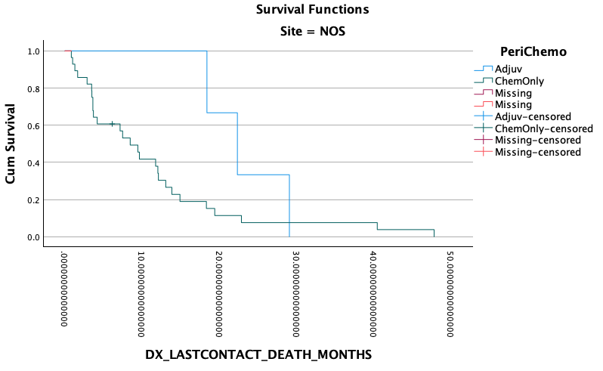
Adjuvant vs chemo P=0.166

Chemotherapy only: 8.4 months
Adjuvant chemo: 22.3 months

0 50 100 150 200

Months since Diagnosis
Site: NOS

