"Green SDG-Based Remediation of Sugarcane Vinasse via HA–nCaO: Integrating Computational Sustainability Evaluation with Innovative COD Removal, Organic Load, and pH Control"

Mahmoud F. Mubarak¹, Ahmed M. Saleh ^{2,3}
¹ Petroleum Applications Department, Egyptian Petroleum Research Institute (EPRI), Ahmed El-Zomer,
Nasr City, Cairo, Egypt.
² Pharmaceutical Chemistry Department, Faculty of Pharmacy, Horus University, Horus 34518, Egypt
³ Biosensors Research Lab, Zewail City of Science and Technology, 6th October City, Giza 12578, Egypt

^{*Corresponding authors:}
Ahmed M. Saleh
Pharmaceutical Chemistry Department, Faculty of Pharmacy, Horus University, Horus 34518, Egypt
Biosensors Research Lab, Zewail City of Science and Technology, 6th October City, Giza 12578, Egypt
E-mail address: asaleh@horus.edu.eg

Mahmoud F. Mubarak
Petroleum Applications Department, Egyptian Petroleum Research Institute (EPRI), Ahmed El-Zomer,
Nasr City, Cairo, Egypt.
E-mail address: fathy8753@yahoo.com
TABLE S1
Sustainable aspects and coordination relationship with the UN's sustainable development goals.
SDG Category |  | Application
GOAL 3: Good Health and Well-being (Social) | Minimizes chronic health risks by removing harmful organics and metals from vinasse-contaminated water.
GOAL 4: Quality Education (Social)  GOAL 5: Gender Equality (Social)  GOAL 6: Clean Water and Sanitation (Environmental)  GOAL 8: Decent Work and Economic Growth (Financial, social and governance)  GOAL 9: Industry, Innovation and Infrastructure (Financial and Governance)  GOAL 10: Reduced Inequalities (Social)  GOAL 11: Sustainable Cities and Communities (Social and environmental)  GOAL 12: Responsible Consumption and Production (Social and environmental)  GOAL 15: Life on Land (Environmental)  GOAL 17: Partnerships to achieve the Goal (Finance, environmental, social) | Promote innovation and provide educational and practical training opportunities.  Reduces the burden on women in researh areas with also improving water security  Achieves efficient vinasse purification—removing COD, TOC, and color—while neutralizing pH without added chemicals.  Creates green job opportunities through waste-to-resource recovery and circular economy pathways.  Demonstrates an innovative, scalable treatment system that advances eco-industrial water technologies.  Affordable and accessible water treatment solutions.  Integrating advanced water purification systems into urban infrastructure promotes environmental health.  Wastewater fostering circular economy principles and sustainable industrial practices  Preventing contamination to protect terrestrial ecosystems and biodiversity.  Promoting global cooperation in research, policy, and technology .

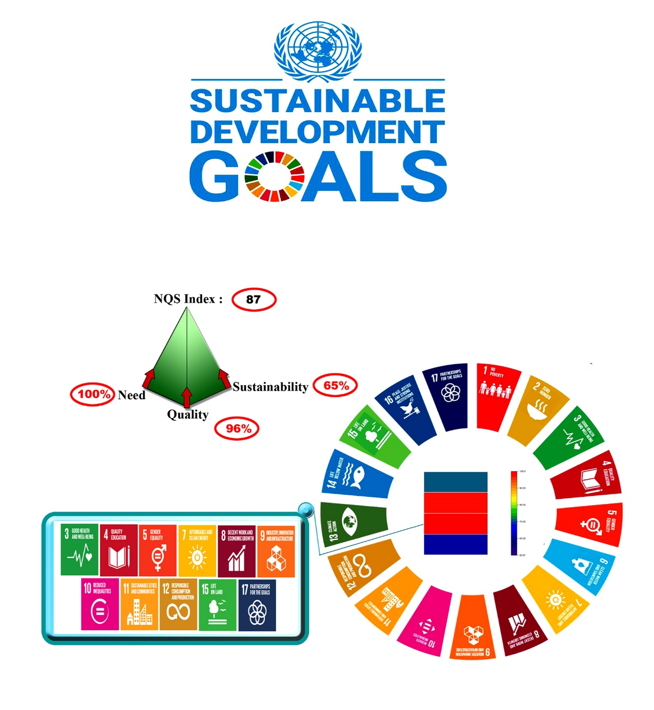
Figure S1: Sustainability Evaluation using Need Quality Sustainability (NQS) index , Koel’s Pyramid and UN Sustainable Development Goals (SDGs)

