Supplementary File
Index
Supplementary Table 1: Detailed search strategies used in each database
Supplementary Table 2: Newcastle Ottawa Scale quality assessment of the non-randomized studies
Supplementary Figure 1: Functional independence leave-one-out sensitivity analysis
Supplementary Figure 2: Successful recanalization leave-one-out sensitivity analysis
Supplementary Figure 3: All-cause mortality leave-one-out sensitivity analysis
Supplementary Figure 4: All-cause mortality leave-one-out sensitivity analysis
Supplementary Figure 5: Functional Independence funnel plot
Supplementary Figure 6: Successful recanalization funnel plot
Supplementary Figure 7: Symptomatic intracerebral hemorrhage funnel plot
Supplementary Figure 8: All-cause mortality funnel plot
Supplementary Figure 9: Functional Independence Egger’s regression test
Supplementary Figure 10: Successful recanalization Egger’s regression test
Supplementary Figure 11: Symptomatic intracerebral hemorrhage Egger’s regression test
Supplementary Figure 12: All-cause mortality Egger’s regression test

Supplementary Table 1: Detailed search strategies used in each database
Databases | Search String | Articles Retrieved
PubMed | ("Thrombectomy"[MeSH Terms] OR "Aspiration Thrombectomy"[All Fields] OR "Percutaneous Aspiration Thrombectomy"[All Fields] OR "Mechanical thrombectomy"[All Fields] OR "Endovascular thrombectomy"[All Fields]) AND ("posterior circulation stroke"[All Fields] OR "basilar artery stroke"[All Fields] OR "isolated basilar artery occlusion"[All Fields] OR ("vertebrobasilar"[All Fields] AND ("tandem"[All Fields] OR "tandems"[All Fields]) AND ("dental occlusion"[MeSH Terms] OR ("dental"[All Fields] AND "occlusion"[All Fields]) OR "dental occlusion"[All Fields] OR "occlusion"[All Fields] OR "occlused"[All Fields] OR "occlusions"[All Fields] OR "occlusive"[All Fields] OR "occlusives"[All Fields])) OR "tandem occlusion"[All Fields] OR "tandem occlusion stroke"[All Fields]) | 333
Cochrane Central | ("Thrombectomy" OR "Aspiration Thrombectomy" OR "Percutaneous Aspiration Thrombectomy" OR "Mechanical thrombectomy" OR "Endovascular thrombectomy") AND ( "posterior circulation stroke" OR "basilar artery stroke" OR "isolated basilar artery occlusion" OR "vertebrobasilar tandem occlusion" OR "tandem occlusion" OR "tandem occlusion stroke" ) | 70
Science Direct | ("Thrombectomy" OR "Mechanical thrombectomy" OR "Endovascular thrombectomy") AND ( "posterior circulation stroke" OR "basilar artery stroke" OR "isolated basilar artery occlusion" OR "vertebrobasilar tandem occlusion" OR "tandem occlusion") | 915

Supplementary Table S2: Newcastle Ottawa Scale for the quality assessment of the non-randomized studies
Cohort Studies |  | Selection |  |  |  | Comparability | Exposure |  |  | Total
Author | Year | Representativeness of Exposed Cohort | Selection of the Non exposed cohort | Ascertainment of Exposure | Outcome was not Present at the start of Study | Comparability | Assessment of Outcome | Follow-up long enough for Outcomes to occur | Adequacy of follow-up of Cohorts | Total
Sun | 2020 | * | * | * |  | ** | * | * |  | 7
Elhorany | 2020 | * | * | * | * | ** | * | * |  | 8
Piechowiak | 2020 | * | * | * |  | ** | * | * | * | 8
Baik | 2019 | * | * | * |  | * | * | * | * | 7
Klail | 2024 | * | * | * | * | ** | * | * | * | 9
Dogan | 2024 | * | * | * | * | ** | * | * | * | 9
Cohen | 2016 | * | * | * | * | * | * |  | * | 7
Xing | 2020 | * | * | * | * | * | * | * | * | 8
Baik | 2020 | * | * | * | * | * | * | * | * | 8

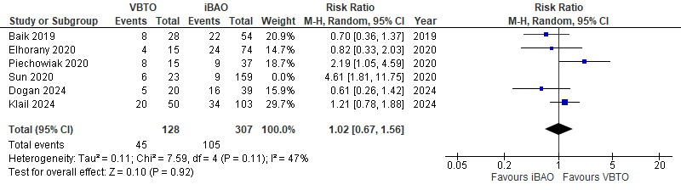
Supplementary Figure 1: Functional independence leave-one-out sensitivity analysis
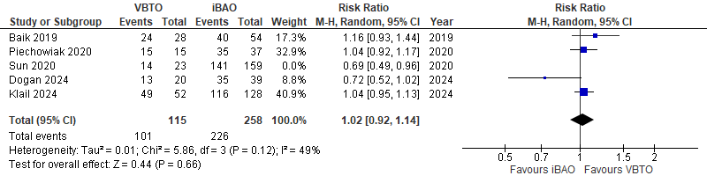
Supplementary Figure 2: Successful recanalization leave-one-out sensitivity analysis
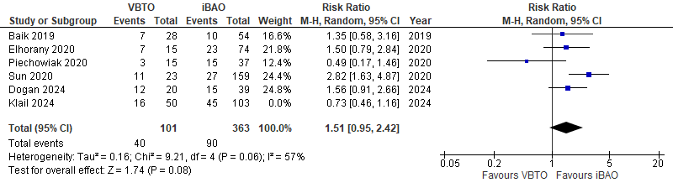
Supplementary Figure 3: All-cause mortality leave-one-out sensitivity analysis
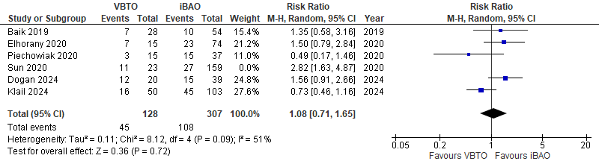
Supplementary Figure 4: All-cause mortality leave-one-out sensitivity analysis
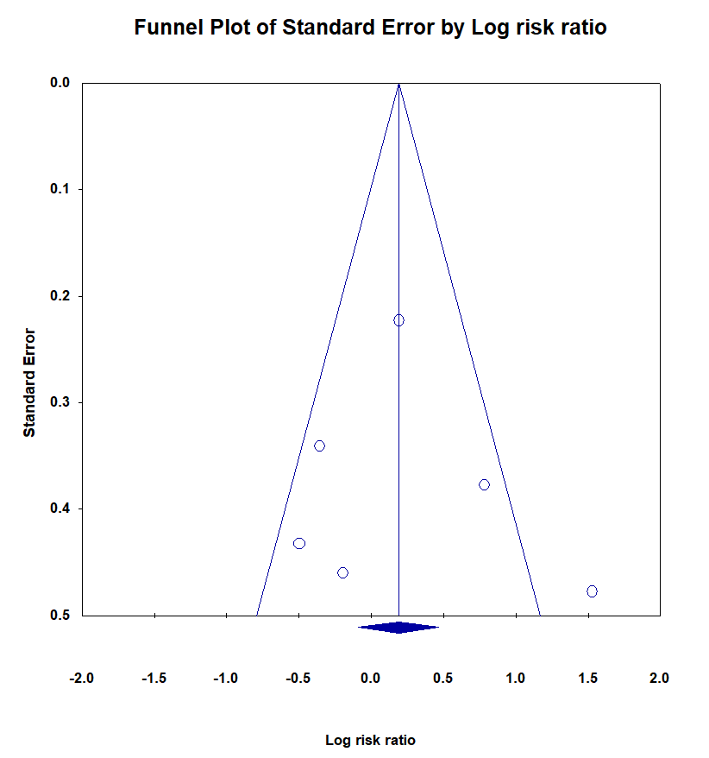

Supplementary Figure 5: Functional Independence funnel plot
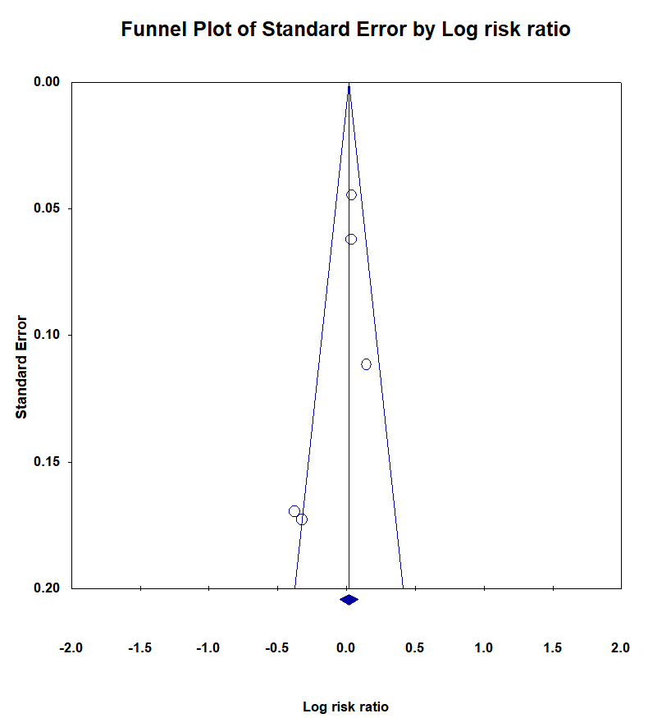

Supplementary Figure 6: Successful recanalization funnel plot
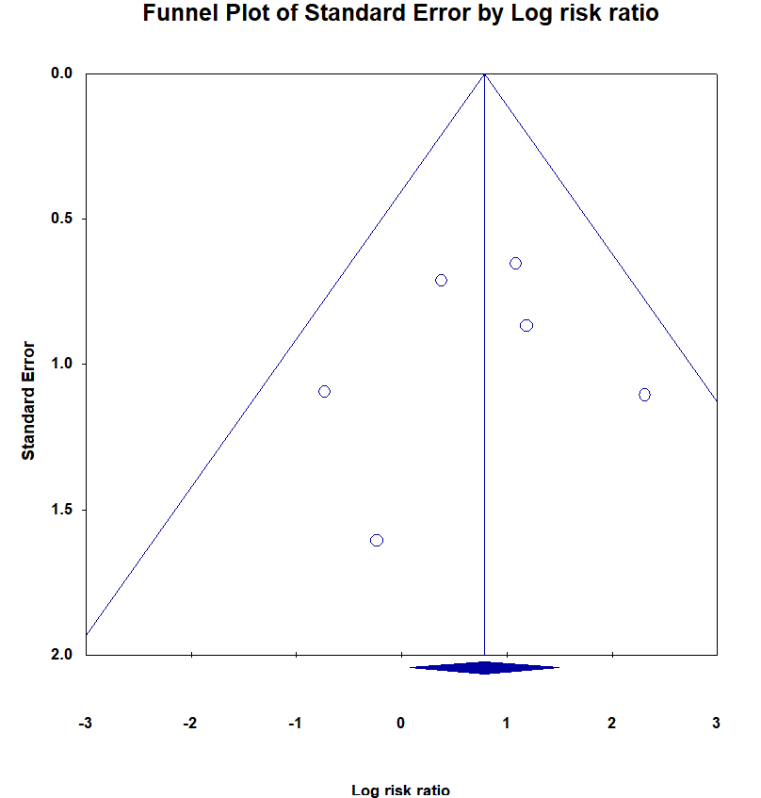

Supplementary Figure 7: Symptomatic intracerebral hemorrhage funnel plot
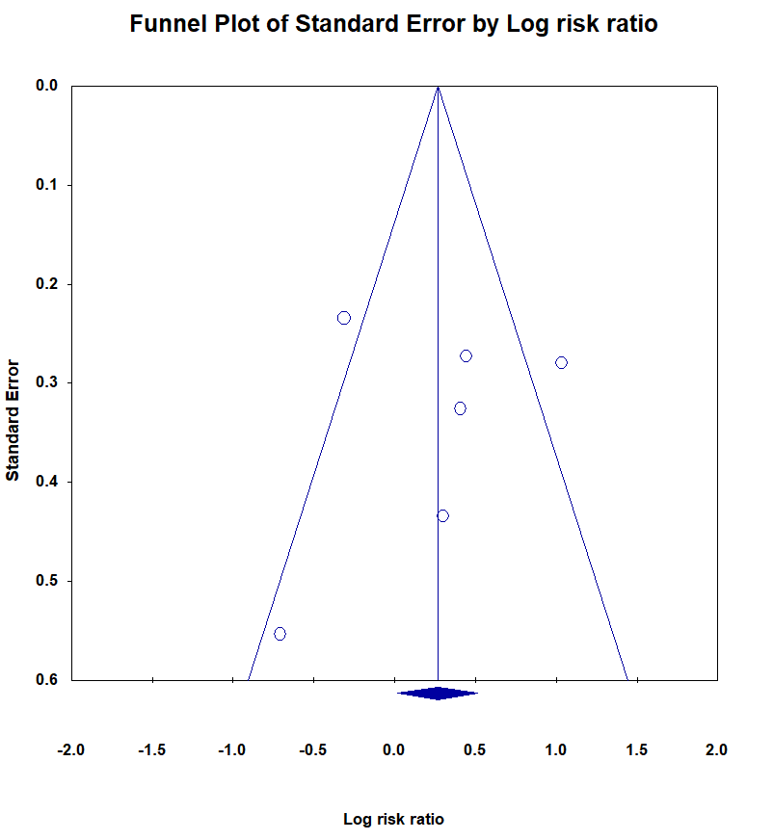

Supplementary Figure 8: All-cause mortality funnel plot
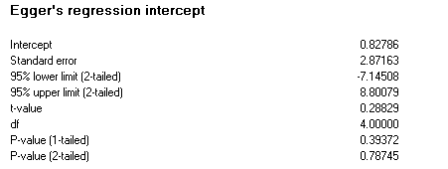

Supplementary Figure 9: Functional Independence Egger’s regression test
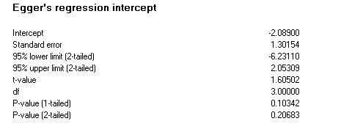

Supplementary Figure 10: Successful recanalization Egger’s regression test
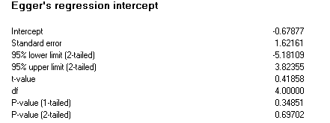

Supplementary Figure 11: Symptomatic intracerebral hemorrhage Egger’s regression test
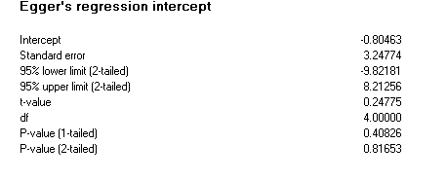

Supplementary Figure 12: All-cause mortality Egger’s regression test

