Supplements to article:

Enhancing procedural knowledge
in pregraduate surgical education:
A controlled field study of interactive blended learning.

Figures

Supplementary figure 1
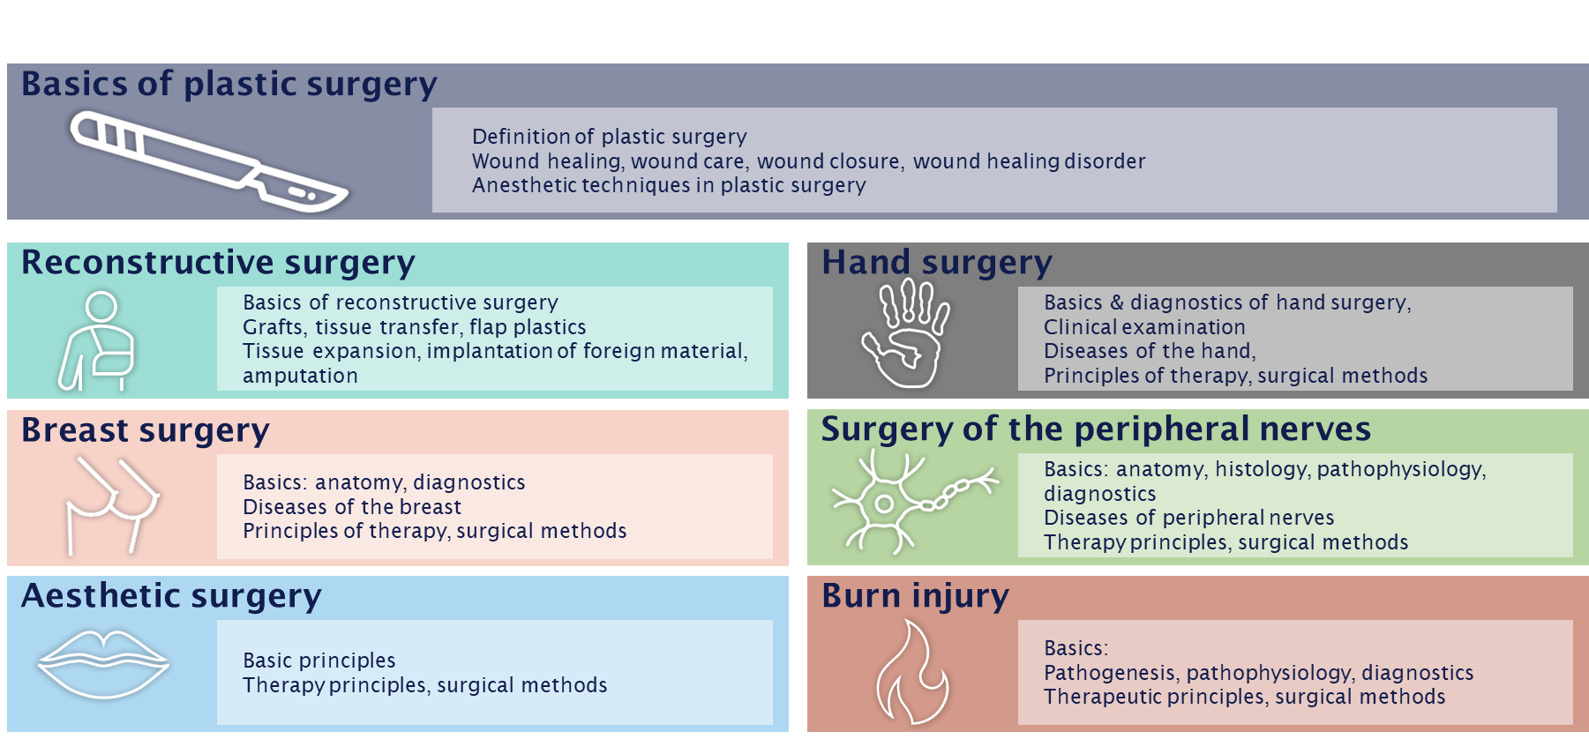
Supplementary figure 2: Course contents of the seven chapters, depicting the fields of conceptual knowledge.

Supplementary figure 2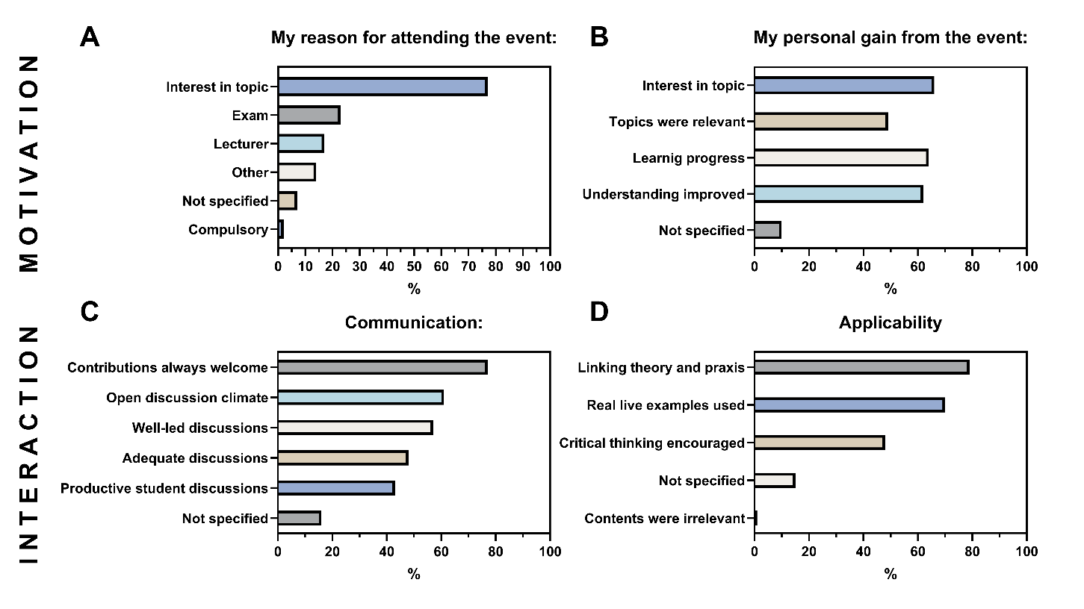
Supplementary figure 3: TRIL questionnaire: Student identification assessed via TRIL questionnaire excerpt on motivation and interaction, Figures A and B describe aspects of student motivation, figures C and D depict aspects of student interaction.

Supplementary figure 3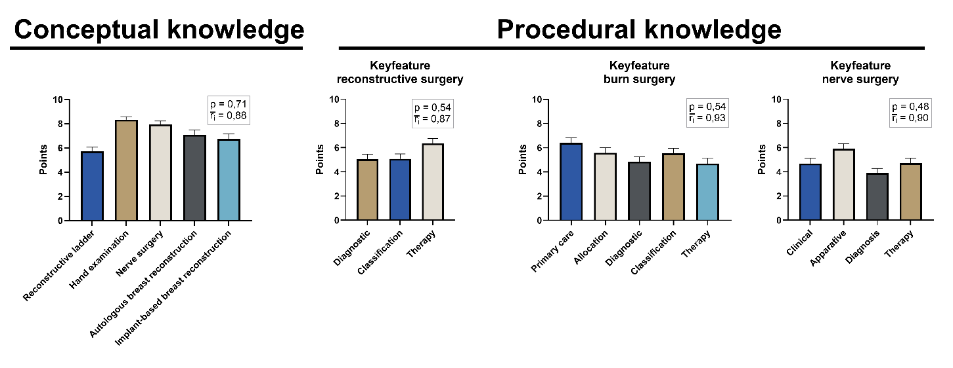
Supplementary figure 3: Posttest results: posttest scores depicted as mean + SEM for conceptual

Tables

Supplementary table 1
Test | Area | test modality | n | test items | mean ± SD | Difficulty p | Discriminatory power ri
Pretest | Anatomy | Short answer | 101 | 2 | 24.75% ± 38.30% | 0.25 | 0.52
 | Surgical basics | Short answer | 101 | 4 | 78.71% ± 27.56% | 0.79 | 0.60
 | Assign diseases | Kprim | 101 | 8 | 58.75% ± 28.30% | 0.59 | 0.20
 | Assign surgeries | Kprim | 101 | 11 | 83.91% ± 21.13% | 0.84 | 0.60
 | Pretest total | multiple | 101 | 25 | 61.53% ± 28.82% | 0.62 | 0.48
Posttest | Conceptional knowledge
 | Reconstructive ladder | Drag & drop | 132 | 7 | 57.25% ± 38.59% | 0.57 | 0.80
 | Hand examination | Drag & drop | 132 | 6 | 83.33% ± 29.30% | 0.83 | 0.79
 | Nerve surgery | Drag & drop | 132 | 4 | 79.55% ± 30.28% | 0.80 | 0.83
 | Breast reconstruction | Short answer | 132 | 2 | 69.13% ± 45.84% | 0.69 | 0.91
 | Conceptual knowledge total | multiple | 132 | 19 | 71.25% ± 39.28% | 0.71 | 0.86
 | Procedural knowledge
 | Keyfeature reconstructive surgery | Key feature | 132 | 3 | 54.92% ± 40.71% | 0.55 | 0.88
 | Keyfeature burn injury | Key feature | 132 | 5 | 54.11% ± 40.41% | 0.54 | 0.95
 | Keyfeature nerve surgery | Key feature | 132 | 4 | 48.11% ± 40.23% | 0.48 | 0.93
 | Procedural knowledge total | Key feature | 132 | 12 | 52.31% ± 37.46% | 0.52 | 0.92
 | Post test total | multiple | 132 | 31 | 63.77% ± 37.91% | 0.64 | 0.87

Supplementary table 2

 | Conceptual knowledge |  |  | Procedural knowledge
Column A | Presence | Presence | Online | Presence | Presence | Online
vs. | vs. | vs. | vs. | vs. | vs. | vs.
Column B | Online | No participation | No participation | Online | No participation | No participation
Unpaired t test with Welch's correction

P value | 0.0274 | <0.0001 | 0.0373 | <0.0001 | <0.0001 | 0.5617
P value summary | n.s. | ** | n.s. | ** | ** | n.s.
Significantly different (P < 0.0083)? | No | Yes | No | Yes | Yes | No
One- or two-tailed P value? | Two-tailed | Two-tailed | Two-tailed | Two-tailed | Two-tailed | Two-tailed
Welch-corrected t. df | t=2.263.  df=57.49 | t=4.286.  df=45.50 | t=2.134.  df=55.30 | t=8.628.  df=88.31 | t=6.116.  df=59.16 | t=0.5858.  df=36.34
How big is the difference?
Mean of column A | 42.48 | 42.48 | 35.96 | 82.05 | 82.05 | 35.96
Mean of column B | 35.96 | 27.66 | 27.66 | 35.96 | 31.8 | 31.8
Difference between means  (B - A) ± SEM | -6.518 ± 2.881 | -14.81 ± 3.457 | -8.296 ± 3.888 | -46.09 ± 5.341 | -50.25 ± 8.216 | -4.160 ± 7.101
95% confidence interval | -12.29 to -0.7508 | -21.77 to -7.854 | -16.09 to -0.5062 | -56.70 to -35.47 | -66.68 to -33.81 | -18.56 to 10.24
R squared (eta squared) | 0.08178 | 0.2876 | 0.07608 | 0.4574 | 0.3874 | 0.009354
F test to compare variances
F. DFn. Dfd | 1.065. 30. 64 | 1.687. 29. 64 | 1.584. 29. 30 | 8.341. 64. 30 | 1.105. 64. 29 | 7.547. 29. 30
P value | 0.8118 | 0.0839 | 0.2162 | <0.0001 | 0.7854 | <0.0001
P value summary | ns | ns | ns | **** | ns | ****
Significantly different (P < 0.05)? | No | No | No | Yes | No | Yes

Supplementary table 3

 | Interest in plastic surgery | Experience | Interest in lecture | Pretest score | Participation in case discussion | Enthusiasm after lesson | Posttest score
Interest in plastic surgery |  | R = 0.55 p = <0.0001 **** | R = 0.54 p = <0.0001 **** | R = 0.18 p = 0.2307 ns | R = 0.18 p = 0.2368 ns | R = 0.21 p = 0.1503 ns | R = 0.09 p = 0.5535 ns
Experience | R = 0.55 p = <0.0001 **** |  | R = 0.28 p = 0.0559 ns | R = 0.25 p = 0.0946 ns | R = -0.02 p = 0.9070 ns | R = 0.08 p = 0.5918 ns | R = -0.02 p = 0.8975 ns
Interest in lecture | R = 0.54 p = <0.0001 **** | R = 0.28 p = 0.0559 ns |  | R = 0.17 p = 0.2613 ns | R = 0.07 p = 0.6340 ns | R = 0.48 p = 0.0007 *** | R = 0.13 p = 0.3951 ns
Pretest score | R = 0.18 p = 0.2307 ns | R = 0.25 p = 0.0946 ns | R = 0.17 p = 0.2613 ns |  | R = 0.00 p = 0.9932 ns | R = 0.28 p = 0.0573 ns | R = 0.35 p = 0.0157 *
Participation in case discussion | R = 0.18 p = 0.2368 ns | R = -0.02 p = 0.9070 ns | R = 0.07 p = 0.6340 ns | R = 0.00 p = 0.9932 ns |  | R = 0.60 p = <0.0001 **** | R = 0.51 p = 0.0004 ***
Enthusiasm after lesson | R = 0.21 p = 0.1503 ns | R = 0.08 p = 0.5918 ns | R = 0.48 p = 0.0007 *** | R = 0.28 p = 0.0573 ns | R = 0.60 p = <0.0001 **** |  | R = 0.60 p = <0.0001 ****
Posttest score | R = 0.09 p = 0.5535 ns | R = -0.02 p = 0.8975 ns | R = 0.13 p = 0.3951 ns | R = 0.35 p = 0.0157 * | R = 0.51 p = 0.0004 *** | R = 0.60 p = <0.0001 ****

Correlations of pre- and posttest items, R = Pearson correlation coefficient, p = level of significance, (* = p < 0.05; ** = p < 0.01; *** = p < 0.001; *** = p < 0.0001)

