Supplementary Figures

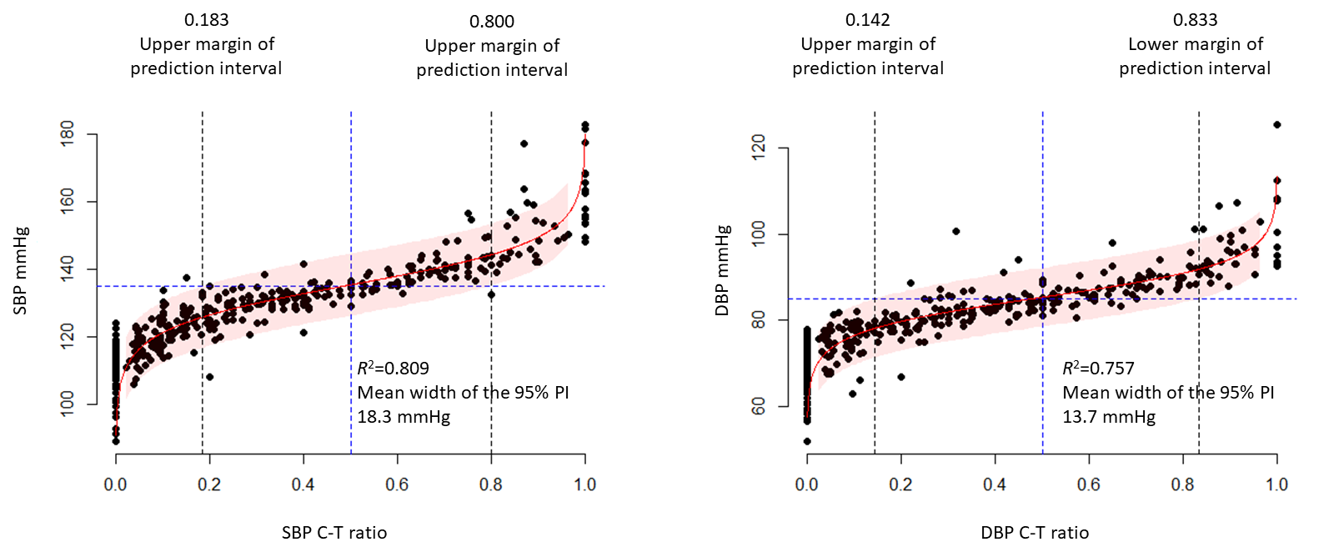

Supplementary Figure 1. Non-linear relationship between the high BP count-to-total BP reading (C-T) ratio and BP.
The relationship between the C-T ratio and SBP/DBP is fitted well with a logit curve. The red curved line represents BP estimated using the C-T ratio and the reddish ribbon represents the 95% prediction interval of the SBPs/DBPs corresponding to the C-T ratio. The mean widths of the 95% prediction intervals are wider than those estimated in the linear models with BP range restrictions.

Supplementary Tables
Supplementary Table 1. Diagnostic performances of the high BP counts at the best threshold
 | SBP |  |  |  |  |  |  |  | DBP
K | SD | uncontrolled SBP (N/100) | Thres | Sens | Spec | PPV | NPV | CCR | SD | uncontrolled DBP (N/100) | Thres | Sens | Spec | PPV | NPV | CCR
24 | 5 | 50 | ≥12 | 0.907 | 0.895 | 0.867 | 0.927 | 0.90 | 3.5 | 54 | ≥12 | 1.000 | 1.000 | 1.000 | 1.000 | 1.00
 | 10 | 50 | ≥12 | 0.880 | 0.800 | 0.815 | 0.870 | 0.84 | 7 | 56 | ≥12 | 1.000 | 0.867 | 0.902 | 1.000 | 0.94
 | 15 | 49 | ≥12 | 0.878 | 0.902 | 0.896 | 0.885 | 0.89 | 10.5 | 57 | ≥12 | 0.912 | 0.930 | 0.945 | 0.889 | 0.92
 | 20 | 48 | ≥11 | 1.000 | 0.577 | 0.686 | 1.000 | 0.78 | 14 | 53 | ≥13 | 0.830 | 0.979 | 0.978 | 0.836 | 0.90
20 | 5 | 44 | ≥11 | 0.909 | 0.946 | 0.930 | 0.930 | 0.93 | 3.5 | 51 | ≥10 | 0.980 | 0.959 | 0.962 | 0.979 | 0.97
 | 10 | 54 | ≥11 | 0.796 | 0.978 | 0.977 | 0.804 | 0.88 | 7 | 47 | ≥11 | 0.915 | 1.000 | 1.000 | 0.930 | 0.96
 | 15 | 49 | ≥10 | 0.878 | 0.804 | 0.811 | 0.872 | 0.84 | 10.5 | 53 | ≥10 | 0.943 | 0.957 | 0.962 | 0.938 | 0.95
 | 20 | 50 | ≥10 | 0.940 | 0.740 | 0.783 | 0.925 | 0.84 | 14 | 54 | ≥10 | 0.889 | 0.848 | 0.873 | 0.867 | 0.87
16 | 5 | 48 | ≥9 | 0.844 | 1.000 | 1.000 | 0.887 | 0.93 | 3.5 | 51 | ≥8 | 1.000 | 0.957 | 0.964 | 1.000 | 0.98
 | 10 | 50 | ≥8 | 0.933 | 0.800 | 0.792 | 0.936 | 0.86 | 7 | 53 | ≥8 | 0.897 | 0.929 | 0.945 | 0.867 | 0.91
 | 15 | 54 | ≥9 | 0.816 | 0.941 | 0.930 | 0.842 | 0.88 | 10.5 | 56 | ≥9 | 0.820 | 0.960 | 0.953 | 0.842 | 0.89
 | 20 | 51 | ≥8 | 0.857 | 0.818 | 0.857 | 0.818 | 0.84 | 14 | 53 | ≥9 | 0.776 | 0.922 | 0.905 | 0.810 | 0.85
K, the number of BP measurements; SD, standard deviation; PPV, postive predictive value; NPV, negative predictive value; CCR, correct classification rate; SBP, systolic BP
* Threshold was derived from Youden's J indexes
The high SBP/DBP were defined as SBP ≥135 mmHg or DBP ≥85 mmHg.

