Rosmarinic Acid as a Potential GSK3β Inhibitor for Autism Spectrum Disorder: Insights from an Integrative In-Silico Study
Priya Joon^{1†}, Deepak Deepak^{2,*,†} and Anil Kumar^{1,*}

¹Pharmacology Division, University Institute of Pharmaceutical Sciences, Panjab University, Chandigarh, 110014, India.
²Faculty of Chemistry and Pharmacy, Ludwig-Maximilians-Universitat Munchen, Munich, 81377, Germany.
*Corresponding authors: deepmalik828@gmail.com; kumaruips@yahoo.com
Contributing authors: piks.priya@gmail.com; deepmalik828@gmail.com
†These authors contributed equally to this work.
Supplementary Data
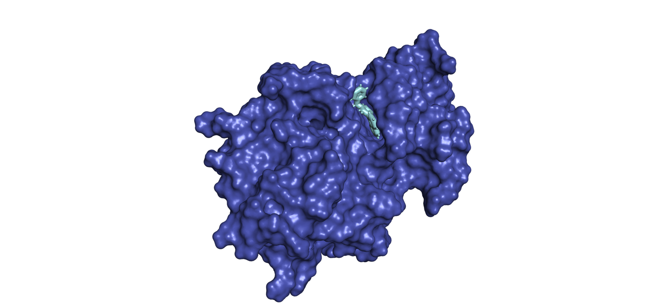
Fig. S 1 Interaction of Tidesglusib within the GSK3β Binding Site. GSK3β (surface representation in blue) with docked Tidesglusib (stick representation in cyan).
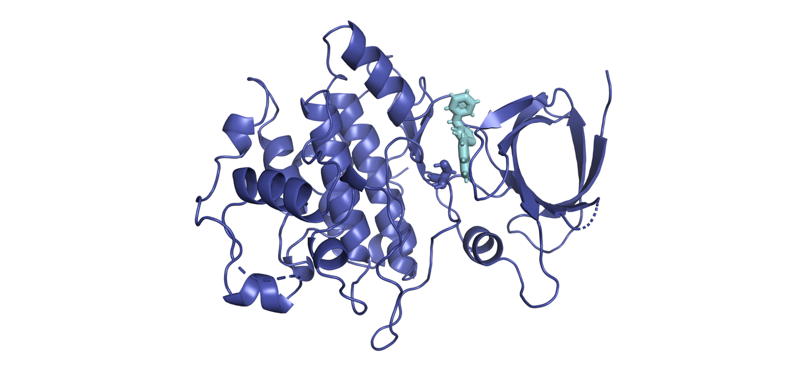
Fig. S 2 Interaction of Tidesglusib within the GSK3β Binding Site. GSK3β (ribbon representation in blue) with docked Tidesglusib (stick representation in cyan).
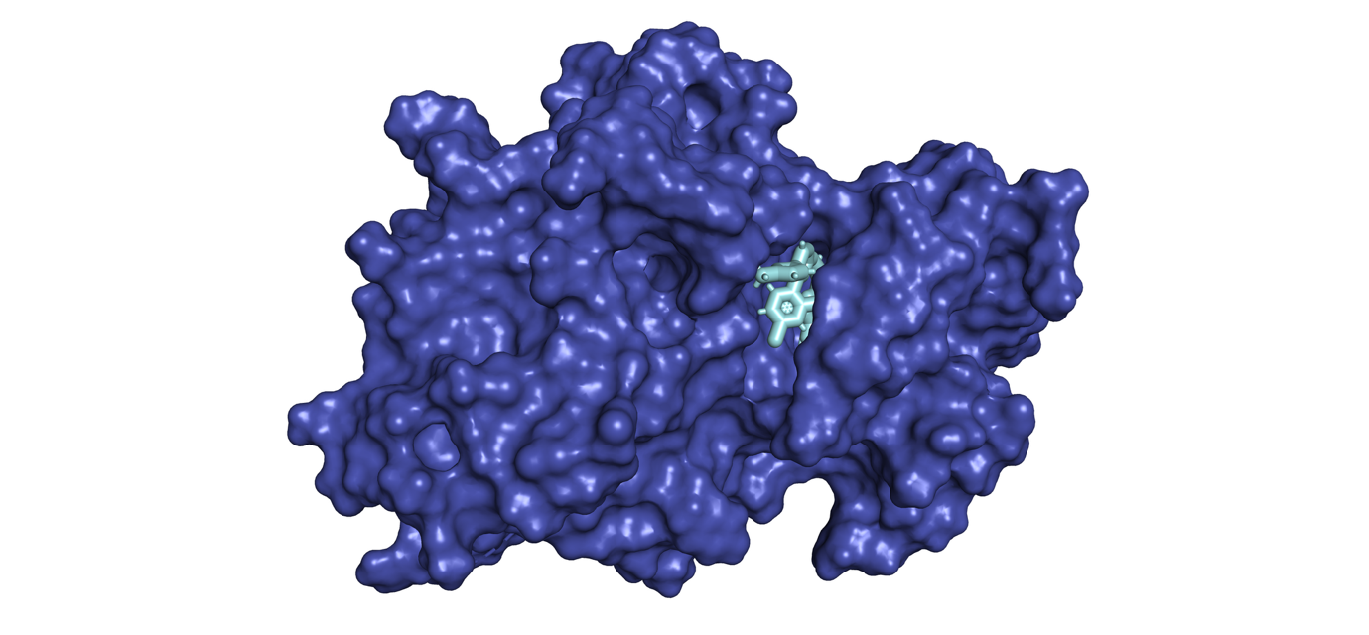
Fig. S 3 Interaction of Laduviglusib within the GSK3β Binding Site. GSK3β (surface representation in blue) with docked Laduviglusib (stick representation in cyan).
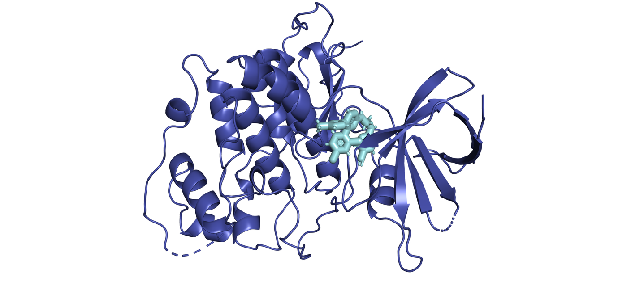
Fig. S 4 Interaction of Laduviglusib within the GSK3β Binding Site. GSK3β (ribbon representation in blue) with docked Laduviglusib (stick representation in cyan).
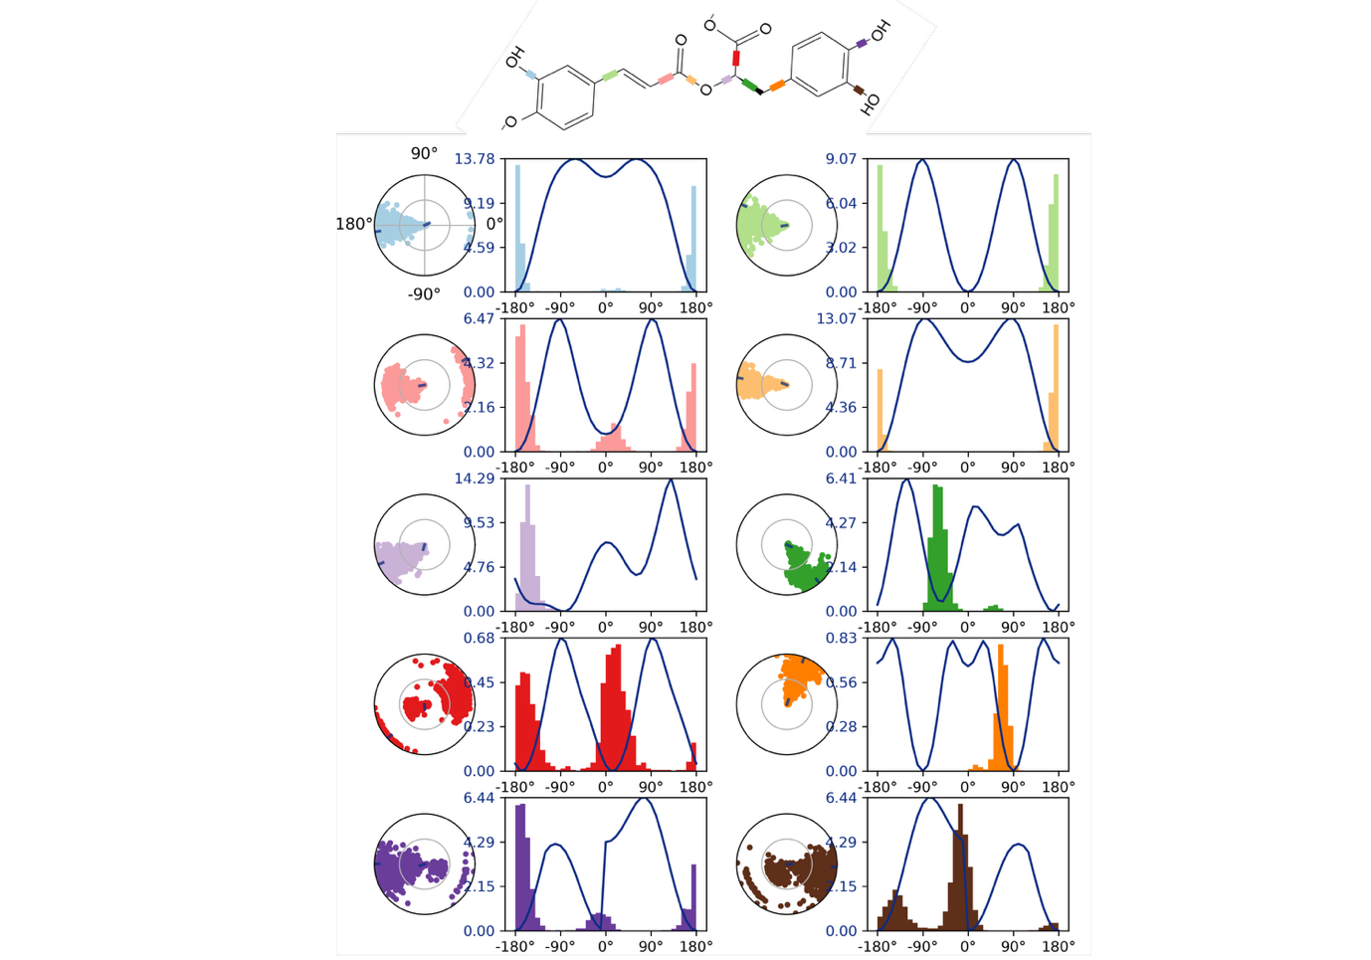
Fig. S 5 Torsional analysis of Rosmarinic acid in complex with GSK3β. The top panel shows the chemical structure of Rosmarinic acid with color-coded bonds corresponding to the analyzed torsions. For each rotatable bond, the left polar plot depicts the sampled dihedral angle distributions during molecular dynamics simulations, while the adjacent right plot displays the corresponding torsional potential energy profiles. The six most relevant torsional angles are presented, highlighting areas of conformational flexibility and preferred energetically favorable states, as sampled over the simulation trajectory. These analyses provide insights into the conformational landscape and stability of Rosmarinic acid when bound to the GSK3β active site.

