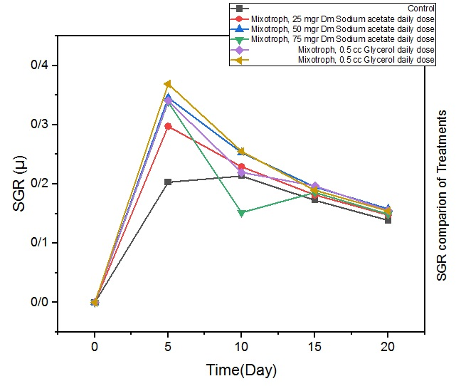
Fig 1: SGR comparison between treatments during 20 days of cultivation of Arthrospira platensis.

Fig 2: Biomass production for Arthrospira platensis based on the number of cells produced per 20 days of culture.

Fig 3: Phycobilin pigment production in cultures of Arthrospira platensis after 20 days of cultivation (Data shown as % of pigment/crude extract).
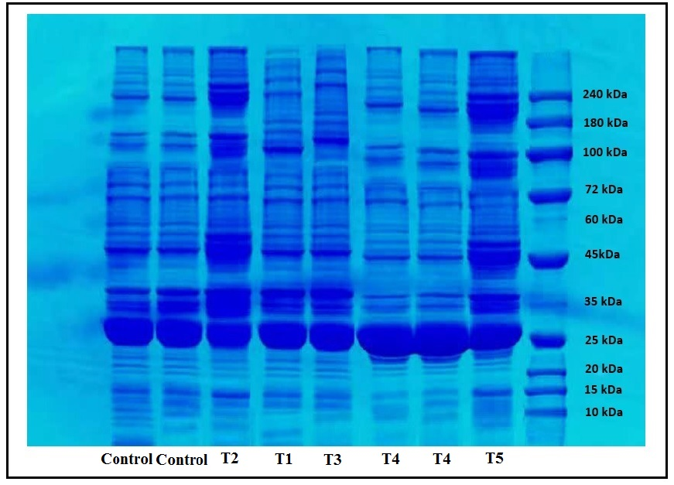
Fig 4: SDS-PAGE results for crude extracts of Arthrospira platensis samples cultivated using different carbon sources. Bands for Phycocyanin (20-25 kDa), Phycoerythrin (240 kDa), and Allophycocyanin (100-110 kDa) are visible.
Table 1: Chemical composition of Zarrouk culture medium with some modifications (Zarrouk, 1966). Solution A5: (gL-1): H3BO3, 2.86- MnCl2.4H2O, 1.81- ZnSO4.7H2O, 0.222 – Na2MoO4.2H2O, 0.390 – CuSO2.5H2O, 0.79 Solution B6(mg L-1): NH4VO3, 22.86 – KCr (SO4)2.12H2O, 192 – NiSO4.6H2O, 44.8 – Na2WO4.2H2O, 17.94 – TiOSO4.8H2O, 61.1 – CO(NO3)2.6H2O, 43.98

Reagents | Amount(gL-1)
NaHCO3 | 16.8
K2HPO4 | 0.50
NaNO3 | 2.5
SK2SO4 | 1.00
NaCl | 1.00
MgSO4.7H2O | 0.20
CaCl2 | 0.04
FeSO4.7H2O | 0.01
EDTA | 0.08
Solution A5 | 1 ml
Solution B6 | 1ml

Table 2: Arthrospira platensis Cultivation specifications by treatment for one-liter batch culture during 20 days of cultivation. (*Significance level at α = 0.05
*Significant changes are shown in alphabetical order)
Treatments | pH _{first-day} | pH_{20th day} | Biomass First-day Cell/L | Biomass last day  Cell/L | Algae weight  gr DM | SGR  (µ/d)
Control (photoautotroph) | 9.2 ±0.001 | 9.63 ± 0.047 | 2×10⁷ ± 0.047 | 32 × 10⁷ ± 4714045 | 3.41 ± 0.004 | 0.14 ± 0.001
Sodium acetate 25 mg/L (T1) | 9.2 ±0.001 | 9.90 ± 0.16 ª | 2×10⁷ ± 0.047 | 38 × 10⁷ ± 12472191^{c} | 4.04 ± 0.22^{c} | 0.15 ± 0.001^{ab}
Sodium acetate 50 mg/L (T2) | 9.2 ±0.001 | 10.7 ± 0.12 ^{b} | 2×10⁷ ± 0.047 | 47 × 10⁷ ± 12472191ª | 4.96 ± 0.07 ª | 0.16 ± 0.001ª
Sodium acetate 75 mg/L (T3) | 9.2 ±0.001 | 9.80 ± 0.08^{ab} | 2×10⁷ ± 0.047 | 39 × 10⁷ ± 16996732^{c} | 4.03 ± 0.028 ^{c} | 0.15 ± 0.002^{b}
Glycerol 0.5 cc (T4) | 9.2 ±0.001 | 10.7 ± 0.12 ^{c} | 2×10⁷ ± 0.047 | 44 × 10⁷ ± 9428090^{b} | 4.07 ± 0.085 ª | 0.16 ± 0.000ª
Glycerol 1 cc (T5) | 9.2 ±0.001 | 10 ± 0.08 ^{ac} | 2×10⁷ ± 0.047 | 44 × 10⁷ ± 8164965^{b} | 4.54 ± 0.08 ^{b} | 0.15 ± 0.001^{b}

Table 3: weight gain statistics obtained by Origin Pro 2021 during 20 days of cultivation for Arthrospira platensis.

Carbon Source | Growth equation | (SLOPE)
Control | Y= a+b*x | 0.1765 ± 0.019
25 mg Dm/l Sodium acetate (T1) | Y= a+b*x | 0.1981 ±0.0127
50 mg Dm/l Sodium acetate (T2) | Y= a+b*x | 0.2278 ± 0.0057
75 mg Dm/l Sodium acetate (T3) | Y= a+b*x | 0.24226 ± 0.0086
0.5 cc Glycerol (T4) | Y= a+b*x | 0.23204 ± 0.011
1 cc Glycerol (T5) | Y= a+b*x | 0.23217 ± 0.015

Table 4: The results of the one-way ANOVA to check the significance of the differences between the optical absorption of samples dried by spray drying, freeze-drying, and oven. (٭Significant differences at α= 0.05)

 |  | Sum of squares | df | Mean square | F | Sig.
680 nm | Between groups | 0.283 | 2 | 0.141 | 1.397 | 0.273
680 nm | Within groups | 1.820 | 18 | 0.101
680 nm | Total | 2.103 | 20
620 nm | Between groups | 23.611 | 2 | 11.806 | 4.211 | 0.032 *
620 nm | Within groups | 50.466 | 18 | 2.804
620 nm | Total | 74.078 | 20
280 nm | Between groups | 67.029 | 2 | 33.514 | 2.347 | 0.124
280 nm | Within groups | 257.017 | 18 | 14.279
280 nm | Total | 324.046 | 20

