Supplementary Material

CONTAMINATION BY MICROPLASTICS IN FREE-LIVING WHITE-EARED OPOSSUMS (Didelphis albiventris) RESIDENT IN CAMPO GRANDE, MATO GROSSO DO SUL – BRAZIL

Fernanda Mayara Gauto de Meloª, Heitor Miraglia Herrera^{a,b}, Amanda Costa Rodriguesª, Oscar Fernandes Juniorª, Filipe Martins Santos^{a,b,c}, Taynara Gabrielly Santos Pintoª, Wesley Arruda Gimenes Nantesª, Nayara Yoshie Sano^{a,c}, Priscila Sabioni Cavalheri^{d*}, Gisele Braziliano de Andradeª

Table S1. Summary of candidate models developed to assess the effects of microplastic area—measured in specific organs (ileum, stomach, and lung) as well as total microplastic area—on the body condition of collected white-eared opossums (Didelphis albiventris). K = number of parameters; AICc = corrected Akaike Information Criterion; AICcWt = Akaike weight; Cum.Wt = cumulative Akaike weight.
Models | K | AICc | ΔAICc | AICcWt | Cum.Wt
Model 5 (Body Condition ~ 1) | 2 | 290.66 | 0 | 0.48 | 0.48
Model 2 (Body Condition ~ microplastic area in the lung) | 3 | 293.23 | 2.57 | 0.13 | 0.61
Model 3 (Body Condition ~ microplastic area in the ileum) | 3 | 293.26 | 2.6 | 0.13 | 0.74
Model 1 (Body Condition ~ total microplastic area) | 3 | 293.29 | 2.63 | 0.13 | 0.87
Model 4 (Body Condition ~ microplastic area in the stomach) | 3 | 293.33 | 2.67 | 0.13 | 1

The Fourier-transform infrared (FTIR) spectroscopy analysis of the stomach sample (Fig. 1S) revealed spectral bands that allow for the identification of the material’s probable composition. The band at 1678 cm⁻¹ suggests the presence of C=O (carbonyl) groups, characteristic of polymers containing ester or ketone groups, or resulting from oxidative degradation. This is particularly common in PVC that has undergone environmental exposure, leading to the formation of carbonyl groups. Additionally, the band at 1404 cm⁻¹ was attributed to the angular deformation of C-H in methylene groups (CH₂), a common feature in aliphatic polymers such as PET and PVC.
The band at 1002 cm⁻¹ corresponds to C-O or C-C stretching vibrations, often observed in materials with ester groups or aromatic rings. The band at 849 cm⁻¹ indicates out-of-plane vibrations in aromatic rings, which may also be present in PVC. Finally, the bands at 667 cm⁻¹ and 602 cm⁻¹ provide direct evidence of C–Cl (carbon–chlorine) bonds, representing a clear spectral signature of PVC. Based on this spectral profile, it is concluded that the analyzed sample consists predominantly of degraded PVC.
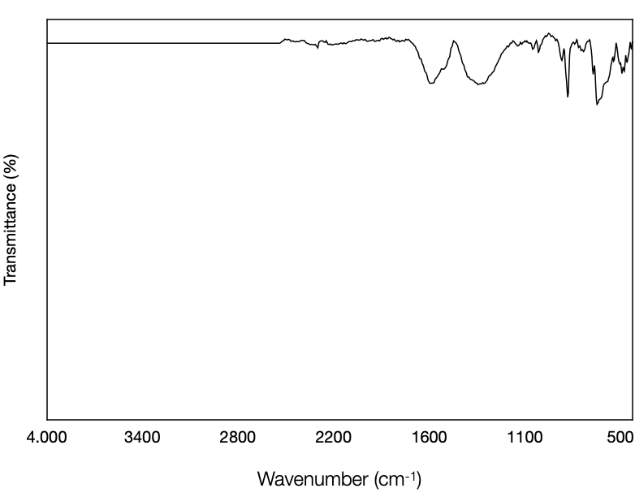

Fig. 1S. Infrared spectroscopic analysis of microplastics found in the stomach of a white-eared opossum, showing the possible composition of the microplastics based on wavelength and transmittance.

The FTIR spectrum analysis of the ileum sample (Fig. 2S) revealed characteristic bands indicating the presence of PVC, such as the one observed at 702 cm⁻¹, attributed to C–Cl bond vibrations—a clear signature of this polymer—and the band at 833 cm⁻¹, related to out-of-plane deformations, also typical of PVC. The presence of PET is suggested by several bands. The band at 1667 cm⁻¹ can be attributed to the stretching of the C=O group in PET esters. Bands at 1008 and 1000 cm⁻¹ are related to C–O or C–C vibrations, typical of ester structures present in PET. The 833 cm⁻¹ band, which also indicates aromatic ring deformations, is characteristic of PET.
Additional bands may be associated with degradation or the presence of polymer mixtures. The band at 1867 cm⁻¹ suggests the formation of carbonyl groups, indicative of degradation in both polymers. The band at 1377 cm⁻¹ corresponds to C–H deformation, commonly found in both PVC and PET. Based on this analysis, it is concluded that the sample contains a mixture of PVC and PET, both of which show signs of degradation likely caused by environmental exposure.

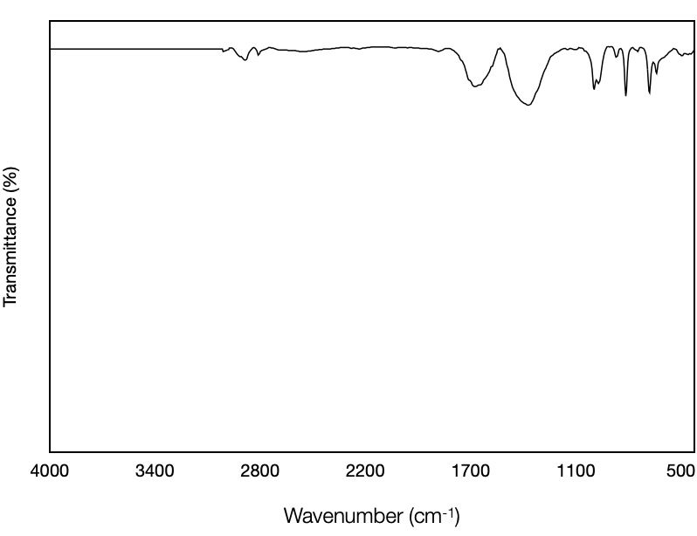

Fig. 2S. Infrared spectroscopic analysis of microplastics found in the ileum of a white-eared opossum, showing the possible composition of the microplastics based on wavelength and transmittance.

​​The spectroscopic analysis of the lung sample (Fig. 3S) indicates that the bands at 2927 and 2854 cm⁻¹ are attributed to the stretching vibrations of C–H in methylene (CH₂) and methyl (CH₃) groups, characteristic of aliphatic polymers such as PET (polyethylene terephthalate) and other plastics. The band at 2295 cm⁻¹, in turn, is attributed to the stretching of the nitrile group (C≡N), a typical signature of polymers like ABS (acrylonitrile-butadiene-styrene). The band at 1670 cm⁻¹ suggests the presence of C=O stretching, commonly found in polyesters such as PET .​
Additionally, the band at 1423 cm⁻¹ was identified as due to angular deformation of C–H or C=C stretching, a feature of polymers like PVC or other aromatic materials. The band at 1011 cm⁻¹ indicates C–O vibrations or deformations in aromatic rings, which may be attributed to either PET or ABS. The bands at 780 and 697 cm⁻¹ provide further relevant information: the band at 697 cm⁻¹ confirms out-of-plane C–Cl deformations, indicating the presence of PVC, while the band at 780 cm⁻¹ may be associated with aromatic ring deformations, suggesting PET or ABS.
Based on this spectral profile, it is concluded that the sample contains a mixture of different microplastics. PVC is the predominant component, as evidenced by the strong band at 697 cm⁻¹ and other bands associated with this polymer. The presence of PET is supported by the bands at 2923, 2850, 1470 and 1011 cm⁻¹, which indicate ester groups and aromatic rings. Finally, the band at 2295 cm⁻¹ confirms the presence of nitrile groups, characteristic of ABS. Therefore, the analyzed sample is composed predominantly of PET, with additional indications of ABS.

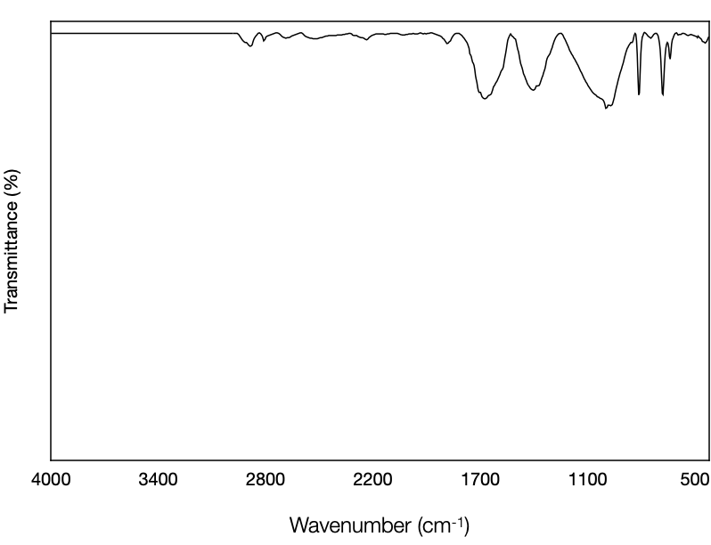
​​ ​

Fig. 3S. Infrared spectroscopic analysis of microplastics found in the lung of a white-eared opossum, showing the possible composition of the microplastics based on wavelength and transmittance.

