Table S1 α diversity analysis of bacteria by groups./
Microorganism | Sample | Sobs | Ace | Chao | Shannon | Simpson
Bacteria | B1 | 20956 | 20956 | 20956 | 5.343018 | 0.032646
Bacteria | B2 | 20627 | 20627 | 20627 | 5.372179 | 0.032004
Bacteria | B3 | 20739 | 20739 | 20739 | 5.395109 | 0.029964
Bacteria | B4 | 20142 | 20142 | 20142 | 5.295995 | 0.034585
Bacteria | B5 | 20739 | 20739 | 20739 | 5.382448 | 0.031949
Bacteria | BE1 | 21094 | 21094 | 21094 | 5.414799 | 0.031364
Bacteria | BE2 | 21200 | 21200 | 21200 | 5.46985 | 0.028991
Bacteria | BE3 | 20884 | 20884 | 20884 | 5.471662 | 0.02894
Bacteria | BE4 | 21443 | 21443 | 21443 | 5.578471 | 0.02675
Bacteria | BE5 | 20993 | 20993 | 20993 | 5.466617 | 0.029152
Bacteria | CK1 | 21178 | 21178 | 21178 | 5.589712 | 0.024509
Bacteria | CK2 | 21297 | 21297 | 21297 | 6.158164 | 0.012136
Bacteria | CK3 | 21856 | 21856 | 21856 | 5.973743 | 0.016265
Bacteria | CK4 | 21520 | 21520 | 21520 | 6.091182 | 0.013669
Bacteria | CK5 | 21707 | 21707 | 21707 | 6.069457 | 0.013732
Bacteria | E1 | 21078 | 21078 | 21078 | 6.081099 | 0.014137
Bacteria | E2 | 21474 | 21474 | 21474 | 5.837186 | 0.018889
Bacteria | E3 | 21223 | 21223 | 21223 | 5.916772 | 0.018102
Bacteria | E4 | 21900 | 21900 | 21900 | 5.719754 | 0.023781
Bacteria | E5 | 22007 | 22007 | 22007 | 6.005076 | 0.016121

Table S2 β diversity analysis of fungi by groups
Microorganism | Sample | Sobs | Ace | Chao | Shannon | Simpson
Fungi | B1 | 449 | 449 | 449 | 4.248119 | 0.034246
Fungi | B2 | 441 | 441 | 441 | 4.269806 | 0.034495
Fungi | B3 | 454 | 454 | 454 | 4.197371 | 0.038719
Fungi | B4 | 454 | 454 | 454 | 3.995889 | 0.049281
Fungi | B5 | 422 | 422 | 422 | 4.214145 | 0.036512
Fungi | BE1 | 388 | 388 | 388 | 4.312464 | 0.030568
Fungi | BE2 | 415 | 415 | 415 | 4.412795 | 0.027815
Fungi | BE3 | 389 | 389 | 389 | 4.374984 | 0.028859
Fungi | BE4 | 406 | 406 | 406 | 4.406049 | 0.028527
Fungi | BE5 | 436 | 436 | 436 | 4.303731 | 0.03529
Fungi | CK1 | 433 | 433 | 433 | 4.316802 | 0.033095
Fungi | CK2 | 334 | 334 | 334 | 4.408405 | 0.031729
Fungi | CK3 | 373 | 373 | 373 | 4.485282 | 0.024903
Fungi | CK4 | 337 | 337 | 337 | 4.422489 | 0.027156
Fungi | CK5 | 394 | 394 | 394 | 4.365324 | 0.030322
Fungi | E1 | 324 | 324 | 324 | 4.471311 | 0.025235
Fungi | E2 | 384 | 384 | 384 | 4.433745 | 0.027215
Fungi | E3 | 359 | 359 | 359 | 4.404555 | 0.027092
Fungi | E4 | 359 | 359 | 359 | 4.402069 | 0.025757
Fungi | E5 | 369 | 369 | 369 | 4.405303 | 0.028294

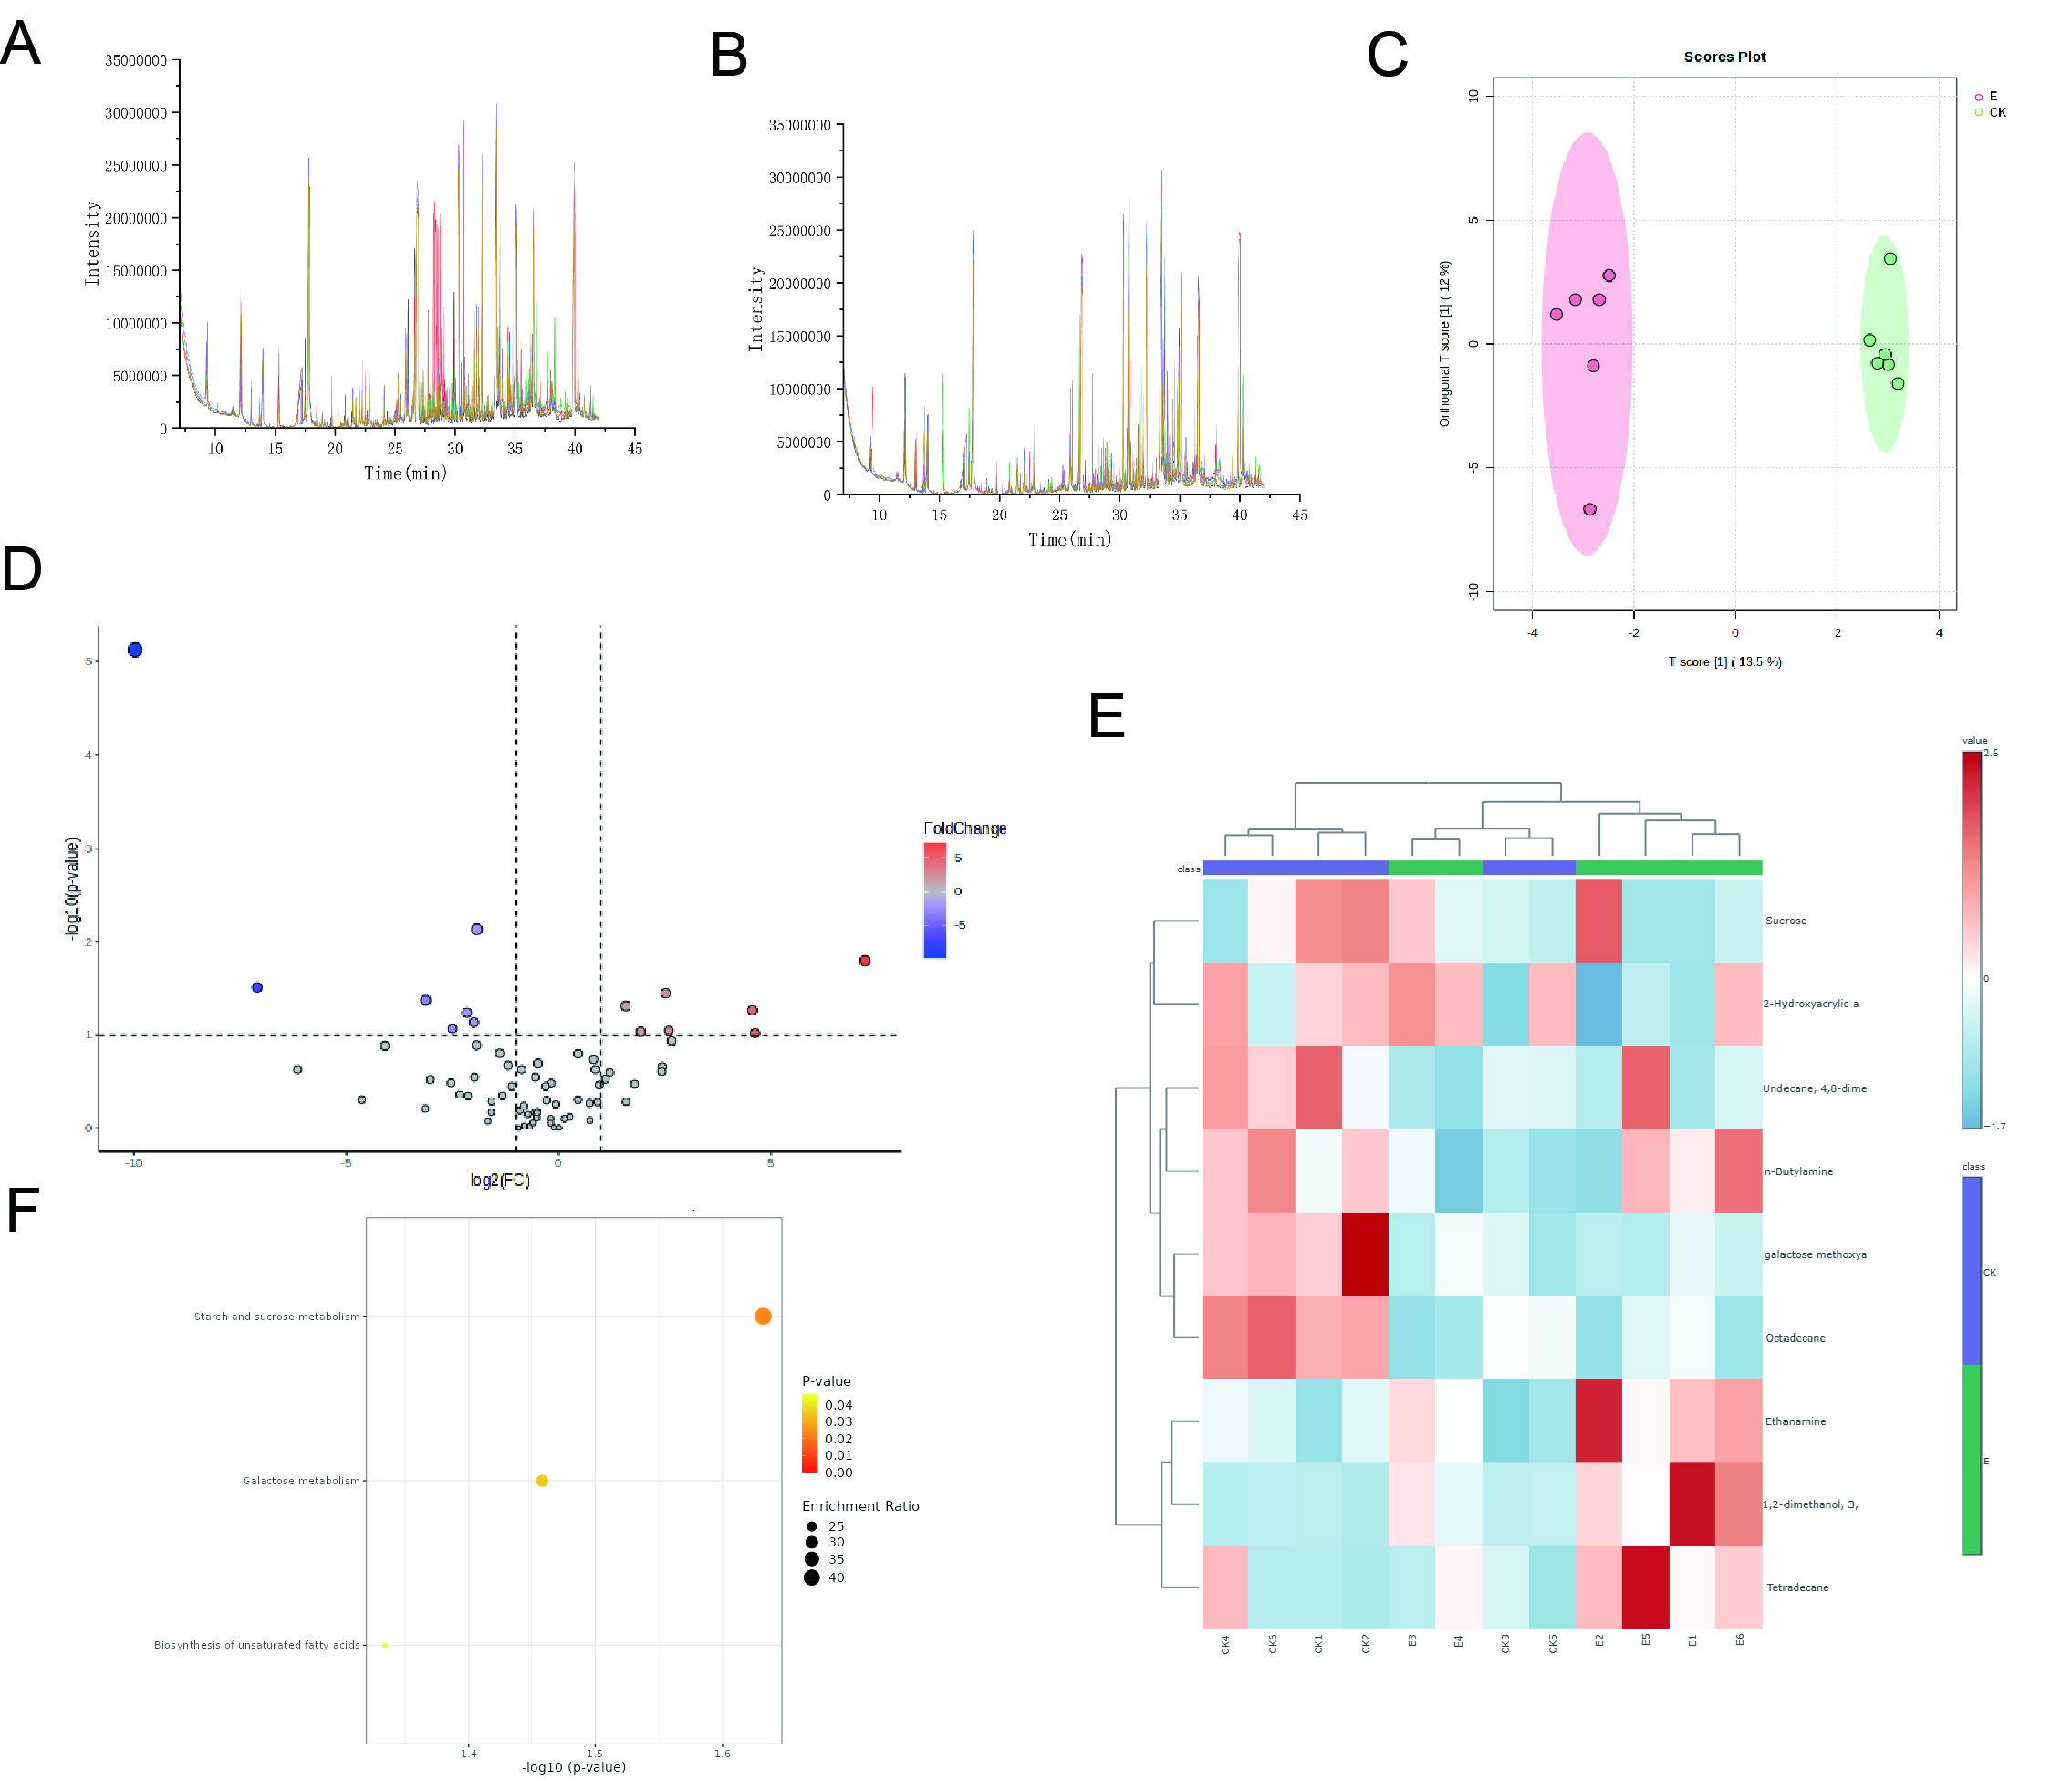
Figure S1. Metabolomic analysis of soybean root exudates under Bacillus velezensis ES2-4 treatment. (A, B) Total ion chromatograms (TIC) of metabolites in CK and E groups, showing distinct intensity profiles across retention times. (C) OPLS-DA score plot demonstrating clear metabolic separation between CK and E groups. (D) Volcano plot highlighting significantly upregulated (red) and downregulated (blue) metabolites (|log2FC| > 1.5, VIP > 1.0). (E) Heatmap of the top 25 enriched metabolite clusters, with red indicating high abundance between CK and E groups. (F) Overview of enriched metabolic pathways. Pathway mapping was conducted using the Kyoto Encyclopedia of Genes and Genomes (KEGG) database.

Table S3 Topological properties of the relevant network of rhizosphere bacteria in each group
Topological features | CK | E | B | BE
Nodes | 49 | 48 | 47 | 50
Links | 388 | 379 | 139 | 154
Average degree | 15.837 | 15.792 | 5.915 | 6.16
Network Diameter | 10 | 9 | 8 | 13
graph density | 0.33 | 0.336 | 0.129 | 0.126
Average Clustering coefficient | 0.753 | 0.736 | 0.649 | 0.573
Average Path Length | 2.625 | 2.542 | 3.358 | 4.114
Positive correlation | 50.77 | 54.35 | 56.12 | 53.9
Negative correlation | 49.23 | 45.65 | 43.88 | 46.1

Table S4 Topological properties of the relevant network of rhizosphere fungi in each group
Topological features | CK | E | B | BE
Nodes | 49 | 49 | 47 | 49
Links | 180 | 159 | 104 | 108
Average degree | 7.347 | 6.49 | 4.426 | 4.408
Network Diameter | 9 | 11 | 12 | 12
graph density | 0.153 | 0.135 | 0.096 | 0.092
Average Clustering coefficient | 0.533 | 0.583 | 0.434 | 0.645
Average Path Length | 3.312 | 3.702 | 4.261 | 4.758
Positive correlation | 53.33 | 61.01 | 68.27 | 66.67
Negative correlation | 46.67 | 38.99 | 31.73 | 33.33

Table S5 Key bacterial in the correlation network of each group at the genus level
CK |  | E |  | B |  | BE
Genus | Degree | Genus | Degree | Genus | Degree | Genus | Degree
Alphaproteobacteria | 26 | Reticulibacter | 28 | Ktedonobacter | 11 | Reticulibacter | 14
Reticulibacter | 26 | Alphaproteobacteria | 28 | Edaphobacter | 11 | Ktedonobacteraceae | 14
Devosia | 26 | Proteobacteria | 28 | Acidobacterium | 11 | Chloroflexi | 14
Myxococcales | 26 | Acidobacteria | 28 | Ktedonobacteraceae | 11 | Mycobacterium | 14
Chloroflexi | 26 | Ktedonobacteraceae | 28 | Chloroflexi | 11 | Ktedonobacter | 14
Phenylobacterium | 26 | Ktedonobacter | 28 | Devosia | 11 | Edaphobacter | 14
Acidobacteriia | 26 | Bacteroidota | 28 | Nitrobacteraceae | 10 | Dictyobacter | 14
Pseudonocardia | 24 | Dictyobacter | 28 | Xanthobacteraceae | 10 | Ktedonosporobacter | 14
Proteobacteria | 24 | Planctomycetota | 28 | Granulicella | 10 | Acidobacteriia | 14
Acidobacteria | 24 | Acidobacteriia | 28 | Verrucomicrobia | 10 | Deltaproteobacteria | 13

Table S6 Key fungi in the correlation network of each group at the genus level
CK |  | E |  | B |  | BE
Genus | Degree | Genus | Degree | Genus | Degree | Genus | Degree
Rhizopus | 13 | Penicillium | 8 | Tulasnella | 16 | Pleurotus | 8
Aureobasidium | 13 | Termitomyces | 8 | Trametes | 14 | Madurella | 8
Ceratobasidium | 13 | Suillus | 8 | Termitomyces | 14 | Rhizophagus | 7
Anaeromyces | 13 | Oidiodendron | 8 | Sporothrix | 14 | Botryobasidium | 7
Trametes | 12 | Tulasnella | 7 | Pseudogymnoascus | 11 | Aspergillus | 7
Toensbergia | 12 | Pseudogymnoascus | 7 | Suillus | 11 | Gyrodon | 7
Tulasnella | 12 | Tulasnellaceae | 7 | Mycena | 11 | Suillus | 7
Aspergillus | 12 | Ceratobasidium | 7 | Serendipita | 11 | Anaeromyces | 7
Tulasnellaceae | 12 | Aspergillus | 7 | Cantharellus | 11 | Cantharellus | 7
Syncephalis | 12 | Rhizophagus | 7 | Agaricus | 11 | Oidiodendron | 7

