Chiral Generation of Hot Carriers for Polarization-Sensitive Plasmonic Photocatalysis with Hybrid Nanostructures
Yoel Negrín-Montecelo,^{1,2} Artur Movsesyan,^{3,4} Jie Gao,⁵ Sven Burger,^{6,7} Zhiming M. Wang,⁴ Sylvain Nlate,⁵ Emilie Pouget,⁵ Reiko Oda,⁵ Miguel Comesaña-Hermo,^{8,}* Alexander O. Govorov,^{3,}* and Miguel A. Correa-Duarte^{1,2,}*
¹CINBIO, Universidade de Vigo, Department of Physical Chemistry, 36310 Vigo, España
²Instituto de Investigación Sanitaria Galicia Sur (IIS Galicia Sur), CIBERSAM. SERGAS-UVIGO
³Department of Physics and Astronomy, Nanoscale and Quantum Phenomena Institute, Ohio University, Athens, Ohio 45701, United States
⁴Institute of Fundamental and Frontier Sciences, University of Electronic Science and Technology of China, Chengdu, 610054, China
⁵Chimie et Biologie des Membranes et des Nanoobjets (CBMN), CNRS, Université de Bordeaux, Bordeaux INP, UMR 5248, 33607, Pessac, France
⁶Zuse Institute Berlin, 14195 Berlin, Germany
⁷JCMwave GmbH, 14050 Berlin, Germany
⁸Université de Paris, ITODYS, CNRS, UMR 7086, 15 rue J-A de Baïf, F-75013 Paris, France

Corresponding authors: miguel.comesana-hermo@u-paris.fr, govorov@ohio.edu, macorrea@uvigo.es
Supporting Information
- Synthetic procedure
Materials
Tartrate precursors (16-2-16, L or R), (3-aminopropyl)-triethoxysilane (APTES), tetrachloroauric acid (HAuCl₄·3H₂O), 98% O-(2-carboxyethyl)-O′-(2-mercaptoethyl) (PEG) solution, tartaric acid, 1-ethyl-3-(3-dimethylaminopropyl)-carbodiimide (EDC), N-hydroxysuccinimide (NHS), poly(allylamine hydrochloride) (PAH), sodium chloride (NaCl), tannic acid (TA), 98% tetraethyl orthosilicate (TEOS), 28−30% ammonium hydroxide (NH₄OH) solution and sodium citrate (Na₃C₆H₅O₇) were purchased from Sigma-Aldrich. TiO₂ nanoparticles (anatase, 5 nm) were purchased from Nanoamor. Pure ethanol, pure isopropanol or Milli-Q–grade water was used in all preparations. All materials were used as received.
Synthesis, fragmentation and functionalization of L- and R-SiO₂ nanoribbons
First, 16-2-16 gemini amphiphiles with tartrate counterions were prepared using the method developed by Oda et al.^{1,2} To prepare the organic gel, 3.58 mg of 16-2-16 (L or R) tartrate powder was dissolved in 5 mL of Milli-Q water (1 mM 16-2-16 tartrate). The solution was heated to 60 °C (above the Krafft temperature, which is 43 °C for 16-2-16 tartrate at 10 mM) for 20 min to achieve complete dissolution and incubated at 20 °C. The formation of helical ribbons (L from the R tartrate and R from the L tartrate) was observed after 2 hours. These organic ribbons were directly used as templates to prepare silica nanostructures through a sol-gel transcription procedure.
The corresponding monodisperse L- and R-SiO₂ nanoribbons with a width of 21 (±1) nm and a pitch of 100 nm were prepared using a published protocol.³ In this preparation, 500 μL of TEOS was added to 10 mL of a 0.1 mM aqueous solution of L-tartaric acid at pH 3.8 and prehydrolyzed at 20 °C by stirring on a roller-mixer for 7 h. Equal volumes of the prehydrolyzed TEOS in a 0.1 mM aqueous solution of tartaric acid and the organic gels were mixed (2 mL of each) and stirred at 20 °C in a roller-mixer overnight. Once transcription was complete, the mixture was washed with isopropanol through 5 centrifugation-dispersion cycles (5 min, 5000g) to remove the excess TEOS and redispersed in 2 mL of 1:1 ethanol/isopropanol (final sample concentration of approximately 0.5 mg/mL SiO₂).
The obtained silica nanoribbons were fragmented into submicrometric pieces by tip sonication.⁴ A 20 kHz pulse mode (130 W) was chosen for fragmentation (15 min with pulses of 1 s and cooling in an ice bath during the process). Finally, the fragmented SiO₂ ribbons were functionalized with APTES.⁵ To do this, 50 μmol of APTES was added to a 2 mL solution of the chiral substrates. The dispersion was stirred for 5 min and then kept overnight at 80 °C, followed by five washes via centrifugation (5 min, 5000g) and redispersion in 2 mL of absolute ethanol.

Synthesis and stabilization of tannic acid/citrate-Au NPs
Au NPs with a diameter of 11 (±1) nm were synthesized using tannic acid and sodium citrate as reducing and capping agents by a method that was previously reported in the literature.⁶ To prepare 100 mL of a Au NP suspension, two stock solutions were prepared. Solution A consisted of 1 mL of 1% HAuCl₄ solution in 80 mL of water. Solution B consisted of 4 mL of 1% sodium citrate and 0.1 mL of 1% tannic acid in 15.9 mL of water. Then, A and B were kept at 60 °C for 15 min, and the solutions were mixed and heated to 100 °C under reflux for 1 h.⁶ Next, 8 mL of the solution was centrifuged at 21000g for 30 min, and 6 mL of the supernatant was removed. Finally, 2 mL of a 10 mM solution of PEG in ethanol was added, and the solution was placed on a shaker at 400 rpm overnight at 4 °C. The mixture was washed three times and redispersed in water.
Synthesis and PAH functionalization of L- and R-SiO₂@Au nanoribbons
To form covalent bonds between the PEG-Au NPs and the NH₂-SiO₂ ribbon, the -COOH ligand groups stabilizing the Au NPs must be activated.⁶ First, an aqueous solution containing 12 mM EDC and 60 mM NHS was aged for 5 h at 4 °C and then used to activate the PEG-Au NPs by mixing (volume ratio 1:1) with PEG-Au NPs (with a concentration 16 times higher than the initial concentration of the as-synthesized objects). The mixture was shaken on a plate shaker at 400 rpm for 6 h at 4 °C and washed with water by centrifugation (30 min at 21000g). Next, 50 μL of 0.6 mg/mL NH₂-SiO₂ ribbons were added to 0.5 mL of the activated Au NPs. The mixture was sonicated for 10 min and transferred to a shaker plate at 400 rpm for 1 day at 20 °C. The samples were then washed five times with Milli-Q water via centrifugation (15 min, 2000g), after which the supernatant remained transparent.
Subsequently, PAH was dissolved in 0.5 M NaCl (pH 5.0) for a final polymer concentration of 1 mg/mL. Then, 2.5 mL of the positively charged PAH solution was added to 1 mL of SiO₂@Au nanoribbons (0.5 mg/mL) and stirred at room temperature for 30 min in order to confer the latter with a positive surface charge in aqueous solution.⁷ The excess reagents were removed in three centrifugation-redispersion cycles (4000g, 20 min), and the solid was redispersed in 1 mL of Milli-Q water.
Synthesis and PAH functionalization of spherical SiO₂@Au hybrids
Monodisperse silica spheres with a diameter of 420 nm were prepared using a modified Stöber method.⁸ To do this, a TEOS solution (1.7 mL, 1.2 M) was added to a solution containing ethanol (18.12 mL), ammonium hydroxide (1.96 mL), and water (3.21 mL). This mixture was stirred at room temperature for 2 h. The excess reagents were removed in three centrifugation-redispersion cycles with ethanol (2800g, 30 min). Subsequently, 5 mL of the silica sphere-containing solution (1 mg/mL) was added to 5 mL of the positively charged PAH solution and stirred at room temperature for 30 min. The excess reagents were removed in three centrifugation-redispersion cycles with water (2800g, 30 min), and the solid was redispersed in 5 mL of Milli-Q water.⁹ Next, 4 mL of Au NPs stabilized with sodium citrate (diameter = 11 (±1) nm, [Au] = 0.25 mM) prepared as described previously¹⁰ was added to 5 mg of the functionalized silica NPs. The mixture was stirred at room temperature for 3 h and washed three times with water (2800g, 30 min). Finally, the product was functionalized with a second layer of PAH and redispersed in 10 mL of water.⁹
Deposition of TiO₂ NPs
Twenty-five milligrams of TiO₂ nanoparticles (5 nm) redispersed in 50 mL of a sodium citrate solution (2.5 mM) were sonicated for 1 h with an ultrasonic tip (30 W, 1 s pulses, cooling the samples in an ice bath during the process). The aggregated particles were removed by centrifugation (1340g, 10 min). Then, 1 mL of the TiO₂ solution was added to 1 mL of the PAH-functionalized SiO₂@Au nanoribbon solution (0.5 mg/mL) with either L- or R-handedness and to 1 mL of the PAH-functionalized spherical SiO₂@Au nanohybrids (0.5 mg/mL). Both solutions were stirred at room temperature for 60 min. The excess TiO₂ was removed in three centrifugation-redispersion cycles (4000g, 30 min). Finally, the product was redispersed in 1 mL of water. The Au/TiO₂ molar ratio was 0.60 for the R-SiO₂@Au@TiO₂ nanoribbons, 0.62 for the L-SiO₂@Au@TiO₂ nanoribbons and 0.23 for the SiO₂@Au@TiO₂ spherical nanohybrids.
- Characterization
Electron microscopy
Transmission electron microscopy (TEM) images were obtained using a JEOL JEM 1010 transmission electron microscope operating at an acceleration voltage of 100 kV. High-resolution transmission electron microscopy (HRTEM) and scanning transmission electron microscopy (STEM) images were obtained with a JEOL JEM 2010F transmission electron microscope operating at an acceleration voltage of 200 kV.
UV-visible-NIR spectroscopy
Absorbance spectra were recorded on a Cary 8454 UV−Vis spectrophotometer fitted with a thermostatic holder and collected from a 1 cm path length quartz cuvette.
Photocatalytic study
The photocatalytic activities of the L- and R-SiO₂@Au@TiO₂ nanoribbons were evaluated on the basis of the degradation of rhodamine B (RhB) in an aqueous solution inside a controlled water recirculator at 20 °C for 8 h under light irradiation with a 150 W SLS401 xenon short-arc light source. LCP or RCP polarizers were introduced in the system to transform the original unpolarized light into CPL (λ = 400‒800 nm).
The photodegradation solutions were prepared by mixing 100 µL of an aqueous solution of RhB (0.1 mM), 1 mL of the hybrid solution under evaluation (0.5 mg/mL) and 0.9 mL of water. The mixtures were stirred for 1 h in the dark to ensure good blending and that adsorption-desorption equilibrium was reached before irradiation. The variation in absorbance was measured within 60-minute intervals under CPL irradiation.

- Modeling
Our model consists of 11 nm Au NPs built into a homogeneous matrix with an effective dielectric constant, ε_{eff}. Our model was composed of 138 Au NPs, which were arranged in a ribbon-like geometry (see the geometry in Figure S3). Following the experimental parameters, the ribbon-like assembly is constructed as follows: NP diameter, d_{NP}=11 nm; diameter of the Au NP ribbon, 40 nm; and pitch of one Au-chain helix, 115 nm. The optical properties were calculated with the solver JCMsuite,¹¹ allowing us to compute spectra for a large number of light sources. For arrangements with random orientations of ribbons in solution, the resulting CD spectrum should be computed as an averaged value. We varied the number of incidence directions between 6 and 160; however, it was found that the six major directions of light incidence are sufficient for obtaining sufficiently accurate results with our model. The CD properties (Figure 1j) were calculated with the standard equations:
Here, and are the extinctions averaged over the six light-propagation configurations, and are the peak values at the plasmon resonance. Then, the computation of the hot-electron generation rates was performed with COMSOL Multiphysics using the six major directions of light incidence, and the NP number in this computation was 66. Here we note that the number of NPs in the COMLSOL computation was smaller than that using the solver JCMsuite; this is because of the smaller computational speed of COMSOL. In our calculations, the effective matrix constants for the SiO₂@Au and SiO₂@Au@TiO₂ systems are taken as ε_{eff} =1.77 (n=1.33) and 2.1 (n=1.45), respectively. These constants were chosen to fit the measured and calculated plasmon peak positions (see Figures 1d and i in the main text). The generation rates for the over-barrier hot electrons and the related surface maps were computed according to quantum theory:^{12–14}
, (Equation S1)
where is the normal component of the surface electric field, which should be calculated inside the NP; is the total number of NPs in the helical assembly; is the Fermi energy of gold;¹³ and is the barrier energy of the Au-TiO₂ Schottky junction.¹³ The light intensity used in the calculation is 400 W/cm². As provided above, Equation S1 describes the integrated rate of hot-electron generation due to the quantum surface mechanism.^{13,14} From this equation, we infer the CD rate and its g-factor:
where is the plasmonic-peak value for the averaged rate, . Then, the local hot-electron generation rate at the surface of i-NP is given by the following expression:
. (Equation S2)
Correspondingly, for the local CD generation,
. (Equation S3)
We should emphasize here that, in all computed figures, the optical and optoelectronic properties given by Equations S1-S3 were averaged over the six major directions of light incidence. A similar procedure was used previously by us.¹³
Figure S8 provides a summary of the optoelectronic properties of our chiral many-NP system. Two remarkable behaviors can be observed. First, the peak-dip spectral shape in Figure S8a is inverted relative to that for the averaged CD in the main text (Figures 1e and j and 3d). This was expected since the unidirectional CD for the K||+z configuration for a plasmonic helical arrangement is typically inverted compared to the orientation-averaged CD.¹⁵ Second, we see that the local hot electron maps, , are rather nonuniform in the ribbon. These maps show the formation of plasmonic hot spots at the NP-NP junctions (Figure S8b). The intensities of the hot spots depend on the light polarization. Correspondingly, the local hot electron CD maps, , also contain hot spots (see Figure S8c).
Table S1. Experimental g-factors for the hybrid materials presented in this study.
Sample | CD max (mdeg) | CD min (mdeg) | Absorbance (max) | Absorbance (min) | g_{max} | g_{min} | g_{max}-g_{min}
L-SiO₂@Au | 9.87 | -20.8 | 0.73358 | 0.58747 | 4.08∙10⁻⁴ | -1.07∙10⁻³ | 1.48∙10⁻³
L-SiO₂@Au@TiO₂ | 8.23 | -12.73 | 0.71959 | 0.63741 | 3.47∙10⁻⁴ | -6.06∙10⁻⁴ | 9.52∙10⁻⁴
R-SiO₂@Au | 23.23 | -11.24 | 0.38854 | 0.28619 | 1.81∙10⁻³ | -1.19∙10⁻⁴ | 3.00∙10⁻³
R-SiO₂@Au@TiO₂ | 12.11 | -7.97 | 0.48923 | 0.40456 | 7.51∙10⁻⁴ | -5.97∙10⁻⁴ | 1.35∙10⁻³

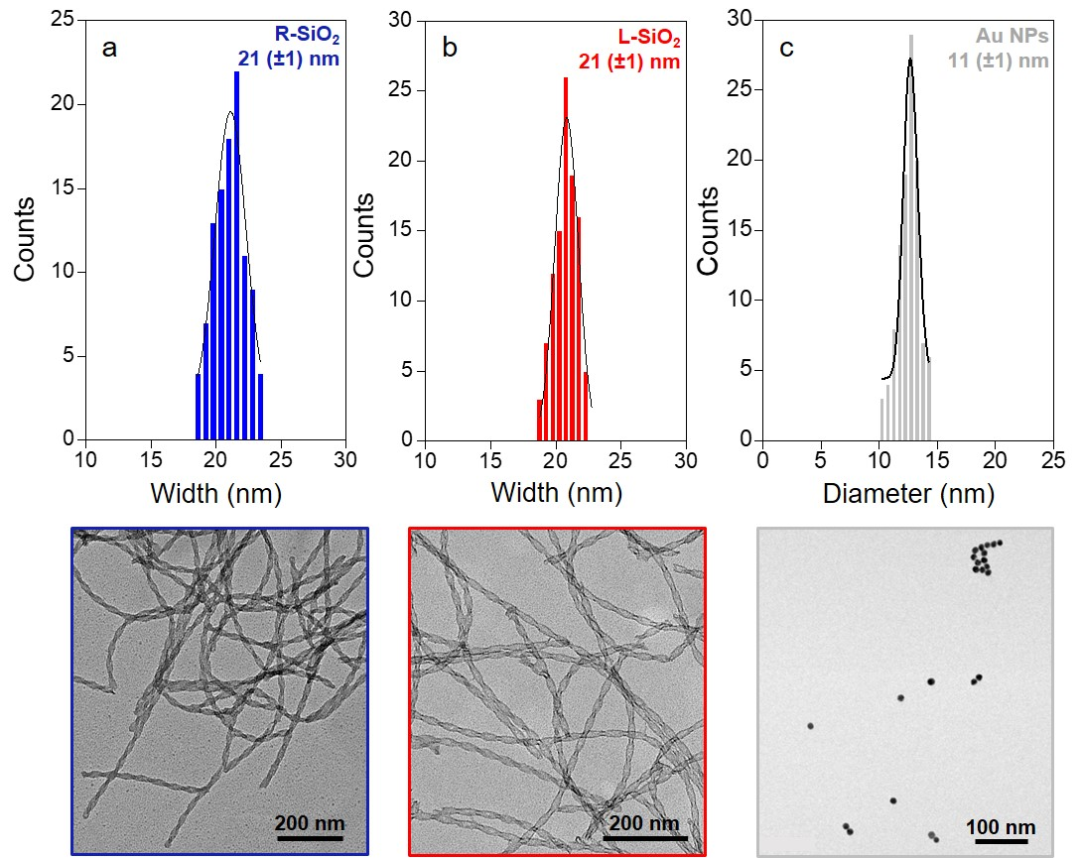
Figure S1. Size histograms (top), accompanied by TEM images (bottom) for the widths of (a) R-SiO₂ nanoribbons, (b) L-SiO₂ nanoribbons and the diameter of (c) presynthesized Au NPs prior to adsorption.
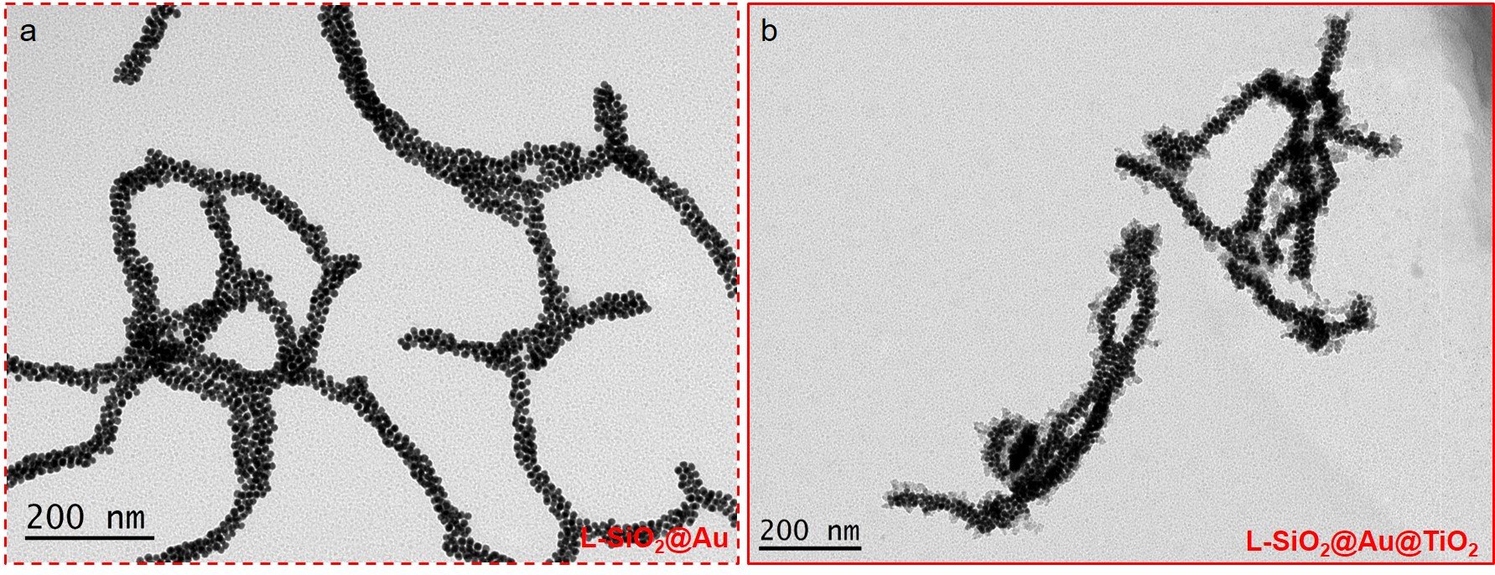
Figure S2. Low-magnification TEM images of (a) L-SiO₂@Au and (b) L-SiO₂@Au@TiO₂ nanohybrids.
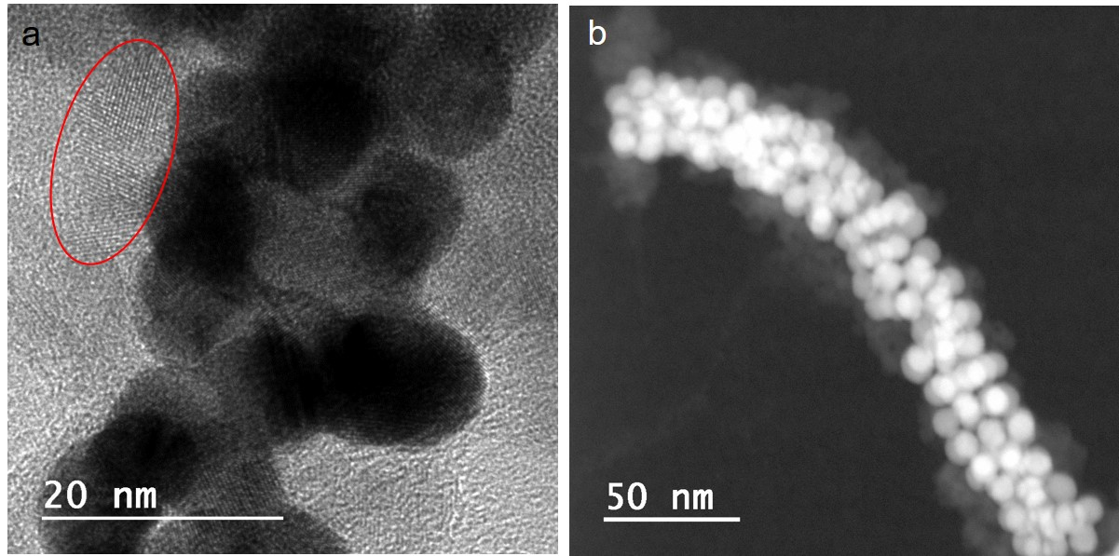
Figure S3. (a) HRTEM image of L-SiO₂@Au@TiO₂ nanoribbons. The crystalline nature of TiO₂ can be clearly observed (highlighted in red). (b) STEM image of L-SiO₂@Au@TiO₂ nanoribbons with homogeneous deposition of the semiconductor onto the plasmonic objects.
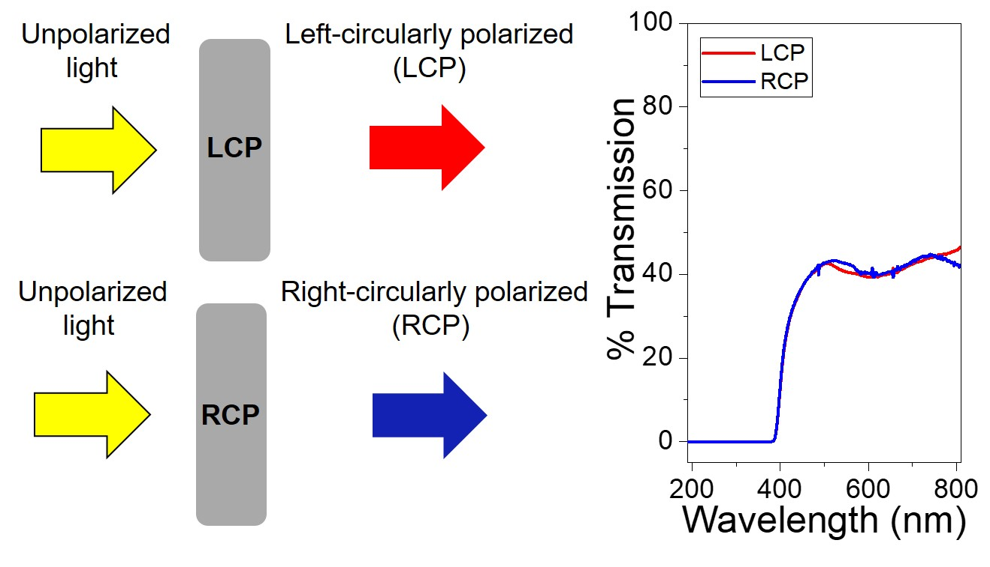
Figure S4. Transmission of the polarizers that transform unpolarized light in either RCP or LCP used for the independent excitation of each plasmonic signature.
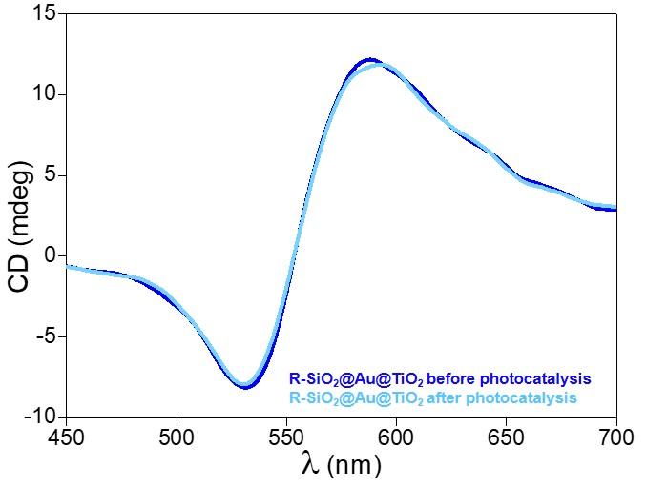
Figure S5. Experimental CD spectra of the R-SiO₂@Au@TiO₂ nanoribbons before (blue) and after (cyan) photocatalytic experiments, which were conducted under 8 hours of irradiation.
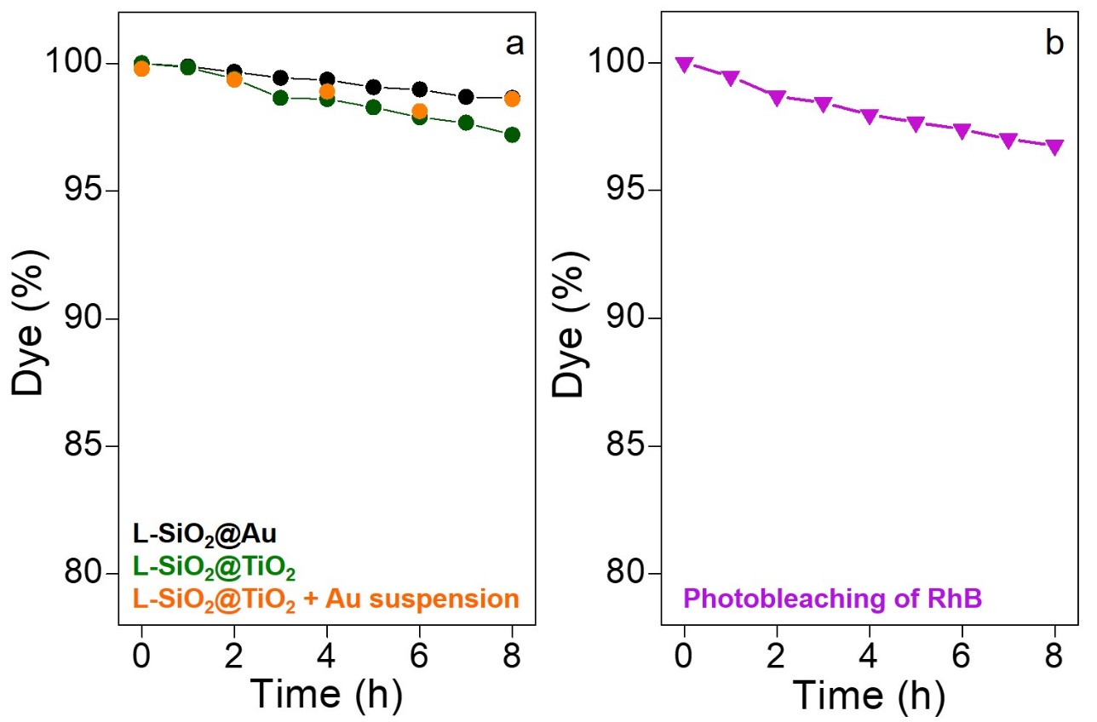
Figure S6. (a) Photodegradation profiles of RhB in the presence of L-SiO₂@Au (black), L-SiO₂@TiO₂ (green) or L-SiO₂@TiO₂ with the same concentration of Au NPs in solution (orange) as catalysts and using an LCP filter. (b) Photobleaching of RhB under the same irradiation conditions (with an LCP filter) and without photocatalyst.
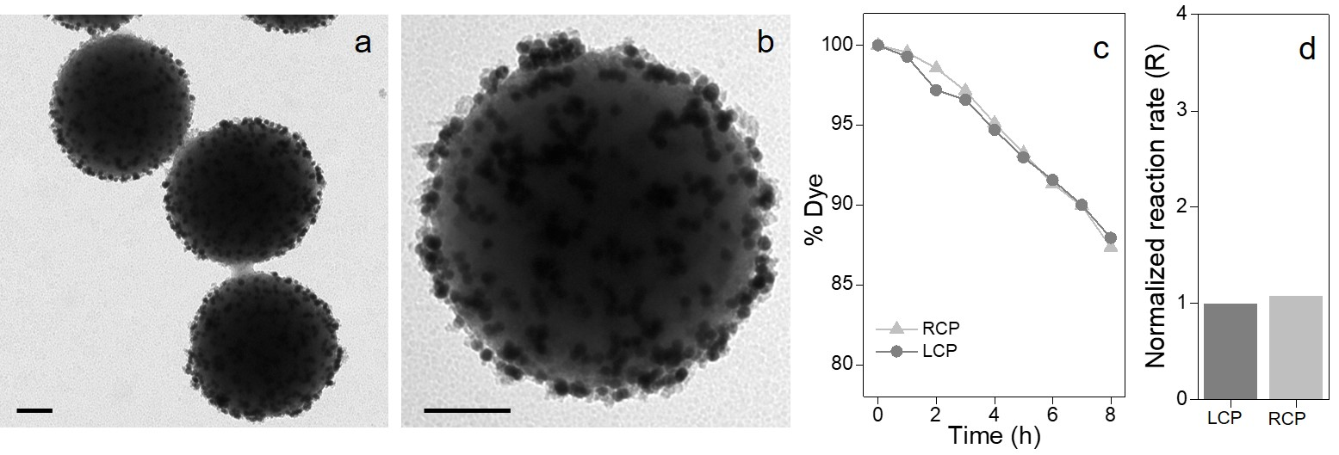
Figure S7. Nonchiral photocatalyst formed by the adsorption of 12 nm Au NPs and 5 nm TiO₂ NPs onto 500 nm SiO₂ spheres. (a, b) TEM images of the spheres, where the scale bars are each 100 nm. (c) Photodegradation profiles of RhB in the presence of the catalyst with either LCP or RCP light. (d) Normalized reaction rates derived from the photodegradation profiles assuming a linear fit.
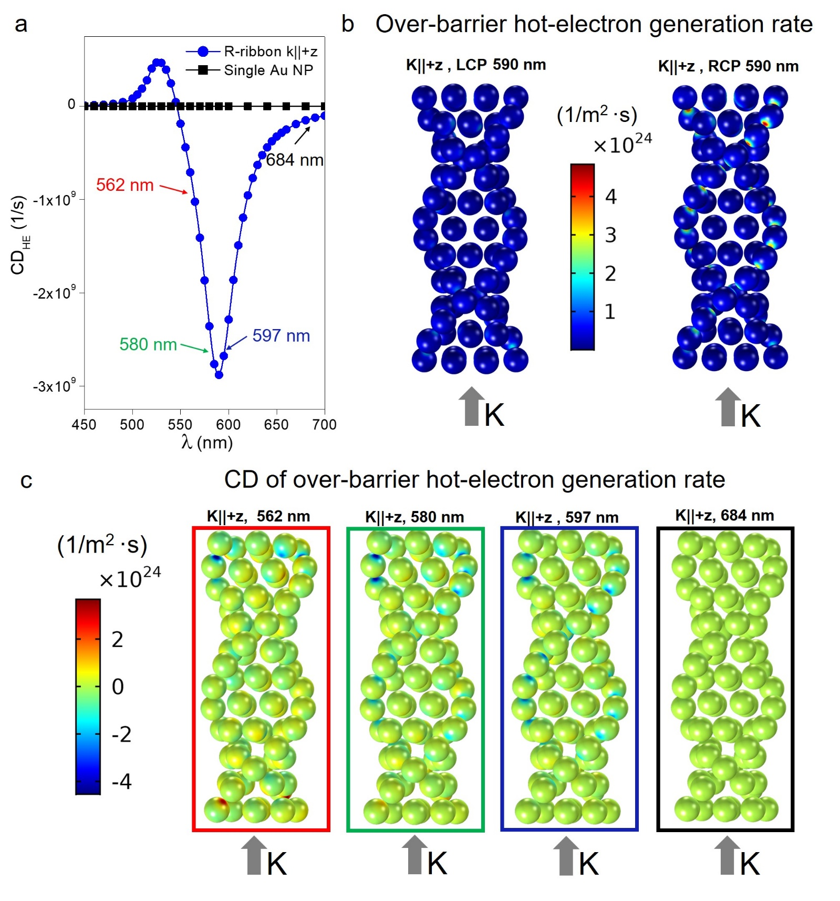
Figure S8. Optoelectronic properties of the Au ribbon-like assembly (R-ribbon) for the direction of excitation k||+z. (a) CD for the over-barrier hot-electron generation rate for the unidirectional excitation k||+z. For comparison, the response of a single 11 nm Au NP is included. We observe here that the CD for a nonchiral NP is negligibly small. (b) Surface maps of the local hot-electron generation. The formation of plasmonic hot spots in the NP-NP gap regions can be observed for the RCP case. The surface rates are recorded inside the NPs. (c) Local hot electron CD maps for four selected wavelengths. In this case, the intensities of the hot spots are wavelength dependent.
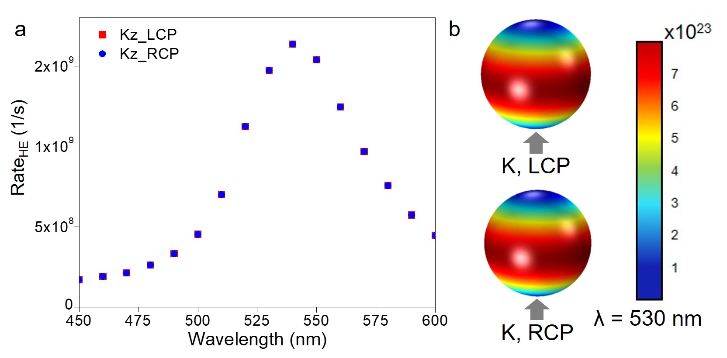
Figure S9. Properties of a nonchiral object (11 nm spherical Au NP) with k||+z excitation for both RCP and LCP illumination. (a) Hot-electron generation rates for CPL. (b) Surface maps of local hot-electron generation.
Bibliography
1. Oda, R., Artzner, F., Laguerre, M. & Huc, I. Molecular structure of self-assembled chiral nanoribbons and nanotubules revealed in the hydrated state. J. Am. Chem. Soc. 130, 14705–14712 (2008).
2. Delclos, T. et al. Individualized silica nanohelices and nanotubes: Tuning inorganic nanostructures using lipidic self-assemblies. Nano Lett. 8, 1929–1935 (2008).
3. Cheng, J. et al. GoldHelix: Gold Nanoparticles Forming 3D Helical Superstructures with Controlled Morphology and Strong Chiroptical Property. ACS Nano 11, 3806–3818 (2017).
4. Okazaki, Y. et al. Chiral colloids: Homogeneous suspension of individualized SiO₂ helical and twisted nanoribbons. ACS Nano 8, 6863–6872 (2014).
5. Tamoto, R. et al. Gold nanoparticle deposition on silica nanohelices: A new controllable 3D substrate in aqueous suspension for optical sensing. J. Phys. Chem. C 116, 23143–23152 (2012).
6. Gao, J. et al. Tuning the Chiroptical Properties of Elongated Nano-objects via Hierarchical Organization. ACS Nano 14, 4111–4121 (2020).
7. Pastoriza-Santos, I., Pérez-Juste, J. & Liz-Marzán, L. M. Kinetically Controlled Seeded Growth Synthesis of Citrate-Stabilized. Chem. Mater. 18, 2465–2467 (2006).
8. Stöber, W., Fink, A. & Bohn, E. Controlled growth of monodisperse silica spheres in the micron size range. J. Colloid Interface Sci. 26, 62–69 (1968).
9. Sousa-Castillo, A. et al. Boosting Hot Electron-Driven Photocatalysis through Anisotropic Plasmonic Nanoparticles with Hot Spots in Au−TiO₂ Nanoarchitectures. J. Phys. Chem. C 120, 11690–11699 (2016).
10. Bastús, N. G., Comenge, J. & Puntes, V. Kinetically Controlled Seeded Growth Synthesis of Citrate-Stabilized Gold Nanoparticles of up to 200 nm: Size Focusing versus Ostwald Ripening. Langmuir 27, 11098–11105 (2011).
11. Pomplun, J., Burger, S., Zschiedrich, L. & Schmidt, F. Adaptive finite element method for simulation of optical nano structures. Phys. Status Solidi B 244, 3419–3434 (2007).
12. Khorashad, L. K. et al. Hot Electrons Generated in Chiral Plasmonic Nanocrystals as a Mechanism for Surface Photochemistry and Chiral Growth. J. Am. Chem. Soc. 142, 4193–4205 (2020).
13. Besteiro, L. V., Kong, X.-T., Wang, Z., Hartland, G. & Govorov, A. O. Understanding Hot-Electron Generation and Plasmon Relaxation in Metal Nanocrystals: Quantum and Classical Mechanisms. ACS Photonics 4, 2759–2781 (2017).
14. Santiago, E. Y. et al. Efficiency of Hot-Electron Generation in Plasmonic Nanocrystals with Complex Shapes: Surface-Induced Scattering, Hot Spots, and Interband Transitions. ACS Photonics 7, 2807–2824 (2020).
15. Schreiber, R. et al. Chiral plasmonic DNA nanostructures with switchable circular dichroism. Nat. Commun. 4, 1–6 (2013).

