Supporting Information

Comparative Study of 52734-U-SupelMIP™ Solid-Phase and QuEChERS Extraction Methods for Monitoring 5-Nitroimidazoles in Albanian Honey

Kozeta Vaso*ª, Ina Pasho^{a,b}, Landi Dardha^{c}, Esenina Stroka^{d}
ªDepartment of Chemistry, University of Tirana, Tirana, Albania.
^{b}Novartis Pharma Albania & Kosovo & North Macedonia, Tirana, Albania.
^{c}Department of Chemical Sciences, Ariel University, Ari’el, Israel.
^{d}Department of Mechanical and Industrial Engineering, University of Brescia, Brescia, Italy
*Corresponding author: Kozeta Vaso, kozeta.vaso@fshn.edu.al

Abbreviations:

Å – Angstrom (unit of length, used for pore size in chromatography)
ACS – American Chemical Society (for reagent grade)
ANOVA – Analysis of Variance
C18 – Octadecylsilane (used in chromatography)
CCD – Colony Collapse Disorder
CCα – Decision Limit
CCβ – Detection Capability
CE – Collision Energy
CIR – Commission Implementing Regulation
CITAC – Cooperation on International Traceability in Analytical Chemistry
DMSO – Dimethyl Sulfoxide
DMZ – Dimetridazole
EU – European Union
EU CIR 2021/808 – European Commission Implementing Regulation 2021/808
EURACHEM – European Network of Analytical Chemistry Laboratories
EURL – European Reference Laboratory
FAPAS – Food Analysis Performance Assessment Scheme
HCL – Highest Calibration Level
Hg – Mercury (used in vacuum/pressure units)
HRMS – High-Resolution Mass Spectrometry
IPZ – Ipronidazole
kPa – Kilopascal (pressure unit)
LCL – Lowest Calibration Level
LC-MS/MS – Liquid Chromatography-Tandem Mass Spectrometry
LOD – Limit of Detection
LOQ – Limit of Quantification
ME – Matrix Effect
MIPs – Molecularly Imprinted Polymers
MMPR – Minimum Method Performance Requirement
MNZ – Metronidazole
MS – Mass Spectrometry
MS1/MS2 – Mass Spectrometry Stages 1 and 2
MU – Measurement Uncertainty
NDZs – Nitroimidazoles
Orbitrap Exploris 480 – High-Resolution Mass Spectrometer
pKa – Acid Dissociation Constant
PMCID – PubMed Central Identifier
PMID – PubMed Identifier
QuEChERS – Quick, Easy, Cheap, Effective, Rugged, and Safe
R² – Coefficient of Determination (used in calibration curves)
RNZ – Ronidazole
RS – Resolution
RSD – Relative Standard Deviation
RSD% – Relative Standard Deviation Percentage
SE – Standard Error
SPE – Solid-Phase Extraction
SupelMIP™ SPE – SupelMIP™ Solid-Phase Extraction
TIC – Total Ion Chromatogram
Tukey Test – Tukey's Honest Significant Difference Test

Table S1. Eluent timing for the Agilent Technologies 6460 Triple Quadrupole LC/MS system
Time (min) | 3.00 min | 7.00 min | 8.50 min | 11.00 min
Eluent A (%) | 5.0 % | 5.0 % | 85.0 % | 85.0 %
Eluent B (%) | 95.0 % | 95.0 % | 15.0 % | 15.0 %

Table S2. Accuracy, repeatability, within-lab reproducibility, and measurement uncertainty obtained for the studied extracted compounds in honey via 52734-U-SupelMIP columns.
Compound | Spike level (μg/kg) | Trueness (%) | Repeatability |  |  | Within-laboratory reproducibility |  |  | MU (%)
Compound | Spike level (μg/kg) | Trueness (%) | Mean (μg/kg) | SD | RSD (%) | Mean (μg/kg) | SD | RSD (%) | MU (%)
Metronidazole | 0.30  0.50  1.00  1.50  2.00  3.00 | 99.66  97.68  102.70  98.70  100.08  99.89 | 0.29  0.47  1.00  1.48  1.99  2.98 | 0.01  0.03  0.00  0.03  0.02  0.03 | 2.10  5.35  0.01  1.72  0.78  0.98 | 0.29  0.45  0.99  1.47  1.99  2.95 | 0.01  0.05  0.02  0.04  0.01  0.05 | 3.88  10.64  0.58  2.47  0.66  1.71 | 10.55
Metronidazole-OH | 0.30  0.50  1.00  1.50  2.00  3.00 | 102.48  98.77  98.99  98.39  80.81  89.99 | 0.30  0.47  0.97  1.49  1.98  2.97 | 0.01  0.03  0.03  0.01  0.03  0.06 | 1.99  6.14  2.50  0.63  1.48  1.95 | 0.28  0.50  0.97  1.46  1.92  2.96 | 0.03  0.00  0.06  0.05  0.14  0.05 | 9.95  0.12  5.63  3.62  7.40  1.76 | 13.01
Dimetridazole | 0.30  0.50  1.00  1.50  2.00  3.00 | 78.99  85.69  75.41  79.99  83.44  69.98 | 0.29  0.48  0.96  1.47  1.95  2.95 | 0.01  0.03  0.03  0.02  0.05  0.05 | 3.45  5.63  3.06  1.05  2.31  1.69 | 0.25  0.46  0.91  1.44  1.95  2.80 | 0.05  0.07  0.10  0.05  0.08  0.10 | 17.24  14.74  10.15  3.51  4.15  3.39 | 15.95
HMMNI | 0.30  0.50  1.00  1.50  2.00  3.00 | 99.09  78.67  95.99  87.88  89.56  88.88 | 0.29  0.44  0.99  1.46  1.94  2.94 | 0.02  0.02  0.01  0.05  0.01  0.07 | 7.96  3.31  0.68  3.42  0.30  2.45 | 0.29  0.44  0.99  1.44  1.94  2.94 | 0.06  0.00  0.06  0.03  0.12  0.11 | 19.90  0.25  5.51  2.20  6.22  3.75 | 15.05
Ipronidazole | 0.30  0.50  1.00  1.50  2.00  3.00 | 95.79  79.98  89.59  79.99  88.99  97.89 | 0.28  0.47  0.93  1.46  1.94  2.94 | 0.02  0.03  0.06  0.03  0.06  0.07 | 5.27  5.35  5.63  2.21  2.92  2.20 | 0.30  0.47  0.93  1.47  1.96  2.95 | 0.01  0.01  0.060.03  0.04  0.07 | 1.99  2.23  6.08  2.09  2.07  2.48 | 14.45
Ronidazole | 0.30  0.50  1.00  1.50  2.00  3.00 | 101.11  87.38  95.65  97.77  99.04  87.93 | 0.30  0.48  0.93  1.48  1.96  2.85 | 0.00  0.03  0.05  0.03  0.06  0.26 | 0.00  6.02  5.20  2.30  3.26  8.80 | 0.28  0.48  0.96  1.49  1.97  2.96 | 0.03  0.02  0.06  0.02  0.05  0.08 | 9.95  4.52  6.35  1.58  2.37  2.54 | 13.99
Tinidazole | 0.30  0.50  1.00  1.50  2.00  3.00 | 97.65  79.79  90.90  97.88  95.45  76.65 | 0.27  0.48  0.93  1.48  2.00  2.70 | 0.03  0.03  0.06  0.03  0.00  0.25 | 9.12  6.14  5.77  2.37  0.00  8.38 | 0.30  0.47  1.00  1.50  1.94  2.81 | 0.01  0.01  0.00  0.00  0.03  0.23 | 1.79  2.23  0.00  0.14  1.36  7.84 | 12.12

Table S3. FAPAS proficiency test results for 5-nitroimidazole analysis in blank honey samples.
Analyte | Assigned Value (μg/kg) | This work results (μg/kg) | Z-score | Performance
Metronidazole | 1.21 | 1.11 | -0.80 | Satisfactory
Metronidazole-OH | 0.77 | 0.90 | +1.04 | Satisfactory
Dimetridazole | 1.10 | 1.07 | -0.24 | Satisfactory
HMMNI | 0.50 | 0.49 | -0.08 | Satisfactory
Ipronidazole | 1.00 | 1.09 | +0.72 | Satisfactory
Ronidazole | 0.33 | 0.33 | 0.00 | Satisfactory
Tinidazole | 0.35 | 0.30 | -0.4 | Satisfactory

Table S4. FAPAS proficiency test results for 5-nitroimidazole analysis in blank honey samples.
Analyte | Assigned Value (μg/kg) | This work results (μg/kg) | Z-score | Performance
Metronidazole | 1.21 | 1.05 | -1.28 | Satisfactory
Metronidazole-OH | 0.77 | 0.75 | -0.16 | Satisfactory
Dimetridazole | 1.10 | 1.15 | +0.40 | Satisfactory
HMMNI | 0.50 | 0.45 | -0.40 | Satisfactory
Ipronidazole | 1.00 | 0.97 | -0.24 | Satisfactory
Ronidazole | 0.33 | 0.40 | +0.56 | Satisfactory
Tinidazole | 0.35 | 0.31 | -0.32 | Satisfactory

Table S5. The ion fragmentation of metronidazole and the metabolite metronidazole-OH from precursor ion to product ions through MS.
Scan Segments: | $$t_{R} (min)$$ | Precursor ion: | MS1/MS2 Residue: | Product ion: | CE (V):
Metronidazole | $$≃6.80$$ | 172 | Unit/Enh (6490) | 128 and 82 | 7 and 9
Metronidazole-OH | $≃$ 3.47 | 1.88 | Unit/Enh (6490) | 144 and 123 | 7 and 9
Metronidazole - $D_{3}$ | $$≃6.80$$ | 175 | Unit/Enh (6490) | 131 | 9
Metronidazole-$D_{4}$ | $≃$ 3.47 | 190 | Unit/Enh (6490) | 125 | 9

Table S6. The data values for all the positive samples regarding MNZ and MNZ-OH (extraction method: 52734-U-SupelMIP columns vs. QuEChERS salts).
Sample | M₁₁ | M₁₂ | M₆
City | Përmet | Përmet | Leskovik
Analyte | MNZ | MNZ | MNZ-OH
Extraction method | 52734-U-SupelMIP columns
C (μg/kg) | 53 | 0.59 | 35
SE (μg/kg) | $±$ 11.3 | $±$ 0.25 | $±$ 5.6
Extraction method | QuEChERS salts
C (μg/kg) | 43 | 0.98 | 30
SE (μg/kg) | $±$ 15.33 | $±$ 1.99 | $±$ 10.02
* SE (μg/kg) means the standard error measured within the same sample after testing it three times with the same detection principle.

Table S7. Descriptive Statistics between MNZ, DMZ and MNZ-OH variables for two different extraction methods.
 | N | Missing | Mean | Standard Deviation | SE of mean | Lower 95% CI of Mean | Upper 95% CI of Mean
MNZ | 7 | 0 | 0.90286 | 0.84263 | 0.31848 | 0.12356 | 1.68216
MNZ-OH | 7 | 0 | 0.32071 | 0.28388 | 0.1073 | 0.05817 | 0.58326
DMZ | 7 | 0 | 0.2 | 0.18824 | 0.07115 | 0.02591 | 0.37409
MNZ | 7 | 0 | 0.90571 | 0.85011 | 0.32131 | 0.11949 | 1.69194
MNZ-OH | 7 | 0 | 0.30071 | 0.27219 | 0.10288 | 0.04898 | 0.55245

Quantiles
 | Mini-mum | 1st Quartile (Q1) | Median | 3rd Quartile (Q3) | Maxi-mum | Interquartile Range  (Q3 - Q1) | Range (Maximum - Minimum) | Median Absolute Deviation | Robust Coefficient of Variation
MNZ | 0 | 0.18 | 0.74 | 1.54 | 2.36 | 1.36 | 2.36 | 0.56 | 1.12197
MNZ-OH | 0 | 0.075 | 0.27 | 0.55 | 0.8 | 0.475 | 0.8 | 0.195 | 1.07077
DMZ | 0 | 0.05 | 0.15 | 0.33 | 0.53 | 0.28 | 0.53 | 0.12 | 1.18608
MNZ | 0 | 0.23 | 0.67 | 1.54 | 2.4 | 1.31 | 2.4 | 0.48 | 1.06216
MNZ-OH | 0 | 0.075 | 0.2 | 0.55 | 0.75 | 0.475 | 0.75 | 0.18 | 1.33434

Parameter Estimates
 | Distribution | Parameter | Estimate | Lower 95% | Upper 95% | SD of Estimate
MNZ | Normal | Location mu | 0.90286 | 0.27864 | 1.52707 | 0.31848
MNZ |  | Scale sigma | 0.84263 | 0.46665 | 1.52154 | 0.25406
MNZ-OH | Normal | Location mu | 0.32071 | 0.11042 | 0.53101 | 0.1073
MNZ-OH |  | Scale sigma | 0.28388 | 0.15721 | 0.5126 | 0.08559
DMZ | Normal | Location mu | 0.2 | 0.06055 | 0.33945 | 0.07115
DMZ |  | Scale sigma | 0.18824 | 0.10425 | 0.3399 | 0.05676
MNZ | Normal | Location mu | 0.90571 | 0.27595 | 1.53548 | 0.32131
MNZ |  | Scale sigma | 0.85011 | 0.47079 | 1.53506 | 0.25632
MNZ-OH | Normal | Location mu | 0.30071 | 0.09908 | 0.50235 | 0.10288
MNZ-OH |  | Scale sigma | 0.27219 | 0.15074 | 0.49149 | 0.08207

(a)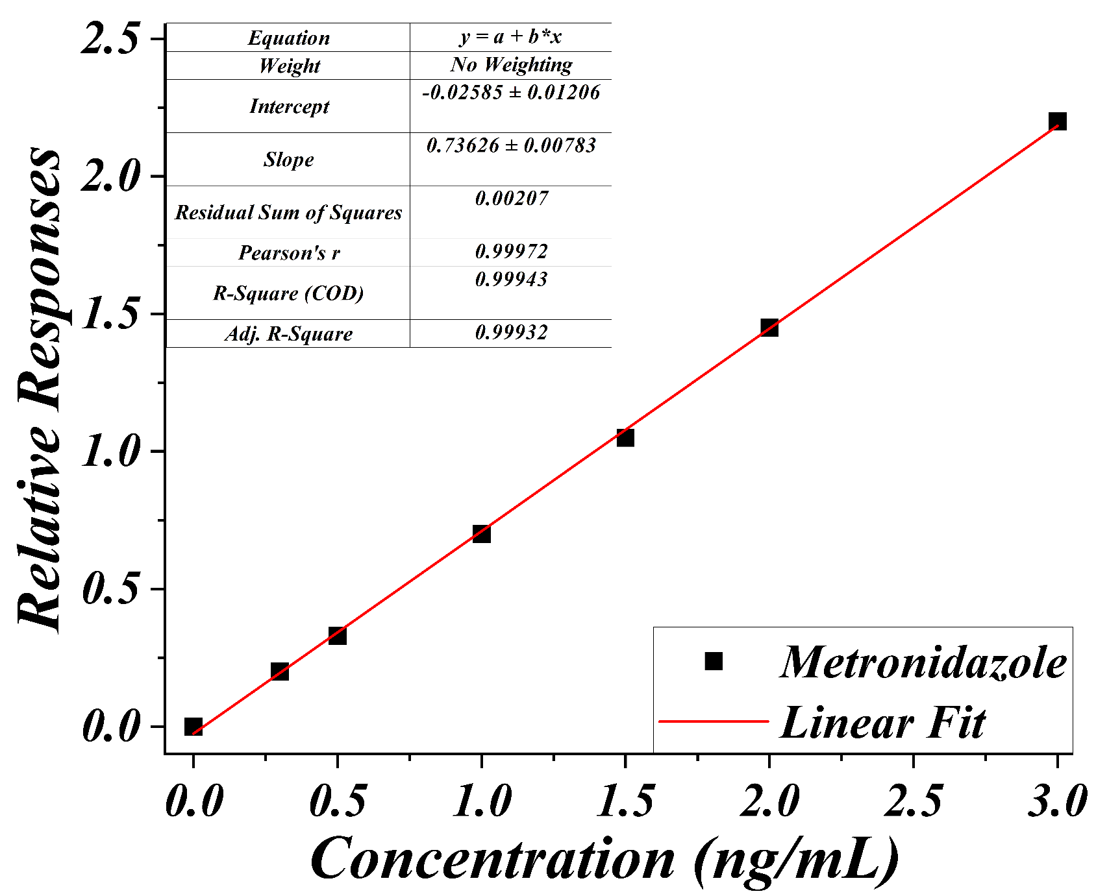(b)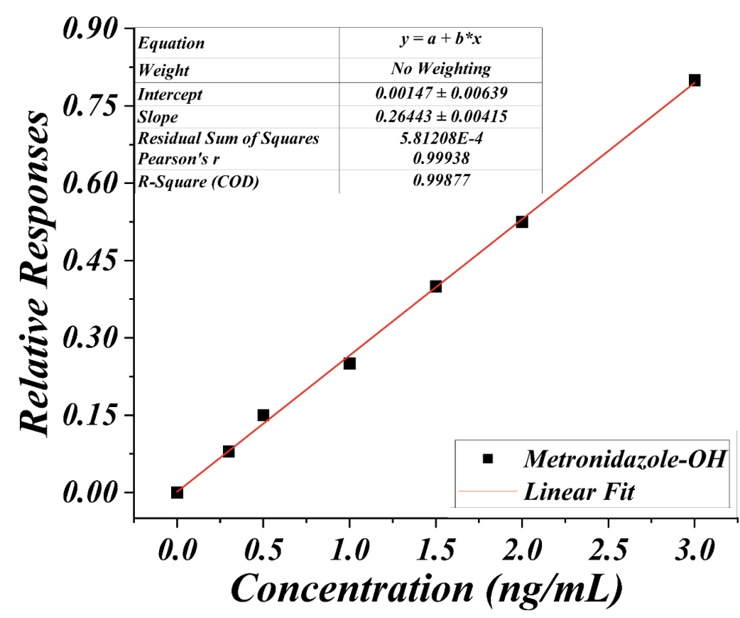
(c)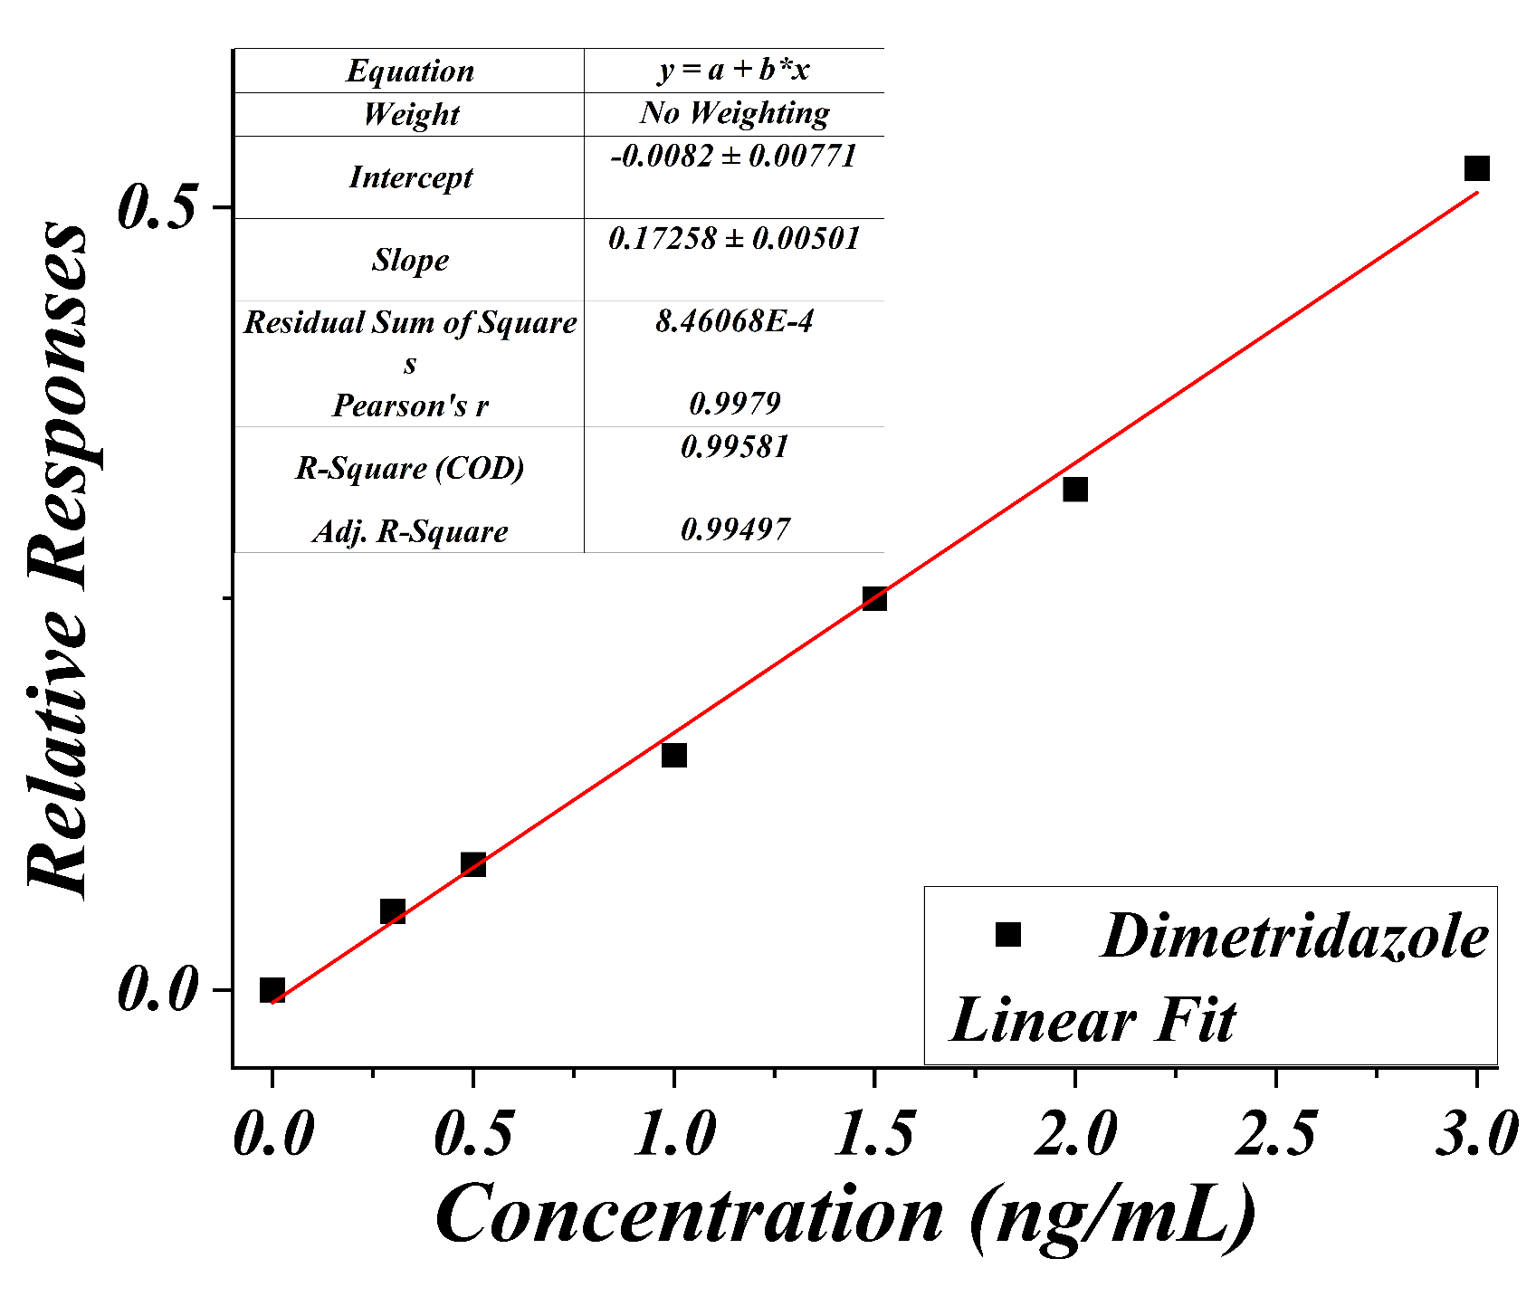 (d)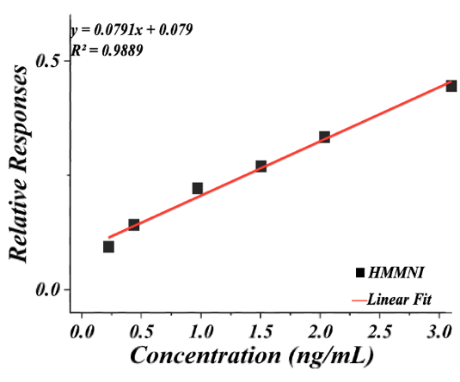
(e) 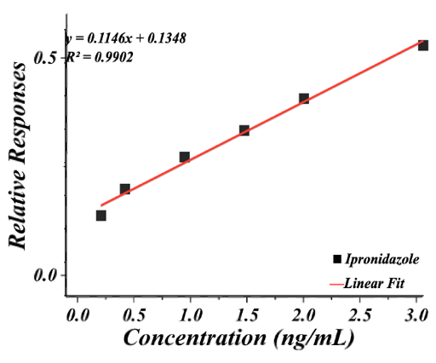 (f) 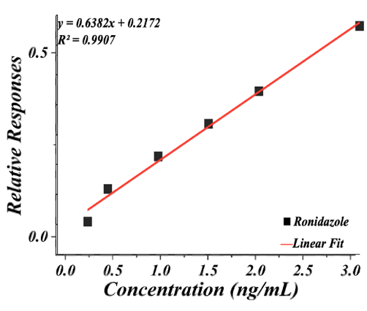
(g) 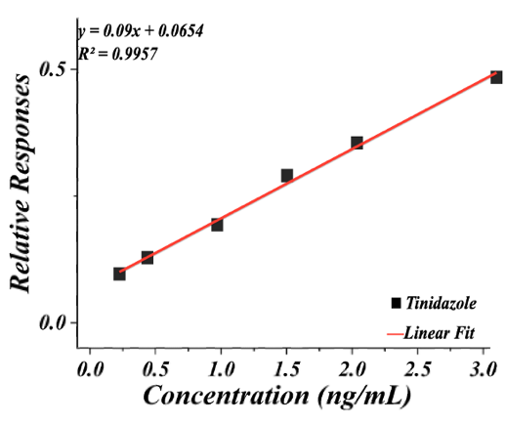
Figure S1. The calibration curves for analytes (nitroimidazole extraction via 52734-U-SupelMIP columns): (a) metronidazole (MNZ), (b) Metronidazole-OH (MNZ-OH), (c) Dimetridazole (DMZ), (d) Hydroxy dimetridazole (HMMNI), (e) Ipronidazole, (f) Ronidazole, and (g) Tinidazole.

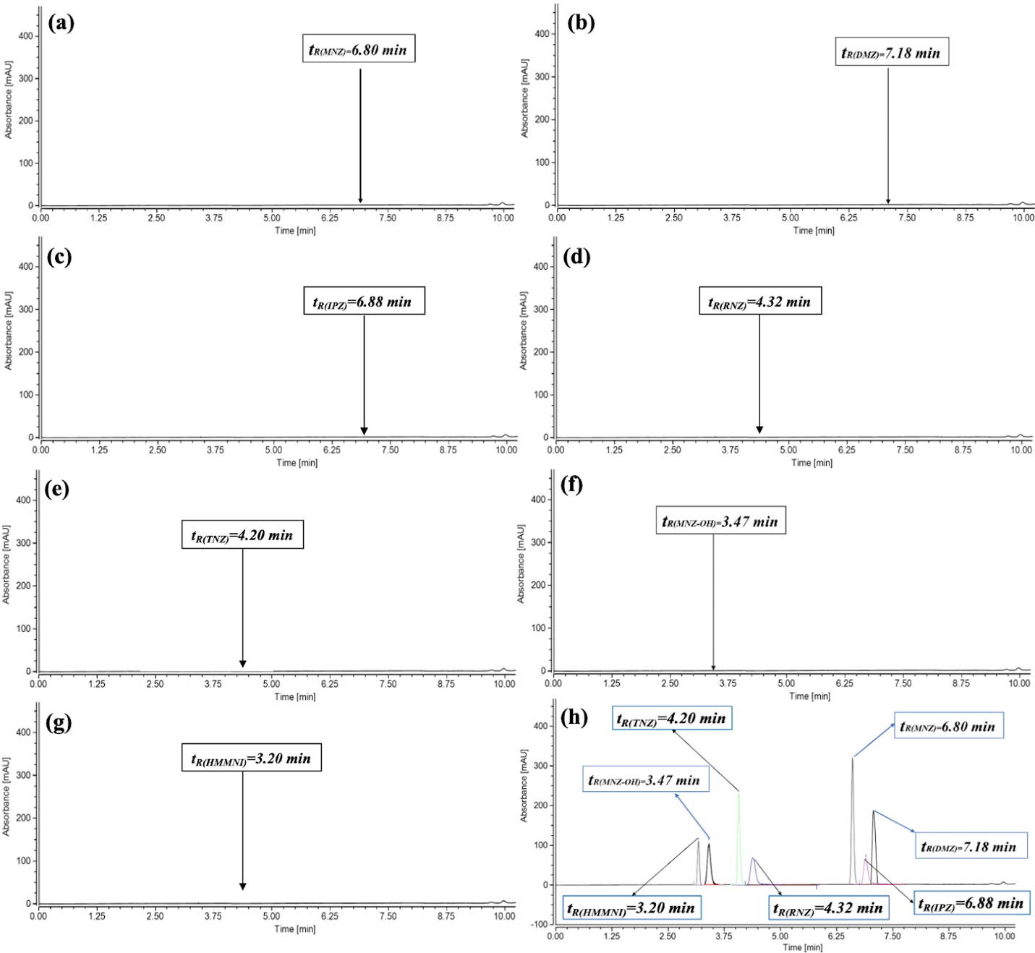
Figure S2. (a, b, c, d, e, f, and g) Extracted ion chromatograms for the investigated compounds, showing the absence of peaks in blank honey samples extracts (from both extraction methods) and (h) TIC chromatogram peaks of internal standards 5-nitroimidazoles at a concentration level of 1 μg/kg. (Analyzed using ChromeleonSoft).

(a)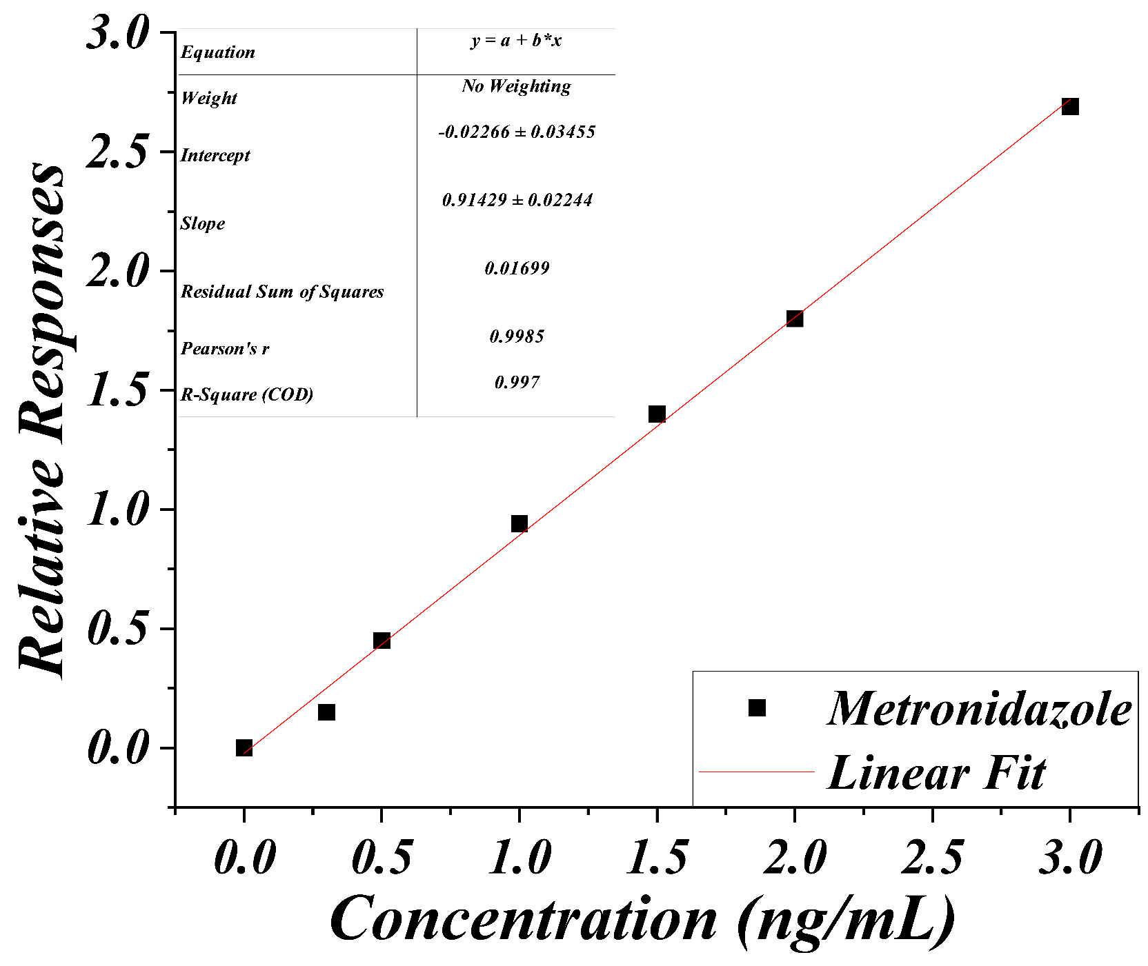(b)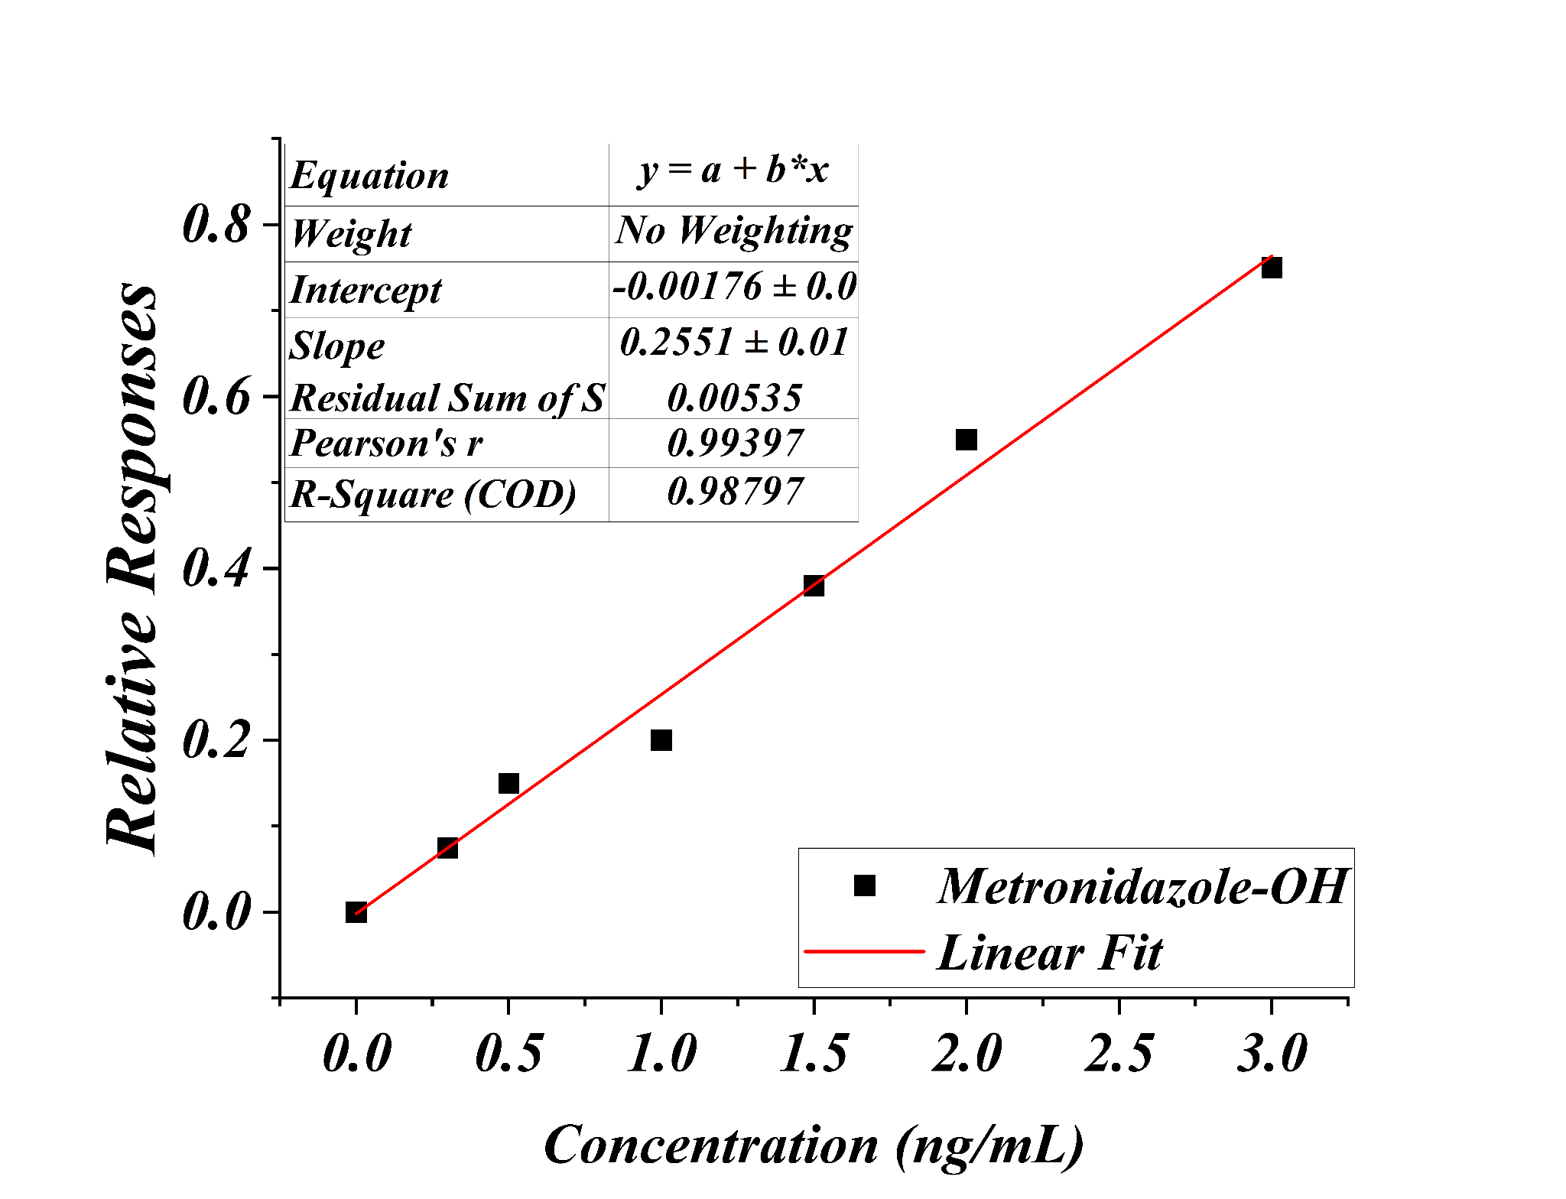
(c)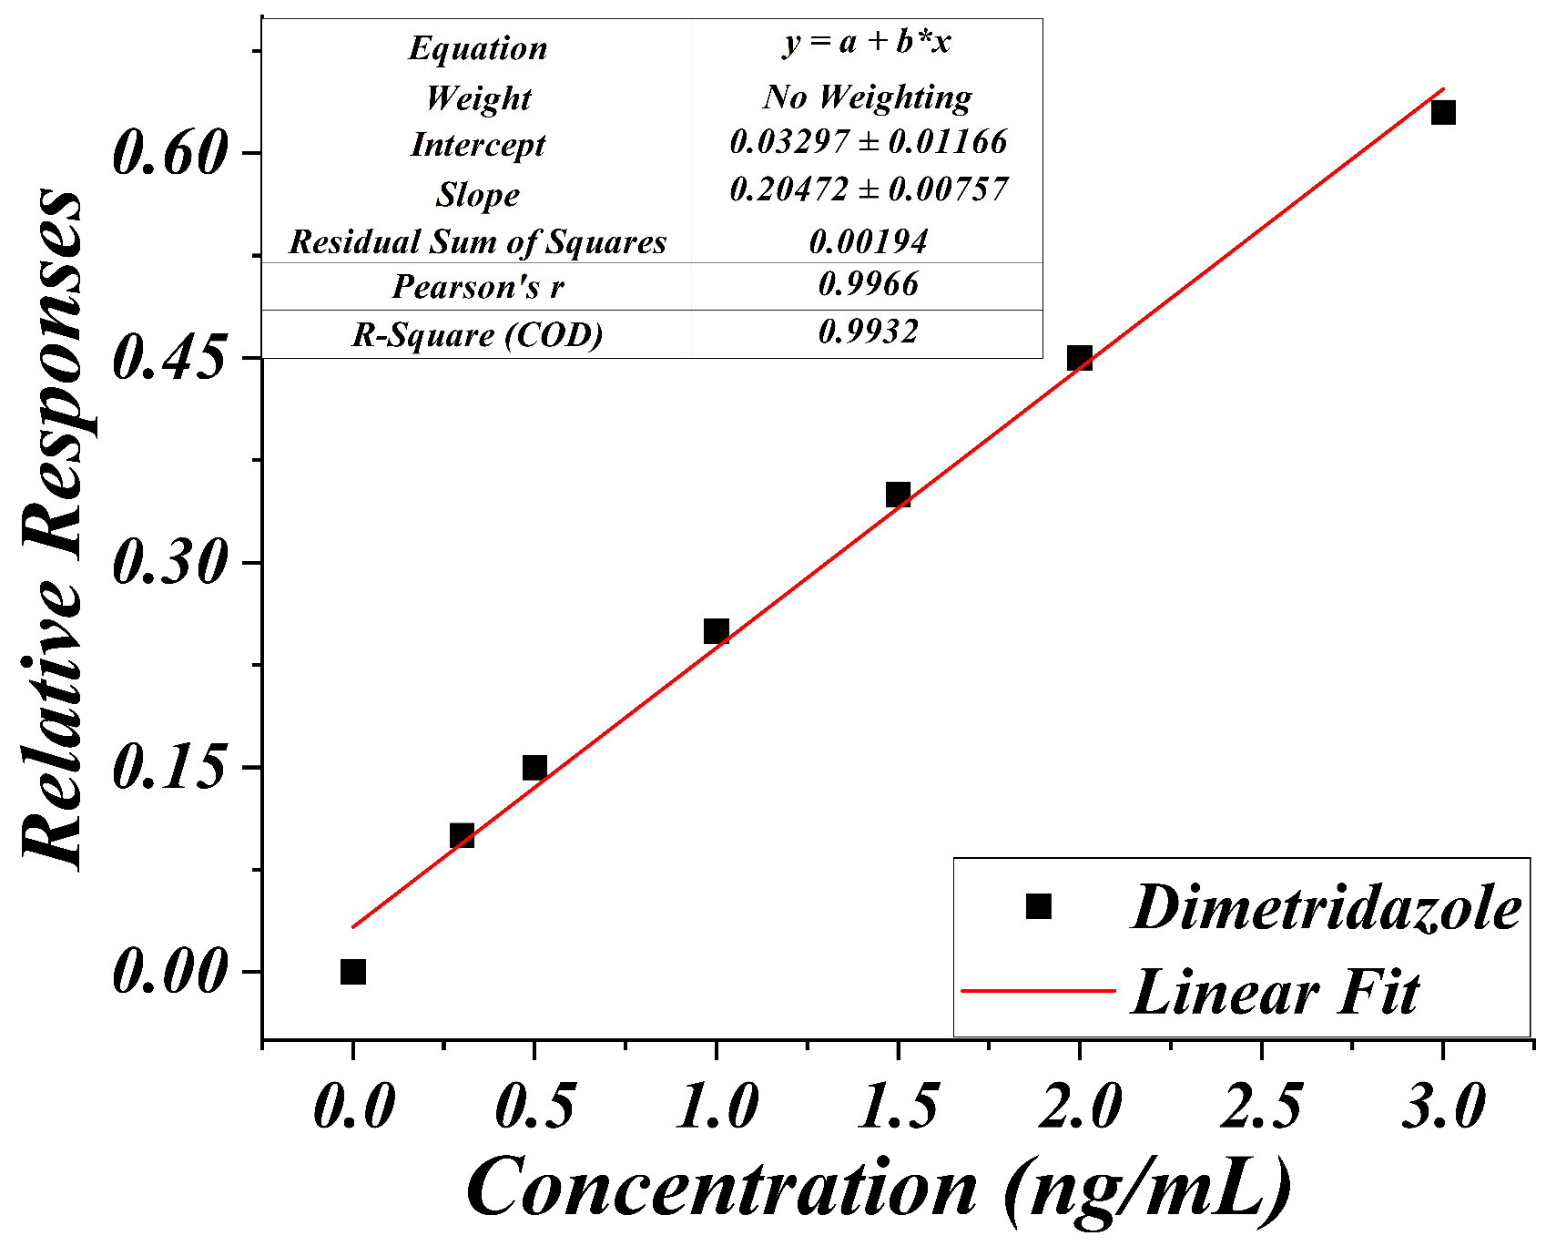(d) 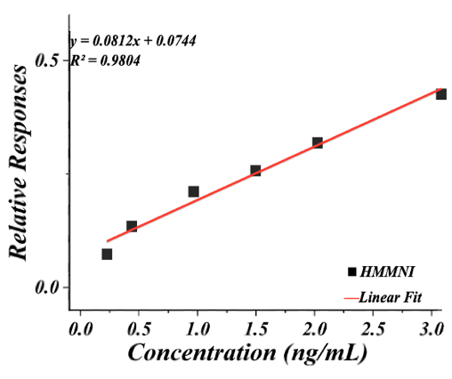
(e) 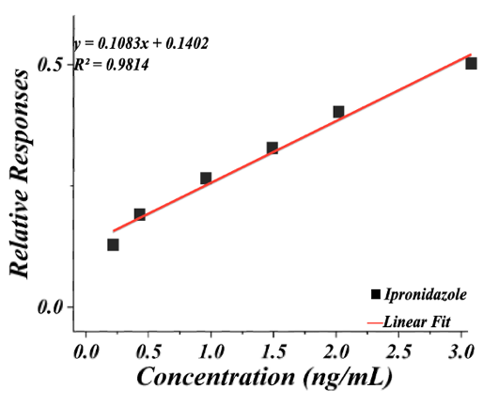 (f) 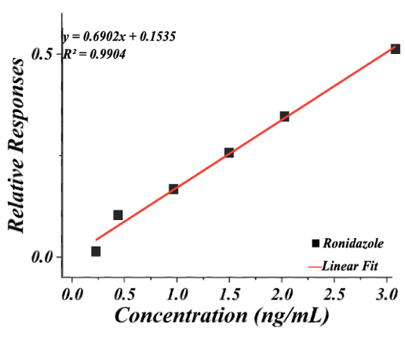
(g) 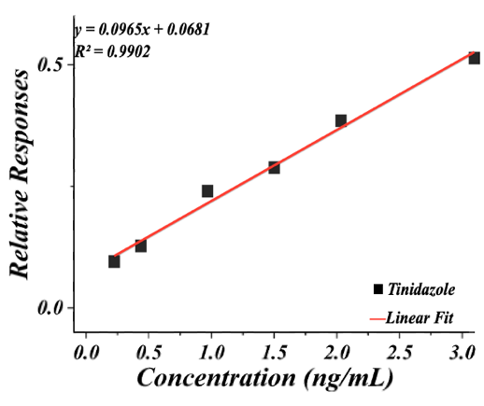
Figure S3. The calibration curves for analytes (5-nitroimidazole extraction via QuEChERS salts): (a) metronidazole (MNZ), (b) Metronidazole-OH (MNZ-OH), (c) Dimetridazole (DMZ), (d) Hydroxy dimetridazole (HMMNI), (e) Ipronidazole, (f) Ronidazole, and (g) Tinidazole.

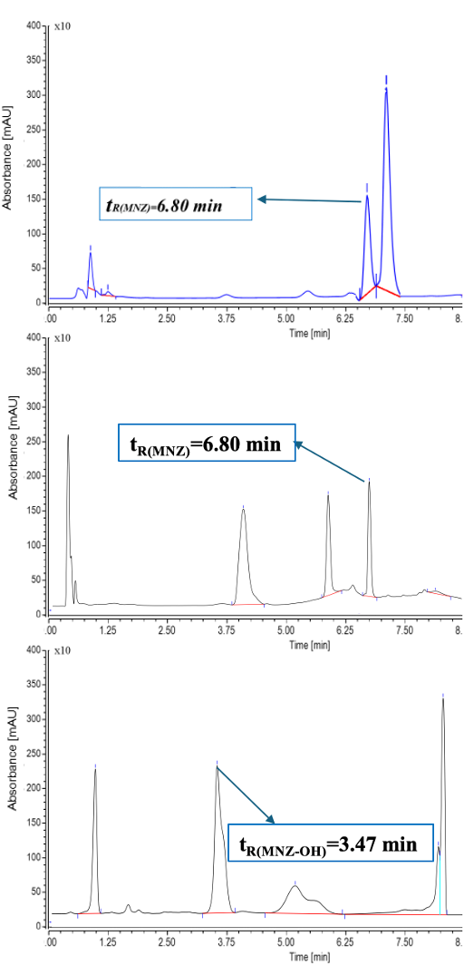
Figure S4. Total Ion Chromatography via LC-MS/MS after QuEChERS salt extraction process for the following samples out of the 24 testes samples: (a) MNZ peak for M_{11,} (b) MNZ peak for M₁₂ (t_{R(MNZ)}= 6.80 min), and (c) MNZ-OH peak for M₀₆(t_{R(MNZ-OH)}= 3.47 min).

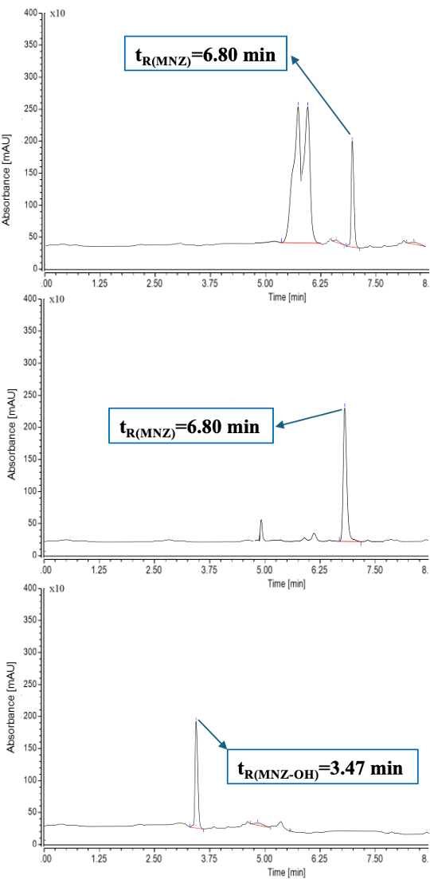
Figure S5. Total Ion Chromatography via LC-MS/MS after 52734-U-SupelMIP column extraction process for the following samples out of the 24 testes samples: (a) MNZ peak for M_{11,} (b) MNZ peak for M₁₂ (t_{R(MNZ)}= 6.80 min), and (c) MNZ-OH peak for M₀₆(t_{R(MNZ-OH)}= 3.47 min).

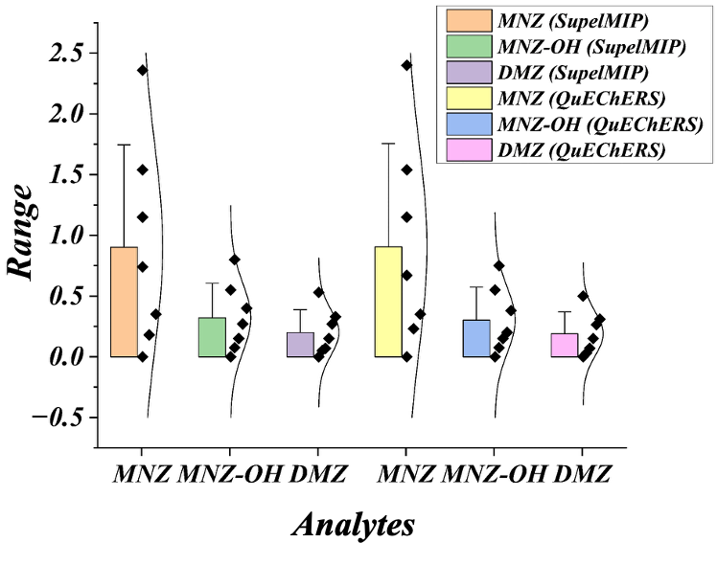
Figure S6. Bar Normal Distribution chart for MNZ, DMZ and MNZ-OH variables for two different extraction methods.

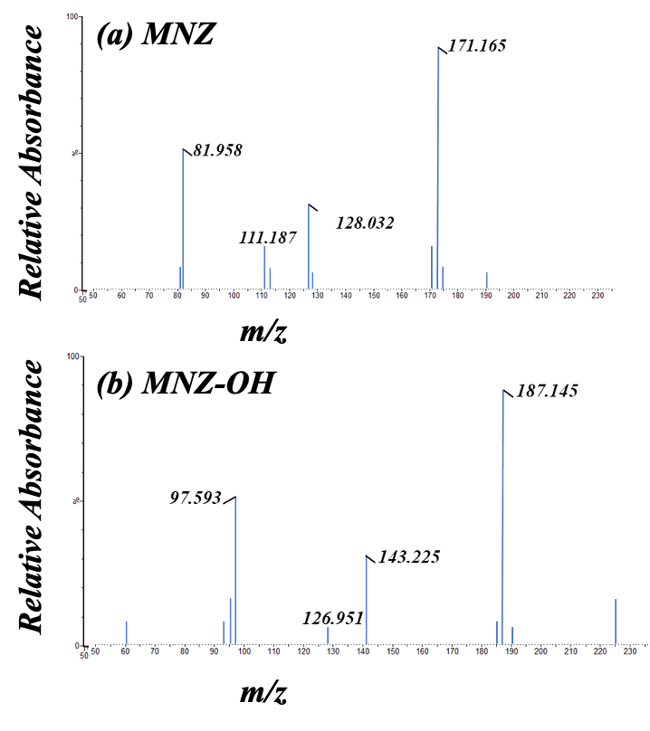
Figure S7. (a) MNZ m/z values and (b) MNZ-OH m/z values and their precursor/product ions (control experiment) for the positive samples via Orbitrap Exploris 480 Mass Spectrometer (HRMS).

