Supplementary Information

The complexity of the relationship between spontaneous brain activity and glucose metabolism

Volpi et al.

Supplementary Results

SUVR-fMRI bivariate associations are (slightly) nonlinear
Motivated by the evidence of a stronger coupling between SUVR and fMRI features when selecting nodes from decreasing percentiles of the SUVR distribution (Figure 3), and by findings in the literature highlighting a nonlinear relationship between [¹⁸F]FDG and rs-fMRI signal and FC¹, we explored which model structure, amongst four options with equal number of parameters (linear, mono-exponential, power law, log-linear), was the most appropriate at fitting each of the 50 bivariate SUVR-fMRI associations. Model selection was performed according to the residual sum of squares (RSS) of SUVR, and the difference in RSS between the three model options for a given association.
Notably, a nonlinear relationship was identified as the winning model for most (86%) of the SUVR-fMRI associations, with the power law as the model of choice for 72% of them (36/50 features). For many features, however, it must be noted that the differences between the linear and nonlinear models were fairly minor.
Importantly, as the log-linear model (i.e., a logarithmic transformation of the rs-fMRI variables)
- would be easier to integrate in a feature selection framework than a fully nonlinear model like the power law, allowing for the use of a more robust linear estimator;
- was still superior to the linear model in 62% of the cases (31/50 associations);
- displayed very small differences in RSS with respect to the power law, in the range of [-0.05; 0.01];
we chose to perform multivariable model selection using the log-linear model.
A representative association (static betweenness centrality, s-BC, vs. SUVR) in which the power law model is superior to the linear model, and the log-linear model matches the power law almost perfectly, is shown in the scatter plot of (Supplementary Figure S2).

Choice of feature selection method at the group median level
The group-wise log-linear model was estimated via ordinary least squares (OLS) with SUVR as dependent variable, and the 50 log-transformed rs-fMRI variables as predictors, to assess the maximum explanatory power provided by the available rs-fMRI features.
We show the scatter plot of SUVR vs. model prediction, with nodes color-coded by network (Supplementary Figure S3a): the fit is quite good, with a R² of 0.62 and no strong outliers, but the 50 features do not reach saturation of the explain variance. Notably, even in this overparameterization context, some high SUVR parcels are poorly explained by the available features, particularly a group of nodes belonging to default mode (DMN) and control (CTR) networks (Supplementary Figure S3c). The CVs% of parameter estimates, with ceiling set at 300%, are shown in (Supplementary Figure S3b): as most CVs% are higher than 100%, indicating low precision of the estimates, feature selection is necessary to build a rigorous multiple regression model.
We therefore explored multiple methods to try and reach a sparse solution. The employed selection strategies are: 1) Ward hierarchical clustering, 2) non-negative least squares (NNLS), 3) general-to-specific (GETS) modelling, 4) Ward, then NNLS, 5) Ward, then GETS, 6) Ward, then stepwise selection, 7) Ward, then elastic net regression, 8) NNLS, then GETS, 9) NNLS, then elastic net, 10) GETS, then NNLS, 11) GETS, then elastic net. These were compared in terms of number of selected features, condition number $κ\left(X\right)$ of the predictor matrix after selection, goodness-of-fit indices (R², RSS), parsimony criteria (Bayesian Information Criterion), and precision of the estimates (mean $μ$ and standard deviation $σ$ of CVs%), as it can appreciated in (Supplementary Figure S4, Supplementary Table S1). Moreover, we also considered other aspects of the solutions, i.e., the sign of the model coefficients with respect to bivariate correlations with SUVR (checking for sign switching), and the number of features related to each rs-fMRI pool (trying to avoid solutions with very few features and lacking most of the feature categories).
We present here the results of the optimal feature selection process for the log-linear model, which was performed in two stages.
First, a NNLS estimator² was employed, with the predictor design matrix which had been previously sign-constrained³ (using the signs provided by the first right-singular vector derived from singular value decomposition⁴ which explained 54% of the variance across predictors). While the solution was well-conditioned ($κ\left(X\right)$ = 8.08) and providing a good description of the data (R² = 0.42), the precision of the estimates was still in an unacceptable range (CVs% mean $μ$ ± standard deviation $σ$ = 778.24 ± 1674.6 %).
The NNLS estimates were therefore refined with a second stage of feature selection using elastic net regression⁵ ($α$ = 0.7, $λ$ = 0.061 optimized by k-fold cross-validation⁶). The reached solution was optimal in terms of both goodness of fit (R² = 0.411), representing only a minor loss with respect to the one-stage NNLS solution, and precision of the estimates (CVs% $μ$ ± $σ$ = 66.73 ± 17.79 %). Moreover, the number of selected features is sufficiently high to represent all pools of rs-fMRI predictors: this would prove useful when assessing between-subject (BSV) and between-network variability (BNV) of the model through multilevel modelling, as more features provide more information and flexibility. Even sparser solutions for the model were available, with as few as 3 rs-fMRI predictors (Supplementary Figure S4, Supplementary Table S1), but were not chosen for the above reasons.
Notably, the 9 selected features were in most cases highly reproducible across feature selection approaches, which proves the consistency in their association with SUVR: amongst them, ReHo, peaks-BOLD, and hrf-LE are the most frequently encountered (Supplementary Figure S5).

Supplementary Discussion

Hemodynamic response function (HRF) features

Neuronal events at the synaptic level are associated to vascular responses through neurovascular coupling mechanisms⁶. The HRF, that was extracted from the BOLD signal time series according to the method by ⁸, was interpreted as a proxy of cerebral blood flow (CBF)-related information: the amplitude of the HRF peak, in particular, had already been correlated with ASL estimates of CBF, with good agreement, especially when estimated with smooth finite impulse response, sFIR⁹. Moreover, we built ‘vascular connectivity networks’ by correlating the estimated HRF curves across brain regions. The HRF variability across brain areas, which is increasingly recognized as a confounding factor in rs-fMRI FC studies¹⁰, relates to the heterogeneous regional distribution of CBF and its modulation by excitatory and inhibitory neuronal populations: for instance, lower local GABA concentration results in quicker, taller, and narrower HRF¹¹. Additional variability will depend on the vasculature, with different HRF shapes for brain regions neighboring larger blood vessels compared to smaller ones. This complex contribution from neural and non-neural factors results in a moderate positive association with SUVR, but notably higher than that of many sFC graph metrics (Figure 2b, main text), which is likely to mainly reflect the common influence of CBF on the HRF peak and correlation structure, as well as on SUVR. Interestingly, the HRF network structure is also highly correlated with the one derived from sFC, as well as with ReHo and more local signal features, further highlighting the tight dependence between BOLD signal, local coherence, sFC and CBF proxies (Figure 2a, main text). Moreover, the correlation between the HRF peak and the variance of the BOLD signal is very high: this is interesting because the BOLD variance has already been identified as a marker of cerebrovascular reactivity¹², but also to be a correlate of the distribution of GABAergic interneurons¹³, and of aerobic glycolytic processes¹⁴. This explains the relevance of both the HRF peak and BOLD variance to regional metabolism. Finally, these interpretations are reinforced by noting that the HRF peak is amongst the very few variables (together with BOLD variance) that increases its association with SUVR when the correlation is assessed in high SUVR nodes (Figure 3a), which are expected to be the most enriched in receptors, long-range connections, etc. Further investigations on this are thus required.

Time-varying FC (tvFC) – Sample Entropy

Sample entropy (SampEn) of graph metrics gives a slightly different picture of tvFC and of the tvFC-SUVR coupling. SampEn was selected as an additional measure of tvFC to provide information on the temporal complexity of brain network properties¹⁵. Similarly to what was previously found for the clustering coefficient (CC) and participation coefficient¹⁵, we detected opposite behavior for strength (STR), betweenness centrality (BC) and global efficiency (GE) on the one hand, whose static FC (sFC) values were positively correlated with tvFC-SampEn values, while for CC and local efficiency (LE) on the other hand, sFC values were negatively related with tvFC-SampEn values (Figure 2a, main text). This was previously interpreted as brain segregation attempting to minimize entropy, with nodes with high CC and LE displaying low SampEn, and thus having a regular and predictable temporal pattern, while high integration nodes, with high sFC STR, BC and GE, also have high tvFC-SampEn and thus, high temporal complexity. Interestingly, the SampEn of LE and CC demonstrates significant negative correlations with SUVR.

Phase coherence (PC) measures

These metrics are known to provide a complementary view of FC with respect to correlation of BOLD magnitude. Nonetheless, the temporal variability of FC derived from PC has been found to be compatible with that of sliding windows correlations, especially if considering specific window lengths (20 s), frequency bands (0.03-0.07 Hz), and the absolute value of sliding windows FC weights¹⁶. For this study, however, no effort was made to increase the correlation between the tvFC graph metrics and the PC features, as we wanted to maximize the amount of information that could be extracted from rs-fMRI (Figure 2a, main text) to then relate it to SUVR.

Spearman’s correlations between SUVR and PC measures across all regions were similar to those of sFC and tvFC metrics, with the median of the instantaneous leading eigenvectors (med-LEig) being positively correlated (similar to sFC), and their variability (median absolute deviation, MAD) being negatively correlated with metabolism. However, subsequent analyses revealed a notably different behavior, with correlations with SUVR being emphasized in substantially different clusters of nodes with respect to graph measures: notably, these PC measures seemed to be quite insensitive to the selection of nodes with progressively higher SUVR, while the rest of the features lost their significant association (Figure 3, main text).

Nonlinear modelling
The tighter coupling between SUVR and rs-fMRI in low SUVR nodes led us to comparing different model structures (linear, mono-exponential, and power law) for each of the 50 bivariate SUVR-fMRI associations. A nonlinear relationship was identified as the winning model for 86% of the SUVR-fMRI associations, despite slight differences in many cases. As the power law model was the most frequently selected, it would make sense to use it in the multivariable modelling step. However, since performing feature selection in a nonlinear environment would prove quite difficult, it was chosen to transform the rs-fMRI predictors via the natural logarithm, which would help the most positively skewed predictors to be more fairly selected and allow to perform model selection in the robust estimation framework offered by linear models (Supplementary Figure S2). Notably, SUVR and its log-transformed counterpart are almost identical (Pearson’s R² = 0.99), thus even employing a multivariable power law (log-log) model structure, i.e.,
$$SUVR_{i}= fMRI_{i1 }^{β_{1}}⋅ fMRI_{i2}^{β_{2}}⋅…⋅fMRI_{ip}^{ β_{p}}+ ε_{i}$$
$$\log{{SUVR}_{i}}= β_{1}⋅\log{fMRI_{i1 }}+ β_{2}⋅\log{fMRI_{i2}}+…+ β_{p}⋅\log{fMRI_{ip}}+ ε_{i}$$
with log-SUVR as dependent variable would lead to similarly interpretable results.

Supplementary Methods

Feature extraction

Linear and nonlinear signal-based features (1a)

Pre-processed EPI signals were averaged within each parcel to obtain a representative time course.

The temporal median, median absolute deviation (MAD) and skewness of the parcel-wise BOLD signal, i.e., the first, second, and third-moment statistics of the BOLD time series distribution, were calculated in a nonparametric framework. The median BOLD signal has been found to be a proxy not only of activity but also of cell density^{17,18} , and the BOLD MAD is known to carry significant physiological information on cellular properties^{13,19} and also to be a correlate of cerebrovascular reactivity¹²; the skewness, which captures extreme BOLD events, has been found to be related to structural connectivity (SC), with more connected regions exhibiting resting-state activity with high negative skewness²⁰. Moreover, nonlinear metrics of BOLD signal complexity were computed, in particular approximate entropy (ApEn)²¹ and range approximate entropy (rApEn)²². ApEn is given by the following equations:

$$ApEn =\lim_{N→∞}{Φ^{m}\left(r\right)- Φ^{m+1 }}(r)$$

$$Φ^{m}\left(r\right)= \sum_{i=1}^{N-m+1}{\ln{C_{i}^{m}\left(r\right)}}$$

$$C_{i}^{m}\left(r\right)= \frac{1}{N-m+1}B_{i}^{m}\left(r\right), i=1,…, N-m+1.$$
It quantifies the mean negative log-probability that an m-dimensional state vector will repeat itself at dimension (m + 1). It is recommended that the tolerance is corrected as r × SD (SD being the standard deviation of the signal) to account for amplitude variations across different signals. The embedding dimension m was set equal to 2, and the tolerance r was set to 0.2 multiplied by the SD of the signal²¹. The recently introduced rApEn²², obtained by the following:
$$B_{i}^{m}\left(r\right)= \sum_{j=1}^{N-m+1}{Ψ (r-d_{range}\left(X_{i}^{m}, X_{j}^{m}\right))}$$
$$\left\{\begin{aligned}d_{range}\left(X_{i}^{m}, X_{j}^{m}\right)= \frac{\max\left|x_{i+k}-x_{j+k}\right|-\min{|x_{i+k}-x_{j+k}|}}{\max\left|x_{i+k }-x_{j+k}\right|+\min{|x_{i+k }-x_{j+k }|}} \\ k=0, …, m-1\end{aligned}\right.$$
$$Ψ\left(a\right)=\left\{\begin{aligned}0, &a<0 \\ 1, &a≥0\end{aligned}\right.$$
is more robust to nonstationary signal amplitude changes and sensitive to changes in the Hurst exponent with respect to ApEn, thus being more appropriate to evaluate self-similarity in the signal. For what concerns the parameter r, it is constrained to the range [0,1], so it does not need any amplitude correction.
A first-order autoregressive AR(1) model was fit to the windowed BOLD time series by minimizing the forward prediction error in the least squares sense; the Yule-Walker equations were solved by the Levinson-Durbin recursion, obtaining the AR(1) reflection coefficients, whose absolute value was taken as the time dependence between y(n) and y(n – 1). The exponents of a first-order autoregressive AR(1) model fit to the BOLD signal are tightly linked to the Hurst exponent, that had previously been found to have physiological and cognitive relevance^{21,22}.

ALFF, ReHo, and time-varying ReHo (1b)

After high-pass filtering, the vertex-wise BOLD signal’s spectral content was quantified by the amplitude of low frequency fluctuations (ALFF), as signal power within [0.01, 0.1] Hz band²³. The local coherence of the BOLD signal was described by Regional Homogeneity (ReHo)²⁴ computed as Kendall’s W coefficient of concordance among one vertex’s time series and its 27 neighbors’. Parcel-wise ReHo and ALFF values were extracted as the median of the vertices within the region.

Time-varying ReHo was computed with a sliding window approach (window size: 30 TRs, step: 1 TR), as Kendall’s W coefficient of concordance amongst neighboring vertices within each window²⁵. Motion-corrupted volumes were corrected by voxel-wise despiking with a cubic and spline interpolation, using the icatb_despike_tc function from the Group ICA Toolbox GIFT²⁶, in order to avoid more extreme censoring methods that would interrupt the temporal autocorrelation structure of the data²⁷. ReHo time courses at the parcel level were derived by averaging vertices within a region. Regional ReHo variability was calculated as nonparametric median absolute deviation (MAD) and coefficient of variation (CV%) of the parcel-wise time series²⁸, i.e.,

$$CV_{nonpar}=\frac{MAD}{median} ∙ 100$$

Static FC estimation and graph analysis (2)

sFC matrices were obtained as pairwise Pearson's correlation coefficients of the BOLD time series, which were subsequently Fisher r-to-z transformed. Motion-corrupted volumes with frame-wise displacement (FD) higher than 0.3 mm were discarded before sFC calculation²⁹. Subject-wise sFC matrices were thresholded retaining only connections associated with FC weights over a pre-defined connection density, set to the 80th percentile³⁰. Topological features of sFC matrices were estimated using the Brain Connectivity Toolbox³¹.
Node degree (DEG), defined as the number of links connected to a node, was used to characterize network structure and local connectivity:
$$DEG\left(i\right)= \sum_{j=1}^{N}{δ(i,j)}$$
$$δ\left(i,j\right)=\left\{\begin{aligned}1, &W\left(i,j\right)≠0 \\ 0, &W\left(i,j\right)=0\end{aligned}\right.$$
Node strength (STR), i.e., the sum of all link weights, was used to complement node DEG as a measure of connectivity profile:
$$STR\left(i\right)= \sum_{j=1}^{N}{W(i,j)}$$

Eigenvector centrality (EC), which uses eigendecomposition of the sFC matrix to measure if strong connections tend to link nodes with equally strong connections, accounting for the importance of indirect pathways³², was calculated as a node centrality measure as follows:
$$EC\left(i\right)= \frac{1}{λ_{1}}FCμ_{1}=\frac{1}{λ_{1}}\sum_{j=1}^{N}{W\left(i,j\right)μ_{1}(j)}$$
Betweenness centrality (BC), another node centrality measure, was calculated as the number of shortest paths between nodes passing through a specific node³³:
$$BC\left(i\right)= \frac{1}{\left(n-1\right)(n-2)}\sum_{∀j, k≠i}^{N}{\frac{ρ_{hj}(i)}{ρ_{hj}}}$$
Network segregation was measured by the clustering coefficient (CC), which locally represents the number of triangles around an individual node over the number of connected triples in the network^{34,35}, and is calculated as:
$$CC\left(i\right)= \frac{2t_{i}}{k_{i}(k_{i}-1)}$$
$$t_{i}= \frac{1}{2} \sum_{j,h∈N}{{\left(W\left(i,j\right)W\left(i,h\right)W\left(j,h\right)\right)}^{\frac{1}{3}}}$$
Segregation was also evaluated through local efficiency (LE)³⁶, i.e., the ratio of the number of connections between a node’s neighbors to the total number of possible links, calculated as:
$$d_{ij}= \sum_{W(u,v)∈gi↔j}{W(i,j)}$$
$$LE\left(i\right)= \frac{\sum_{j,h∈N}{W\left(i,j\right)W\left(i,h\right){\left[d_{jh}\left(N_{i}\right)\right]}^{-1}}}{K_{i}(k_{i}-1)}$$
Finally, another measure of integration was the global efficiency (GE), which is the inverse shortest path length in the network³⁶:

$$GE\left(i\right)= \frac{\sum_{j,h∈N}{d_{ij}^{-1}}}{n-1}$$

Time-varying FC estimation and graph analysis (3)
tvFC was computed with a sliding window approach (window size: 30 TRs, step: 1 TR), as Fisher r-to-z transformed Pearson’s correlation.

Motion-corrupted rs-fMRI volumes were dealt with by parcel-wise despiking with cubic and spline interpolation, using the icatb_despike_tc function from the Group ICA Toolbox GIFT²⁶: despiking is frequently used in tvFC studies (e.g.,^{37,38}), in order to avoid more extreme censoring methods that would interrupt the temporal autocorrelation structure of the data and result in sliding windows of differing lengths. Sliding windows were thresholded using the connection density threshold approach (80th percentile): FC weights were selected on the population sFC matrix, and then propagated to the single sliding windows, to assess the temporal variability of the connections that are most likely to be significant at the population level. The same nodal graph metrics used in the sFC analysis (STR, CC, BC, EC, LE, GE) were computed for each window in every subject. Three metrics to quantify temporal variability across sliding windows were selected and applied to the graph metrics’ time series at the parcel level:
a) nonparametric coefficient of variation (CV%, MAD/median ratio), as a measure of fluctuation of the graph metric around its average value²⁸;
b) temporal median of the absolute value of 1st order differentials (mdiff) between graph metrics’ values in adjacent sliding windows divided by the absolute value of the previous window, as a measure of average deviation of the graph metric’s value $x_{it}$ from its previous values $x_{it-1}$:
$$mdiff_{x_{i}}=median\left(\frac{|x_{it}-x_{it-1}|}{|x_{it-1}|}\right)$$
c) sample entropy of graph metrics’ time series as a measure of graph metrics’ time series complexity¹⁵
$$SampEn\left(m,r,N\right)= -\ln\left(\frac{U^{m+1}(r)}{U^{m}(r)}\right)$$
$$U^{m}\left(r\right)= \frac{1}{N-mτ}\sum_{i=1}^{N-mτ}{C_{i}^{m}(r)}$$
$$C_{i}^{m}\left(r\right)= \frac{B_{i}}{N-(m+1)τ}$$

BOLD phase coherence (PC) estimation (4)

The Leading Eigenvector Dynamic Analysis (LEiDA) framework^{39,40} was employed to characterize FC as BOLD phase coherence, which is complementary to the more frequently employed ‘magnitude FC’ approach. After demeaning and detrending the BOLD time series, the parcel-wise BOLD signal phases, 𝜃(n,t), were estimated using the Hilbert transform, which expresses a given signal as $x\left(t\right)= A\left(t\right)∙cos{θ(t)}$, where $A(t)$ is the time-varying amplitude and 𝜃 is the time-varying phase. BOLD phase coherence is then calculated at each single time point t, which results in a 3D matrix of time-varying phase-locking values (tvPLV) between each pair of brain areas n and p at each time t, estimated as:
$$tvPLV\left(n,p,t\right)=cos⁡(θ\left(n,t\right)-θ\left(p,t\right))$$
By using the cosine function, two regions with no BOLD phase difference at a given TR will have a $tvPLV\left(n,p,t\right)=\cos\left(0°\right)=1$, while time points when BOLD signals have 180˚ phase difference have a $tvPLV\left(n,p,t\right)=\cos\left(180°\right)= -1$, which makes the tvPLV(t) matrix symmetric with values ranging between -1 and 1. Then, the leading eigenvector (LEig) of the tvPLV(t) matrix at time t is computed to capture the main orientation of regional BOLD phases over all other brain areas. The signs of LEig, if both positive and negative, naturally divide brain regions into two clusters according to their BOLD phase relationship, while the magnitude of each element indicate the strength with which each brain region belong to its community. It is noteworthy that the LEig consistently represents > 50% of the variance in phase coherence at all time points. The parcel-wise median value of LEig across time was calculated in every subject and interpreted as a ‘static’ measure of phase coherence, while the regional MAD, CV% (MAD/median ratio) and mdiff were calculated as metrics of temporal variability of phase coherence.

BOLD signal deconvolution and HRF correlation estimation (5)
The parcel-wise BOLD signal was subjected to a blind deconvolution algorithm^{8,9} employing the rs-HRF toolbox v2.0 (https://www.nitrc.org/projects/rshrf). This approach builds on previous work describing the rs-fMRI signal as a point process, with events that exceed a given threshold governing the dynamics^{41,42}. In a linear, time-invariant (LTI) system framework, the BOLD signal, y(t), is thus modeled as the convolution of the HRF, h(t), and the underlying neural states, s(t), with the addition of an error term:
$$y\left(t\right)=s\left(t\right)⊗h\left(t\right)+e(t)$$
Before deconvolution, the high-pass filtered BOLD signal was despiked using a hyperbolic tangent squashing function. The HRF was estimated as the linear combination of basis vectors for a smooth finite impulse response (sFIR)^{43,44}, which captures any shape up to a given smooth frequency filter, without constraining the HRF to the canonical model, i.e. two gamma functions with time and dispersion derivatives⁴⁵. BOLD pseudo-events were detected using a threshold, which was set to the default value of 1 SD from the mean of the BOLD signal, and their parcel-wise number was calculated (peaks-BOLD). Serial correlations in BOLD time series due to aliasing of biorhythms and unmodelled neuronal activity were accounted for using an autoregressive AR(1) model during parameter estimation⁸. The outputs of the deconvolution process were:
- three parcel-wise HRF parameters, i.e., 1) HRF height, which was used for further analyses; 2) HRF full-width-at-half-maximum (FWHM); 3) HRF time-to-peak;
- the time course of the parcel-wise HRFs (16 time points, with time bins of 2 seconds, each corresponding to one TR);
- the time course of the deconvolved BOLD signal.
For each subject, a pairwise Spearman’s correlation matrix was calculated from the parcel-wise HRFs, as the matrix of temporal correlations between signals of (putatively) vascular origin; these matrices were Fisher r-to-z transformed and thresholded (80th percentile), then parcel-wise graph metrics (STR, DEG, BC, EC, CC, LE, GE) were estimated, as for sFC and tvFC, at the single-subject level.

SUVR-fMRI bivariate association: linear vs. nonlinear models
The relationship between SUVR and each of the 50 rs-fMRI properties ($fMRI_{ip}$, for i = 1, …, 218 regions, and p = 1, …, 50 features) was tested with four different bivariate models:
- a linear model,
$$SUVR_{i}=α_{p}+ β_{p}⋅fMRI_{ip}$$
- a mono-exponential model,
$$SUVR_{i}= α_{p}⋅e^{ β_{p} ⋅ fMRI_{ip}}$$
- a power law model,
$$SUVR_{i}=α_{p}⋅fMRI_{ip}^{β_{p}}$$
- a log-linear model,
$$SUVR_{i}=α_{p}+β_{p}⋅log fMRI_{ip}$$

Model selection was performed according to the residual sum of squares (RSS)⁴⁶ to evaluate whether the SUVR-fMRI association was better described by a linear or a nonlinear model for each of the 50 features. The RSS values of the nonlinear models (exp, power, log-linear) were expressed in terms of percentualized difference with respect to the linear model (lin), as follows:
$$∆_{RSS_{lin-exp} }=\frac{RSS_{lin}-RSS_{exp}}{RSS_{lin}} ∙100$$
$$∆_{RSS_{lin-power} }=\frac{RSS_{lin}-RSS_{power}}{RSS_{lin}} ∙100$$
$$∆_{RSS_{lin-log} }=\frac{RSS_{lin}-RSS_{log}}{RSS_{lin}} ∙100$$
in order to perform a ranking.
It must be noted that the number of model parameters (intercept/amplitude $α$ and slope $β$) was equal for the four model structures that were examined.

Feature selection strategies

Eleven feature selection strategies were employed to identify the best log-linear multivariable model at the group level, with SUVR as the dependent variable (y), and the log-transformed rs-fMRI variables as predictors (X).
The employed approaches were: (a) non-negative least squares (NNLS), (b) elastic net regression, (c) hierarchical clustering (Ward), (d) stepwise selection, (e) general-to-specific (GETS) modelling. The following combinations of methods were employed: 1) Ward clustering, 2) NNLS, 3) GETS, 4) Ward + NNLS, 5) Ward + GETS, 6) Ward + stepwise, 7) Ward + elastic net, 8) NNLS + GETS, 9) NNLS + elastic net, 10) GETS + NNLS, 11) GETS + elastic net.
NNLS (a) and elastic net regression (b), which were in the chosen feature selection procedure, i.e., method 9), are detailed in the following.
A NNLS algorithm, i.e.,
$$\hat{β}=\arg{\min_{β≥0}{\frac{1}{n}∥y-Xβ∥_{2}^{2}}}$$
was implemented in methods 2), 4), 8), 9), 10), using the Lawson-Hanson active-set method for convex optimization² (lsqnonneg function in MATLAB). NNLS estimation, employed for PET quantification in the so-called ‘spectral analysis’ framework⁴⁷ and in a variety of deconvolution problems in science, has been shown to be effective in obtaining sparse estimates; its performance has been found to be comparable to that of the well-known least absolute shrinkage and selection operator (LASSO)⁴⁸, but without the need to perform the delicate choice of the regularization parameter, since the non-negativity constraint suffices for sparse recovery⁴⁹. As a preprocessing step, SVD was performed⁴,
$$X=UΣV^{T}$$
with X as the $n×p$ matrix of rs-fMRI predictors, U as a $n×n$ matrix of left-singular vectors, 𝛴 as a $n×p$rectangular diagonal matrix of singular values, and V as a $p×p$ matrix of right-singular vectors. The value and sign of the weights of the first right-singular vector (V₁) were evaluated: in order to meet the NNLS assumption that $β$s are non-negative, the values of the z-scored predictors with negative weights on V₁ were multiplied by -1.
Elastic net regression⁵ was implemented as a second step in methods 7), 9) and 11), by solving the following optimization problem:
$$\hat{β}=\arg{\min_{β}{\frac{1}{n}\sum_{i=1}^{n}{{(y_{i}-Xβ_{i})}^{2}}+λ\left[α\sum_{j=1}^{p}{\left|β_{j}\right|}+\left(1-α\right)\sum_{j=1}^{p}{β_{j}^{2}}\right]}}$$
with $α∈(0,1)$ controlling the influence of the L₁ and L₂ penalties (left and right parts of the sum in square brackets, respectively), and $λ$ as the tuning parameter.
The $α$ parameter value was set as 0.7, i.e., leaning towards LASSO, but with the inclusion of the L₂ penalty in order to better handle the residual multicollinearity. The selection of the regularization parameter $λ∈\{λ_{1},…, λ_{m}\}$ over 100 possible values, geometrically spaced between 0 and the highest value giving a non-null model, was performed through k-fold cross-validation (k-CV)⁶ as follows
$$CV\left(λ\right)= \frac{1}{n}\sum_{k=1}^{K}{e_{k}(λ)}=\frac{1}{n}\sum_{k=1}^{K}{\sum_{i∈F_{k}}{{\left(y_{i}-{\hat{f}}_{λ}^{-k}(x_{i})\right)}^{2}}}$$
with K as the number of subsets in which the dataset $\{1,…, n\}$ was divided, $λ ∈\{λ_{1}, …, λ_{m}\}$ as the tuning parameter, ${\hat{f}}_{λ}^{-k}$ as the estimate obtained on the training set, and $e_{k}(λ)$ as the total error on the validation set, which is then averaged over all folds. The choice falls on the $λ$ value that minimizes the following
$$\hat{λ}={\underset{λ∈\{λ_{1}, …,λ_{m}\}}{argmin}{CV(λ)}}$$
k-CV was implemented with repeated random sub-sampling with 1,000 Monte Carlo independent realizations. As the elastic net results are known to be affected by bias due to shrinkage of the estimates, OLS regression was re-fit using only the remaining predictors after feature selection to debias the estimates⁵⁰. The model’s R² was calculated as a measure of its explanatory power and goodness of fit, and the CVs% were re-assessed to evaluate precision of the estimates.
Hierarchical cluster analysis (c), used in methods 1), 4), 6), 7), was performed on the Spearman’s correlation matrix of the rs-fMRI predictors using Ward’s linkage method⁵¹ and Euclidean distance. The dendrogram structure was evaluated by means of the cophenetic correlation coefficient, i.e., the linear correlation coefficient between the cophenetic distances obtained from the cluster tree and the original distances among observations. The cluster solution was chosen by means of a cut-off determined by the inconsistency coefficient, which compares the height of each link in the cluster tree with the mean height of links below it in the tree normalized by their SD, and thus indicates the border of a natural division in the data⁵². An inconsistency coefficient of 1 was used as cut-off. After the choice of the cluster cut, for each cluster only the feature with the highest Spearman’s correlation with SUVR was selected.
Stepwise selection⁵³ (d) was implemented in method 6) by starting from the log-linear model provided by Ward clustering, and using both forward and backward stepwise regression to determine the final model. At each step, the function searches for terms to add or remove from the model, based on the the change in the sum of squared error (evaluated by the p-value of an F-test) resulting from adding (p = 0.05) or removing (p = 0.10) the term. There are known limitations to stepwise regression, as it proceeds along a single path without performing back-testing, it is sensitive to multicollinearity among predictors, and usually results in R² that are biased towards high values^{54,55}.
The general-to-specific (GETS) modelling strategy (e) was employed in methods 3), 5), 8), 10), 11), to overcome limitations of stepwise⁵⁶, using the implementation in R (R Core Team, 2018) by the package gets⁵⁷. This approach involves three steps: 1) formulating a General Unrestricted Model (GUM), with regressors considered non-significant if the p-value of a two-sided t-test is lower than the chosen significance level (p = 0.01); 2) backward elimination of the insignificant regressors (as determined in step 1) along multiple paths with repeated regressor significance testing through Wald tests (p = 0.01), i.e. multiple hypothesis tests on subsets of $β$s which compare the proposed value of $β$ against the GUM at each regressor deletion; 3) choosing the best terminal model amongst the multi-path elimination results according to an goodness-of-fit criterion, in this case the Bayesian Information Criterion (BIC)⁴⁶. Variables are distinguished into relevant ($β$_{j} ≠ 0) or irrelevant ($β$_{j} = 0), and GETS modelling aims at finding a model solution that contains as many relevant variables as possible and keeping in the model a proportion of irrelevant variables that corresponds to the chosen significance level for the t-tests (p = 0.01). GETS has been previously found to perform favorably with respect to stepwise and penalty-based approaches in terms of false positive rate, which is difficult to control in conventional methods, especially in the case of multicollinear predictors^{57,58}.

The results obtained by each of the feature selection strategies were evaluated⁴⁶ in terms of:
- number of selected features;
- condition number $κ\left(X\right)$of the design matrix after selection;
- Pearson’s coefficient of determination (ordinary R²);
- Bayesian Information Criterion (BIC), which proves useful when models to compare result in different number of parameters;
- RSS, as indicator of goodness of fit;
- parameter CVs% as indicators of the precision of the estimates;
- $β$ estimates and their signs, i.e., the concordance with the signs of Spearman’s correlation of the rs-fMRI predictors with SUVR.

Supplementary figures and tables

Supplementary Figure S1 – Binary selection matrix based on increasing and decreasing percentiles of SUVR. SUVR percentile thresholds, both increasing (right) and decreasing (left), are plotted on the x axis. The RSNs to which the nodes belong are highlighted on the y axis. Nodes selected for correlation at each percentile level are represented in yellow, excluded nodes in blue. The increasing percentiles go from 1st to 85th (33 nodes included), the decreasing percentiles from 100th to 15th (again, 33 nodes included). The dashed black line identifies the 40th percentile: the nodes below it, i.e., in the 1st – 40th percentile range of the SUVR distribution, are the ones over which the correlations between SUVR and rs-fMRI features are the strongest.
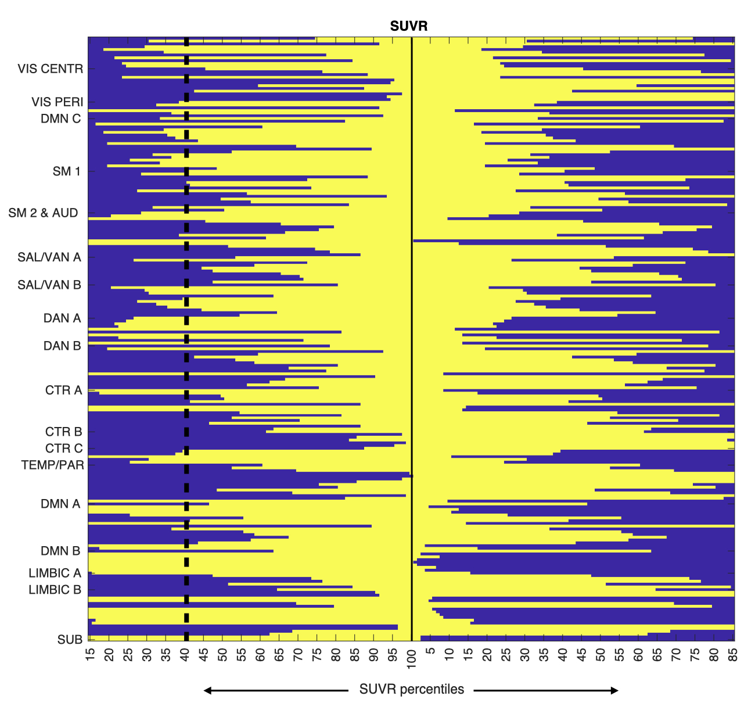
Supplementary Figure S2 – Investigation of nonlinearity in the bivariate associations between SUVR and the 50 rs-fMRI features. Example of a power law (red) and log-linear model (green) outperforming the linear model (black) and the exponential model (purple) in terms of residual error, with the linear model having around a 30% higher residual sum of squares (RSS) than power law and log-linear model, and thus worse fit of the data, with equal number of parameters.

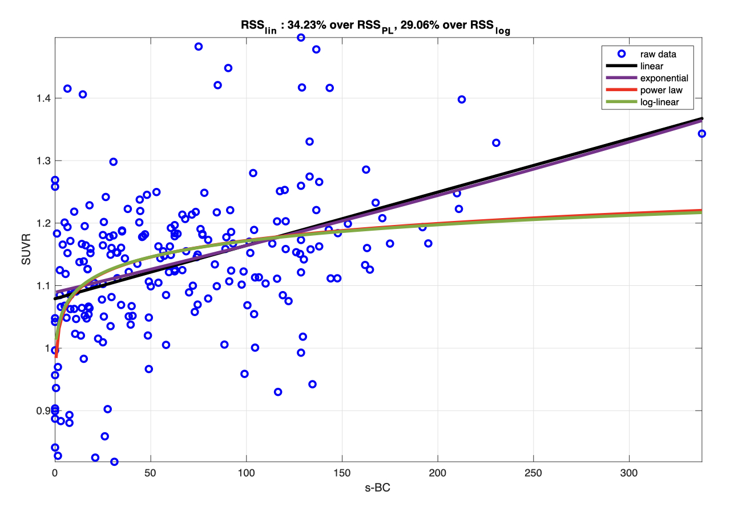

Supplementary Figure S3 – Group level log-linear model estimated from SUVR and the 50 log-transformed rs-fMRI variables. Scatter plot of SUVR vs. model prediction, with least squares regression line (black plain) and its 95% confidence intervals (black dashed lines), and nodes color-coded by network (a). Precision (CVs%) of parameter estimates, with ceiling set at 300% (b). Plot of model prediction (red line) against SUVR data values (blue dots) ordered by network (c). The ordinary least squares (OLS) log-linear model’s R² is 0.62, so the maximum explanatory power provided by the 50 rs-fMRI features does not reach saturation; as most CVs% are higher than 100%, feature selection is necessary to build a rigorous multiple regression model.

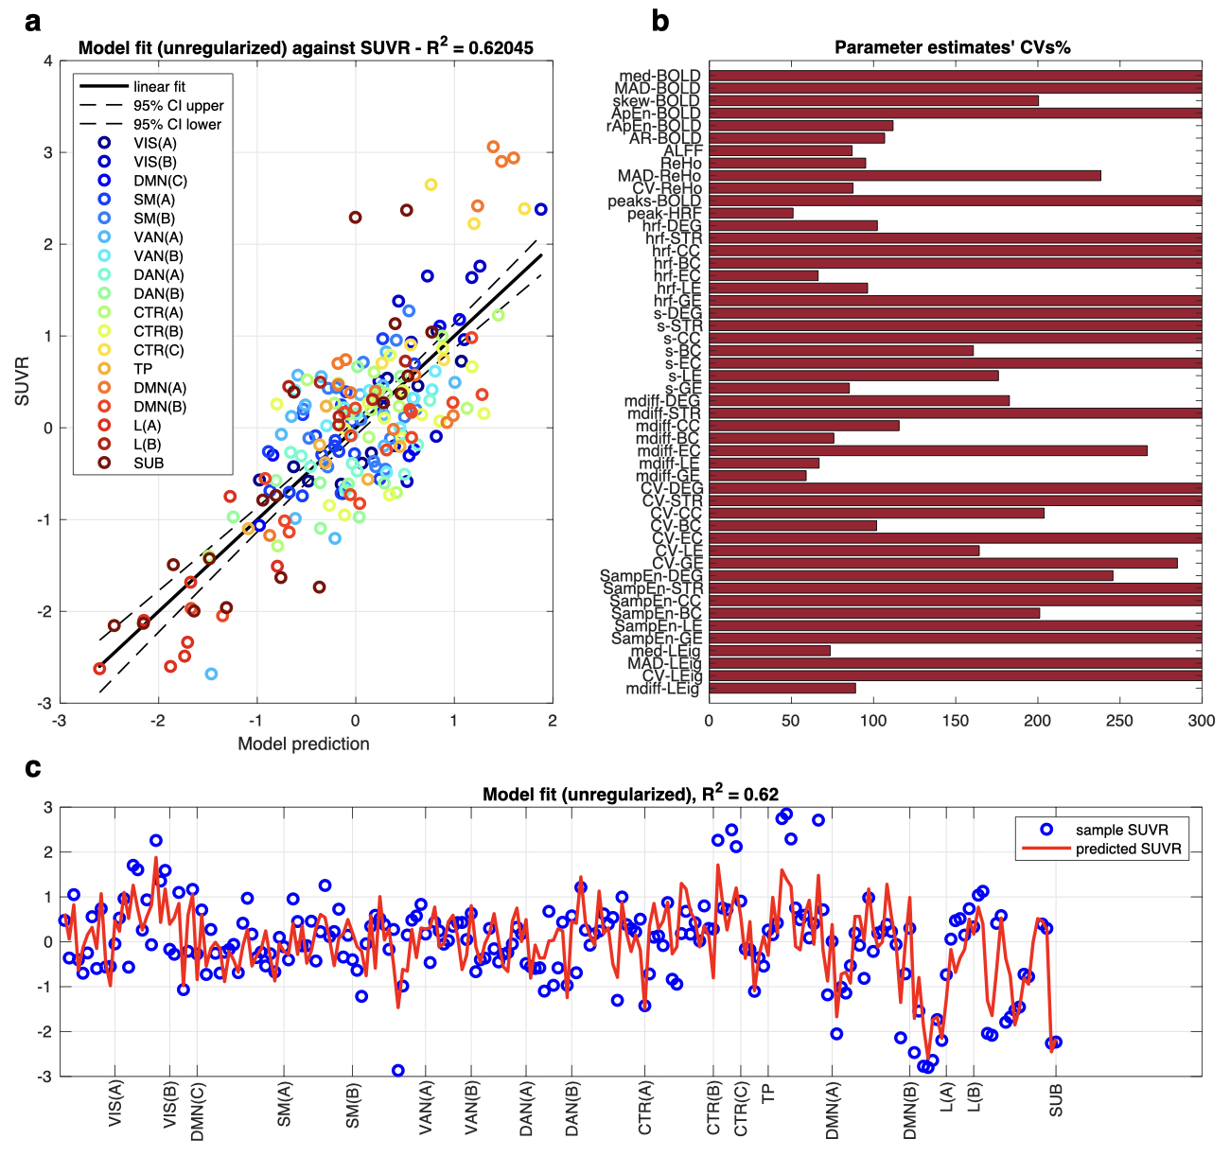

Supplementary Figure S4 – Feature selection results for the group level log-linear model. Selected variables (top matrix, in red) and CVs% of the estimated parameters (bottom matrix, ceiling at 100%). The employed selection strategies (y axis) are: 1) Ward hierarchical clustering, 2) NNLS, 3) GETS, 4) Ward, then NNLS, 5) Ward, then GETS, 6) Ward, then stepwise, 7) Ward, then elastic net, 8) NNLS, then GETS, 9) NNLS, then elastic net, 10) GETS, then NNLS, 11) GETS, then elastic net. The 50 rs-fMRI features are on the x axis.

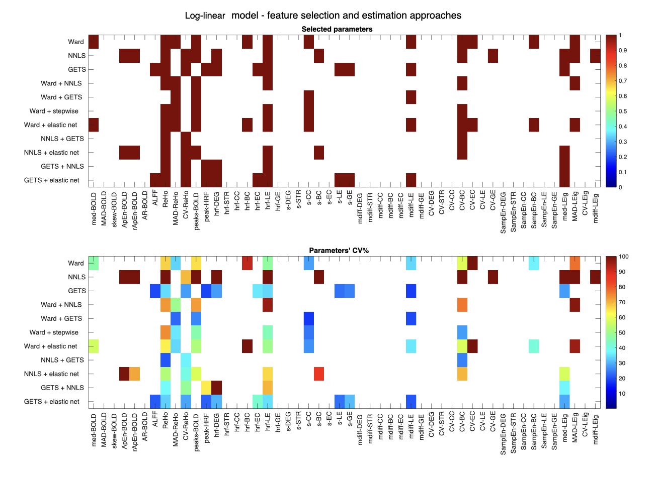
Supplementary Figure S5 – Feature selection reproducibility across methods. Final choice of features (ApEn-BOLD, rApEn-BOLD, ReHo, CV-ReHo, peaks-BOLD, hrf-LE, s-BC, CV-BC, med-LEig) for the log-linear model, as selected by method 9), i.e., NNLS + elastic net combined approach, on the x axis, with the number of times these predictors were selected across the eleven methods on the y axis.

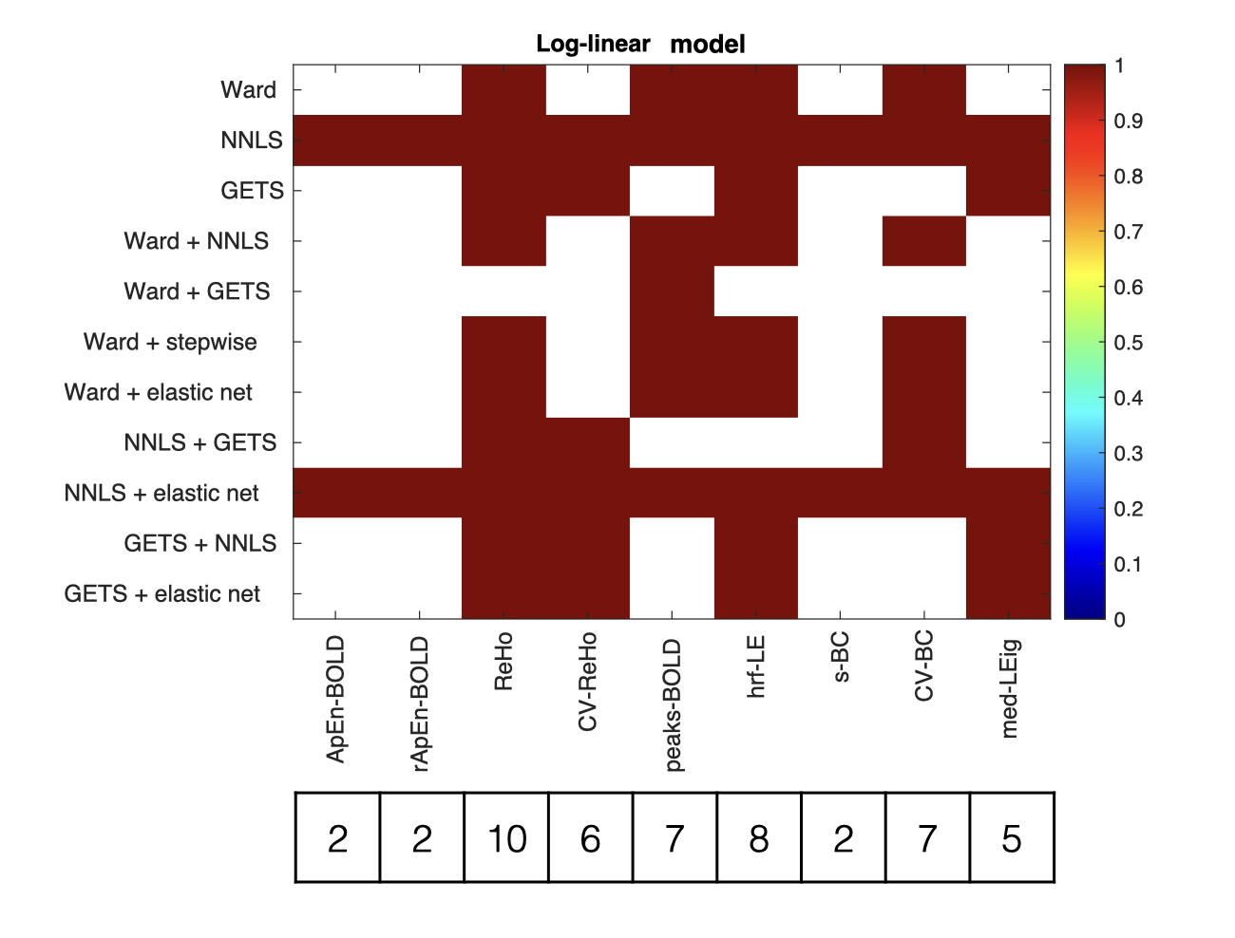
Supplementary Figure S6 – Group level log-linear model estimated from SUVR and the chosen rs-fMRI variables after feature selection. Multivariable model results for log-linear model, obtained at the group level by feature selection (NNLS + elastic net regression, $α$ = 0.7, $λ_{opt}$ = 0.061 after k-fold cross-validation) and refit using OLS. Scatter plot of SUVR vs. model prediction, with least squares regression line (black plain) and its 95% confidence intervals (black dashed lines), and nodes color-coded by network (a). Precision (CVs%) of parameter estimates, with ceiling set at 300% (b). Plot of model prediction (red line) against SUVR data values (blue dots) ordered by network (c).

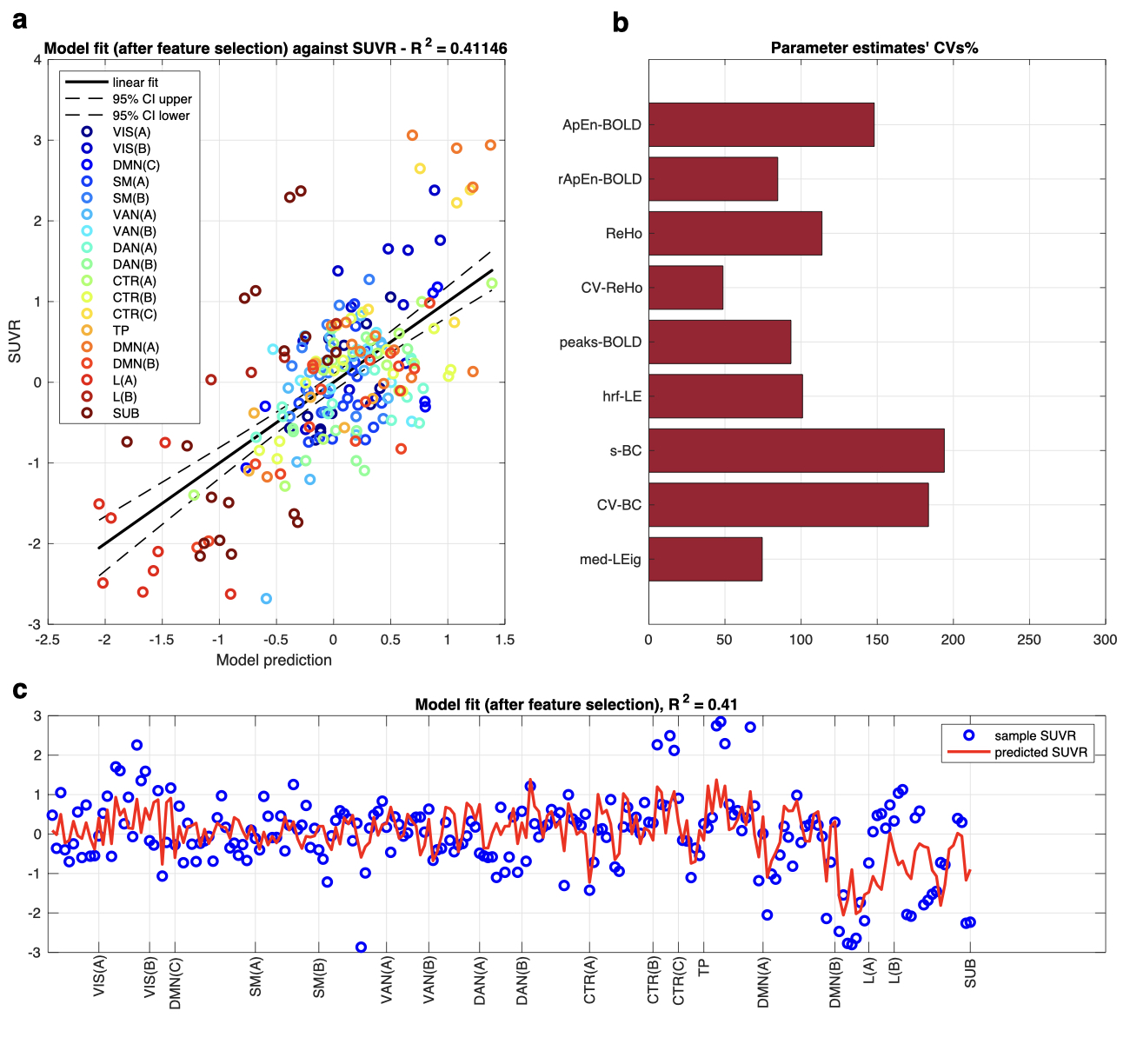

Supplementary Figure S7 – Multilevel model of SUVR across subjects – explained variance and between-subject variability. Boxplot of individual R² values (median and boxes of 25th and 75th percentile are in overlay) representing the percentage of SUVR variance explained by the multilevel model at the subject level (a). The random effects $η_{Si}$, showing the variability of each of the nine parameters from the fixed effect $θ_{S}$ for each subject i (b).

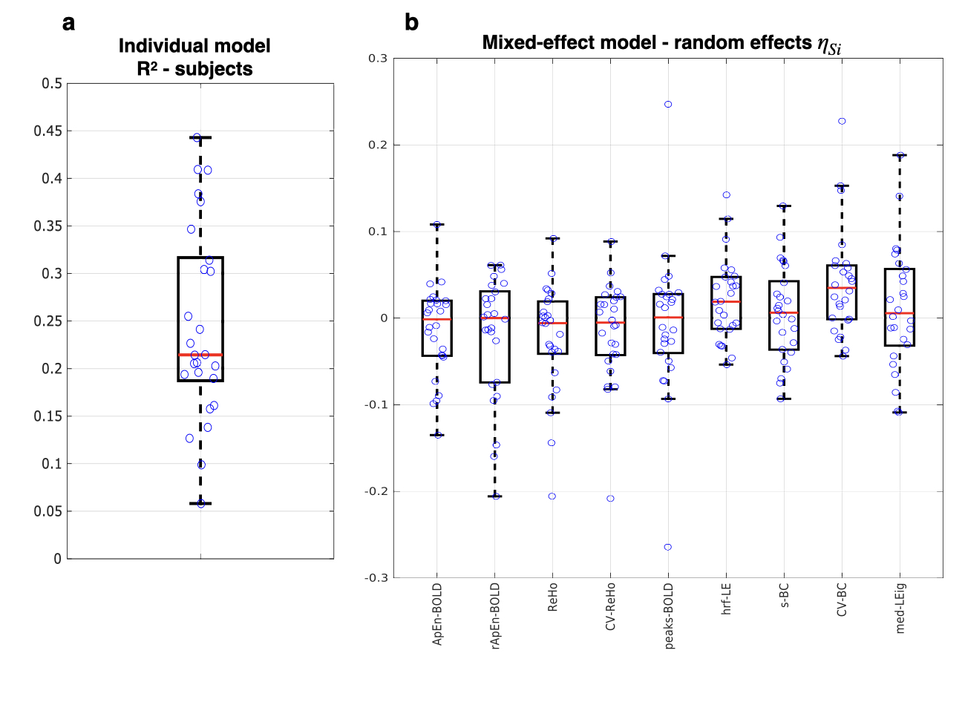

Supplementary Table S1 – Feature selection strategies for the log-linear model at group level
For each of the eleven feature selection methods, the table’s columns display 1) number of features after selection, 2) condition number of design matrix after selection, 3) ordinary R², 4) Bayesian Information Criterion (BIC), 5) model residual sum of squares (RSS), 6) mean ($μ$) and standard deviation ($σ$) of CVs% of estimates. The feature selection strategy that was chosen as the most informative (NNLS + elastic net) is highlighted in red.

Modelling  approach | number of  features | Condition  Number | Ordinary  R² | Bayesian Information  Criterion | Model  RSS | CV%  (μ+σ)
OLS | 50 | 75,72 | 0,630 | 670,03 | 80,25 | 533.68 + 1092.1
Ward | 50 → 12 | 13,23 | 0,472 | 543,02 | 114,57 | 124.27 +246.41
NNLS | 50 → 13 | 8,08 | 0,420 | 568,82 | 122,67 | 778.24 + 1674.6
GETS | 50 → 11 | 12,93 | 0,564 | 495,84 | 94,58 | 26.73 + 6.11
Ward + NNLS | 12 → 6 | 13.23 → 4.71 | 0,394 | 540,82 | 131,53 | 77.68 + 17.89
Ward + GETS | 12→ 4 | 13.23 → 3.44 | 0,428 | 517,26 | 124,04 | 21.57+3.34
Ward + stepwise | 12 → 6 | 13.23→ 5.06 | 0,436 | 525,05 | 122,35 | 42.07 + 17.92
Ward + elastic net | 12 → 12 | 13.23 → 13.10 | 0,461 | 545,37 | 115,81 | 203.26 + 509.03
NNLS + GETS | 13 → 3 | 8.08 → 2.39 | 0,390 | 526,23 | 132,48 | 27.62 + 8.06
NNLS + elastic net | 13 → 9 | 8.08 → 6.56 | 0,411 | 550,01 | 127,40 | 66.73 + 17.79
GETS + NNLS | 11 → 6 | 12.93 → 3.51 | 0,396 | 539,91 | 130,98 | 64.58 + 35.15
GETS + elastic net | 11 → 11 | 12.93 → 12.93 | 0,561 | 497,92 | 95,48 | 28.86 + 6.52

Supplementary References

- Tomasi, D., Wang, G. J. & Volkow, N. D. Energetic cost of brain functional connectivity. Proceedings of the National Academy of Sciences of the United States of America 110, 13642–13647 (2013).
- Lawson, C. L. & Hanson, R. J. Solving least squares problems. (Englewood Cliffs:Prentice-Hall, 1974).
- Meinshausen, N. Sign-constrained least squares estimation for high-dimensional regression. Electronic Journal of Statistics 7, 1607–1631 (2013).
- Golub, G. H. & Reinsch, C. Singular value decomposition and least squares solutions. Numer. Math. 14, 403–420 (1970).
- Zou, H. & Hastie, T. Regularization and variable selection via the elastic net. J Royal Statistical Soc B 67, 301–320 (2005).
- Stone, M. Cross-Validatory Choice and Assessment of Statistical Predictions. Journal of the Royal Statistical Society: Series B (Methodological) 36, 111–133 (1974).
- Logothetis, N. K., Pauls, J., Augath, M., Trinath, T. & Oeltermann, A. Neurophysiological investigation of the basis of the fMRI signal. Nature 412, 150–157 (2001).
- Wu, G.-R. et al. A blind deconvolution approach to recover effective connectivity brain networks from resting state fMRI data. Medical Image Analysis 17, 365–374 (2013).
- Wu, G.-R. & Marinazzo, D. Retrieving the Hemodynamic Response Function in resting state fMRI: methodology and applications. https://peerj.com/preprints/1317v1 (2015).
- Rangaprakash, D., Wu, G.-R., Marinazzo, D., Hu, X. & Deshpande, G. Hemodynamic response function (HRF) variability confounds resting-state fMRI functional connectivity. Magn. Reson. Med. 80, 1697–1713 (2018).
- Muthukumaraswamy, S. D., Evans, C. J., Edden, R. A. E., Wise, R. G. & Singh, K. D. Individual variability in the shape and amplitude of the BOLD-HRF correlates with endogenous GABAergic inhibition. Hum. Brain Mapp. 33, 455–465 (2012).
- Golestani, A. M., Wei, L. L. & Chen, J. J. Quantitative mapping of cerebrovascular reactivity using resting-state BOLD fMRI: Validation in healthy adults. NeuroImage 138, 147–163 (2016).
- Anderson, K. M. et al. Transcriptional and imaging-genetic association of cortical interneurons, brain function, and schizophrenia risk. Nature Communications 11, (2020).
- Raichle, M. E. The restless brain: how intrinsic activity organizes brain function. Phil. Trans. R. Soc. B 370, 20140172 (2015).
- Pedersen, M., Omidvarnia, A., Walz, J. M., Zalesky, A. & Jackson, G. D. Spontaneous brain network activity: Analysis of its temporal complexity. Network Neuroscience 1, 100–115 (2017).
- Pedersen, M., Omidvarnia, A., Zalesky, A. & Jackson, G. D. On the relationship between instantaneous phase synchrony and correlation-based sliding windows for time-resolved fMRI connectivity analysis. NeuroImage 181, 85–94 (2018).
- Ulrich, X. & Yablonskiy, D. A. Separation of cellular and BOLD contributions to T2* signal relaxation. Magn. Reson. Med. 75, 606–615 (2016).
- Wen, J., Goyal, M. S., Astafiev, S. V., Raichle, M. E. & Yablonskiy, D. A. Genetically defined cellular correlates of the baseline brain MRI signal. Proc Natl Acad Sci USA 115, E9727– E9736 (2018).
- Garrett, D. D., Kovacevic, N., McIntosh, A. R. & Grady, C. L. Blood Oxygen Level- Dependent Signal Variability Is More than Just Noise. Journal of Neuroscience 30, 4914–4921 (2010).
- Amor, T. A. et al. Extreme brain events: Higher-order statistics of brain resting activity and its relation with structural connectivity. EPL 111, (2015).
- Sokunbi, M. O. et al. Inter-individual Differences in fMRI Entropy Measurements in Old Age. IEEE Trans. Biomed. Eng. 58, 3206–3214 (2011).
- Omidvarnia, A., Mesbah, M., Pedersen, M. & Jackson, G. Range Entropy: A Bridge between Signal Complexity and Self-Similarity. Entropy 20, 962 (2018).
- Zou, Q.-H. et al. An improved approach to detection of amplitude of low-frequency fluctuation (ALFF) for resting-state fMRI: Fractional ALFF. Journal of Neuroscience Methods 172, 137–141 (2008).
- Zang, Y., Jiang, T., Lu, Y., He, Y. & Tian, L. Regional homogeneity approach to fMRI data analysis. NeuroImage 22, 394–400 (2004).
- Deng, L., Sun, J., Cheng, L. & Tong, S. Characterizing dynamic local functional connectivity in the human brain. Scientific Reports 6, (2016).
- Calhoun, V. D., Adali, T., Pearlson, G. D. & Pekar, J. J. A Method for Making Group Inferences from Functional MRI Data Using Independent Component Analysis. Human Brain Mapping 14, 140–151 (2001).
- Hutchison, R. M. et al. Dynamic functional connectivity: Promise, issues, and interpretations. NeuroImage 80, 360–378 (2013).
- Arachchige, C. N. P. G., Prendergast, L. A. & Staudte, R. G. Robust analogs to the coefficient of variation. Journal of Applied Statistics 1–23 (2020)
- Power, J. D. et al. Methods to detect, characterize, and remove motion artifact in resting state fMRI. NeuroImage 84, 320–341 (2014).
- van Wijk, B. C. M., Stam, C. J. & Daffertshofer, A. Comparing Brain Networks of Different Size and Connectivity Density Using Graph Theory. PLoS ONE 5, e13701 (2010).
- Rubinov, M. & Sporns, O. Complex network measures of brain connectivity: Uses and interpretations. NeuroImage 52, 1059–1069 (2010).
- Lohmann, G. et al. Eigenvector Centrality Mapping for Analyzing Connectivity Patterns in fMRI Data of the Human Brain. PLoS ONE 5, e10232 (2010).
- Freeman, L. C. A Set of Measures of Centrality Based on Betweenness. Sociometry 40, 35 (1977).
- Watts, D. J. & Strogatz, S. H. Collective dynamics of ‘small-world’ networks. Nature 393, 440–442 (1998).
- Onnela, J.-P., Saramäki, J., Kertész, J. & Kaski, K. Intensity and coherence of motifs in weighted complex networks. Phys. Rev. E 71, 065103 (2005).
- Latora, V. & Marchiori, M. Efficient Behavior of Small-World Networks. Phys. Rev. Lett. 87, 198701 (2001).
- Allen, E. A. et al. Tracking whole-brain connectivity dynamics in the resting state. Cerebral Cortex 24, 663–676 (2014).
- Damaraju, E. et al. Dynamic functional connectivity analysis reveals transient states of dysconnectivity in schizophrenia. NeuroImage: Clinical 5, 298–308 (2014).
- Cabral, J. et al. Cognitive performance in healthy older adults relates to spontaneous switching between states of functional connectivity during rest. Scientific Reports 7, (2017).
- Lord, L.-D. et al. Dynamical exploration of the repertoire of brain networks at rest is modulated by psilocybin. NeuroImage 199, 127–142 (2019).
- Tagliazucchi, E., Balenzuela, P., Fraiman, D. & Chialvo, D. R. Criticality in Large-Scale Brain fMRI Dynamics Unveiled by a Novel Point Process Analysis. Front. Physio. 3, (2012).
- Zhang, X., Pan, W.-J. & Keilholz, S. D. The relationship between BOLD and neural activity arises from temporally sparse events. NeuroImage 207, 116390 (2020).
- Goutte, C., Nielsen, F. A. & Hansen, K. H. Modeling the hemodynamic response in fMRI using smooth FIR filters. IEEE Trans. Med. Imaging 19, 1188–1201 (2000).
- Wu, G.-R. & Marinazzo, D. Sensitivity of the resting-state haemodynamic response function estimation to autonomic nervous system fluctuations. Phil. Trans. R. Soc. A. 374, 20150190 (2016).
- Friston, K. J. et al. Event-Related fMRI: Characterizing Differential Responses. NeuroImage 7, 30–40 (1998).
- Müller, S., Scealy, J. L. & Welsh, A. H. Model Selection in Linear Mixed Models. Statist. Sci. 28, (2013).
- Bertoldo, A. et al. Evaluation of compartmental and spectral analysis models of [18F]FDG kinetics for heart and brain studies with PET. IEEE Trans. Biomed. Eng. 45, 1429–1448 (1998).
- Tibshirani, R. Regression Shrinkage and Selection Via the Lasso. Journal of the Royal Statistical Society: Series B (Methodological) 58, 267–288 (1996).
- Meinshausen, N. Sign-constrained least squares estimation for high-dimensional regression. Electronic Journal of Statistics 7, 1607–1631 (2013).
- Belloni, A. & Chernozhukov, V. Least squares after model selection in high-dimensional sparse models. Bernoulli 19, (2013).
- Ward, J. H. Hierarchical Grouping to Optimize an Objective Function. Journal of the American Statistical Association 58, 236–244 (1963).
- Jain, A. K. & Dubes, R. C. Algorithms for clustering data. (Prentice Hall, 1988).
- Hocking, R. R. A Biometrics Invited Paper. The Analysis and Selection of Variables in Linear Regression. Biometrics 32, 1 (1976).
- Desboulets, L. D. D. A review on variable selection in regression analysis. Econometrics 6, (2018).
- Smith, S. M. & Nichols, T. E. Statistical Challenges in “Big Data” Human Neuroimaging. Neuron 97, 263–268 (2018).
- Hoover, K. D. & Perez, S. J. Data mining reconsidered: encompassing and the general-to- specific approach to specification search. The Econometrics Journal 2, 167–191 (1999).
- Pretis, F., Reade, J. J. & Sucarrat, G. Automated General-to-Specific (GETS) Regression Modeling and Indicator Saturation for Outliers and Structural Breaks. J. Stat. Soft. 86, (2018).
- Castle, J., Hendry, D. & Doornik, J. Evaluating automatic model selection. Journal of Time Series Econometrics 3, (2011).

