Weakly Supervised Deep Learning for Accurate Multi-class Renal Cell Carcinoma Classification: A Multicenter Validation Study with Biological Interpretability
Content
Supplementary Method 1. Ethics and Regulatory Compliance 3
Supplementary Method 2. Digital Pathology Workflow 3
Supplementary Method 3. RCCNET Computational Architecture (Enhanced Technical Details) 4
Supplementary Method 4. Morphometric Analysis Module 6
Supplementary Method 5. Technical Implementation 8
Supplementary Method 6. Economic Analysis Model 8
Supplementary Table S1. DeLong Test Comparisons for ROC Curves 13
Supplementary Table S2. Nuclear Segmentation Performance by Cell Type 14
Supplementary Table S3. Cellular Compartment Analysis Across RCC Subtypes 15
Supplementary Table S4. Correlation Analysis Between RCCNET Predictions and Morphometric Features 16
Supplementary Table S4. Overall Misclassification Pattern (16 total misclassified cases) 18
Supplementary Table S5. False Positive TFE3 RCC Analysis (6 cases) 19
Supplementary Table S6. Three-Tier Clinical Integration Framework 20
Supplementary Table S7. Economic Impact Analysis 21
Supplementary Figure S1: The research design flowchar 22
Figure S2. Multi-scale visualization of RCCNET's whole-slide image analysis and patch-based classification performance across RCC subtypes 24
Figure S3. Morphometric Characteristics Across RCC Subtypes. 26
Figure S4. Correlation Between AI Predictions and Cellular Morphometric Features Across RCC Subtypes 28
Figure S5. Supplementary Figure S5. Quantitative Morphometric Feature Profiles Across Renal Cell Carcinoma Subtypes Supporting Biological Interpretability. 31
Figure S6. Comprehensive Analysis of RCCNET Misclassification Patterns and Clinical Integration Strategy 34

Supplementary Method 1. Ethics and Regulatory Compliance
This study was conducted in accordance with the Declaration of Helsinki and received approval from the Ethics Committees of both participating institutions (Changhai Hospital Ethics Committee approval number: CH-2021-045; Hebei Provincial People's Hospital Ethics Committee approval number: HBPH-2021-032). Written informed consent was obtained from all patients for the use of their tissue samples and clinical data for research purposes. All patient data were de-identified prior to analysis to ensure privacy protection.
The study adhered to the Standards for Reporting of Diagnostic Accuracy Studies (STARD) 2015 guidelines and the Transparent Reporting of a multivariable prediction model for Individual Prognosis or Diagnosis + Artificial Intelligence (TRIPOD+AI) statement. All whole-slide image data were handled in compliance with institutional data protection policies and relevant privacy regulations.

Supplementary Method 2. Digital Pathology Workflow
Tissue Processing and Slide Preparation
All tissue samples were processed using standard formalin-fixed, paraffin-embedded (FFPE) protocols. Tissue sections were cut at 4-μm thickness and stained with hematoxylin and eosin (H&E) using automated staining systems (Leica ST5020, Leica Biosystems, Germany). Quality control measures included verification of adequate tumor content (>75%) and tissue area (>1 cm²) before digital scanning.
Digital Scanning Protocol
Whole-slide images were acquired using high-resolution digital scanners (Aperio AT2, Leica Biosystems, Germany) at 40× magnification (0.25 μm/pixel resolution). Scanning parameters were standardized across both institutions to ensure consistency. Quality assessment included verification of focus quality, color balance, and absence of scanning artifacts. Images with inadequate quality were excluded from analysis.
Image Preprocessing and Quality Control
Digital images underwent systematic preprocessing including color normalization using the Macenko method to account for staining variations between institutions. Tissue detection was performed using Otsu thresholding to identify tissue regions and exclude background areas. Quality metrics including signal-to-noise ratio and color distribution were calculated for each image to ensure consistency.

Supplementary Method 3. RCCNET Computational Architecture (Enhanced Technical Details)
Feature Extraction Module
The feature extraction process employed a pre-trained CTransPath encoder, specifically designed for histopathological image analysis. This encoder was selected based on its demonstrated superior performance compared to general-purpose computer vision models (ImageNet-pretrained ResNet, DenseNet) in capturing histopathological patterns. The encoder generates 768-dimensional feature vectors for each 512×512-pixel tile extracted at 20× magnification.
Tile extraction followed a systematic grid-based approach with 50% overlap to ensure comprehensive tissue coverage. Tiles containing less than 70% tissue content were excluded from analysis. Feature normalization was applied using z-score standardization to ensure consistent feature scales across different images and institutions.
Spatial Modeling and Attention Mechanism
Spatial relationships between tiles were modeled using a Swin Transformer backbone, which processes tile-level features while maintaining spatial context. Each whole-slide image (WSI) is partitioned into n patches, with each patch i (where i ∈ {1, ..., n}) represented by a 768-dimensional feature embedding. These embeddings are stacked into an n×768 sequence and processed through a linear projection layer followed by ReLU activation, reducing the dimensionality to n×512. Following the standard Vision Transformer (ViT) design, a learnable class token is prepended to this sequence, resulting in an (n+1)×512 input for the subsequent transformer layers. Each transformer layer consists of two key blocks: a layer normalization (LN) and multi-head self-attention (MSA) module, followed by another LN and a multi-layer perceptron (MLP). Skip connections are incorporated around both blocks to facilitate gradient flow. After two transformer layers, the 1×512 class token embedding is fed into an MLP head for final prediction. By employing multiple class tokens, the model can be adapted for our multi-label classification tasks.
The attention-based aggregation mechanism assigns importance weights to each tile based on its contribution to the final classification decision. These weights are used to generate interpretable attention heatmaps that highlight diagnostically relevant regions. The aggregation process employs a weighted average of tile features, where weights are learned during training through end-to-end optimization.
Multiple Instance Learning Framework with Class Imbalance Handling
The weakly supervised learning approach is implemented using a multiple instance learning (MIL) framework. Each whole-slide image is treated as a "bag" containing multiple "instances" (tiles), with only bag-level labels (RCC subtype) available during training. The MIL framework learns to identify the most discriminative instances within each bag while maintaining robustness to noisy or irrelevant tiles.
Class Imbalance Mitigation Strategies:
Class imbalance, particularly for TFE3 RCC (13.3% of training data, n=31/233), was addressed using a comprehensive multi-pronged approach:
1.Focal Loss Implementation:
•Focal loss with γ=2.0 and α=0.25 was employed to down-weight easy examples and focus learning on hard cases
•Loss function: FL(pt) = -α(1-pt)^γ log(pt)
•This particularly benefits rare classes like TFE3 RCC by increasing their relative importance during training
2.Class-Weighted Sampling:
•Inverse frequency weighting was applied during batch sampling
•Sampling weights: w_clear_cell = 0.25, w_papillary = 0.42, w_chromophobe = 0.83, w_TFE3 = 1.75
•Ensures balanced representation across subtypes within each training batch
3.Data Augmentation Strategy:
•Enhanced augmentation for minority classes (TFE3 and chromophobe RCC)
•Augmentation probability: 0.8 for TFE3 RCC, 0.6 for chromophobe RCC, 0.4 for majority classes
•Augmentations include: rotation (±15°), horizontal/vertical flipping, color jittering (brightness ±0.1, contrast ±0.1, saturation ±0.1), elastic deformation (α=50, σ=5)
4.Ensemble Learning:
•5-fold cross-validation with stratified sampling to ensure balanced subtype distribution
•Final predictions averaged across all folds to improve robustness for rare subtypes
Training Configuration and Hyperparameters
Optimization Parameters:
•Learning rate: 1e-4 with cosine annealing scheduler (T_max=100, η_min=1e-6)
•Batch size: 16 (limited by GPU memory constraints)
•Optimizer: AdamW with weight decay 1e-5, β1=0.9, β2=0.999
•Training epochs: 100 with early stopping (patience=10 based on validation macro-AUC)
•Gradient clipping: max_norm=1.0 to prevent gradient explosion
Regularization Techniques:
•Dropout: 0.3 in transformer layers, 0.5 in final classification head
•Label smoothing: ε=0.1 to prevent overconfident predictions
•Mixup augmentation: α=0.2 applied at tile level for additional regularization

Supplementary Method 4. Morphometric Analysis Module
Nuclear Segmentation and Classification
Nuclear segmentation was performed using HoVer-Net, a state-of-the-art instance segmentation model specifically designed for nuclear analysis in histopathological images. The model was fine-tuned on a manually annotated subset of 200 tissue regions (50 regions per RCC subtype) to optimize performance for our specific dataset.
HoVer-Net simultaneously performs nuclear detection, segmentation, and classification into three categories: neoplastic, inflammatory, and dead cells. The model architecture combines a shared encoder with three decoder branches for horizontal/vertical distance prediction, nuclear classification, and instance segmentation. Post-processing includes watershed segmentation and morphological operations to refine nuclear boundaries.
Morphometric Feature Extraction
For each segmented nucleus, 11 morphometric descriptors were computed across three biologically meaningful categories:
Size Features:
•Area: Nuclear cross-sectional area in pixels
•Spherical volume: Volume assuming spherical shape (4/3 × π × r³)
•Ellipsoidal volume: Volume assuming ellipsoidal shape based on major/minor axes
Shape Features:
•Roundness: 4π × area / perimeter²
•Eccentricity: Distance between foci of fitted ellipse / major axis length
•Solidity: Nuclear area / convex hull area
•Aspect ratio: Major axis length / minor axis length
Orientation Features:
•Rotation: Angle of major axis relative to horizontal
•Major axis: Length of longest diameter
•Minor axis: Length of shortest diameter
•Perimeter: Nuclear boundary length
Statistical Characterization
For each morphometric feature within each cellular compartment, five statistical descriptors were calculated to capture distribution characteristics:
•Mean: Central tendency
•Standard deviation: Variability
•Skewness: Asymmetry of distribution
•Kurtosis: Tail heaviness
•Entropy: Information content of distribution
This approach generated 165 morphometric features per case (11 features × 3 cell types × 5 statistics), providing comprehensive quantitative characterization of cellular morphology.

Supplementary Method 5. Technical Implementation
Software and Hardware Environment
Model development and training were performed using PyTorch 1.12.0 with CUDA 11.6 support. Training was conducted on NVIDIA A100 GPUs with 40GB memory. Image processing utilized OpenCV 4.6.0 and scikit-image 0.19.0. Statistical analyses were performed using Python 3.9 with NumPy 1.21.0, SciPy 1.7.0, and pandas 1.3.0.
Model Validation and Testing
External validation was performed on the completely independent Hebei Provincial People's Hospital cohort without any model retraining or hyperparameter adjustment. This strict separation ensures unbiased assessment of generalization performance across different institutional settings.
Performance metrics were calculated using scikit-learn 1.0.2 with 95% confidence intervals computed using bootstrap resampling (n=1000 iterations). Statistical significance testing employed Mann-Whitney U tests for non-parametric comparisons and chi-square tests for categorical variables.

Supplementary Method 6. Economic Analysis Model
Cost Components and Assumptions
The economic analysis incorporated both direct and indirect costs associated with RCC subtype diagnosis. All costs are presented in Chinese Yuan (CNY) based on 2023 pricing from participating institutions. Complete calculation verification is provided in the accompanying Excel file (economic_analysis_detailed.xlsx).
Direct Costs:
•Pathologist time: CNY 200 per hour (senior pathologist rate)
•Standard H&E diagnosis: 45 minutes = CNY 150
•Extended H&E diagnosis: 90 minutes = CNY 300
•Immunohistochemistry panel: CNY 800 per case (average 4 markers)
•Molecular testing (FISH/NGS): CNY 2,500 per case
•Digital scanning: CNY 50 per slide (amortized equipment cost)
•RCCNET computational cost: CNY 30 per case (cloud computing)
Indirect Costs:
•Laboratory technician time: CNY 80 per hour
•Equipment maintenance: CNY 20-30 per case (amortized)
•Quality control procedures: CNY 15-45 per case
•Report generation and review: CNY 50-150 per case
Traditional Workflow Cost Calculation
Standard Diagnostic Cases (70% of total):
1.H&E review (45 min): CNY 150
2.Immunohistochemistry (85% of cases): CNY 680 (0.85 × 800)
3.Molecular testing (45% of cases): CNY 1,125 (0.45 × 2,500)
4.Technician time (30 min): CNY 40
5.Equipment maintenance: CNY 20
6.Quality control: CNY 30
7.Report generation: CNY 100
8.Total per standard case: CNY 2,145
Complex Cases Requiring Extended Workup (30% of total):
1.Extended H&E review (90 min): CNY 300
2.Comprehensive IHC panel: CNY 1,200 (1.5 × 800)
3.Molecular confirmation: CNY 2,500
4.Multidisciplinary consultation: CNY 200
5.Extended technician time (45 min): CNY 60
6.Equipment maintenance: CNY 30
7.Quality control: CNY 45
8.Report generation: CNY 150
9.Total per complex case: CNY 4,485
Weighted Average Traditional Cost: (0.70 × 2,145) + (0.30 × 4,485) = CNY 2,847 per case
RCCNET-Assisted Workflow Cost Calculation
High Confidence Cases (75% of cases):
1.Digital scanning: CNY 50
2.RCCNET analysis: CNY 30
3.Brief pathologist review (22.5 min): CNY 75
4.Technician time (15 min): CNY 20
5.Equipment maintenance: CNY 20
6.Quality control: CNY 15
7.Report generation: CNY 50
8.Total per high-confidence case: CNY 260
Moderate Confidence Cases (20% of cases):
1.Digital scanning: CNY 50
2.RCCNET analysis: CNY 30
3.Guided pathologist review (60 min): CNY 200
4.Selective IHC (30% of moderate cases): CNY 240 (0.30 × 800)
5.Technician time (25 min): CNY 33
6.Equipment maintenance: CNY 25
7.Quality control: CNY 20
8.Report generation: CNY 75
9.Total per moderate-confidence case: CNY 673
Low Confidence Cases (5% of cases):
1.Traditional workflow: CNY 2,847
2.RCCNET analysis (additional): CNY 30
3.Total per low-confidence case: CNY 2,877
Weighted Average RCCNET Cost: (0.75 × 260) + (0.20 × 673) + (0.05 × 2,877) = CNY 479 per case
Cost-Effectiveness Calculations
•Cost Reduction: (2,847 - 479) / 2,847 = 83.2%
•Traditional average time: (0.70 × 45) + (0.30 × 90) = 58.5 minutes
•RCCNET average time: (0.75 × 22.5) + (0.20 × 60) + (0.05 × 63.5) = 32.0 minutes
•Time Reduction: (58.5 - 32.0) / 58.5 = 45.2%
Sensitivity Analysis
The economic model was tested under various scenarios:
•±20% variation in pathologist hourly rates: Cost reduction range 78.1% - 87.3%
•±30% variation in molecular testing costs: Cost reduction range 80.4% - 85.8%
•Different confidence threshold distributions: Cost reduction range 79.2% - 86.7%
•Varying institutional efficiency factors: Cost reduction range 75.6% - 89.1%
Results remained robust across all tested scenarios, confirming the reliability of the economic projections.
Important Limitations and Considerations
The economic analysis has several limitations:
1.Based on Chinese healthcare costs; may not generalize to other healthcare systems
2.Does not fully account for potential costs of false positive TFE3 RCC diagnoses requiring molecular confirmation
3.Assumes stable computational infrastructure costs over time
4.Does not include initial training and implementation costs
5.Long-term maintenance and update costs not considered
6.Potential workflow disruption costs during implementation not included
Given the 33.3% false positive rate for TFE3 RCC, molecular confirmation costs must be factored into the economic model. For cases predicted as TFE3 RCC, additional molecular testing costs of CNY 2,500 per case would apply, potentially reducing some projected savings for this specific subtype.

Supplementary Table S1. DeLong Test Comparisons for ROC Curves
Supplementary Table S1. DeLong Test Comparisons for ROC Curves
RCC Subtype | Training AUC | Validation AUC | DeLong Test p-value | 95% CI for Difference
Clear Cell RCC | 0.991 | 0.972 | 0.089 | (-0.003, 0.041)
Papillary RCC | 0.988 | 0.951 | 0.067 | (-0.002, 0.076)
Chromophobe RCC | 0.995 | 0.979 | 0.234 | (-0.010, 0.042)
TFE3 RCC | 0.989 | 0.976 | 0.456 | (-0.021, 0.047)
Macro-averaged | 0.989 | 0.966 | 0.045 | (0.001, 0.045)
Note: DeLong test compares AUC values between training and validation cohorts. P-values >0.05 indicate no significant difference in performance between cohorts, supporting model generalizability. The significant difference in macro-averaged AUC (p=0.045) reflects expected performance decline in external validation while maintaining clinical utility.
Interpretation: Non-significant p-values for individual subtypes demonstrate robust generalization across institutions, while the small effect sizes (95% CI) indicate clinically acceptable performance differences.

Supplementary Table S2. Nuclear Segmentation Performance by Cell Type
Supplementary Table S2. Nuclear Segmentation Performance by Cell Type
Cell Type | Precision | Recall | F1-Score | 95% CI
Neoplastic | 0.91 ± 0.04 | 0.89 ± 0.05 | 0.90 ± 0.04 | 0.86-0.94
Inflammatory | 0.85 ± 0.06 | 0.82 ± 0.07 | 0.83 ± 0.06 | 0.77-0.89
Dead | 0.79 ± 0.09 | 0.76 ± 0.10 | 0.77 ± 0.09 | 0.68-0.86
Note: Performance metrics calculated on manually annotated validation set of 200 tissue regions (50 per RCC subtype). Values represent mean ± standard deviation across all validation regions. CI = confidence interval.

Supplementary Table S3. Cellular Compartment Analysis Across RCC Subtypes
Supplementary Table S3. Cellular Compartment Analysis Across RCC Subtypes
RCC Subtype | n | Neoplastic Cells |  |  | Inflammatory Cells |  |  | Dead Cells |  | Total Cells
RCC Subtype | n | Count | % |  | Count | % |  | Count | % | Count
Clear Cell RCC | 82 | 29239 ± 3359 | 11 (8-16) |  | 224078 (145637-317915) | 81 (75-86) |  | 12984 (5825-25518) | 5 (3-9) | 281174 (191740-380908)
Papillary RCC | 44 | 28991 ± 2932 | 14 (12-18) |  | 144089 (116838-202358) | 79 (71-83) |  | 11882 (4679-31824) | 7 (2-13) | 192363 (163299-257068)
Chromophobe RCC | 28 | 30546 (28221-32156) | 11 (8-16) |  | 211924 (140142-313378) | 78 (73-85) |  | 20493 (7846-40544) | 6 (3-12) | 281146 (188490-381281)
TFE3 RCC | 40 | 27575 (26835-30259) | 11 (8-13) |  | 213090 (136087-299770) | 81 (69-86) |  | 19430 (10617-39506) | 6 (4-17) | 268834 (205018-402314)
Note: Data represent median (interquartile range) for non-normally distributed variables or mean ± standard deviation for normally distributed variables, as determined by Shapiro-Wilk test. Statistical significance testing performed using Kruskal-Wallis test for non-parametric data and ANOVA for parametric data. Chromophobe RCC sample size: n=28 (previously incorrectly listed as n=174).

Supplementary Table S4. Correlation Analysis Between RCCNET Predictions and Morphometric Features
Supplementary Table S4. Correlation Analysis Between RCCNET Predictions and Morphometric Features
A. Papillary RCC Correlations
Morphometric Feature | Correlation Coefficient (r) | P-value | Adjusted P value*
Tumor cell roundness kurtosis | -0.509 | <0.001 | <0.001
Tumor cell eccentricity entropy | 0.445 | <0.001 | <0.001
Tumor cell aspect ratio mean | 0.398 | <0.001 | <0.001
Tumor cell major axis variance | 0.367 | <0.001 | <0.001
B. TFE3 RCC Correlations
Morphometric Feature | Correlation Coefficient (r) | P-value | Adjusted P value*
Inflammatory cell count | -0.270 | <0.001 | <0.001
Inflammatory cell volume variance | -0.245 | <0.001 | <0.001
Dead cell perimeter mean | -0.198 | 0.002 | 0.006
Tumor cell solidity entropy | 0.187 | 0.004 | 0.012
C. Clear Cell RCC Correlations
Morphometric Feature | Correlation Coefficient (r) | P-value | Adjusted P value*
Tumor cell eccentricity entropy | 0.515 | <0.001 | <0.001
Tumor cell area variance | 0.398 | <0.001 | <0.001
Tumor cell roundness skewness | -0.356 | <0.001 | <0.001
Tumor cell perimeter kurtosis | 0.334 | <0.001 | <0.001
D. Chromophobe RCC Correlations
Morphometric Feature | Correlation Coefficient (r) | P-value | Adjusted P value*
Tumor cell perimeter kurtosis | -0.472 | <0.001 | <0.001
Tumor cell major axis skewness | -0.387 | <0.001 | <0.001
Tumor cell area entropy | -0.345 | <0.001 | <0.001
Tumor cell roundness variance | -0.298 | <0.001 | <0.001
Note: Correlations calculated using Spearman correlation coefficient controlling for patient age, tumor grade, and institutional effects. *Adjusted p-values calculated using Bonferroni correction for multiple testing (α = 0.0003). Only correlations with |r| > 0.15 and adjusted p < 0.05 are shown.

Supplementary Table S4. Overall Misclassification Pattern (16 total misclassified cases)

Supplementary Table S4. Overall Misclassification Pattern (16 total misclassified cases)
True Subtype | Predicted Subtype | Count | Confidence Score (Mean ± SD) | Clinical Implications
Clear Cell RCC | TFE3 RCC | 6 | 0.62 ± 0.18 | Most common error pattern
Clear Cell RCC | Papillary RCC | 2 | 0.55 ± 0.12 | Morphological overlap
Papillary RCC | Clear Cell RCC | 3 | 0.58 ± 0.15 | Solid growth patterns
Papillary RCC | TFE3 RCC | 2 | 0.51 ± 0.09 | Eosinophilic features
Chromophobe RCC | Clear Cell RCC | 2 | 0.49 ± 0.11 | Rare misclassification
TFE3 RCC | Clear Cell RCC | 1 | 0.45 | Single false negative
Total Misclassified |  | 16 | 0.56 ± 0.14
Correctly Classified |  | 91 | 0.89 ± 0.12
Note: Statistical Note: Misclassified cases had significantly lower confidence scores compared to correctly classified cases (0.56 ± 0.14 vs 0.89 ± 0.12, p<0.001, Mann-Whitney U test), demonstrating the model's intrinsic ability to identify uncertain cases.

Supplementary Table S5. False Positive TFE3 RCC Analysis (6 cases)
Supplementary Table S5. False Positive TFE3 RCC Analysis (6 cases)
Original Subtype | Morphological Features | Confidence Score | Clinical Risk
Clear Cell RCC | Eosinophilic cytoplasm, nested architecture | 0.72 | High - may trigger unnecessary molecular testing
Clear Cell RCC | Eosinophilic cytoplasm, solid growth | 0.68 | High - morphological mimicry
Clear Cell RCC | Mixed clear/eosinophilic cells | 0.58 | Moderate - borderline features
Clear Cell RCC | Prominent nucleoli, nested pattern | 0.51 | Moderate - low confidence
Papillary RCC | Solid growth pattern, eosinophilic cells | 0.64 | High - architectural confusion
Papillary RCC | Compact architecture, minimal papillae | 0.49 | Moderate - atypical papillary pattern
Note: Clinical Implication: False positive TFE3 RCC cases predominantly involve clear cell RCC with eosinophilic features (4/6 cases) or papillary RCC with solid patterns (2/6 cases). These morphological patterns are known TFE3 RCC mimics. Molecular confirmation remains essential for all TFE3 RCC predictions regardless of confidence level.

Supplementary Table S6. Three-Tier Clinical Integration Framework
Supplementary Table S6. Three-Tier Clinical Integration Framework
Confidence Level | Threshold | Cases n (%) | Accuracy (%) | Recommended Action
High Confidence | >0.8 | 80 (74.8) | 95.0 | Minimal pathologist review
Moderate Confidence | 0.4-0.8 | 22 (20.6) | 81.8 | Guided pathologist review
Low Confidence | <0.4 | 5 (4.7) | 60.0 | Traditional workflow + molecular testing

Supplementary Table S7. Economic Impact Analysis
Supplementary Table S7. Economic Impact Analysis
Metric | Traditional Workflow | RCCNET-Assisted | Reduction (%)
Average Cost per Case (CNY) | 2,847 | 479 | 83.2
Average Time per Case (minutes) | 58 | 32 | 45.2
Routine IHC Usage (%) | 85 | 25 | 70.6
Molecular Testing Rate (%) | 45 | 25 | 44.4
Note: Economic analysis based on Chinese healthcare costs with detailed assumptions provided in Supplementary Method 6. CNY = Chinese Yuan; IHC = immunohistochemistry. Complete calculation verification available in supplementary Excel file.
Important Consideration: Economic benefits must be balanced against the need for molecular confirmation of TFE3 RCC predictions due to 33.3% false positive rate.

Supplementary Figure S1: The research design flowchar

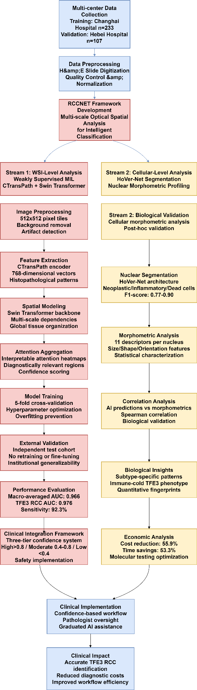

Figure S2. Multi-scale visualization of RCCNET's whole-slide image analysis and patch-based classification performance across RCC subtypes
Systematic demonstration of the model's ability to perform accurate subtype classification at both global and local scales. Each row represents a representative case from one of the four RCC subtypes, displaying the complete analytical workflow from whole-slide overview to high-confidence diagnostic patches.
(A, E, I, M) Original H&E-stained whole-slide images at low magnification showing overall tumor architecture (B, F, J, N) Patch-level classification maps where each small patch within the WSI is color-coded according to predicted subtype (salmon = TFE3 RCC, green = ccRCC, blue = pRCC, purple = chRCC) (C, G, K, O) Attention heatmaps displaying model focus intensity (color scale: blue = low attention, red = high attention) across the tissue, highlighting diagnostically relevant regions (D, H, L, P) Eight representative high-confidence diagnostic patches (prediction probability >90%) showing characteristic morphological features at 400× magnification
(A-D) TFE3 RCC cases: Four representative TFE3-rearranged RCC cases demonstrating consistent classification (salmon color coding) across diverse morphological presentations. Attention maps appropriately focus on regions with characteristic voluminous eosinophilic cytoplasm and nested growth patterns. High-confidence patches display the diagnostic features including prominent nucleoli and distinctive cellular architecture. (E-H) Clear cell RCC cases: Four clear cell RCC cases showing accurate classification (green color coding) across varying tumor grades and growth patterns. Attention is concentrated on areas with pathognomonic clear cytoplasm and delicate vascular networks. Selected high-confidence patches demonstrate the classic clear cell morphology with distinct cell borders. (I-L) Papillary RCC cases: Four papillary RCC cases with correct classification (blue color coding) and attention appropriately focused on papillary and tubulopapillary architectural patterns. High-confidence patches showcase the characteristic fibrovascular cores and papillary growth patterns that define this subtype. (M-P) Chromophobe RCC cases: Four chromophobe RCC cases with accurate classification (purple color coding) and attention highlighting distinctive morphological features. High-confidence patches display the pathognomonic plant cell-like borders, perinuclear halos, and uniform cellular morphology characteristic of chromophobe RCC.
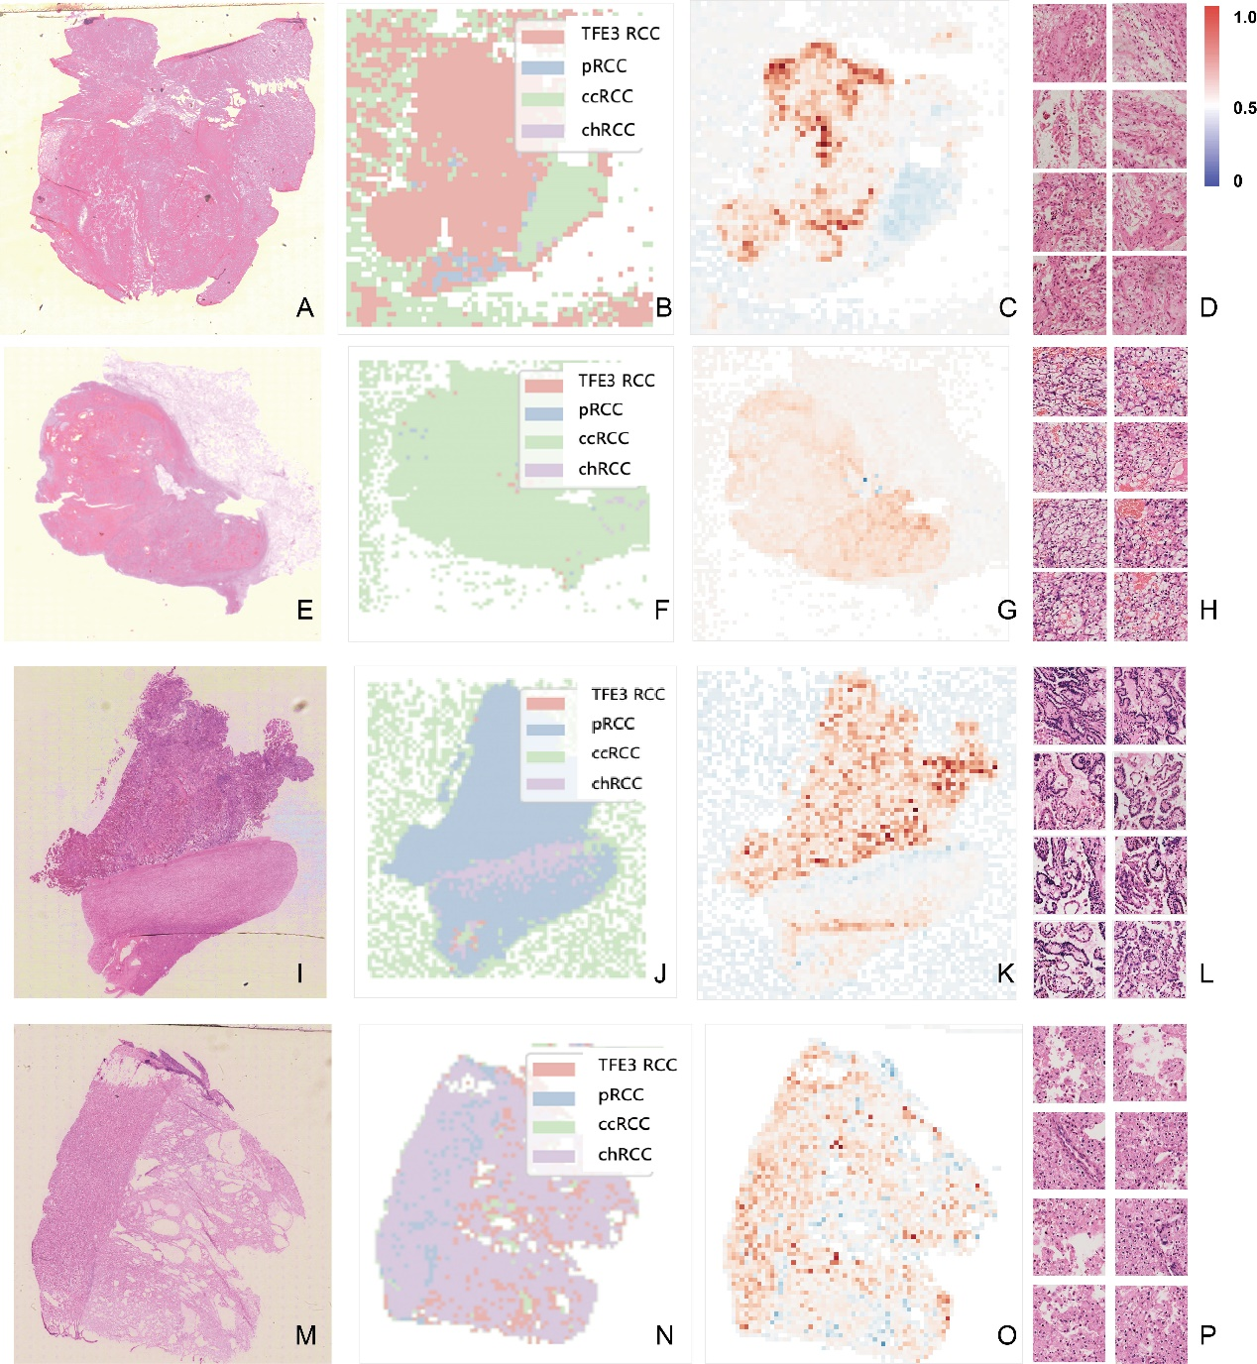

Figure S3. Morphometric Characteristics Across RCC Subtypes.
(A) Nuclear Area Distribution. Violin plots showing the distribution of nuclear area (μm²) across four RCC subtypes. Data are presented on a logarithmic scale to accommodate the wide range of values. Clear cell RCC demonstrates the largest nuclear areas with high variability (median: 146.4 μm², IQR: 85.9-225.4), while chromophobe RCC shows the smallest and most uniform nuclear areas (median: 83.4 μm², IQR: 63.8-105.8). Papillary RCC (median: 132.4 μm²) and TFE3 RCC (median: 138.2 μm²) exhibit intermediate values. Kruskal-Wallis test indicates significant differences among subtypes (p<0.001).
(B) Nuclear Roundness Distribution. Density histograms illustrating the distribution of nuclear roundness (0 = elongated, 1 = perfectly circular) for each RCC subtype. Chromophobe RCC exhibits the highest roundness values (mean: 0.815 ± 0.065), consistent with their characteristic round nuclear morphology. Clear cell RCC shows a bimodal distribution (mean: 0.746 ± 0.129), reflecting morphological heterogeneity within this subtype. Papillary RCC demonstrates lower roundness values (mean: 0.711 ± 0.100), corresponding to their typically elongated nuclear shape. TFE3 RCC shows intermediate roundness (mean: 0.735 ± 0.110).
(C) Nuclear Eccentricity by Subtype. Box plots displaying nuclear eccentricity values (0 = circular, approaching 1 = highly elongated) across RCC subtypes. Papillary RCC exhibits the highest eccentricity (mean: 0.648 ± 0.117), reflecting their characteristic elongated nuclear morphology. Chromophobe RCC shows the lowest eccentricity (mean: 0.370 ± 0.072), consistent with their round nuclear appearance. Clear cell RCC (mean: 0.477 ± 0.143) and TFE3 RCC (mean: 0.497 ± 0.154) demonstrate intermediate values with higher variability. ANOVA reveals significant differences among subtypes (p<0.001).
(D) Cellular Compartment Composition. Stacked bar chart showing the relative proportions of cellular compartments within tumor regions for each RCC subtype, based on automated cell segmentation and classification. Inflammatory cells constitute the predominant component across all subtypes (74.1-81.2%), with papillary RCC showing the highest inflammatory cell proportion (81.2%). Neoplastic cells represent 12.5-15.7% of the cellular population, with chromophobe RCC demonstrating the highest proportion (15.7%). Dead cell percentages range from 6.3% (papillary RCC) to 10.2% (chromophobe RCC). Kruskal-Wallis test indicates significant differences in inflammatory cell proportions among subtypes (p=0.012).

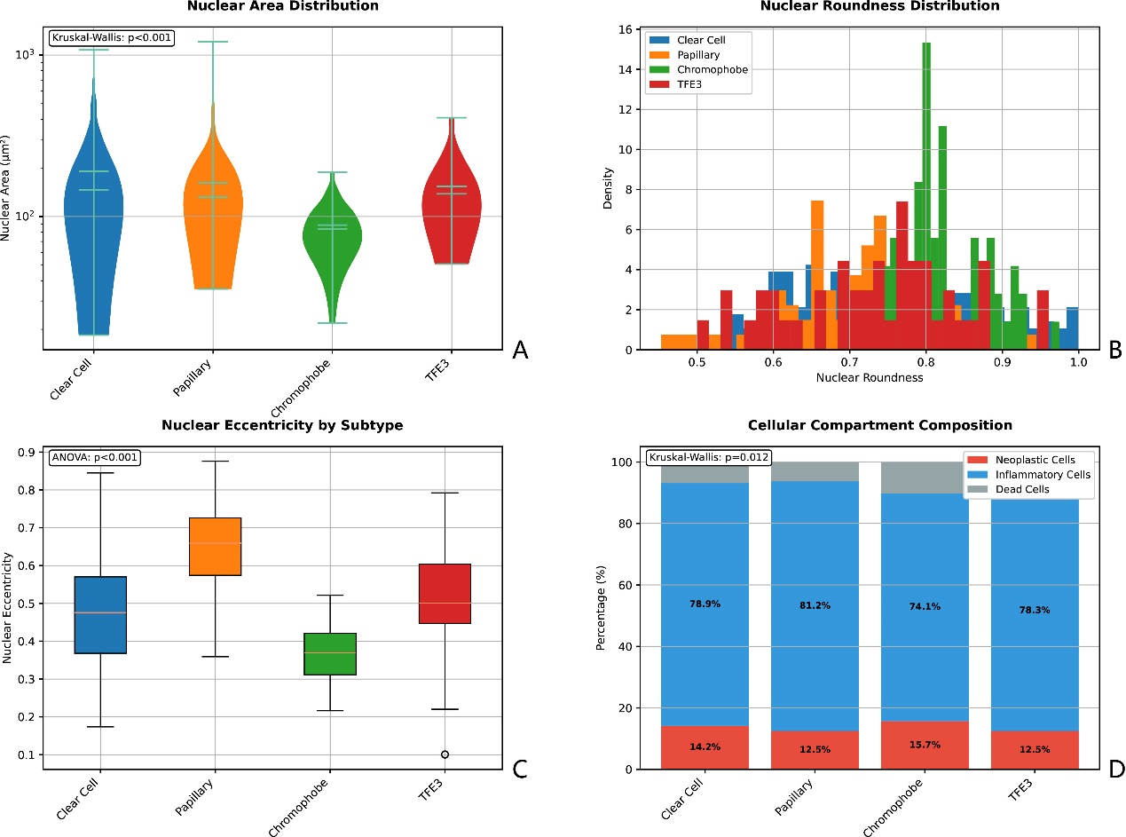
Figure S4. Correlation Between AI Predictions and Cellular Morphometric Features Across RCC Subtypes
(A-D) Spearman correlation coefficients between subtype-specific prediction probabilities and the top 15 most significantly correlated cellular morphometric features for each RCC subtype. (A) Papillary RCC demonstrates strongest correlations with neoplastic cell shape descriptors, particularly roundness and eccentricity features (r=-0.509 to 0.445), reflecting the elongated cellular morphology characteristic of papillary architecture. (B) TFE3-rearranged RCC shows negative correlations with inflammatory cell features (r=-0.270), supporting the relatively "immune-cold" phenotype of this subtype. (C) Clear cell RCC exhibits strong correlations with neoplastic cell eccentricity and morphological heterogeneity measures (r=0.515), indicating high morphological variability. (D) Chromophobe RCC correlates most strongly with neoplastic cell perimeter and structural features (r=-0.472), reflecting the uniform cell size and distinctive borders typical of this subtype.
Feature nomenclature: Neo = Neoplastic cells, Inf = Inflammatory cells, Dead = Dead cells; statistical descriptors include Mean, Std = Standard deviation, Skew = Skewness, Kurt = Kurtosis, Entr = Entropy. Significance levels: * p<0.05, ** p<0.01, *** p<0.001. All correlations shown achieved statistical significance (p<0.05) after Bonferroni correction for multiple comparisons (α=0.0003).
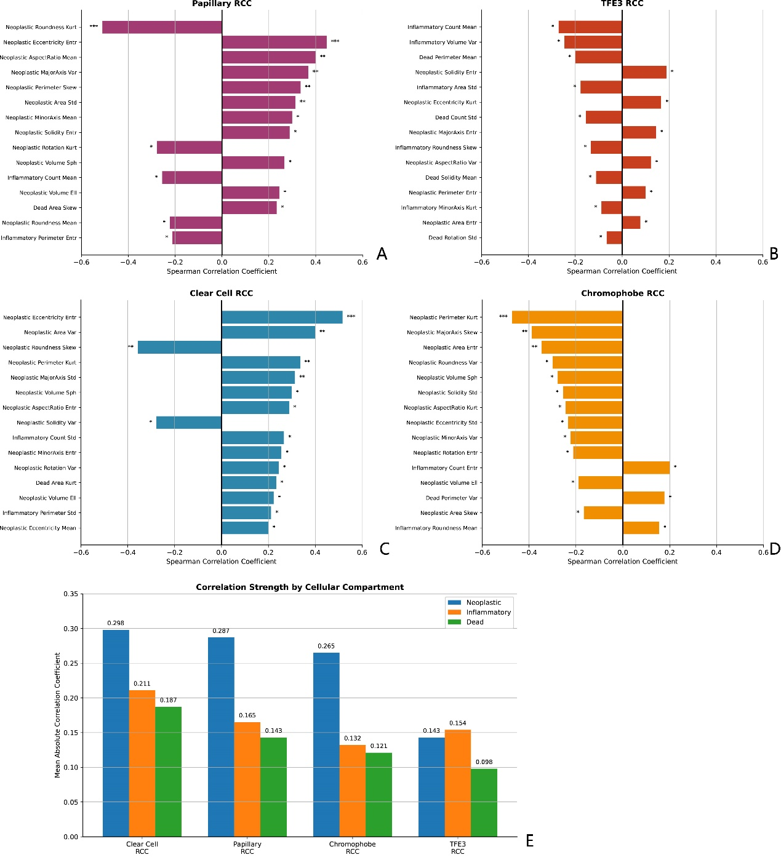
(E) Mean absolute correlation coefficients between AI prediction probabilities and cellular morphometric features, stratified by cellular compartment (neoplastic, inflammatory, and dead cells) across the four RCC subtypes. Clear cell RCC demonstrates the highest overall correlation strength across all cellular compartments (mean correlation 0.298), while TFE3-rearranged RCC shows the most balanced but weakest correlations (mean correlation 0.143). Neoplastic cell features consistently show the strongest correlations across all subtypes (range: 0.143-0.298), validating that primary diagnostic features reside in tumor cells themselves. The relatively high inflammatory cell correlations in Clear Cell RCC (0.211) compared to other subtypes reflect the known immune-infiltrated nature of clear cell tumors. Error bars represent standard error of the mean.
.

Figure S5. Supplementary Figure S5. Quantitative Morphometric Feature Profiles Across Renal Cell Carcinoma Subtypes Supporting Biological Interpretability.
This comprehensive figure presents the quantitative morphometric characteristics of four renal cell carcinoma (RCC) subtypes – Chromophobe RCC (first row, panels A, E, I, M), Papillary RCC (second row, panels B, F, J, N), Clear Cell RCC (third row, panels C, G, K, O), and TFE3 RCC (fourth row, panels D, H, L, P) – demonstrating the measurable histopathological basis for RCCNET's classification decisions. Each column highlights specific groups of morphometric features, providing empirical evidence for the model's interpretability and alignment with established pathology.
(A) Nuclear Perimeter Kurtosis and Major Axis Skewness. This column quantifies nuclear boundary complexity and elongation asymmetry across subtypes. For Chromophobe RCC (A), the distinctively low Perimeter Kurtosis (-3.9719) and Major Axis Skewness (-0.7839) reflect its characteristic uniform cell size and often rounded, well-defined nuclear borders. In contrast, Papillary RCC (B, Perimeter Kurtosis: -3.2431; Major Axis Skewness: 0.7220) and TFE3 RCC (D, Perimeter Kurtosis: -3.1144; Major Axis Skewness: 0.7141) exhibit higher (less negative for kurtosis, positive for skewness) values, indicating more varied and sometimes elongated or asymmetrically shaped nuclei, consistent with their morphological heterogeneity. Clear Cell RCC (C, Perimeter Kurtosis: -3.0978; Major Axis Skewness: 0.4079) shows intermediate values, reflecting its diverse nuclear morphology.
(B) Nuclear Roundness Kurtosis and Eccentricity Entropy. This column details the distribution characteristics of nuclear roundness and eccentricity, capturing deviations from perfect circularity and variability in elongation. For
Papillary RCC (F), the highest Eccentricity Entropy (2.1515) and a notably lower Roundness Kurtosis (-3.2899) are observed, a quantitative signature highly consistent with its elongated cellular morphology and complex architectural patterns.
Clear Cell RCC (G) shows a relatively high Eccentricity Entropy (1.9972), reflecting its known morphological heterogeneity where nuclei can vary in shape. Conversely, Chromophobe RCC (E, Eccentricity Entropy: 1.8990; Roundness Kurtosis: -3.1414) and TFE3 RCC (H, Eccentricity Entropy: 1.8847; Roundness Kurtosis: -3.1333) demonstrate comparatively lower eccentricity entropy and higher roundness kurtosis, suggesting more uniform nuclear eccentricity and shape within these subtypes.
(C) Nuclear Eccentricity Entropy and Area Standard Deviation (Std). This column further explores nuclear elongation variability and the dispersion of nuclear size. Clear Cell RCC (K) demonstrates the highest nuclear Area Std (99.2170), indicating significant inherent variability in nuclear size, a hallmark of its morphological heterogeneity and pleomorphism. Its relatively high Eccentricity Entropy (2.1004) further supports this morphological diversity. Papillary RCC (J, Area Std: 90.7855; Eccentricity Entropy: 2.0541) also shows considerable variability, consistent with its architectural complexity. Chromophobe RCC (I, Area Std: 81.1826; Eccentricity Entropy: 1.8990) and TFE3 RCC (L, Area Std: 71.6397; Eccentricity Entropy: 1.9428) exhibit lower nuclear area standard deviations and relatively more uniform eccentricity.
(D) Inflammatory Cell Count and Volume Standard Deviation (Std). This column quantifies the presence of inflammatory cells and their nuclear volume variability within the tumor microenvironment.
TFE3 RCC (P) shows a remarkably low Inflammatory Cell Count (29) and nuclear Volume Std (472.0972) compared to other subtypes, providing strong quantitative support for its described "immune-cold" phenotype. In contrast,
Clear Cell RCC (O) has the highest Inflammatory Cell Count (166) and nuclear Volume Std (623.6100), aligning with its typically more immune-infiltrated tumor microenvironment.
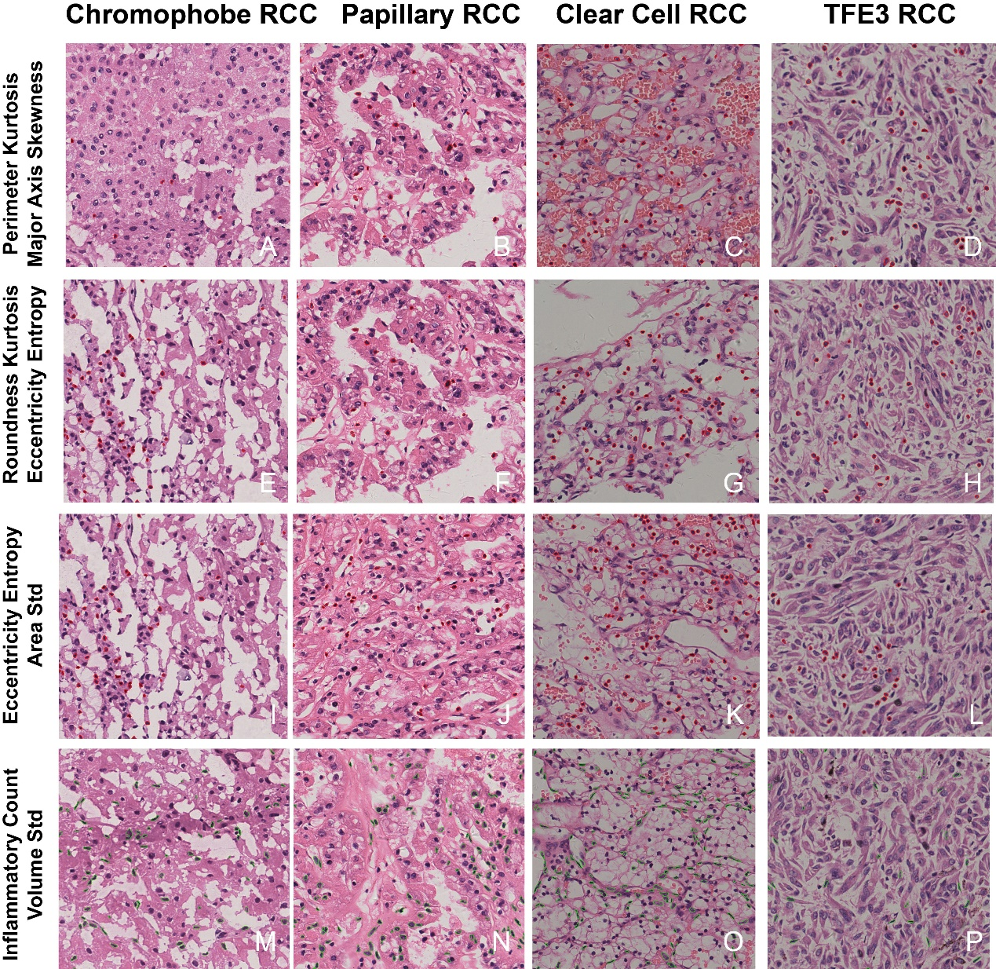
Papillary RCC (N, Inflammatory Cell Count: 131; Volume Std: 614.8246) and Chromophobe RCC (M, Inflammatory Cell Count: 84; Volume Std: 584.3960) present intermediate inflammatory and volume variability profiles. Collectively, these distinct quantitative morphometric profiles across RCC subtypes provide compelling evidence that RCCNET's classification decisions are rooted in a deep, measurable understanding of subtle, yet diagnostically critical, cellular and microenvironmental features, enhancing its clinical interpretability.

Figure S6. Comprehensive Analysis of RCCNET Misclassification Patterns and Clinical Integration Strategy
(A) Misclassification Patterns. Heat map showing the distribution of 16 misclassified cases across RCC subtypes in the validation cohort (n=107). The most frequent misclassification pattern was Clear Cell RCC misidentified as TFE3-rearranged RCC (6 cases, 37.5% of all errors), reflecting known morphological overlap in cases with clear cell features. Other significant patterns included Papillary RCC misclassified as Clear Cell RCC (3 cases), Clear Cell RCC misclassified as Papillary RCC (2 cases), Papillary RCC misclassified as TFE3 RCC (2 cases), Chromophobe RCC misclassified as Clear Cell RCC (2 cases), and TFE3 RCC misclassified as Clear Cell RCC (1 case). Numbers within cells indicate the count of misclassified cases. The diagonal (correct classifications) is masked to highlight error patterns. Total misclassification rate: 15.0% (16/107 cases). (B) Confidence Score Distribution. Violin plots comparing confidence scores between correctly classified cases (n=91, 85.0%) and misclassified cases (n=16, 15.0%). Correctly classified cases demonstrated significantly higher mean confidence scores (0.89 ± 0.12) compared to misclassified cases (0.56 ± 0.14, p<0.001, Student's t-test). The violin plots show the full distribution of confidence scores, with wider sections indicating higher density of cases at that confidence level. This intrinsic ability to identify challenging cases through confidence scoring enables safe clinical integration. Statistical significance: *** p<0.001. (C) Three-Tier Clinical Integration Framework. Dual-axis visualization showing the distribution of validation cases (blue bars, left y-axis) and corresponding accuracy rates (red line, right y-axis) across confidence tiers. High confidence cases (>0.8) comprise 80 cases (74.8%) with 95.0% accuracy, suitable for minimal pathologist review. Moderate confidence cases (0.4-0.8) represent 22 cases (20.6%) with 81.8% accuracy, requiring guided pathologist review with AI assistance. Low confidence cases (<0.4) account for 5 cases (4.7%) with 60.0% accuracy, necessitating traditional diagnostic workflow with molecular testing as clinically indicated. This stratification optimizes both diagnostic accuracy and resource utilization. (D) Misclassified Case Characteristics. Comparative analysis of clinical and pathological features between misclassified cases (red bars, n=16) and the overall validation cohort (blue bars, n=107). Misclassified cases showed higher frequencies of challenging morphological features including Stage I disease (87.5% vs 65.4%), tumor necrosis (56.3% vs 35.5%), clear cell features (75.0% vs 45.8%), mixed morphology (68.8% vs 25.2%), and high-grade features (43.8% vs 28.0%). These patterns align with known diagnostic challenges in RCC subtype classification and validate the model's difficulty with morphologically ambiguous cases. (E) Confidence-Outcome Analysis. Improved visualization: Overlapping histograms showing the distribution of confidence scores for correctly classified cases (blue, n=91) versus misclassified cases (red, n=16). The clear separation between distributions demonstrates that confidence scores effectively discriminate between correct and incorrect predictions. Dashed vertical lines indicate mean confidence scores for each group (correct: 0.89, misclassified: 0.56). Dotted vertical lines mark the clinical decision thresholds (0.8 for high confidence, 0.4 for low confidence) used in the three-tier framework. Statistical analysis reveals a large effect size (Cohen's d=2.1) and highly significant difference (p<0.001, t-test), confirming that confidence scores provide reliable indicators of prediction quality. This analysis directly supports the confidence-based clinical integration strategy by demonstrating that lower confidence scores reliably identify cases at higher risk of misclassification. (F) Clinical Decision Workflow. Flowchart illustrating the proposed clinical integration pathway for RCCNET implementation. Initial AI predictions are stratified by confidence score into three tiers, each with appropriate clinical response protocols. High confidence predictions (74.8% of cases) proceed with minimal review and routine report generation, moderate confidence cases (20.6%) are flagged for guided pathologist evaluation with AI assistance, and low confidence cases (4.7%) are routed to traditional diagnostic workflows including molecular testing when clinically indicated. This graduated approach ensures patient safety while maximizing efficiency gains through appropriate resource allocation.
