Supplementary Material A. Method Details

1. CRITIC-TOPSIS
The Criteria Importance Through Intercriteria Correlation (CRITIC) approach is an objective weighting technique for determining indicator weights rooted in multi-indicator datasets (Diakoulaki et al., 1995). This technique accounts for both the standalone volatility of each metric and their systemic interdependencies, resulting in more objective and realistic weight assignments. Additionally, Similarly, Technique for Order of Preference by Similarity to Ideal Solution (TOPSIS) is a multicriteria decision-making framework which leverages variations within indicator datasets (Chen, 2021). It preserves the original information of the data while enabling precise and objective comparisons among evaluated entities. To improve the evaluation framework, the CRITIC and TOPSIS are combined to compute the score of UR and US. This integrated approach is further enhanced by incorporating a time dimension across different years, allowing for more accurate and comprehensive assessments. Let $X_{aij}$ be the $j$ index of the $i$ city in the year $a$, where $a ∈ \left\{1,…,n\right\}$, $i∈\left\{1,…,s\right\}$, $j∈\left\{1,…,m\right\}$, with $n, s, m ∈ N$denoting the overall counts of cities, years, and indicators. The detailed calculation steps are shown in Figure S1.
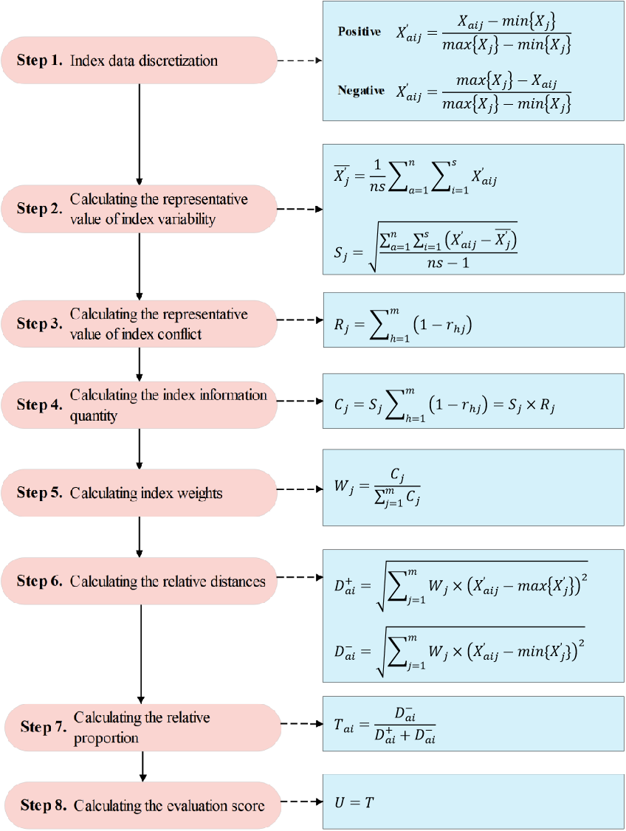
Figure S1. Calculation steps of the CRITIC-TOPSIS model.

2. Coupling coordination degree
To assess the coordinated development between UR and US, this study adopts the coupling coordination model. As outlined by (Li et al., 2012), the model includes two aspects: coupling degree, which quantifies the interaction strength among systems (Tomal, 2021), and coordination degree, which gauges the harmonization level in their development (Tian et al., 2020). A higher coupling degree implies more robust interactions, while a higher coordination degree indicates superior synchronization.
3.3.1 Coupling degree calculation
Previous research has demonstrated that conventional methods for computing coupling degree tend to produce clustered results, which significantly diminishes their reliability. To handle the limitation, this study adopts the improved approach developed by Wang et al. (2021). To optimize the calculation procedure and enhance the validness of the coupling degree, this analysis focuses on exploring the coupling relationship between UR and US. The formula is presented below:
$C=\sqrt{\left[(1-\sqrt{(U_{2}-U_{1})^{2}})×\frac{U_{1}}{U_{2}}\right]}$.
3.3.2 Coordination degree calculation
The coordination degree is based on coupling degree calculations, with the detailed steps are outlined below:
First, calculate the UR and US system harmonic index using the following formula:
$T=αU_{r}+βU_{s}$,
where $T$ represents the urban system harmonic index, with $U_{r}$ (UR score) and $U_{s}$ (urban smartification score) as key variables, and $α$ and $β$ as corresponding weighting coefficients. Considering the equal importance of UR and smartification, this study sets $α=β=0.5$.
Second, calculate the UR and US system’s coordination degree applying the subsequent formula:
$D=\sqrt{C×T}$,
where $D$ represents the coordination degree, $C$ represents the coupling degree, and $T$ represents the harmonic index. Following the research framework of (Liu et al., 2020), this study categories the coordination degree into 10 types and 3 development stages, with the differences in coordination effects across stages listed in Table S1.
Table S1. Coordination types and stages.
Range of D value | Type | Stage | Features
$$0≤D≤0.1$$ | Extreme disorder | Disorder stage | Substantial disparities exist in the degrees of UR and US, leading to ineffective coordinated development of the urban system.
$$0.1<D≤0.2$$ | Serious disorder | Disorder stage
$$0.2<D≤0.3$$ | Moderate disorder | Disorder stage
$$0.3<D≤0.4$$ | Mild disorder | Disorder stage
$$0.4<D≤0.5$$ | Verge of disorder | Transition stage | Notable discrepancies in UR and US remain apparent, with the urban system potentially gravitating toward either disequilibrium or harmonious development at any juncture.
$$0.5<D≤0.6$$ | Bare coordination | Transition stage
$$0.6<D≤0.7$$ | Primary coordination | Coordination stage | Minimal variations exist in the UR and US levels, enabling efficient coordination of the urban system.
$$0.7<D≤0.8$$ | Moderate coordination | Coordination stage
$$0.8<D≤0.9$$ | High coordination | Coordination stage
$$0.9<D≤1$$ | Excellent coordination | Coordination stage

3. Relative development index
Following Han et al.'s (2023) methodology, we utilize the relative development model to evaluate multi-systems’ relative developmental effects. The following formula calculates the relative development index (RDI):
$RDI=\frac{U_{r}}{U_{s}}$,
where $RDI$ stands for the relative development index, $U_{r}$ denotes the resilience score and $U_{s}$ denotes US score. Three distinct phases emerge: $R<0.8$ indicates UR lag; $0.8≤R≤1.2$ shows synchronization; $R>1.2$ suggests US lag.

4. Obstacle degree model
The Obstacle Degree Model (ODM) serves as an analytical framework for identifying developmental constraints through three core components: factor contribution, indicator deviation, and obstacle magnitude. This methodology has gained widespread adoption for pinpointing critical factors influencing system coordination(Qu et al., 2024). The model's computational framework comprises:
$O_{j} =\frac{F_{j}I_{j}}{\sum_{j=1}^{n}{F_{j}I_{j}}} × 100\%$,
$I_{j} = 1 - Y_{j}$,
where $O_{j}$ quantifies the obstacle degree for each indicator within the UR and US system, with $n$ representing total indicator count, $F_{j}$ represents each indicator's contribution to the UR and US system, $I_{j}$ denotes deviation degree reflecting the disparity between actual and ideal values and $Y_{j}$ is standardized indicator values.

5. Panel regression analysis
Based on ODM analysis results, this study identifies crucial factors impacting system coordination. Following Huang et al.'s (2024) framework, we construct a panel data model to explore the mechanisms underlying coordinated development of UR and US. The baseline specification is expressed as:
$D_{it} = C + α_{i}X_{it} + ε_{it}$,
where $D_{it}$ stands for the CCD of city $i$ in year $t$; $p$ denotes the constant, $α_{i}$ indicates the regression coefficient, $X_{it}$ is the influencing factors, and $ε_{it}$denotes the random error term.

Supplementary Material B. Basic information about the research area
Table S2. Basic information about the research area
City | Abbr. | Population (Ten thousand) | Administrative Area (km2 ) | Per capita GDP (yuan) | Type of city
Beijing | BJ | 2189 | 16411 | 87475 | megacity
Chengdu | CD | 1417.78 | 12121 | 57624 | megacity
Chongqing | CQ | 3209 | 82374 | 38914 | megacity
Guangzhou | GZ | 1283.89 | 7434 | 105909 | megacity
Shanghai | SH | 2488 | 6340 | 85373 | megacity
Shenzhen | SZ | 1195.85 | 1997 | 123247 | megacity
Tianjin | TJ | 1387 | 11760 | 93173 | megacity
Changsha | CS | 714.66 | 11816 | 89903 | supercity
Dalian | DL | 689.2 | 12574 | 102922 | supercity
Dongguan | DG | 829.23 | 2460 | 58804 | supercity
Foshan | FS | 726.18 | 3798 | 91259 | supercity
Hangzhou | HZ | 880.2 | 16571 | 88962 | supercity
Harbin | HB | 1064.2 | 53068 | 45810 | supercity
Jinan | JN | 694.96 | 8177 | 69444 | supercity
Kunming | KM | 860 | 21012 | 46256 | supercity
Nanjing | NJ | 816.1 | 6587 | 88525 | supercity
Qingdao | QD | 903.2 | 11282 | 82680 | supercity
Shenyang | SY | 822.8 | 12980 | 80480 | supercity
Wuhan | WH | 1012 | 8494 | 79482 | supercity
Xi'an | XA | 914 | 10108 | 51166 | supercity
Zhengzhou | ZZ | 903.1 | 7446 | 62054 | supercity
Changchun | CC | 910.42 | 20604 | 58691 | large city
Changzhou | CZ | 468.68 | 4372 | 85039 | large city
Fuzhou | FZ | 747 | 13066 | 58304 | large city
Guiyang | GY | 445.17 | 8034 | 38447 | large city
Hefei | HF | 757.2 | 11445 | 55186 | large city
Nanchang | NC | 513.2 | 7402 | 58715 | large city
Nanning | NN | 679.08 | 22244 | 35133 | large city
Ningbo | NB | 763.9 | 9816 | 86228 | large city
Shijiazhuang | SJZ | 1038.6 | 15848 | 43552 | large city
Suzhou | SU | 1054.91 | 8488 | 114029 | large city
Taiyuan | TY | 425.63 | 6977 | 54440 | large city
Urumqi | UR | 335 | 13788 | 59645 | large city
Wuxi | WX | 646.55 | 4627 | 117357 | large city
Xiamen | XM | 367 | 1573 | 77392 | large city
Supplementary Material C. Results of panel regression model
Table S3. Results of panel regression model.
Variables | All |  |  | Supercity
Variables | OLS | FE | FE_robust | OLS | FE | FE_robust
InR1 | 0.00080** | 0.00266*** | 0.00266*** | 0.00232*** | 0.00248*** | 0.00248***
log_SEn3 | 0.02102*** | 0.02799*** | 0.02799*** | 0.02579*** | 0.01647 | 0.01647
log_SP2 | -0.01706*** | 0.04617** | 0.04617* | -0.04106*** | 0.04924 | 0.04924
log_SG1 | 0.06768*** | 0.05531*** | 0.05531*** | 0.03497*** | 0.03272*** | 0.03272**
SR1 | 0.00069** | 0.00079** | 0.00079** | 0.00137*** | 0.00206*** | 0.00206**
SR2 | -0.11463*** | -0.45934*** | -0.45934*** | -0.21454*** | -0.42778*** | -0.42778***
log_SEc2 | -0.00423** | -0.00288 | -0.00288 | -0.01905*** | -0.01661** | -0.01661*
log_SI2 | 0.02188*** | 0.02519*** | 0.02519*** | 0.00741 | 0.00577 | 0.00577
log_SP1 | 0.00769*** | 0.00892** | 0.00892** | 0.02007*** | 0.01217*** | 0.01217***
const | 0.12486*** | -0.25444*** | -0.25444*** | 0.48049*** | 0.18032 | 0.18032
R-square | 0.7183 | 0.7518 | 0.7518 | 0.7766 | 0.6079 | 0.6079
N | 442 | 442 | 442 | 91 | 91 | 91
Variables | Megacity |  |  | Large City
Variables | OLS | FE | FE_robust | OLS | FE | FE_robust
InR1 | 0.00024 | 0.00335*** | 0.00335*** | -0.00003 | 0.00070 | 0.00070
log_SEn3 | 0.01408** | 0.03823*** | 0.03823** | 0.02802** | 0.04659*** | 0.04659***
log_SP2 | -0.00840 | -0.14604*** | -0.14604*** | -0.00718 | 0.15696*** | 0.15696***
log_SG1 | 0.05891*** | 0.03593*** | 0.03593*** | 0.07518*** | 0.06870*** | 0.06870***
SR1 | 0.00016 | 0.00157** | 0.00157*** | -0.00078 | 0.00072 | 0.00072
SR2 | -0.14147 | 1.59966*** | 1.59966*** | 0.18713 | -2.21074*** | -2.21074***
log_SEc2 | 0.00370 | 0.00533 | 0.00533 | -0.01082*** | -0.01290*** | -0.01290***
log_SI2 | 0.03313*** | 0.06270*** | 0.06270*** | 0.02129*** | 0.01156 | 0.01156
log_SP1 | 0.00110 | 0.02056*** | 0.02056*** | 0.00706 | 0.00326 | 0.00326
const | 0.10147 | 0.09731 | 0.09731 | 0.07426 | -0.59328*** | -0.59328***
R-square | 0.6527 | 0.8045 | 0.8045 | 0.7819 | 0.8786 | 0.8786
N | 182 | 182 | 182 | 169 | 169 | 169
***, **, and * denote statistical significance at the 1%, 5%, and 10% levels

