Appendix A Instruments installed at study sites.
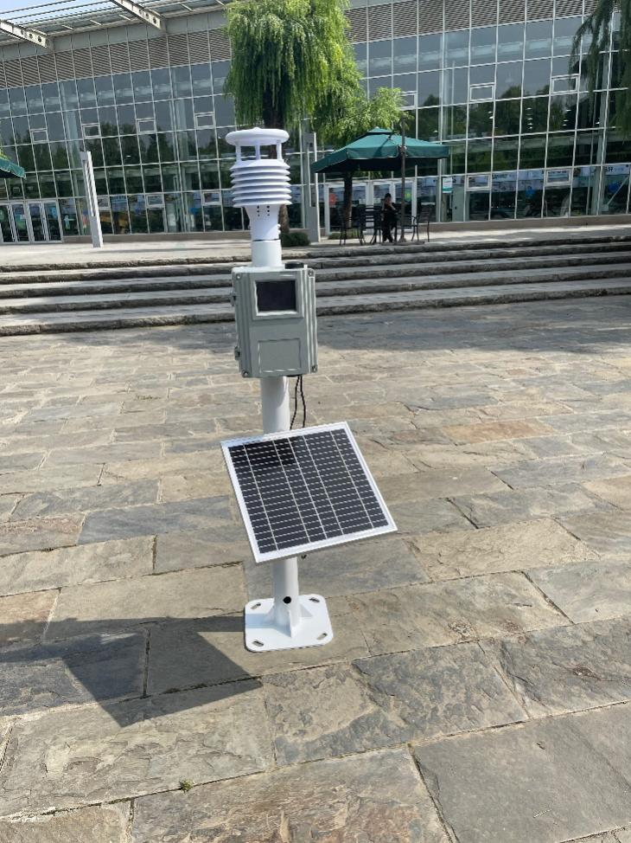
Appendix B Simplified garment checklist.
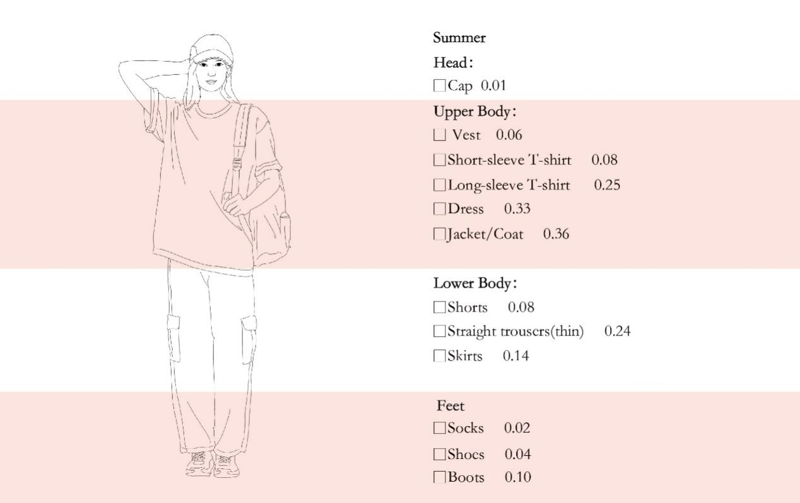

Appendix C Thermal comfort questionnaire (English translation from the original Chinese).
