Supplemental information

Climate change dominates variations in water fluxes and availability than tree restoration and their interactions

Qing Yang^{1,2}, Congyu Hou^{3#}, Gengyuan Liu^{4,5,*}, Ginevra Virginia Lombardi⁶, Jian Zhao³, Zhifeng Yang^{2,7*}
¹ Advanced Interdisciplinary Institute of Environment and Ecology, Guangdong Provincial Key Laboratory of Wastewater Information Analysis and Early Warning, Beijing Normal University, Zhuhai 519087, China
² Key Laboratory for City Cluster Environmental Safety and Green Development of the Ministry of Education, School of Ecology, Environment and Resources, Guangdong University of Technology, Guangzhou, 510006, China
³ Chinese Research Academy of Environmental Sciences, Beijing 100012, China
⁴ State Key Laboratory of Regional Environment and Sustainability, School of Environment, Beijing Normal University, Beijing, 100875, China
⁵ Institute of Hainan National Park, Haikou 570228, China
⁶ Department of Economies and Management, University of Firenze, Via delle Pandette 9, Firenze, 50127, Italy
⁷ Southern Marine Science and Engineering Guangdong Laboratory (Guangzhou), Guangzhou, 511458, China

S1: Utrack dataset for moisture recycling
Utrack dataset for moisture recycling is a dataset of global atmospheric moisture connections from evaporation to precipitation provided by Tuinenburg et al. (2020). The data in the dataset means the percentage of how much precipitation in target cell are from the evapotranspiration from source cell, and this model is demonstrated by Fig. S1. Therefore, by multiplying the percentage provide by this dataset and the increased evaporation from tree cover, we can obtain the increased precipitation after tree cover. It has both 0.5◦ and 1.0◦ spatial resolution and the specific data is availability at https://doi.org/10.1594/PANGAEA.912710.

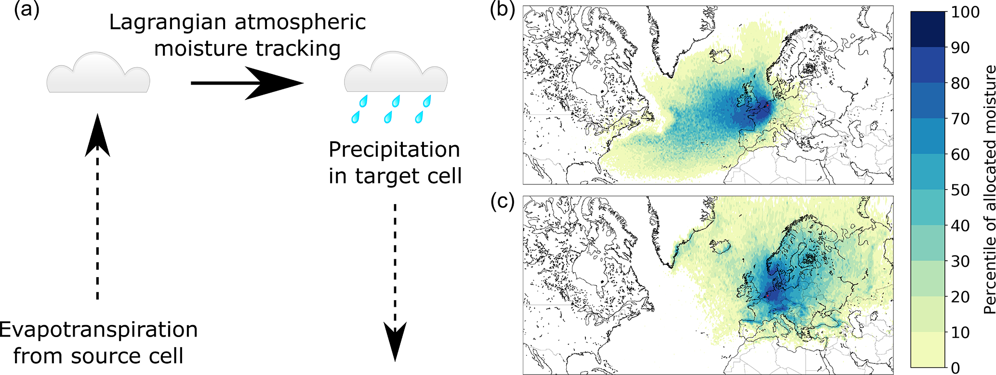
Fig. S1 The UTrack atmospheric moisture tracking model. (a) The model tracks evaporation through the atmosphere from source cells to target cells using a Lagrangian moisture tracking scheme forced with ERA5 reanalysis data. (b) An example of an “evaporation footprint”, or “evaporation shed”, from the UTrack model. (c) An example of a “precipitation footprint”, or “precipitation shed”. The examples show the distribution of reprecipitation for evaporated water from Utrecht (the Netherlands) during 2008–2017 (b) and the distribution of the city’s source of precipitation (c), given as percentages of allocated moisture. This figure and the explanation are derived from Tuinenburg et al. (2020).

S2: Figures
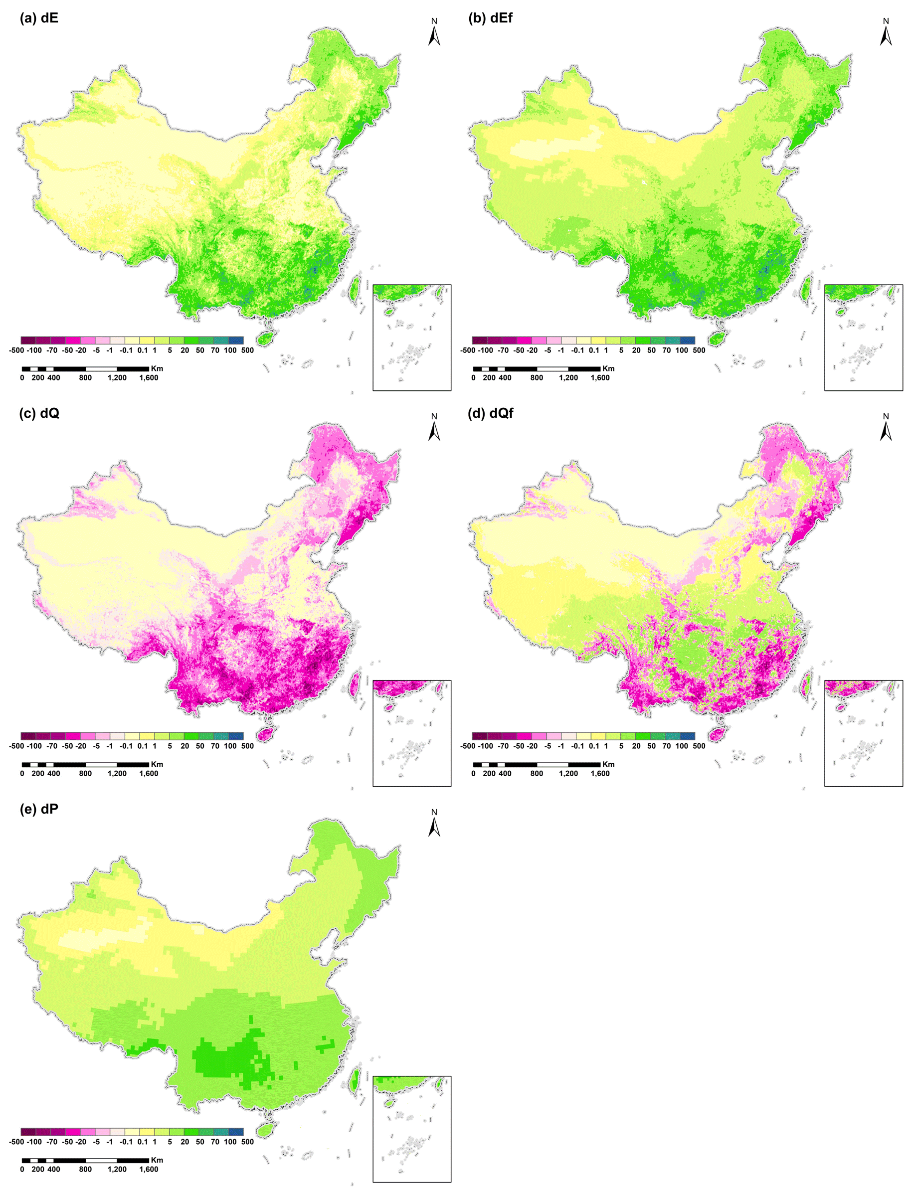
Fig. S2 Changes in evaporation (E), precipitation (P) and streamflow (Q) due to global tree restoration potential conducted by Hoek van Dijke et al. (2022). (a) dE and (c) dQ: ΔE and ΔQ excluding atmospheric moisture cycling, respectively; (b) dE, (d) dQ and (e) dP: ΔE, ΔQ and ΔQ including atmospheric moisture cycling.

S3: Budyko-models selection
Six Budyko-models was used to calculate the impacts of tree restoration on evaporation (E) and streamflow (Q) from precipitation (P) and potential evaporation (E₀) at global scales as listed in Table S1 (Hoek van Dijke et al., 2022). This study selects Budyko model 1, 2 and 4 applying in China’s case because these three models calibrated by the data collected from the region including China.
For each Budyko model, the E and Q before and after tree cover are calculated as follows:
$E=E_{trees}×TC+E_{grass}×NTC$ (S1)
$Q=Q_{trees}×TC+Q_{grass}×NTC$ (S2)
$NTC=1-TC$ (S3)
Where, $E_{trees}$ and $Q_{trees}$ are used to calculate E and Q for trees (unit: mm·yr^{–1}); $TC$ refers to tree cover; $E_{grass}$ and $Q_{grass}$ are used to calculate E and Q for grass (unit: mm·yr^{–1}); $NTC$ means no tree cover, including bare land, shrubland and built-up land. Evaporation from land use types is different from that of grassland and cropland. These differences are assumed negligible because the E for bare land is close to zero, and built-up land has a limited extend, and the Budyko vegetation parameters for shrubland are close to parameters for grassland and cropland (Oudin et al., 2008; Zhou et al., 2015). These calculation methods for E and Q are from Hoek van Dijke et al. (2022).

Table S1 The six Budyko-models that are used to calculate evaporation (E) and streamflow (Q) from precipitation (P) and potential evaporation (E0). Streamflow Q is calculated as: Q/P = 1 – E/P
Model | Equation | Calibrated ω | Descriptions
1 | $$\frac{E}{P}=\frac{1+ω\frac{E_{0}}{P}}{1+ω\frac{E_{0}}{P}+\frac{P}{E_{0}}}$$ | $ω_{grass}$=0.5  $ω_{trees}$=2 | Model developed and calibrated by Zhang et al. (2001). Calibrated using 240 global river basins. $ω_{trees}$ is calculated using natural and plantations data, and $ω_{grass}$ is calibrated using grassland and cropland data.
2 | $$\frac{E}{P}=\frac{1+ω\frac{E_{z}}{P}}{1+ω\frac{E_{z}}{P}+\frac{P}{E_{z}}}$$ | $ω_{grass}$=0.5  $ω_{trees}$=2 | As model 1. E₀ is also calibrated (E_{z}). E_{z, grass}=1100, E_{z, trees}=1410
3 | $$\frac{E}{P}=1+\frac{E_{0}}{P}-{\left(1+{\left(\frac{E_{0}}{P}\right)}^{ω}\right)}^{\frac{1}{ω}}$$ | $ω_{grass}$=2.55  $ω_{trees}$=2.84 | Model developed by Fu et al. (1981), calibrated by Zhang et al. (2014). Calibrated based on 200 Australian and 270 worldwide river basins. $ω_{trees}$ and $ω_{forest }$ are calibrated using river basins >75% forest and grassland cover.
4 | $$\frac{E}{P}=1+\frac{E_{0}}{P}-{\left(1+{\left(\frac{E_{0}}{P}\right)}^{ω}\right)}^{\frac{1}{ω}}$$ | $ω_{grass}$=2.28  $ω_{trees}$=2.83 | Model developed by Fu et al. (1981), calibrated by Zhou et al. (2015). Calibrated with 1420 river basins with forest ($ω_{forest}$), and grassland and cropland ($ω_{grass}$) cover.
5 | $$\frac{E}{P}=1+\frac{{aE}_{0}}{P}-{\left(1+{\left(\frac{{aE}_{0}}{P}\right)}^{ω}\right)}^{\frac{1}{ω}}$$ | $ω_{grass}$=1.7  $ω_{trees}$=3.1 | Model by Fu et al. (1981), calibrated by Teuling et al. (2019). Calibrated based on European Lysimeter data. Teuling et al. (2019) introduced the adjusted potential evaporation (${aE}_{0}$= 1.6$E_{0}$) to account for lysimeter observations above the energy line.
a) | $$\frac{E}{P}=1-exp\left(\frac{{ωE}_{0}}{P}\right)$$ | $ω_{grass}$=0.977  $ω_{trees}$=1.248 | Mean E calculated from five Budyko equations of: a) Schreiber, b) Ol’DeKop, c) Turc, d) Budyko, and e) Zhou et al. (2015) and Zhang et al. (2014) introduced $ω$ in these equations to capture the vegetation effects. The formulas are calibrated using data from 1508 river basins in United States, United Kingdom, Sweden and France.
b) | $$\frac{E}{P}=ω\frac{E_{0}}{P}tanh\left({\left(ω\frac{E_{0}}{P}\right)}^{-1}\right)$$ | $ω_{grass}$=0.767  $ω_{trees}$=0.91
c) | $$\frac{E}{P}=\frac{1}{(1+{\left(1+{\left(ω\frac{E_{0}}{P}\right)}^{-2}\right)}^{0.5}}$$ | $ω_{grass}$=0.831  $ω_{trees}$=1.025
d) | $$\frac{E}{P}={\left(\frac{E_{0}}{P}\left(1-exp\left(\frac{{ωE}_{0}}{P}\right)\right)tanh\left(\frac{P}{E_{0}}\right)\right)}^{0.5}$$ | $ω_{grass}$=0.762  $ω_{trees}$=1.125
e) | $$\frac{E}{P}=\frac{1+ω\frac{E_{0}}{P}}{1+ω\frac{E_{0}}{P}+ω+\frac{P}{E_{0}}}$$ | $ω_{grass}$=0.682  $ω_{trees}$=1.404
Note: this table is concluded based on the Budyko-models used in Hoek van Dijke et al. (2022).

References:
Fu, B. P. (1981). On the calculation of the evaporation from land surface (in Chinese). Sci. Atmos. Sin. 5, 23–31.
Hoek van Dijke, A. J. H., Herold, M., Mallick, K., Benedict, I., Machwitz, M., Schlerf, M., Pranindita, A., Theeuwen, J.J., Bastin, J.-F., and Teuling, A.J. (2022). Shifts in regional water availability due to global tree restoration. Nat. Geosci. 15, 363–368.
Oudin, L., Andréassian, V., Lerat, J., and Michel, C. (2008). Has land cover a significant impact on mean annual streamflow? An international assessment using 1508 catchments. J. Hydrol. 357, 303–316.
Teuling, A. J., De Badts, E.A., Jansen, F.A., Fuchs, R., Buitink, J., Hoek van Dijke, A.J., and Sterling, S.M. (2019). Climate change, reforestation/afforestation, and urbanization impacts on evapotranspiration and streamflow in Europe. Hydrol. Earth Syst. Sci. 23, 3631–3652.
Tuinenburg, O. A., Theeuwen, J. J. E., and Staal, A. (2020). High-resolution global atmospheric moisture connections from evaporation to precipitation. Earth Syst. Sci. Data 12, 3177–3188.
Zhang, L., Dawes, W. R., and Walker, G. R. (2001). Response of mean annual evapotranspiration to vegetation changes at catchment scale. Water Resour. Res. 37, 701–708.
Zhang, L., Hickel, K., Dawes, W., Chiew, F.H., Western, A., and Briggs, P. (2004). A rational function approach for estimating mean annual evapotranspiration. Water Resour. Res. 40, W02502.
Zhou, S., Yu, B., Huang, Y., and Wang, G. (2015). The complementary relationship and generation of the Budyko functions. Geophys. Res. Lett. 42, 1781–1790.

#: This author contributes equally to the first author. *Corresponding authors. Email: zfyang@bnu.edu.cn, liugengyuan@bnu.edu.cn

