Photograph 1: The remains of the high mast light installed at Pozhiyūr in 2018-19
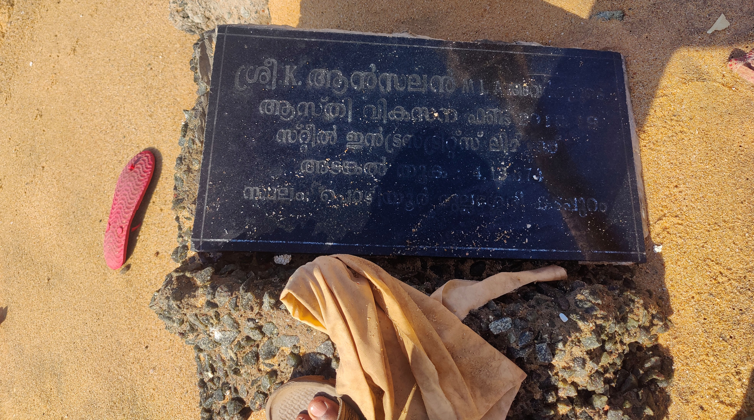
Source: Primary Data

Photograph 2: Wide, accreting beach at Azhimala
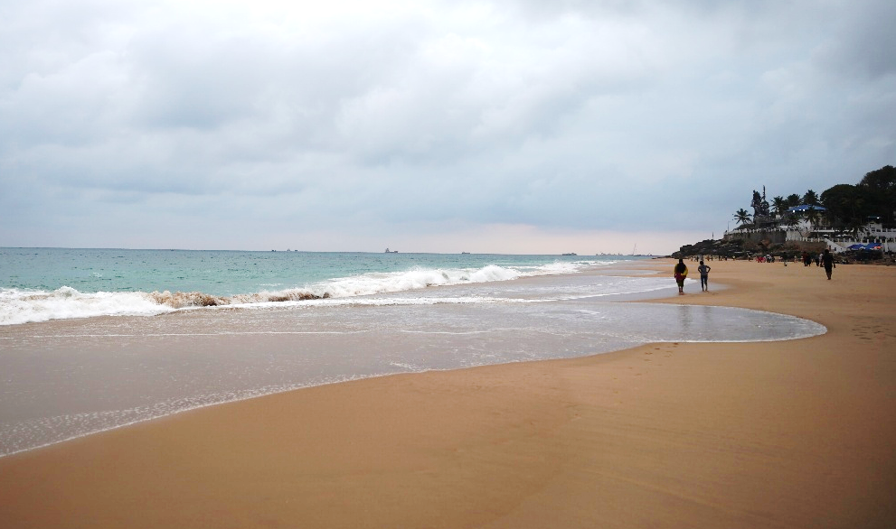
Source: Primary Data

Photograph 3: Comepletely destroyed and abandoned house North of Muthalapozhi
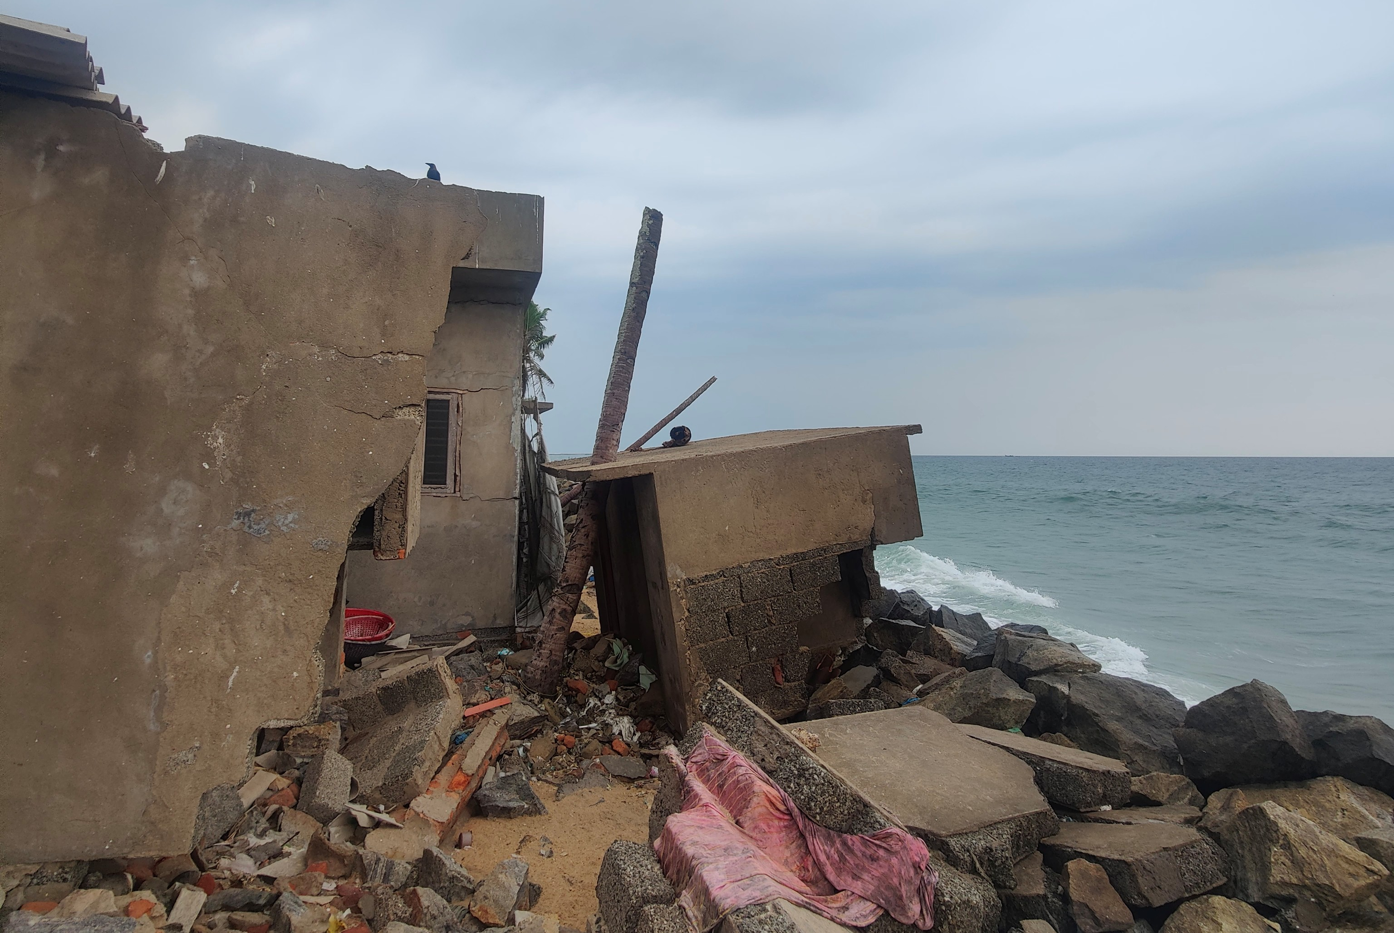
Source: Primary Data

Photograph 4: Severely eroded seawall at Palappetty, Perumpadappu Panchayat
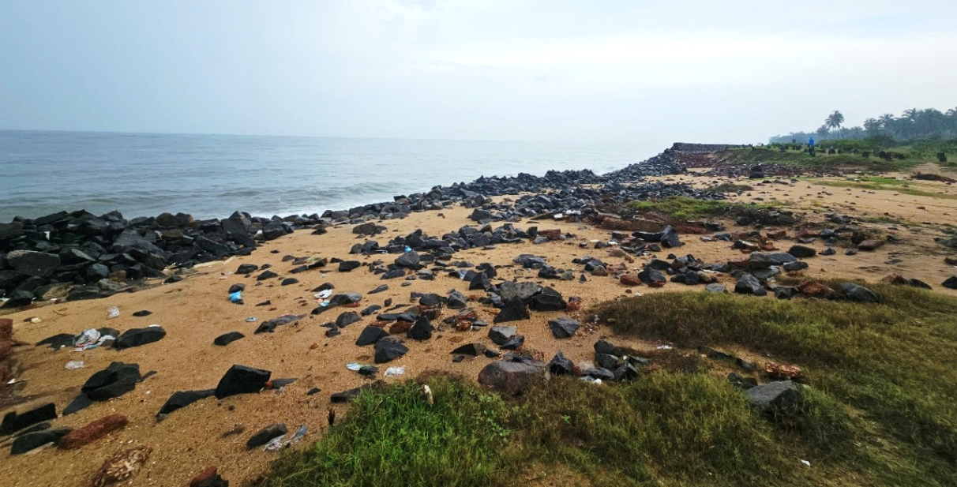
Source: Primary Data

Photograph 5: Wide accreting beach at Padinjarekkara
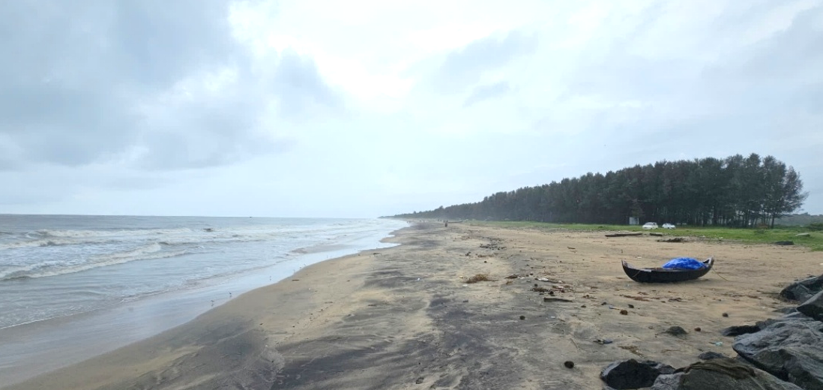
Source: Primary Data

