Supplementary sheet:
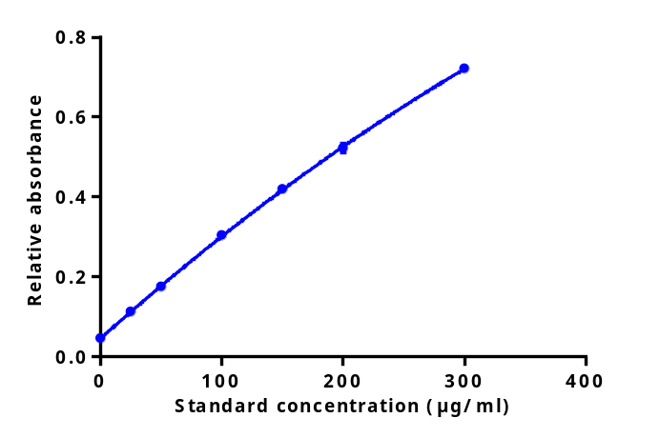
Fig SS1: Representative standard Lowry curve for determination of protein content.

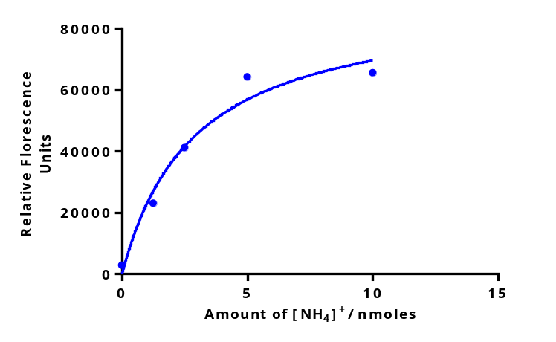
Fig SS2: Representative (NH₄)₂SO₄ standard curve for determination of amount of ammonia generated by FAAH hydrolysis of substrates.

