Supporting information – Raw images

Unveiling the culturable Bacillus sp. from honey in Burkina Faso as a potential source for antimicrobial peptides in plant disease control

Figures containing gels and blot images

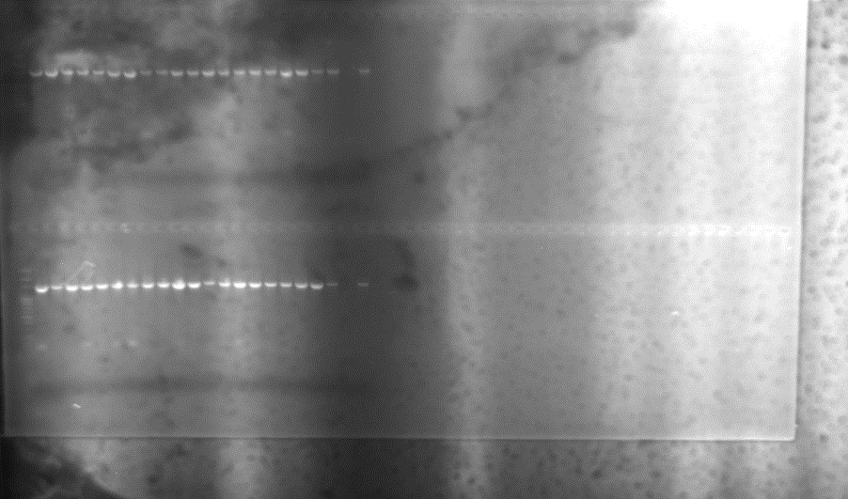
MPM 10 11 12 14 15 18 21 22 21 28 29 31 33 34 35 38
Figure 1: PCR-amplified fragments on 2% agarose gel of Bacillus sp. strains using 16S DNA primers

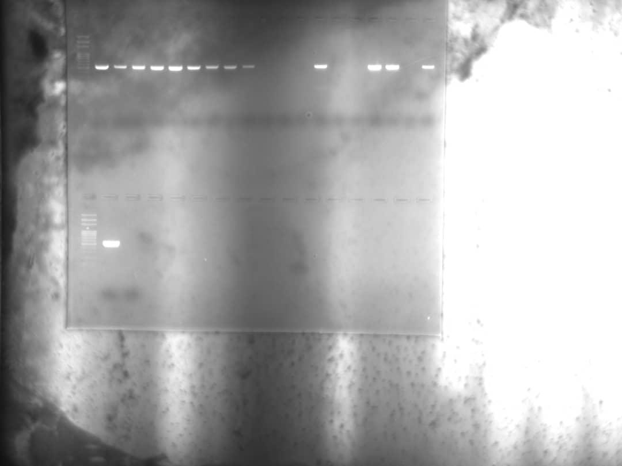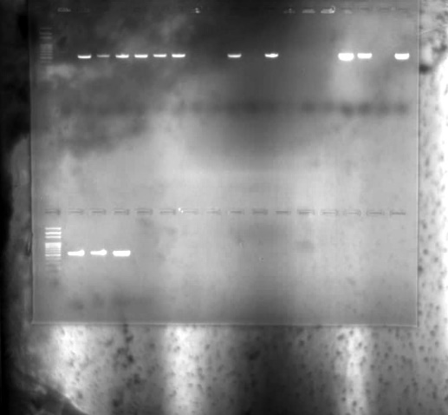
MPM 40
MPM 22 23 24 25 26 27 30 32 36 37 39
MPM 1 2 3 4 5 6 7 8 9 13 16 17 19
MPM 20

Figure 2 : PCR-amplified fragments on 2% agarose gel of B. cereus isolated from honey

Table 1: Size of detected gene after DNA fragments amplification
Strains | Code | Bacillus cereus | ituA | hag | tasA | srf | spaS | mrsA
BH1.0 | 1 | 621 | 0 | 0 | 0 | 0 | 0 | 0
BH1.1 | 2 | 621 | 0 | 0 | 0 | 0 | 0 | 0
BH1.2 | 3 | 621 | 0 | 0 | 0 | 0 | 0 | 0
BH2.0 | 4 | 621 | 743 | 700 | 719 | 0 | 0 | 7
BH2.1 | 5 | 621 | 0 | 0 | 0 |  | 0 | 0
BH2.2 | 6 | 621 | 0 | 0 | 0 | 743 | 0 | 0
HT3.0 | 7 | 621 | 0 | 0 | 0 | 0 | 0 | 0
HT3.1 | 8 | 621 | 0 | 0 | 0 | 0 | 0 | 0
HT3.2 | 9 | 621 | 0 | 0 | 0 | 0 | 0 | 0
HT4.0 | 10 | 0 | 743 | 700 | 0 | 743 | 0 | 0
HT4.1 | 11 | 0 | 743 | 700 | 719 | 743 | 0 | 707
HT4.2 | 12 | 0 | 743 | 700 | 719 | 0 | 0 | 0
HT5.0 | 13 | 621 | 0 | 0 | 719 | 743 | 0 | 0
HT5.1 | 14 | 0 | 743 | 700 | 0 | 0 | 0 | 0
HT5.2 | 15 | 0 | 743 | 700 | 719 | 743 | 0 | 0
BT6.0 | 16 | 621 | 0 | 0 | 719 | 0 | 0 | 0
BT6.1 | 17 | 621 | 0 | 700 | 0 | 0 | 0 | 0
BT6.2 | 18 | 0 | 0 | 0 | 0 | 743 | 0 | 0
BT7.0 | 19 | 621 | 0 | 0 | 0 | 0 | 0 | 0
BT7.1 | 20 | 621 | 743 | 0 | 0 | 0 | 0 | 0
BT7.2 | 21 | 0 | 743 | 0 | 0 | 0 | 0 | 0
BT8.0 | 22 | 621 | 0 | 700 | 0 | 0 | 0 | 707
BT8.1 | 23 | 621 | 0 | 700 | 719 | 0 | 0 | 0
BT8.2 | 24 | 621 | 0 | 0 | 719 | 0 | 0 | 0
BT8.3 | 25 | 621 | 0 | 0 | 719 | 0 | 0 | 0
OK9.0 | 26 | 621 | 0 | 0 | 0 | 0 | 0 | 0
OK9.1 | 27 | 621 | 743 | 0 | 0 | 0 | 0 | 0
OK9.2 | 28 | 0 | 0 | 0 | 0 | 0 | 0 | 707
OK9.3 | 29 | 0 | 743 | 700 | 0 | 0 | 0 | 0
OK10.0 | 30 | 621 | 0 | 0 | 0 | 0 | 0 | 0
OK10.1 | 31 | 0 | 0 | 700 | 719 | 743 | 0 | 0
OK10.2 | 32 | 621 | 0 |  | 0 | 0 | 0 | 707
OK10.3 | 33 | 0 | 743 | 700 | 719 | 0 | 0 | 707
KK11.0 | 34 | 0 |  |  | 0 | 0 | 0 | 0
KK11.1 | 35 | 0 | 743 | 700 | 0 | 0 | 0 | 0
KK11.2 | 36 | 621 | 0 | 0 | 0 | 0 | 0 | 0
KK11.3 | 37 | 621 | 0 | 0 | 719 | 743 | 0 | 0
KK12.0 | 38 | 0 | 0 | 0 | 0 | 0 | 0 | 707
KK12.1 | 39 | 621 | 0 | 0 | 0 | 0 | 0 | 707
KK12.2 | 40 | 621 | 0 | 0 | 0 | 0 | 0 | 0

