This supplementary information is subject to change with the main text that is under review.

Supplementary Information
Recycled piezoelectric materials with competitive second-life functional properties

Mohadeseh Tabeshfar^{1,2}, Sivagnana Sundaram Anandakrishnan^{1,2,}*, Yang Bai^{1,}*
¹Microelectronics Research Unit, Faculty of Information Technology and Electrical Engineering, University of Oulu, FI-90570 Oulu, Finland
²Infotech Oulu, FI-90570 Oulu, Finland
*Correspondence: sivagnana.anandakrishnan@oulu.fi; yang.bai@oulu.fi

Section S1 – Overview and explanation of sample properties and background and rationale of this work
Table S1. Summary of compositions, densities and properties of the samples studied in this work (supplementary to Table 1)
Sample code | Composition |  | Measured density  (g cm⁻³) | Theoretical density (g cm⁻³) | Real part of relative permittivity (ε_{r}') at 1 kHz, unpoled | ε_{r}' at 100 kHz, unpoled | Dielectric loss (tan δ, x10⁻²) at 1 kHz, unpoled | tan δ (x10⁻²) at 10 kHz, unpoled | tan δ (x10⁻²) at 100 kHz, unpoled
Sample code | Filler | Binder
PZ1 | PZT-5H | This is filler | ≈7.57 | 7.73 ± 0.10 | ≈1950 | ≈1800 | ≈2.5 | ≈3.0 | ≈3.5
PZ2 | PZ29 | This is filler | ≈7.46 | 7.91 ± 0.10 | ≈1500 | ≈1400 | ≈2.5 | ≈3.0 | ≈3.0
PZ3 | PZT-5A | This is filler | ≈7.59 | 7.96 ± 0.04 | ≈1350 | ≈1250 | ≈1.5 | ≈2.0 | ≈2.5
B1 | This is binder | PVDF-TrFE-CTFE | 1.70 ± 0.02 | 1.80^{a)} | ≈35^{b)} | ≈20^{b)} | ≈5.0^{b)} | ≈13^{b)} | ≈35^{b)}
B2 | This is binder | TMCM-CdCl₃ | 2.11 ± 0.20 | 2.15 | ≈10^{c)} | ≈9^{c)} | 4.2 ± 3.6^{c)} | 2.4 ± 1.3^{c)} | 6.8 ± 0.2^{c)}
B3 | This is binder | PTMA-CdCl₃ | 1.78 ± 0.02 | 1.80 | ≈5^{c)} | ≈5^{c)} | 1.3 ± 0.7^{c)} | 0.4 ± 0.2^{c)} | 0.1 ± 0.1^{c)}
PZ1-B1 | Crushed PZT-5H ceramics | PVDF-TrFE-CTFE powder | 6.14 ± 0.08 | ≈6.64 | 658 ± 13 | 507 ± 7 | 7.4 ± 0.5 | 8.1 ± 0.3 | 13.2 ± 0.4
PZ1-B2 | Crushed PZT-5H ceramics | Crushed TMCM-CdCl₃ crystals | 6.31 ± 0.09 | ≈6.84 | 307 ± 26 | 285 ± 23 | 4.0 ± 0.1 | 2.6 ± 0.1 | 2.4 ± 0.2
PZ1-B3 | Crushed PZT-5H ceramics | Crushed PTMA-CdCl₃ crystals | 6.31 ± 0.07 | ≈6.64 | 278 ± 6 | 264 ± 7 | 2.4 ± 0.3 | 1.9 ± 0.1 | 1.6 ± 0.1
PZ2-B1 | Crushed PZ29 ceramics | PVDF-TrFE-CTFE powder | 5.98 ± 0.06 | ≈6.76 | 478 ± 25 | 386 ± 13 | 4.8 ± 1.7 | 6.5 ± 0.7 | 11.8 ± 0.3
PZ2-B2 | Crushed PZ29 ceramics | Crushed TMCM-CdCl₃ crystals | 6.19 ± 0.02 | ≈6.88 | 337 ± 41 | 285 ± 16 | 13.9 ± 6.8 | 6.3 ± 2.8 | 3.6 ± 1.1
PZ2-B3 | Crushed PZ29 ceramics | Crushed PTMA-CdCl₃ crystals | 6.20 ± 0.10 | ≈6.76 | 260 ± 7 | 245 ± 10 | 2.6 ± 0.8 | 2.1 ± 0.5 | 1.8 ± 0.4
PZ3-B1 | Crushed PZT-5A ceramics | PVDF-TrFE-CTFE powder | 6.18 ± 0.06 | ≈6.80 | 450 ± 31 | 364 ± 12 | 4.3 ± 1.9 | 6.4 ± 1.2 | 11.8 ± 0.5
PZ3-B2 | Crushed PZT-5A ceramics | Crushed TMCM-CdCl₃ crystals | 6.15 ± 0.06 | ≈7.01 | 264 ± 14 | 249 ± 12 | 2.9 ± 0.1 | 2.0 ± 0.1 | 19.3 ± 0.2
PZ3-B3 | Crushed PZT-5A ceramics | Crushed PTMA-CdCl₃ crystals | 6.19 ± 0.05 | ≈6.80 | 249 ± 3 | 233 ± 5 | 3.3 ± 0.7 | 2.3 ± 0.3 | 1.8 ± 0.2
^{a)}From https://piezotech.arkema.com/en/Technical-center/Documentation
^{b)}Value measured from sample fabricated at 80 °C, the highest safe temperature to yield solid sample after cooling down, although sample melted at 80 °C. Fabricating samples at 150 °C is unsafe.
^{c)}Value measured on polycrystalline sample fabricated at 150 °C which reflects the real material format (polycrystalline instead of monocrystalline) in the recycled composites

Introduction to piezoelectric upside-down composites
Piezoelectric materials are generally classified into five categories: monocrystals,^{1,2} polycrystals (commonly known as piezoelectric ceramics),^{3,4} polymers,^{5,6} semiconductors,^{7,8} and composites.^{9–11} Piezoelectric composites can be made via the upside-down compositing method that has been developed under the ultralow-temperature densification mechanism. The upside-down composites feature an exceptionally high filler content (>75 vol.%) with multimodal particle sizes (predominantly over 100 μm) and significantly low binder content (serving as an inversed matrix) compared to the situation in conventional composites. Therefore, such composites are named ‘‘upside-down’’.¹²
The first piezoelectric upside-down composite was made from a commercial soft-type Pb(Zr,Ti)O₃ (PZT) as the filler and Li₂MoO₄ (LMO) as the binder.¹³ This material gave a longitudinal piezoelectric charge coefficient (d₃₃) of 84 pC N⁻¹ and a longitudinal piezoelectric voltage coefficient (g₃₃) of 33 mV·m N⁻¹. The second version of the material replaced LMO with a TiO_{x} precursor gel as the binder. The binder formed amorphous TiO₂ after a heat treatment at an elevated temperature of 350 °C. The piezoelectric properties of the composite were improved to 150 pC N⁻¹ for d₃₃ and 53 mV·m N⁻¹ for g₃₃.¹⁴

Introduction to recycling of piezoelectric ceramics and factor of filler and binder permittivity
Recently, halide perovskites have been developed as binders for upside-down composites. Halide perovskites have better chemical and microstructural compatibility with the oxide perovskite phase of the piezoelectric ceramic fillers. Also, many halide perovskites can crystallize near room temperature (RT). This essential feature enabled the recycling of piezoelectric ceramics. Production of the recycled materials requires minimal energy input while achieving a high material densification of over 92 % and competitive g₃₃ values even compared to the pristine piezoelectric ceramic counterparts.^{15,16} g₃₃ is a universal indicator for the sensing capability of a piezoelectric material. The competitive g₃₃ grants the recycled materials opportunity for a second life of being used as piezoelectric sensors.
Despite the initial success on large g₃₃, d₃₃ of the recycled materials is inferior and hence needs improvement. Compared to g₃₃, d₃₃ is a universal indicator of piezoelectric properties that is even more commonly referred to. It influences the potential performance of a piezoelectric material in actuators, transducers, and energy harvesters. To improve d₃₃, a fundamental understanding on upside-down composites, based on the theories for ordinary composites, must be established first. Therefore, in our recent work, we researched upside-down composites made from different fillers with high d₃₃, including the PZT-based, the Pb(Mg_{1/3}Nb_{2/3})O₃-PbTiO₃-based and the Pb-free compounds, with two different halide perovskite binders, C₆H₅N(CH₃)₃CdCl₃ (PTMA-CdCl₃) and Me₃NCH₂ClCdCl₃ (TMCM-CdCl₃).^{15–17} We found that coincidence of the binder’s decomposition during fabrication with the filler’s ferroelectric-paraelectric phase transition can significantly degrade the composite’s dielectric and piezoelectric properties, due to enlarged permittivity mismatch between the filler and binder, microstructural frustration along porosity increase, and densification lag.¹⁷
It is well-known that in ordinary composites where the binder matrix takes the majority of the material’s volume, the composite permittivity is restricted by the low binder permittivity. From our studies, this turns out to be true also for upside-down composites, even though the filler loading is considerably high. This is primarily due to the fact that the permittivity mismatch between the filler and binder distorts the actual electric field that is applied to the ceramic fillers. Therefore, there exists a fundamental challenge in improving the composite piezoelectric properties,^{18–20} despite the fact that the resulting low composite permittivity benefits the piezoelectric voltage coefficient.^{15,21} However, the negligible charge mobility in the binder increases the charge relaxation time, hindering effective poling and resulting in a piezoelectric charge coefficient that is an order of magnitude lower than that of piezoelectric ceramic counterparts.^{15,16,22}
This conclusion is confirmed by us in a systematic investigation combining experimental and modelling approaches to explore the influence of filler permittivity on both the overall permittivity and d₃₃ of upside-down composites. We intentionally selected fillers with identical d₃₃ values but with significantly different permittivity values, and made upside-down composites using a single, identical binder. With sufficiently large filler permittivity (e.g, 1900 for a filler d₃₃ of 480 pC N⁻¹), the distortion of the electric field distribution inside the composite, for instance, the concentration of local electric field on the binder, appears to reach a saturation.²³ As a result, the dielectric and piezoelectric properties cannot be obviously improved regardless of the attempts to optimize the filler’s properties and the microstructure of the composite.²³ This result can be supported by research carried out in another group, where the relationship between dielectric properties and composition in SrTiO₃-LMO upside-down composites across a wide range of the LMO binder content is assessed in both experiment and modelling.²⁴

Development needs for recycled piezoelectric ceramics and rationale of this work
Based on the above understanding, finding a proper binder with relatively large permittivity is of utmost importance. This is not only because the d₃₃ values may be improved with increased binder permittivity, but also experimental data with improved composite d₃₃ and binder permittivity are crucial for extending the composite models towards the higher end of d₃₃. After all, the experimental data obtained to date remain in the saturation region in the models, which do not provide valuable insights into the region that is only predicted by models but is not validated by experiments.
Therefore, this work carries out a multi-variable investigation using different fillers and binders with diverse dielectric and piezoelectric properties. By adding a polymer compound, PVDF-TrFE-CTFE [poly(vinylidene fluoride-trifluoroethylene-chlorotrifluoroethylene)], into the binder pool that includes the previously studied TMCM-CdCl₃ and PTMA-CdCl₃, we are able to predict a comprehensive, three-dimensional map that correlates the composite’s dielectric and piezoelectric properties to the filler’s and binder’s properties. The map successfully extends towards the higher end of the composite properties, and thus can guide future works and save cost and time that are incurred by extensive trial and error in experiments.²⁵
As can be seen in Table S1 and Figure S8 (in Section S6 below) as well as in Table 1 and Figure 1 in the main text, this study demonstrates that the binder type, through its electrical, chemical and mechanical properties, plays a decisive role in the dielectric, piezoelectric and ferroelectric performance of upside-down composites. Binders that exhibit large permittivity, better chemical stability, and higher mechanical flexibility become the primary prerequisite for the recycled materials. In an actual recycling procedure, the fillers and binders need to be carefully chosen, especially when there are multiple sources to be recycled. Specifically, high-permittivity binders with adequate flexibility, such as relaxor-ferroelectric terpolymers, are identified as promising candidates as the binder for high-performance recycled piezoelectric ceramics.

Section S2 – Optimization of binder content
Figure S1 shows the dielectric and piezoelectric properties of the recycled materials made from the PZ1 filler and the B1 binder. In this work, the 5 wt.% binder concentration was determined via a series of experimental optimization procedures. In our previous work,¹⁵ we have shown that a binder concentration beyond 5-10 wt.% will significantly degrade the functionality of the composite. In addition, Figure S1 demonstrates that the dielectric and piezoelectric properties are optimized when the binder concentration is 5 wt.%. In practice, it was more accurate to control the weight fraction than the volume fraction, because both the fillers and binders were solid-state particles. It should be noted that although dielectric loss and d₃₃ remained similar for samples with binder concentrations of 2.5-7.5 wt.% (Figure S1b and c) while g₃₃ decreased with the increase of binder concentration (Figure S1d), the 5 wt.% was still considered the optimum point due to the sample’s significantly improved unpoled permittivity (Figure S1a). Unpoled permittivity is considered to be very sensitive to the general quality of an upside-down composite sample. Higher permittivity is preferred in case other parameters are deemed comparable.

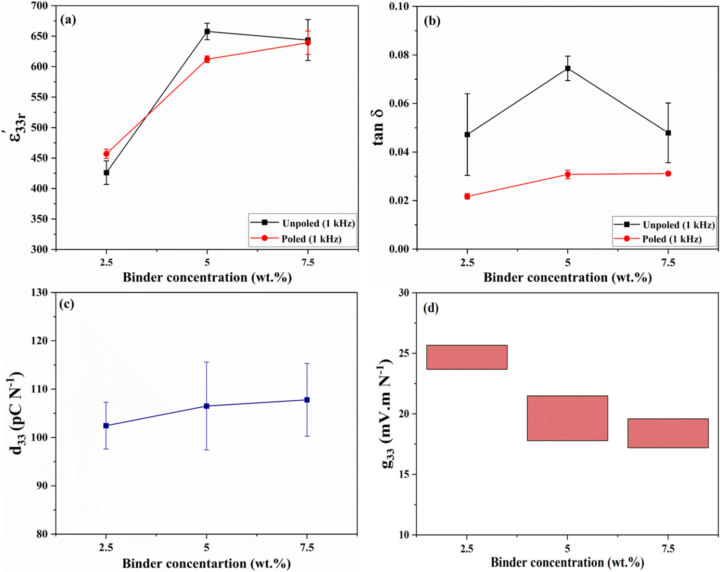
Figure S1. Real part of longitudinal relative permittivity (ε'_{33r}) measured at 1 kHz, (b) dielectric loss (tan 𝛿) measured at 1 kHz, (c) longitudinal piezoelectric charge coefficient (d₃₃) measured at the 24th hour after poling [unoptimized poling condition, 3 kV mm⁻¹ at room temperature (RT)], and (d) longitudinal piezoelectric voltage coefficient (g₃₃) for composite samples with PZ1 as the filler and B1 as the binder with binder concentrations of 2.5 wt.%, 5 wt.% and 7.5 wt.%.

Section S3 – Optimization of poling conditions
In Tables S2-S4, the history and evolution of the d₃₃ values of some samples after each poling step are recorded. The data clearly indicate that an electric field of 4-5 kV mm⁻¹ and a poling temperature of 80 °C were the favoured conditions for the composites with the B1 and B3 binders, while 3 kV mm⁻¹ and RT were preferred for the composites with the B2 binder. The criteria for the optimum poling conditions are: (1) The d₃₃ reached the maximum possible value, and (2) for reaching the same maximum d₃₃ values, lower possible electric field and temperature are preferred.

Table S2. Evolution of longitudinal piezoelectric charge coefficient (d₃₃) values after each poling step for the PZ1-B1 sample
Poling temperature (°C) | Electric field (kV mm⁻¹) | Poling time (minute)^{a)} | Polarity flipped?^{b)} | d₃₃ (pC N⁻¹)^{c)}
Specimen 1
RT (room temperature) | 3 | 0 | From unpoled state | 102 ± 16
80 | 3 | 36 | Yes | 118 ± 10
RT | 3 | 36 | Yes | 42 ± 8
RT | 4 | 0 | No | 59 ± 8
80 | 5 | 36 | No | 160 ± 9^{d)}
110 | 5 | 36 | No | 161 ± 7
110 | 6 | 36 | No | 160 ± 6
RT | 7 | 10 | No | 164 ± 11
Specimen 2
RT | 3 | 0 | From unpoled state | 109 ± 3
RT | 3 | 36 | Yes | 23 ± 8
80 | 3 | 36 | Yes | 146 ± 8
80 | 5 | 36 | Yes | 157 ± 89^{d)}
Specimen 3
RT | 3 | 0 | From unpoled state | 109 ± 8
RT | 4 | 0 | No | 120 ± 8
RT | 4 | 36 | No | 136 ± 9
RT | 5 | 36 | No | 144 ± 9
80 | 5 | 36 | No | 169 ± 11^{d)}
140 | 5 | 43 | No | 163 ± 11
80 | 6 | 36 | No | 166 ± 9
^{a)}The poling time was primarily controlled for RT. For elevated temperatures, the poling time was not controlled but instead was determined by the time needed for cooling. The specimen under poling was first heated to the target poling temperature and then the target electric field was applied. For poling at RT, the target electric field was kept on for the indicated poling time. For poling at elevated temperatures, the heating was turned off immediately once the target electric field was reached and this field was kept on during cooling until the temperature of the sample dropped to near RT.
^{b)}For each first poling step, the specimen was poled from the pristine, unpoled state. No particular depoling process was carried out before each subsequent poling step due to the lower decomposition temperatures of the binders than some fillers’ Curie temperatures. In order to reveal the true influence of the re-poling conditions, the polarity of a poled specimen was sometimes flipped with respect to the situation in the last poling step.
^{c)}Measured at the 24th hour after poling
^{d)}Optimum value under the optimized poling conditions

Table S3. Evolution of d₃₃ values after each poling step for the PZ1-B2 sample
Poling temperature (°C) | Electric field (kV mm⁻¹) | Poling time (minute)^{a)} | Polarity flipped?^{b)} | d₃₃ (pC N⁻¹)^{c)}
Specimen 1
RT | 3 | 0 | From unpoled state | 79 ± 6^{d)}
80 | 3 | 36 | Yes | 71 ± 5
80 | 4 | 36 | No | 73 ± 5
RT | 5 | 0 | No | 76 ± 5
Specimen 2
RT | 3 | 0 | From unpoled state | 83 ± 5^{d)}
RT | 4 | 0 | Yes | 69 ± 6
RT | 5 | 36 | No | 75 ± 4
Specimen 3
RT | 3 | 0 | From unpoled state | 101 ± 16^{d)}
RT | 4 | 0 | No | 90 ± 12
RT | 5 | 0 | No | 92 ± 11
^{a)}The poling time was primarily controlled for RT. For elevated temperatures, the poling time was not controlled but instead was determined by the time needed for cooling. The specimen under poling was first heated to the target poling temperature and then the target electric field was applied. For poling at RT, the target electric field was kept on for the indicated poling time. For poling at elevated temperatures, the heating was turned off immediately once the target electric field was reached and this field was kept on during cooling until the temperature of the sample dropped to near RT.
^{b)}For each first poling step, the specimen was poled from the pristine, unpoled state. No particular depoling process was carried out before each subsequent poling step due to the lower decomposition temperatures of the binders than some fillers’ Curie temperatures. In order to reveal the true influence of the re-poling conditions, the polarity of a poled specimen was sometimes flipped with respect to the situation in the last poling step.
^{c)}Measured at the 24th hour after poling
^{d)}Optimum value under the optimized poling conditions

Table S4. Evolution of d₃₃ values after each poling step for the PZ1-B3 sample
Poling temperature (°C) | Electric field (kV mm⁻¹) | Poling time (minute)^{a)} | Polarity flipped?^{b)} | d₃₃ (pC N⁻¹)^{c)}
Specimen 1
RT | 3 | 0 | From unpoled state | 44 ± 4
80 | 3 | 36 | Yes | 59 ± 4
80 | 4 | 36 | No | 59 ± 3^{d)}
80 | 5 | 36 | No | 59 ± 4
^{a)}The poling time was primarily controlled for RT. For elevated temperatures, the poling time was not controlled but instead was determined by the time needed for cooling. The specimen under poling was first heated to the target poling temperature and then the target electric field was applied. For poling at RT, the target electric field was kept on for the indicated poling time. For poling at elevated temperatures, the heating was turned off immediately once the target electric field was reached and this field was kept on during cooling until the temperature of the sample dropped to near RT.
^{b)}For each first poling step, the specimen was poled from the pristine, unpoled state. No particular depoling process was carried out before each subsequent poling step due to the lower decomposition temperatures of the binders than some fillers’ Curie temperatures. In order to reveal the true influence of the re-poling conditions, the polarity of a poled specimen was sometimes flipped with respect to the situation in the last poling step.
^{c)}Measured at the 24th hour after poling
^{d)}Optimum value under the optimized poling conditions

Section S4 – Optimization of fabrication temperature
Figure S2 presents a series of trials that were made for sample PZ1-B1 fabricated at RT and in the range of 50 °C to 200 ºC with a 50 ºC interval. The sample fabricated at 150 °C exhibited the largest d₃₃. The fabrication temperature for samples with the B2 or B3 binder has been reported in detail in our previous works.^{15,17}

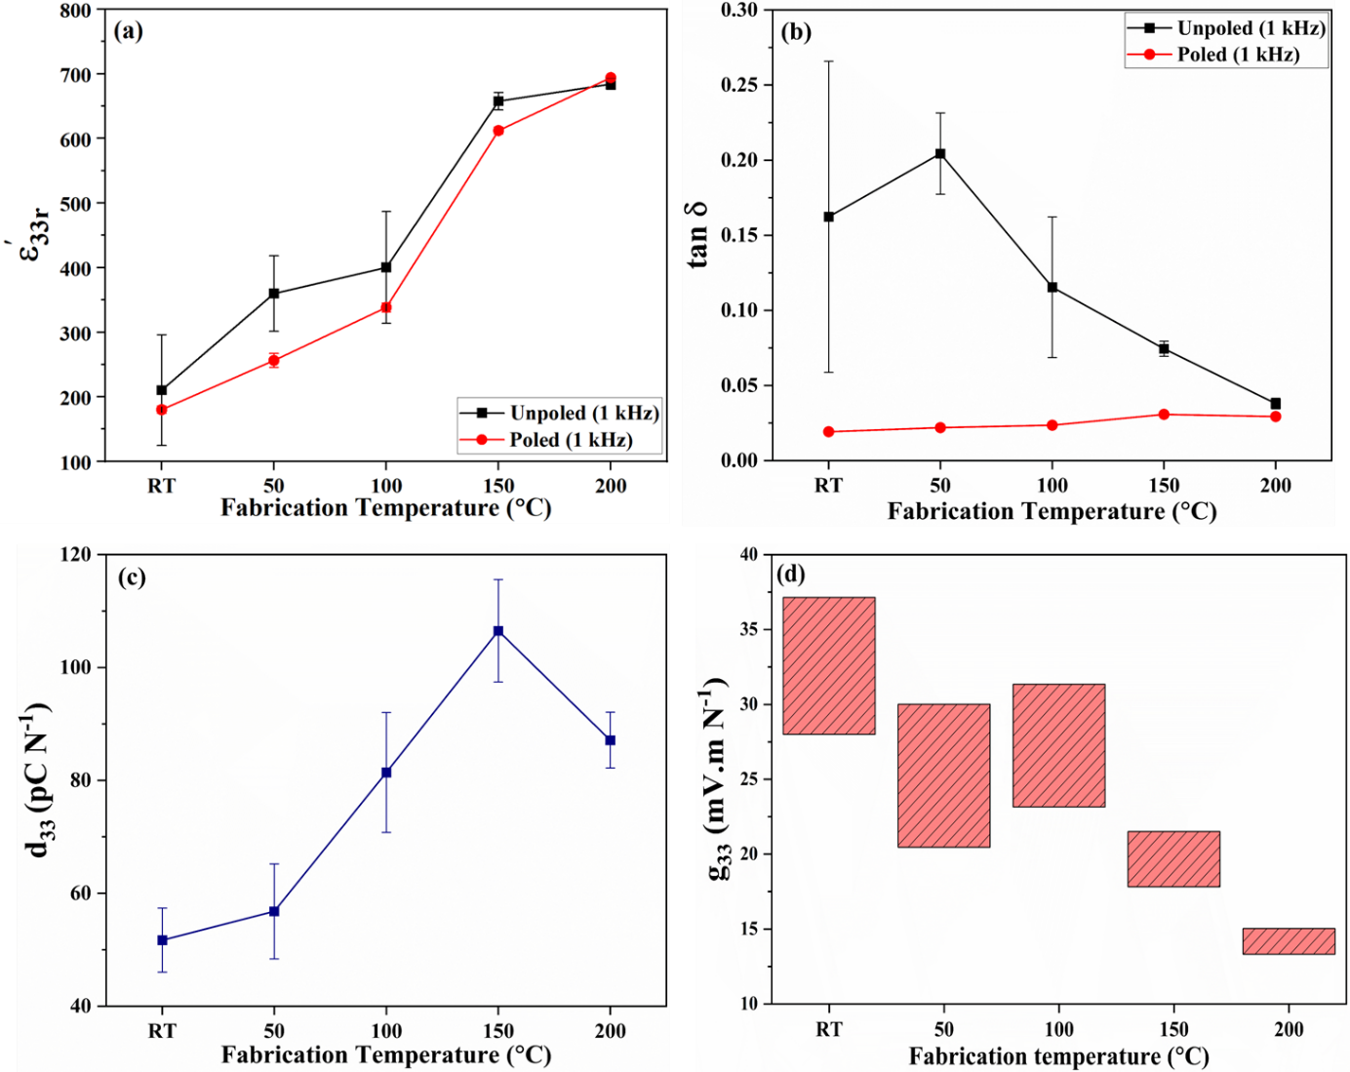
Figure S2. Dependence of (a) ε'_{33r} measured at 1 kHz, (b) tan 𝛿 measured at 1 kHz, (c) d₃₃ measured at the 24th hour after poling (unoptimized poling condition, 3 kV mm⁻¹ at RT), and (d) g₃₃ on fabrication temperature for the PZ1-5 wt.% B1 composite sample.

Section S5 – Analyses of compositions, phases, microstructure and resulting properties of the recycled composites
The compositions and phases of the composite samples are examined in Figure S3. All the major XRD (X-ray diffraction) reflections belong to the fillers due to their large concentration (95 wt.%). These major reflections indicate PZT-based perovskite phases as expected. No reflection matching the B1 binder is noticed, indicating its amorphous state. The amorphous state of the B1 binder implies that it is a non-piezoelectric phase, as the piezoelectricity in PVDF-based compounds must originate from the polar crystal dipoles of the β-phase.²⁶ In comparison, reflections matching the B2 and B3 binders, which are crystalline halide perovskites, can be clearly seen. All the expected phases matching the compositions of the fillers can be observed, pointing the cause of the difference in properties towards the different binders used.

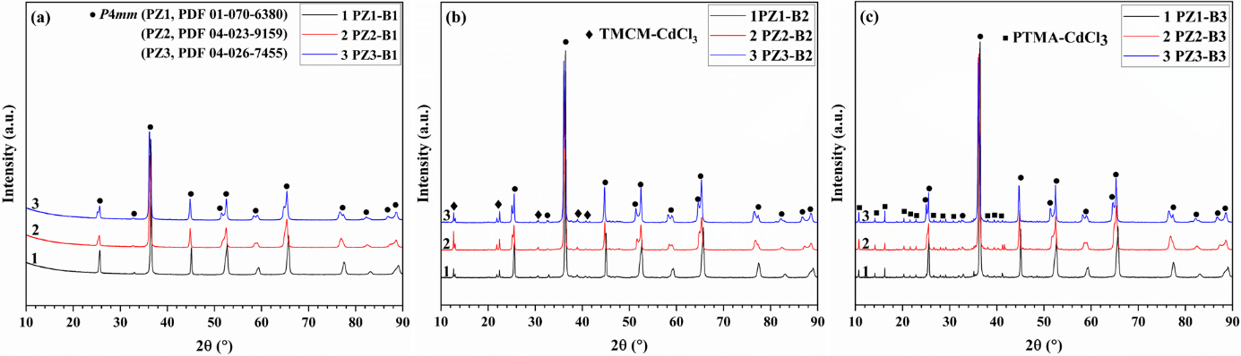
Figure S3. XRD (X-ray diffraction) results for samples with the (a) B1, (b) B2, and (c) B3 binder, i.e., composites of PZ1, PZ2 or PZ3 filler with 5 wt.% binder fabricated at 150 ºC.

Figures S4-S6 show the microstructure of the composites with different binders. Although all the composites were packed tightly due to the proper use of the binders,^{15,17} the polymer binder (B1) seemed to distribute more homogenously, likely due to the fact that the B1 binder completely melted during fabrication and then solidified as a continuous, whole piece of material after cooling down, as evidenced in Figure S7, where the glass transition temperature and melting point are shown to be 39 ºC and 132 ºC, respectively. In comparison, the B2 and B3 binders recrystallized as discrete grains after cooling down, which may result in a less homogenous microstructure compared to the situation for the B1 binder because the grain size of B2 or B3 after precipitation can be dependent on the intergranular space between filler particles. The more homogenous binder distribution in B1-based samples can smoothen the electric field distribution during poling. Also, polymers usually have high dielectric strength and thus can sustain much higher electric field before breaking down compared to the situation for halide perovskites,²⁷ which partially explains why fillers in B1-based samples could be poled more effectively, since the applied electric field tends to target on the material’s weak spots, causing early mechanical or electrical failure.²⁸

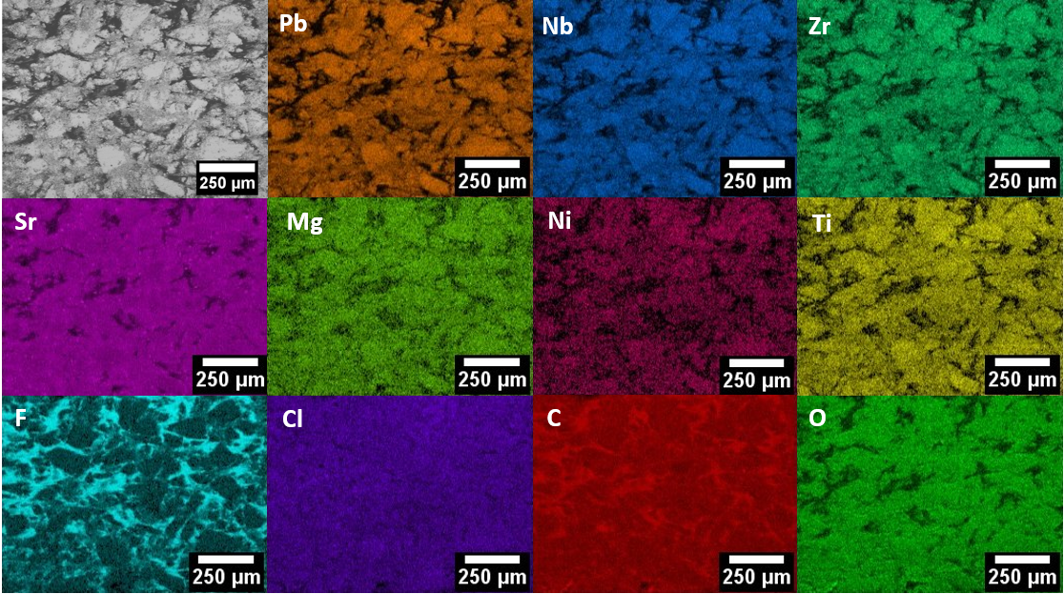
Figure S4. FESEM (field emission scanning electron microscopy) micrograph and EDS (energy-dispersive X-ray spectroscopy) elemental maps for the polished, cross-sectional surface of sample PZ1-B1.

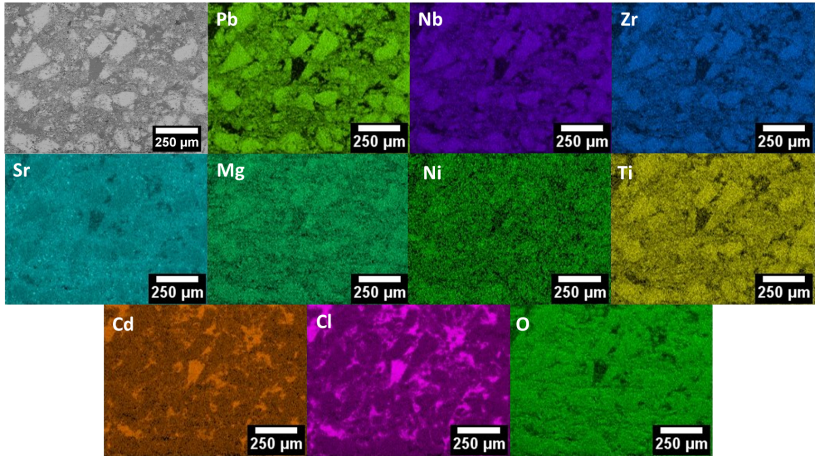
Figure S5. FESEM micrograph and EDS elemental maps for the polished, cross-sectional surface of sample PZ1-B2.

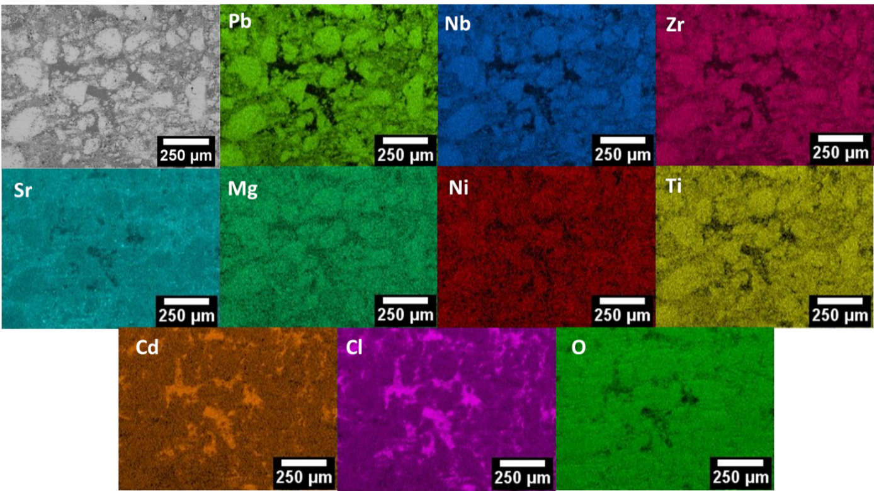
Figure S6. FESEM micrograph and EDS elemental maps for the polished, cross-sectional surface of sample PZ1-B3.

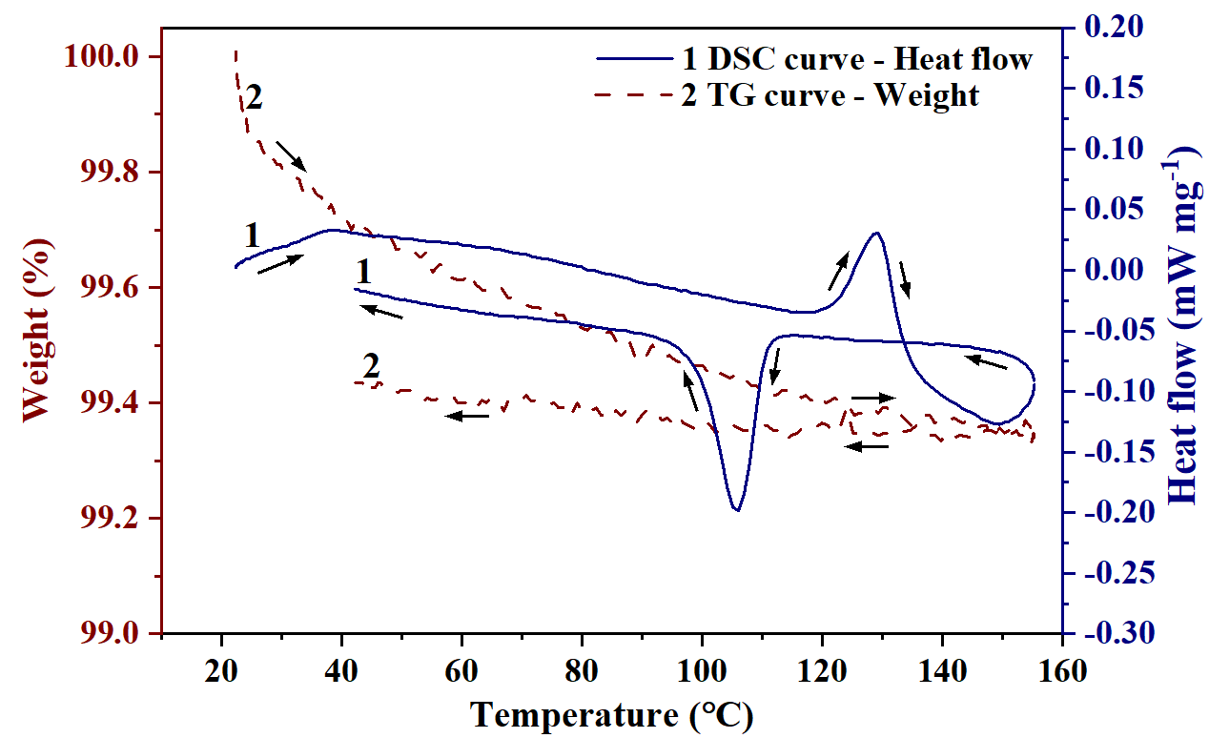
Figure S7. Results of DSC/TGA (differential scanning calorimetry/thermogravimetric analysis): Dependence of weight and heat flow on temperature for PVDF-TrFE-CTFE (pure B1 binder).

Different from the situation for the B2 and B3 binders, the filler particles were not coated by the B1 binder. An extra coating procedure was not needed thanks to the melted binder during fabrication, making the fabrication simpler. This feature could further facilitate the acceleration of the recycling procedure as only dry mixtures are involved.
As explained in previous work,¹⁷ the filler particles were coated with the halide binder compound in order to obtain a densely packed microstructure. Compared to the samples with the B1 binder (Figure S4), the distribution of the B2 and B3 binders is less homogenous. The reason is that, although the added saturated binder solutions facilitated the rearrangement of smaller filler particles before elevating the fabrication temperature as what B1 did after being melted, the liquid phase in B2 or B3 was actually dried out at the elevated fabrication temperature of 150 °C. During cooling down, only a solid-state phase transition happened in the TMCM-CdCl₃ at 120-130 °C ^{17,29} and no liquid phase was involved anymore. Nevertheless, based on the data in Table 1, a high level of densification (relative density of 87-92 %) was still achieved with the B2 binder, thanks to the improved dispersion of binder after coating.
Similar to the situation for the B2 binder, no liquid-solid phase transition occurred in PTMA-CdCl₃ (the B3 binder) during cooling down from the fabrication temperature.^{15,30} The B3 binder resulted in slightly larger relative densities (constantly over 90 %) than the B2 binder (Table 1). However, the larger density did not induce higher properties, partially due to the non-piezoelectric nature of the binder and also partially due to the discrepancy of the permittivity of filler and binder, as discussed in previous studies.^{15,17,23}

Section S6 – Ferroelectric properties and analysis of poling efficiency
Figure S8a-c show the ferroelectric hysteresis loops of the composite samples made from the PZ1 filler and different binders, i.e., PZ1-B1, PZ1-B2, and PZ1-B3. The loops are found to be frequency-dependent, with smaller frequencies inducing larger loops. This behaviour is commonly observed in ferroelectric materials, where domain alignment under external electric field is inherently time-dependent. Specifically, the polarization–electric field (P–E) loop is highly sensitive to experimental parameters such as magnitude of the electric field, frequency of the applied signal, and microstructural characteristics of the material.^{31,32} At higher frequencies, the rapid phase change of the applied AC field exceeds the response time of the ferroelectric domains. As a result, polarization switching becomes incomplete, as the 180° domain walls primarily oscillate around their initial positions rather than undergoing full reorientation, leading to a reduced extent of 180° domain switching and thereby altering the shape of the hysteresis loop.³³ Furthermore, when the phase change of the applied electric field is slower than the microstructure can evolve, the domains can undergo a sequential 90° + 90° switching process. However, if this field phase changes at a speed equal to or faster than the microstructure can evolve, the second 90° switching becomes less likely, as the domains are unable to respond quickly enough within a cycle of the rapidly changing field.³¹ In this case, the switching is predominantly limited to a single 90° reorientation. Consequently, polarization does not saturate under high-frequency loading conditions.³³

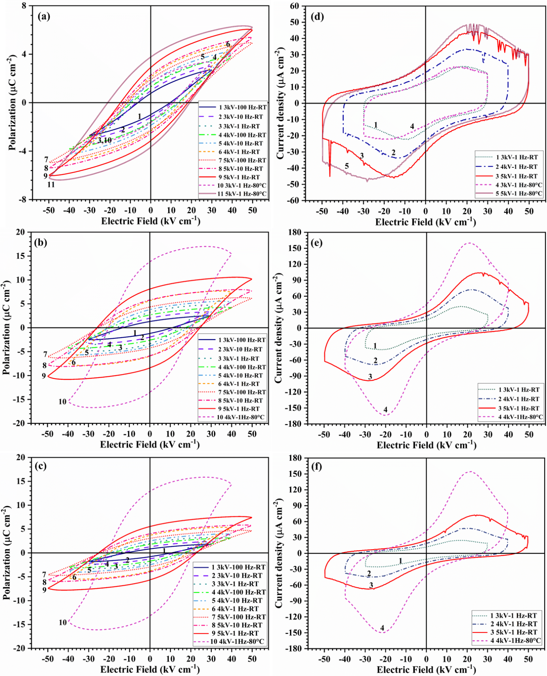
Figure S8. Dependence of (a)-(c) polarization and (d)-(f) current density on electric field measured at different frequencies for composite samples of (a)(d) PZ1-B1, (b)(e) PZ1-B2, and (c)(f) PZ1-B3. In the legends, ‘‘kV’’ actually means ‘‘kV mm⁻¹’’. For instance, ‘‘3 kV’’ in the legend represents the loop measured with a maximum electric field of 3 kV mm⁻¹.

Also, in Figure S8a–c, B2-based samples exhibit larger remanent polarization at RT than those of B1- and B3-based samples. This is attributed to the ferroelectric nature of B2, which enhances the overall ferroelectric response of the composites. According to literature, TMCM-CdCl₃ crystals can show stronger ferroelectric response than PTMA-CdCl₃ with the former demonstrating both longitudinal piezoelectricity and ferroelectricity, while the latter is only considered ferroelectric in the shear mode.^{29,30} This distinction is reflected by the composites: Despite the same filler used, PZ1-B2 and PZ1-B3 exhibited remanent polarizations of approximately 8 μC cm⁻² and 5 μC cm⁻², measured at RT and at 1 Hz under a maximum electric field of 5 kV mm⁻¹. In comparison, the terpolymer B1 binder, which contains 4–7.5% CTFE, exhibits relaxor behaviour (https://piezotech.arkema.com/en/Products/high-k-terpolymers/). Its negligible remanent polarization further degraded the composite’s remanent polarization (approximately 3 μC cm⁻² at RT, 1 Hz and 5 kV mm⁻¹). Certainly, during fabrication the B1 binder melted and resolidified, and thus the original phase may have further lost its ferroelectricity in the amorphous state (see Section S5). In other words, neither being a relaxor or a non-ferroelectric phase could help to sustain a large remanent polarization for the B1-based composites.
On the other hand, a larger remanent polarization in the composite does not guarantee a large d₃₃ after poling (see Table 1, Tables S2-S4, Figure1, or Extended Data Figure A1). According to Figure S8d, the peak of the current density of the PZ1-B1 sample did not increase when the measurement temperature, or equivalently the poling temperature, was elevated from RT to 80 °C. This indicates that B1-based samples did not show lossy ferroelectric hysteresis loops and thus would not have increased leakage during poling at 80 °C. However, PZ1-B2 and PZ1-B3 exhibited significantly increased leakage currents (Figure S8e-f) when the measurement (poling) temperature increased. The leaky samples prohibited the electric field from being more effectively applied to the fillers. This explains why fillers in B1-based samples could be poled more effectively at 80 °C, where domain walls become more mobile.
The reason behind the increased leakage for B2- and B3-based samples may be that their halide perovskite binders contain mobile ions that become increasingly active when subject to increased heat. The halide interfaces tend to be more reactive, defect-rich, and susceptible to thermal degradation.³⁴ All these factors imply that a substantial portion of the applied electric field was consumed by the conduction rather than contributing to switch the domains which should happen under an insulative boundary condition. Consequently, increasing the temperature did not enhance the poling efficiency in the same way as it did for B1, that is, poling at 80 °C was ineffective for B2-based samples and only moderately effective for B3-based samples (see Tables S2-S4).

Section S7 – Supplementary methods, detailed fitting approaches and elaboration on fitting parameters
Synthesis of halide perovskite binders and fabrication of oxide-halide perovskite upside-down composites
TMCM-CdCl₃ crystals (material of the B2 binder) were synthesized from TMCM-Cl (chloromethyltrimethylammonium) and CdCl₂ (99.99 %, Sigma–Aldrich, India). First, trimethylamine (43–49 wt.% in water, Sigma-Aldrich, Switzerland) and dichloromethane (≥99.9 %, Sigma-Aldrich, France) in molar ratio of 1:3 were reacted using acetonitrile as the solvent. The reaction was carried out at 55 °C under continuous stirring for 72 hours. After the reaction, the solvent was removed under reduced pressure, yielding a colourless, gel-like compound of TMCM-Cl. Subsequently, equimolar amounts (200 mmol each) of TMCM-Cl and CdCl₂ were dissolved in 40 mL deionized water to form a clear solution. This solution was left to evaporate slowly at room temperature over a course of approximately three weeks, resulting in the formation of colourless, block-shaped TMCM-CdCl₃ crystals.¹⁷
PTMA-CdCl₃ crystals (material of the B3 binder) were synthesized by slowly precipitating the solution composed of filtered acetonitrile and deionized water containing PTMA (C₆H₅N(CH₃)₃⁺) and Cd²⁺ and Cl⁻ ions. The starting materials were PTMA-Cl (≥98 %, Sigma–Aldrich, USA) and CdCl₂ (99.99 %, Sigma–Aldrich, USA). They were accurately weighed according to stoichiometric ratios and dissolved in a solvent mixture of acetonitrile and deionized water. The volume ratio of acetonitrile to water was 3:2. The total concentration of the reactants in the solution was 13.3 w/v%. The solution was stirred continuously for 24 hours and then filtered through a 0.2 μm PTFE (polytetrafluoroethylene) membrane. After filtration, the clear solution was left undisturbed for three to four weeks, during which centimetre-sized crystals gradually formed.¹⁵
To fabricate B2- and B3-based composites, the filler particles were coated. First, a suspension containing 60 w/v% filler particles was prepared in a 0.6 v/w% halide perovskite solution (B2 or B3) in an acetonitrile-deionized water mixture. The suspension was heated on a hot plate under stirring to evaporate the solvent. Upon evaporation, the binders were uniformly coated on the filler particles.^{15,17} Subsequently, 5 wt.% crushed binder particles were mixed with 95 wt.% coated fillers. During mixing, 2–3 drops of the corresponding saturated halide perovskite solution were added in order to facilitate dispersion. The filler-binder mixture was compacted in a 10 mm die under 250 MPa uniaxial pressure. The pressure was applied at RT, and then the die was heated to the target fabrication temperature with a dwell time of 30 minutes. After cooling to approximately 40 °C, the pressure was released, and the fabricated pellets were obtained after demoulding. Pure B2 and B3 pellets were also made using the same method. The only difference is that dry, crushed crystal particles were directly mixed with 2-3 drops of saturated solution of the same composition without any coating procedure involved.

Generation of 2D line models for composite permittivity
The experimental datapoints of the unpoled composite permittivity were fit by the Lichteneker model which is given in Equation 1. Considering that our experimental data consisted of nine different types of composite samples fabricated from three different fillers and three different binders, the unpoled filler permittivity (ε_{f}) and unpoled binder permittivity (ε_{b}) were treated as variables. It is to be noted that the properties of the fillers can be assumed equivalent to those of the corresponding ceramics with identical compositions, as each filler is in fact a small piece of its corresponding ceramic. The rest of the parameters were considered as constants.
The constant k can vary between -1 and 1, which are the so-called Wiener boundary conditions.^{35,36} k reflects the microgeometry in the composite. k = -1 represents a series connection for the filler particles inside the composite, where the filler particles are aligned in perpendicular to the direction of the applied electric field during measurement. k = 1 represents a parallel connection, where the filler particles are aligned in parallel with the electric field direction. In this work, as the electric field is applied along the thickness direction in all the samples, k = -1 and 1 then indicate the situations where fillers are aligned more towards a radial and a longitudinal configuration, respectively. k = 0 represents randomly distributed filler particles without a net preference in terms of the direction for connectivity.³⁷
There are two possible approaches to predict the composite permittivity (ε_{c}): the constant binder (CB) approach and the constant filler (CF) approach. In the CB approach, the ε_{b} value was kept constant, that is, ε_{b} = 35, 10 and 5 for B1-, B2- and B3-based samples, respectively, while ε_{f} was treated as the variable. For each ε_{b} value, ε_{f} varied from 5 to 2000 with an interval (δε_{f}) of 5. ε_{c} was then predicted for each ε_{f} value using Equation 1 to generate three line models (each corresponding to a specific binder). The respective phase volume fractions were averaged between each set of samples with constant binder (refer to Table 1).
In the CF approach, the ε_{f} value was kept constant, that is, ε_{f} = 1950, 1500 and 1350 for PZ1-, PZ2- and PZ3-based samples, respectively, while ε_{b} was treated as the variable. For each ε_{f} value, ε_{b} varied from 1 to 50 with an interval (δε_{b}) of 0.1. ε_{c} was then predicted for each ε_{b} value using Equation 1 to generate three line models (each corresponding to a specific filler). The respective phase volume fractions were averaged between each set of samples with constant filler (refer to Table 1).
The accuracy of the fit with respect to experimental data was quantified using the Least Squares method and the errors between the model and experiment were reduced to the minimum level by adjusting the value of k. The line models for ε_{c} generated from the CB and CF approaches are visualised in Figure S9. The adjusted k value for each line model, displayed as k_{fitting}, is also given in the figure. Table S5 summarises the values of the modelling parameters, where φ_{f-average} and φ_{b-average} are the averaged phase volume fractions for the filler and binder, respectively.

Figure S9. Dependence of ε_{c} on ε_{f} and ε_{b} for the experimental data and the predicted data generated from the Lichteneker model using the (a) CB approach and (b) CF approach. The k_{fitting} values are also provided.

Table S5. Modelling parameters for predicting ε_{c} using the CB and CF approaches
Fitting approach | Sample type | φ_{f-average} | φ_{b-average} | k_{fitting}
CB | B1-based | 0.813 | 0.187 | -0.274
CB | B2-based | 0.839 | 0.161 | -0.341
CB | B3-based | 0.813 | 0.187 | -0.226
CF | PZ1-based | 0.824 | 0.176 | -0.283
CF | PZ2-based | 0.821 | 0.179 | -0.273
CF | PZ3-based | 0.820 | 0.180 | -0.292

In this work, negative k_{fitting} values were obtained (see Table S5). This is a consequence of the pressure-assisted fabrication process. The high pressure is likely to drive the binder to flow in the direction perpendicular to the direction of the pressure, that is, in the radial direction towards the sides of the composite pellet. As a result, the connectivity of the fillers along the thickness direction is reduced and the series connectivity increases.²³
Despite both the CB and CF approaches agreed to result in negative k_{fitting} values, the use of CF approach was discontinued from this step. The reason is that the kinetics of the microstructure formation was more dependent on the binder than on the filler due to the unique crystallization or densification mechanism for each binder. In comparison, the mechanical properties of the fillers are comparable to each other. As a consequence, as the deviation of the phase volume fractions across samples made from different binders is large (see Table 1), the yielded fit of the three line models in the CF approach is less reliable than that in the CB approach.

Generation of 2D line models for composite d₃₃
The experimental composite d₃₃ values obtained under the optimum poling conditions were fit into the Yamada model, which is given in Extended Data Equation A1. Considering ε_{c} is predicted from the Lichteneker model, there are two variables present in the Yamada model, filler d₃₃ (d_{33f}) and ε_{f}. The rest of the parameters were considered as constants.
Errors between the model and experiment were reduced to the minimum level by appropriately adjusting n and α. The resulting line models are shown in Figure S10. The adjusted values for n and α, that is, n_{fitting} and α_{fitting}, respectively, are also provided in the figure. Table S6 summarises the values of the modelling parameters.

Figure S10. Dependence of composite d₃₃ (d_{33c}) on (a) ε_{f} and ε_{b} and (b) d_{33f} and ε_{b} for the experimental data and the predicted data generated from the Yamada model using the (a) CB approach based on optimum d₃₃ and (b) CB approach based on optimum permittivity. Values of k_{fitting}, n_{fitting} and α_{fitting} are also provided.

Table S6. Modelling parameters for predicting d_{33c} using the CB approach
Fitting approach | Sample type | φ_{f-average} | φ_{b-average} | k_{fitting} | α_{fitting} | n_{fitting}
CB based on optimum d₃₃ | PZ1-B1, PZ2-B1 | 0.814 | 0.186 | -0.274 | 0.69 | 3
CB based on optimum d₃₃ | PZ1-B2, PZ2-B2 | 0.840 | 0.160 | -0.341 | 0.55 | 3
CB based on optimum d₃₃ | PZ1-B3, PZ2-B3 | 0.814 | 0.186 | -0.226 | 0.54 | 3
CB based on optimum permittivity | PZ2-B1, PZ3-B1 | 0.812 | 0.188 | -0.274 | 0.73 | 3
CB based on optimum permittivity | PZ2-B2, PZ3-B2 | 0.838 | 0.162 | -0.341 | 0.54 | 3
CB based on optimum permittivity | PZ2-B3, PZ3-B3 | 0.812 | 0.188 | -0.226 | 0.63 | 3

In this work, the n_{fitting} value was adjusted to 3, as all the fillers were evenly crushed with a hydraulic press prior to composite fabrication and no measure was taken to align the fillers during fabrication. Although randomly shaped fillers were observed (Figures S4-S6), the average shape of the fillers across the entire composite’s volume was considered spherical.

Generation of 3D surface model for composite permittivity
The 3D surface model for composite permittivity using the CB approach is achieved by connecting multiple line models with each sweeping across ε_{f} values at constant ε_{b}, where a large range of ε_{b} values were involved. First, k_{fitting} and phase volume fraction values obtained for all the line models in Figure S9a were averaged. The ε_{c} on the surface was then predicted based on the same range and interval of ε_{f} used for the line models, and this procedure was repeated for each ε_{b} value from 1 to 50 with a δε_{b} of 1. In order to create a tolerance region, standard deviation of the surface model ε_{c}, termed as Δε_{c}, was calculated by replicating the above-mentioned surface model generation procedure but rather using the k_{fitting} and phase volume fraction values derived for each individual line model (three groups in total, see Figure S9a). Results derived from Δε_{c} constituted the error regions for the surface model. Table S7 summarises the modelling parameters used for generating the predicted ε_{c} and Δε_{c} values. The predicted ε_{c} serves as the surface model itself and the Δε_{c} values were fed into the Origin software in a matrix format with dimensions of 400 by 50, where the columns (400) correspond to the x-axis (ε_{f}) and the rows (50) correspond to the y-axis (ε_{b}).

Table S7. Modelling parameters for the 3D surface model of ε_{c} using the CB approach
Predicted value | Sample type | φ_{f-average} | φ_{b-average} | k_{fitting}
ε_{c} | All samples | 0.822 | 0.178 | -0.280^{a)}
Δε_{c} | B1-based | 0.813 | 0.187 | -0.274
Δε_{c} | B2-based | 0.839 | 0.161 | -0.341
Δε_{c} | B3-based | 0.813 | 0.187 | -0.226
^{a)}k_{fitting-average} value in Figure 1 and Extended Data Figure A2d

Generation of 3D surface models for composite d₃₃
The composite d₃₃ (d_{33c}) surface models were generated under the same principle as is for the ε_{c}. Constant values of k_{fitting}, α_{fitting}, n_{fitting} and phase volume fractions were averaged. The d_{33c} on the surface was calculated from the Yamada model using the above predicted surface ε_{c} values. Similarly, standard deviation of d_{33c}, termed as Δd_{33c}, was obtained by replicating the surface modelling procedure but using constants for the individual line models (Figure S10). Results derived from Δd_{33c} constituted the error regions for the surface models.
Specific conditions include:
- In the CB approach based on optimum d₃₃, d_{33f} was fixed at the optimum value of 480 pC N⁻¹. d_{33c} was predicted using ε_{c} in the same range and with the same interval for ε_{f} in the line models, and this procedure was repeated for ε_{b} values from 1 to 50 with a δε_{b} of 1.
- In the CB approach based on optimum permittivity, ε_{f} was fixed at 1425, which is approximately the optimum value. d_{33c} was predicted using ε_{c} in the same range and with the same interval for d_{33f} in the line models, and this procedure was repeated for ε_{b} values from 1 to 50 with a δε_{b} of 1.
Table S8 summarises the modelling parameters used for generating the predicted d_{33c} and Δd_{33c} values. The predicted d_{33c} serves as the surface model itself and the Δd_{33c} values were fed into the Origin software in a matrix format with dimensions of 400 by 50 for the CB approach with optimum d₃₃ and 501 by 50 for the CB approach with optimum permittivity.

Table S8. Modelling parameters for the 3D surface model of d_{33c} using the CB approach
Fitting approach | Predicted value | Sample type | φ_{f-average} | φ_{b-average} | k_{fitting} | α_{fitting} | n_{fitting}
CB based on optimum d₃₃ | d_{33c} | All samples | 0.823 | 0.177 | -0.280^{a)} | 0.59^{b)} | 3^{c)}
CB based on optimum d₃₃ | Δd_{33c} | PZ1-B1, PZ2-B1 | 0.814 | 0.186 | -0.274 | 0.69 | 3
CB based on optimum d₃₃ |  | PZ1-B2, PZ2-B2 | 0.840 | 0.160 | -0.341 | 0.55 | 3
CB based on optimum d₃₃ |  | PZ1-B3, PZ2-B3 | 0.814 | 0.186 | -0.226 | 0.54 | 3
CB based on optimum permittivity | d_{33c} | All samples | 0.821 | 0.179 | -0.280^{a)} | 0.63^{b)} | 3^{c)}
CB based on optimum permittivity | Δd_{33c} | PZ2-B1, PZ3-B1 | 0.812 | 0.188 | -0.274 | 0.73 | 3
CB based on optimum permittivity | Δd_{33c} | PZ2-B2, PZ3-B2 | 0.838 | 0.162 | -0.341 | 0.54 | 3
CB based on optimum permittivity | Δd_{33c} | PZ2-B3, PZ3-B3 | 0.812 | 0.188 | -0.226 | 0.63 | 3
^{a)}k_{fitting-average} value in Figure 1 and Extended Data Figure A2d
^{b)}α_{fitting-average} values in Figure 1
^{c)}n_{fitting-average} value in Figure 1

Generation of 3D surface models for composite g₃₃
Prior to the generation of the 3D surface models for composite g₃₃ (g_{33c}), a model that predicts the poled permittivity of the composites is necessary. To solve this issue, a statistical method based on regression was employed to produce a model based on experimental data. Experimental values of the poled composite permittivity along with experimental ε_{f} and ε_{b} values ³⁸ were fed into Origin and the ‘‘3D colour map surface’’ function was used to plot a surface connecting the datapoints. The surface was then fitted with a 2D polynomial function, which is given in Equation 2. This provided a mathematical map of the surface and thus producing a model that could be used for modelling the poled composite permittivity (ε_{c,poled}).
The regression involves an iterative procedure to predict the values of the coefficients in Equation 2, and the Levenberg-Marquardt algorithm was used for this purpose.³⁹ To control the fitting level and to prevent the iteration algorithm from ending in an infinite loop, the maximum number of the iterations was limited to 400 with a tolerance of 10⁻⁹. The confidence interval in the values of the coefficients were computed using an asymptotic symmetry-based method. The R² parameter was used to judge the goodness of the fit of the polynomial function to the experimental data. The obtained value is 0.99968, close to the ideal value of 1, suggesting an excellent correlation between the model and experiment. The coefficients of the polynomial function determined after the fitting procedure are listed Table S9.

Table S9. Values of the coefficients of the polynomial function determined after the fitting procedure
Coefficient | Value after fitting
ε_{offset} | -330.16105 ± 82.11251
a | 0.67548 ± 0.10049
b | 5.14363 ± 0.90116
c | -1.85634×10⁻⁴ ± 3.01197×10⁻⁵
d | -0.10144 ± 0.01894
m | 0.00351 ± 2.84114×10⁻⁴

Quantified by the predicted confidence intervals, the deviations in the coefficients of the polynomial function are sufficiently small. Therefore, only their average values were used. The complete poled permittivity model for the composites in this work is expressed by Equation S1.

$$ε_{c,poled}= -330.16105+0.67548∙ε_{f}+5.14363∙ε_{b}+\left(-1.85634×{10}^{-4}\right)∙{ε_{f}}^{2}+\left(-0.10144\right)∙{ε_{b}}^{2}+0.00351∙ε_{f}∙ε_{b}$$
(Equation S1)

It is to be noted that this model becomes applicable only for ε_{f} > 800 because of its statistical nature. Below this limit, the predicted poled permittivity drops significantly towards unrealistic values. The g_{33c} values were computed by dividing all the d_{33c} values predicted from their 3D surface model by the corresponding poled permittivity determined from Equation S1. The procedure of generating the 3D surface models that predict the g_{33c} along with their error regions is identical to that used for the d_{33c} surface models.

Section S8 – Influence of filler and binder permittivity on composite dielectric and piezoelectric properties
The local electric field acting on the ceramic filler particles, E_{f}, can be described as:⁴⁰
$E_{f}=\frac{3ε_{b}}{ε_{f}+2ε_{b}}∙E_{0}$,
where E₀ is the electric field applied to the composite. The equation suggests that the actual electric field that contributes to the poling of the highly ferroelectric fillers in the composite is dominated by the binder permittivity. This explains why only a moderate increase in the binder permittivity shown in Figure 1 is considerably effective on enhancing the composite piezoelectric properties. The experimental finding aligns reasonably well with the theoretical expectation, that is, a composite containing piezoelectric ceramic fillers with larger permittivity does not necessarily exhibit correspondingly large d₃₃, as these fillers experience reduced effective poling electric field, which is E_{f} in the equation above. In other words, it is the dielectric property of the binder rather than the piezoelectricity of the filler that determines the piezoelectricity of the composite.²¹ Figure S9 provides the full-range permittivity data of all the composite samples investigated in this work.

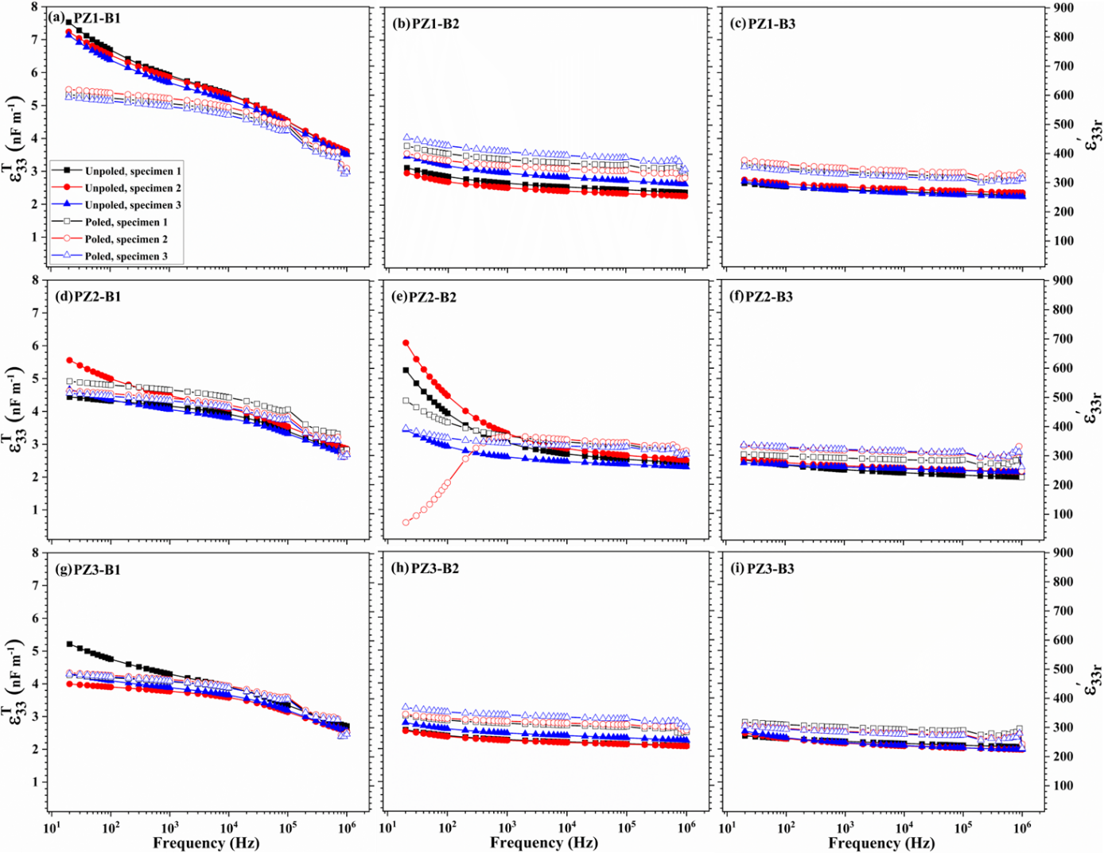
Figure S9. Dependence of real part of longitudinal permittivity under constant stress (ε₃₃^{T}) and ε'_{33r} measured in the unpoled and poled states and in the frequency range of 20 Hz to 1 MHz for composite samples of (a) PZ1-B1, (b) PZ1-B2, (c) PZ-1-B3, (d) PZ2-B1, (e) PZ2-B2, (f) PZ2-B3, (g) PZ3-B1, (h) PZ3-B2, and (i) PZ3-B3.

Section S9 – Elaboration on impedance analysis results
It is well-known that the largest observed phase angle (Θ) correlates to the poling efficiency of ferroelectric-based piezoelectric ceramics, given identical composition and microstructure. For a well poled sample, Θ will cross the zero line from the negative side to the positive side and reach the maximum value of 90°.^{41,42} However, it is evident in Figure 2a-c that Θ did not even cross the zero line. This significant decrease in ΔΘ (phase angle difference between the baseline and the peak) is a partial reflection of the relatively low poling efficiency (see Extended Data Table A1). It is also due to the discontinuity of the filler grains caused by the binders that sit in the intergranular area.
For all the samples, the peaks from the thickness resonance mode are effectively wider than those of the radial mode (see Figure 2d), indicating less damped response in the radial direction compared to that in the thickness direction. The adjusted peak positions (see Figure 2e) across all B1-based samples coincide within the radial and thickness modes, respectively, while those for B2- and B3-based samples do not match. This is a sign of the more uniform microstructure for B1-based samples (see Section S5).
The ratio between ΔΘ for the radial and thickness modes (ΔΘ_{r}/ΔΘ_{th}, see Figure 2f) is smaller than one for B1-based samples, meaning that the radial resonance is weaker than the thickness resonance in these samples. On the other hand, the ratio is larger than one for B2- and B3-based samples, indicating stronger radial resonance than thickness resonance. This anisotropic electromechanical behaviour is the result of different mechanical properties of the binders. As the k_{fitting} values are negative for all samples (see Extended Data Table A1), the filler particles tend to be better connected in the radial direction. In the thickness direction, the connectivity of filler particles is more likely to be interrupted by the binder. This situation is the same in B1-, B2- and B3-based samples. However, the B1 binder is more compliant than the B2 or B3 binder. For instance, the shear moduli of B1, B2 and B3 are approximately 0.03-0.18 GPa, 14-23 GPa and 6 GPa, respectively.^{30,43} (https://page.arkema.com/rs/253-HSZ-754/images/Technical%20Guide%20Piezotech%20RT-TS.pdf) We know that acoustic impedance (Z) is positively related to material density (ρ) and speed of sound (υ), and υ is negatively related to ρ and compliance, that is,
$Z=ρ∙υ$ and $υ=\sqrt{\frac{1}{κ∙ρ}}$ ,
where κ is a form of material compliance. Therefore,
$Z=\sqrt{\frac{ρ}{κ}}$ .
The densities of B1, B2 and B3 are comparable (see Table S1), but B1 can be orders of magnitude more compliant than B2 and B3 and thus B1’s acoustic impedance is smaller than those of B2 and B3. Reduced acoustic impedance implies better mechanical impedance matching. As a result, the resonance in the thickness mode is stronger than the resonance in the radial mode for B1-based samples.

References
1. Wang, J. et al. Ferroelectric domains and piezoelectricity in monocrystalline Pb(Zr, Ti)O3 nanowires. Appl. Phys. Lett. 90, 133107 (2007).
2. Campos, R. V. B. et al. High-Performance Piezoelectric Generator Based on a Monocrystalline LiNbO3 Fiber. Cryst. Growth Des. 25, 672-679 (2025).
3. Panda, P. K. & Sahoo, B. PZT to lead free piezo ceramics: a review. Ferroelectrics 474, 128–143 (2015).
4. Okazaki, K. Developments in fabrication of piezoelectric ceramics. Ferroelectrics 41, 77–96 (1982).
5. Harrison, J. S., Ounaies, Z. & Bushnell, D. M. Piezoelectric polymers. (2001). DOI: 10.1002/0471440264.pst427
6. Smith, M. & Kar-Narayan, S. Piezoelectric polymers: theory, challenges and opportunities. Int. Mater. Rev. 67, 65–88 (2022).
7. Yang, J. Analysis of piezoelectric semiconductor structures. 2020). DOI: 10.1007/978-3-030-48206-0
8. Haydl, W. H., Harker, K. & Quate, C. F. Current oscillations in piezoelectric semiconductors. J. Appl. Phys. 38, 4295–4309 (1967).
9. Kabakov, P., Kim, T., Cheng, Z., Jiang, X. & Zhang, S. The versatility of piezoelectric composites. Annu. Rev. Mater. Res. 53, 165–193 (2023).
10. Akdogan, E. K., Allahverdi, M. & Safari, A. Piezoelectric composites for sensor and actuator applications. IEEE Trans. Ultrason. Ferroelectr. Freq. Control 52, 746–775 (2005).
11. Uchino, K. Piezoelectric composite materials. in Advanced Piezoelectric Materials 353–382 (2017). DOI: 10.1016/B978-0-08-102135-4.00009-6
12. Nelo, M., Peräntie, J., Siponkoski, T., Juuti, J. & Jantunen, H. Upside-down composites: electroceramics without sintering. Appl. Mater. Today 15, 83–86 (2019).
13. Nelo, M. et al. Upside-down composites: Fabricating piezoceramics at room temperature. J. Eur. Ceram. Soc. 39, 3301–3306 (2019).
14. Siponkoski, T., Nelo, M., Ilonen, N., Juuti, J. & Jantunen, H. High performance piezoelectric composite fabricated at ultra low temperature. Compos. Part B Eng. 229, 109486 (2022).
15. Tabeshfar, M. et al. Oxide‐Halide Perovskite Composites for Simultaneous Recycling of Lead Zirconate Titanate Piezoceramics and Methylammonium Lead Iodide Solar Cells. Small Methods 8, 2300830 (2023).
16. Anandakrishnan, S. S. et al. Recycling hazardous and energy-demanding piezoelectric ceramics using an oxide–halide perovskite upside-down composite method. RSC Sustain. 2, 961–974 (2024).
17. Tabeshfar, M., Nelo, M., Anandakrishnan, S. S., Peräntie, J. & Bai, Y. Study on recycling of lead‐based piezoceramics using trimethylchloromethyl ammonium‐based halide perovskite binder. J. Am. Ceram. Soc. 108, e20714 (2025).
18. Padurariu, C. et al. Role of the pore interconnectivity on the dielectric, switching and tunability properties of PZTN ceramics. Ceram. Int. 43, 5767–5773 (2017).
19. Guo, R. et al. Significantly enhanced permittivity and energy density in dielectric composites with aligned BaTiO 3 lamellar structures. J. Mater. Chem. A 8, 3135–3144 (2020).
20. Zhang, Y. et al. Enhanced pyroelectric and piezoelectric properties of PZT with aligned porosity for energy harvesting applications. J. Mater. Chem. A 5, 6569–6580 (2017).
21. Khaliq, J. et al. Effect of the piezoelectric ceramic filler dielectric constant on the piezoelectric properties of PZT-epoxy composites. Ceram. Int. 43, 2774–2779 (2017).
22. Anandakrishnan, S. S. et al. Toward Ecofriendly Piezoelectric Ceramics—Reduction of Energy and Environmental Footprint from Conceptualization to Deployment. Glob. Challenges 7, 2300061 (2023).
23. Sivagnana Sundaram Anandakrishnan, Mikko Nelo, Mohadeseh Tabeshfar, Viktoria Kraft, Neamul Hayet Khansur, J. P. and Y. B. Influence of permittivity between fillers and binders on properties of upside-down composites for recycling purpose. Mater. Adv. (2025). In press. DOI: 10.1039/D5MA00554J
24. Kuzmić, N., Škapin, S. D., Nelo, M., Jantunen, H. & Spreitzer, M. Room temperature fabrication and post-impregnation of LMO-ST composites: Engineering and modeling of dielectric properties. Open Ceram. 16, 100495 (2023).
25. Shao, J., Zhou, L., Chen, Y., Liu, X. & Ji, M. Model-based dielectric constant estimation of polymeric nanocomposite. Polymers (Basel). 14, 1121 (2022).
26. Tsutsumi, N., Okumachi, K., Kinashi, K. & Sakai, W. Re-evaluation of the origin of relaxor ferroelectricity in vinylidene fluoride terpolymers: An approach using switching current measurements. Sci. Rep. 7, 15871 (2017).
27. Gyan, D. S. & Dwivedi, A. Structural and electrical characterization of NaNbO3-PVDF nanocomposites fabricated using cold sintering synthesis route. J. Appl. Phys. 125, 024103 (2019).
28. Okazaki, T., Sada, T., Tsuji, K., Fujioka, Y. & Randall, C. A. BaTiO3-based composites provide new opportunities enabled by the cold sintering process. Jpn. J. Appl. Phys. 62, SM1030 (2023).
29. You, Y.-M. et al. An organic-inorganic perovskite ferroelectric with large piezoelectric response. Science (80-. ). 357, 306–309 (2017).
30. Hu, Y. et al. Ferroelastic-switching-driven large shear strain and piezoelectricity in a hybrid ferroelectric. Nat. Mater. 20, 612–617 (2021).
31. Liu, N. & Su, Y. A comparative study of the phase-field approach in modeling the frequency-dependent characteristics of ferroelectric materials. Acta Mech. 227, 2671–2682 (2016).
32. Yang, S. M. et al. Ac dynamics of ferroelectric domains from an investigation of the frequency dependence of hysteresis loops. Phys. Rev. B—Condensed Matter Mater. Phys. 82, 174125 (2010).
33. Su, Y. & Weng, G. J. The frequency dependence of microstructure evolution in a ferroelectric nano-film during AC dynamic polarization switching. Acta Mech. 229, 795–805 (2018).
34. Park, B. & Seok, S. Il. Intrinsic instability of inorganic–organic hybrid halide perovskite materials. Adv. Mater. 31, 1805337 (2019).
35. Dang, Z.-M. et al. Fundamentals, processes and applications of high-permittivity polymer–matrix composites. Prog. Mater. Sci. 57, 660–723 (2012).
36. Goncharenko, A. V, Lozovski, V. Z. & Venger, E. F. Lichtenecker’s equation: applicability and limitations. Opt. Commun. 174, 19–32 (2000).
37. Guo, J. et al. Cold sintering process of composites: bridging the processing temperature gap of ceramic and polymer materials. Adv. Funct. Mater. 26, 7115–7121 (2016).
38. Mohadeseh Tabeshfar & Sivagnana Sundaram Anandakrishnan. Data of Recycled piezoelectric materials with competitive second-life functional properties. (2025). DOI: https://doi.org/10.23729/fd-eb290daf-14d4-32ce-9fa4-676c2ab33df6
39. William H. Press, Saul A. Teukolsky, William T. Vetterling, B. P. F. Numerical Recipes: The Art of Scientific Computing, Third edition, Chapter 15.
40. Eltouby, P., Shyha, I., Li, C. & Khaliq, J. Factors affecting the piezoelectric performance of ceramic-polymer composites: A comprehensive review. Ceram. Int. 47, 17813–17825 (2021).
41. Wang, T. et al. Enhanced piezoelectricity and temperature stability in LaFeO3‐modified KNN‐based lead‐free ceramics. J. Am. Ceram. Soc. 102, 6126–6136 (2019).
42. Huang, Y., Xue, H., Zheng, T. & Wu, J. Enhanced pyroelectric performance in potassium sodium niobate‐based ceramics via multisymmetries coexistence design. J. Am. Ceram. Soc. 106, 1113–1126 (2023).
43. Lv, H.-P., Liao, W.-Q., You, Y.-M. & Xiong, R.-G. Inch-size molecular ferroelectric crystal with a large electromechanical coupling factor on par with barium titanate. J. Am. Chem. Soc. 144, 22325–22331 (2022).

