Supplementary Materials to the manuscript entitled

Recreational Screen Use and Internalizing Problems from Preadolescence to Young Adulthood: A population-based Cohort and Co-Twin Control Study

Tong Gong¹, Emma Frans¹, Anna Ohlis^{2,3}, Shuyang Yao¹, Ruyue Zhang¹, Anders Nilsson⁴, Yasmina Molero^{1,4}, Miriam A Mosing^{1,5,6}, Isabell Brikell^{1,7,8}, Henrik Larsson^{1,9}, Paul Lichtenstein¹, Lisa B Thorell¹⁰, Patrik KE Magnusson¹, Ralf Kuja-Halkola¹, Yi Lu¹

1 Department of Medical Epidemiology and Biostatistics, Karolinska Institutet, Stockholm, Sweden
2 Department of Global Public Health, Karolinska Institutet, Stockholm, Sweden
3 Center for epidemiology and community medicine, Stockholm Region Stockholm, Sweden
4 Centre for Psychiatry Research, Department of Clinical Neuroscience, Karolinska Institutet & Stockholm Health Care Services, Region Stockholm, Norra Stationsgatan 69, 113 64, Sweden
5 Max Planck Institute of Empirical Aesthetics, Frankfurt am Main, Germany
6 Melbourne School of Psychological Sciences, The University of Melbourne, Victoria, Australia
7 Department of Global Public Health and Primary Care, University of Bergen, Årstadveien 17, 5009 Bergen, Norway
8 Department of Biomedicine, Aarhus University, 8000, Aarhus C, Denmark
9 School of Medical Sciences, Örebro University, Örebro, Sweden
10 Division of Psychology, Department of Clinical Neuroscience, Karolinska Institutet, Nobels Väg 9, 171 77, Stockholm, Sweden

Contents
Supplementary Materials to the manuscript entitled 1
eMethods 4
Clinically ascertained depressive and anxiety disorders from the national registers 4
Covariates 4
Survival analysis 4
Online-only Figures 5
eFigure 1. The Child and Adolescent Twin Study in Sweden (CATSS) flowchart 5
eFigure 2. An example of plausible directed acyclic graph (DAG) used to motivate covariate selections when investigating the cross-sectional associations between screen use with depression and anxiety at age 9. 6
eFigure 3. Frequencies (in relative percentage) of screen use by activities and sex using CATSS-9, -15, and -18 samples. 7
eFigure 4. Patterns of weekday screen use between age 15 and 18 in Sankey Diagrams. 8
eFigure 5. Associations between all patterns of screen use (16 combinations) with depressive and/or anxiety symptoms using CATSS-18 and -24 samples. 9
eFigure 6. Upset plot illustrating the overlap of clinical diagnoses of depression, anxiety, and antidepressant dispensing among the subsets of CATSS-9/15 participants that have ever been diagnosed at hospital inpatient or outpatient care or dispensed at least one package of antidepressant during follow-up period (n=704 for CATSS-9 and n=977 for CATSS-15). 10
eFigure 7. Crude cumulative incidence of clinically ascertained depression, anxiety, and antidepressant dispensing by screen use frequencies on playing games, chat, browsing internet during weekdays at 15 years of age. 11
eFigure 8. Crude cumulative incidence of clinically ascertained depression, anxiety, and antidepressant dispensing by screen use frequencies on playing games, chat, browsing internet during weekend at 15 years of age. 12
eFigure 9. Crude cumulative incidence of clinically ascertained depression, anxiety, and antidepressant dispensing by screen use frequencies on watching TV, video, DVD during weekdays at 15 years of age. 13
eFigure 10. Crude cumulative incidence of clinically ascertained depression, anxiety, and antidepressant dispensing by screen use frequencies on watching TV, video, DVD during weekend at 15 years of age. 14
eFigure 11. Crude cumulative incidence of clinically ascertained depression, anxiety, and antidepressant dispensing by screen use frequencies on playing games at 9 years of age. 15
eFigure 12. Crude cumulative incidence of clinically ascertained depression, anxiety, and antidepressant dispensing by screen use frequencies on chat, downloading music, surfing internet at 9 years of age. 16
eFigure 13. Crude cumulative incidence of clinically ascertained depression, anxiety, and antidepressant dispensing by screen use frequencies on watching TV, video, DVD at 9 years of age. 17
Online-only Tables 18
eTable 1. Detailed information on screen use questions in CATSS. 18
eTable 2. Detailed information on depression, anxiety, and other psychiatric traits assessment instruments used in CATSS. 19
eTable 3. Diagnostic and drug codes used to identify depressive and anxiety disorders, as well as antidepressant dispenses from the register data. 21
References 22

eMethods

Clinically ascertained depressive and anxiety disorders from the national registers
The National Patient Register (NPR), established in 1964, has nearly complete hospital records of psychiatric inpatient care since 1973 and >80% (more specifically nearly 100% for public funded) records of the outpatient specialist care through the entire Sweden since 2001¹. The Prescribed Drug Register (PDR) includes information of all drugs on prescription from primary care or outpatient specialist care, dispensed at pharmacies (July 2005-onwards)². The Cause of Death Register (CDR) has virtually complete national data coverage since 1952³ and includes information such as date of death, place of residence, main and other underlying cause of death based on ICD codes, etc.
Using the unique personal identification numbers of the twins, we linked the consented participants with NPR and PDR data to identify those diagnosed with depressive and/or anxiety disorders and/or dispensed at least one package of antidepressants (see eTable 3 for diagnostic or drug code used). The incident date of the relevant outcome was defined based on the discharge/visit date with the first diagnosis of depressive/anxiety disorders or the dispensing date of the first or second package of antidepressant, anytime from date of questionnaire/interview completion to December 31, 2016 (i.e., the latest record we could retrieve from the NPR). We excluded individuals if they were diagnosed with depressive/anxiety disorders, or dispensed antidepressants prior to the questionnaire/interview time.

Covariates
We obtained twin participants’ calendar year of birth, sex, and zygosity (i.e. monozygotic or dizygotic twins) related information through parental responses to five questions on twin similarity. The algorithm-based zygosity determination has been shown with high validity⁴. Data on parental country of birth were collected in CATSS-9 and -15, we classified as Sweden or abroad. Parental educational attainment, also reported in CATSS-9 and -15, was categorized as compulsory school, high school, or university/higher education, and we used the highest category of each parent reported at either time as the covariates. The civil status of the responding parent, available in CATSS-15 and -18, was categorized as married/cohabiting, single/divorced/separated/widowed/other. To assess adverse childhood experiences, we used responses to the Life Stressor Checklist-Revised in CATSS-9, which captures six indicators: emotional neglect or abuse, physical neglect, physical abuse, sexual abuse, rape, and witnessing family violence.⁵.

Survival analysis
We performed survival analyses on two subsets of populations, i.e. twins born 1994-2000, for whom we could follow up for 1-7 years from the two registers after they participated in CATSS-15 (n=9,524) and twins born 1998-2006, for whom we could follow up for 1-9 years after their parents participated in CATSS-9 (n=15,484). Twins diagnosed with depressive or anxiety disorders, or dispensed antidepressants before 9 or 15 years of age were excluded for survival analyses. We censored individuals either when they died, received the diagnosis of depression /anxiety, or dispensed at least one antidepressant any time before December 31, 2016, or if they remained “at risk” until December 31, 2016 (n=9,373 and 15,470 left). The overlap of the diagnoses with antidepressant dispensing was presented in an Upset plot (see eFigure 5). We plotted the crude cumulative incidence curve during follow-up period by each screen-time use measure at 9 and 15 years. Cox models were then fitted while adjusting for birth year, sex, parental birth country and education, parent-reported adverse childhood experiences at 9 years or civil status at 15 years, as well as parent/self-reported depression and anxiety symptoms at 9 or 15 years of age, and standard errors have been adjusted for twin clustering. We reported the overall associations (adjusted hazard ratios and 95% confidence intervals) between screen use at 9 or 15 years of age and subsequent risk of clinical diagnosed depression/anxiety/any antidepressant dispensing, as well as associations stratified by sex. Sensitivity analyses were performed on the medication dispensing outcome when we restricted to at least two packages of antidepressants.

Online-only Figures

eFigure 1. The Child and Adolescent Twin Study in Sweden (CATSS) flowchart
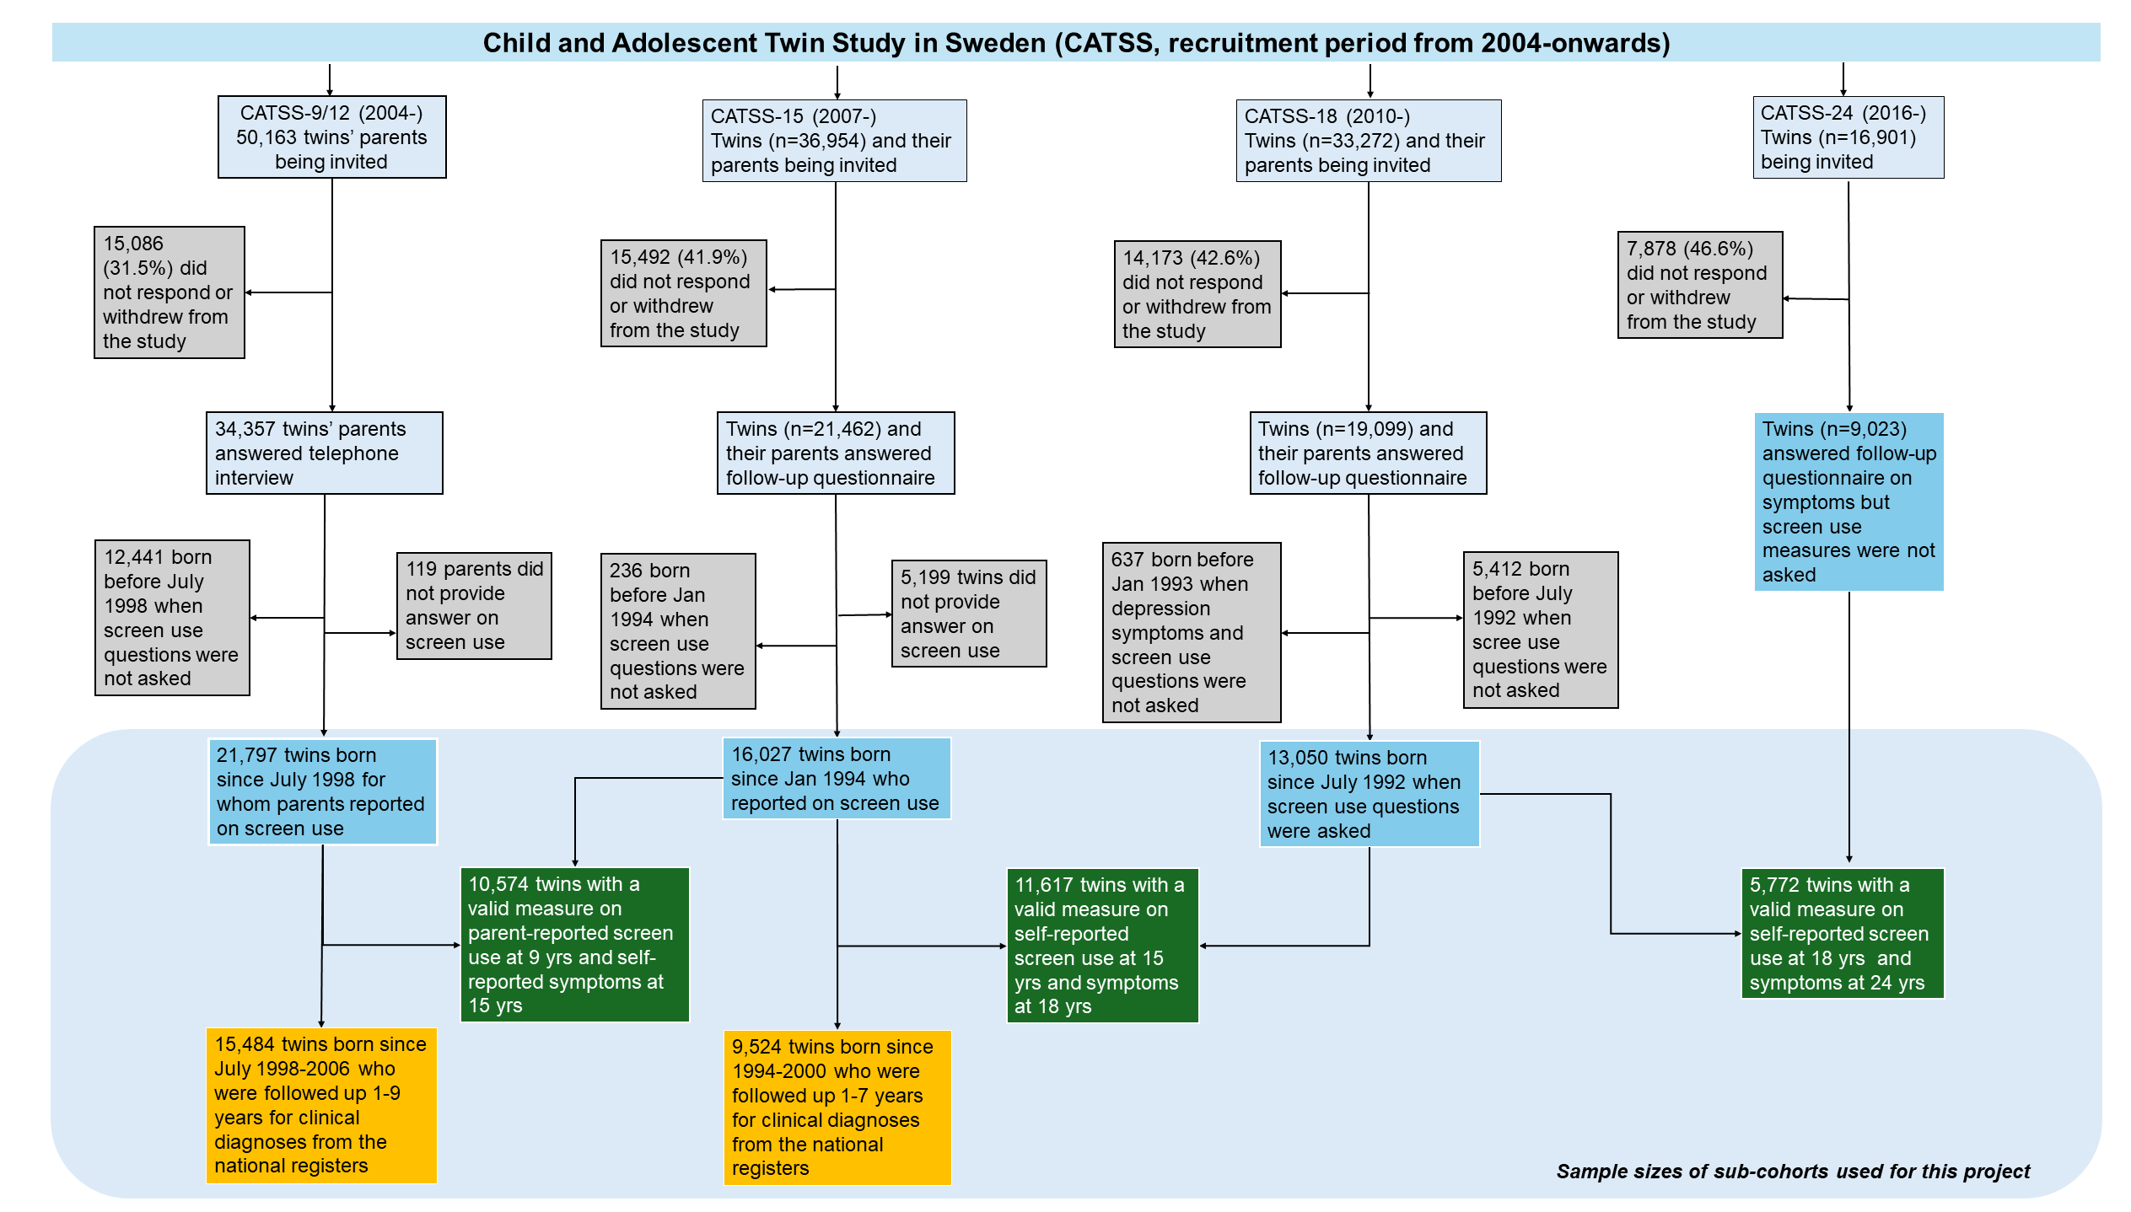

eFigure 2. An example of plausible directed acyclic graph (DAG) used to motivate covariate selections when investigating the cross-sectional associations between screen use with depression and anxiety at age 9.
Given a priori knowledge⁶⁻⁸, we drew this DAG and should control for covariates including calendar year of birth, sex, adverse childhood experience (as a proxy because we did not have earlier symptoms before age 9), parental birth countries, education, and civil status (data not available at age 9 but available at later age). Additional shared genetic liability as well as family environment (e.g. parenting practice), illustrated in two light grey ovals in this DAG, should also be controlled for, which we did via co-twin control design.
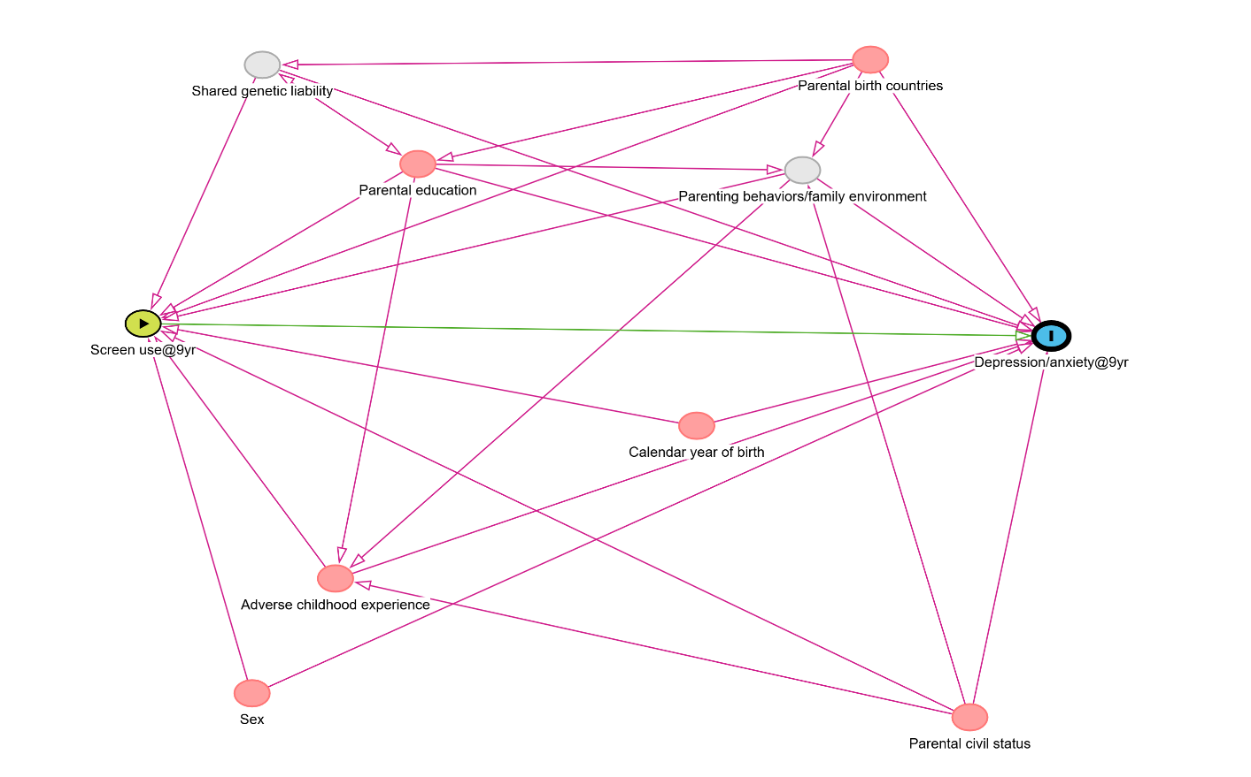

eFigure 3. Frequencies (in relative percentage) of screen use by activities and sex using CATSS-9, -15, and -18 samples.

eFigure 4. Patterns of weekday screen use between age 15 and 18 in Sankey Diagrams.
Two Sankey diagrams illustrate the patterns of weekday screen use between age 15 and 18 (darker green for <2 hours/day, green for 2-4 hours/day, lighter green for 4-6 hours/day, yellow for >6 hours/day) involving A) gaming, chatting, browsing internet, and B) watching TV (also online), video, and DVD. Grey lines depict the physical flows of participants associated with each screen use categories at two time points.
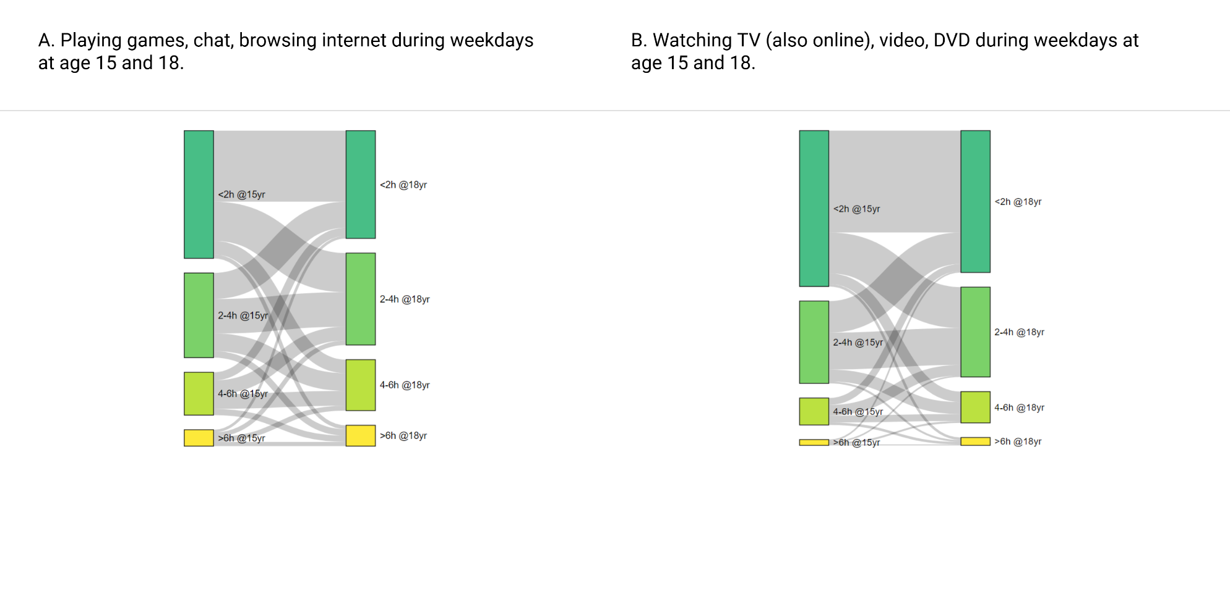

eFigure 5. Associations between all patterns of screen use (16 combinations) with depressive and/or anxiety symptoms using CATSS-18 and -24 samples.
Standardized beta coefficients for depressive (Dep) and anxiety (Anx) symptoms with 95% CIs are presented after fitting generalized estimating equations, and adjusting for birth year, sex, parental birth countries, education, and civil status, as well as twins’ prior depressive/anxiety symptoms.

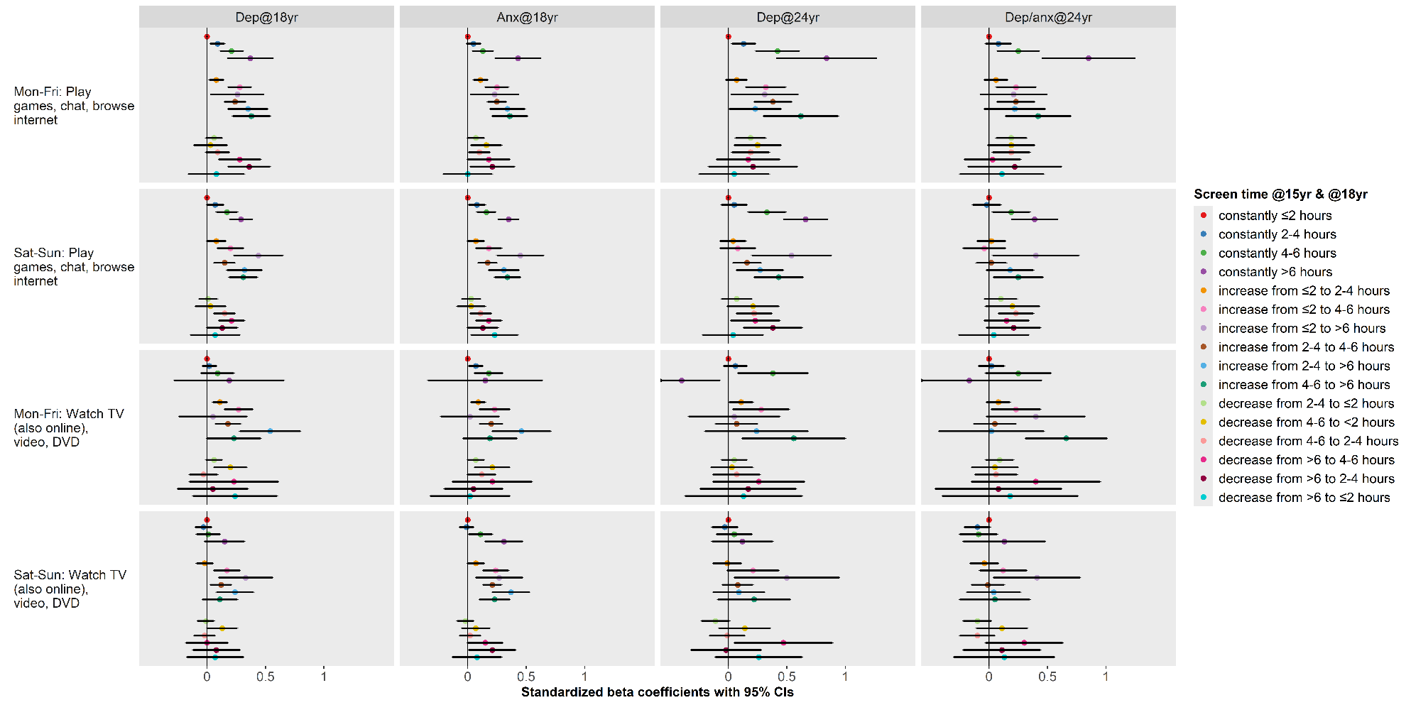

eFigure 6. Upset plot illustrating the overlap of clinical diagnoses of depression, anxiety, and antidepressant dispensing among the subsets of CATSS-9/15 participants that have ever been diagnosed at hospital inpatient or outpatient care or dispensed at least one package of antidepressant during follow-up period (n=704 for CATSS-9 and n=977 for CATSS-15).

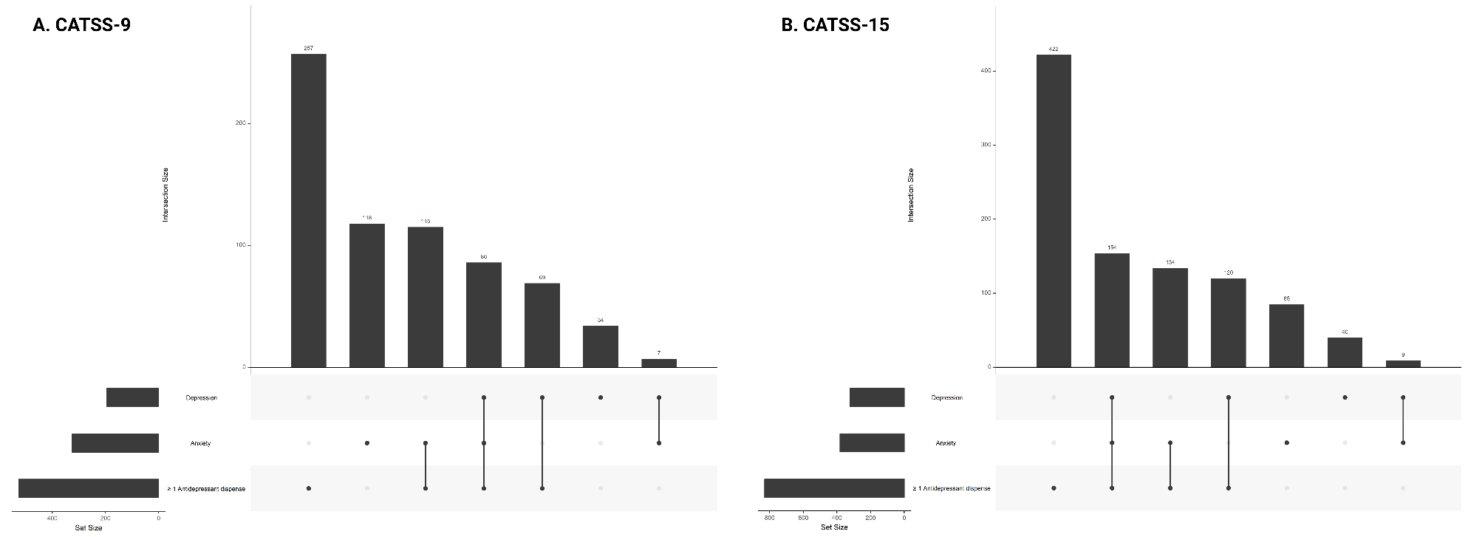

eFigure 7. Crude cumulative incidence of clinically ascertained depression, anxiety, and antidepressant dispensing by screen use frequencies on playing games, chat, browsing internet during weekdays at 15 years of age.
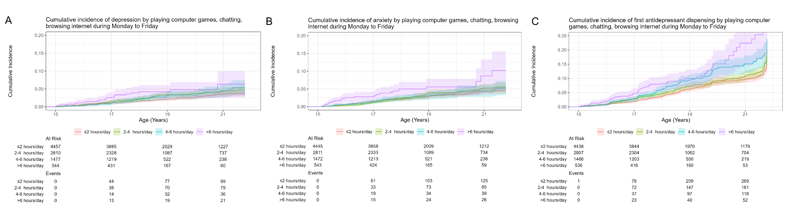

eFigure 8. Crude cumulative incidence of clinically ascertained depression, anxiety, and antidepressant dispensing by screen use frequencies on playing games, chat, browsing internet during weekend at 15 years of age.

eFigure 9. Crude cumulative incidence of clinically ascertained depression, anxiety, and antidepressant dispensing by screen use frequencies on watching TV, video, DVD during weekdays at 15 years of age.
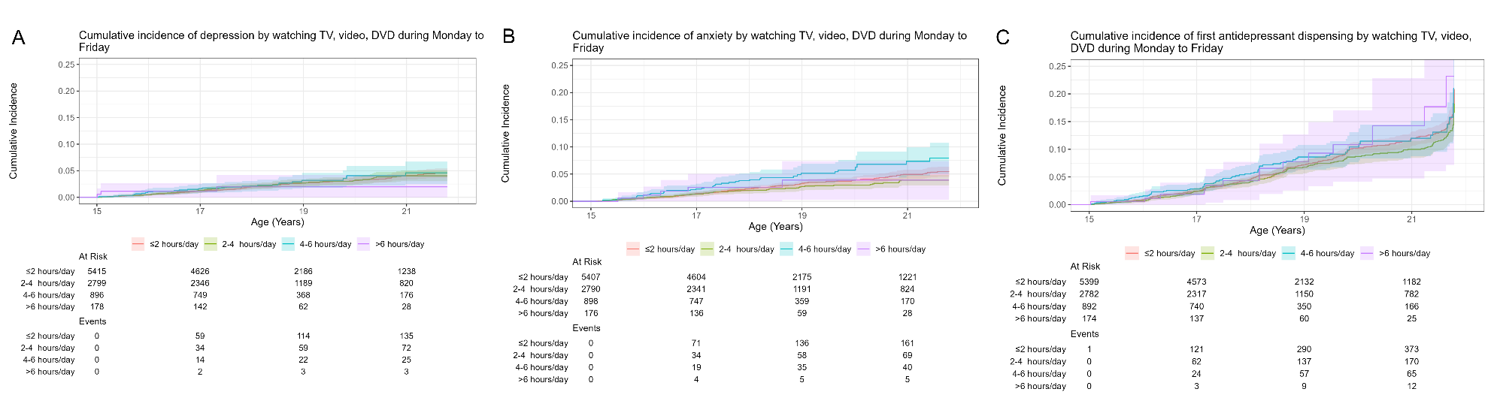

eFigure 10. Crude cumulative incidence of clinically ascertained depression, anxiety, and antidepressant dispensing by screen use frequencies on watching TV, video, DVD during weekend at 15 years of age.
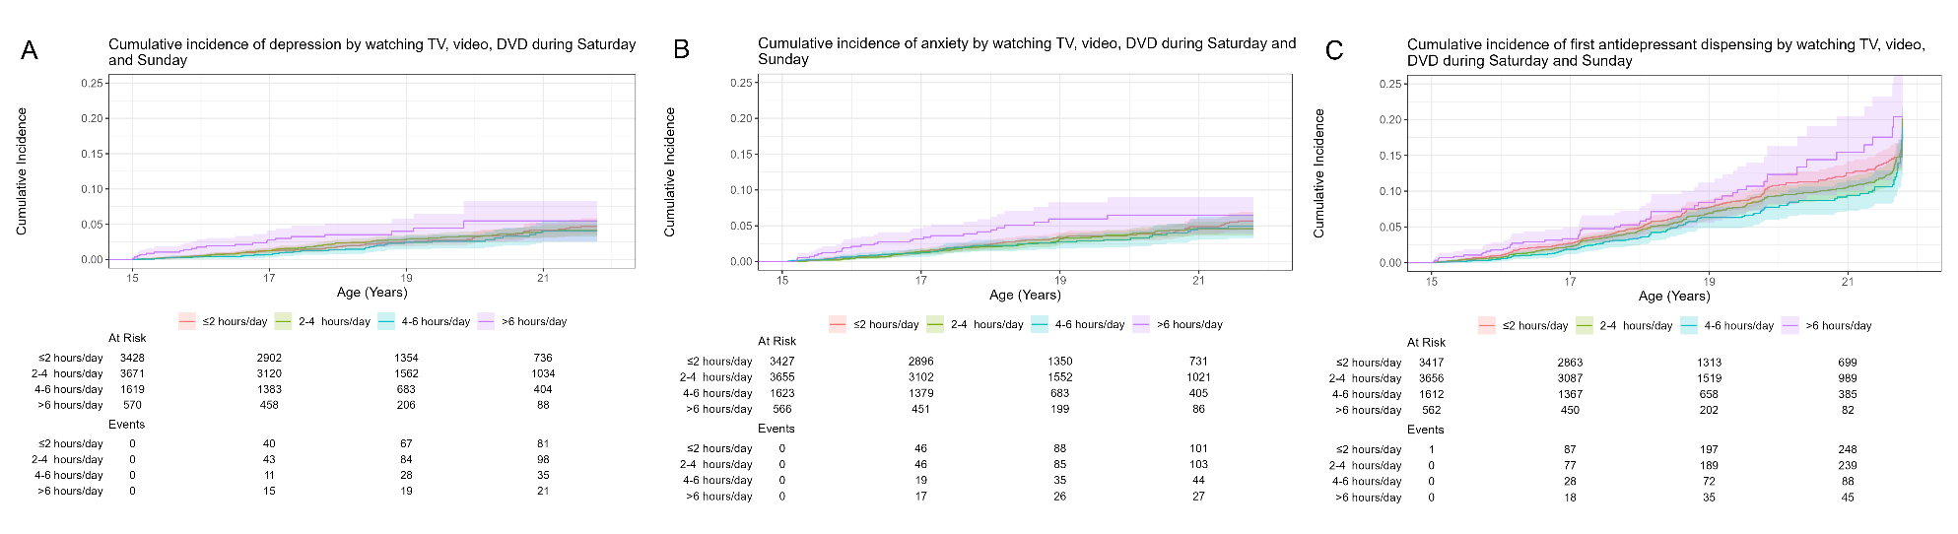

eFigure 11. Crude cumulative incidence of clinically ascertained depression, anxiety, and antidepressant dispensing by screen use frequencies on playing games at 9 years of age.
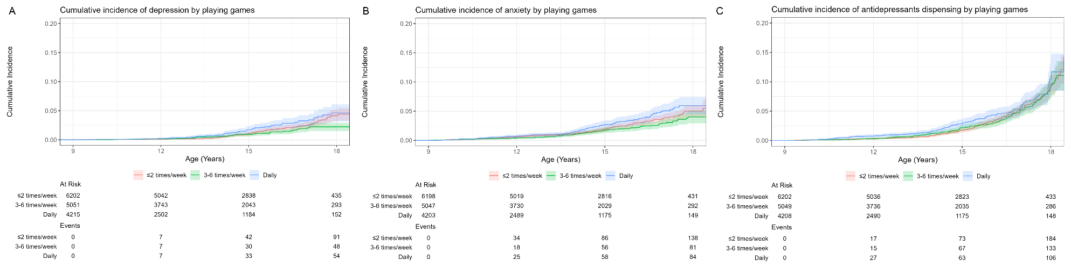

eFigure 12. Crude cumulative incidence of clinically ascertained depression, anxiety, and antidepressant dispensing by screen use frequencies on chat, downloading music, surfing internet at 9 years of age.
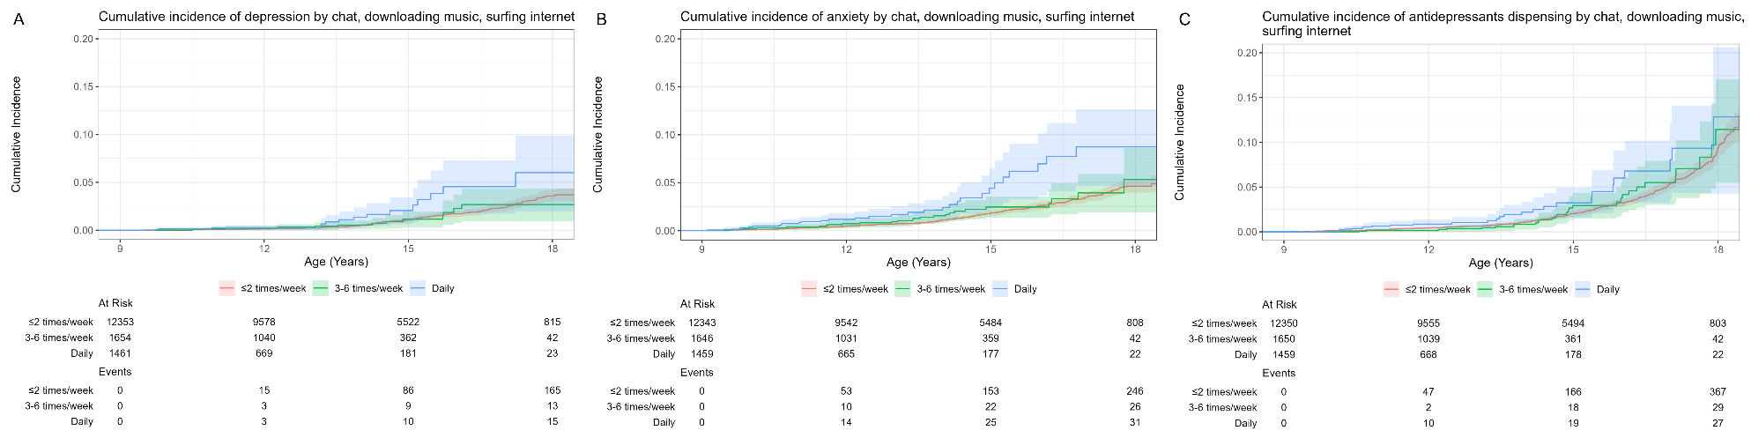

eFigure 13. Crude cumulative incidence of clinically ascertained depression, anxiety, and antidepressant dispensing by screen use frequencies on watching TV, video, DVD at 9 years of age.
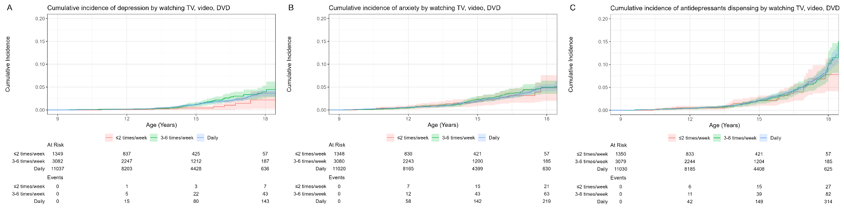

Online-only Tables

eTable 1. Detailed information on screen use questions in CATSS.
Cohort | Original questions | Twin or parent reported | Coding | Birth cohort with data
CATSS-9 | How often does your child engage in the following spare time activities, for at least half an hour per time. Playing computer games | Parent | 0=Never;  some time a month;  1-2 times a week.  1=3-6 times a week.  2=daily.  Equivalent average values: 1.5 times/week  4.5 times/week  7 times/week | 1998.07-ongoing
CATSS-9 | How often does your child engage in the following spare time activities, for at least half an hour per time. Surfing, chatting, downloading music from the internet | Parent |  | 1998.07-ongoing
CATSS-9 | How often does your child engage in the following spare time activities, for at least half an hour per time. Watching TV, videos or DVDs | Parent |  | 1998.07-ongoing
CATSS-9 | How often does your child engage in the following spare time activities, for at least half an hour per time. Playing video games e.g. PlayStation, Xbox, GameCube | Parent |  | 1998.07-ongoing
CATSS-15 | How many hours a day do you use to watch TV (also online), video or DVD? (Mon-Fri) | Twin | 0=Never;  <1h/day;  1-2h/day.  1=2-4h/day.  2=4-6h/day.  3=>6h/day.  Equivalent average values:  1, 3, 5, 7 h/week | 1994.01-ongoing
CATSS-15 | How many hours a day do you use to watch TV (also online), video or DVD? (Sat-Sun) | Twin |  | 1994.01-ongoing
CATSS-15 | How many hours a day do you use to play computer games, video games, chat, blog or surf the internet? (Mon-Fri) | Twin |  | 1994.01-ongoing
CATSS-15 | How many hours a day do you use to play computer games, video games, chat, blog or surf the internet? (Sat-Sun) | Twin |  | 1994.01-ongoing
CATSS-18 | How many hours a day do you use to watch TV (also online), video or DVD? (Mon-Fri) | Twin | 0=Never;  <1h/day;  1-2h/day.  1=2-4h/day.  2=4-6h/day.  3=>6h/day.  Equivalent average values:  1, 3, 5, 7 h/week | 1992.07-ongoing
CATSS-18 | How many hours a day do you use to watch TV (also online), video or DVD? (Sat-Sun) | Twin |  | 1992.07-ongoing
CATSS-18 | How many hours a day do you use to play computer games, video games, chat, blog or surf the internet? (Mon-Fri) | Twin |  | 1992.07-ongoing
CATSS-18 | How many hours a day do you use to play computer games, video games, chat, blog or surf the internet? (Sat-Sun) | Twin |  | 1992.07-ongoing

eTable 2. Detailed information on depression, anxiety, and other psychiatric traits’ assessment instruments used in CATSS.
Cohort | Trait | Twin or parent reported | Instrument and reference | Number of questions | Coding per item | Birth cohort with collected data | Score ranges and distributions in percentiles  (p0, p5, p10, p25, p50, p75, p90, p95, p100)
CATSS-9 | Anxiety | Parent | Screen for Child Anxiety Related Emotional Disorders (SCARED)⁹ | 41 | 0=No  1=Yes, to certain degree  2=Yes | 1998.07-ongoing | 0,0,0,1,4,8,14,19,74
CATSS-9 | Anxiety (incl. separating anxiety) | Parent | Autism - Tics, AD/HD and other Comorbidities inventory (A-TAC)^{10,11} | 8 | 0=No  0.5=Yes, to certain degree  1=Yes | 1992.07-1998.06 | 0,0,0,0,0,0,0,0.5,6.5
CATSS-9 | Depression | Parent | Short Mood and Feelings Questionnaires (SMFQ)¹² | 13 | 0=No  1=Yes, to certain degree  2=Yes | 1998.07-ongoing | 0,0,0,0,0,1,3,6,26
CATSS-9 | Adverse childhood experience | Parent | Life Stressor Checklist - Revised (LSC-R)¹³ | 6 or 10 | 0=No  1=Yes | 7 items 1992.07-1998.06  11 items 1998.07-onwards | 0,0,0,0,0,0,0,1,6
CATSS-15 | Depression or anxiety | Twin | Strength and Difficulties Questionnaire (SDQ, Subscale Emotional Symptoms)¹⁴ | 5 | 0=Not true  1=Somewhat true  2=Certainly true | 1994.01-ongoing | 0,0,0,1,3,5,6,8,10
CATSS-18 | Anxiety | Twin | SCARED⁹ | 38 | 0=No  1=Yes, to certain degree  2=Yes | 1992.07-ongoing | 0,2,4,8,14,23,33,39,76
CATSS-18 | Depression | Twin | Center for Epidemiologic Studies Depression Scale (CESD)¹⁵ | 11 | 0=Rarely or none of the time  1=Some or a little of the time  2=Occasionally or a moderate amount of time  3=Most or all the time | 1993.01-ongoing | 0,4,5,7,9,13,17,19,33
CATSS-24 | Depression or anxiety | Twin | Hospital Anxiety and Depression Scale (HADS)¹⁶ | 14 | 0=Never  1=Sometimes  2=Often  3=Almost always | 1992.07-ongoing | 1,8,9,11,14,17,21,23,35
CATSS-24 | Depression | Twin | CESD revised¹⁷ | 20 | 0=Not at all or less than 1 day a week  1=1-2 days a week  2=3-4 days a week  3=5-7 days a week  4=Nearly every day for two weeks | 1992.07-ongoing | 0,0,1,3,8,16,29,38,76

eTable 3. Diagnostic and drug codes used to identify clinical outcomes of internalizing conditions from the register data.
Trait/Drug | ICD-9 codes (used 1987-1997) | ICD-10 codes (used 1997-)
Depression | 296B, 300E | F32, F33, F34, F38, F39
Anxiety | 300 (excluding 300D) | F40, F41, F42, F44
 | Anatomical Therapeutic Chemical (ATC) code
Antidepressants | N06A

References
1. Ludvigsson JF, Andersson E, Ekbom A, et al. External review and validation of the Swedish national inpatient register. BMC Public Health. 2011;11:450. doi:10.1186/1471-2458-11-450
2. Wallerstedt SM, Wettermark B, Hoffmann M. The First Decade with the Swedish Prescribed Drug Register - A Systematic Review of the Output in the Scientific Literature. Basic Clin Pharmacol Toxicol. Nov 2016;119(5):464-469. doi:10.1111/bcpt.12613
3. Brooke HL, Talbäck M, Hörnblad J, et al. The Swedish cause of death register. Eur J Epidemiol. Sep 2017;32(9):765-773. doi:10.1007/s10654-017-0316-1
4. Lichtenstein P, De Faire U, Floderus B, Svartengren M, Svedberg P, Pedersen NL. The Swedish Twin Registry: a unique resource for clinical, epidemiological and genetic studies. Journal of internal medicine. Sep 2002;252(3):184-205. doi:10.1046/j.1365-2796.2002.01032.x
5. Daníelsdóttir HB, Aspelund T, Shen Q, et al. Adverse Childhood Experiences and Adult Mental Health Outcomes. JAMA psychiatry. 2024;81(6):586-594. doi:10.1001/jamapsychiatry.2024.0039
6. Riehm KE, Feder KA, Tormohlen KN, et al. Associations Between Time Spent Using Social Media and Internalizing and Externalizing Problems Among US Youth. JAMA psychiatry. 2019;76(12):1266-1273. doi:10.1001/jamapsychiatry.2019.2325
7. Khouja JN, Munafò MR, Tilling K, et al. Is screen time associated with anxiety or depression in young people? Results from a UK birth cohort. BMC Public Health. 2019/01/17 2019;19(1):82. doi:10.1186/s12889-018-6321-9
8. Xu J, Baldwin J, Hughes A, Herbert A, Munafo MR, Howe LD. Exploring genetic confounding of the associations between excessive screen time and depressive symptoms in adolescence and early adulthood. medRxiv. 2024:2024.12.02.24318295. doi:10.1101/2024.12.02.24318295
9. Hale WW, 3rd, Raaijmakers Q, Muris P, Meeus W. Psychometric properties of the Screen for Child Anxiety Related Emotional Disorders (SCARED) in the general adolescent population. Journal of the American Academy of Child and Adolescent Psychiatry. Mar 2005;44(3):283-90. doi:10.1097/00004583-200503000-00013
10. Hansson SL, Svanstrom Rojvall A, Rastam M, Gillberg C, Gillberg C, Anckarsater H. Psychiatric telephone interview with parents for screening of childhood autism - tics, attention-deficit hyperactivity disorder and other comorbidities (A-TAC): preliminary reliability and validity. The British journal of psychiatry : the journal of mental science. Sep 2005;187:262-7. doi:10.1192/bjp.187.3.262
11. Larson T, Anckarsater H, Gillberg C, et al. The autism--tics, AD/HD and other comorbidities inventory (A-TAC): further validation of a telephone interview for epidemiological research. BMC psychiatry. 2010;10:1. doi:10.1186/1471-244x-10-1
12. Turner N, Joinson C, Peters TJ, Wiles N, Lewis G. Validity of the Short Mood and Feelings Questionnaire in late adolescence. Psychol Assess. Sep 2014;26(3):752-62. doi:10.1037/a0036572
13. Wolfe J, Kimerling, R., Brown, P. J., Chrestman, K. R., & Levin, K. Life Stressor Checklist--Revised (LSC-R) [Database record]. APA PsycTests.
14. Pedrelli P, Blais MA, Alpert JE, Shelton RC, Walker RS, Fava M. Reliability and validity of the Symptoms of Depression Questionnaire (SDQ). CNS Spectr. Dec 2014;19(6):535-46. doi:10.1017/s1092852914000406
15. Radloff LS. The CES-D Scale: A self-report depression scale for research in the general population. Applied Psychological Measurement. 1977;1(3):385-401. doi:10.1177/014662167700100306
16. Zigmond AS, Snaith RP. The hospital anxiety and depression scale. Acta Psychiatr Scand. Jun 1983;67(6):361-70. doi:10.1111/j.1600-0447.1983.tb09716.x
17. Van Dam NT, Earleywine M. Validation of the Center for Epidemiologic Studies Depression Scale--Revised (CESD-R): pragmatic depression assessment in the general population. Psychiatry Res. Mar 30 2011;186(1):128-32. doi:10.1016/j.psychres.2010.08.018

