Electronic Supplementary Information (ESI)

A sacrificial additive agent mediated strategy for high performance sodium ion capacitor
Zhaowen Huangª, Xiaolin Liª, Yang Hu^{b}, Jingbo Liu^{a*} Manlan Guoª, Fenglin Wangª, Xianjie Yangª, Longwen Chenª, Youpeng Li^{a*}
ªSchool of Energy and Automotive Engineering, Shunde Polytechnic University, Foshan 528300 China.
^{b}Qing Yun Senior High School, shunde, Foshan, 528313, China.
*Corresponding author, E-mail: youpli@163.com (Y. Li); liu.jingbo@qq.com (J. Liu)

Experimental
1. Preparation of composite di-sodium squarate-AC electrode
Di-sodium squarate salt was synthesized using the acid 3,4-dihydroxy-3-cyclobutene-1,2-dione and sodium carbonate with 1:1 molar ratio in 80 mL deionized water to stir overnight. Then, the deionized water was removed by using a Buchi®rotavapor and dried under a vacuum at 60 °C.
To prepare composite positive electrodes, 0.40 g of di-sodium squarate, 0.40 g of commercial Kuraray activated carbon (AC), 0.15 g of carbon black, and 0.05 g of Polytetrafluoroethylene (PTFE) powder were mixed in a mortar to obtain the products. The final composition consists of 40 wt% of di-sodium squarate, 40 wt% of AC, 15 wt% of Super C and 15 wt% of PTFE, which was rolled between two plastic foils to form a self-standing sheet with thickness of 120 μm. Self-standing discs (diameter = 16 mm) or square electrodes (2 cm × 2 cm) were cut from the sheet inside the glove box (the ppm of water and oxidation below 0.1) by using hollow punchers, respectively. Then, self-standing square electrodes (2 cm × 2 cm) were attached to an Al foil (thickness 35 µm) and coated with conductive glue. Finally, the electrodes were dried under vacuum at 120°C for 12 h.
2. Preparation of hard carbon negative electrodes
A slurry was prepared by mixing 0.91 g of commercial Kureha hard carbon, 0.08 g of PVDF solution dispersed in 2 mL 1-methyl-2-pyrrolidinone and 0.01 g of carbon black for 15 minutes. The final composition of the negative electrode was 91 wt.% of hard carbon or graphite, 8 wt.% of PVDF, and 1 wt.% of carbon black. Next, the slurry was coated on Al foil and dried under vacuum at 120 °C for 12 h. Next, the coated Al foil was calendared with a laboratory roll press until reaching a thickness of approximately 70 μm, allowing the electrode material density increased and contacting with the current collector to be improved. Finally, negative electrodes were cut with the size of 2 cm × 2 cm.
3. Assembly of sodium ion capacitor
When considering the device's packaging, adjusting the quality of the positive and negative electrodes is very important. The pouch-type di-sodium squarate-AC//hard carbon is assembled with di-sodium squarate-AC positive electrode, and the negative electrode was hard carbon, respectively. The electrolyte for Na⁺ capacitors is 1 mol L⁻¹ NaClO₄ in EC:PC (vol. ratio 1:1).
The positive and negative electrodes (2 cm × 2 cm), coated by AC(YP-50F) reference electrode (92.5 wt% of YP-50F, 2.8 wt% of Super C, 4.7 wt% of PVDF; 1 cm × 2 cm) and two glass microfiber membranes GF/A (3 cm × 4 cm), were cut and dried under vacuum at 120 °C for 12 h in the glass oven (Büchi B-585). For both electrodes, two pieces of GF/A separator and YP-50F reference electrode were introduced in a pouch cell consisting of Al laminated film (5 cm × 30 cm), and 2.0 mL of electrolyte was introduced inside the cell. Afterward, each cell was degassed for 12 s under vacuum before closing and sealing with a Vacuum Packer. After assembly, the pouch cells were allowed to stabilize at open circle voltage (OCV) for 12 h to enable the electrolyte to penetrate the porosity of the electrodes. The oxidation of the squarate anion and pre-sodiation of the anodic host was performed by charging the di-sodium squarate-AC//hard carbon cells at C/20 (where C corresponds to the theoretical capacity of di-sodium, i.e. 339 mAh g⁻¹) until reaching cell voltage of 3.9 V for sodium-ion capacitor. Afterward, the sodium-ion capacitors were conditioned by floating at the cut-off voltage for 5h. Finally, the sodium-ion capacitors were continually charged and discharged at 2 A g⁻¹ (based on the per total mass of the two electrodes) for cycling performance.
4. Material and electrodes characterizations
The crystal structures of di-sodium squarate are measured with a D8 X-ray diffraction (Bruker AXS). The vibrational bands of di-sodium squarate powders and electrodes are carried out by a Raman spectroscope. Electrochemical mass spectrometry was used to test the gas evolution during the oxidation of di-sodium squarate. Morphological characterization was conducted using a scanning electron microscope (SEM, Quanta FEG 250) equipped with energy-dispersive X-ray spectroscopy (EDS).
5. Electrochemical measurements
The electrochemical performance of the sodium-ion capacitors is tested using cyclic voltammetry at 0.05 mV s⁻¹ and chronopotentiometry at C/20 in the potential range from ca. 2.5 V to 4.1 V.

Figures
1-Raman spectrum on Na₂C₄O₄.
Synthesized Na₂C₄O₄ powder was carried out by Raman spectroscopy with DXR-2 computer-controlled Raman microscope (ThermoFisher Scientific®, USA). The laser was operating at 532 nm from 250 cm⁻¹ and 2000 cm⁻¹.
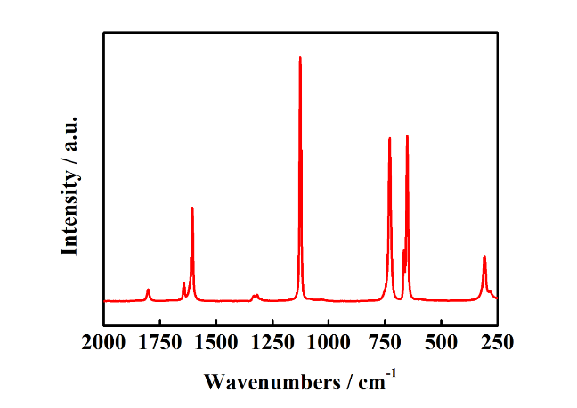
Fig. S1. Raman spectra of Na₂C₄O₄ powder.

Table S1. Experimental vibrational bands of Na₂C₄O₄ salt with respective tentative assignment
Na₂C₄O₄ salt
Wavenumbers [cm⁻¹] | Tentative assignment
1803 | v (C=O)
1644 | v (C=C)
1606 | v (C=C) + v (C=O)
1127 | v (C-C)
729 | Ring breathing
651 | δring
307 | δ(CO)

2-Nitrogen adsorption-desorption isotherms at 77 K and pore size distribution of positive electrode carbon
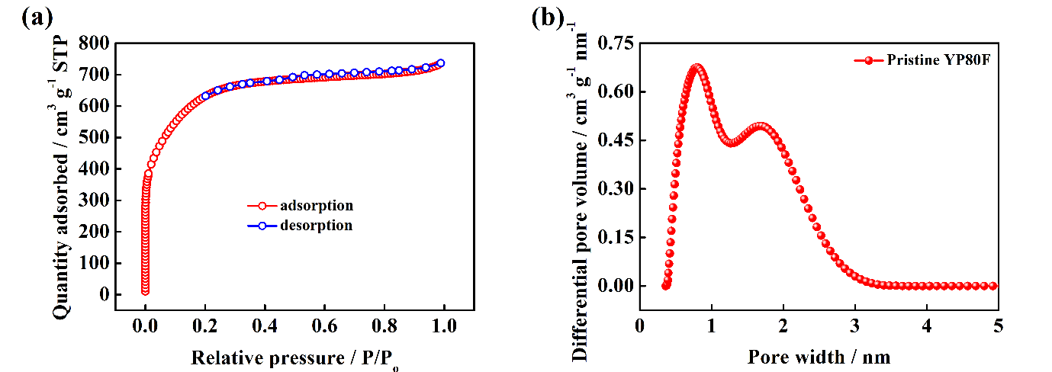
Fig. S2. (a) N₂ adsorption-desorption isotherms of pristine activated carbon (YP80F) at 77 K, (b) pore size distribution of pristine activated carbon (YP80F).

3-Galvanostatic discharge and charge of a HC (hard carbon) electrode.
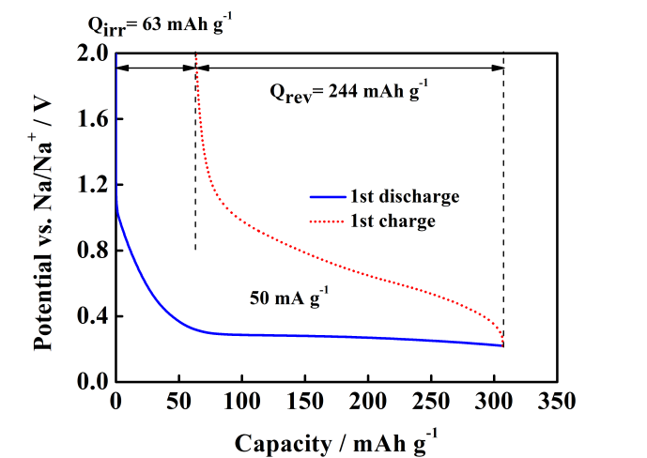
Fig. S3. Galvanostatic discharge and charge of a HC electrode at 50 mA g⁻¹ using a sodium disk as counter/reference electrode and NaClO₄; EC/PC as electrolyte.
Table S2. Calculation of negative/positive electrode capacity ratio of NIC
 | Na₂C₄O₄ | YP80F | HC
Mass of materials | 5.31 mg | 4.13 mg | 5.34 mg
Capacity of materials | 340 mAh g⁻¹ | 60 mAh g⁻¹ | 358 mAh g⁻¹
Electrode capacity | 1.805 mAh | 0.248 mAh | 1.912 mAh
Electrode capacity ratio (negative/positive) | 7.7

4-Impedances of sodium ion capacitor
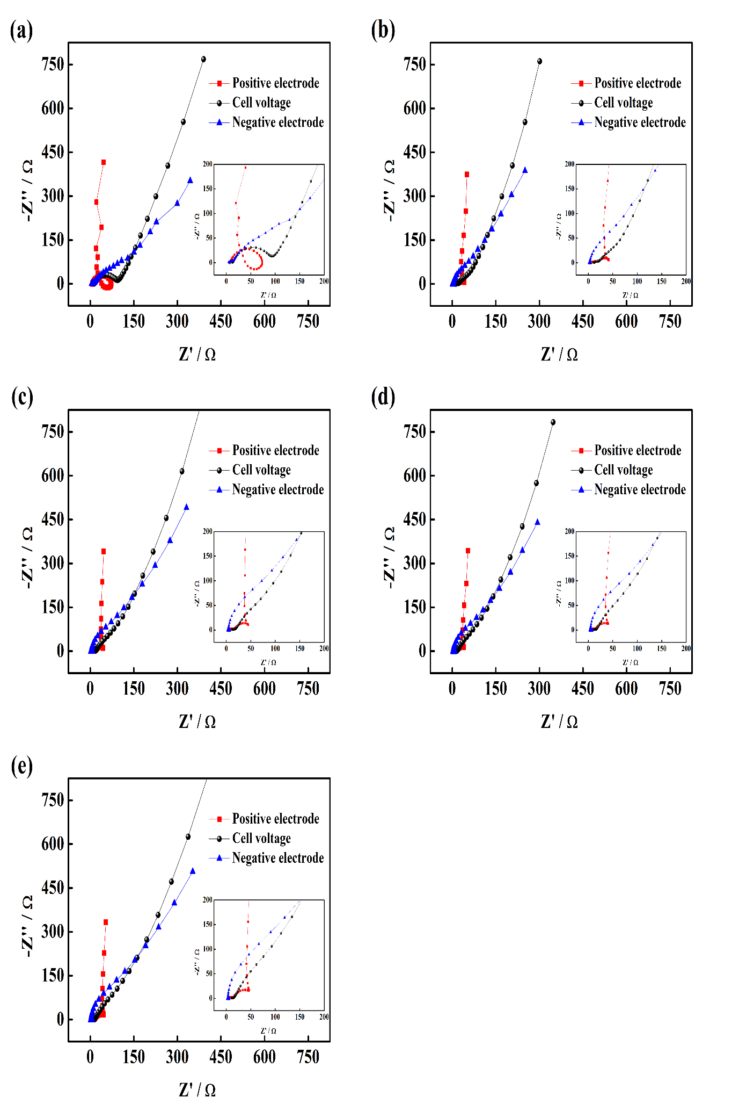Fig. S4. Impedance of YP80F//Na_{2.15}(HC) NIC (a) before cycle, (b) after 500 cycles. The black, red and blue lines represent the impedance of cell voltage, positive and negative electrodes, respectively. The electrolyte was NaClO₄; EC/PC and a sodium pin was used as reference electrode.

5-ESR and EDR of cell from discharge curve and impedance
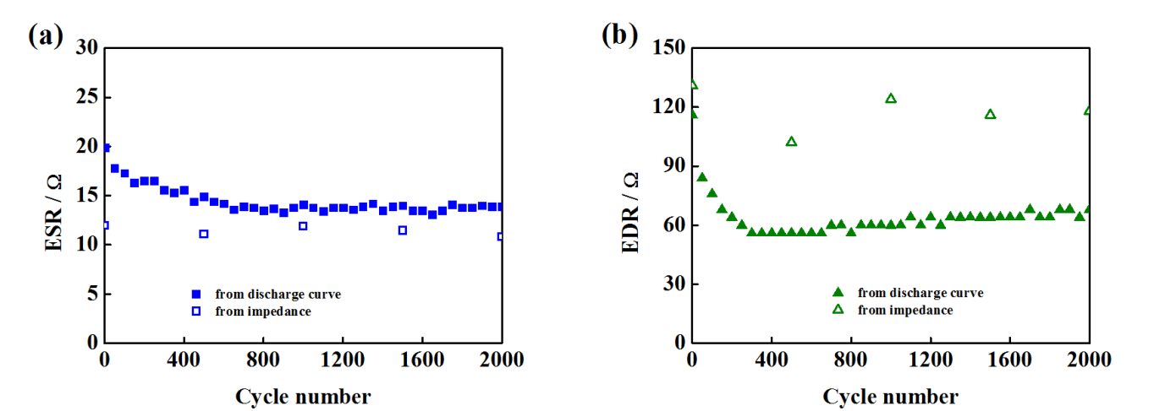
Fig. S5. ESR and EDR of YP80F//Na_{2.15}(HC) NIC from discharge curve and impedance during cycling.

Table S1 The electrochemical performance comparison of NIC with other reported anode materials in NICs.
Types of materials | Cycling performance |  | Rate performance |  | Ref.
Types of materials | Capacity(mAh g⁻¹)/cycles | Current (A g⁻¹) | Energy density (Wh kg⁻¹) | Power density (W kg⁻¹) | Ref.
RGO400 | 166/100 | 1 | 48 | 10896 | [19]
MnS Nanocubes | 357/1000 | 1 | 49 | 5136 | [20]
TiN | 160/100 | 0.1 | 38 | 4400 | [21]
FeVO | 153/4000 | 0.1 | 20 | 5200 | [22]
Doped Carbon | 260/10000 | 0.4 | 13.7 | 180 | [23]
MoS₂-Carbon | 29.2/10000 | 2 | 40.4 | 2500 | [24]
TiO₂/Sheared  CNT | 136/1000 | 0.3 | 54.9 | 1410 | [25]
This work | 333/13600 | 1 | 59 | 1500

