Supplementary data
The effect of different boron deficiency stress time on the growth and development of sugar beet root system
Compared with normal boron treatment, boron deficiency inhibited the root elongation of sugar beet varieties with different boron efficiency. On the first day of stress, the difference between the two varieties was small, and the root elongation of the H variety was significantly better than that of the boron inefficient sugar beet variety. On the 3rd day of stress, the treatment of boron deficiency inhibited the growth of lateral roots and reduced the number of roots forks. With the increase of stress time, boron deficiency hindered root elongation, boron deficiency also caused the lateral roots of plants to be tightly distributed and shorter in root length.
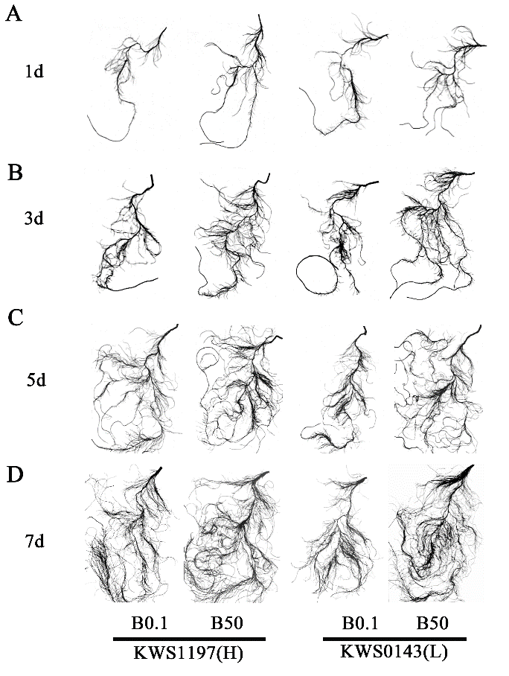
Fig.S1 The effect of different boron deficiency stress time on root morphology
Note: The figure shows that the seedlings of different boron-efficiency sugar beet varieties under the stress treatment of boron deficiency: (A) The root morphology of sugar beet seedlings with 8d seedling age after 1d of stress treatment; (B) stress treatment 3d, seedling age 10d; (C) stress treatment 5d, seedling age 12d; (D) stress treatment 7d, seedling age 14d.
The influence of boron deficiency on root morphology
Further analysis of the root scan data showed that compared with normal boron treatment, boron deficiency significantly reduced the root length ratio of the L variety (32.18%), and the root length ratio of the H variety decreased by 27.94% (Fig. S2A); Boron deficiency significantly reduced the root fineness of the two varieties. The two sugar beet varieties reduced by 51.85% and 46.14% respectively (Fig. S2B); Boron deficiency significantly reduced the root tissue density of the H variety, resulting in a decrease of 37.50%. Boron deficiency caused a 31.03% reduction in the root tissue density of L varieties (Fig. S2D); boron deficiency also reduced the specific root length of the two sugar beet varieties, resulting in a reduction of 22.09% and 21.95% for the two varieties, respectively; boron deficiency caused L The specific root surface area of the variety increased by 38.33%, but it had no effect on the specific root surface area of the H variety, and decreased by 0.14% (Fig. S2F).
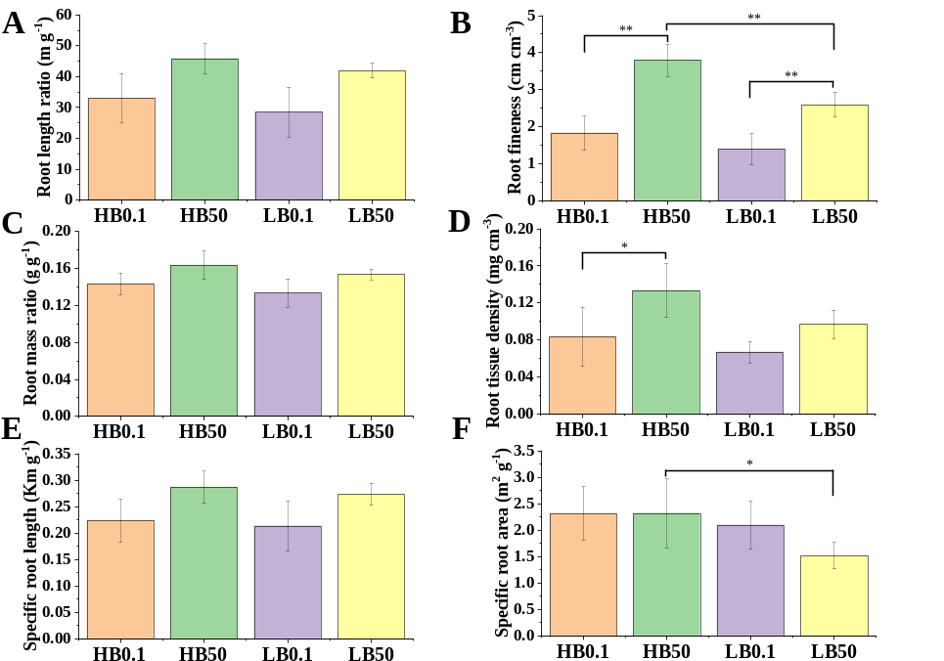
Fig. S2 The effect of boron deficiency on the morphological indexes of sugar beet roots
Note: The effect of boron deficiency on (A) root length ratio; (B) root fineness; (C) root mass ratio; (D) root tissue density; (E) specific root length; (F) specific root surface area.
Gene specific primer list
In order to verify the accuracy and reproducibility of the Illumina RNA-seq results, 14 representative genes, such as those involved in cell wall synthesis, regulation of POD enzymes, and carbon and nitrogen metabolism, were selected to pass real-time fluorescent quantitative PCR (qRT-PCR) Verify the relative expression levels of these genes. The list of gene-specific primers is shown in the following table:
Table S1 Specific qRT-PCR primers
NO. | Gene ID | Forward primer  (F-primer) | Reverse primer  (R-primer)
1 | LOC104895441 | cctccgccagctctataaatc | CTGGGCTGTGATGGCATT
2 | LOC104888246 | ccaacaggatggatagagtgg | TTCTGCATCTTCCCTAGACATGT
3 | LOC104908274 | tgcagcccctagattaccaa | TCGCCTTGCTTCATAGCATA
4 | LOC104895312 | cgagcaaacaaggatagatcg | AAAGAAGGATCATCTGCGAGA
5 | LOC104908142 | tgctcgaggtttgaccataa | CCGCACATACCCTTAAGGTTA
6 | LOC104888143 | tcttagccaaccgaggctt | ATTTCTCCAGCAGAGCCAGTAA
7 | LOC104908318 | acaagcaattcttcactcagacc | TTAGTTGGCTCTCCTGCAATT
8 | LOC104900294 | tcttgcacacaatggcgt | AACCTGTGAGGACACCAATTCTA
9 | LOC104887841 | tgagttcagagaacgagtgaagg | GAGGTCCACAGGTGAGTGCTA
10 | LOC104903729 | acgctactagcacatagtgcga | ATTGGTGGAGGACAATAGCCT
11 | LOC104883129 | tgacggttcattatttgcgaa | GAATGTGATGCAGCAACAACA
12 | LOC104886961 | tactacgatggtcgctactgga | GATGCATTGCACTTGACGA
13 | LOC104894044 | tgtgcttatgtggagtcgactt | TAGCCTTGAGTTCAGGCTTCA
14 | LOC104898474 | agtaccctcaaggcctggtc | GAAGGCTCTCAGAGGCATCA
15 | GAPDH | gctttgaacgaccacttcgc | ACGCCGAGAGCAACTTGAAC
Expression of genes related to boron absorption and transfer in roots
Gene quantification of related candidate genes such as aquaporins NIP5-1, NIP6-1, NIP7-1, BOR2, BOR4, and BOR7 in the beet root system showed that NIP5-1 and NIP6-1 were up-regulated in the two comparison groups. While NIP7-1 and BOR4 were down-regulated in the HB0.1 vs HB50 comparison group, but BOR4 (LOC104904615) was up-regulated in the LB0.1 vs LB50 comparison group; BOR7 was down-regulated in the HB0.1 vs HB50 comparison group, and in LB0 .1 vs. LB50 up-regulated expression in the comparison group.
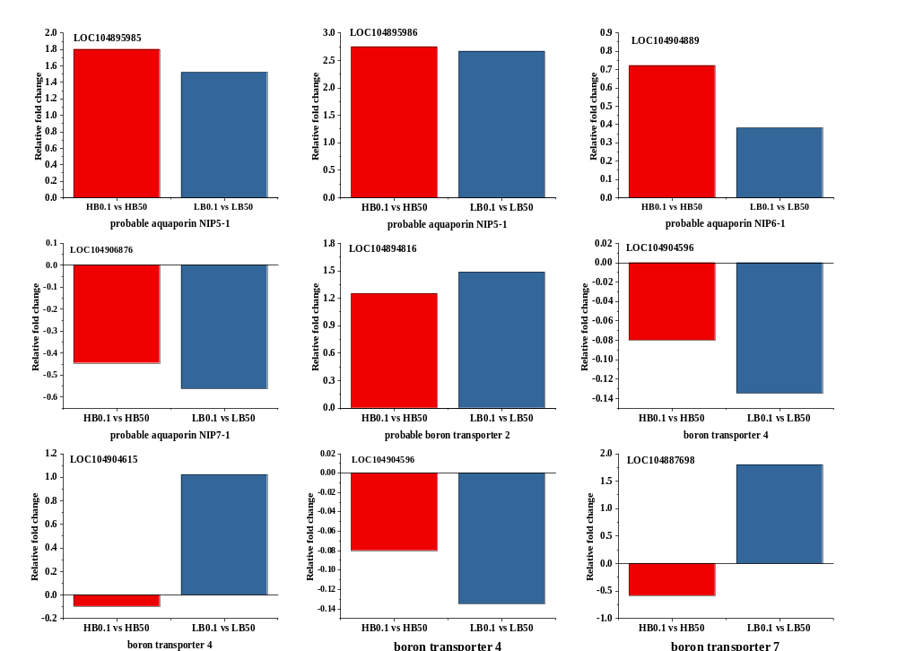
Fig. S3 Effect of boron deficiency on the expression of genes related to boron absorption and transportation in the roots of different boron efficiency sugar beet variety

Boron deficiency regulates hormone-related genes
Further analysis of the 30 DEGs related to plant hormone signal transduction pathways was identified as plant hormone-related genes, which play an irreplaceable role in controlling plant growth and mediating stress response. The auxin-responsive protein IAA33 (LOC104902411), auxin response factor 5 (LOC104905779) and abscisic stress-ripening protein 2 (LOC104895990) were upregulated in the two comparison groups. In contrast, auxin-responsive protein IAA32 (LOC104884870) and The abscisic stress-ripening protein 3 (LOC104895972) was specifically down-regulated in the H variety, and the gene expression was -1.915-fold and -0.16-fold. The abscisic stress-ripening protein 2 (LOC104895999 and LOC104895972) was specifically upregulated in L variety. IAA-amino acid hydrolase ILR1 (LOC104898277) was up-regulated in the two comparison groups. IAA-amino acid hydrolase ILR1-like 4 (LOC104903695) and IAA-amino acid hydrolase ILR1-like 5 (LOC104904730) are up-regulated in H variety.
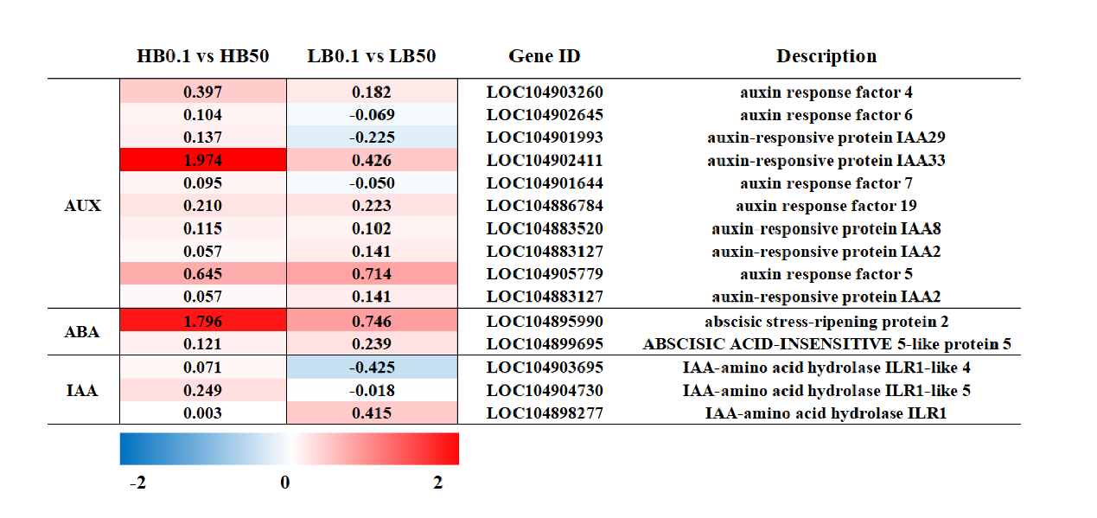Fig. S4 The effect of boron deficiency on the expression of hormone-related genes. The heat map shows the differential regulation of auxin (AUX), abscisic acid (ABA) and indoleacetic acid (IAA)related genes in different boron efficiency sugar beet varieties under the treatment of boron deficiency. The scale color represents Log₂(fold change). The red in the figure indicates that the gene is up-regulated, and the blue indicates that the gene is down-regulated.
Regulation of boron deficiency on candidate genes related to transporters
Transporters mediate active or passive transport of stress-induced signaling molecules such as hormones, ions, and osmolytes. ATP-dependent transporters like ABC transporter B family member 11 (LOC104902345), putative ABC transporter B family member 8 (LOC104902295), ABC transporter C family member 10-like (LOC104892207) were highly up-regulated in two varieties. However, ABC transporter B family member 15-like (LOC104887441), ABC transporter C family member 3 (LOC104894186) and ABC transporter C family member 14-like (LOC104883717) were specially down-regulated in L variety, and the expression of genes were -0.295-fold, -0.228-fold and -0.107-fold, respectively. The dual affinity nitrate protein transporters NRT1/ PTR FAMILY 6.2 (LOC104902051), protein NRT1/ PTR FAMILY 5.6 (LOC104901970), protein NRT1/ PTR FAMILY 5.5-like (LOC109135722 and LOC104895489) and protein NRT1/ PTR FAMILY 2.9 (LOC104894118) were up-regulated in two varieties, the highest expression level of the gene was 1.725-fold. There also found some genes like protein NRT1/PTR FAMILY 5.5-like (LOC109135723), protein NRT1/PTR FAMILY 6.1 (LOC104897451) and protein NRT1/ PTR FAMILY 2.11 (LOC104894119) were down-regulated in L variety, the lowest expression level of gene was -1.909-fold.
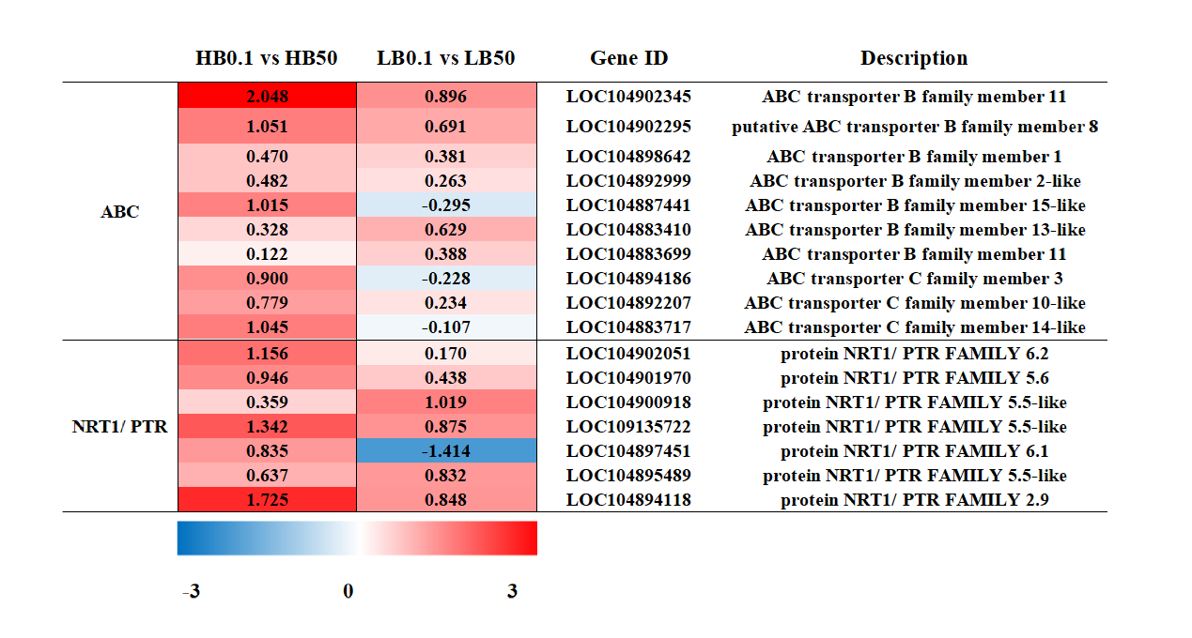
Fig. S5 Regulation of boron deficiency on candidate genes of transporters. The heat map shows the differential regulation of ABC and NRT1/PTR related genes in different boron efficiency sugar beet varieties under the treatment of boron deficiency. The scale color represents Log₂(fold change). The red in the figure indicates that the gene is up-regulated, and the blue indicates that the gene is down-regulated. Heatmap illustrating differential regulation of ABC and NRT1/PTR related genes in two sugar beet varieties.

