Supporting Information

Two-pronged anti-tumor therapy by a new polymer-paclitaxel conjugate micelle with an anti-multidrug resistance effect
Juan Du^{a,∗}, Lanlan Zong^{b}, Mengmeng Li^{b}, Yonghui Qiao^{c}, Keke Yu^{b}, Xiaohui Pu^{b,∗}
ª Department of Pharmacy, The Affiliated Cancer Hospital of Zhengzhou University, Dongming Rd., Zhengzhou, 450003, China;
^{b} Institute of Pharmacy, School of Pharmacy, Henan University, N. Jinming Ave., Kaifeng, Henan, 475004, China;
^{c} Henan University of Chinese Medicine, E. Jinshui Rd., Zhengzhou, Henan, 450046, China;

∗ Corresponding author
Tel/Fax: +86-371-23880680, E-mail: pgh425@163.com (X.H. Pu), jindalai66@163.com (J. Du)

1 Characterization of mPEG-DCA, mPEG-DCA-DTPA and mPEG-DCA-SA
The ¹H-NMR spectra (Fig. S1) of mPEG-DCA, mPEG-DCA-DTPA and mPEG-DCA-SA was analyzed as follows. mPEG-DCA (Chloroform-d): [δ 4.22 (s, 2H), 3.88 (s, 2H), 3.64 (d, J = 2.3 Hz, 217H), 3.56 (s, 3H), 3.38 (d, J = 2.3 Hz, 6H), 1.96 ~ 1.03 (m, 45H), 0.97 (d, J = 5.7 Hz, 3H), 0.91 (s, 3H), 0.68 (s, 3H)]; mPEG-DCA-SA (DMSO-d6): [δ 12.21 (s, 1H), 4.58 (t, J = 5.5 Hz, 1H), 4.47 ~ 4.36 (m, 1H), 4.24 (d, J = 4.1 Hz, 1H), 4.14 ~ 4.08 (m, 3H), 3.68 (s, 2H), 3.43 (d, J = 5.7 Hz, 8H), 3.33 (s, 26H), 3.24 (s, 6H), 2.48 ~ 2.44 (m, 2H), 2.37 ~ 2.16 (m, 3H), 1.91 (s, 1H), 1.80 ~ 1.61 (m, 5H), 1.47 (s, 2H), 1.35 (s, 4H), 1.27 ~ 1.17 (m, 4H), 1.16 ~ 1.04 (m, 6H), 0.99 (d, J = 12.1 Hz, 2H), 0.87 (d, J = 6.2 Hz, 3H), 0.83 (s, 3H), 0.61 (d, J = 5.4 Hz, 3H)]; and mPEG-DCA-DTPA (DMSO-d6): [δ 12.37 (s, 1H), 4.52 (d, J = 34.9 Hz, 2H), 4.22 ~ 4.08 (m, 4H), 3.43 (s, 16H), 3.33 (s, 15H), 3.24 (d, J = 2.4 Hz, 10H), 2.88 (s, 3H), 2.72 (s, 2H), 2.63 (d, J = 7.1 Hz, 2H), 2.28 (s, 2H), 1.76 (s, 7H), 1.61 ~ 1.05 (m, 19H), 0.91 (d, J = 5.7 Hz, 3H), 0.84 (s, 3H), 0.59 (s, 3H)].
The ¹H-NMR spectra of PTX, PDCP, and PDSP were shown in Fig. S2. These ¹H-NMR spectra were as follows. PTX (Chloroform-d): [δ 8.13 (m, 2H, o-2O-ArH), 7.74 (dt, J = 7.0, 1.4 Hz, 2H, o-3’NH-ArH), 7.60 (m, 1H, p-2O-ArH), 7.55 ~ 7.33 (m, 10H, 3’-ArH and 2O-ArH and 3’NH-ArH), 6.99 (d, J = 8.8 Hz, 1H, 1H, 3’-NH-), 6.31 ~ 6.16 (m, 2H, 10-H and 13-H), 5.79 (dd, J = 8.9, 2.6 Hz, 1H, 3’-H), 5.67 (d, J = 7.0 Hz, 1H, 2-H), 4.94 (dd, J = 9.7, 2.2 Hz, 1H, 5H), 4.79 (d, J = 2.7 Hz, 1H, 2’-H), 4.40 (dd, J = 10.9, 6.7 Hz, 1H, 7-H), 4.30 (d, J = 8.4 Hz, 1H, 20-H), 4.23 ~ 4.16 (m, 1H, 20-H), 3.80 (d, J = 7.0 Hz, 1H, 3-H), 2.58 ~ 2.54 (m, 6-HH), 2.42 ~ 2.27 (m, 5H, 4O-Ac-H and 14H₂ ), 2.24 (s, 3H, 10O-Ac-H), 1.88 (ddd, J = 14.8, 10.9, 2.4 Hz, 2H, 6-HH), 1.79 (d, J = 1.4 Hz, 3H, 18-H₃), 1.24 (s, 3H, 16-H₃), 1.14 (s, 3H, 17-H₃)]; PDCP (DMSO-d₆): [δ 9.22 (d, J = 8.6 Hz, 1H), 8.25 (d, J = 8.0 Hz, 1H), 8.00 ~ 7.95 (m, 3H), 7.87 ~ 7.84 (m, 3H), 7.74 (t, J = 7.3 Hz, 2H), 7.66 (t, J = 7.5 Hz, 3H), 7.56 (d, J = 5.8 Hz, 1H), 7.53 ~ 7.42 (m, 10H), 7.20 (d, J = 4.1 Hz, 1H), 6.29 (s, 2H), 5.82 (t, J = 9.1 Hz, 2H), 5.55 (t, J = 8.7 Hz, 2H), 5.38 (dd, J = 24.4, 8.1 Hz, 4H), 4.93 ~ 4.89 (m, 3H), 4.64 (s, 2H), 4.20 (s, 1H), 4.13 – 4.05 (m, 4H), 3.43 (d, J = 5.3 Hz, 6H), 3.33 (s, 40H), 3.24 (s, 6H), 2.66 (d, J = 6.0 Hz, 3H), 2.61 (d, J = 5.7 Hz, 2H), 2.55 (d, J = 5.3 Hz, 1H), 2.34 ~ 2.29 (m, 2H), 2.24 (s, 5H), 2.10 (s, 5H), 1.86 ~ 1.60 (m, 18H), 1.49 (s, 9H), 1.24 (s, 12H), 1.01 (d, J = 11.2 Hz, 10H), 0.93 – 0.80 (m, 6H), 0.59 (s, 3H)]; PDSP(DMSO-d₆): [δ 8.08 – 7.79 (m, 3H), 7.70 (dt, J = 31.0, 7.4 Hz, 2H), 7.60 ~ 7.39 (m, 5H), 6.29 (s, 1H), 5.82 (t, J = 9.0 Hz, 1H), 5.66 ~ 5.32 (m, 2H), 4.21 (d, J = 4.4 Hz, 1H), 4.17 ~ 4.09 (m, 4H), 4.01 (d, J = 3.8 Hz, 1H), 3.68 (s, 2H), 3.44 ~ 3.30 (m, 43H), 3.24 (s, 5H), 2.96 – 2.81 (m, 6H), 2.74 ~ 2.65 (m, 3H), 2.24 (s, 2H), 2.10 (s, 2H), 1.75 (d, J = 22.5 Hz, 8H), 1.50 (s, 3H), 1.26 (td, J = 31.5, 30.1, 14.5 Hz, 12H), 1.09 (t, J = 7.0 Hz, 9H), 1.01 (d, J = 11.1 Hz, 5H), 0.91 (dd, J = 6.5, 3.0 Hz, 3H), 0.86 (d, J = 10.5 Hz, 3H), 0.59 (d, J = 2.1 Hz, 3H)].
As showed in Fig. S3, in the infrared spectrum of mPEG-DCA, the stretching vibration peak of carbonyl V_{C=O} was at 1734.0 cm⁻¹, and the stretching vibration peak of methyl V_{C-H} was showed at 1344.4 cm⁻¹. Also, the in-plane rocking vibration peak, in-plane deformation vibration peak, and symmetrical stretching vibration peak of V_{C-H} in the structure of mPEG were displayed at 842.9 cm⁻¹, 1467.8 cm⁻¹, and 2885.5 cm⁻¹, and the stretching vibration peak of V_{C-O-C} was showed at 1111.0 cm⁻¹. In the infrared spectrum of PTX, there was an overlap between the stretching vibration absorption peak of hydroxyl V_{O-H} and the stretching vibration peak of V_{N-H} at 3300-3500 cm⁻¹. The V_{C-H} stretching vibration peak on the benzene ring was at 2943.4 cm⁻¹, the peaks at 1734.0 cm⁻¹ and 1712.8 cm⁻¹ were assigned to two splitting peaks of ketone carbonyl V_{C=O}. The peak at 1645.3 cm⁻¹ was ascribed to the carbonyl in the amide group, and the stretching vibration peak of the V_{C-N} bond was at 1244.1 cm⁻¹. The stretching vibration absorption peak of V_{C-O} in secondary alcohols and tertiary alcohols were at 1072.4 cm⁻¹ and 1109.1 cm⁻¹. The peak at 709.8 cm⁻¹ was the characteristic absorption peak of a monosubstituted benzene ring. In the infrared spectrum of mPEG-DCA-SA, we can see the symmetrical stretching vibration peaks of V_{C-H} in DCA’s structure at 2885.5 cm⁻¹, which overlapped with the stretching vibration peak of carboxyl V_{O-H} and the symmetrical stretching vibration peak of V_{C-H} in the structure of mPEG. The stretching vibration peaks of V_{C=O} in carboxyl and ester at 1735.9 cm⁻¹. Similarly, the peak position of each functional group in mPEG-DCA-DTPA was similar to that in mPEG-DCA-SA.
2 The fitting equations of CCD-response surface method
Multiple linear equation
Y₁=180.40278-0.95389X₁+0.29X₂+1.77944X₃, r²=0.6232 (Eq. S1)
Y₂=0.32346+0.01X₁+0.01X₂+0.026X₃, r²=0.5106 (Eq. S2)
Quadratic polynomial
Y₁=314.15972-1.87222X₁-2.21375X₂-0.31347X₃+3.50000×10⁻³X₁X₂-0.075833 X₁X₃-0.035813X₂X₃+0.023167X₃²+0.015313X₂²+0.22717X₃², r²=0.8513 (Eq. S3)
Y₂=1.38011-0.038590X₁-5.02812×10⁻³X₂+4.55139×10⁻³X₃-4.93750×10⁻⁵X₁X₂-1.39167×10⁻⁴X₁X₃-3.52000×10⁻⁵X₂X₃+5.26111×10⁻⁴X₁²+4.20486×10⁻⁵X₂²+1.89444 ×10⁻⁴X₃², r²=0.7426 (Eq. S4)
Cubic polynomials
Y₁=174.49-16.05X₁-11.57X₂+5.16X₃-3.26X₁X₂-7.24X₁X₃-17.51X₂X₃-8.53X₁² +6.12X₂²+25.88X₃²-0.34X₁X₂X₃+10.85X₁²X₂+16.77X₁²X₃+1.98X₁X₂²+3.77X₁X₃² +5.17X₂²X₃-3.16X₂X₃², R²=0.9232 (Eq. S5)
Y₂=0.39+0.034X₁-0.03X₂+0.044X₃-0.023X₁X₂-0.019X₁X₃-9.25×10⁻³X₂X₃ +0.032X₁²+0.017X₂²+0.03X₃²+5.375×10⁻³X₁X₂X₃+0.021X₁²X₂-0.021X₁²X₃+6.646 ×10⁻³X₁X₂²-0.037X₁X₃²+1.375×10⁻³X₂²X₃-0.011X₂X₃², R²=0.9481 (Eq. S6)

3 Figures and Tables
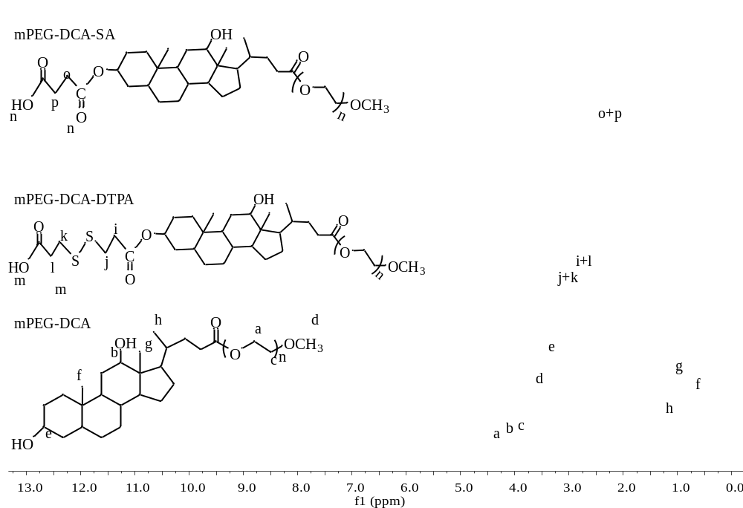
Fig. S1 The ¹H-NMR spectra of mPEG-DCA, mPEG-DCA-SA, and mPEG-DCA-DTPA.
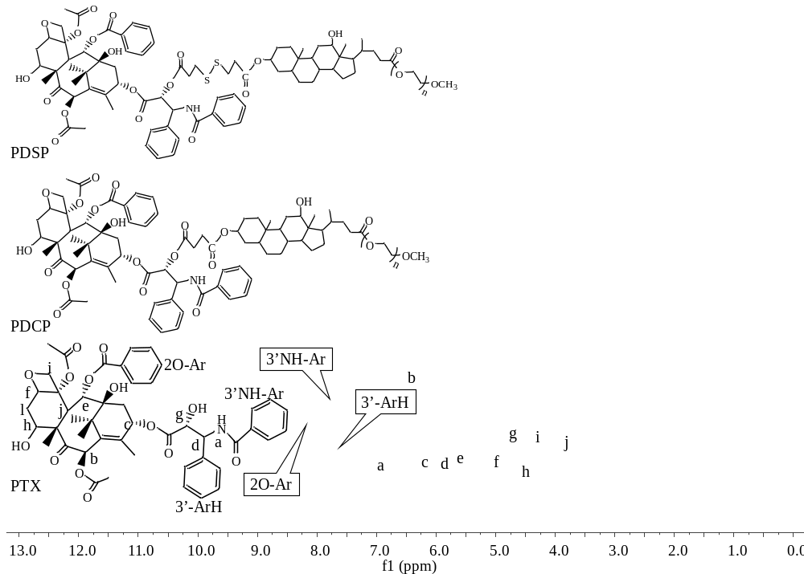
Fig. S2 The ¹H-NMR spectra of PDCP, PDSP, PTX.
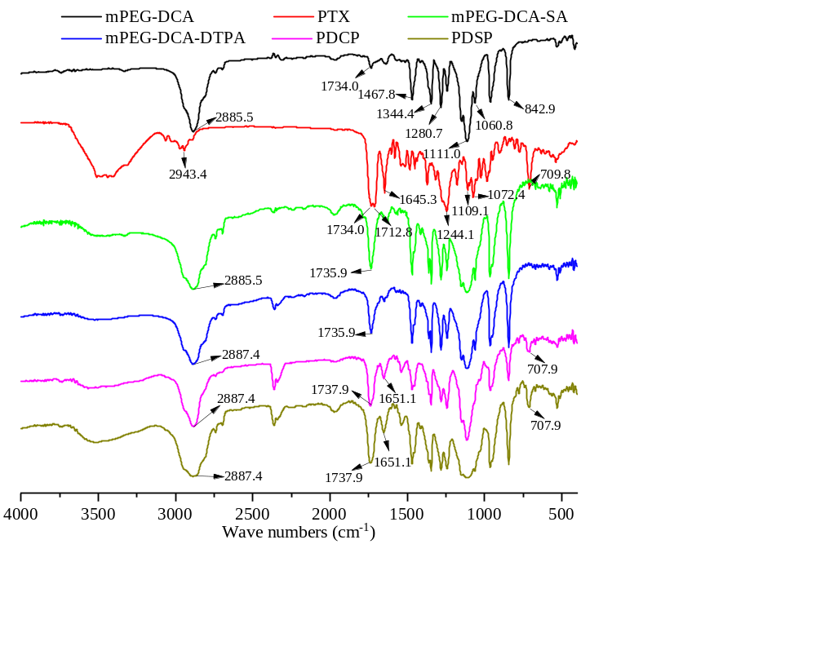
Fig. S3 The IR spectra of mPEG-DCA, mPEG-DCA-SA, mPEG-DCA-DTPA, PDCP, and PDSP.
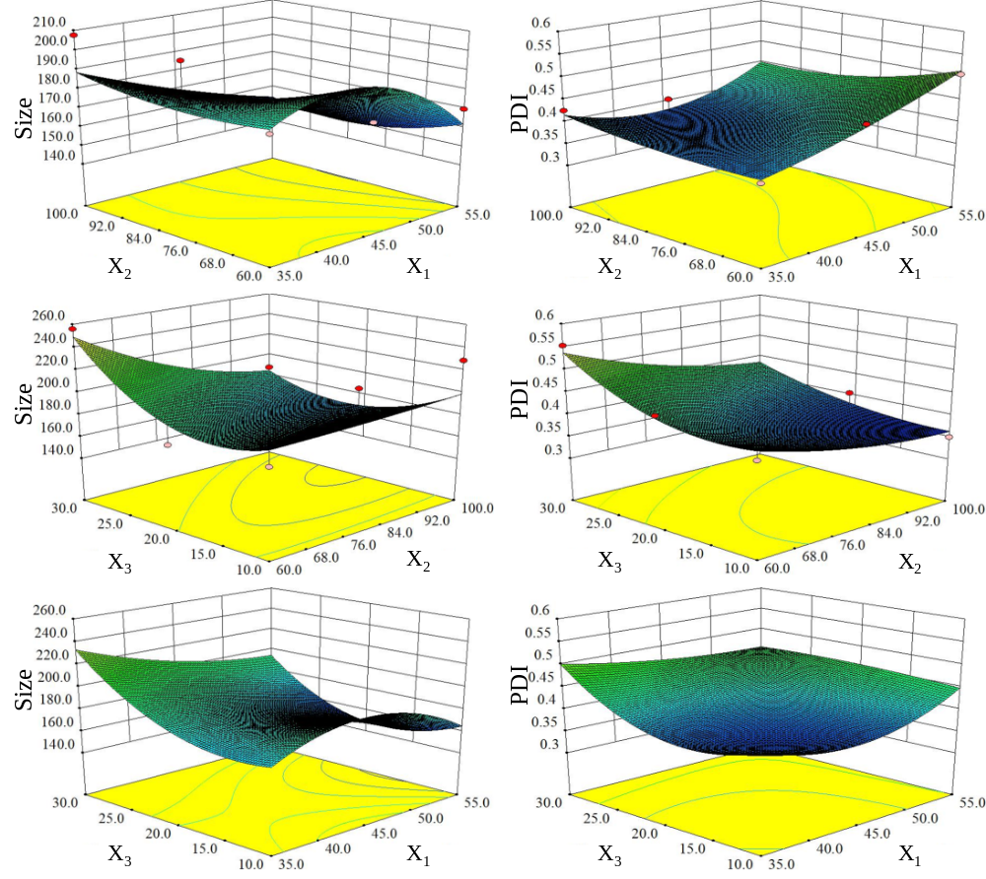
Fig. S4 The figures of the central composite design-response surface method.
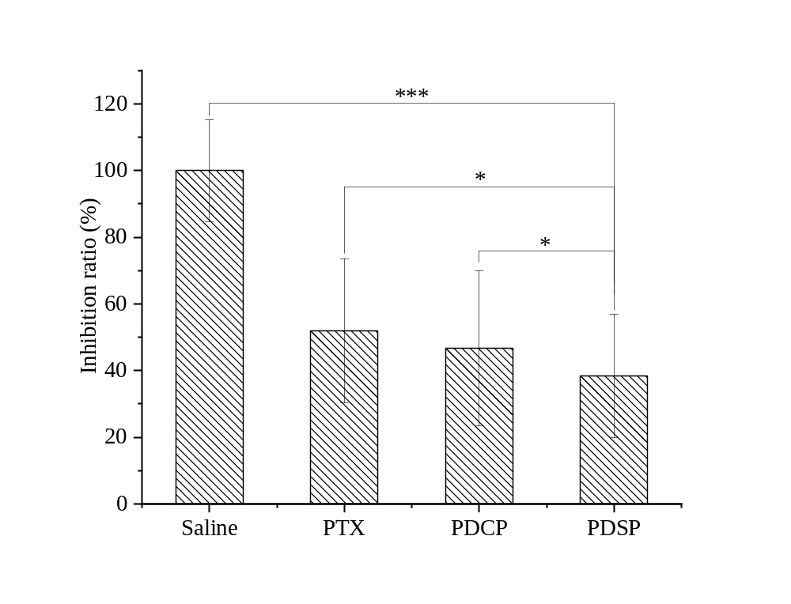
Fig. S5 The inhibition rate of tumors calculated by tumor mass.
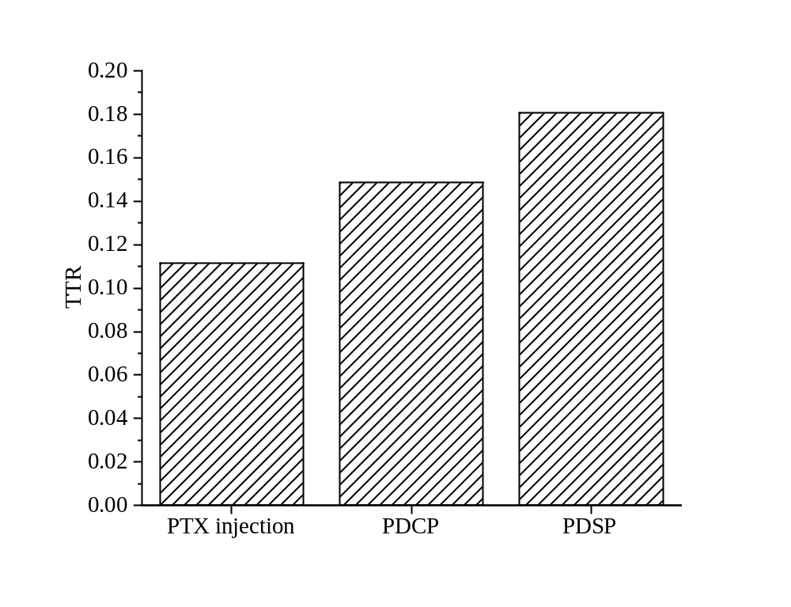
Fig. S6 The TTR of three PTX formulations in tumor tissues within 24 h (n=6).

Tab. S1 Particle size and PDI of two prodrug micelles after or before lyophilization.
Samples | Before lyophilization |  | After lyophilization |  | Zeta potential  (mV)
Samples | Siz (nm) | PDI | Size (nm) | PDI | Zeta potential  (mV)
PDSP | 177.6±5.0 | 0.307±0.1 | 185.0±4.1 | 0.315±0.11 | -14.3±1.25
PDCP | 228.6±4.9 | 0.329±0.1 | 232.3±8.3 | 0.318±0.15 | -9.4±0.87

Tab. S2 The IC₅₀ values (μg/mL) of six PTX formulations against SMMC-7721, MCF-7, and A549/PTX cells after treatment for 24 h and 48 h.
Formulations | 24 h |  |  | 48 h
Formulations | SMMC-7721 | MCF-7 | A549/PTX | SMMC-7721 | MCF-7 | A549/PTX
PTX | 84.62 | 42.11 | 2542.09 | 106.02 | 14.23 | 632.49
PTX+BM | 29.43 | 19.51 | 304.88 | 58.04 | 4.80 | 184.92
PDCP | 10.83 | 8.91 | 129.83 | 6.19 | 3.79 | 94.33
PDCP+GSH | 9.47 | 6.68 | 93.65 | 3.74 | 2.18 | 53.71
PDSP | 3.17 | 2.65 | 33.72 | 1.25 | 0.77 | 17.33
PDSP+GSH | 1.63 | 1.33 | 16.23 | 0.70 | 0.29 | 8.01
R₁ | 2.88 | 2.16 | 8.34 | 1.83 | 2.97 | 3.42
R₂ | 3.42 | 3.36 | 3.85 | 4.97 | 4.93 | 5.44
R₃ | 1.94 | 1.99 | 2.08 | 1.79 | 2.64 | 2.16
R₁: the IC₅₀ ratio of PTX to PTX+BM; R₂: the IC₅₀ ratio of PDCP to PDSP; R₃: the IC₅₀ ratio of PDSP to PDSP+GSH.

