Supplemental information
Measurements
Eating Disorders Inventory 2 (EDI-2). The EDI-2 consists of 91 items organized into 11 factors: Drive for Thinness (Dft), an excessive concern with dieting, preoccupation with weight and fear of weight gain; Bulimia (Bul), episodes of binge eating and purging; Body Dissatisfaction (Bod), not being satisfied with one's physical appearance; Ineffectiveness (Ine), feelings of inadequacy, insecurity, worthlessness and having no control over their lives; Perfectionism (Per), not being satisfied with anything less than perfect; Interpersonal Distrust (Dis), reluctance to form close relationships; Interoceptive Awareness (Awa), ability of an individual to discriminate between sensations and feelings, and between the sensations of hunger and satiety; Maturity Fears (Fea), fear of facing the demands of adult life; Asceticism (Asc), avoidance of sexual relationships; Impulse Regulation (Imp), ability to regulate impulsive behavior, especially the binge behavior; Social Insecurity (Soc), social fears and insecurity.

Results
Table S1. Cronbach's of EDI-2 factors and EDI-2 before and after surgery
Factor | Item | Cronbach's α^{b}
Dft | 1、7、11、16、25、32、49 | 0.812
Bul | 4、5、28、38、46、53、61 | 0.888
Bod | 2 、9 、12 ᵃ、19 ᵃ、31 ᵃ、45 、55 ᵃ、59 、62 ᵃ | 0.893
Ine | 10、18、20 ᵃ、24、27、37 ᵃ、41、42 ᵃ、50 ᵃ、56 | 0.894
Per | 13、29、36、43、52、63 | 0.736
Dis | 15 ᵃ、17 ᵃ、23 ᵃ、30 ᵃ、34 、54 、57 ᵃ | 0.772
Awa | 8、21、26 ᵃ、33、40、44、47、51、60、64 | 0.793
Fea | 3、6、14、22 ᵃ、35、39 ᵃ、48、58 ᵃ | 0.6
Asc | 66、68、71 ᵃ、75、78、82、86、88 | 0.695
Imp | 65、67、70、72、74、77、79、81、83、85、90 | 0.771
Soc | 69 ᵃ、73 ᵃ、76 ᵃ、80 ᵃ、84、87、89 ᵃ、91 ᵃ | 0.782
EDI-2 | - | 0.978
Note ᵃ Inverse scale items, ^{b} indicates preoperative Cronbach's for 11 factors of EDI-2 and EDI-2.

Table S2. Test for normality of factor Social Insecurity
Factor | n | Mean | Median | Standard deviation | Shapiro-Wilk W | Shapiro-Wilk p
Soc | 72 | 1.52 | 1.5 | 0.599 | 0.983 | 0.459
Note Normal distribution was determined by Shapiro-Wilk p test with p> 0.05. Soc, Social insecurity.

Table S3. The simple fixed effects parameter estimates of linear mixed model of EDI-2 total score.

 |  |  |  | 95% Confidence Interval
Names | Effect | Estimate | SE | Lower | Upper | df | t | p
(Intercept) | (Intercept) | 9.94 | 0.48 | 8.99 | 10.88 | 82.50 | 20.53 | < .001
time1 | 1 - 0 | -0.50 | 0.70 | -1.61 | 0.62 | 430.10 | -0.87 | 0.383
time2 | 2 - 0 | -0.97 | 0.61 | -2.16 | 0.23 | 428.60 | -1.59 | 0.113
time3 | 3 - 0 | -1.08 | 0.54 | -2.14 | -0.02 | 428.90 | -2.00 | 0.046
time4 | 4 - 0 | -1.88 | 0.45 | -2.77 | -0.99 | 430.10 | -4.14 | < .001
time5 | 5 - 0 | -2.11 | 0.48 | -3.06 | -1.16 | 429.90 | -4.36 | < .001
time6 | 6 - 0 | -2.23 | 0.46 | -3.13 | -1.32 | 429.50 | -4.83 | < .001
time7 | 7 - 0 | -2.40 | 0.45 | -3.29 | -1.51 | 429.80 | -5.31 | < .001
time8 | 8 - 0 | -20.00 | 0.44 | -2.85 | -1.14 | 430.40 | -4.57 | < .001
time9 | 9 - 0 | -2.25 | 0.40 | -3.03 | -1.46 | 431.40 | -5.64 | < .001
time10 | 10 - 0 | -1.78 | 0.39 | -2.55 | -1.01 | 431.50 | -4.54 | < .001
time11 | 11 - 0 | -1.88 | 0.39 | -2.64 | -1.12 | 431.60 | -4.86 | < .001
time12 | 12 - 0 | -2.04 | 0.36 | -2.74 | -1.34 | 433.00 | -5.74 | < .001
time13 | 13 - 0 | -2.14 | 0.42 | -2.95 | -1.33 | 430.80 | -5.16 | < .001
time14 | 14 - 0 | -2.04 | 0.40 | -2.82 | -1.26 | 431.40 | -5.13 | < .001
time15 | 15 - 0 | -2.11 | 0.41 | -2.91 | -1.31 | 431.00 | -5.16 | < .001
time16 | 16 - 0 | -2.30 | 0.44 | -3.16 | -1.45 | 430.00 | -5.30 | < .001
time17 | 17 - 0 | -1.72 | 0.42 | -2.53 | -0.91 | 430.80 | -4.15 | < .001
time18 | 18 - 0 | -2.66 | 0.36 | -3.36 | -1.96 | 432.70 | -7.46 | < .001
time19 | 24 - 0 | -1.80 | 0.50 | -2.78 | -0.81 | 431.40 | -3.56 | < .001

Note Table content indicates the change in EDI-2 total score per month compared to EDI-2 total score before bariatric surgery.

Table S4. The repeated fixed effects parameter estimates of linear mixed model of EDI-2 total score

 |  |  |  | 95% Confidence Interval
Names | Effect | Estimate | SE | Lower | Upper | df | t | p
(Intercept) | (Intercept) | 9.94 | 0.48 | 8.99 | 10.88 | 82.50 | 20.53 | < .001
time1 | 0-1 | 0.50 | 0.57 | -0.62 | 1.61 | 430.10 | 0.87 | 0.383
time2 | 1-2 | 0.47 | 0.76 | -1.01 | 1.95 | 425.50 | 0.63 | 0.532
time3 | 2-3 | 0.11 | 0.73 | -1.32 | 1.55 | 423.20 | 0.16 | 0.875
time4 | 3-4 | 0.80 | 0.62 | -0.42 | 2.01 | 423.90 | 1.28 | 0.2
time5 | 4-5 | 0.23 | 0.57 | -0.89 | 1.35 | 424.00 | 0.41 | 0.683
time6 | 5-6 | 0.12 | 0.58 | -1.01 | 1.25 | 423.90 | 0.20 | 0.839
time7 | 6-7 | 0.17 | 0.55 | -0.91 | 1.25 | 422.90 | 0.31 | 0.753
time8 | 7-8 | -0.41 | 0.54 | -1.46 | 0.65 | 423.60 | -0.76 | 0.45
time9 | 8-9 | 0.25 | 0.50 | -0.73 | 1.23 | 424.60 | 0.50 | 0.617
time10 | 9-10 | -0.46 | 0.46 | -1.37 | 0.45 | 424.50 | -1.00 | 0.319
time11 | 10-11 | 0.10 | 0.46 | -0.80 | 1.00 | 424.90 | 0.22 | 0.826
time12 | 11-12 | 0.16 | 0.42 | -0.67 | 0.99 | 424.30 | 0.37 | 0.712
time13 | 12-13 | 0.10 | 0.45 | -0.77 | 0.98 | 423.70 | 0.23 | 0.821
time14 | 13 - 14 | -0.10 | 0.48 | -1.04 | 0.84 | 423.80 | -0.21 | 0.836
time15 | 14 - 15 | 0.07 | 0.48 | -0.87 | 1.00 | 424.10 | 0.14 | 0.888
time16 | 15 - 16 | 0.20 | 0.50 | -0.78 | 1.17 | 422.90 | 0.39 | 0.695
time17 | 16 - 17 | -0.58 | 0.50 | -1.57 | 0.40 | 422.90 | -1.16 | 0.246
time18 | 17 - 18 | 0.94 | 0.45 | 0.06 | 1.83 | 424.70 | 2.09 | 0.037
time19 | 18 - 24 | -0.87 | 0.54 | -1.92 | 0.18 | 427.70 | -1.62 | 0.106

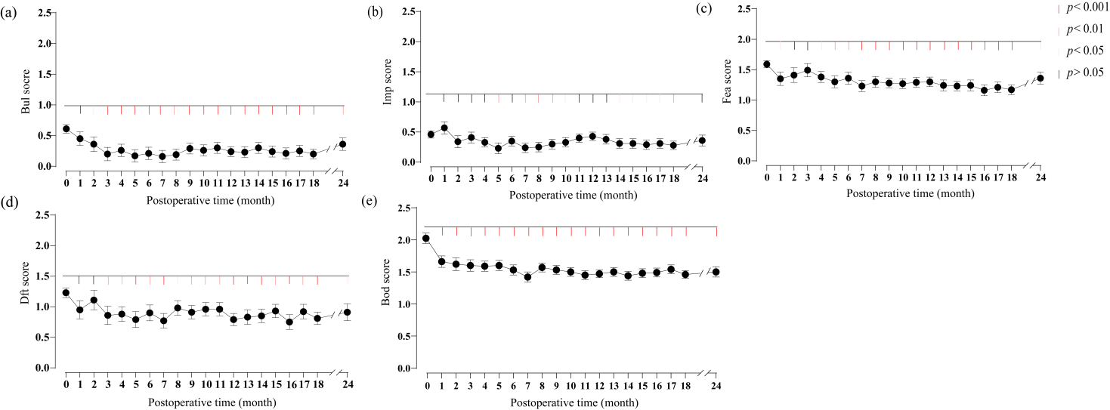
Fig. S1 The dynamic changes in factors such as bulimia, impulse regulation, maturity fears, drive for thinness, and body dissatisfaction following bariatric surgery. Figures (a)-(e) respectively illustrate the comparative trends of scores for bulimia, impulse regulation, maturity fears, drive for thinness, and body dissatisfaction before and after the surgery. Scores for bulimia, impulse regulation, maturity fears, drive for thinness, and body dissatisfaction were used as dependent variables, with postoperative time serving as the independent variable, and each participant in the obese group treated as a random effect. A p-value of less than 0.05 indicates statistical significance.

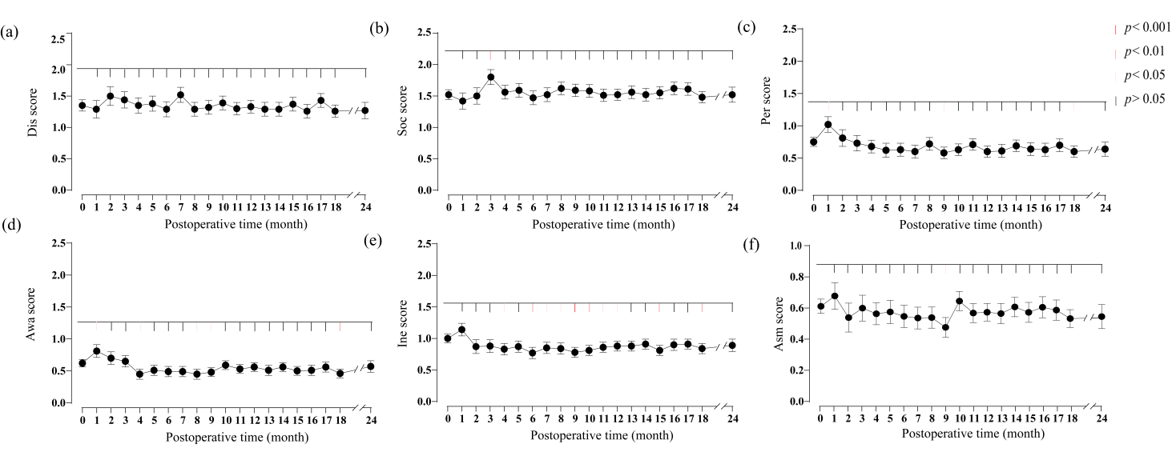Fig. S2 The dynamic changes in factors such as interpersonal distrust, social insecurity, perfectionism, interoceptive awareness, ineffectiveness, and asceticism following bariatric surgery. Figures (a)-(f) respectively depict the comparative trends of scores for interpersonal distrust, social insecurity, perfectionism, interoceptive awareness, ineffectiveness, and asceticism before and after the surgery. Scores for interpersonal distrust, social insecurity, perfectionism, interoceptive awareness, ineffectiveness, and asceticism were used as dependent variables, with postoperative time serving as the independent variable, and each participant in the obese group treated as a random effect. A p-value of less than 0.05 indicates statistical significance.

Table S5. STROBE Statement—checklist of items that should be included in reports of observational studies
 | Item No | Recommendation | Page  No
Title and abstract | 1 | (a) Indicate the study’s design with a commonly used term in the title or the abstract | 2
Title and abstract | 1 | (b) Provide in the abstract an informative and balanced summary of what was done and what was found | 2
Introduction
Background/rationale | 2 | Explain the scientific background and rationale for the investigation being reported | 2-4
Objectives | 3 | State specific objectives, including any prespecified hypotheses | 4
Methods
Study design | 4 | Present key elements of study design early in the paper | 5
Setting | 5 | Describe the setting, locations, and relevant dates, including periods of recruitment, exposure, follow-up, and data collection | 5
Participants | 6 | (a) Cohort study—Give the eligibility criteria, and the sources and methods of selection of participants. Describe methods of follow-up  Case-control study—Give the eligibility criteria, and the sources and methods of case ascertainment and control selection. Give the rationale for the choice of cases and controls  Cross-sectional study—Give the eligibility criteria, and the sources and methods of selection of participants | 4-5
Participants | 6 | (b) Cohort study—For matched studies, give matching criteria and number of exposed and unexposed  Case-control study—For matched studies, give matching criteria and the number of controls per case | 4-5
Variables | 7 | Clearly define all outcomes, exposures, predictors, potential confounders, and effect modifiers. Give diagnostic criteria, if applicable | 4-5
Data sources/ measurement | 8* | For each variable of interest, give sources of data and details of methods of assessment (measurement). Describe comparability of assessment methods if there is more than one group | 4-5
Bias | 9 | Describe any efforts to address potential sources of bias | NA
Study size | 10 | Explain how the study size was arrived at | 4-5
Quantitative variables | 11 | Explain how quantitative variables were handled in the analyses. If applicable, describe which groupings were chosen and why | 5
Statistical methods | 12 | (a) Describe all statistical methods, including those used to control for confounding | 6-7
Statistical methods | 12 | (b) Describe any methods used to examine subgroups and interactions | 6-7
Statistical methods | 12 | (c) Explain how missing data were addressed | 7
Statistical methods | 12 | (d) Cohort study—If applicable, explain how loss to follow-up was addressed  Case-control study—If applicable, explain how matching of cases and controls was addressed  Cross-sectional study—If applicable, describe analytical methods taking account of sampling strategy | NA
Statistical methods | 12 | (e) Describe any sensitivity analyses | NA

Results
Participants | 13* | (a) Report numbers of individuals at each stage of study—eg numbers potentially eligible, examined for eligibility, confirmed eligible, included in the study, completing follow-up, and analysed | NA
Participants | 13* | (b) Give reasons for non-participation at each stage | NA
Participants | 13* | (c) Consider use of a flow diagram | 5
Descriptive data | 14* | (a) Give characteristics of study participants (eg demographic, clinical, social) and information on exposures and potential confounders | 8-9
Descriptive data | 14* | (b) Indicate number of participants with missing data for each variable of interest | NA
Descriptive data | 14* | (c) Cohort study—Summarise follow-up time (eg, average and total amount) | 9
Outcome data | 15* | Cohort study—Report numbers of outcome events or summary measures over time | NA
Outcome data | 15* | Case-control study—Report numbers in each exposure category, or summary measures of exposure | NA
Outcome data | 15* | Cross-sectional study—Report numbers of outcome events or summary measures | NA
Main results | 16 | (a) Give unadjusted estimates and, if applicable, confounder-adjusted estimates and their precision (eg, 95% confidence interval). Make clear which confounders were adjusted for and why they were included | 6-7
Main results | 16 | (b) Report category boundaries when continuous variables were categorized | 6-7
Main results | 16 | (c) If relevant, consider translating estimates of relative risk into absolute risk for a meaningful time period | NA
Other analyses | 17 | Report other analyses done—eg analyses of subgroups and interactions, and sensitivity analyses | NA
Discussion
Key results | 18 | Summarise key results with reference to study objectives | 11
Limitations | 19 | Discuss limitations of the study, taking into account sources of potential bias or imprecision. Discuss both direction and magnitude of any potential bias | 14
Interpretation | 20 | Give a cautious overall interpretation of results considering objectives, limitations, multiplicity of analyses, results from similar studies, and other relevant evidence | 12-14
Generalisability | 21 | Discuss the generalisability (external validity) of the study results
Other information
Funding | 22 | Give the source of funding and the role of the funders for the present study and, if applicable, for the original study on which the present article is based | 15

*Give information separately for cases and controls in case-control studies and, if applicable, for exposed and unexposed groups in cohort and cross-sectional studies.

Note: An Explanation and Elaboration article discusses each checklist item and gives methodological background and published examples of transparent reporting. The STROBE checklist is best used in conjunction with this article (freely available on the Web sites of PLoS Medicine at http://www.plosmedicine.org/, Annals of Internal Medicine at http://www.annals.org/, and Epidemiology at http://www.epidem.com/). Information on the STROBE Initiative is available at www.strobe-statement.org.

