Appendix A. Multilingual Equivalents of “Multipolarity,” “Multipolar World,” and “Multipolar World Order”
The following list presents the search terms used in eight major languages to query “multipolarity,” “multipolar world,” and “multipolar world order” in the Google Ngram corpus:
1. Multipolar World Order
- English: Multipolar world order
- Chinese: 多极世界秩序 (Duō jí shìjiè zhìxù)
- French: Ordre mondial multipolaire
- German: Multipolare Weltordnung
- Hebrew: סדר עולמי רב-קוטבי (Seder olami rav-kotvi)
- Italian: Ordine mondiale multipolare
- Russian: Многополярный мировой порядок (Mnogopolyarnyy mirovoy poryadok)
- Spanish: Orden mundial multipolar
2. Multipolar World
- English: Multipolar world
- Chinese: 多极世界 (Duō jí shìjiè)
- French: Monde multipolaire
- German: Multipolare Welt
- Hebrew: עולם רב-קוטבי (Olam rav-kotvi)
- Italian: Mondo multipolare
- Russian: Многополярный мир (Mnogopolyarnyy mir)
- Spanish: Mundo multipolar
3. Multipolarity
- English: Multipolarity
- Chinese: 多极化 (Duō jí huà)
- French: Multipolarité
- German: Multipolarität
- Hebrew: רב-קוטביות (Rav-kotviyut)
- Italian: Multipolarità
- Russian: Многополярность (Mnogopolyarnost')
- Spanish: Multipolaridad

Appendix B. Cross-Linguistic Temporal Patterns of Multipolarity Discourse (Ngram Analysis)

English
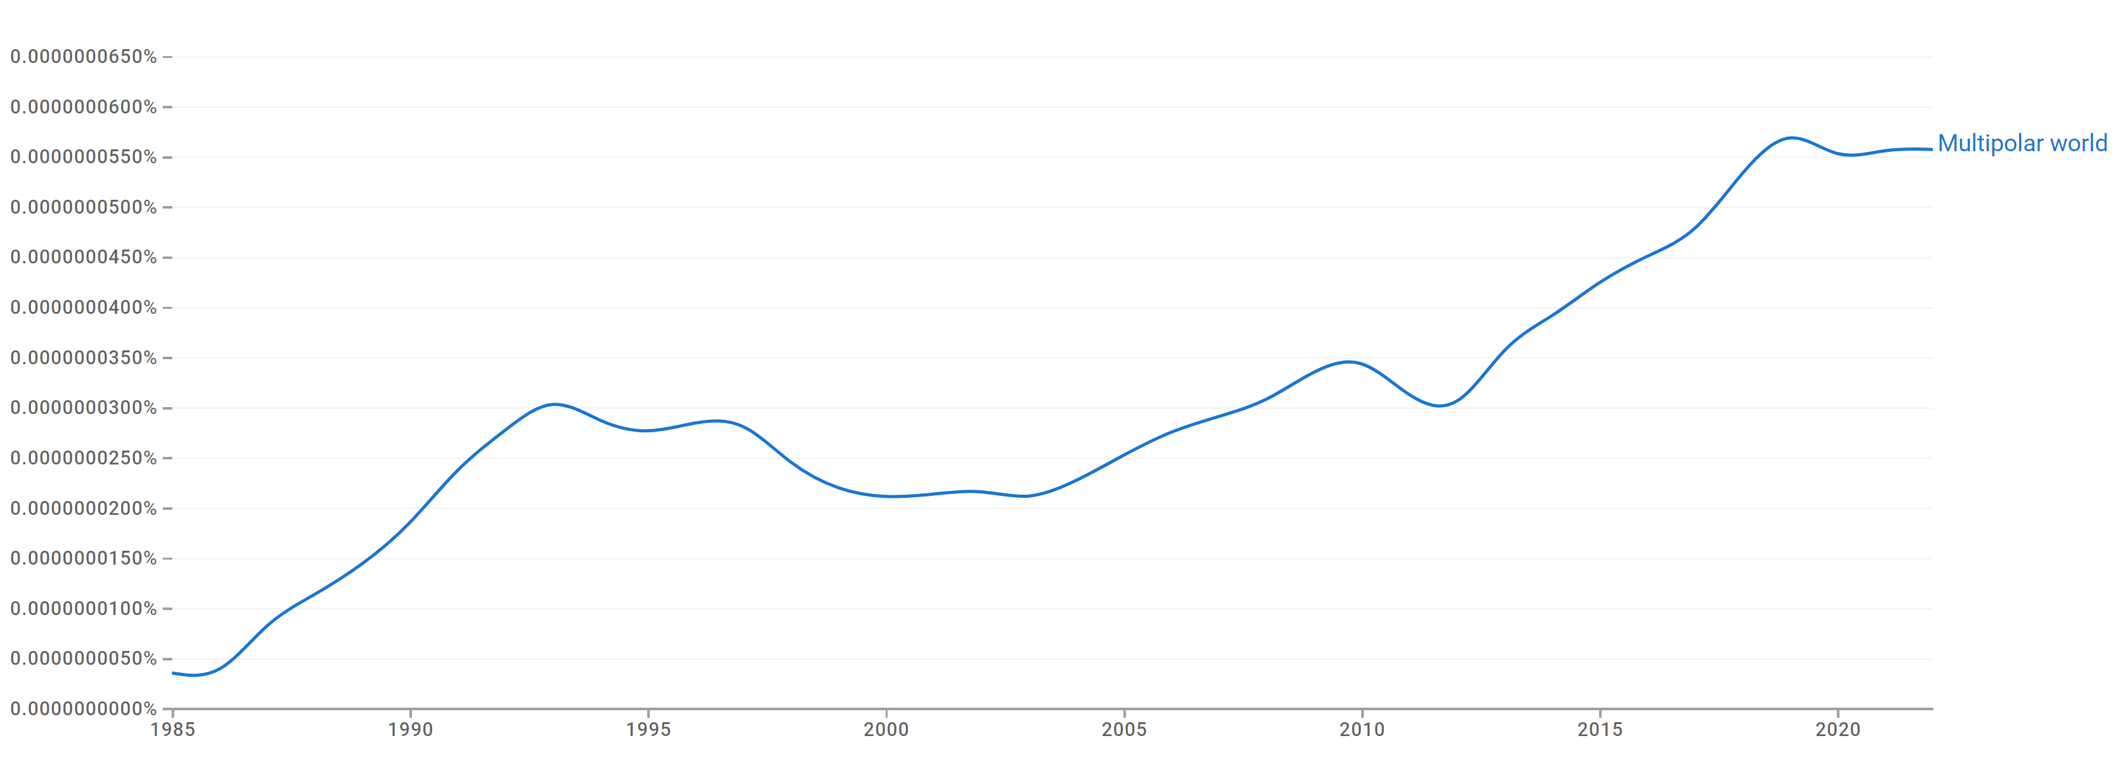
Fig. 6. Google Ngram frequency for “Multipolar world” in English (1985–2023):
Maximum attained at around 6.0×10⁻⁸ % in 2020, indicating a peak in textual visibility during that year.

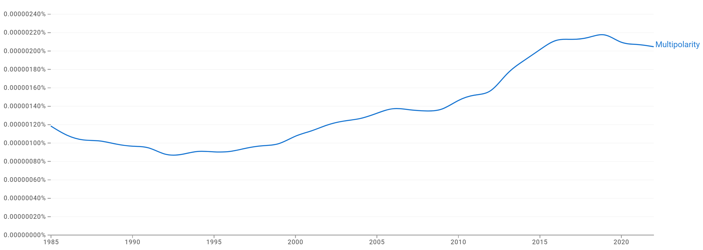
Fig. 7. Google Ngram frequency for “Multipolarity” in English (1985–2023):
Maximum attained at around 2.2×10⁻⁶ % in 2020, indicating a peak in textual visibility during that year.

British English
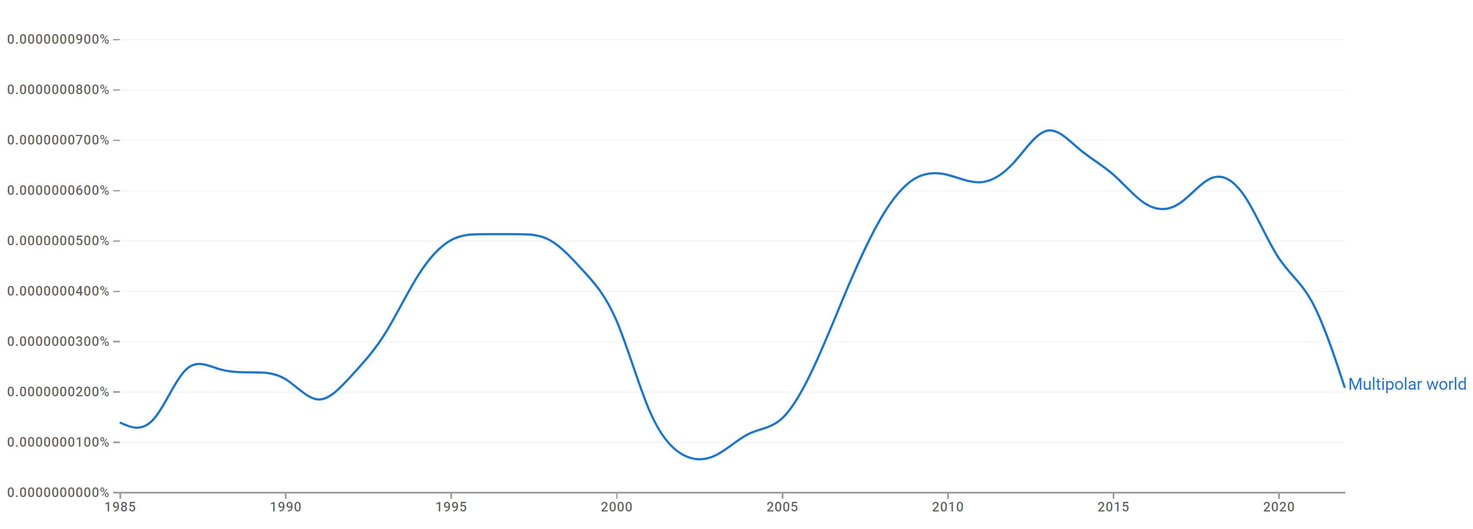
Fig. 8. Google Ngram frequency for “Multipolar world” in British English (1985–2023):
Maximum attained at around 8.0×10⁻⁸ % in 2015, indicating a peak in textual visibility during that year.

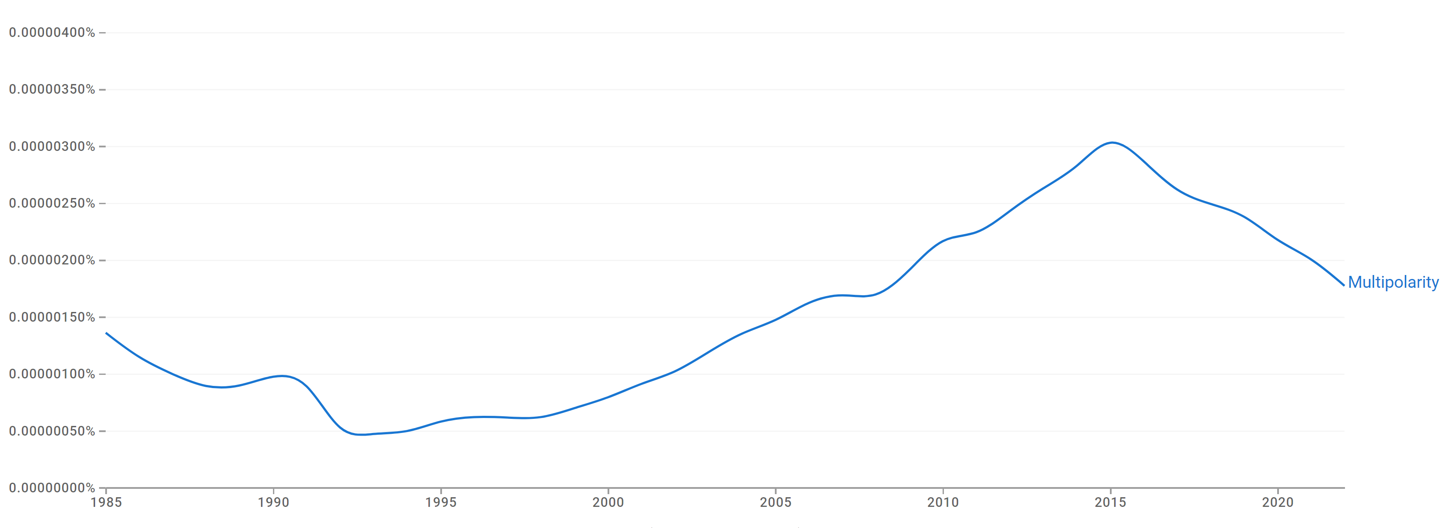
Fig. 9. Google Ngram frequency for “Multipolarity” in British English (1985–2023):
Maximum attained at around 3.0×10⁻⁶ % in 2015, indicating a peak in textual visibility during that year.

American English
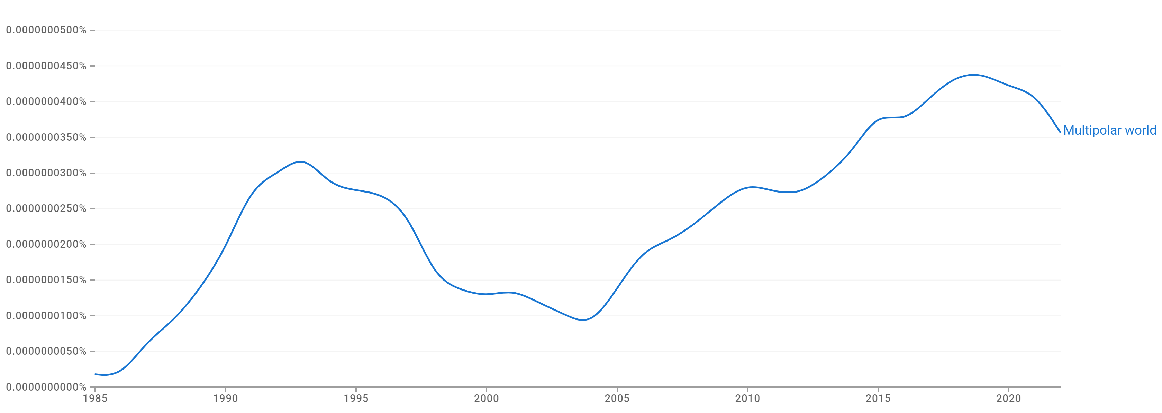
Fig. 10. Google Ngram frequency for “Multipolar world” in American English (1985–2023):
Maximum attained at around 4.5×10⁻⁸ % in 2020, indicating a peak in textual visibility during that year.

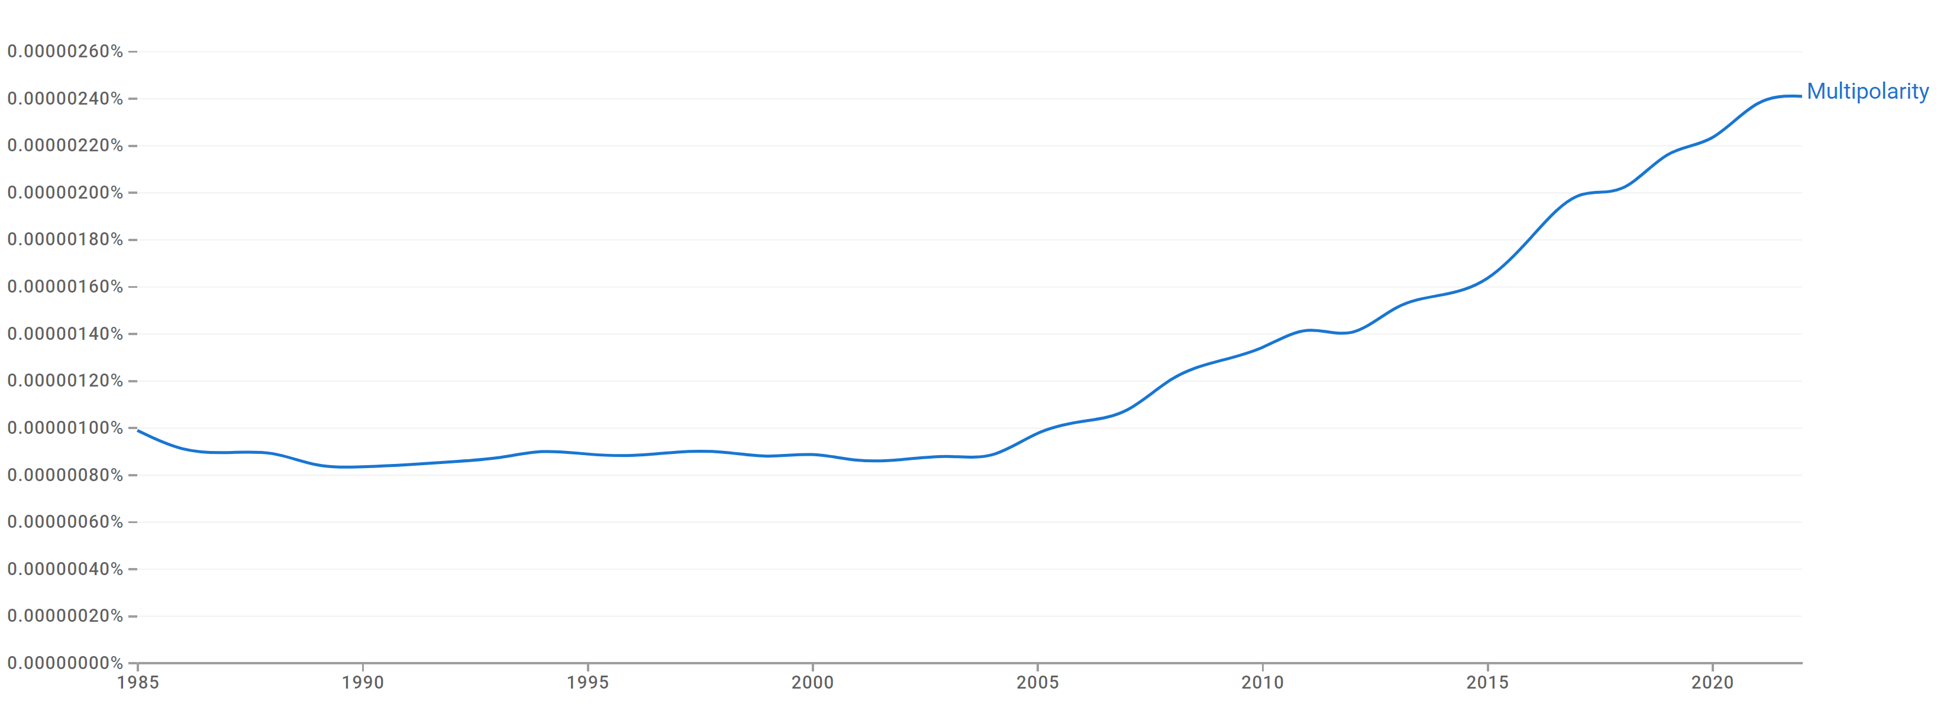
Fig. 11. Google Ngram frequency for “Multipolarity” in American English (1985–2023):
Maximum attained at around 2.4×10⁻⁶ % in 2020, indicating a peak in textual visibility during that year.

Chinese
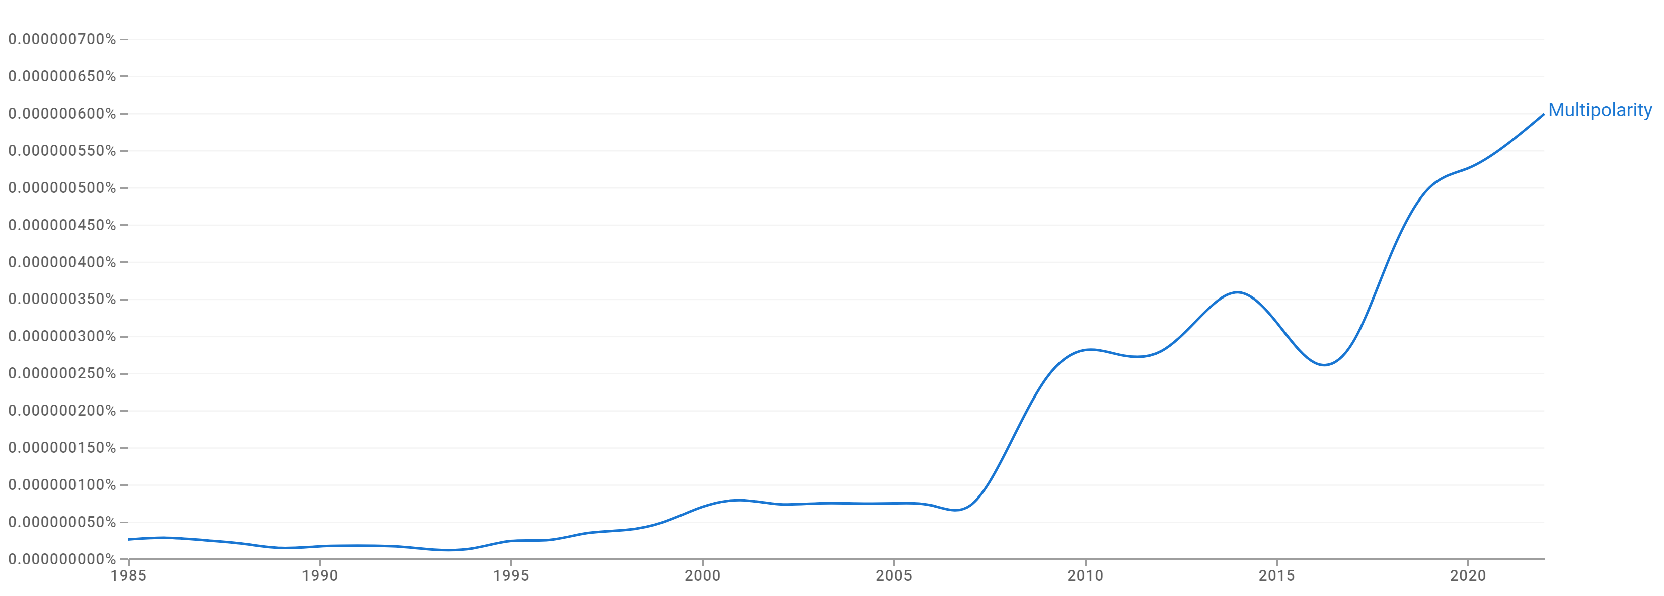
Fig. 12. Google Ngram frequency for “Multipolarity” in Chinese (1985–2023):
Maximum attained at around 6.0×10⁻⁷ % in 2020, indicating a peak in textual visibility during that year.

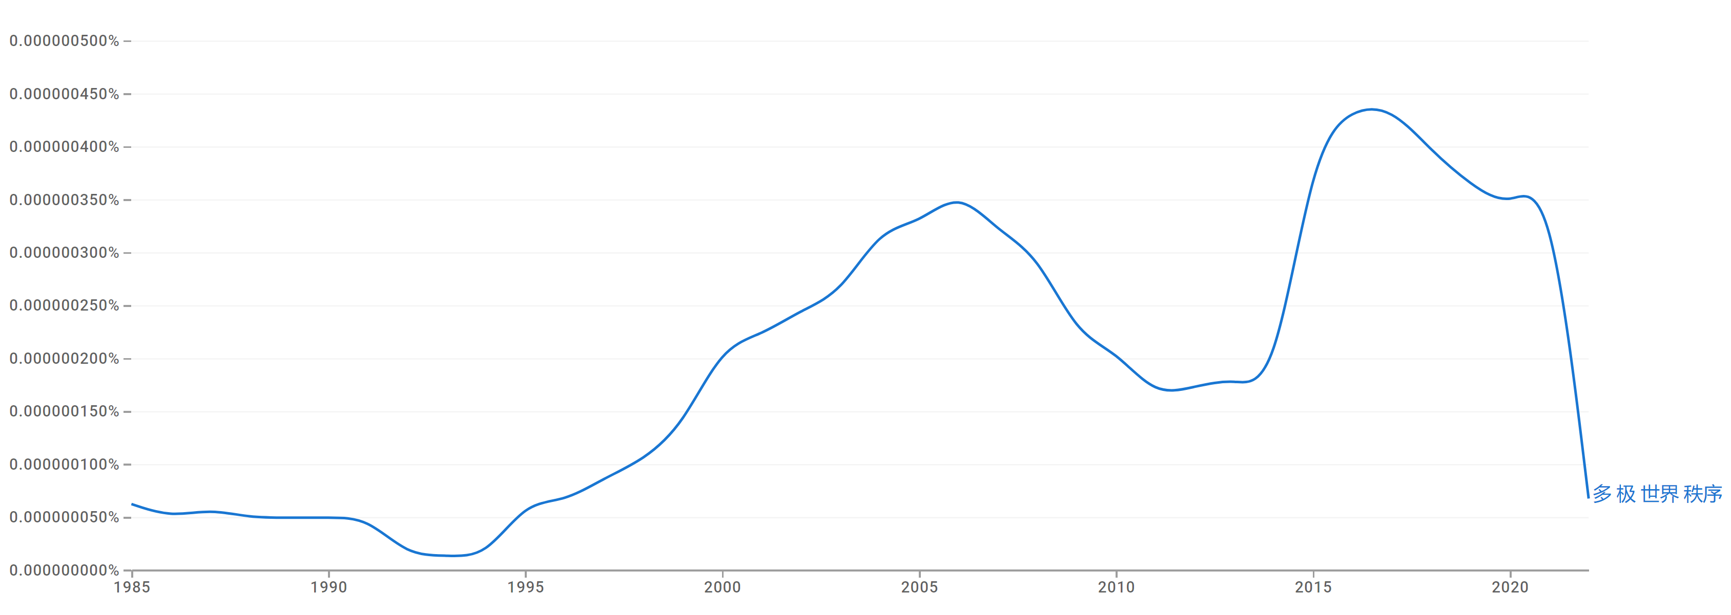
Fig. 13. Google Ngram frequency for “Multipolar world order” (translated) in Chinese (1985–2023):
Maximum attained at around 4.5×10⁻⁷ % in 2015, indicating a peak in textual visibility during that year.

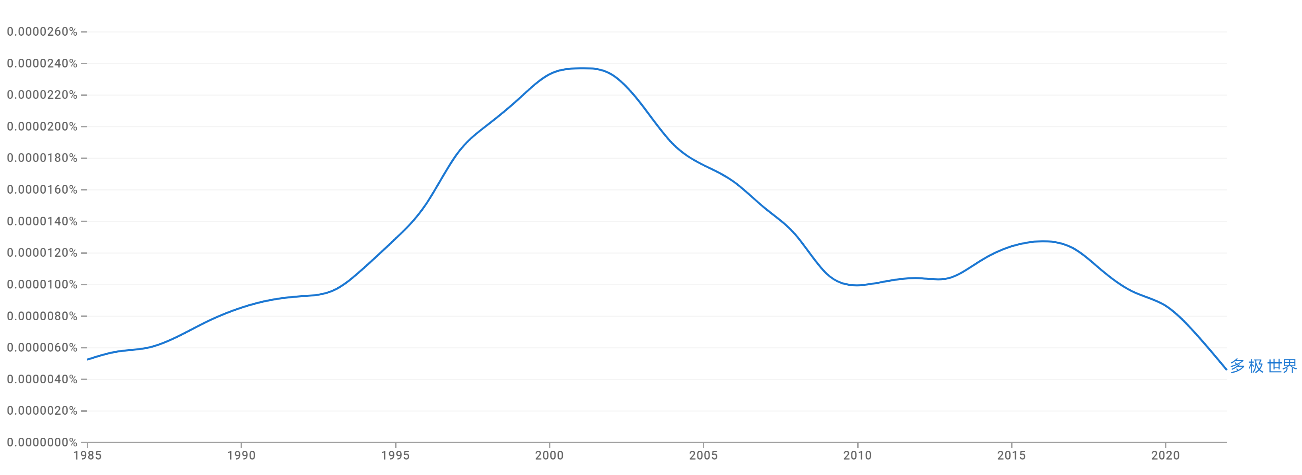
Fig. 14. Google Ngram frequency for “Multipolar world” (translated) in Chinese (1985–2023):
Maximum attained at around 2.4×10⁻⁵ % in 2020, indicating a peak in textual visibility during that year.

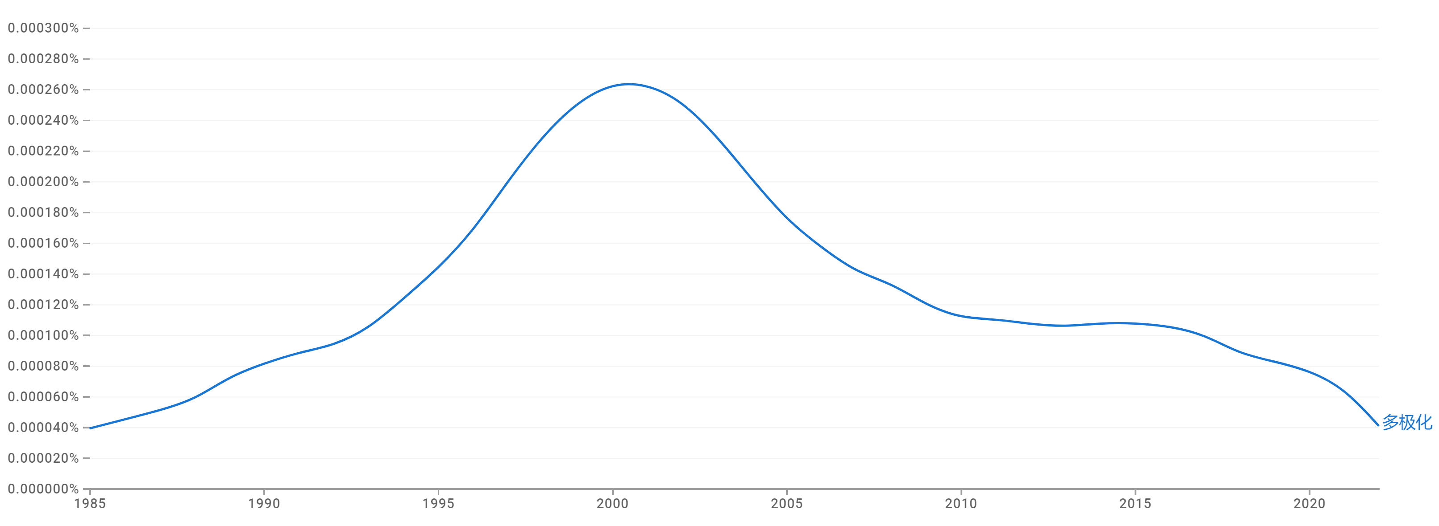
Fig. 15. Google Ngram frequency for “Multipolarity” (translated) in Chinese (1985–2023):
Maximum attained at around 2.6×10⁻⁴ % in 2000, indicating a peak in textual visibility during that year.

French
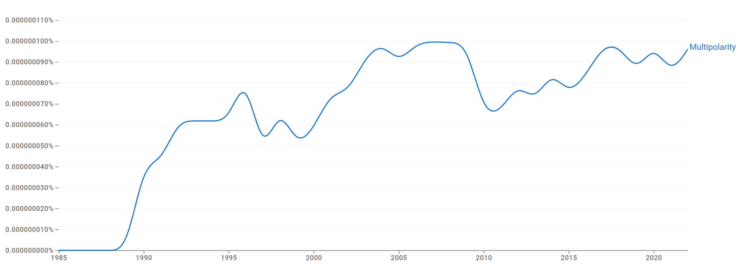
Fig. 16. Google Ngram frequency for “Multipolarity” in French (1985–2023):
Maximum attained at around 1.0×10⁻⁷ % in 2005, indicating a peak in textual visibility during that year.

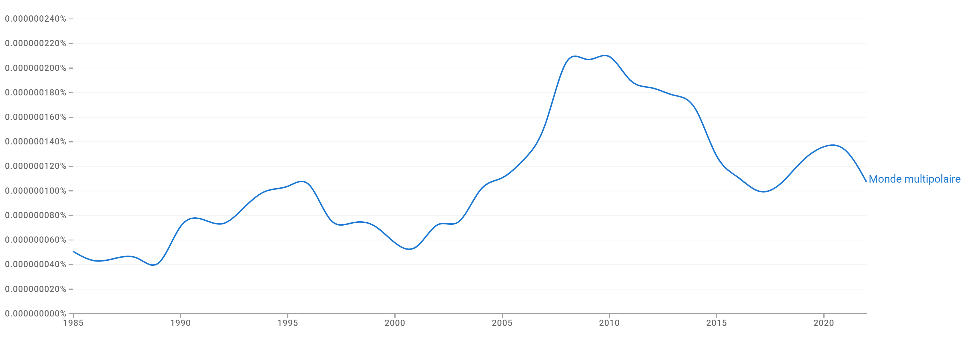
Fig. 17. Google Ngram frequency for “Multipolar world” (translated) in French (1985–2023):
Maximum attained at around 2.2×10⁻⁷ % in 2010, indicating a peak in textual visibility during that year.

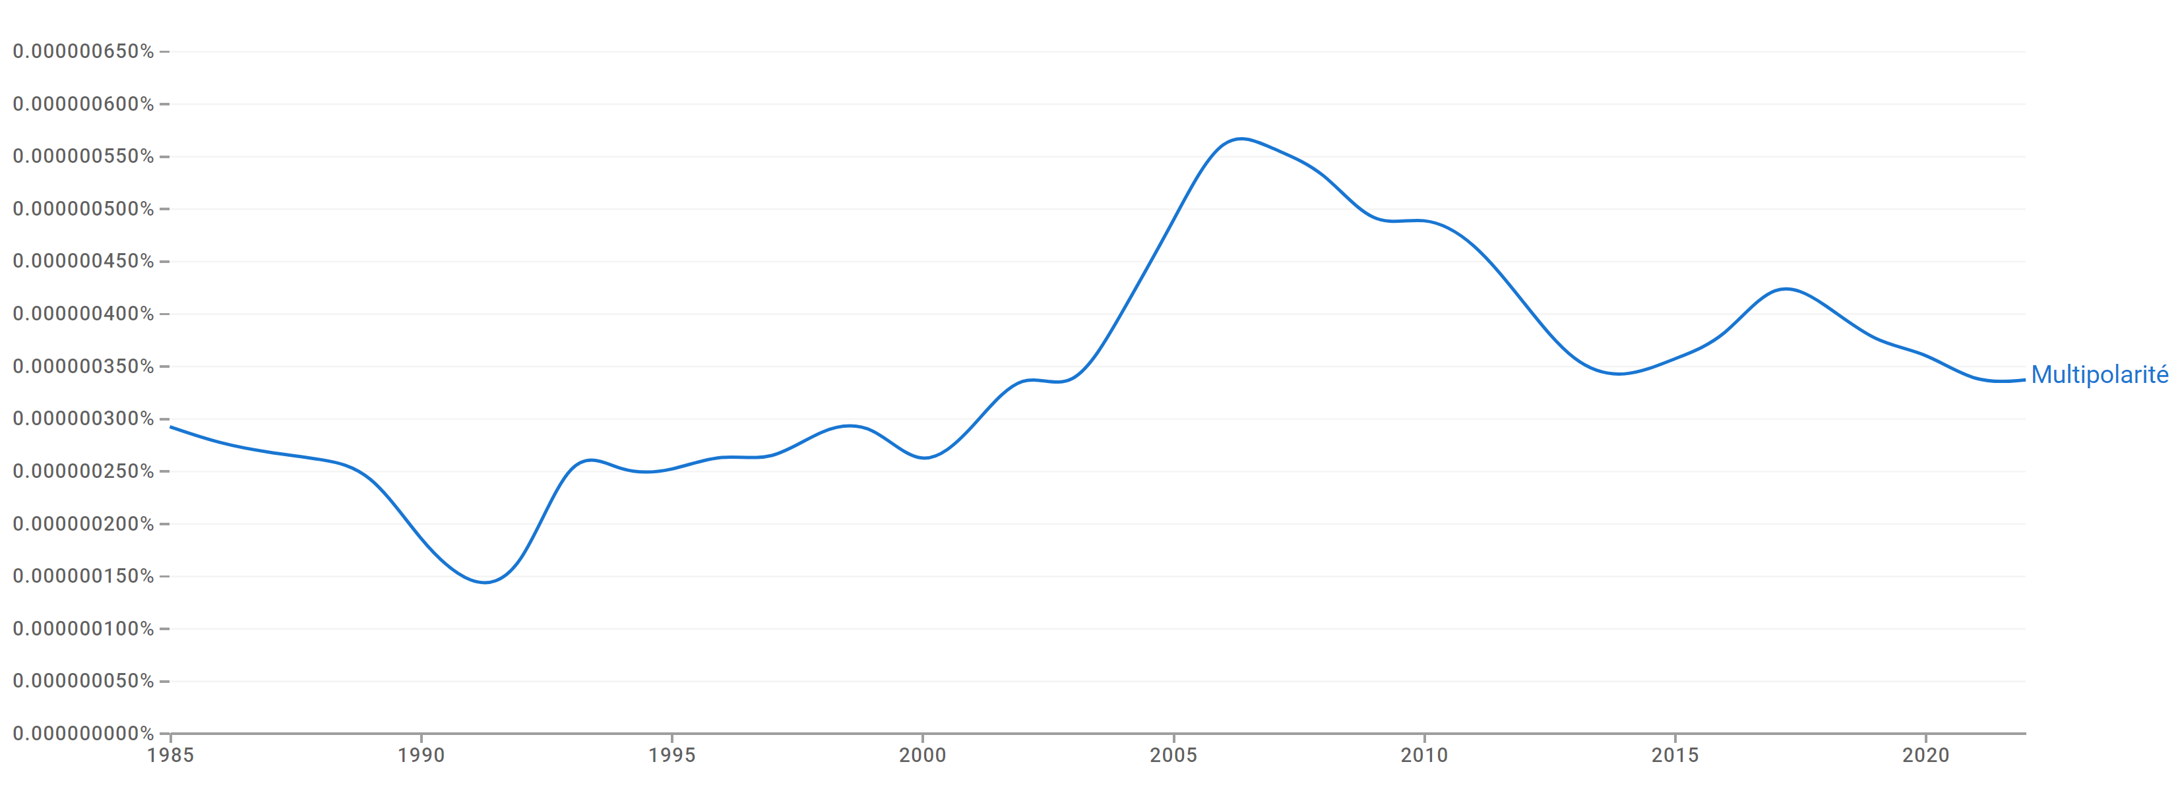
Fig. 18. Google Ngram frequency for “Multipolarity” (translated) in French (1985–2023):
Maximum attained at around 6.0×10⁻⁷ % in 2005, indicating a peak in textual visibility during that year.

German
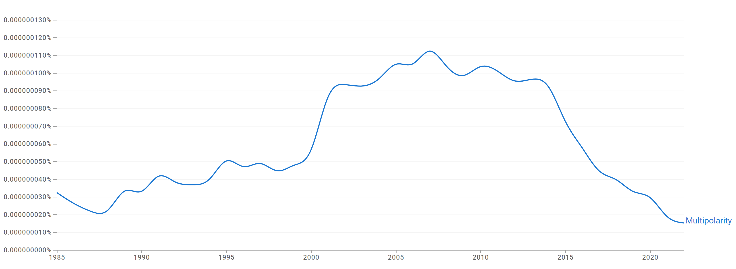
Fig. 19. Google Ngram frequency for “Multipolarity” in German (1985–2023):
Maximum attained at around 1.2×10⁻⁷ % in 2005, indicating a peak in textual visibility during that year.

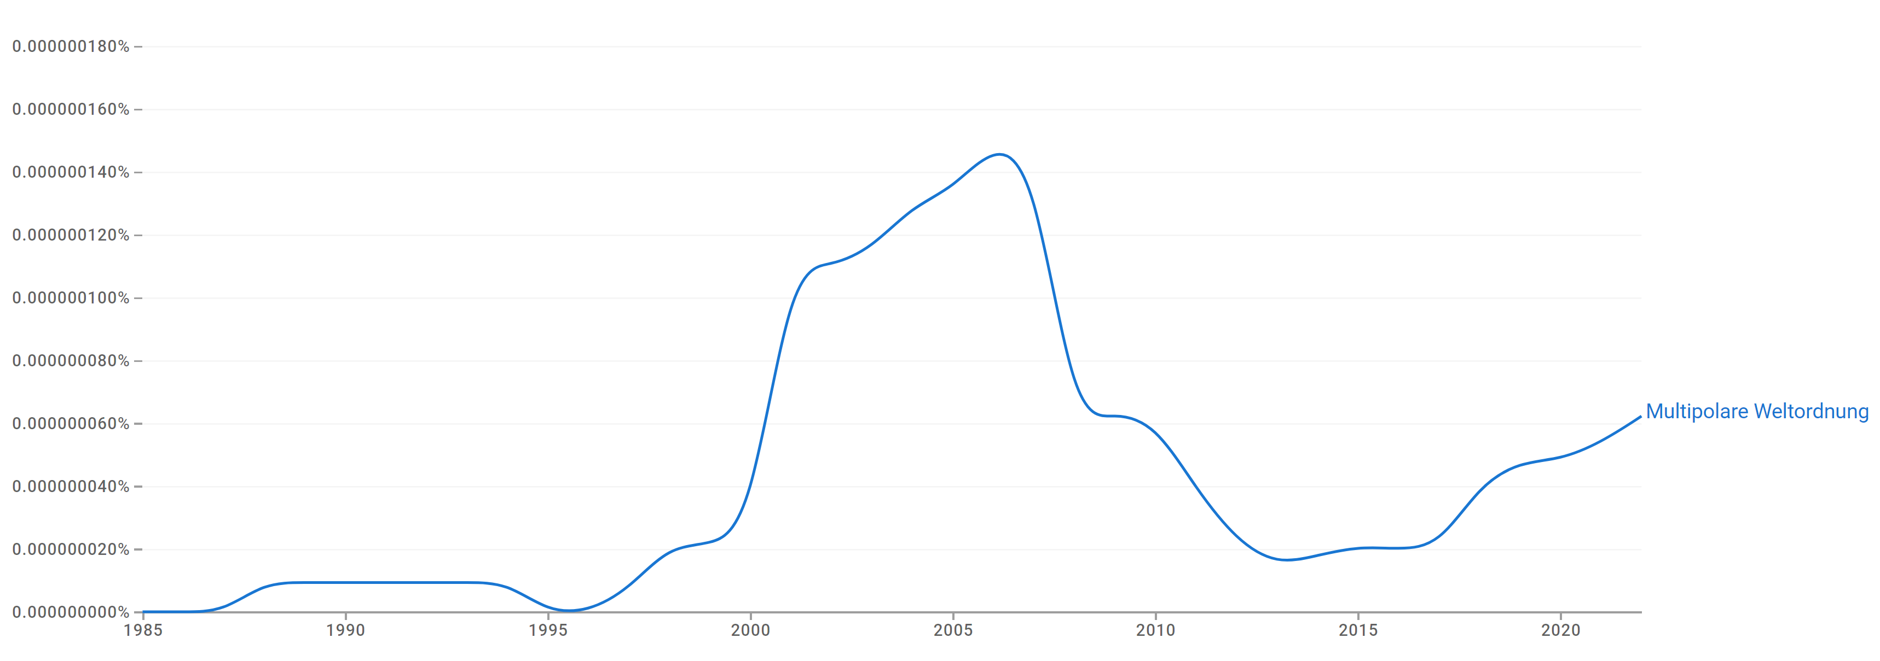
Fig. 20. Google Ngram frequency for “Multipolar world order” (translated) in German (1985–2023):
Maximum attained at around 1.6×10⁻⁷ % in 2005, indicating a peak in textual visibility during that year.

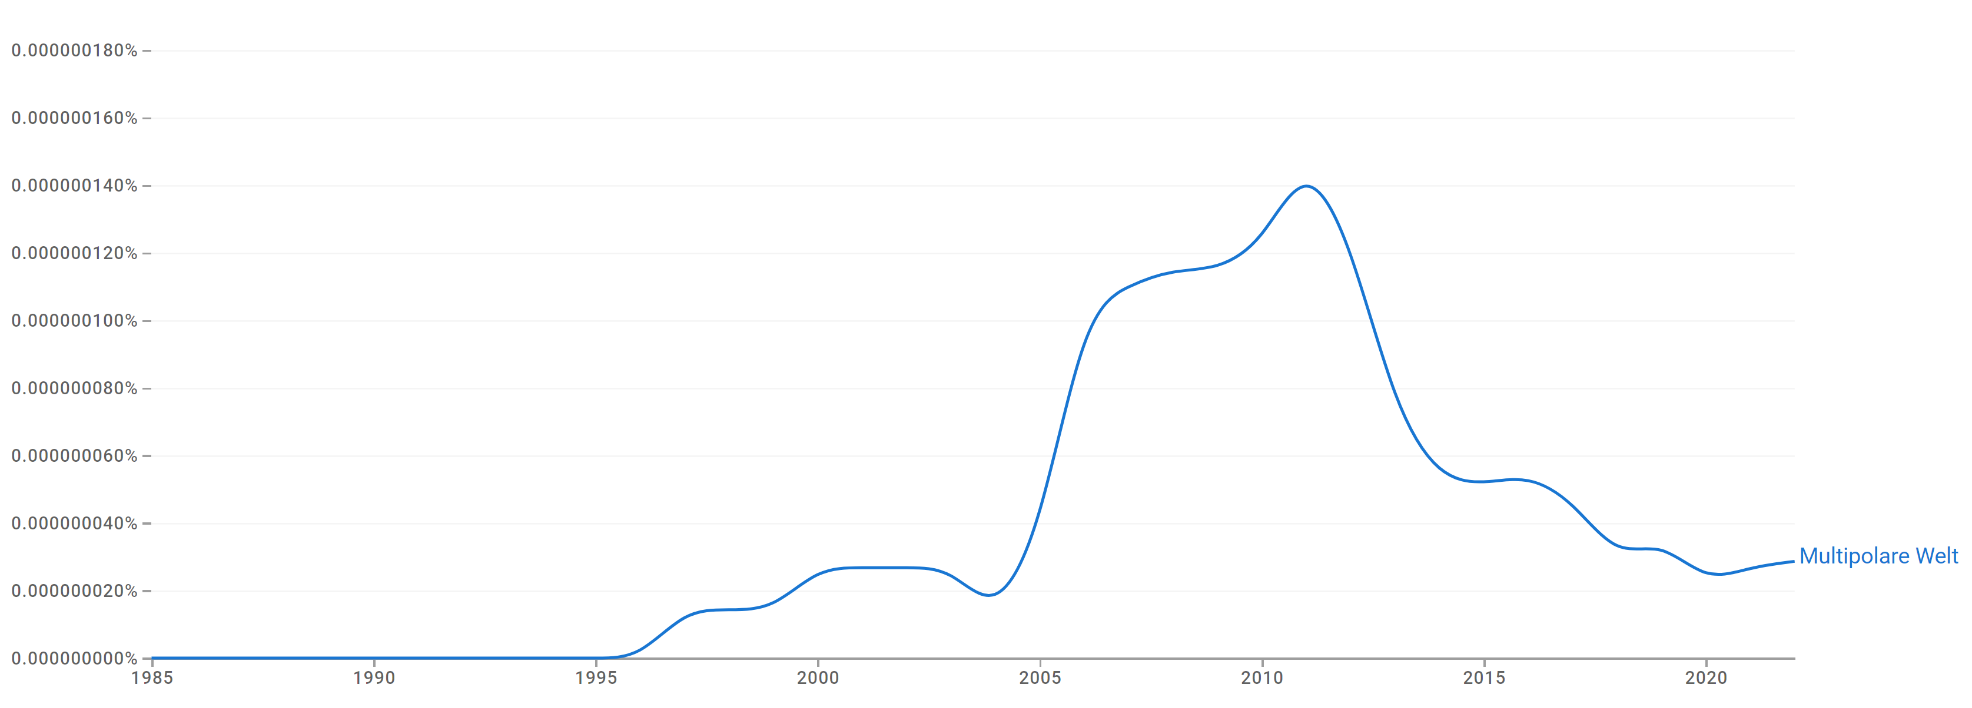
Fig. 21. Google Ngram frequency for “Multipolar world” (translated) in German (1985–2023):
Maximum attained at around 1.4×10⁻⁷ % in 2010, indicating a peak in textual visibility during that year.

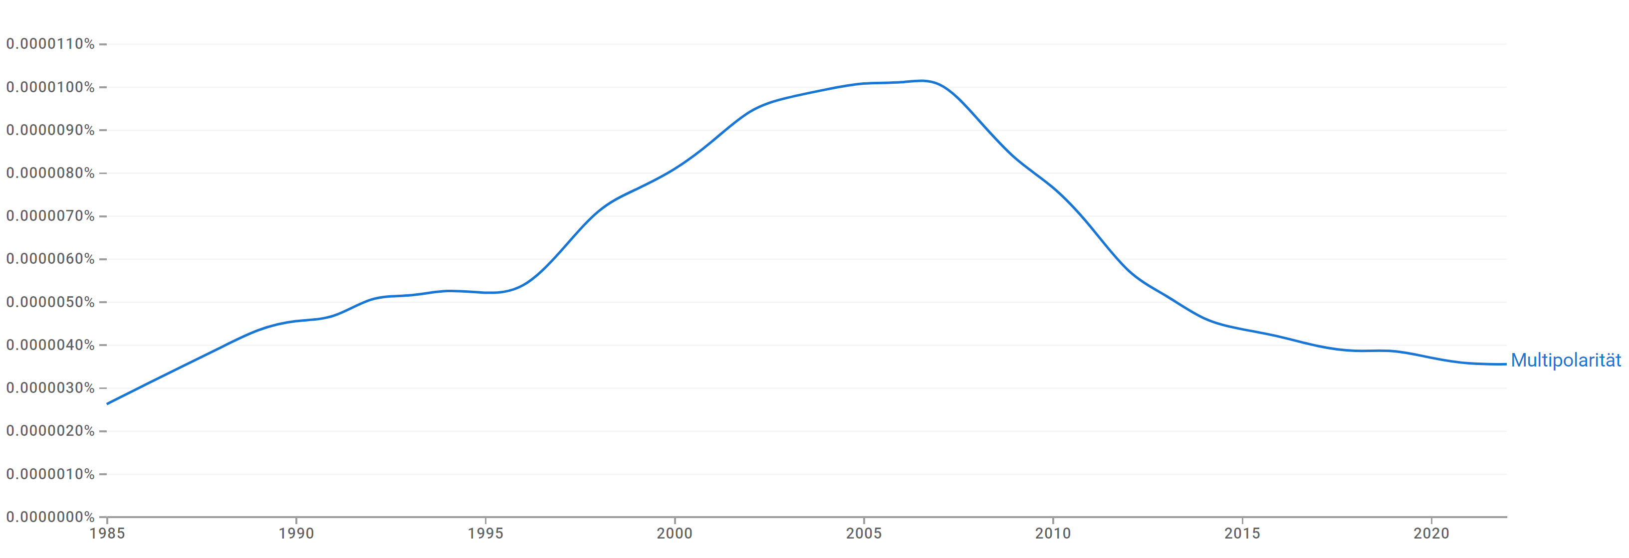
Fig. 22. Google Ngram frequency for “Multipolarity” (translated) in German (1985–2023):
Maximum attained at around 1.0×10⁻⁵ % in 2005, indicating a peak in textual visibility during that year.

Hebrew
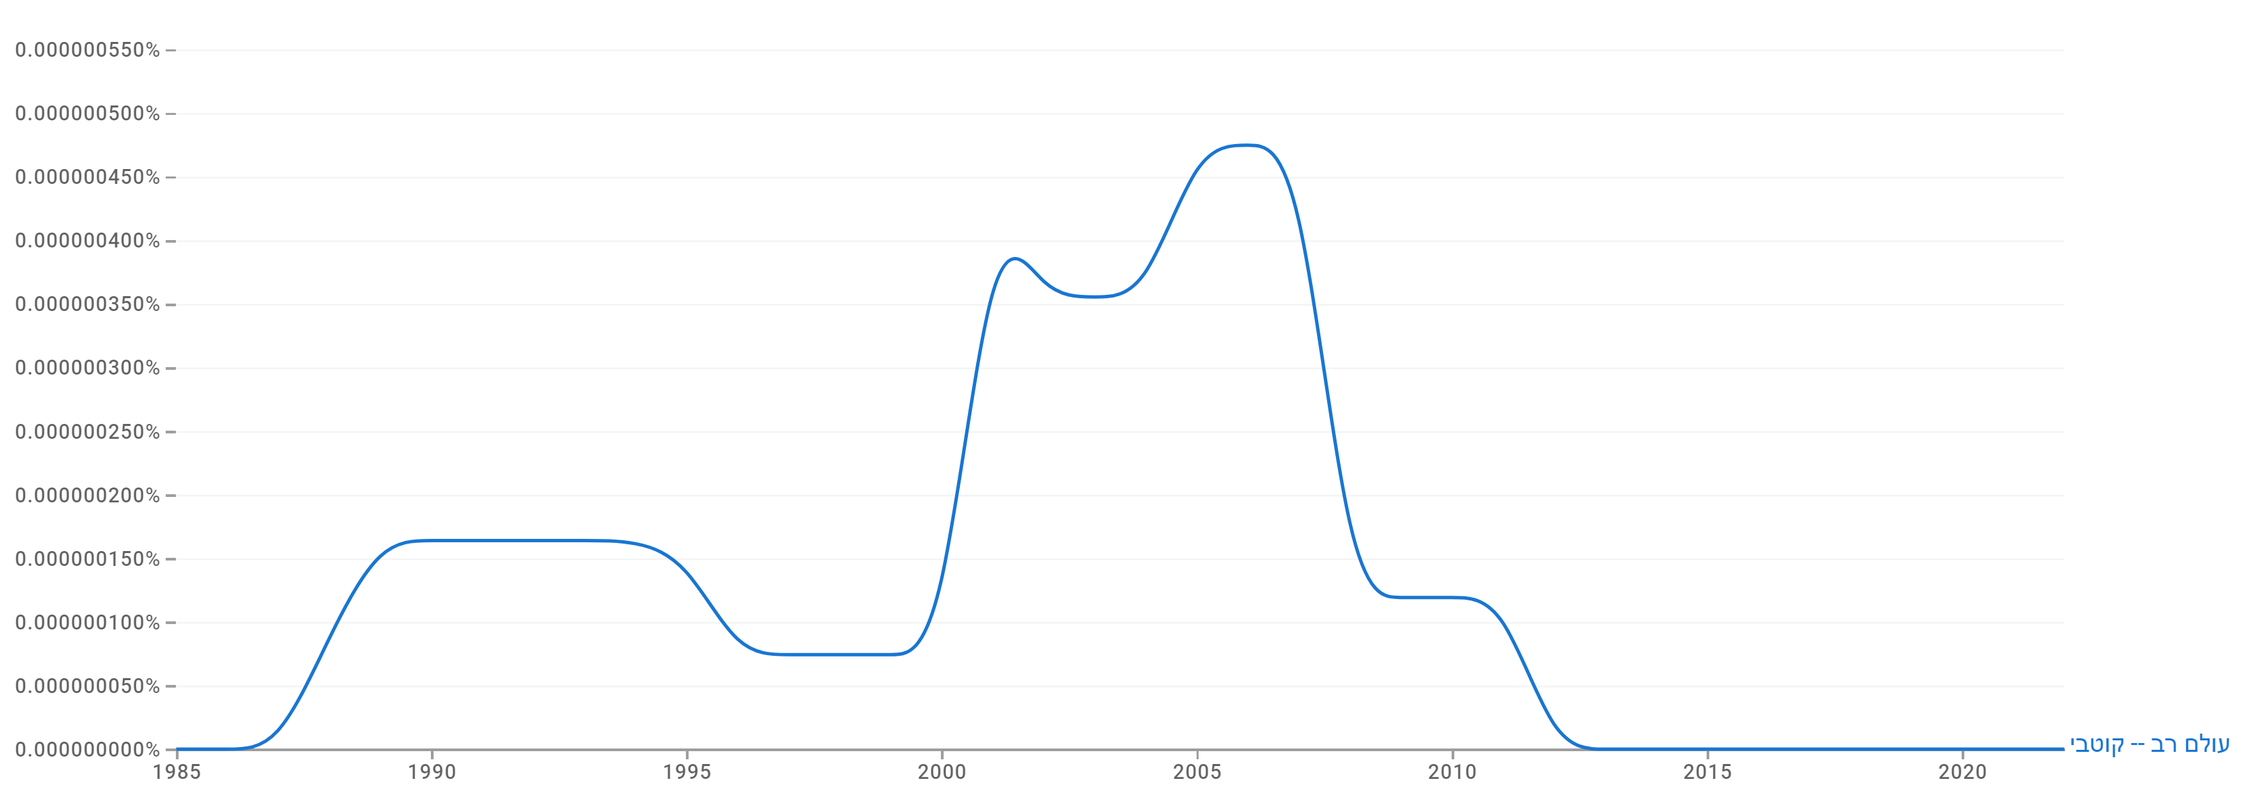
Fig. 23. Google Ngram frequency for “Multipolar world” (translated) in Hebrew (1985–2023):
Maximum attained at around 5.0×10⁻⁷ % in 2005, indicating a peak in textual visibility during that year.

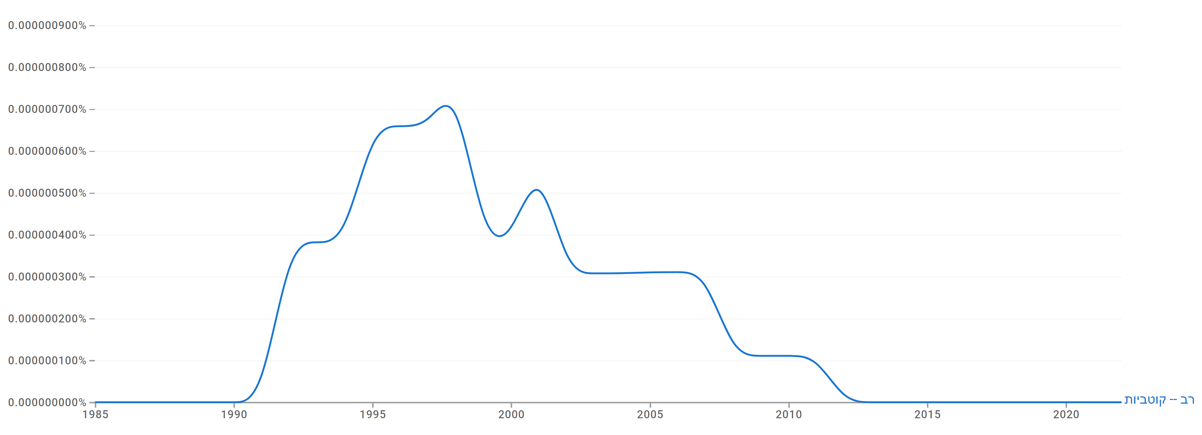
Fig. 24. Google Ngram frequency for “Multipolarity” (translated) in Hebrew (1985–2023):
Maximum attained at around 7.0×10⁻⁷ % in 1995, indicating a peak in textual visibility during that year.

Italian
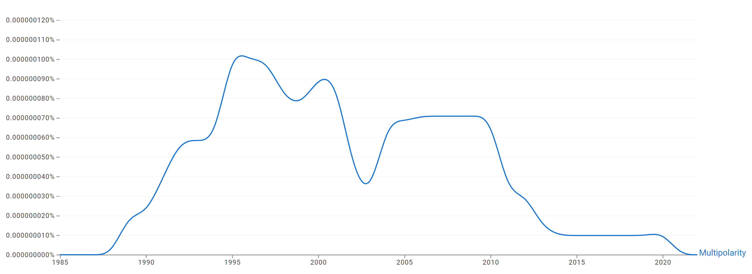
Fig. 25. Google Ngram frequency for “Multipolarity” in Italian (1985–2023):
Maximum attained at around 1.1×10⁻⁷ % in 1995, indicating a peak in textual visibility during that year.

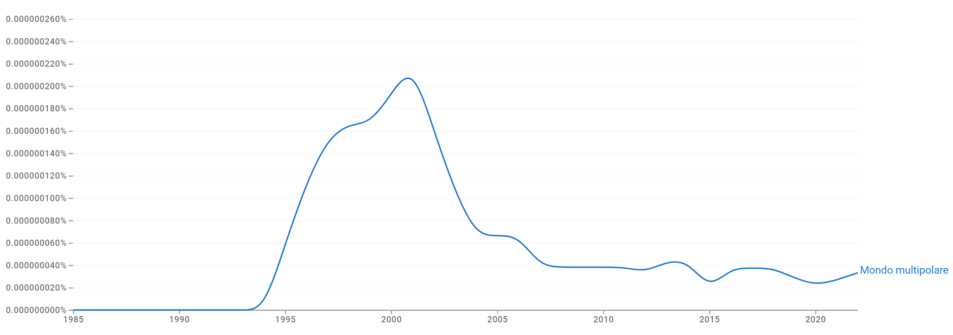
Fig. 26. Google Ngram frequency for “Multipolar world” (translated) in Italian (1985–2023):
Maximum attained at around 2.2×10⁻⁷ % in 2000, indicating a peak in textual visibility during that year.

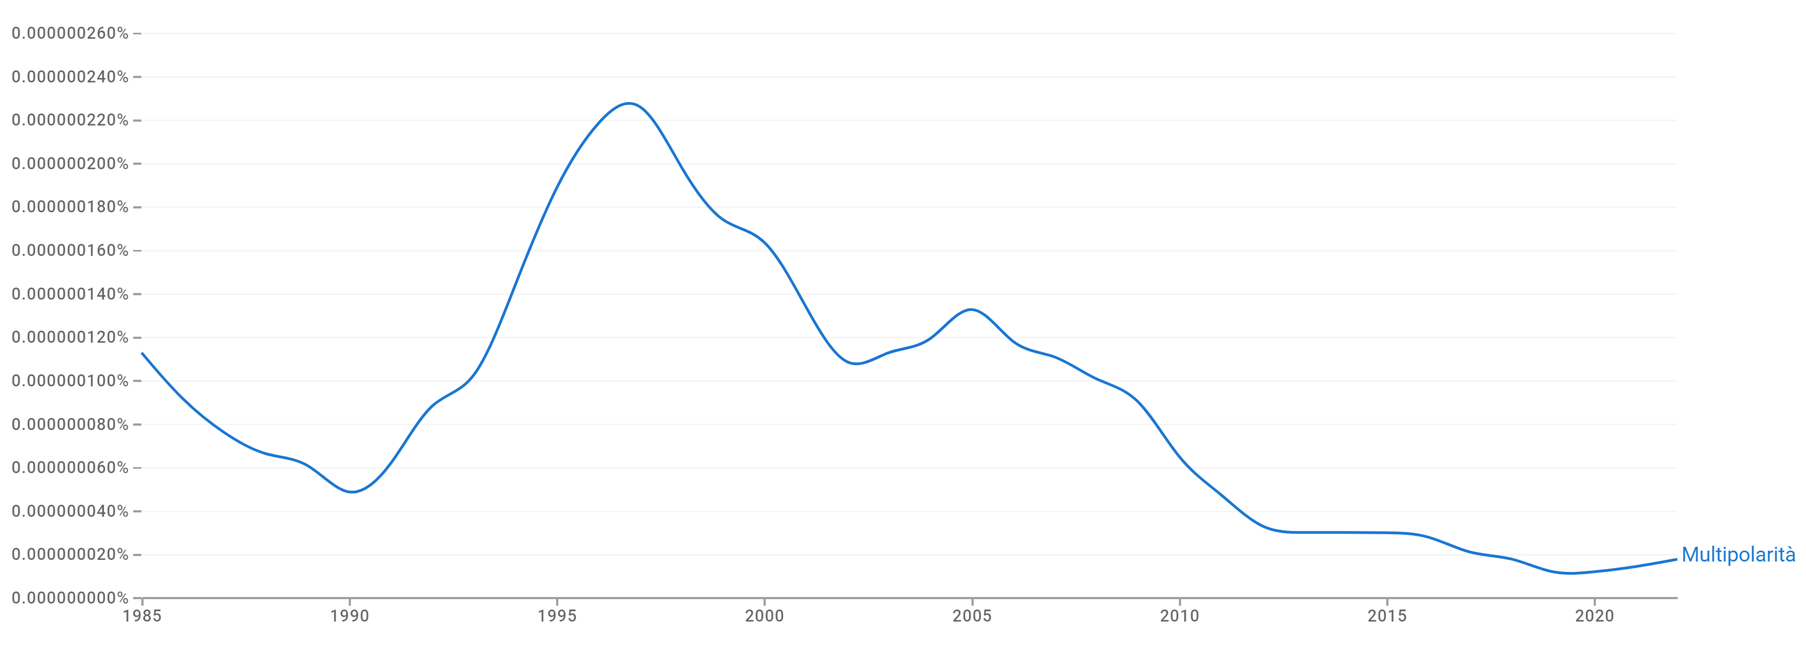
Fig. 27. Google Ngram frequency for “Multipolarity” (translated) in Italian (1985–2023):
Maximum attained at around 2.4×10⁻⁷ % in 1995, indicating a peak in textual visibility during that year.

Russian
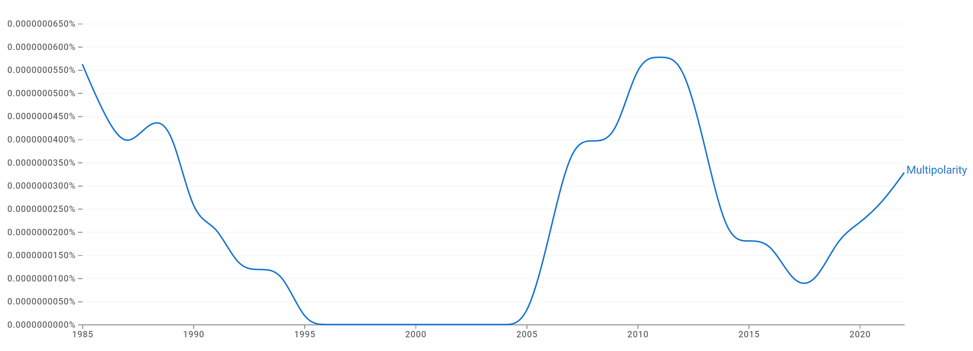
Fig. 28. Google Ngram frequency for “Multipolarity” in Russian (1985–2023):
Maximum attained at around 6.0×10⁻⁸ % in 2010, indicating a peak in textual visibility during that year.

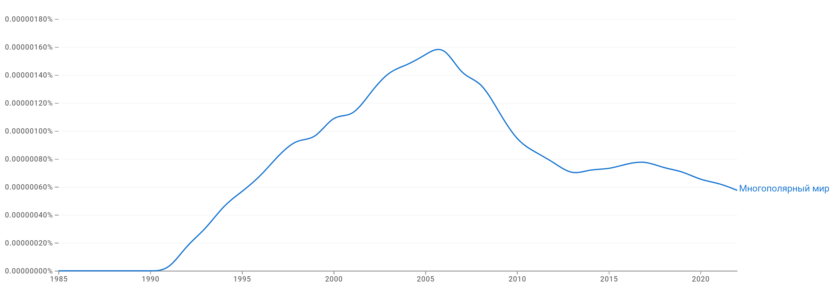
Fig. 29. Google Ngram frequency for “Multipolar world” (translated) in Russian (1985–2023):
Maximum attained at around 1.6×10⁻⁶ % in 2005, indicating a peak in textual visibility during that year.

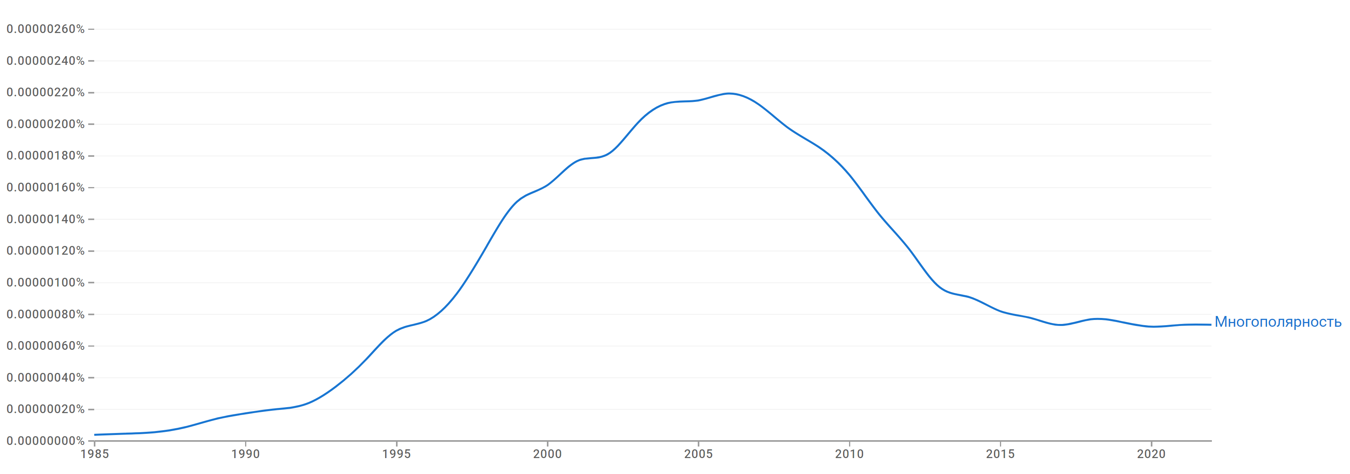
Fig. 30. Google Ngram frequency for “Multipolarity” (translated) in Russian (1985–2023):
Maximum attained at around 2.2×10⁻⁶ % in 2005, indicating a peak in textual visibility during that year.

Spanish
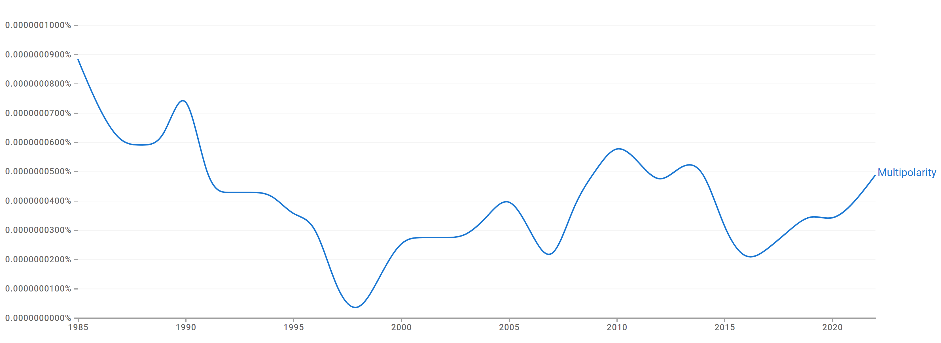
Fig. 31. Google Ngram frequency for “Multipolarity” in Spanish (1985–2023):
Maximum attained at around 9.0×10⁻⁸ % in 1985, indicating a peak in textual visibility during that year.

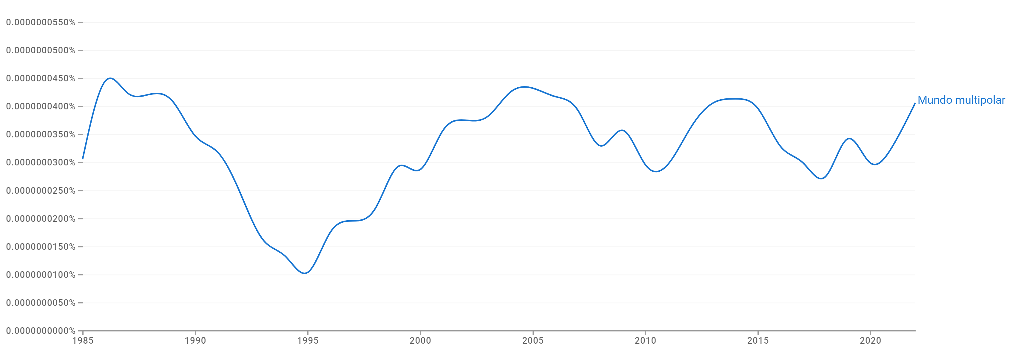
Fig. 32. Google Ngram frequency for “Multipolar world” (translated) in Spanish (1985–2023):
Maximum attained at around 4.5×10⁻⁸ % in 1985, indicating a peak in textual visibility during that year.

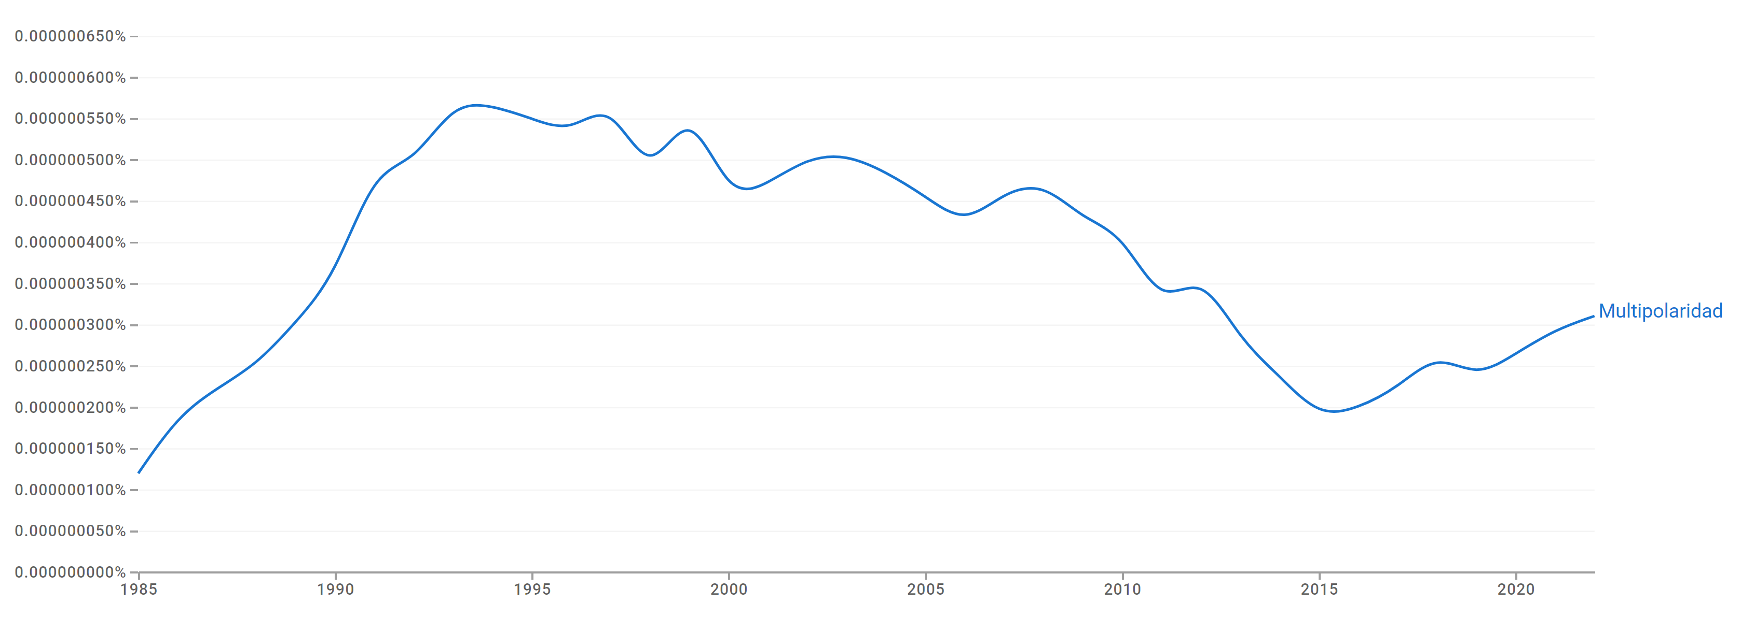
Fig. 33. Google Ngram frequency for “Multipolarity” (translated) in Spanish (1985–2023):
Maximum attained at around 6.0×10⁻⁷ % in 1995, indicating a peak in textual visibility during that year.

