Supplementary Table 1. clinical characteristics and CT manifestation¹
 |  | Total (n = 75) | Moderate (n =53) | Severe (n = 22) | P value
Age (y) |  | 58.1 ± 14 | 55.4 ± 14 | 64.6 ± 12 | .082
Gender | Male | 45 (60.0) | 33 (62.3) | 12 (54.6) | .534
 | Female | 30 (40.0) | 20 (37.7) | 10 (45.5) | .534
Symptoms | Fever | 60 (80.0) | 43 (81.1) | 17 (77.3) | .704
Symptoms | Cough | 48 (64.0) | 38 (71.7) | 10 (45.5) | .031*
Symptoms | Fatigue | 37 (49.3) | 27 (50.9) | 10 (45.5) | .665
Symptoms | Myalgia | 22 (29.3) | 18 (34.0) | 4 (18.2) | .172
Symptoms | Anhelation | 20 (26.7) | 11 (20.8) | 9 (41.0) | .072
Symptoms | Diarrhea | 19 (25.3) | 14 (26.4) | 5 (22.7) | .738
Symptoms | chest tightness | 18 (24.0) | 7 (13.2) | 11 (50.0) | <.001***
Symptoms | Expectoration | 15 (20.0) | 13 (24.5) | 2 (9.1) | .128
Symptoms | Headache | 11 (14.7) | 10 (18.9) | 1 (4.5) | .110
Symptoms | Sore throat | 9 (12.0) | 7 (13.2) | 2 (9.0) | .617
Symptoms | Loss of appetite | 8 (10.7) | 7 (13.2) | 1 (5.0) | .269
Symptoms | Dizziness | 7 (9.3) | 5 (9.4) | 2 (9.0) | .963
Symptoms | Nausea and vomiting | 3 (4.0) | 2 (3.8) | 1 (5.0) | .877
Comorbidities | Hypertension | 19 (25.3) | 9 (17.0) | 10 (45.5) | .010**
Comorbidities | Diabetes | 10 (13.3) | 4 (7.6) | 6 (27.3) | .022
Comorbidities | Cardiovascular disease | 8 (10.7) | 7 (13.2) | 1 (4.5) | .269
Comorbidities | Cerebral infarction | 2 (2.7) | 1 (1.9) | 1 (4.5) | .515
Comorbidities | Chronic respiratory disease | 2 (2.7) | 1 (1.9) | 1 (4.5) | .515
Pulmonary  CT cans | The period ª (d) | 14.4 ± 6.5 | 14.1 ± 6.1 | 15.3 ± 7.6 | .467
Pulmonary  CT cans | Numbers CT scans | 4 (3, 4) | 3.5 (3, 4) | 4 (3.75, 5) | .019
Pulmonary  CT cans | The interval ^{b} (d) | 6 (5, 8) | 6 (5, 8) | 7 (6, 7) | .264
Pulmonary  CT cans | Initial total lung severity score (0 to 20) | 5 (3, 7) | 4 (3, 5) | 8 (7, 12) | <.001***
¹ Note. Except where indicated, data are numbers of patients, with percentages in parentheses.
ª The period between the onset of initial symptoms and the first pulmonary CT scan (d);
^{b} The interval between the adjacent pulmonary CT scans (d); *<0.05, **<0.01, *** <0.001.

Supplementary Table 2. Laboratory investigations²
 | Normal Range | Total | Moderate | Severe | P value
WBC (G/L) | 3.9-9.9 | 5.90±1.84 | 5.81 ± 1.73 | 6.10 ± 2.12 | .534
Neutrophil (G/L) | 2.0-7.4 | 3.79±1.60 | 3.66 ± 1.73 | 4.10 ± 1.94 | .344
LYM (G/L) | 1.1-3.6 | 1.35±0.51 | 1.43 ± 0.47 | 1.17 ± 0.57 | .045*
LYM percentage (%) | 20-40 | 24.17±8.68 | 25.76 ± 8.03 | 20.49 ± 9.20 | .016*
Monocyte (G/L) | 0.12-0.8 | 0.55±0.19 | 0.55 ± 0.18 | 0.55 ± 0.23 | .965
Hemoglobin (g/L) | 120-160 | 122.15±15.83 | 123.86 ±14.91 | 118.18 ± 17.47 | .161
CRP (mg/L) | 0-10 | 10.3 (3.3-33.5) | 8.97 (3.2-19.4) | 38.13 (6.0-121.0) | .017
ESR (s) | ＜20 | 55.70±29.58 | 47.73 ± 24.25 | 77.39 ± 32.51 | <.001***
ALT (U/L) | 0.0-33.0 | 53.24±50.80 | 47.86 ± 45.27 | 68.15 ± 63.40 | .221
AST (U/L) | 0.0-32.0 | 34.55±24.96 | 30.64 ± 19.62 | 45.38 ± 34.58 | .166
LDH (U/L) | 135-214 | 284.98±81.88 | 264.67 ± 66.52 | 340.83 ± 96.45 | .004**
Albumin (g/L) | 35.0-52.0 | 35.88±4.40 | 36.24 ± 4.34 | 34.89 ± 4.61 | .351
Globulin (g/L) | 20-30 | 28.39±4.95 | 27.54 ± 4.60 | 30.64 ± 5.32 | .054
BUN (mmol/L) | 2.9-8.2 | 3.98±1.99 | 4.12 ± 2.24 | 3.61 ± 1.02 | .459
Scr (μmol/L) | 53-106 | 69.44±21.91 | 70.12 ± 23.98 | 67.57 ± 15.55 | .734
D-dimer (mg/L) | 0-0.5 | 0.65 (0.3-1.5) | 0.45 (0.27-0.85) | 1.89 (0.82-4.09) | .002**
FER-1 (ug/L) | 15-200 | 459.67±364.21 | 405.25±380.05 | 677.37±212.85 | .262
IL-6 (pg/mL) | 0.10-2.9 | 17.56(5.2-43.5) | 15.31(4.0-42.2) | 21.45(8.2-48.0) | .600
IL-10 (pg/mL) | 0.10-5.00 | 3.81±1.45 | 3.89 ± 1.47 | 3.58 ± 1.43 | .493
TNF-a (pg/mL) | 0.10-23.00 | 5.92±7.58 | 4.84 ± 4.46 | 9.01 ± 12.66 | .230
CD4/CD8 | 0.41-2.72 | 2.33±1.05 | 2.32 ± 1.10 | 2.36 ± 0.96 | .896
CD4 percentage (%) | 25.34-51.37 | 50.22±11.87 | 49.46 ± 11.00 | 51.23 ± 14.10 | .432
CD8 percentage (%) | 14.23-38.95 | 24.94±10.08 | 24.81 ± 9.48 | 25.27 ± 11.84 | .877
² Note. The numbers in parentheses indicate the interquartile range. CRP, C-reactive protein; ESR, Erythrocyte sedimentation rate; ALT, Alanine aminotransferase; AST, Aspartate aminotransferase; LDH, Lactate dehydrogenase; BUN, Blood urea nitrogen; Scr, Serum creatinine; *<0.05, **<0.01, *** <0.001.

Supplementary Figure 1
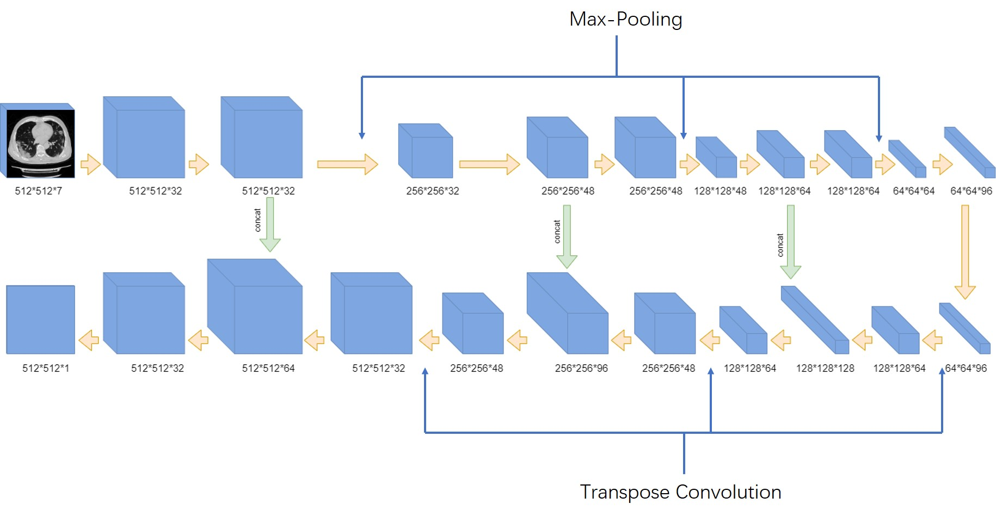
Supplementary Fig. 1. Deep Learning network structure for pneumonia lesion detection and segmentation. This network consists of 12 convolutional segments, 3 max-pooling layers for down-sampling and 3 transpose layers for up-sampling.

