Table 1 Basic Data by Gender and Age Group（Baseline Survey）
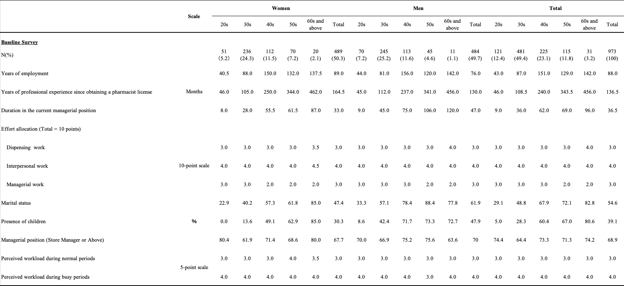

Table 2 Gender-Specific Results of the Brief Job Stress Questionnaire (BJSQ)
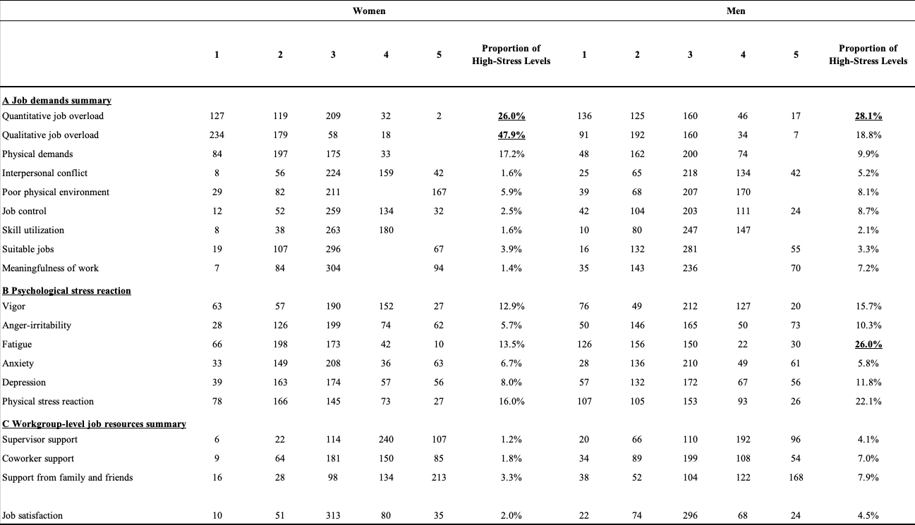

Table 3 Distribution of UWES-17 Scores by Gender and Age Group
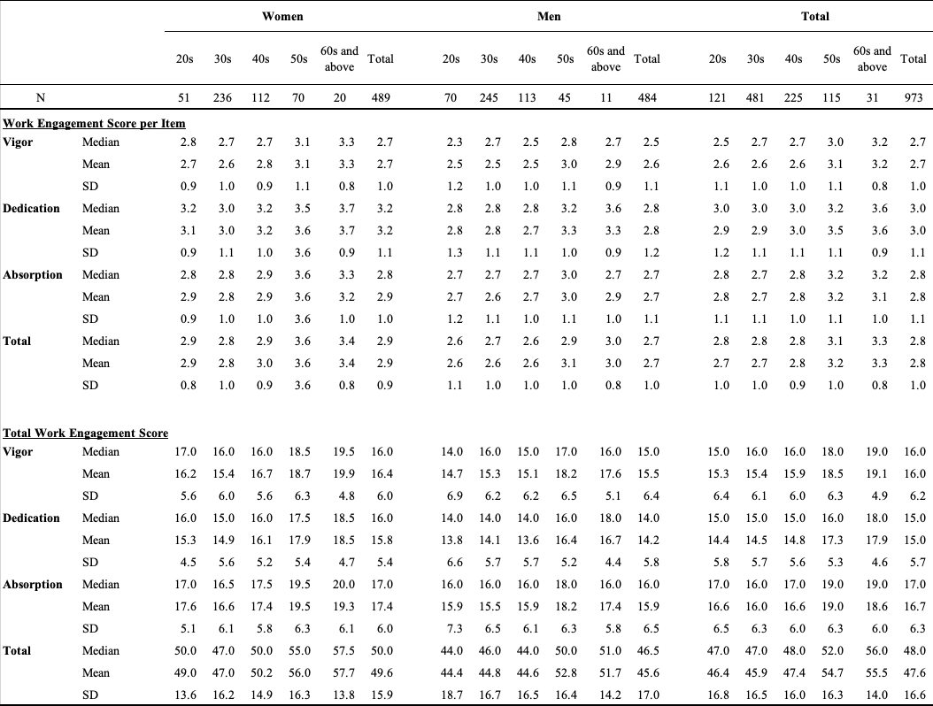

Table 4 Predictors Influencing High Work Engagement: A Logistic Regression Analysis

