Supporting information

Intermolecular interactions governing adsorption of bulky molecules on ZIF-8: Insight from adsorption kinetics of benzene and 6-membered ring alicyclic hydrocarbons

Takahiro Ueda,^{1,2}* Yuta Yamada,² Kota Fujii,² Ryota Mihara,³ Taku Iiyama,³ Yasutaka Hamada,¹ Mitsutaka Okumura¹

^{1*}Department of Chemistry, Graduate School of Science, The University of Osaka, Toyonaka, Osaka 560-0043, Japan.
²Department of Chemistry, Faculty of Science, The University of Osaka, Toyonaka, Osaka 560-0043, Japan.
³Graduate School of Medicine, Science and Technology, Shinshu University, Matsumoto, Nagano 390-8621, Japan.

Molecular structure of adsorbate molecules
The molecular structures shown in Scheme S1 are based on the van der Waals diameters of carbon and hydrogen atoms. In cyclohexane, the molecules adopted a chair conformation. The molecular size is defined by the effective minimum dimensions of the molecule (MIN-1 and MIN-2) proposed by Webster et al. [S1], as shown in Table S1. The molecular size increased in the following order: BZ< 1,4-CHD < 1,3-CHD < CHEN < CHEX. In this series, the molecular thickness increased by more than the molecular diameter.

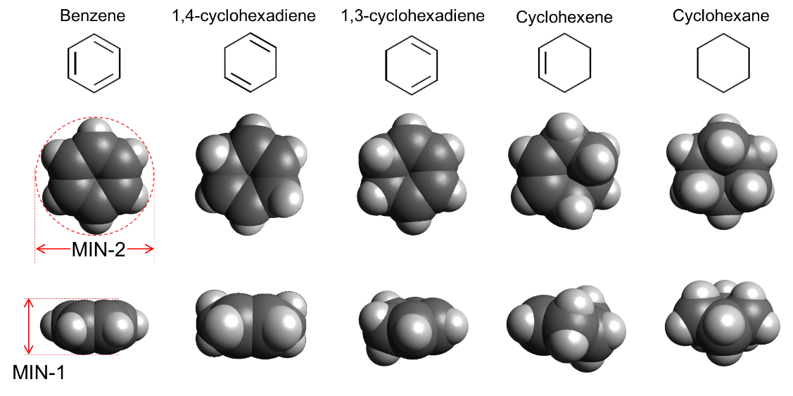
Scheme S1

Table S1 Effective minimum dimensions of molecules (MIN-1 and MIN-2) proposed by Webster et al.
 | MIN-1/nm | MIN-2/nm
C₆H₆ | 0.3277 | 0.6628
1, 4-cyclohexadiene* | 0.3845 | 0.6612
1, 3-cyclohexadiene* | 0.3845 | 0.6612
Cyclohexene* | 0.4414 | 0.6595
C₆H₁₂ | 0.4982 | 0.6580
* The molecular size was evaluated by interpolation between C₆H₆ and C₆H₁₂, assuming a linear change in molecular size per bond.

Estimation of molecular size
The size of the adsorbed molecule was determined from the average of the diameters calculated from the van der Waals (vdw) equation using the critical coefficients and density in the liquid state, assuming that the adsorbate molecule was spherical and highly mobile in air. In the van der Waals (vdw) equation,
$$p= \frac{RT}{V-b}-\frac{a}{V^{2}}$$ | (A-1)
Parameter b is related to the exclusive volume of the actual molecules and can be described using the critical coefficients as follows:
$$b= \frac{RT_{c}}{8P_{c}}$$ | (A-2)
where R is the gas constant, and T_{c} and P_{c} are the critical temperature and pressure, respectively, of the gas. Based on the T_{c} and P_{c} values for each adsorbate molecule [S2], we evaluated the molecular size, σ_{vdw}, using the following equation (note that b is in dm³ m⁻¹):
$$\frac{σ_{vdw}}{2} =0.463b^{\frac{1}{3}} nm$$ | (A-3)
On the other hand, the density of liquid also provides the diameter of molecule, σ_{density}, through the following relation by assuming the closed-packing of spherical particles,
$$\frac{4}{3}π(\frac{σ_{density}}{2})^{3}=0.7405(\frac{M}{N_{A}ρ})$$ | (A-4)
where M is the molar mass ( g mol⁻¹), ρ is the density [S3] in the liquid state ( g nm⁻³), and N_{A} is the Avogadro’s constant. The evaluated σ_{vdw} and σ_{density} values are listed in Table S2.

Table S2 Molecular diameter evaluated from the b parameter of the van der Waals (vdw) coefficients and the density (ρ) of the bulk liquid, and their average values.
 | σ_{vdw} /nm | σ_{density} /nm | σ_{average} /nm
C₆H₆ | 0.456 | 0.593 | 0.525
1,4-cyclohexadiene | 0.469 | 0.605 | 0.537
1,3-cyclohexadiene | 0.469 | 0.606 | 0.538
Cyclohexene | 0.475 | 0.620 | 0.548
C₆H₁₂ | 0.483 | 0.634 | 0.558

Figure S1 Nitrogen adsorption isotherm of ZIF-8 (77 K).

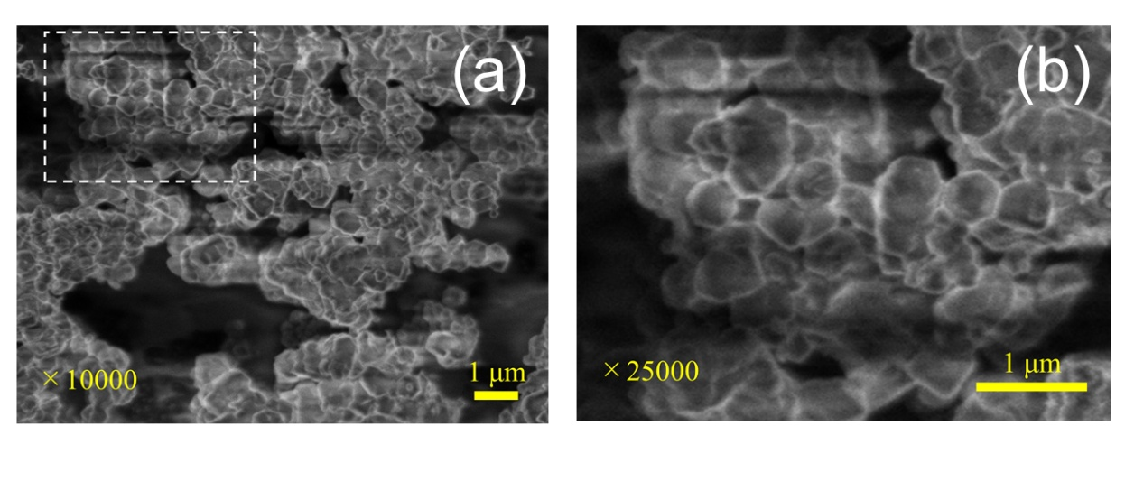
Figure S2 Scanning electron microscopy images of the powdered ZIF-8 specimen: (a) and (b).

Figure S3 Size distribution of the crystallites in the powdered ZIF-8.

Figure S4 Temperature dependence of the saturated vapor pressure of each solvent.

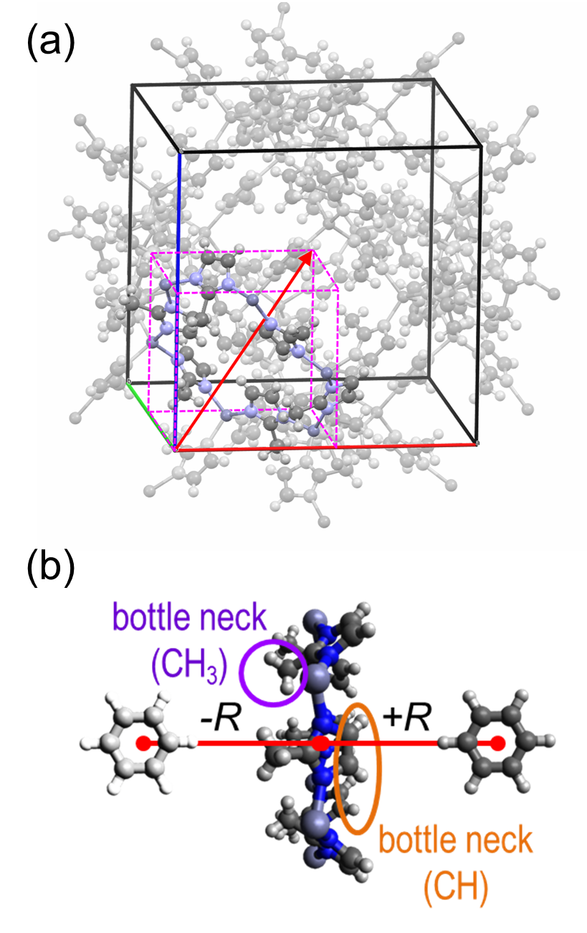
Figure S5 Model of 6-membered ring (6MR) aperture for Monte Carlo simulation: extraction of 6MR from the unit cell of the ZIF-8 crystal (a) and the Z-axis in the reference coordination system for molecular passage (b). The center of gravity for an adsorbed molecule varied along the Z-axis from +R to ‒R.

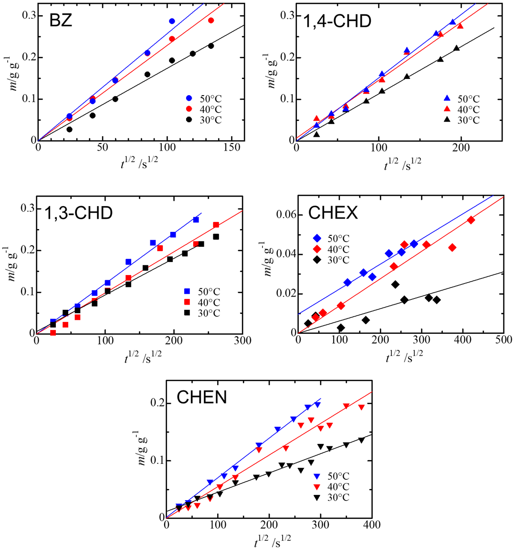
Figure S6 Time dependence of adsorption amount at 303, 313, and 323 K.

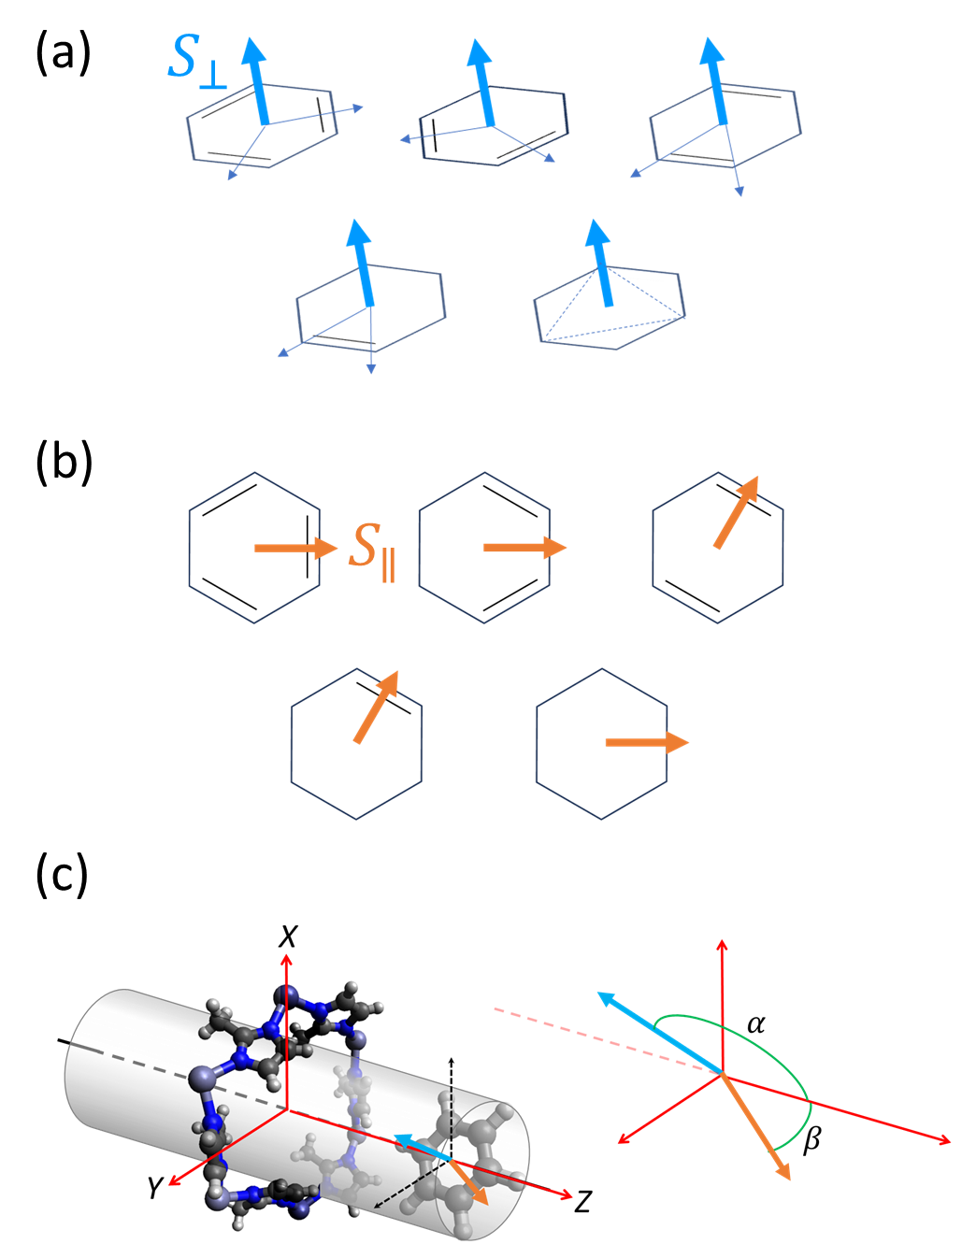

Figure S7 Definition of two types of order parameter, S⊥ (a) and S|| (b), in benzene and 6-membered ring alicyclic hydrocarbons, and the molecular orientation and an angle used for the definition of the order parameters in the reference coordination system for molecular passage (c).

Figure S8 FT-IR spectra of ZIF-8 and specimens, including adsorbates (all wavenumber regions).

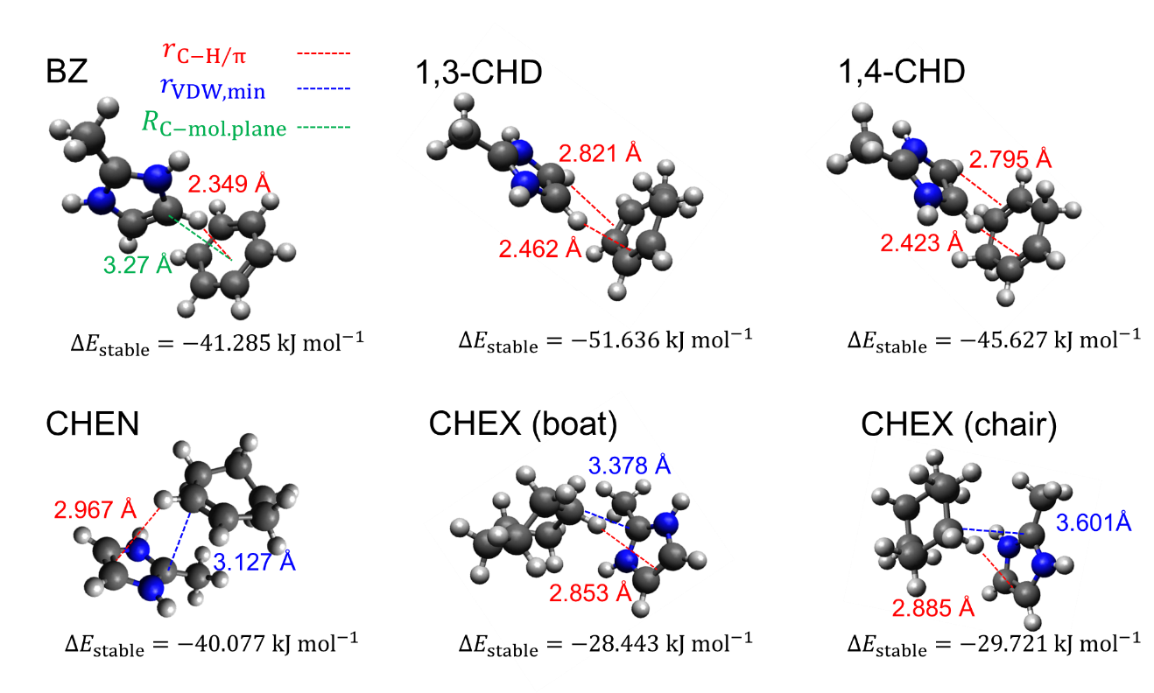
Figure S9 Molecular aggregation of the H-capped 2-methylimidazole ring with BZ, 1,3-CHD, 1,4-CHD, CHEN, and CHEX (boat and chair) as optimized by DFT calculations.

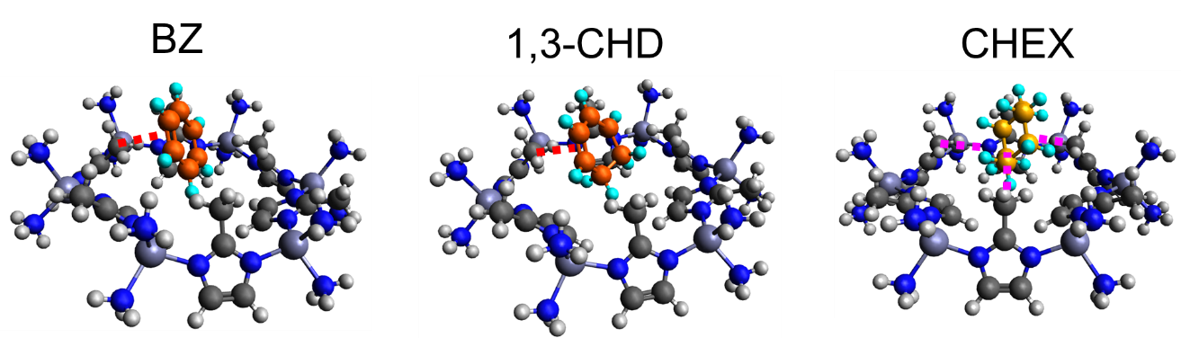
Figure S10 Molecular aggregation of the 6MR aperture with BZ, 1,3-CHD, and CHEX (chair) optimized using DFT calculations.

Table S3 C-H distance and wavenumber of the CH symmetric stretching band in the imidazolate moiety evaluated by DFT calculation.
2-methylimidazolate (H-capped)-adsorbate molecule aggregate
 | Imidazolate ring protons |  | Methyl protons
 | C-H length ^{a)} / pm | $${\tilde{ν}}_{CH symm.}/{cm}^{-1}$$ | C-H length ^{b)} / nm | $${\tilde{ν}}_{CH symm.}/{cm}^{-1}$$
Me-Imd | 107.729 | 3355.66 | 109.310 | 3090.91
BZ | 108.047 | 3344.10 | 109.211 | 3086.95
1,4-CHD | 108.351 | 3345.68 | 109.212 | 3087.05
1,3-CHD | 108.219 | 3342.85 | 109.208 | 3087.32
CHEN | 107.714 | 3349.80 | 109.183 | 3087.32
CHEX (chair) | 107.716 | 3354.24 | 109.214 | 3087.97
CHEX (boat) | 107.719 | 3346.77 | 109.214 | 3086.62
6-membered ring (6MR) moiety-adsorbate molecule aggregate
 | Imidazolate ring protons |  | Methyl protons
 | C-H length ^{c)} / nm | $${\tilde{ν}}_{CH symm.}/{cm}^{-1}$$ | C-H length ^{d)} / nm | $${\tilde{ν}}_{CH symm.}/{cm}^{-1}$$
6MR | 108.001 | 3308.76  3308.86  3310.12 | 109.449 | 3061.44  3061.47  3061.53
BZ | 108.010 | 3307.93  3308.11  3308.70 | 109.426 | 3061.41  3061.66  3065.33
1,3-CHD | 108.008 | 3305.87  3307.77  3309.41 | 109.445 | 3059.58  3062.42  3063.36
CHEX (chair) | 107.999 | 3308.97  3309.41  3309.67 | 109.460 | 3059.74  3060.18  3064.10
a) The longest CH distance contributing to the CH-π interaction.
b) Average value among the three CH distances in a methyl group.
c) Average value among the imidazole ring protons facing the aperture.
d) Average value of nine CH distances in three methyl groups facing the aperture.

References
- Webster, C. E., Drago, R. S., Zerner, M. C.: Molecular Dimensions for Adsorptives. J. Am. Chem. Soc., 120, 5509-5516 (1998).
- Israelachvili, J. N.: Intermolecular and Surface Forces, Third Edition. Academic Press, London, (2011).
- Handbook of Chemistry: Pure Chemistry, 3rd ed., Ch. 5, Ch. 8, Maruzen Publishing, Tokyo, (1984).

