Supporting materials

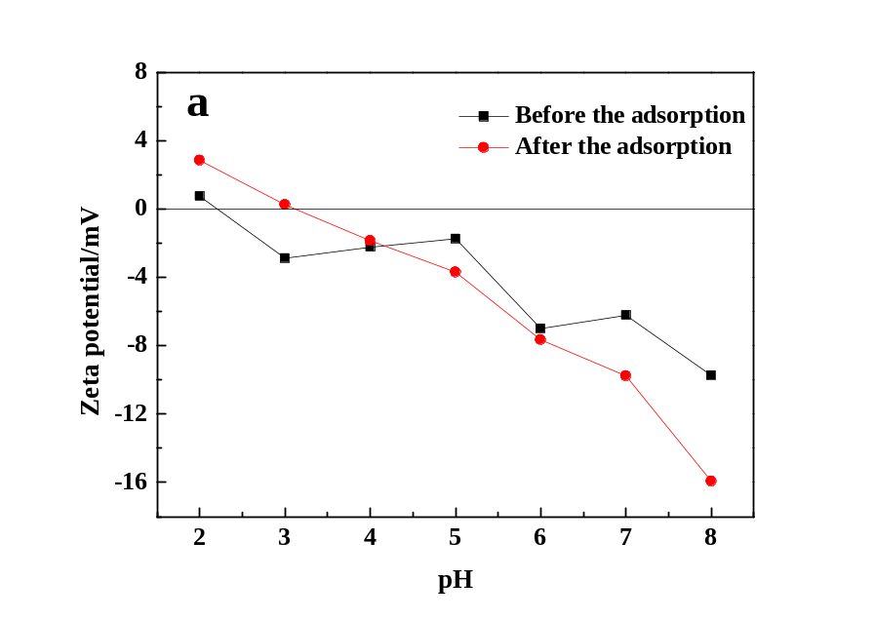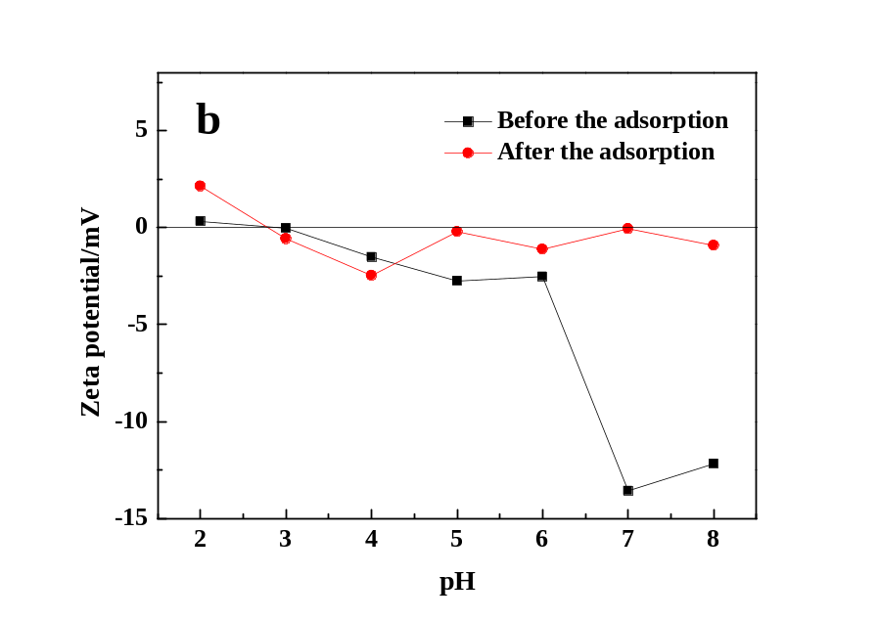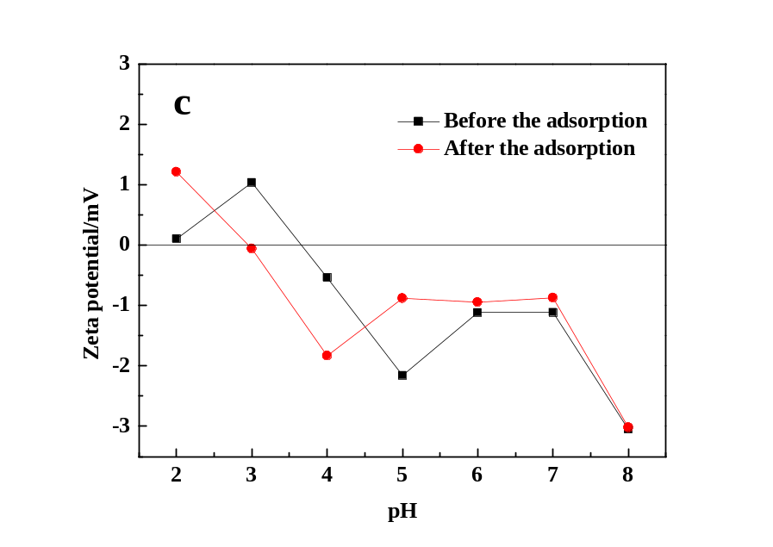
Fig. S1 Zeta potentials of MMC with 0.25 g furfuryl alcohol (a), 0.5 g furfuryl alcohol (b), and 0.1 g furfuryl alcohol (c) before and after the adsorption at varied pH values.
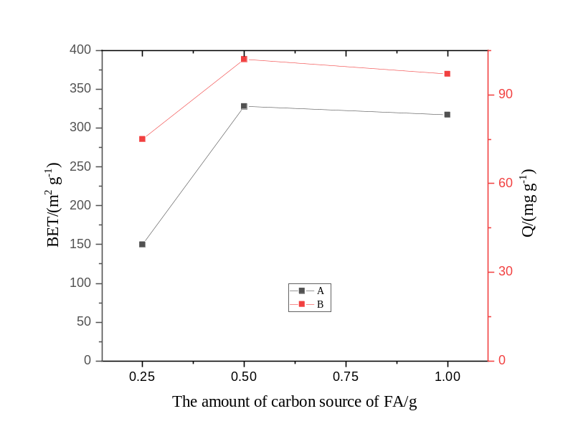
Fig. S2 The effects of the amount of carbon source of FA on the BET (A) and the maximum adsorption capacity of MMCS (B).

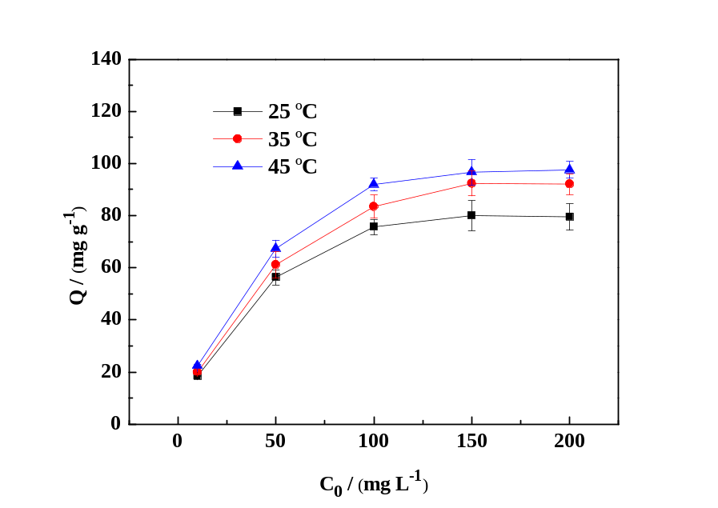
Fig. S3 Effects of initial dye concentration and temperature on the adsorption of MO by MMC (Adsorption conditions: pH=4, contact time=50 min)

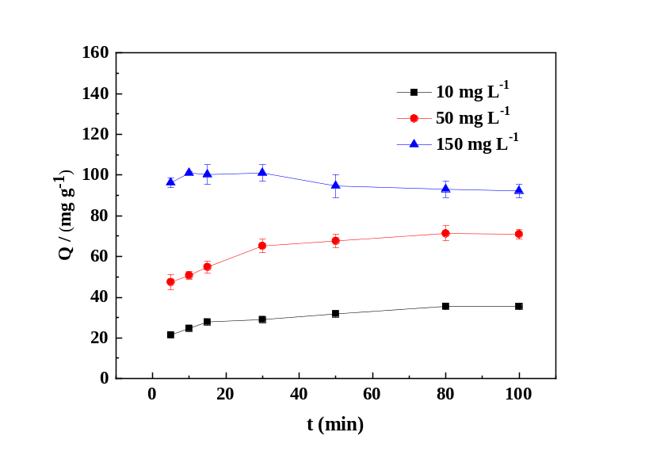
Fig. S4 Effect of contact time on the adsorption of MO by MMC (Adsorption conditions: pH=4, temperature=308 K).

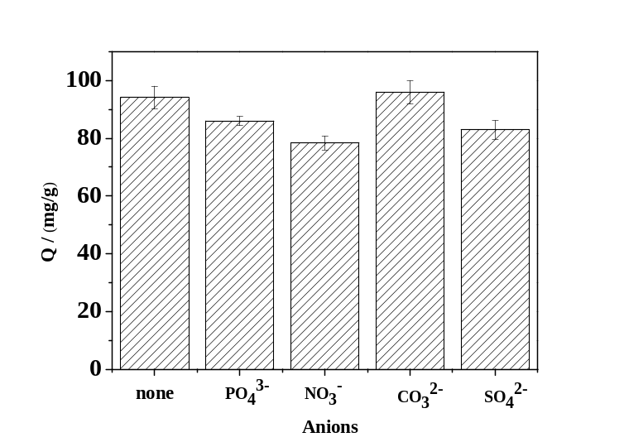
Fig. S5 The effect of coexisting anions on the adsorption of MO by MMC. (Adsorption conditions: pH=4, temperature=308 K, contact time=15 min, C₀=150 mg L⁻¹).

Table S1 EDS analysis of MMCS
Elements | Content (Wt%)
Elements | 0.25 g furfuryl alcohol | 0.5 g furfuryl alcohol | 1.0 g furfuryl alcohol
C | 26.24 | 27.185 | 19.17
O | 15.73 | 22.595 | 18.165
Si | 4.43 | 18.66 | 28.61
Fe | 53.605 | 31.315 | 34.055

Table S2 Pseudo-first-order and pseudo-second-order model constants for the adsorption of MO by MMCS.
C₀  (mg L⁻¹) | Pseudo-first-order |  |  | Pseudo-second-order
C₀  (mg L⁻¹) | q_{e}  (mg g⁻¹) | k₁  (min⁻¹) | R² | q_{e}  (mg g⁻¹) | k₂  (g mg⁻¹ min⁻¹) | R²
10 | 35.51 | 0.05289 | 0.92 | 37.2 | 0.004723 | 0.99
50 | 71.37 | 0.13519 | 0.78 | 74.2 | 0.003189 | 0.99
150 | 101.07 | -0.06143 | 0.10 | 91.6 | -0.008580 | 0.99
C₀: the initial concentration of MO before adsorption; q_{e}: the adsorption capacity of MO at equilibrium; q_{t}: the adsorption capacity of MO at time; k₁ and k₂: the rate constant of pseudo-first-order and pseudo-second-order adsorption, respectively.

Table S3 Langmuir and Freundlich isotherm constants for the adsorption of MO by MMCS.
T  (K) | Langmuir |  |  | Freundlich
T  (K) | q_{m}  (mg g⁻¹) | K_{L}  (L mg⁻¹) | R² | n | K_{F}  (L g⁻¹) | R²
298 | 91.2 | 0.0446 | 0.996 | 2.2107 | 8.9487 | 0.92
308 | 108.3 | 0.0374 | 0.997 | 2.1099 | 9.3101 | 0.95
318 | 113.1 | 0.0408 | 0.997 | 2.1642 | 10.4558 | 0.93
T: the adsorption temperature; q_{m}: the maximum adsorption capacity; K_{L} and K_{F}: the constants of Langmuir and Freundlich, respectively; R²: the correlation coefficient; n: a Freundlich constant associated with the intensity of adsorption.

Table S4 Thermodynamic parameters for the adsorption of MO by MMCS.
T (K) | q_{e}  (kJ mol⁻¹) | ΔG⁰  (kJ mol⁻¹) | ΔH⁰  (kJ mol⁻¹) | ΔS⁰  (J mol⁻¹ K⁻¹)
298 | 80.0 | -0.94 | 3.92 | 16.38
308 | 92.4 | -1.17 | 3.92 | 16.38
318 | 97.6 | -1.27 | 3.92 | 16.38
ΔG⁰: the Gibbs free energy change; ΔH⁰: the enthalpy change; ΔS⁰: the entropy change.

