SUPPLEMENTARY DATA
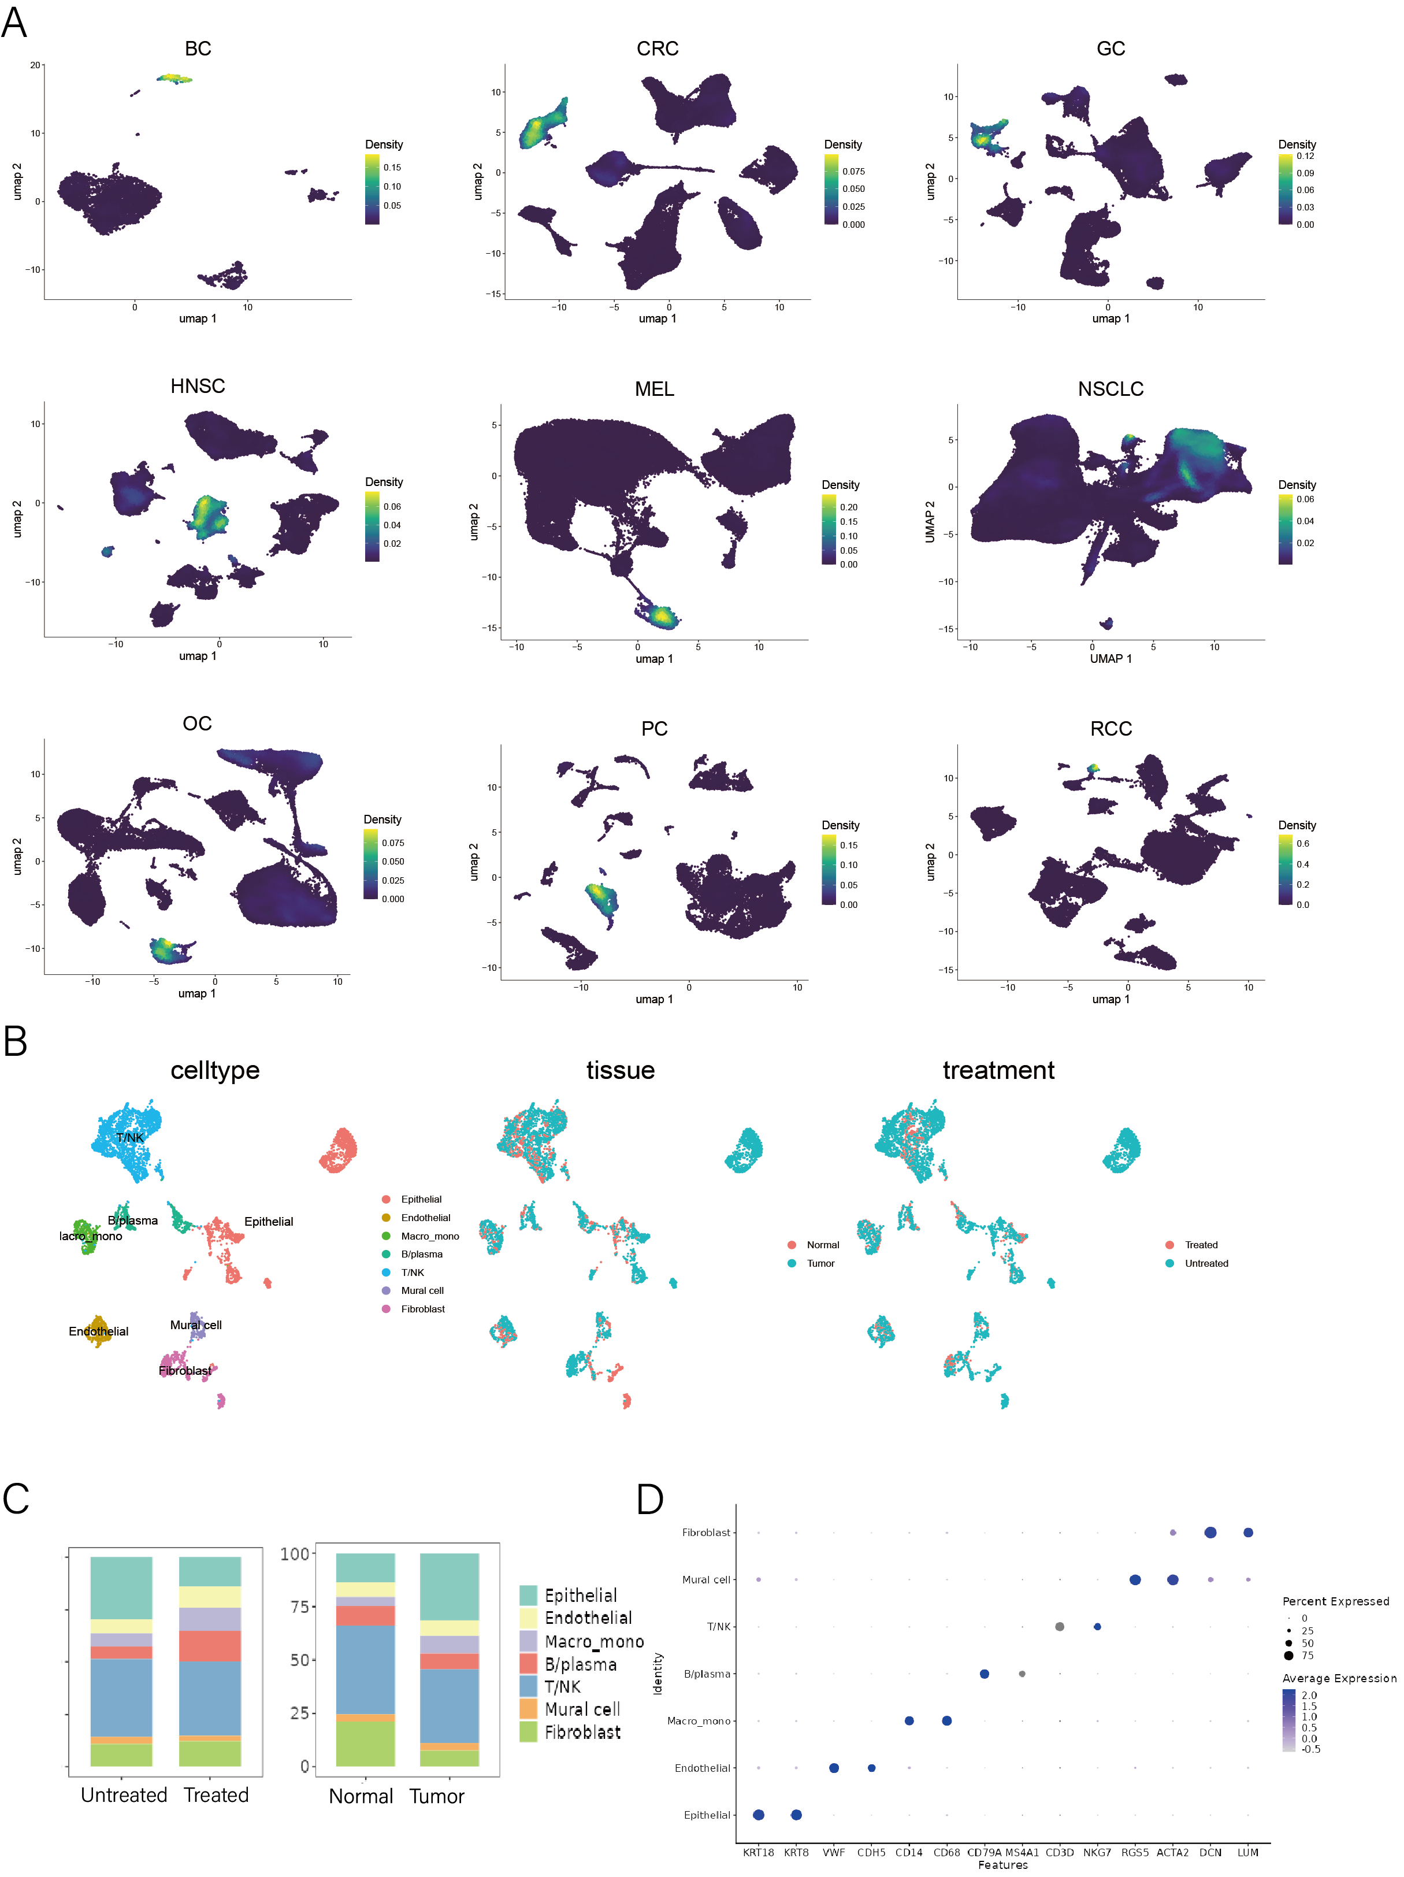
Fig.S1| Original scRNA-seq datasets and integrated data (downsampled). A, UMAP plots showing ECs (annotated by VWF and PECAM1) in each original dataset. B, UMAP plots of integrated dataset (1000 cells were selected randomly from each dataset and integrated) labeled by major cell types, tissues, and treatments. C. Relative fraction of major cell types in different tissues and treatment statuses. D, Dot plot showing marker genes of each major cell types.
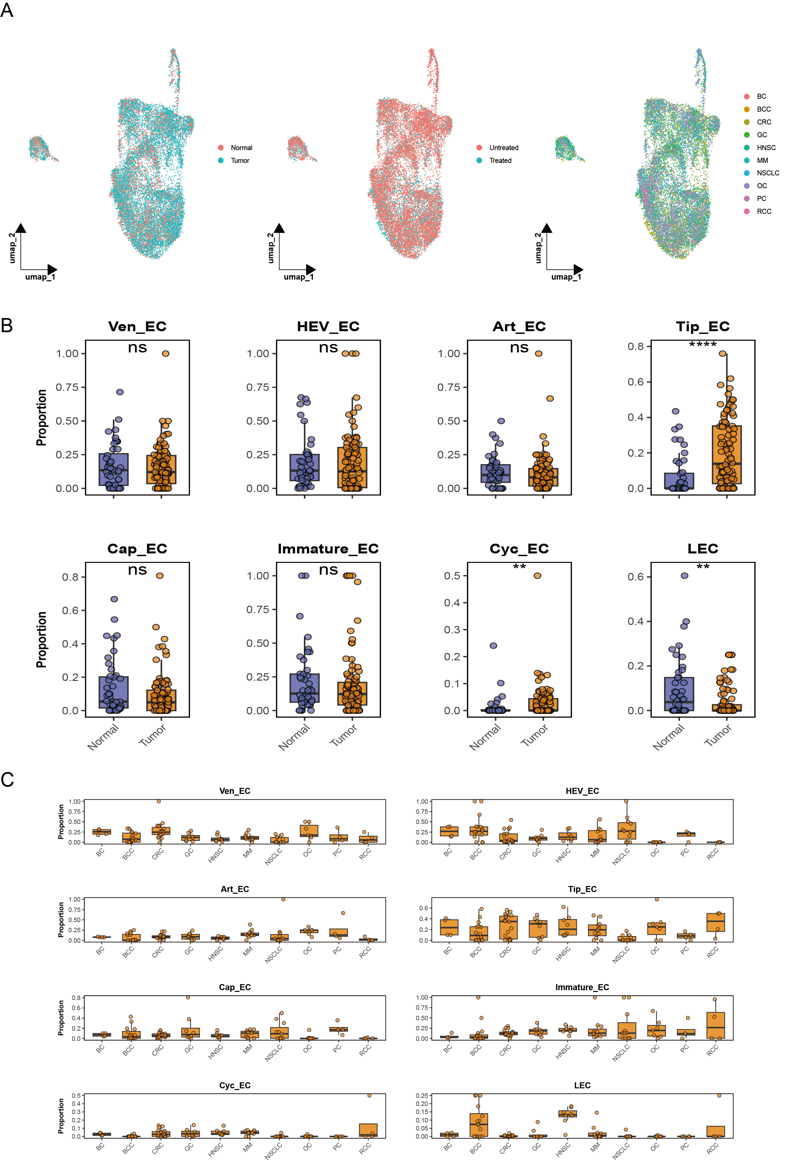
Fig.S2| A, UMAP plots of the integrated EC dataset labeled by tissues, treatments, and cancer types. B, Boxplots showing the fraction of each subcluster in the EC population in different tissues (each dot representing a sample that integrated into the dataset). C, Boxplots showing the fraction of each subcluster in the EC population in different malignancies (each dot representing a sample that integrated into the dataset).
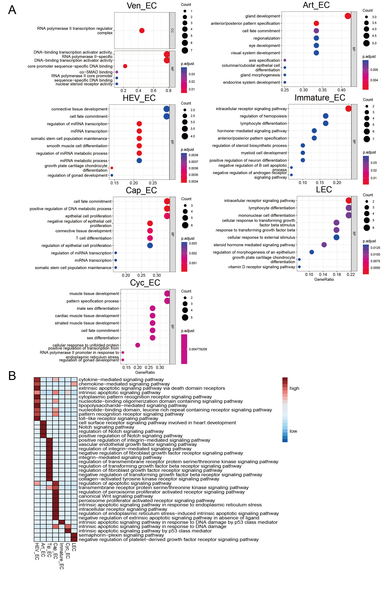
Fig. S3| GO analysis of EC subclusters. A, Top 10 functions enriched in each subcluster except Tip cells (shown in the main Fig. 2A). B, Signaling pathways enriched in each EC subcluster.
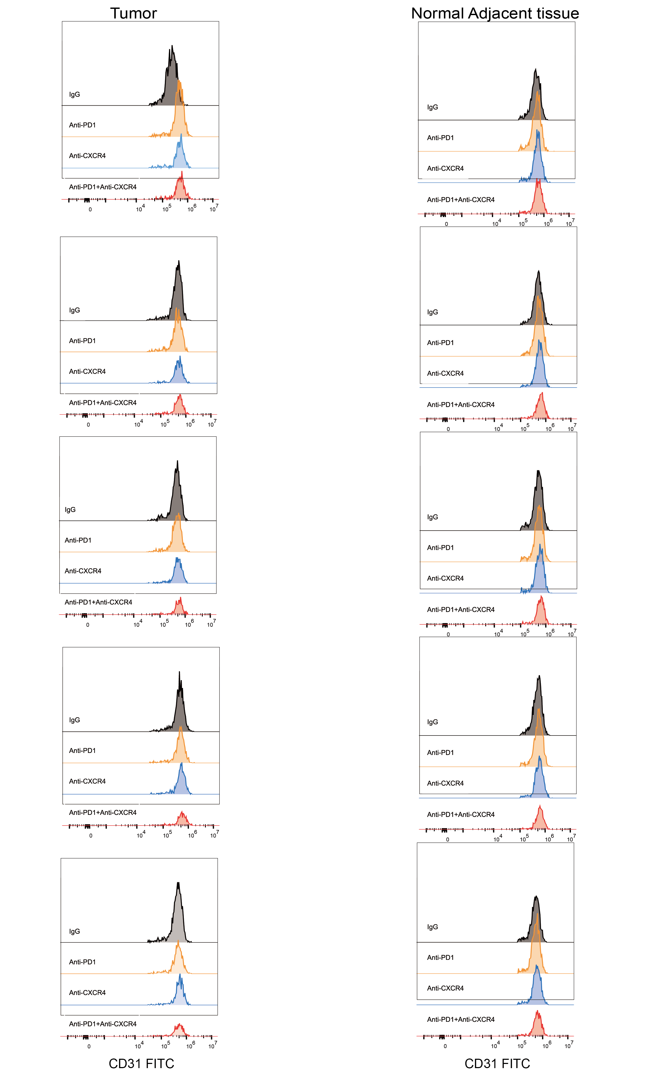
Fig.S4| Flow cytometry screening CD31⁺ cells in tissues from each group.

