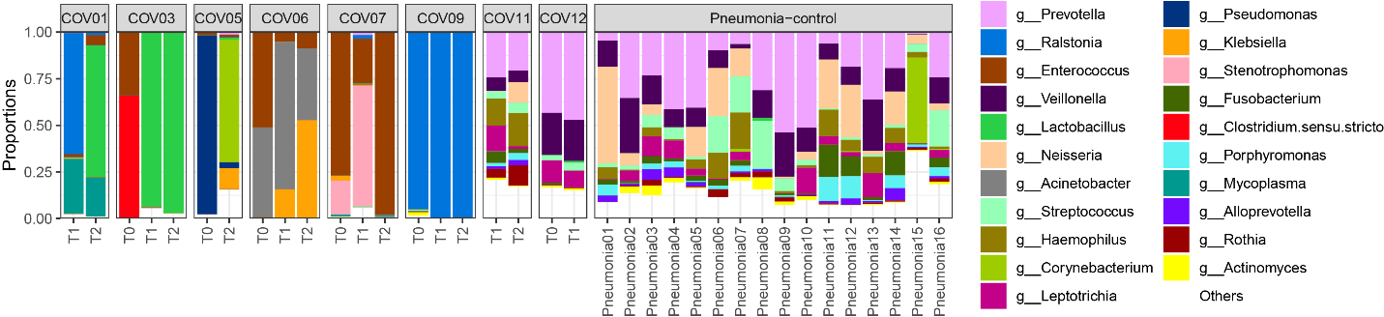

Figure S1. Relative abundance of top 20 taxonomic genus in COVID-19, and non-COVID-19 pneumonia controls.

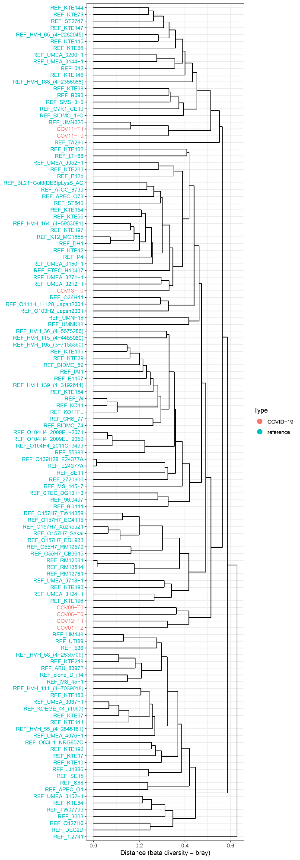

Figure S2. Strain-level cluster tree of Escherichia coli based the BC (Bray-Curtis) distance of presence/absence gene-family profile.

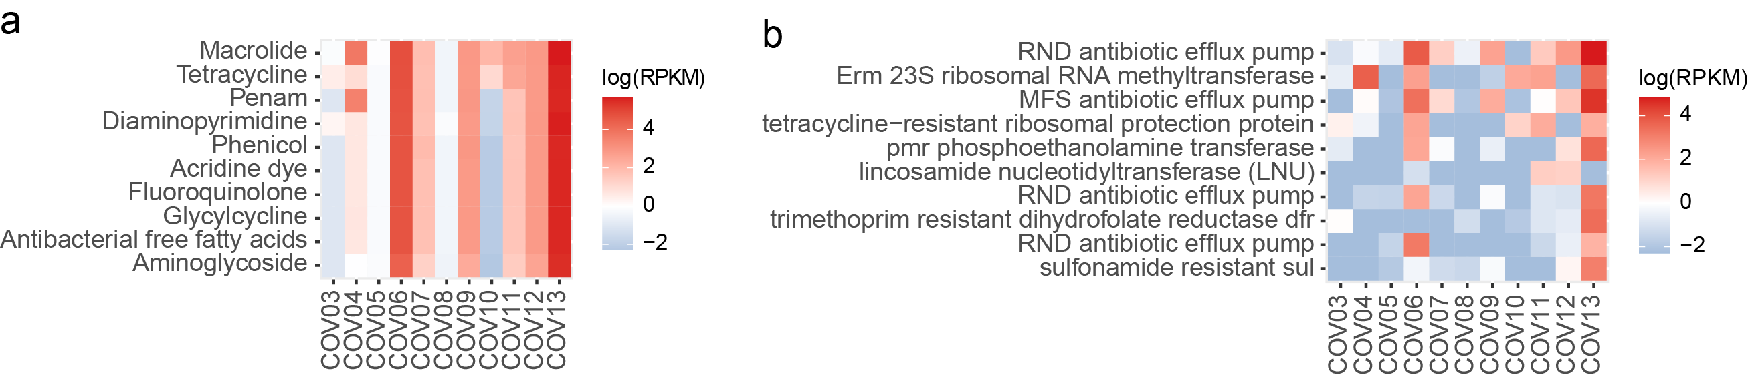

Figure S3. Box plots showing the top 10 most abundant antibiotic resistance targets (a) and antibiotic resistance genes (b).

